- Initialize a new Git repository
git init

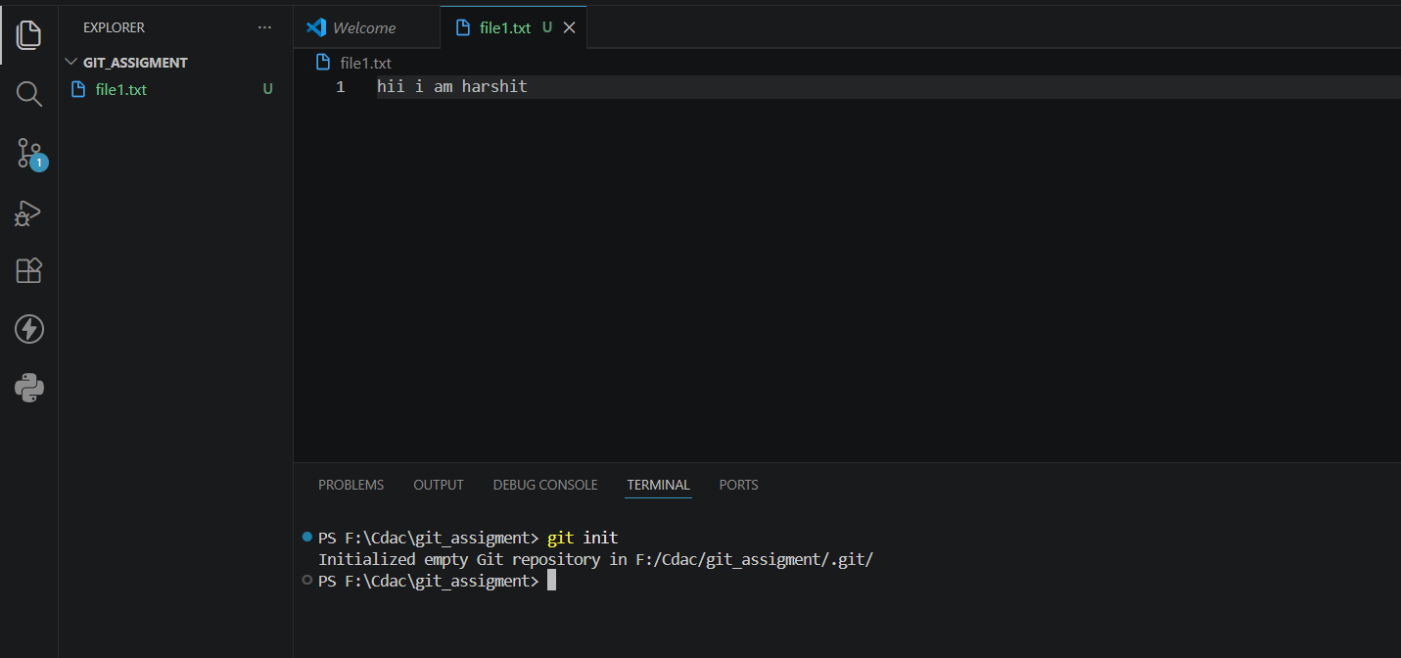

- Add files to the staging area
git add
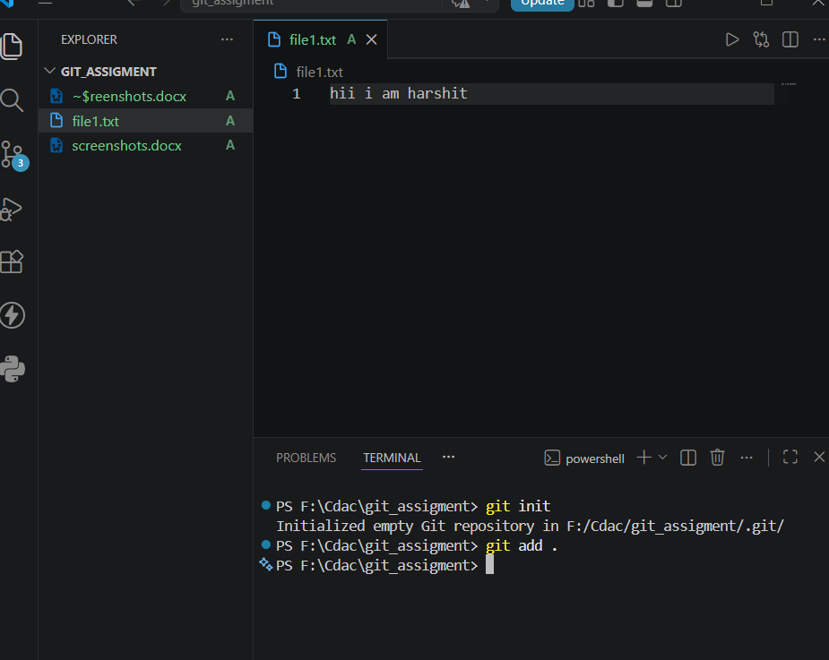
- Commit changes with a message
git commit -m "your message"

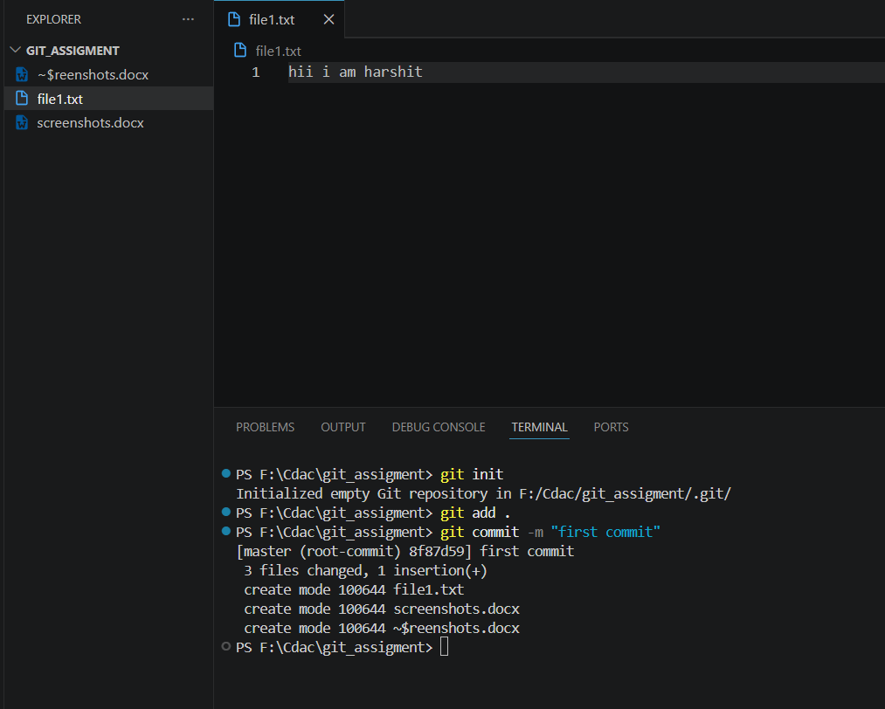

4.Check the status of the repository
git status
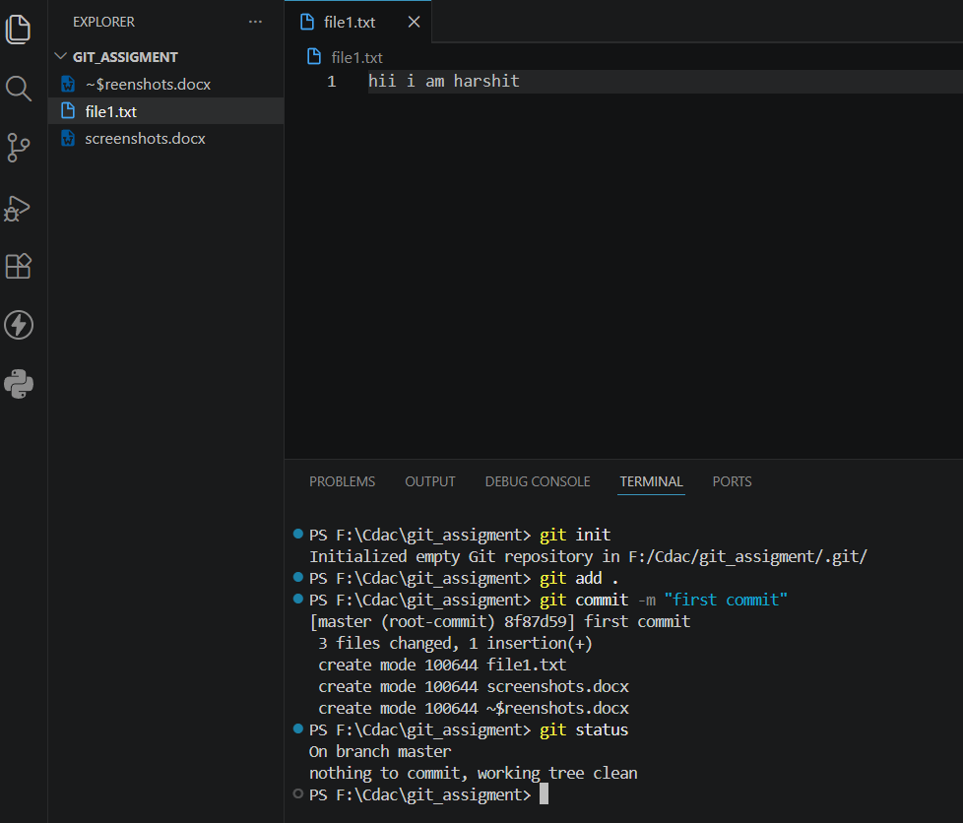
- Create a new branch and switch to it
git checkout -b branch_name

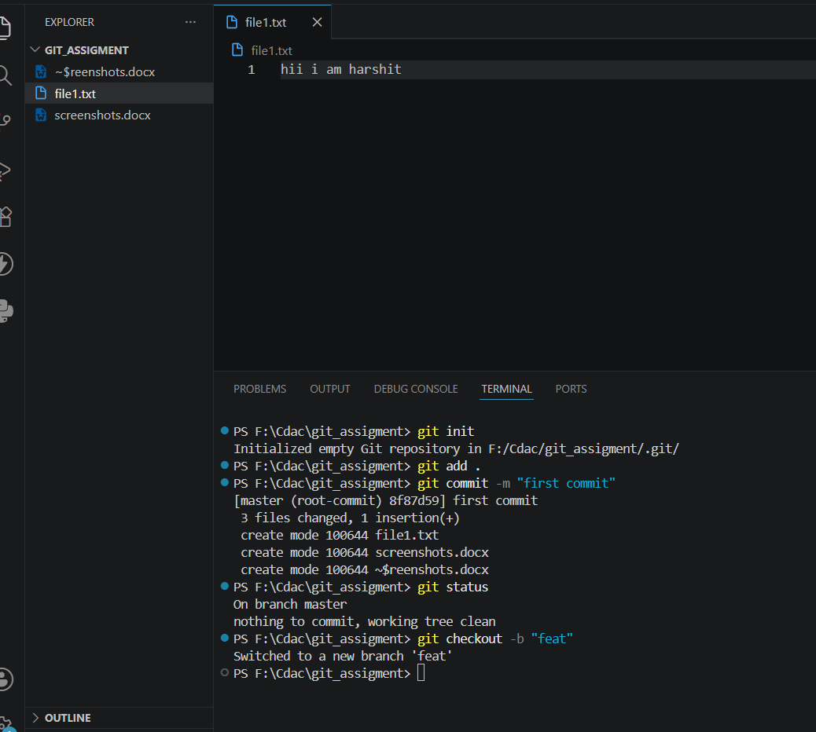
6. Merge a branch into the current branch
git merge branch_name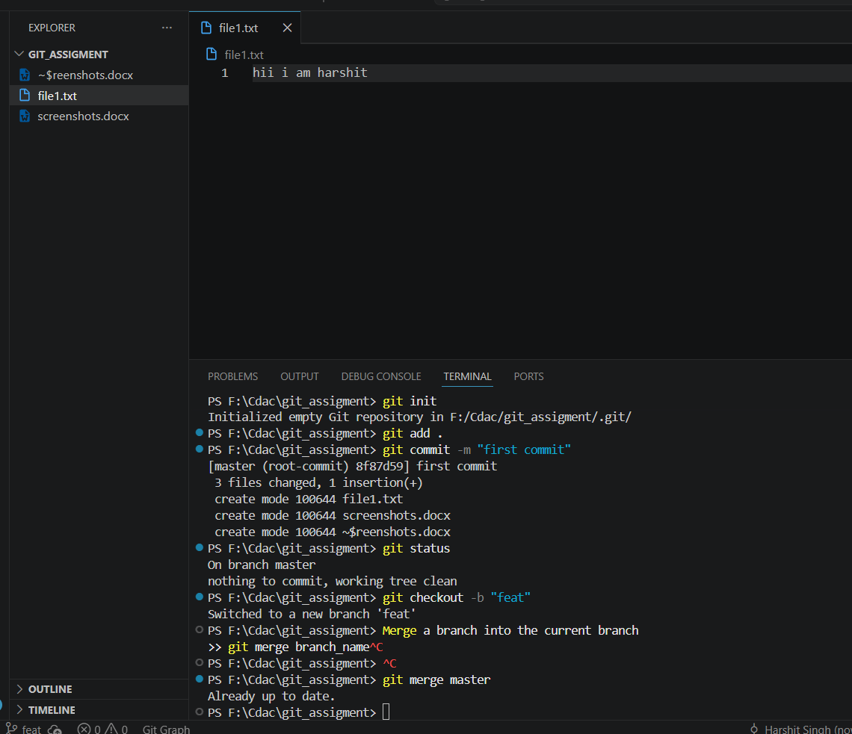

7. View differences between two branches or commits
git diff branch1 branch2
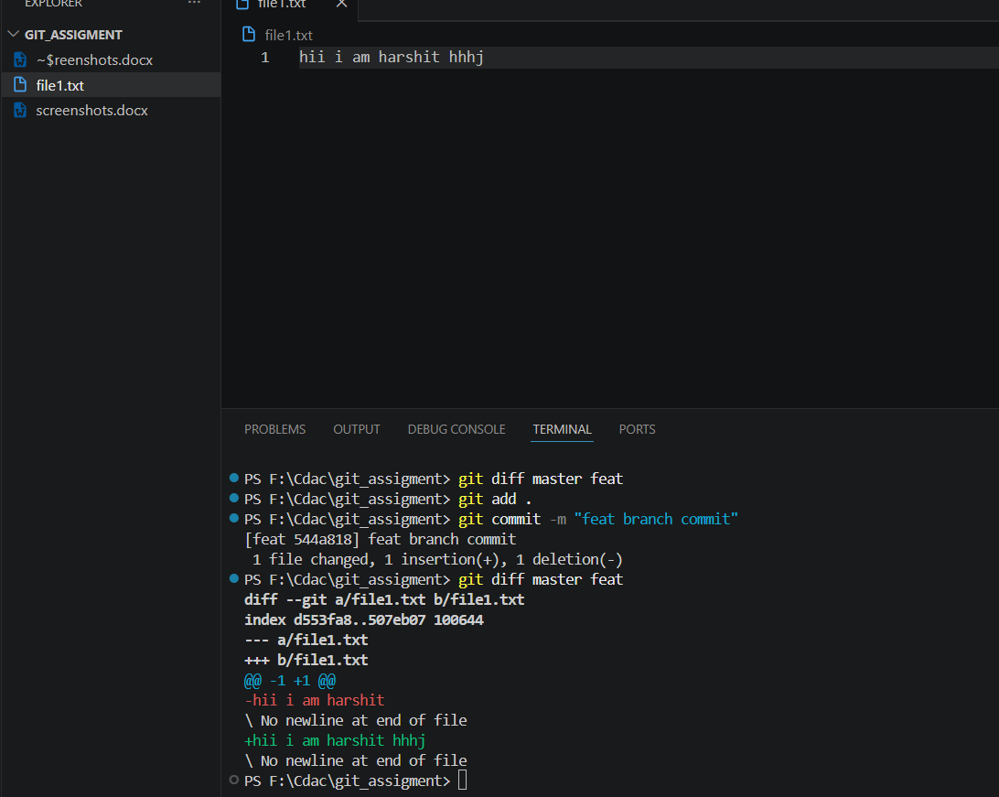
8. Revert changes to a specific file

git restore filename
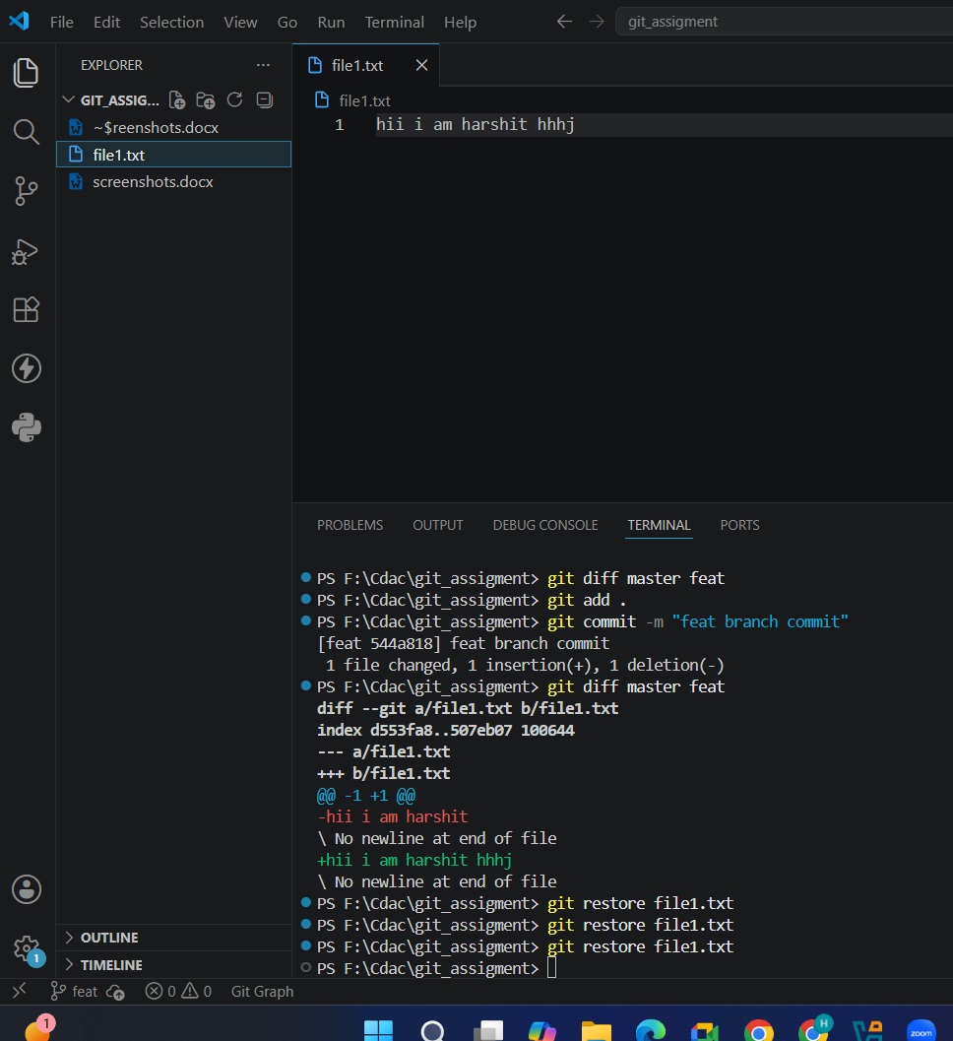

9. Undo the last commit
git reset --soft HEAD~1
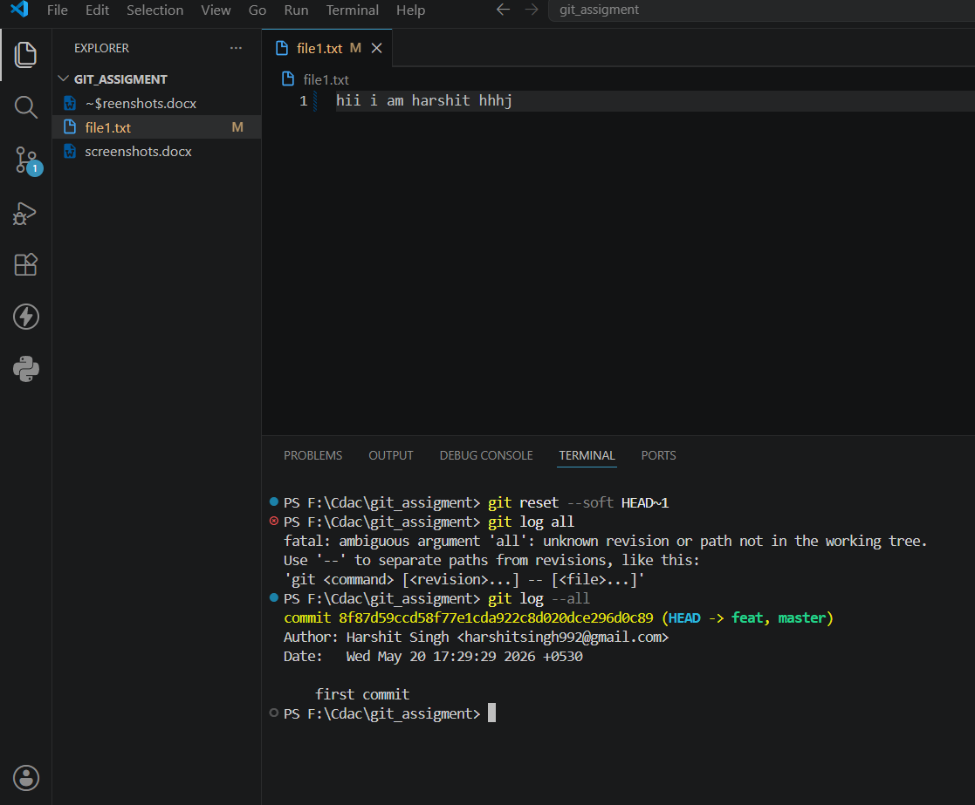

- Push changes to a remote repository
git push origin main