Predicting CRM Sales Opportunities Using Machine Learning
Hong Thai Phan, Nguyen Khanh An Tran, and Hoang Thien Bao Bui
CS 582, Group 2 — First draft for team review

Abstract—We build a reproducible pipeline that estimates the probability that a CRM sales opportunity is Won or Lost and reports the input factors behind each score. We compare Logistic Regression (LR), Random Forest (RF), a multilayer perceptron (MLP) and TabNet against a prior-only control on the Maven CRM Sales Opportunities data, using a time-ordered split that excludes deals whose outcome was not yet known. LR is selected on validation ROC-AUC and reaches a test ROC-AUC of only 0.524, close to chance; no model beats the control in any practical sense. A deliberately invalid control that uses close value reaches AUC 1.0, showing how leakage produces misleading scores. Our contribution is an auditable, explainable evaluation workflow and an honest negative finding, not a new algorithm.
Index Terms—sales opportunity prediction, CRM, TabNet, explainability, temporal evaluation, data leakage
I. INTRODUCTION
Sales teams must decide which open opportunities deserve attention and want to understand why a model favors a deal. We study this as binary classification of eventual outcome (Won = 1, Lost = 0) from attributes known when a deal enters the Engaging stage. The system outputs complementary probabilities P(Won) and P(Lost) and the factors associated with higher or lower scores. We model eventual recorded outcome among closed deals; the data do not support fixed-horizon claims such as “win within 30 days.”
Prior work frames win propensity as part of pipeline management [2] and describes end-to-end B2B prediction workflows [3]. TabNet [4] applies sequential attention to tabular data, and we test whether it helps here. We do not claim a new algorithm: our contribution is the combination of an availability-aware split, an explicit leakage control, probability calibration, local explanations and missing-input warnings, together with a candid report of weak results.
II. RELATED WORK
Yan et al. [2] treat win propensity as a component of sales pipeline management and evaluate a data-driven approach on enterprise B2B data; this motivates our probability output, though we cannot reproduce their proprietary data or claim a comparable business benefit. Rezazadeh [3] presents a B2B workflow linking training, prediction and decision boundaries, which motivates our separation of fitting, evaluation and scoring. We use a small CPU workflow rather than a cloud platform. Arik and Pfister [4] introduce TabNet; we compare an existing implementation with simpler learners, without its self-supervised pretraining. Explainable CRM scoring already exists, so our novelty is the applied design and audit of this workflow.
III. DATA AND PREPARATION
The Maven Analytics CRM data [1] describe a fictitious B2B computer-hardware vendor: 8,800 opportunities, 85 accounts, 7 products and 35 sales-team records. The pipeline table is left-joined to the other tables with many-to-one checks. Of the records, 6,711 are closed (4,238 Won, 2,473 Lost); 2,089 are open, of which 1,589 are Engaging and eligible for scoring while 500 Prospecting records are excluded. Open records are never labeled Lost.
Features are seven categorical fields (product, series, sector, account location, regional office, manager, sales agent) and eleven numeric fields (list price, account revenue, employees, revenue per employee, year established, account age, engagement calendar fields, subsidiary flag). The fields close_value, close_date, deal_stage and opportunity_id are excluded as predictors: dates only control label availability, stage defines the target, and IDs provide traceability. Preprocessing (constant imputation and one-hot encoding for categoricals; training medians and, for LR/MLP/TabNet, standardization for numerics) is fitted on training data only.
IV. EVALUATION DESIGN
Closed deals are ordered by engagement date; the 60th and 80th percentile dates form period boundaries, and rows sharing a date stay together. Training deals must engage and close before the validation start (2017-07-15); validation deals must close before the test start (2017-09-18); test deals engage on or after it, ending 2017-12-27. This yields 2,975 training, 583 validation and 1,361 test deals and purges 1,792 records whose outcomes arrived late. Win rates are 64.6%, 60.7% and 60.0%, respectively.
The model, early-stopping epoch, class threshold and calibration are chosen on validation only. The model is the one with the highest validation ROC-AUC; the threshold maximizes validation macro-F1 over 0.10–0.90. The test period is a single exploratory evaluation, not a pristine test, because the data were examined earlier in the project. We report Accuracy, Precision, Recall, F1 (Won as positive), ROC-AUC and confusion matrices, plus Brier score, as the proposal promised.
V. MODELS
The Dummy control outputs the training win rate. LR uses L2 regularization (C = 1). RF uses 300 trees with minimum leaf size 5. The MLP has two ReLU layers (64, 32) trained with Adam (learning rate 0.001) and early stopping on validation AUC (best epoch 38). TabNet uses n_d = n_a = 8, three decision steps, learning rate 0.02 and batch size 256 (best epoch 12), via the pytorch-tabnet package. All models use seed 42, run on CPU, and use modest fixed budgets rather than an exhaustive search.
VI. RESULTS
Table I lists test results at each model’s validation-selected threshold. Validation AUCs were LR 0.563, TabNet 0.559, RF 0.538, MLP 0.529, so LR was selected before test data were examined.
TABLE I. Test-set metrics (Won = positive; 1,361 deals).
Model | Acc. | Prec. | Rec. | F1 | AUC | Brier
Dummy prior | 0.600 | 0.600 | 1.000 | 0.750 | 0.500 | 0.242
Logistic Reg. | 0.437 | 0.615 | 0.166 | 0.262 | 0.524 | 0.279
Random Forest | 0.590 | 0.598 | 0.966 | 0.739 | 0.519 | 0.251
MLP | 0.485 | 0.593 | 0.453 | 0.514 | 0.495 | 0.331
TabNet | 0.563 | 0.614 | 0.734 | 0.669 | 0.517 | 0.247

All four classifiers have test ROC-AUC between 0.495 and 0.524, essentially chance. The prior control attains 60.0% accuracy and F1 0.750 simply by predicting Won for every deal, so accuracy and F1 alone are misleading: RF reaches similar numbers (recall 0.966, only 14 of 544 Lost deals identified) by behaving almost like the control. LR’s threshold, tuned for macro-F1 on validation, predicts Won rarely on test (recall 0.166), giving 43.7% accuracy. TabNet has the best balanced accuracy (0.520) and macro-F1 (0.513), but the differences are small and we ran no multi-seed or account-clustered uncertainty analysis, so we claim no significant ranking among models. The traditional-versus-TabNet comparison thus shows no advantage for the more complex architecture.
TABLE II. Test confusion counts, validation AUC and selected threshold.
Model | TN | FP | FN | TP | Val. AUC | Thr.
Dummy prior | 0 | 544 | 0 | 817 | 0.500 | 0.50
Logistic Reg. | 459 | 85 | 681 | 136 | 0.563 | 0.48
Random Forest | 14 | 530 | 28 | 789 | 0.538 | 0.54
MLP | 290 | 254 | 447 | 370 | 0.529 | 0.46
TabNet | 166 | 378 | 217 | 600 | 0.559 | 0.61

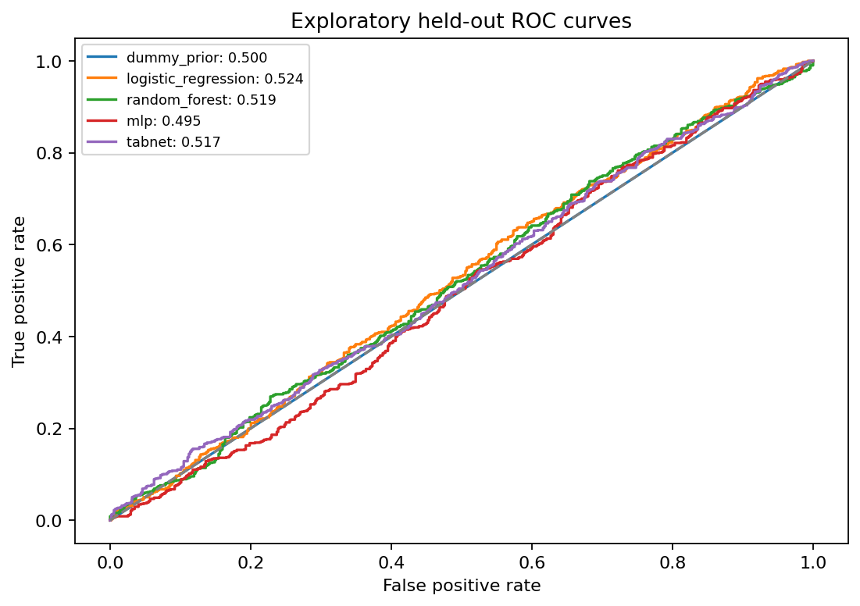
Fig. 1. Test ROC curves for all models.
A. Calibration
A sigmoid calibrator [5] fitted on validation scores of the frozen LR model lowers test Brier score from 0.279 to 0.244. This is still slightly worse than the prior control (0.242), and ROC-AUC is unchanged because calibration preserves ordering. The base model is not refit.
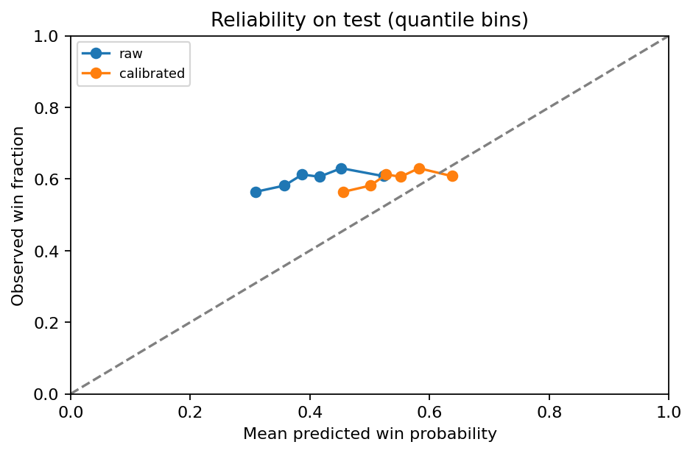
Fig. 2. Reliability of raw and calibrated LR probabilities on test data.
B. Leakage control
A depth-one tree on close_value, which is zero for every Lost deal, attains accuracy and AUC of 1.0 on the same test set. This invalid model is never used for selection or scoring; it illustrates why near-perfect scores from outcome-derived columns must be rejected.
VII. EXPLANATIONS AND DECISION SUPPORT
We export LR coefficients, RF impurity importance, TabNet attention importance and held-out permutation importance. Permutation importance, measured as AUC drop, is largest for sales agent (0.023), followed by office location (0.008) and engagement month (0.006); the remaining features are below 0.004, consistent with a weak signal. For each open deal, the selected calibrated model reports reference sensitivities: the change in P(Won) when one input is replaced by its training median or mode. These are not additive SHAP values and not causal effects. Separately, TreeSHAP [6] on the raw RF for 64 test rows reconstructs its predictions with maximum error 1.8×10⁻¹², serving as an additive diagnostic of that RF only.
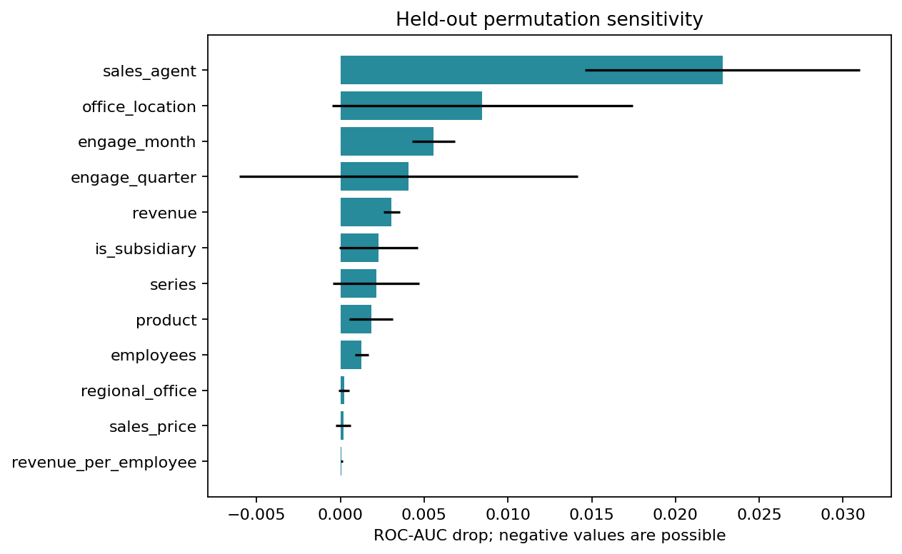
Fig. 3. Held-out permutation importance (mean AUC drop).
Snapshot scores cover 1,589 Engaging open deals with P(Won), P(Lost), a predicted class, a heuristic priority band (Low < 0.40 ≤ Medium < 0.70 ≤ High) and warnings. 1,088 of them lack account data and lie outside training support, so they are flagged. The model was fitted using later events, so these are not historical as-of predictions. On test data the High and Low bands contain only 4 and 5 deals, so the priority bands are unvalidated and make no business claim.
VIII. LIMITATIONS
(1) The dataset was examined earlier, so the test period is exploratory. (2) The availability purge reduces but cannot remove closed-only selection bias and censoring. (3) Account, product and team attributes are static snapshots. (4) Accounts and agents repeat across periods, so this is not a new-customer test. (5) Validation is reused for early stopping, selection, threshold and calibration, which may be optimistic. (6) The features lack richer engagement signals such as activity history, budget or competitors; this is a plausible, not demonstrated, cause of low AUC. (7) The 2,975-row training set is small after purging.
IX. CONCLUSION
We implemented the four required classifiers and a prior control on a leakage-aware temporal split, with calibrated probabilities and explanations. Under this protocol no model discriminates meaningfully (best test AUC 0.524), and complex models, including TabNet, do not help. We report this negative result openly rather than use post-outcome information. Future work includes multiple temporal windows, account-grouped evaluation, richer pre-close activity features, separate calibration data and prospective testing of any priority policy.
REPRODUCIBILITY
Running python -m src.run_project regenerates all numbers, figures and documents in reports/crm/final/. Source-file hashes, split assignments, model configurations (Python 3.12, scikit-learn 1.8.0, PyTorch 2.8.0 CPU, pytorch-tabnet 4.1.0) and raw test probabilities are saved with each run. Colab execution has not yet been independently verified by the team.
Contribution statements are left for each team member to complete.
REFERENCES
[1] Maven Analytics, “CRM Sales Opportunities,” https://mavenanalytics.io/data-playground/crm-sales-opportunities (accessed Oct. 6, 2026).
[2] J. Yan, M. Gong, C. Sun, J. Huang, and S. M. Chu, “Sales pipeline win propensity prediction: A regression approach,” in Proc. IFIP/IEEE IM, 2015.
[3] A. Rezazadeh, “A generalized flow for B2B sales predictive modeling: An Azure machine learning approach,” Forecasting, vol. 2, no. 3, 2020.
[4] S. Ö. Arik and T. Pfister, “TabNet: Attentive interpretable tabular learning,” in Proc. AAAI, vol. 35, no. 8, pp. 6679–6687, 2021.
[5] scikit-learn, “Probability calibration,” https://scikit-learn.org/stable/modules/calibration.html (accessed Oct. 6, 2026).
[6] SHAP documentation, “TreeExplainer,” https://shap.readthedocs.io/en/latest/generated/shap.TreeExplainer.html (accessed Oct. 6, 2026).

