Predicting CRM Sales Opportunities Using Machine Learning
Hong Thai Phan, Nguyen Khanh An Tran, and Hoang Thien Bao Bui
CS 582, Group 2 — Revised draft for team review (adds the decision agent)

Abstract—We estimate the probability that a CRM sales opportunity is Won and add a bounded, deterministic, tool-using agent that decides how that estimate may be used. On the Maven CRM data, six classifiers are trained on raw and on strictly prior history features under a time-ordered, label-availability-aware split, and one pair is locked on validation before testing. Discrimination is near chance: the selected history logistic regression has test ROC-AUC 0.5168, and all twelve learned candidates lie between 0.480 and 0.542. The agent chooses its tools by value of information, gates its final action on evidence quality and model reliability, executes only local actions behind a permission guard, and records a replayable trace. On the same 1,589 open deals and frozen model, it issues no unsupported directional label, against 1,242 for a prediction-only pipeline and 487 for a rule-based assistant, and it detects every known data issue. Ablations attribute the safety benefit to the reliability gate and an efficiency benefit to planning. An outcome-masked replay shows that the agent does not identify lost deals better than chance. We claim workflow quality, not accuracy or sales uplift.
Index Terms—sales opportunity prediction, CRM, intelligent agents, value of information, selective prediction, temporal evaluation, data leakage
I. INTRODUCTION
Sales teams must decide which open opportunities deserve attention and want to understand why a model favors a deal. We study this as binary classification of eventual outcome (Won = 1, Lost = 0) from attributes known when a deal enters the Engaging stage. The system outputs complementary probabilities P(Won) and P(Lost) and the factors associated with higher or lower scores. We model eventual recorded outcome among closed deals; the data do not support fixed-horizon claims such as “win within 30 days.”
Prior work frames win propensity as part of pipeline management [2] and describes end-to-end B2B prediction workflows [3]. TabNet [4] and CatBoost [7] are tested as tabular learners. Our contribution is not a new learning algorithm. It is (i) an audited, explainable prediction workflow whose safeguards are measured (leakage control, availability-aware split, explanation checks, a known-truth simulation), and (ii) an evidence-grounded decision agent that plans which evidence to gather, refuses unsupported recommendations, acts only inside a permission guard and records replayable traces. We compare it with a prediction-only pipeline and a rule-based assistant on identical cases, and ablate each component. We keep three claims apart: prediction quality, agent workflow quality, and business value, which we did not measure.
II. RELATED WORK
Yan et al. [2] treat win propensity as a component of sales pipeline management and evaluate a data-driven approach on enterprise B2B data; this motivates our probability output, though we cannot reproduce their proprietary data or claim a comparable business benefit. Rezazadeh [3] presents a B2B workflow linking training, prediction and decision boundaries, which motivates our separation of fitting, evaluation and scoring. We use a small CPU workflow rather than a cloud platform. Arik and Pfister [4] introduce TabNet; we compare an existing implementation with simpler learners, without its self-supervised pretraining. Explainable CRM scoring already exists, so our novelty is the applied design and audit of this workflow.
Agent design follows the utility-based agent of Russell and Norvig [8]: the agent keeps a belief state, scores actions, and acts toward a goal. Its tool choice uses the value of information [9]: evidence is worth gathering when it can change the decision. Refusing a confident label when evidence is weak relates to classification with a reject option [10] and selective prediction [11]. Language-model agents such as ReAct [12] interleave reasoning with tool calls, but generated text can drift from tool results. Our agent uses no language model: every observation is a tool return value with a cited source. Human-AI guidelines [13] motivate the explicit uncertainty, scoped autonomy and human approval of consequential actions.
III. DATA AND PREPARATION
The Maven Analytics CRM data [1] describe a fictitious B2B computer-hardware vendor: 8,800 opportunities, 85 accounts, 7 products and 35 sales-team records. The pipeline table is left-joined to the other tables with many-to-one checks. Of the records, 6,711 are closed (4,238 Won, 2,473 Lost); 2,089 are open, of which 1,589 are Engaging and eligible for scoring while 500 Prospecting records are excluded. Open records are never labeled Lost.
Features are seven categorical fields (product, series, sector, account location, regional office, manager, sales agent) and eleven numeric fields (list price, account revenue, employees, revenue per employee, year established, account age, engagement calendar fields, subsidiary flag). The history feature set adds 19 aggregates: for the agent, account and product, the count of prior closed deals, a smoothed win rate, mean close value, mean cycle length and a cold-start flag, plus archive-wide values. They are computed from a frozen archive of training deals that closed strictly before the query deal's engagement, excluding its own outcome. The fields close_value, close_date, deal_stage and opportunity_id are excluded as predictors: dates only control label availability and history eligibility, and the identifier links evidence.
IV. EVALUATION DESIGN
Closed deals are ordered by engagement date; the 60th and 80th percentile dates form period boundaries, and rows sharing a date stay together. Training deals must engage and close before the validation start (2017-07-15); validation deals must close before the test start (2017-09-18); test deals engage on or after it, ending 2017-12-27. This yields 2,975 training, 583 validation and 1,361 test deals and purges 1,792 records whose outcomes arrived late. Win rates are 64.6%, 60.7% and 60.0%, respectively.
The feature set, model, early-stopping epoch, class threshold and calibration are chosen on validation only. Among twelve (feature set, model) pairs, the one with the highest validation ROC-AUC is locked (ties: lower Brier) and saved before any test metric is computed. The threshold maximizes validation macro-F1 over 0.10–0.90. The test period is a single exploratory evaluation, not a pristine test, because the data were examined earlier in the project. We report Accuracy, Precision, Recall, F1 (Won as positive), ROC-AUC, average precision, Brier score and confusion matrices.
V. MODELS
The Dummy control outputs the training win rate. LR uses L2 regularization (C = 1). RF uses 300 trees with minimum leaf size 5. The MLP has two ReLU layers (64, 32) trained with Adam (learning rate 0.001) and early stopping on validation AUC (best epoch 19). TabNet uses n_d = n_a = 8, three decision steps, learning rate 0.02 and batch size 256 (best epoch 1). CatBoost [7] uses depth 5, learning rate 0.05 and early stopping on validation AUC. Epochs refer to the selected history feature set. All models share the training rows and a training-fitted preprocessor, run on CPU with seed 42.
VI. RESULTS
Table I lists test results for the selected history feature set at each model's validation-selected threshold. History LR had the highest validation ROC-AUC of all twelve pairs (0.569; raw LR 0.563), so it was locked before test data were examined.
TABLE I. Test-set metrics, history feature set (Won = positive; 1,361 deals).
Model | Acc. | Prec. | Rec. | F1 | AUC | Brier
Dummy prior | 0.600 | 0.600 | 1.000 | 0.750 | 0.500 | 0.242
Logistic Reg. | 0.426 | 0.608 | 0.124 | 0.205 | 0.517 | 0.318
Random Forest | 0.501 | 0.591 | 0.547 | 0.568 | 0.480 | 0.254
MLP | 0.516 | 0.618 | 0.506 | 0.556 | 0.499 | 0.286
TabNet | 0.525 | 0.599 | 0.633 | 0.615 | 0.502 | 0.241
CatBoost | 0.526 | 0.596 | 0.652 | 0.623 | 0.499 | 0.244

Every learned model has test ROC-AUC between 0.480 and 0.542, essentially chance. The prior control attains 60.0% accuracy and F1 0.750 simply by predicting Won for every deal, so accuracy and F1 alone are misleading. History LR's threshold, tuned for macro-F1 on validation, predicts Won rarely (recall 0.124). The highest test AUC belongs to raw CatBoost (0.5424); selecting it now would use the test set for model choice, so it is reported but not adopted. Table IV compares the feature sets: history features did not improve discrimination.
TABLE II. Test confusion counts, validation AUC and threshold (history set).
Model | TN | FP | FN | TP | Val. AUC | Thr.
Dummy prior | 0 | 544 | 0 | 817 | 0.500 | 0.50
Logistic Reg. | 479 | 65 | 716 | 101 | 0.569 | 0.41
Random Forest | 235 | 309 | 370 | 447 | 0.496 | 0.49
MLP | 289 | 255 | 404 | 413 | 0.535 | 0.43
TabNet | 198 | 346 | 300 | 517 | 0.504 | 0.56
CatBoost | 183 | 361 | 284 | 533 | 0.523 | 0.53

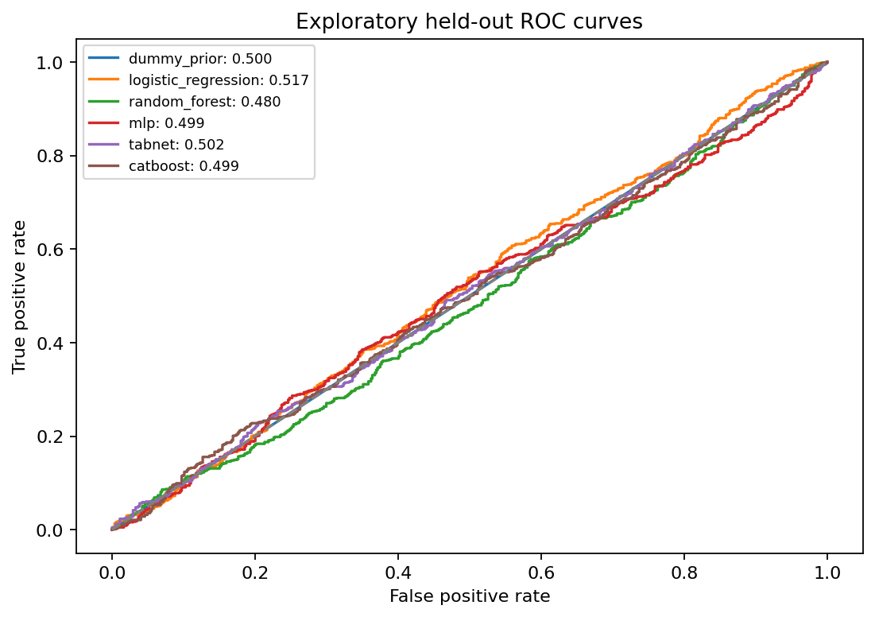
Fig. 1. Test ROC curves for all models.
A. Calibration
A sigmoid calibrator [5] fitted on validation scores of the frozen LR model lowers test Brier score from 0.318 to 0.249. This is still worse than the prior control (0.242), and ROC-AUC is unchanged because calibration preserves ordering. The base model is not refit.
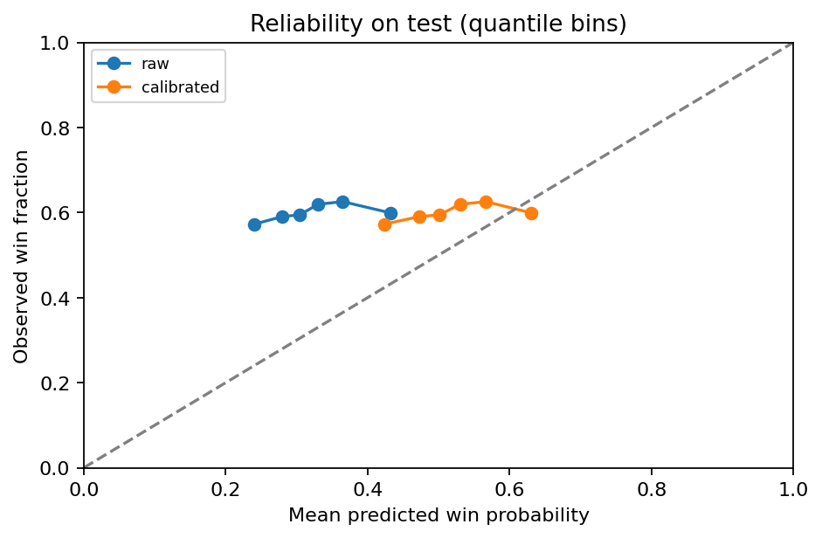
Fig. 2. Reliability of raw and calibrated LR probabilities on test data.
B. Leakage control
A depth-one tree on close_value, which is zero for every Lost deal, attains accuracy and AUC of 1.0 on the same test set. This invalid model is never used for selection or scoring; it illustrates why near-perfect scores from outcome-derived columns must be rejected.
C. Does the split protocol matter?
To measure what the availability-aware split contributes, we refit the five learned models on the 18 raw inputs under two alternatives (Table III). Chronological without purge keeps the same boundaries and the same 1,361 test deals but also trains on deals whose outcome was not yet known at the cutoff. A random stratified 60/20/20 split ignores time and is repeated over five seeds. The random split reports AUC at most 0.036 higher. Every protocol stays near chance, so the split is a safeguard, not the reason the scores are low.
TABLE III. Raw-feature test ROC-AUC under three split protocols.
Model | As-of + purge | No purge | Random (5 seeds)
Logistic Reg. | 0.524 | 0.529 | 0.546 ± 0.009
Random Forest | 0.519 | 0.508 | 0.534 ± 0.009
MLP | 0.495 | 0.475 | 0.531 ± 0.009
TabNet | 0.489 | 0.515 | 0.500 ± 0.013
CatBoost | 0.542 | 0.538 | 0.558 ± 0.029

D. Raw versus history features
History features use only outcomes that closed strictly before each deal's engagement, from the frozen training archive. Changing a held-out label cannot change any feature (tested). They did not help (Table IV). The test AUC change, history minus raw, ranges from -0.044 to +0.013. They also introduce a calendar-like input, the archive closure count, which exceeds its training range for most open deals (Section IX).
TABLE IV. Validation and test ROC-AUC by feature set.
Model | Raw val. | Raw test | Hist. val. | Hist. test
Logistic Reg. | 0.563 | 0.524 | 0.569 | 0.517
Random Forest | 0.538 | 0.519 | 0.496 | 0.480
MLP | 0.529 | 0.495 | 0.535 | 0.499
TabNet | 0.536 | 0.489 | 0.504 | 0.502
CatBoost | 0.545 | 0.542 | 0.523 | 0.499

VII. EXPLANATIONS AND DECISION SUPPORT
We export LR coefficients, RF impurity, TabNet attention and CatBoost importances, and held-out permutation importance of the selected model. Permutation importance, measured as AUC drop, is largest for sales agent (0.028), followed by sales price (0.011) and office location (0.009), consistent with a weak signal. For each open deal, the selected calibrated model reports reference sensitivities: the change in P(Won) when one input is reset to its training median or mode. These are not additive and not causal.
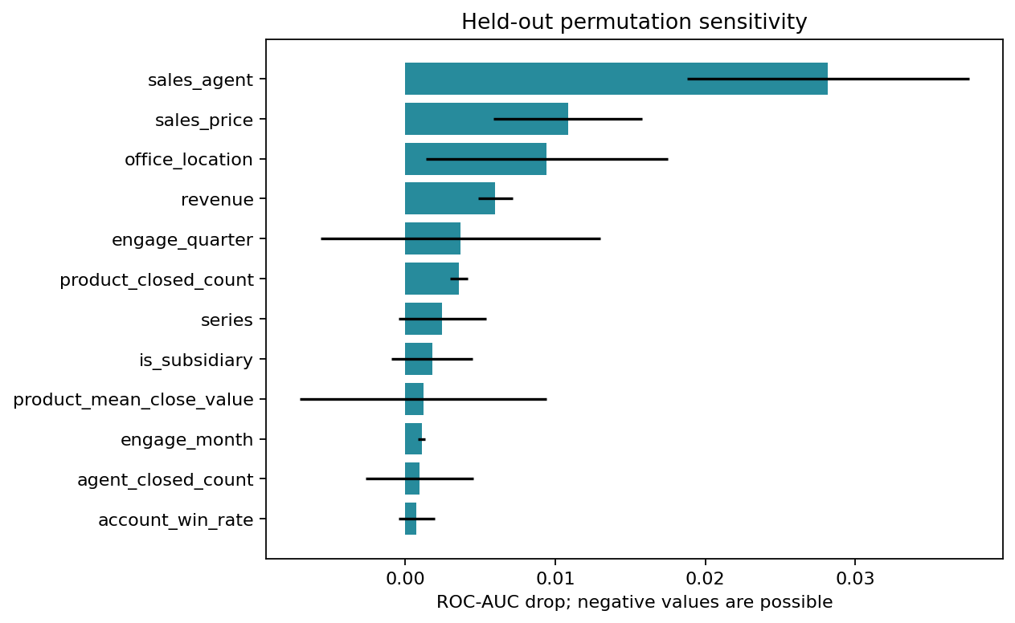
Fig. 3. Held-out permutation importance (mean AUC drop).
We also test whether these explanations describe the model; neither check tests causal effects. On the raw RF, reference sensitivity agrees with grouped TreeSHAP [6] on the same 64 test rows: the median per-row Spearman correlation over the 37 inputs is 0.54, the top three inputs overlap 73% on average (8% expected by chance), and the leading SHAP input has the same sign in 100% of rows. In a deletion test on the selected model, resetting each deal's top three inputs moves P(Won) by 0.356 on average, versus 0.056 for three random inputs (6.3×).
Snapshot scores cover 1,589 Engaging open deals with P(Won), P(Lost), a predicted class, a heuristic priority band (Low < 0.40 ≤ Medium < 0.70 ≤ High) and warnings. 1,088 lack account data and lie outside training support. The model was fitted using later events, so these are not historical as-of predictions. On test data the High and Low bands contain only 2 and 38 deals, so the bands are not validated. Section VIII turns these scores into decisions.
VIII. EVIDENCE-GROUNDED DECISION AGENT
A score alone does not tell a reviewer whether to trust it, what supports it, or what to do next. We therefore built a bounded agent on top of the frozen model (Fig. 4). It runs locally and offline, uses no language model, and is deterministic. Its policy constants are fixed in one file and were not tuned on outcomes.
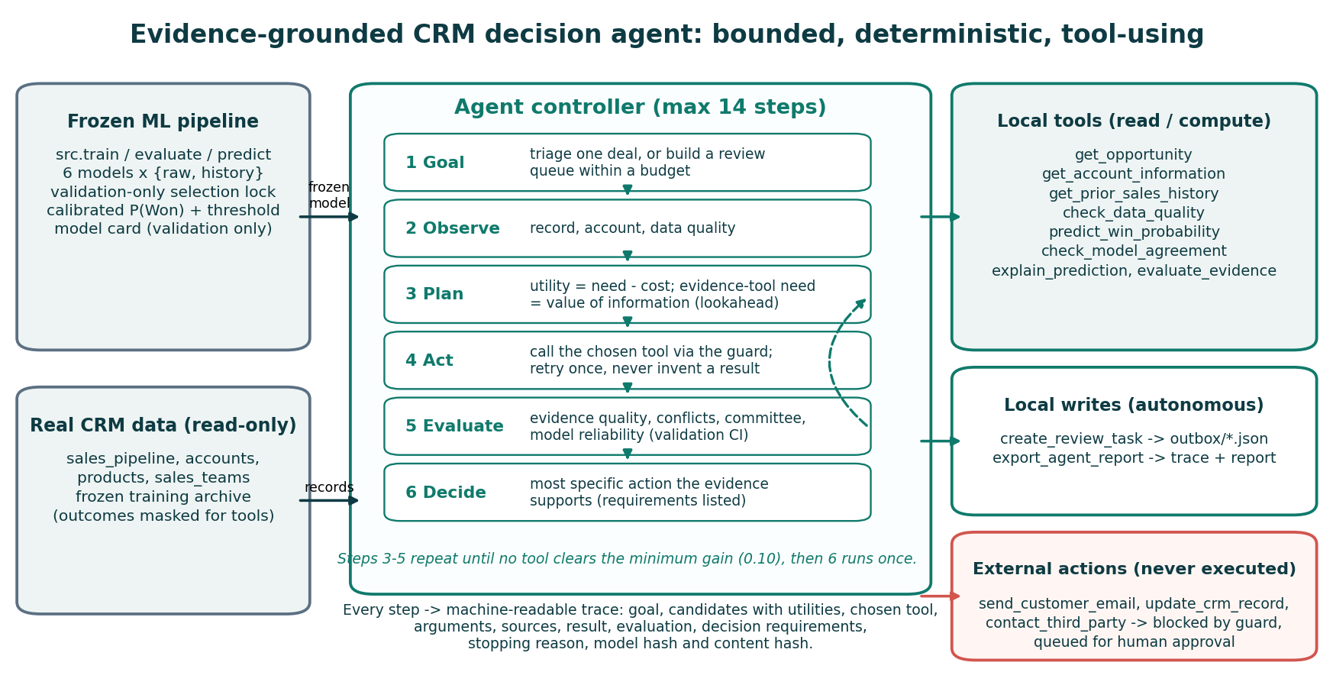
Fig. 4. Agent architecture: goal, observe-plan-act-evaluate loop, decision, guarded tools and trace.
A. Tools and permissions
The agent calls eight read or compute tools: opportunity record, account profile, strictly prior history, data-quality check, calibrated prediction, model-committee agreement, explanation, and evidence assessment. It also has two local-write tools: a review task and the trace report. Every result cites its source table and key. No tool returns close_date, close_value or the label. Three external tools (email a customer, update a CRM record, contact a third party) have no implementation. A permission guard blocks them and records an approval request. Local writes are confined to the run's output folder. Data quality is blocking for a missing or unmatched account. It warns for imputed inputs, unseen categories, inputs outside the training range, scoring before the model existed, and records open longer than 95% of training sales cycles. The committee converts each learned model's score into a percentile of its own validation scores. A split is declared when at least 40% disagree with the selected model's side of the median.
B. Planning by value of information
At each step the planner scores every applicable tool: utility = need − cost. It runs the best tool if utility ≥ 0.10. Observation needs are fixed (opportunity 1.0, account 0.8, data quality 0.9, prediction 0.9, or 0.3 when a blocking issue makes the score context only). For history, agreement and explanation, the need is a one-step value of information [9]. The planner re-runs the decision rule with the slot set to its best and worst plausible value. If the final action could change, the need is 0.8 or 0.7. If not, it is 0.5 when a review task will need the context, and 0.05 otherwise. Failed tools are retried once and never replaced by assumed values. The episode is capped at 14 steps.
C. Evidence-gated decision
The assessment combines seven weighted checks into an evidence-quality score: account present 0.25; account, product and agent history each with at least five prior closures (0.15, 0.10, 0.10); no imputed inputs 0.15; inputs in training support 0.15; committee agreement 0.10. It flags conflicts: a clear score direction contradicted by a prior account win rate at least 0.10 away from the archive rate, or a committee split. Model reliability comes from the validation AUC confidence interval only: unusable if it includes 0.5, weak below 0.65. Here it is weak (validation AUC 0.569, 95% CI 0.523–0.616). The agent takes the most specific action whose requirements all hold (Table V). Escalation additionally requires an explanation. In batch mode it screens all deals, investigates those where evidence matters most, and orders review tasks by tier, evidence quality, P(Won) and age within a review budget. Probabilities only break ties inside a tier.
TABLE V. Final actions, most specific first.
Action | Requires (all)
Escalate at-risk review | score ≥ 0.05 below threshold; no blocking issue; evidence ≥ 0.70; no conflict; model not at chance; explanation
Monitor, no task | score ≥ 0.05 above threshold; no blocking issue; evidence ≥ 0.70; no conflict; model not at chance
Review, uncertain | a score; no blocking issue
Data completion | a blocking data issue
Abstain | always (invalid input, tool failure)

IX. AGENT EVALUATION
We compare three systems on identical cases with the same frozen model. A is the traditional pipeline row: P(Won), label, priority band, factors and a missing-account warning. B is the earlier rule-based assistant, which runs fixed rules over the same score, history and factors. C is the agent. An independent verifier re-derives every cited claim from the raw CSVs and the saved bundle through separate code paths. Ground-truth data issues are computed directly from the data. A directional label (Won/Lost, HIGH/LOW risk, escalate/monitor) is unsupported when the deal is out of training support or within 0.05 of the threshold. Manual steps count the items of a nine-item review checklist that the system leaves to a person. These are workflow measurements, not sales outcomes.
A. All open deals
Table VI summarizes all 1,589 Engaging deals. The agent issued no unsupported label (A: 1,242; B: 487). It detected all known data issues (A 0.28, B 0.64). It left 2.22 of nine manual steps (A 5, B 3), and it created 1,455 local review tasks with no external action. All 17,538 of its cited claims re-verified. On average it cites fewer evidence types than B (4.86 vs 5) because it deliberately does not explain or cross-check the 1,088 out-of-support scores. On complete-account deals it cites 6.73. Relative to B, which shares its batched implementation, it adds 29 ms per deal. For 827 open deals (52%), at least one model input lies outside its training range, mostly the archive closure count. Only the agent reports this.
TABLE VI. Same 1,589 open deals, same frozen model.
Measure | A | B | C
Unsupported labels | 1,242 | 487 | 0
Data-issue recall | 0.28 | 0.64 | 1.00
Evidence types (of 7) | 4.00 | 5.00 | 4.86
Manual steps (of 9) | 5.00 | 3.00 | 2.22
Claims verified | 100% | 100% | 100%
Trace, replayable | no | no | yes
Runtime / deal (ms) | 620* | 56 | 85

*A uses the unbatched 19-call explanation of the original pipeline.
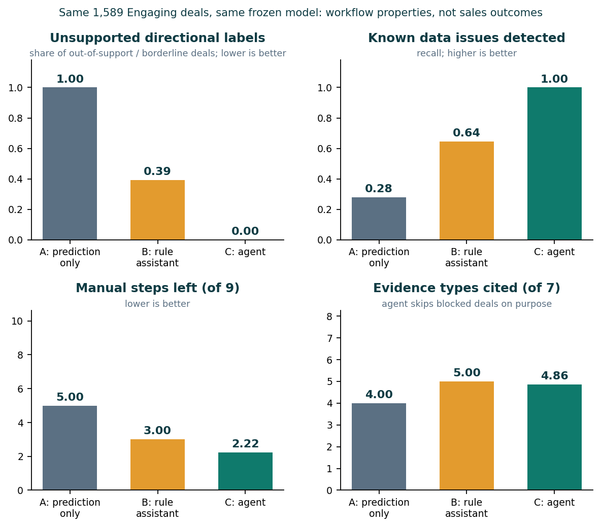
Fig. 5. Workflow measures for A, B and the agent on all open deals.
B. Scenarios
Ten scenarios were fixed in code before any run. They use real records chosen by documented rules: a complete deal, a missing account, the score closest to the threshold, a score contradicted by prior account history, a 25-deal batch with a budget of five, and closed, Prospecting and unknown identifiers. Two are constructed: an injected model failure and a request to email the customer and update the CRM. The agent passed 10/10, B 6/10 and A 4/10. B passed the missing-account and borderline cases. Neither baseline can prioritize a queue, degrade gracefully after a tool failure, or refuse an external action. These checks test capabilities the agent was designed to add, so they show what it adds rather than an open contest.
C. Ablations
Removing the reliability checks changed 80% of decisions, raised unsupported labels to 53% and data-issue recall fell to 0. Removing planning, so that every tool runs in a fixed order, left all decisions unchanged but cost 2.1 more tool calls and 2.9× the runtime per deal. Removing evidence retrieval changed 10% of decisions, because support could no longer be shown. Without tool execution no task was created and 0.92 more manual steps remained. The reliability gate produces the safety benefit; planning produces efficiency.
D. Reproducibility and outcome-masked replay
Re-running 200 cases on fresh resources gave identical trace hashes for all of them. All 880 recorded tool calls replayed to identical results. We then ran the agent on the 1,361 labelled test deals with outcome columns removed, and joined the labels afterwards (base win rate 60.0%). Escalated deals (289) won 62.3%, and uncertain reviews (1,049) won 59.0%. The few deals the baselines rate highest-risk (P(Won) < 0.40, n = 38) won 39.5%. The agent cannot rank deals better than its near-chance model. This replay is an evaluation, not a learning loop.
E. Contributions and evidence
TABLE VII. Novelty contributions, implementation and evidence.
Contribution | Implementation | Evidence
Value-of-information tool planning | planner.py | same decisions, 2.1 fewer tool calls/deal
Reliability-gated decisions | decision rule, assessment | 0 unsupported labels vs 1,242 (A), 487 (B)
Strict-prior, cited evidence | tools.py, history.py | 100% of claims re-verified
Guarded autonomy, approval queue | policy.py | 0 external actions; request blocked
Replayable traces | controller.py | 200/200 hashes; 880/880 tool replays

Failure cases: the agent inherits the model's weakness. Its at-risk escalations are not enriched for losses, 68% of open deals can only be routed to data completion, and its thresholds are design choices that a real sales team has not validated. Its lookahead is one step deep, so evidence that matters only jointly with another unknown slot is fetched as reviewer context rather than as decision-relevant.
X. CONTROLLED SYNTHETIC EXPERIMENT
Because the real data carry little signal, we also ask when the more complex models can help, using synthetic deals whose true win probability is known. A generator reuses the real accounts, agents, products and calendar, adds nine products, competitor attributes and five-year industry trends, and draws each outcome from a planted logistic model. The outcome mechanism is our own design, not an estimate of real sales behavior. Each setting has 100,000 deals and uses the same as-of split, preprocessing and model settings as Section VI, with the synthetic comparison and trend fields added as features, and is repeated over five data seeds.
We vary the planted structure: (a) mostly additive effects with weak interactions; (b) the same with step-like interactions tripled; (c) weak interactions plus four continuous per-deal signals (discount, quote gap, engagement, contact recency) that act through a smooth tanh of their linear combination. Setting (c) was chosen deliberately because it favors neural models.
TABLE VIII. Synthetic test ROC-AUC, mean ± s.d. over five seeds.
Model | (a) Weak | (b) Step-like | (c) Smooth
Logistic Reg. | 0.761 ± 0.012 | 0.827 ± 0.008 | 0.833 ± 0.003
Random Forest | 0.758 ± 0.012 | 0.872 ± 0.007 | 0.846 ± 0.002
MLP | 0.766 ± 0.011 | 0.873 ± 0.008 | 0.866 ± 0.004
TabNet | 0.765 ± 0.013 | 0.875 ± 0.008 | 0.868 ± 0.001
Oracle (true p) | 0.779 | 0.886 | 0.881

With weak interactions all models lie within 0.01 AUC. Step-like interactions open a gap to LR (TabNet +0.048 in every seed) but leave RF, MLP and TabNet within 0.003. With smooth continuous signals TabNet beats RF by 0.021 AUC (range 0.019 to 0.024, all five seeds) and ties the MLP. TabNet’s advantage over trees thus appears only when outcomes depend smoothly on continuous features and data are plentiful, conditions absent from the real CRM data with its 2,975 training deals and mostly categorical inputs. In every setting the best model comes within 0.015 AUC of the oracle, so the same pipeline does learn when signal exists; this points to the inputs, not the pipeline, as the reason for the near-chance real-data result. These results illustrate model behavior; they are not evidence about real opportunities and do not change Section VI.
XI. LIMITATIONS
(1) The dataset was examined earlier, so the test period is exploratory. (2) The availability purge reduces but cannot remove closed-only selection bias and censoring. (3) Account, product and team attributes are static snapshots. (4) Accounts and agents repeat across periods, so this is not a new-customer test. (5) Validation is reused for early stopping, selection, threshold and calibration, which may be optimistic. (6) Open-deal scores are frozen-model snapshots, not as-of replays. (7) The synthetic outcome mechanism is our own design. (8) The agent's weights and thresholds are design choices, not learned from feedback. Its workflow measures follow an evidence policy it was built to satisfy. (9) No user study, sales-team pilot or uplift test was performed, so business value is unknown.
XII. CONCLUSION
We implemented the required classifiers plus CatBoost and strictly prior history features on a leakage-aware temporal split, with calibrated probabilities and checked explanations. Under this protocol no model discriminates meaningfully (selected test AUC 0.517), and neither complex models nor history features help; a known-truth simulation shows the same pipeline learns when signal exists. On top of the frozen model, an evidence-grounded agent plans its evidence by value of information, refuses unsupported recommendations, acts only inside a permission guard and leaves replayable traces. On identical real cases it removes unsupported labels and detects all known data issues, at a small runtime cost. It does not improve prediction, and we did not measure sales uplift. Richer engagement data and a sales-team pilot are the most useful next steps.
REPRODUCIBILITY
Running python -m src.run_project regenerates all numbers and figures in reports/crm/final/ (train, evaluate, predict and the agent experiment). Source-file hashes, split assignments, the selection lock, model configurations (Python 3.12, scikit-learn 1.8.0, PyTorch 2.8.0 CPU, pytorch-tabnet 4.1.0, CatBoost 1.2.10) and raw test probabilities are saved with each run. Two consecutive runs gave identical metrics. The live demo is python -m src.agent_demo (offline, about five seconds).
Contribution statements are left for each team member to complete.
REFERENCES
[1] Maven Analytics, “CRM Sales Opportunities,” https://mavenanalytics.io/data-playground/crm-sales-opportunities (accessed Oct. 6, 2026).
[2] J. Yan, M. Gong, C. Sun, J. Huang, and S. M. Chu, “Sales pipeline win propensity prediction: A regression approach,” in Proc. IFIP/IEEE IM, 2015.
[3] A. Rezazadeh, “A generalized flow for B2B sales predictive modeling: An Azure machine learning approach,” Forecasting, vol. 2, no. 3, 2020.
[4] S. Ö. Arik and T. Pfister, “TabNet: Attentive interpretable tabular learning,” in Proc. AAAI, vol. 35, no. 8, pp. 6679–6687, 2021.
[5] scikit-learn, “Probability calibration,” https://scikit-learn.org/stable/modules/calibration.html (accessed Oct. 6, 2026).
[6] SHAP documentation, “TreeExplainer,” https://shap.readthedocs.io/en/latest/generated/shap.TreeExplainer.html (accessed Oct. 6, 2026).
[7] L. Prokhorenkova, G. Gusev, A. Vorobev, A. V. Dorogush, and A. Gulin, “CatBoost: Unbiased boosting with categorical features,” in Proc. NeurIPS, 2018.
[8] S. Russell and P. Norvig, Artificial Intelligence: A Modern Approach, 4th ed. Hoboken, NJ: Pearson, 2020.
[9] R. A. Howard, “Information value theory,” IEEE Trans. Syst. Sci. Cybern., vol. 2, no. 1, pp. 22–26, 1966.
[10] C. K. Chow, “On optimum recognition error and reject tradeoff,” IEEE Trans. Inf. Theory, vol. 16, no. 1, pp. 41–46, 1970.
[11] Y. Geifman and R. El-Yaniv, “Selective classification for deep neural networks,” in Proc. NeurIPS, 2017.
[12] S. Yao et al., “ReAct: Synergizing reasoning and acting in language models,” in Proc. ICLR, 2023.
[13] S. Amershi et al., “Guidelines for human-AI interaction,” in Proc. CHI, 2019.

