St. Wolfgang’s Vampire Hunters!
A Live Action Role Playing Game

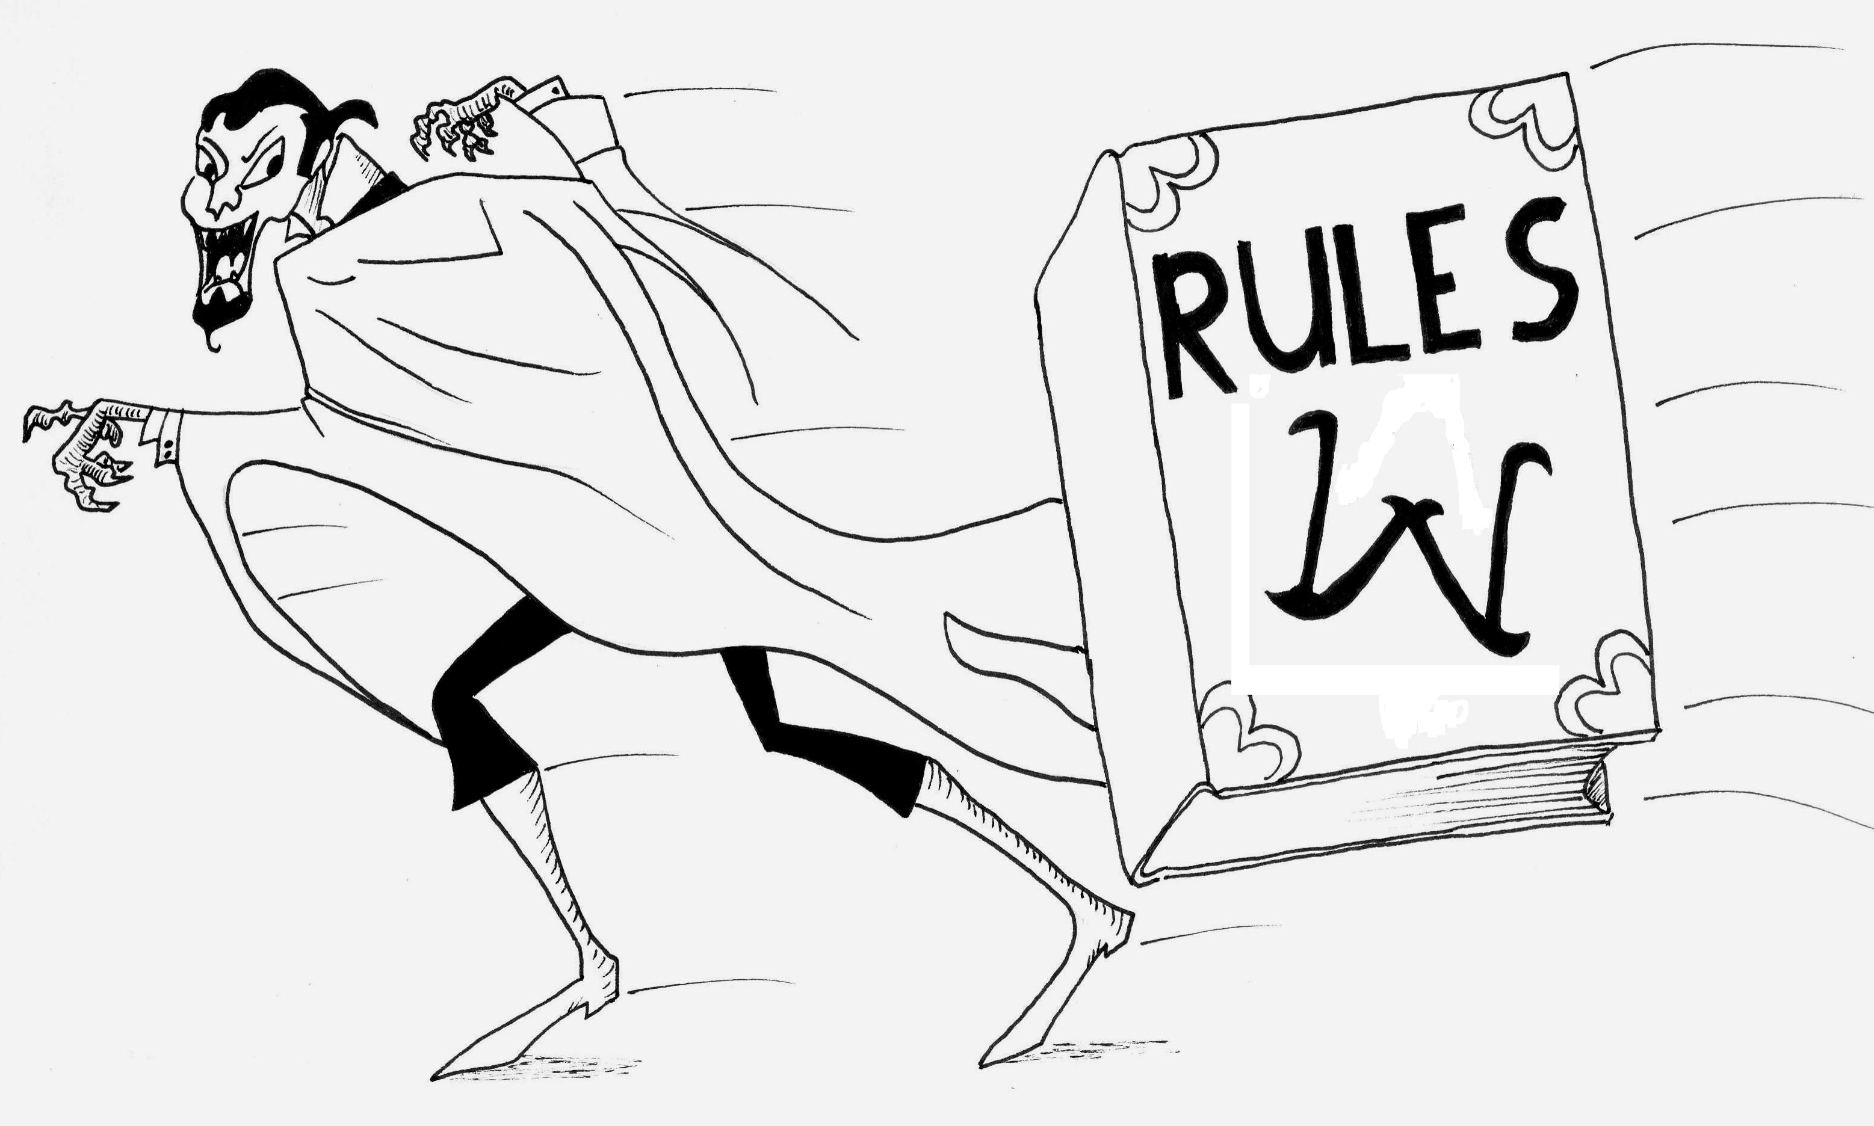

Wolfgang Rules
Version 1.1

Written by Anna Klein and Matthew Brunton
Illustrations by Matthew Brunton

www.nzlarps.org/stwolfgang/


Welcome

Saint Wolfgang’s Vampire Hunters is a live action roleplaying game focusing on the Order of Saint Wolfgang’s fight against evil on behalf of the Catholic Church in 13th century Europe. The rules for this game have been written from scratch with heavy influence from the Mordavia system. We welcome feedback on how it has worked and not worked after the first game.

Table of Contents
Introduction 1
Costuming and Gear 2
Experience Points 2
Combat 3
Creating Your Character 4
Skills 5
Pious Powers 6
Arcane Lore 8
Equipment 9
The Setting 10
Catholicism in Larp 10

Introduction
St. Wolfgang’s Vampire Hunters is a live action roleplaying game (larp) where the players take the roles of the members of a secret order within the Catholic Church dedicated the fighting the undead threat in 13th century Europe. St. Wolfgang’s is an immersive larp, where all participants are in costume and remain in character for the duration of the event. Combat is represented with hit points and latex boffer weapons. Magic is represented through roleplayed ritual and in-character calls.

Player characters (PCs) play one character for the entire weekend, unless that character dies in which case the player may make a new character and enter play once more, or they can join the crew. The crew, also called NPCs, play an assortment of characters and monsters throughout the weekend under the direction of the Game Masters (GM). In St. Wolfgang’s, the crew generally play vampires and other evil creatures, but not always.

St. Wolfgang’s runs weekend events which last from the Friday evening until early Sunday afternoon, with aim of creating an immersive weekend long adventure in a fictional reality. The events are run at Auckland scout camps.

For more information on live action roleplaying, visit the New Zealand Live Action Roleplaying Society website at www.nzlarps.org

If you would like to get involved with St. Wolfgang’s, please email the organizer, Anna Klein, on silver.owl@gmail.com

Don’t worry if you’ve never played in a larp before, we’ll be happy to help you get started and explain anything you are unsure about.
Costuming and Gear
Or, don’t forget your toothbrush on Crusade!

Gear
When attending a weekend long larp event, there are a few important items you need to remember to bring with you:
- Your costume – If you are coming as a player character, you will need to bring your own costume. You also need to bring any equipment your character has, such as armour and weaponry. If your character has Light, please remember to bring a small torch to represent it. Remember, if you’ve taken any Arcane Lore spells, you must bring the physical components of the spells with you. Props and costume make the game environment that much more immersive and enhance the gaming experience.
- Thermals and Socks – It can get quite cold especially in winter games and at night, so it is worthwhile to bring several pairs of warm socks and some thermals to put under your costume.
- Toiletries and Towels – We will not be abiding by authentic 13th century hygiene habits so bring your toothbrush and soap. Bring a towel so you can take advantage of the camp’s shower facilities after a long day of running around.
- Sturdy, in-character looking shoes – You will be on your feet a lot so make sure your shoes are comfortable and sturdy. Please do not wear blatantly modern sneakers.
- Sleeping bag, blanket, pillow – Your bedroom will be an in character area, so bring a blanket to throw over your sleeping bag.
- Plate, bowl, cutlery, cup – Again, this will be part of the in character experience so bring appropriate looking gear. Try op-shops if you are having difficulty.
- Snacks and drinks – While we do provide hearty meals at the game, sometimes a sugar hit is necessary. If you want to bring energy drinks and sugary snacks, please keep them out of sight or put them in character wrappings.
- A roll of toilet paper – with large events, it is always best to come prepared.

Costuming
The 13th century is one of the relatively easy eras to costume. St. Wolfgang’s does not require 100% historical accuracy, but all costumes are required to avoid modern aspects such as jeans, sneakers, t-shirts, jackets etc. and remain in the spirit of the age. Monk and nuns robes are usually fairly simple to fabricate and their loose nature allows you to wear warm clothes underneath to ward off winter chills. There many patterns available on the internet for free, or available commercially.

If you are playing a character wearing armour, we ask that you make every effort to wear armour as representative of what your character is wearing as you possible can.

Props can also help enhance your game experience, so you are encouraged to put effort into brining along personal items of your character and other atmospheric props.

If you are having difficulty with your costuming, visit our online forums to discuss with other players. People are usually more than happy to offer advice and ideas.

Combat
Or, kicking ass for the Lord!

Your Health
In SWVH, each player character starts with three hit points (HP) which can be augmented by purchasing certain skills or arcane abilities. You are also able to wear armour, which gives you armour points (AP) Armour points are only in effect if you are wearing the particular piece of armour – a breastplate in your room affords you no AP!

Taking Damage
When taking damage in combat, damage comes off your AP first. Once you have lost your AP, the armour needs to be repaired by someone with the armouring skill before its AP is restored. Shields block all damage but do not block effects from thrown spell charms. Shields can never be damaged or broken. If you have had been Blessed, you take damage off those two HP before your bodily HP. All hits in combat do one hit point of damage with the exception of blows delivered by individuals with the skills Holy Blow or God’s Fury. Their calls will make their effects apparent.

Incapacitation
If you are damaged down to 0 Health Points then you are incapacitated. You must fall down on the ground. You are still aware of what is happening around you. However, you are in so much pain that you cannot take any action apart from moving your head, talking, or drinking an alchemical potion that is fed to you by someone else. You cannot drag yourself around, attack, cast spells, or use any special ability. You can still be affected by spells or abilities.

Stabilisation
If a character with First Aid treats you, you are stabilised. Being stabilised does not give you any hit points but allows you stand and move. You cannot use any abilities. If you take damage, you are back to incapacitated. You must roleplay being badly injured

Death
If you are incapacitated or knocked out, anyone can kill you by drawing a weapon across your torso and calling “Finishing Blow!” This can only be done once you are lying down. When you are dead, you should roleplay your corpse for a while to allow your fellows to mourn and pray over you. When it is appropriate, you may report to the GMs to either create a new character or to join the crew for the rest of the weekend.

Safety
Do not aim any blows to the head or groin area. Any hits to these areas automatically do no damage. If you have been hit in the head, please do not break play unless you are injured. Inform your opponent by calling “Headshot”. Make every effort to avoid headshots. Please try not to be offended if you receive a headshot, in the chaos of combat, they do happen by accident.

If an injury occurs, call Time Out loudly and repeatedly until all action halts. Please only use the Time Out call in the case of actual injury or emergency. If you hear the time out call, stop moving immediately and inform those around you of the time out. Time Out is an out of character safety measure and please respect it as such.
Character Creation
Or, ‘in the beginning’…
Before you begin generating your character, please think of a character concept that fits inside the bounds of the setting. More details on this can be found in the setting description document. Each character starts with 15 character generation points that can be spent on abilities from the Skills, Pious Powers, Arcane Lore and Equipment lists. Do not feel you have to spend all your character generation points, you can put some aside to save for bigger abilities.

Character Concepts
All characters are required to be in some way associated with the Catholic Church. This, however, does not restrict you to playing nuns and priests. There are many ways in which a character could have been recruited by the Church to serve Saint Wolfgang's, other than being part of a holy order. A victim of a vampire attack who has joined the fight, a skilled mercenary well paid by the church, a member of a non-traditional order of wizard-monks who dabble in the occult, the wife of a dead crusader, village priest, village wise woman…any of these characters could be part of the Order.

Do not feel you must stick to religious orders that historically existed. There is plenty of leeway for you to invent your own order to suit your character concept. If you can bring your friends, you can even have several members of the order present.

The GMs are happy to discuss your character concept with you if you are unsure if your concept is suitable. For more information on the nature of the Order of Saint Wolfgang, please see page

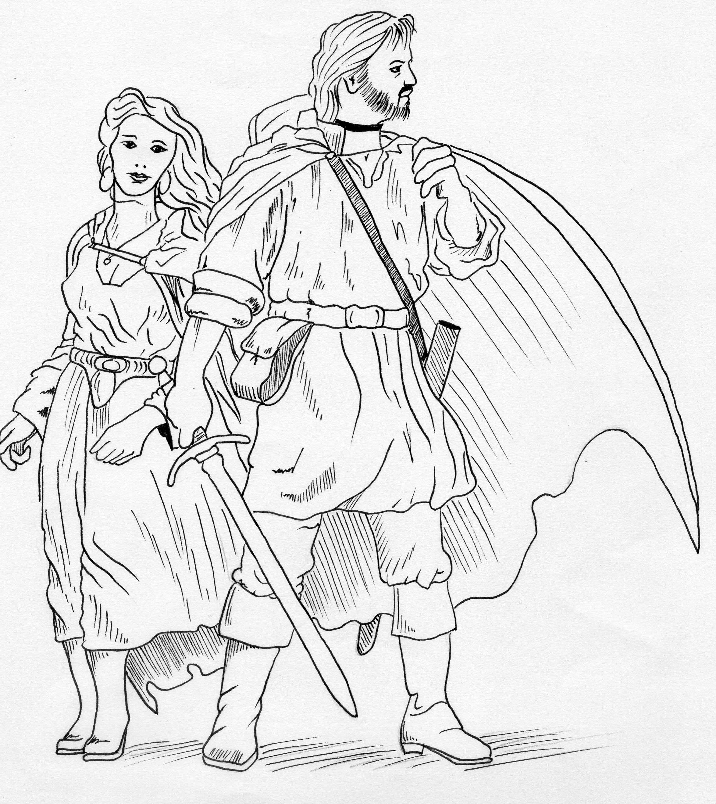
Creating a Personality
When you are creating you character, put some thought in describing their personality. Remember, you will be playing this character for a whole weekend at a time, make them interesting and challenging.

A character goes beyond a back story or a set of abilities. Think about your character’s morals and preferences, mannerisms, character foibles, way of walking, way of speaking etc. Your character will not be perfect, so it pays to put thought into what your characters flaws and weaknesses are, to create a personality that will make your character memorable.

Skills
Or, God helps those that help themselves
This is a list of generic skills and knowledge available.

- Literacy (2)
You can read and write in the language of your country of origin, plus Latin. If you do not have this skill, you cannot read or write. You may purchase additional languages for (1). It is assumed at weekend games that there is a common language by which all the characters are able to communicate.
- Tough (3)
You have an extra hit point. This may be purchased multiple times.
- Lore (2 per domain) Each domain of lore represents knowledge your character would have accumulated in their lifetime. As a skill, it mean that the GMs may give you information not available to other characters and it also enables you to ask for extra information from the GMs if you feel your character would have knowledge of it. (if you have an idea for a domain of lore for your character, please feel free to suggest it)
  - Religious: Knowledge of Church history, procedure and ritual. Extensive knowledge of the Bible.
  - History: You have a good knowledge of general European history up till this point in time.
  - Plants and Poisons: You can identify plants, and know how to use them. You know what is poisonous and how to avoid it.
  - Fauna: You have a knowledge of wildlife.
  - Infernal: Forewarned is forearmed. You have studied workings of the enemy, you have a good, Church-sanctioned learning of hell and its denizens.
  - Literature (Trivia): You’ve spent a lot of time copying manuscripts and in doing so, you’ve picked up interesting bits and pieces that may come in useful.
  - Magical Ritual: You have studied how arcane magicians conduct their work and have a good understanding of the principles of magical rituals. This does not necessarily mean you practice magic, but are able to recognize it when you find it.
  - Regional – this skill represents travel to far flung areas of the world and the knowledge you have gained in the process. Please pick a specific region for this to apply to i.e. The Holy Land.
- Appraisal (2)
You have a good eye for assessing the true value of items.
- First Aid (2)
Stabilizes an incapacitated character in order to allow them to be moved to safer area. This does not heal any hit points.
- Lockpick (2)
You are able to pick locks. Please bring phys-reps of a lockpick.
- Armouring (2)
With the proper tools, you can repair battle damage armour. You must spend at least fifteen minutes on each item. Please roleplay this appropriately.

Pious Powers
Or, the might of the righteous
Pious Powers are the abilities granted by God to His most righteous followers to be used against the forces of undead. Through your strength of faith, you may directly harm evil. The stronger your faith and greater your devotion, the more brightly the power of heaven shines in your body and the greater the effect it will have on the fiends of hell. At their most powerful, only the most wretched creatures of the devil can withstand the power of the pious person.

Most Pious Powers are ranked Novice – Initiate – Elder to indicate a spiritual progression. Each Initiate level power requires you to have three Novice powers. That is, to purchase your first Initiate level power, you must have three Novice powers. To purchase your second, you must have six. In order to acquire the Elder powers, you must have three Initiate level powers.

These powers must be invoked through heartfelt prayer appropriate to your character. These abilities are roleplay heavy, and represent the invocation of heaven. If heaven does not hear you or believe you are making a sufficient effort of the soul, then you may find your powers ineffective. You may use props such as candles, Bibles, rosaries, or any other appropriate item in your prayer and ritual.

Novice Powers (1 each)
- Heal – heals one hit point on a living target, takes an hour to take effect. The prayer may itself take only five or so minutes, but until the completion of the hour, the patient must actively roleplay their continued injuries.
- Spiritual Missile – throw a white spell packet at an undead opponent. If it hits, it does one point of damage.
- Holy Water – Blesses a small vial of water. When thrown onto the enemy, the holy water will destroy minor undead and deal one hit point of damage to major undead. Invoke a prayer when using your holy water to inform the minions of hell.
- Detect Evil – The holy person concentrates on an area in front of them and are able to detect evil. A GM will be required to tell you what lurks.
- Light – A small beam of light, powered by the Lord, shines from your hand. Your holy light must run on AA batteries or smaller.
- Bless – For the duration of one combat will give subject two extra hit points. Bless HP is taken off after AP but before HP. Duration of one combat is defined as until no unvanquished enemies are visible. At the end of combat, any unused Bless HP vanishes. A subject may have only Bless at a time on them.
- Remove Curse – Takes half an hour of prayer. It removes the effects of one curse.
- Remove Fear – Subject is calmed and soothed by holy person’s prayer. Any magical fear effects are nullified.
- God’s Sanctuary – Creates a safe area while caster is chanting. Evil cannot attack but neither can the caster. A circle of chanters may be used to create an area of Sanctuary. Chanters must hold hands. Enemies held inside circle must be equal or less than the number of chanters. Magic cannot enter or leave the circle.
Initiate Powers (3 each)
- Regenerate Talisman – fifteen minutes of prayer to regenerate one charge on a holy talisman.
- Cure Disease – cures patient of one disease.
- Augury – Commune with God on consecrated ground. God will respond in some form after about fifteen minutes prayer time. Please fetch a GM when you are doing this, or the results of your communing will be very disappointing.
- Hold Person – Throw spell packet at subject. If the subject is hit, they may not move at all for five minutes.
- Word of God – In the name of God, the holy person gives someone a one word command that must be obeyed. You cannot command the subject to do any sinful action (including murder and suicide)
- Dispel Evil – Cancels the effects of certain evils.

Elder Powers (5 each)
- Create Talisman – Caster may create a talisman of power. Please discuss this with the GMs. Some suggestions are talismans of armour, strong will, magic resistance.
- Consecrate Ground – Makes an area an appropriate place of worship. Minor undead cannot enter. Major undead are weakened in its bounds.
- Exorcise – Rids subject of possession.
- Touch of Christ – severed limbs grow back

Other Pious Powers
These Pious Powers are stand-alone.

Fear of God
Hold forth your symbol of faith and invoke the power of God in the face of the enemy. Using your pious rhetoric, you are able to put the fear of God into the minions of Satan for the following effects:
- Righteous (5): Keep minor undead at bay. Your holy rhetoric must clearly incorporate the word “righteous”
- Holy (5): (Fear of God – Righteous is a prerequisite)Turns minor undead, keeps major undead at bay. Your holy rhetoric must clearly incorporate the word “holy”
- Saintly (10): (Fear of God – Holy is a prerequisite) Destroys minor undead, forces major undead to retreat significantly. Your holy rhetoric must clearly incorporate the word “saintly”
- Godly (15): (Fear of God – Saintly is a prerequisite) Destroys all but the most hellish of undead. Your holy rhetoric must clearly incorporate the word “godly”

Fast Healing (10) – All your own hit points including tough healed within the space of an hour.

Holy Blow (10) – all hits do 2hp of damage. Call “Holy Strike” as part of your battle rhetoric to indicate your use of this power.

God’s Fury (15) – You must have “Holy Blow” before you can purchase “God’s Fury”. Does 4hp of damage with any weapon larger than a long sword. Call “God’s Fury” as part of your battle rhetoric to indicate your use of this power.
Arcane Lore
Or, magic you don’t want the Church knowing about
Arcane Lore is a domain of powers and abilities whose origins are a little more shrouded in mystery. Through study and experience, you have learned to effect the world around you in a unique way. It is also not necessarily sanctioned by the Church. In its crusade against evil, the Church has turned something of a blind eye to some less questionable practices but beware. Arcane Lore is not accepted by most, and discretion is advised in its use. Most people are not familiar with the workings of the arcane.

Magical Ritual Lore a prerequisite to casting spells. All spells must have five lines of dialogue and two physical components. Please submit these with your character sheet. Their individuality is to reflect the individual nature of these workings.

Arcane Lore is graded in three levels. In order to acquire a second level spell, you must have three first level spells. In order to acquire a second second level spell, you must acquire a further level one spells. Third level spells must be found in game and to use them, you must have three second level spells.

Level 1 (1 point each)
- (Un)Lock – Magically locks or unlocks things that can be opened.
- Speak with Dead – A corpse must answer two questions truthfully.
- Sleep - Caster scatters one dozen spell packets. Any living thing that the spell packet touches falls asleep for five minutes.
- Confuse - Subject loses train of thought, forgets what they were talking about and becomes distracted for about five minutes.
- Charm – Subject regards caster as close friend or ally until subject is convinced otherwise.
- Find the path – if lost, a direct path to the desired location is shown. Please be patient as the GM may be busy.
- Entangle – throw a bundle of five different ropes, each at least 1m in length at the feet of your opponent. Your opponent will then become entangled and be unable to move for ten minutes as they untangle themselves.
- Talk with animals – GM required. Caster may commune with an animal to obtain information.
- Earth Strength – Your strength is greatly increased for sixty seconds.

Level 2 (3 points each)
- Blind – Upon completion of the spell, caster must point at subject and inform them they are blinded. The blind call is entirely out of character. In combat, please be as loud as possible.
- Stone Skin – The target gains 3ap for the duration of one combat. Once all visible opponents are vanquished, your stone skin disappears.
- Dream – GM required. This spell allows you to send a dream to someone of whom you have a personal item.
- Warp – this briefly warps wood or stone long enough to allow a single person passage.
- Neutralize Poison – detoxifies one subject afflicted with venom
- Shape Change – Caster may change form into any subject of roughly the same size.
- Blight Crops – Casting time is half an hour. An acre of land is withered.
Equipment
Or, sometimes the hammer of God really is just a hammer.
You may also purchase combat equipment with your character generation points. In purchasing a weapon, you also purchase the ability to use it. Please bring your own larp-safe physical representation of the weapon.

Stakes (0) – Stakes are free to bring. They must be safe, boffer stakes that are not going to stab a poor, unsuspecting NPC. They will be checked before the game, as with all weapons.
Weapons (1) - For one point, you may purchase any single weapon, with the exception of daggers of which 1 point buys two. Weapons may include: long sword, short sword, polearm, two handed sword, axe etc. For the same price, you may also purchase a sap which deals no damage but knocks a victim unconscious when applied with force to the back of the head, provided they are not wearing a helm. Please ensure your sap is soft.
Helmets (1) – Helmets provide 1AP (as long as you are wearing it!) and protect you from sapping.
Shields (1) – Shields do not provide extra AP but can instead be used to deflect blows. Shields can never be damaged or broken. Any magical effects that land on the shield still take effect.
Leather shirt (1) – Leather torso covers which provides 1AP.
Chainmail shirt (2) – Chainmail torso cover which provides 2AP.
Light limb cover (1) – Either leather or chain, provides 1AP. Can be purchased in conjunction with torso cover.
Heavy limb cover (2) – Plate limb cover, provides 2AP. Can be purchased in conjunction with torso cover.

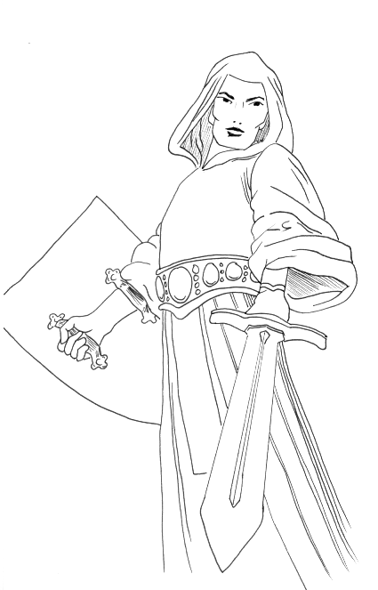
Setting
Or, the world according to Saint Wolfgang

The Order of Saint Wolfgang - Pactum Serva – Keep Faith
The Order of Saint Wolfgang is a secret arm of the Catholic Church. It's agents are many and varied, spread over Christendom, and some beyond. You all have one thing in common. You know the evil is there - perhaps you've been a victim of an attack and survived, perhaps the Church has handpicked you to join the Order, perhaps you knew the right (wrong?) people. This will be further explained in the full setting write up but, know for now, that gladly or grudgingly, you're part of God's army against an insidious evil.
Whenever Christendom is threatened with a force of undead mightier than usual, the Church sends the summons: The Order must convene at the site of the disturbance.

The Order has no headquarters, has no open heraldry and even its members know little of its overall activities or who is in charge. Rumours say that the ultimate head of Wolfgang is Pope Gregory IX. The agents are contacted by missives bearing the seal of the Vatican and may recognize each other by the W they may choose to display somewhere on their person.

The Threat
The Darkness is so called for it obscures truth and only through experience may you learn how to combat the fiends of darkness. You may incorporate any out of character knowledge you have on vampires but be aware you may not be certain what of it is true in character. Faith and stakes are fairly reliable but not always. Be on your guard. One vampire may not be the same as another.

Catholicism in Larp
Or, playing with God.
There is obviously a heavy focus on the Catholic Church in this larp game. Our intention is to avoid being blasphemous as much as possible given the context of the game. We ask our players to behave respectfully in the setting.. In order to more accurately roleplay being part of the Catholic Church, the following elements are being incorporated into the game:

God – God is a responsive entity in the setting but His ways are mysterious and sometimes puzzling. Be aware that He is omnipresent and aware of your actions. Be wary of falling prey to sin and darkness. Misuse of His weapons may result in them being taken away.
Prayer – Prayer must be roleplayed in game but in order to convey your character’s thoughts, feelings and wishes, please write them on a piece of paper and put them into a prayer box provided. All prayers will be heard. Some may even be answered.
Confession – To err is human, to forgive is divine. Twice a day your character must attend confession in order to receive forgiveness for their transgression and to report their actions to the Church. Confessionals will be set up near meal times and NPCs will be taking your confessions.

For more information on the Catholic Church in the period, please visit the forums for discussion or browse through Wikipedia.

Saint Wolfgang’s
Vampire Hunters!

Kill vampires.
Save Christendom.
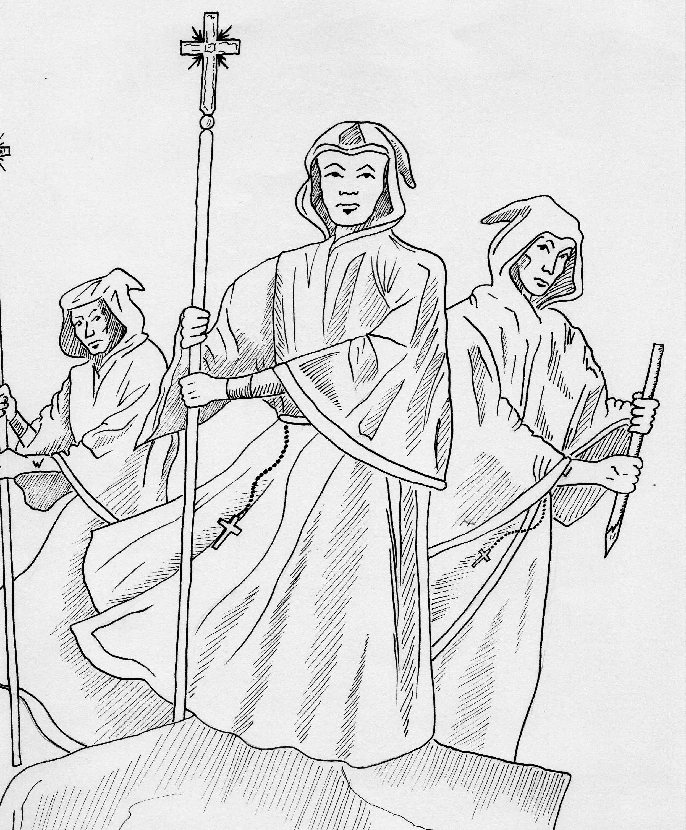
The year is 1230 and Christendom is plagued with evil. The secret Order of Saint Wolfgang in the Catholic Church, with a network of eclectic agents spread over Europe, works to combat the fiends of Satan. You are one of these agents and for whatever reason, you have been called to the fight.

Now, the forces of darkness are massing, the agents of evil are organizing. The Order has been summonsed.

Saint Wolfgang’s Vampire Hunters! live action roleplaying game is holding their first event in August 2007 and all are invited to attend.

When: 17th-19th August, starting 7pm Friday
Where: Motu Moana Scout Camp
Connaught St
Blockhouse Bay
Cost: Players - $65
Players (nzLARPS members) - $55
Crew - $30

Rules: www.nzlarps.org/stwolfgang/rules2.doc
Website: www.nzlarps.org/stwolfgang/

