User Stories

As a customer I want to find appointments so that I can set up an appointment

As a customer I want to log in with my appointment password so that I can manage my appointment and view the price named by the artist

As a customer I want to cancel my appointment so that I can reschedule

As an employee I want to log in to my account so that I can manage my appointments

As an employee I want to edit appointment date and time so that I can reschedule

As an employee I want to edit appointment color indicator so that I can know how much colored ink I will need

As an employee I want to edit appointment price so that the customer can know the price I named when they manage their appointment

Database Schema

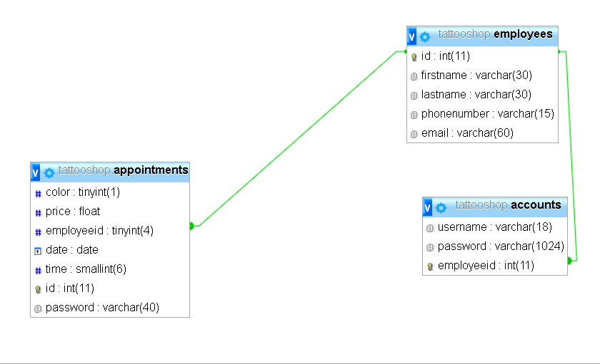

Screenshots

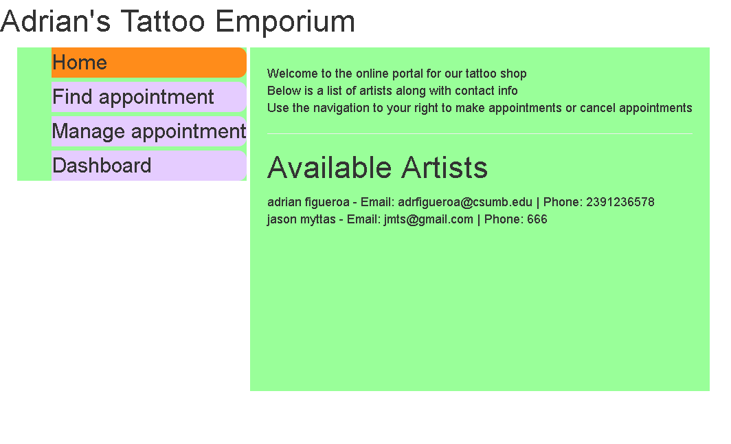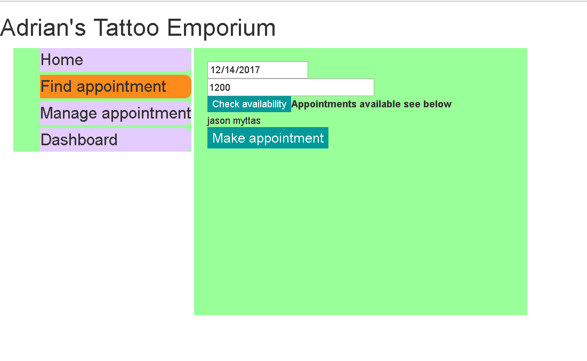

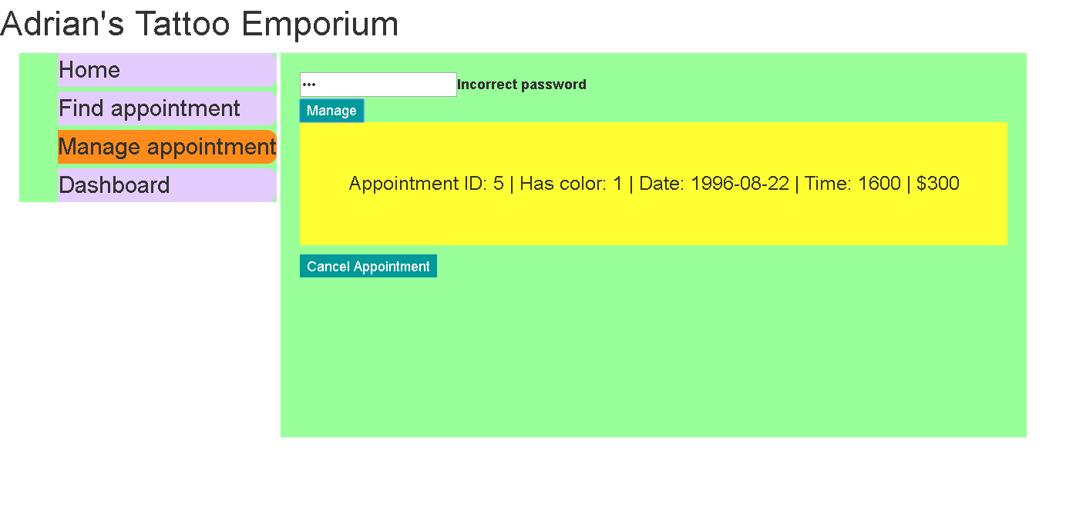

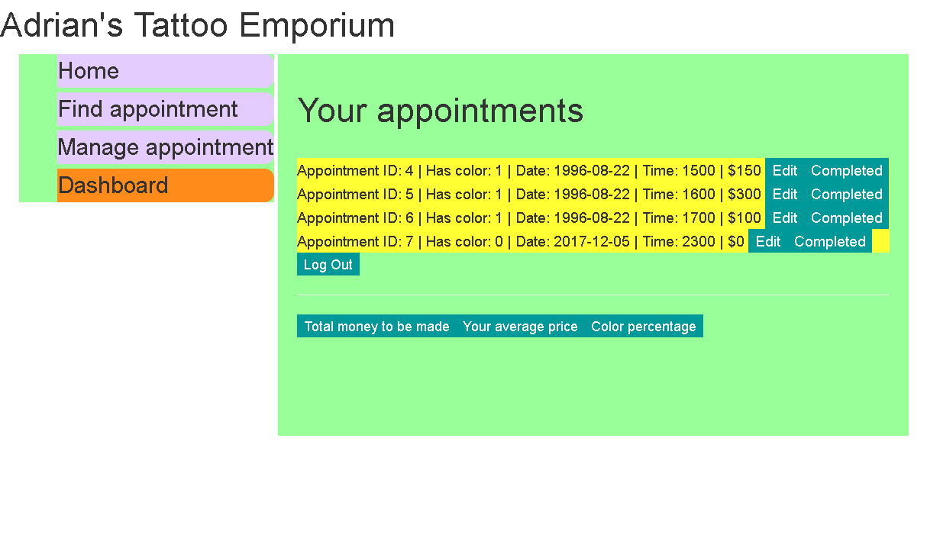

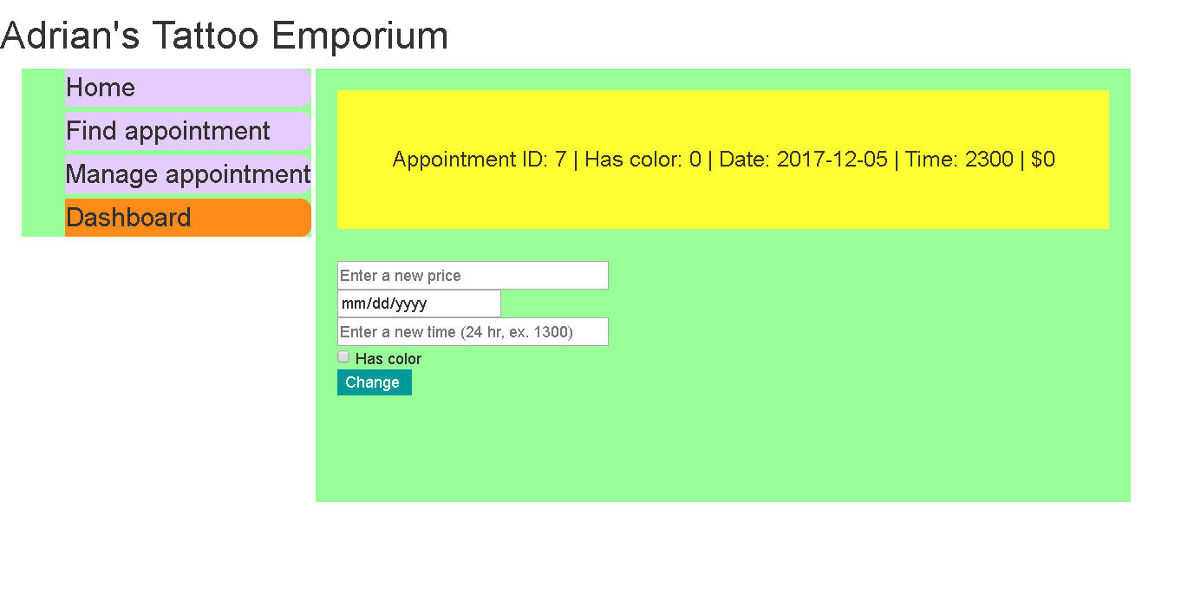

Mockups

Home

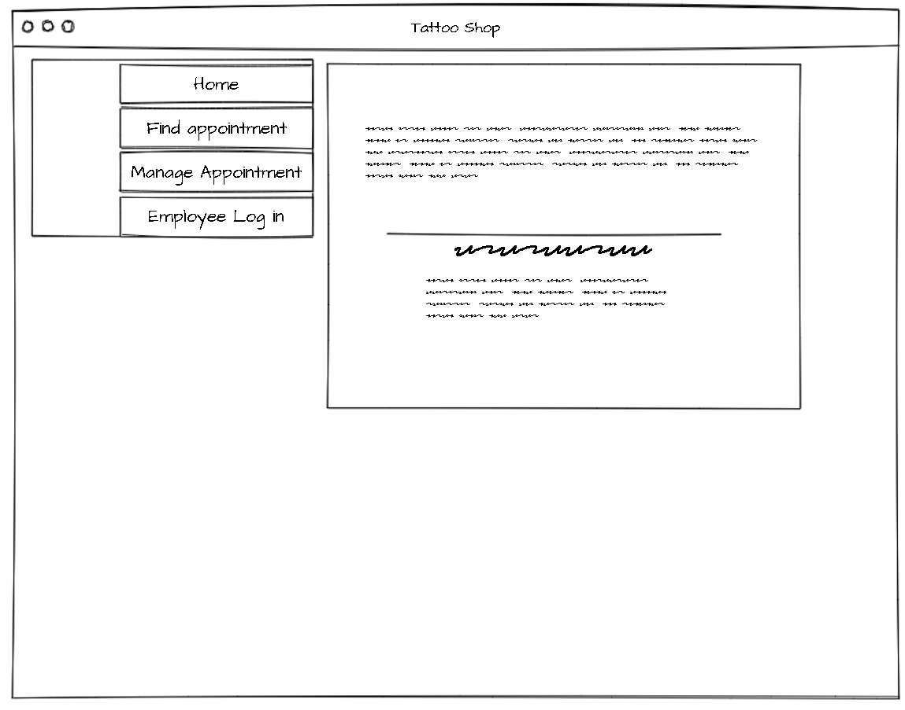

Finding a slot

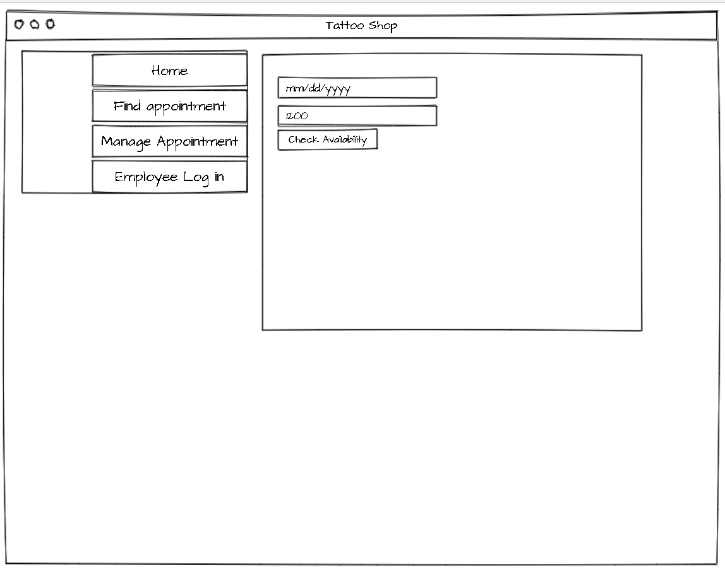

Appointment Management

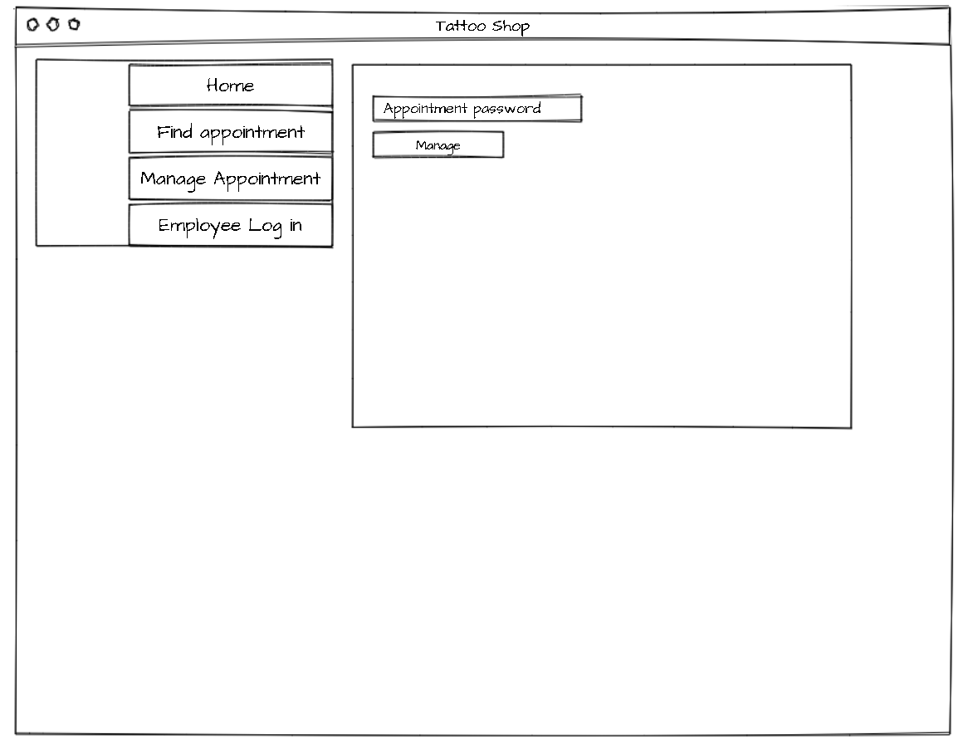

Employee log in

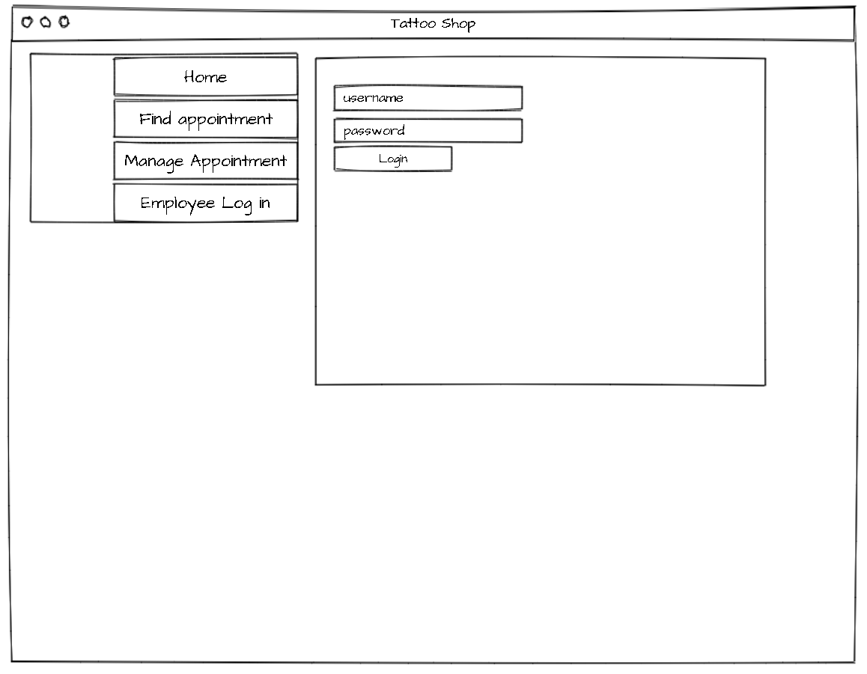

Dashboard

