Productivity estimation in waterfowl using a non-invasive method

Adrien Tableau[1]

Alain Caizergues[2]

Iain Henderson[3]

Sébastien Reeber[4]

Matthieu Guillemain[5]

02 novembre, 2021

The response of a waterfowl population to a harvest pressure depends on its capacity to renew. The recruitment, i.e. the number of young adults reproducing for the first time, is a key indicator to describe the renewal of a population, and therefore an essential tool in population management. The productivity, defined inhere as the number of recruits produced per breeder, is even more informative because it is independent of the breeding population size and allows comparisons over time and between species. The proportion of young adults in a waterfowl population, which is a main step in estimating productivity, is often estimated from game-hunting samples. However, this proportion is not accessible in years without harvest, or with a low harvest rate. Moreover, the age-structure in the harvest samples, commonly called hunting bag, does not necessarily reflect the underlying age-structure of the population. It is often skewed towards juveniles and can lead to an overestimation of the productivity. In waterfowl, adult males usually display brighter colours than immatures and females. This dichromatism can be characterized and monitored from count surveys, a non-invasive method. Such information can be used to infer the proportion of young adults, and consequently the productivity. In using two populations of ruddy duck, *Oxyura oxyura*, this study develops a Bayesian method to estimate the productivity from count data. The results are compared to productivity estimates from samples and are discussed by testing their consistency with the population growth rates. The results suggest that the counting method is a versatile tool to estimate the productivity if the species is monitored during the appropriate time window.

# 1 Introduction

*Definitions* Folliot et al. (2017) says bullshit One defines the productivity of a breeding population as the average number of recruits produced per each breeder (Johnson et al., 1987). This parameter might be called “annual fertility”, or “reproductive success” (Koons et al., 2014). If one considers a species reaching its sexual maturity as early as its first year, all individuals are mature at the reproduction season. The productivity is thus the ratio of the number of young adults at the reproduction season of year , i.e. the recruits, to the number of all individuals at the reproduction season of the previous year, .

The productivity parameter is complex because it is composed of two main sub-parameters: the reproductive success and the juvenile survival. Both sub-parameters can be split into other sub-parameters. For instance, the reproductive success is the product of the nesting success and the hatching success. The juvenile survival is the combination of the post-hatching survival and the fledging juvenile survival. According to Blums & Clark (2004), the recruitment for diving ducks is not related to the reproductive success, but depends mostly on the juvenile survival, which is driven by weather conditions. However, the results of this study does not necessarily reflect a general reality because several sources of variations of the reproductive success are controlled in the experimental plan of this study. The productivity as defined in the present study is thus a parameter integrating many sources of variability affecting all life stages from the egg to the young adult trying to breed for its first time.

*The use of productivity in population management*

The management of an exploited population generally aims at preserving its conservation status, generally by targeting a population size **ref required**. To do so, a first strategy is to test iteratively management rules to reach progressively an optimum. Such approach can be time-consuming given the intrinsic variability of the population response to its changing environment. It might also suffer from a rejection of the stakeholders because of the lack of transparency of its arbitrary process **ref required** (Nichols, 2000)?. Another approach is to try to predict the growth rate of the population as a function of the harvest rate and other environment inputs. Such modelling approach can provide clues on the recovering time of a population upon a variety of managment rules **ref required**. These decision-support tools are then key inputs to status on the best management rules to implement. The growth rate of a population can be simply defined as the sum of the adult survival and the productivity, see Equation (3.1) in Section 2. The adult survival is generally estimated by capture mark recapture methods **ref required**. If the harvest pressure behaves as an additive mortality to the natural mortality, it is quite straightforward to predict its impact of the adult survival. The key to predict the growth rate of a population is then to estimate the average value and the variability of the productivity and to understand how this parameter is impacted by a harvest pressure.

*The variability of the productivity*

A waterfowl species that is released in a favourable habitat will naturally expand (Malthus, 1872). The growth of such a population reflects that the productivity parameter is higher than the adult mortality rate. This expansion is limited by the carrying capacity of the habitat (Sayre, 2008). When a waterfowl species is endemic of an ecosystem and evolves in stable environmental conditions, the population size varies around the carrying capacity because the individuals compete for space or/and food (Nummi et al., 2015), which prevents the population from expanding. This competition commonly induces a lower reproductive success or/and a higher juvenile mortality. The population is then less productive because the productivity parameter is affected by density-dependent effects (Gunnarsson et al., 2013). For an endemic species evolving in stable environmental conditions, a balance between the productivity and the adult mortality rate explains the stabilization of the number of individuals **ref required**.

Hunting waterfowl induces adult and juvenile mortality (Bellrose, 1980). Intuitively, one expects that such a hunted population would observe lower adult survival and productivity and then would rapidly deplete to its extinction. However, hunting waterfowl has a long history, and most of these species have persisted over time **ref required**. So paradoxically, hunting immature individuals does not always induce a decrease of productivity. A reason could be that the harvest pressure reduces the competition for space and food **ref required**. The density-dependent effects affecting the productivity in case of high population density are then reduced by the harvest mortality. In conclusion, a limited exploitation of a population is expected to increase both adult mortality and productivity. A balance between these two parameters can be theoritically reached if the population is exploited to a constant and moderate harvest rate **ref required**. The size of a newly exploited population in stable environmental conditions should thus reach a different equilibrium, which is expected to be lower than the size without exploitation **ref required**.

The reproductive success and the juvenile survival, the two components of the productivity, are very sensitive to weather conditions (Blums & Clark, 2004; Folliot et al., 2017). The environment conditions are thus an additional source of variability of the productivity. The response of the productivity to a harvest pressure is thus not straightforward. It is noisy because of its sensitivity to environmental factors. It also depends directly on the intensity of harvest on the immature individuals and indirectly on the mitigation of the density-dependent effects.

*What part of the productivity gradient is necessary for population management?*

In population mangement, a common question for a threaten or an invasive species is to determine the measure that will allow to reach a targetted population size/density in a limited time period **ref required**. For such question, the carrying capacity of the habitat is theoritically not reached. So a manager should mostly focus on collecting knowledge on the maximum productivity and its variability by removing the potential density-dependent effects occurring only for the highest theoritical densities.

*What is the ideal biological model to explore the gradient of the productivity?*

Hunting waterfowl has a long history, but few species have observed long-term moratorium **ref required**. So there are few opportunities to explore the response of the productivity to a gradient of pressure for such species. Alien species are often introduced during involuntary release events **ref required**. They observe commonly a first period of colonisation on new territories without management measures. Since its presence might impact the balance of the colonized ecosystem, it happens that managers take strong control measures to restrict the growth of these populations or to eradicate them **ref required**. Such species are then a good biological model to overcome density-dependent effects and explore the effects of a harvest gradient on productivity.

*How to estimate productivity?*

The productivity parameter of a population can be assessed by monitoring the number of eggs that survives to the age of the first-breeding event. To do so, a first step consists in quantifying the reproductive success by estimating nesting and hatching success thanks to surveys in habitats representative of the managed population **ref required**. The survival of the post-hatched chick to its recruitment can be done by capture mark recapture method (Blums & Clark, 2004). Even if such approach provides valuable information on the dynamics of the recruitment and can highlight the bottlenecks, the fieldwork required to estimate both components is too time-consuming to generalize the method for waterfowl population management.

In waterfowl, it is generally impossible to differenciate immatures from adults without examining birds in hand. Aging individuals from samples coming from hunting bags is thus another possible approach. Such approach suffers from two caveats. First, it is impossible to explore the productivity when there is no harvest whereas it is necessary to predict what would happen if a moratorium seems required to let a population recover, or to calibrate a priori the harvest effort necessary to control an invasive species (Smith et al., 2005). Secondly, like any predation action, hunting is selective and provides a biased picture of the population age structure in favor of the immatures (Bellrose, 1980). The hunting bag analysis might then lead to overestimate the productivity and consequently the maximum sustainable harvest rate, with adverse consequences on population management **ref required**.

In waterfowl, it is common that adult males display brighter colors than females when immatures from both sexes display cover-up plumage similar to adult females **ref required**. Knowing sex ratios, this discrepancy between adult and immature males might be used to estimate the proportion of immature in a waterfowl population just by counting them from distance **ref required**. Such approach is promising because it requires only to count the proportion of birds of the two plumage kinds to infer an estimate of productivity. Unlike the two previous methods, this one is non-invasive and requires a little time investment, which allows to collect long time series and consequently to track productivity variability.

*Methodology of this study*

From two populations of ruddy duck, an species introduced in Europe in the 40’s, this study develops a Bayesian framework to infer productivity from count data. A comparison to the results of the common approach using samples from hunting bags aims at checking if the productivity variability is well tracked and if the hypothesis of the productivity overestimation by sampling methods is consistent with the results. Using two other approaches using average population growth rates, one testes the consistency of the order of magnitude of the productivity estimates from the counting method.

# 2 Materials & methods

## 2.1 Biological model

The ruddy duck is a diving duck species introduced in the United Kingdom in the 40’s (Gutiérrez-Expósito et al., 2020). The first reproduction was observed in the 60’s. The population rapidely grew to reach more than 5000 individuals spread over the entire country. A new population set up in France from the 90’s, likely because of an arrival of few individuals from the United Kingdom. This population set up around a single wintering spot, the Grand Lieu Lake (geographical coordinates: 47.09°N, 1.67°W). Since this species is considered as a threat to the white-headed duck because of the risk of genetic introgression (Muñoz-Fuentes et al., 2007), an European plan of eradication has been adopted and control measures were taken in both countries (Gutiérrez-Expósito et al., 2020).

Just before the reproduction period, i.e. in winter, one can distinguish from shore individuals with male-like plumage from female-like individuals (Figure 2.1). It is noticeable that the apparent proportion of males in the counts from shore is far below the proportion of males in the samples from hunting bags (Figure 2.2).

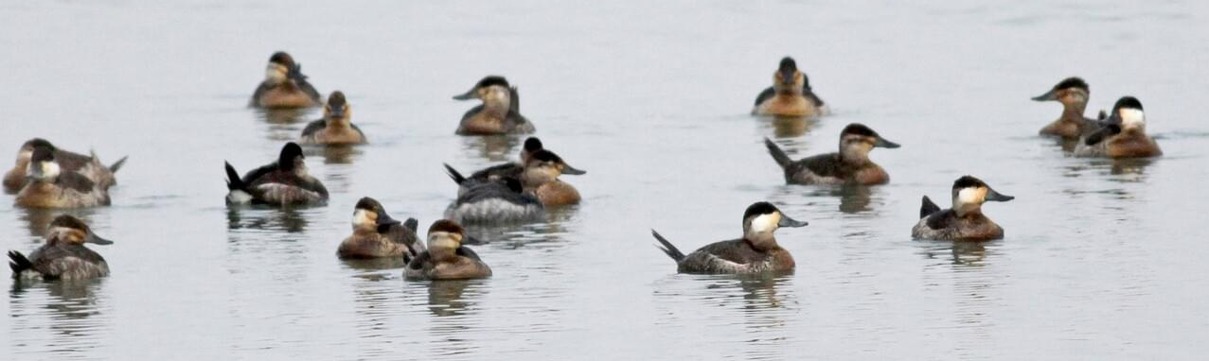

Figure 2.1: Typical observation of a ruddy duck flock in winter: 4 male-like individuals with a white cheek and a black cap, 10 female-like individuals with a whitish cheek and a dark stripe across it, 3 unidentified individuals © Jay McGowan - 3 February 2013 - Tompkins, New York, United States

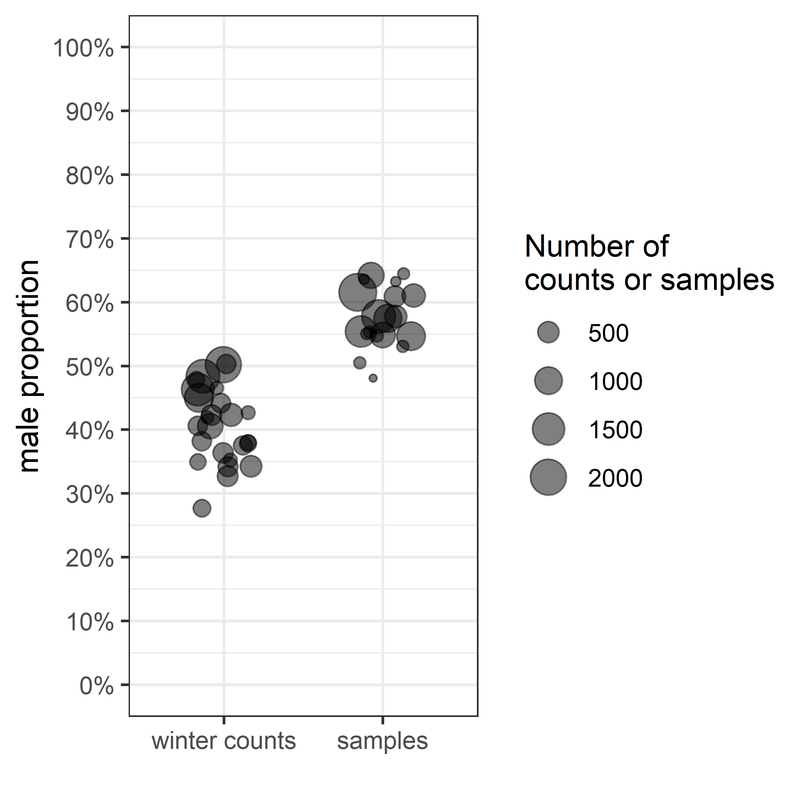

Figure 2.2: Apparent male proportion in winter counts vs male proportion in samples; for the first category, one point corresponds to the proportion of male-like plumage in a population counted in winter; for the second category, the male proportion is estimated from all ruddy ducks sampled over one year

Since sex identification of samples is very accurate **ref required**, the counting method misses the identification of a significant part of males in the population. In many waterfowl species, immature individuals of both sexes display cover-up plumage similar to adult female plumage **ref required**. Consequently, the counts in winter allows adult males to be distinguished from all other individuals (adult females, immature females, and immature males). This property can be valuable to estimate the recruitment with a few assumptions. One assumes in this study that the immature individuals have a equally balanced sex ratio (Bellrose et al., 1961; Blums & Mednis, 1996; Wood et al., 2021)

Ruddy duck populations from the UK and from France follow similar demographic histories (Figure 2.1). They grew freely during some years in both countries until 1999. Limited control measures have been then applied from 1999 to 2005 in the UK and from 1999 to 2018 in France. In both countries, these management measures led to stop the expansion of the ruddy ducks. From 2005 in the UK and from 2018 in France, higher control effort led to a rapid depletion in both populations.

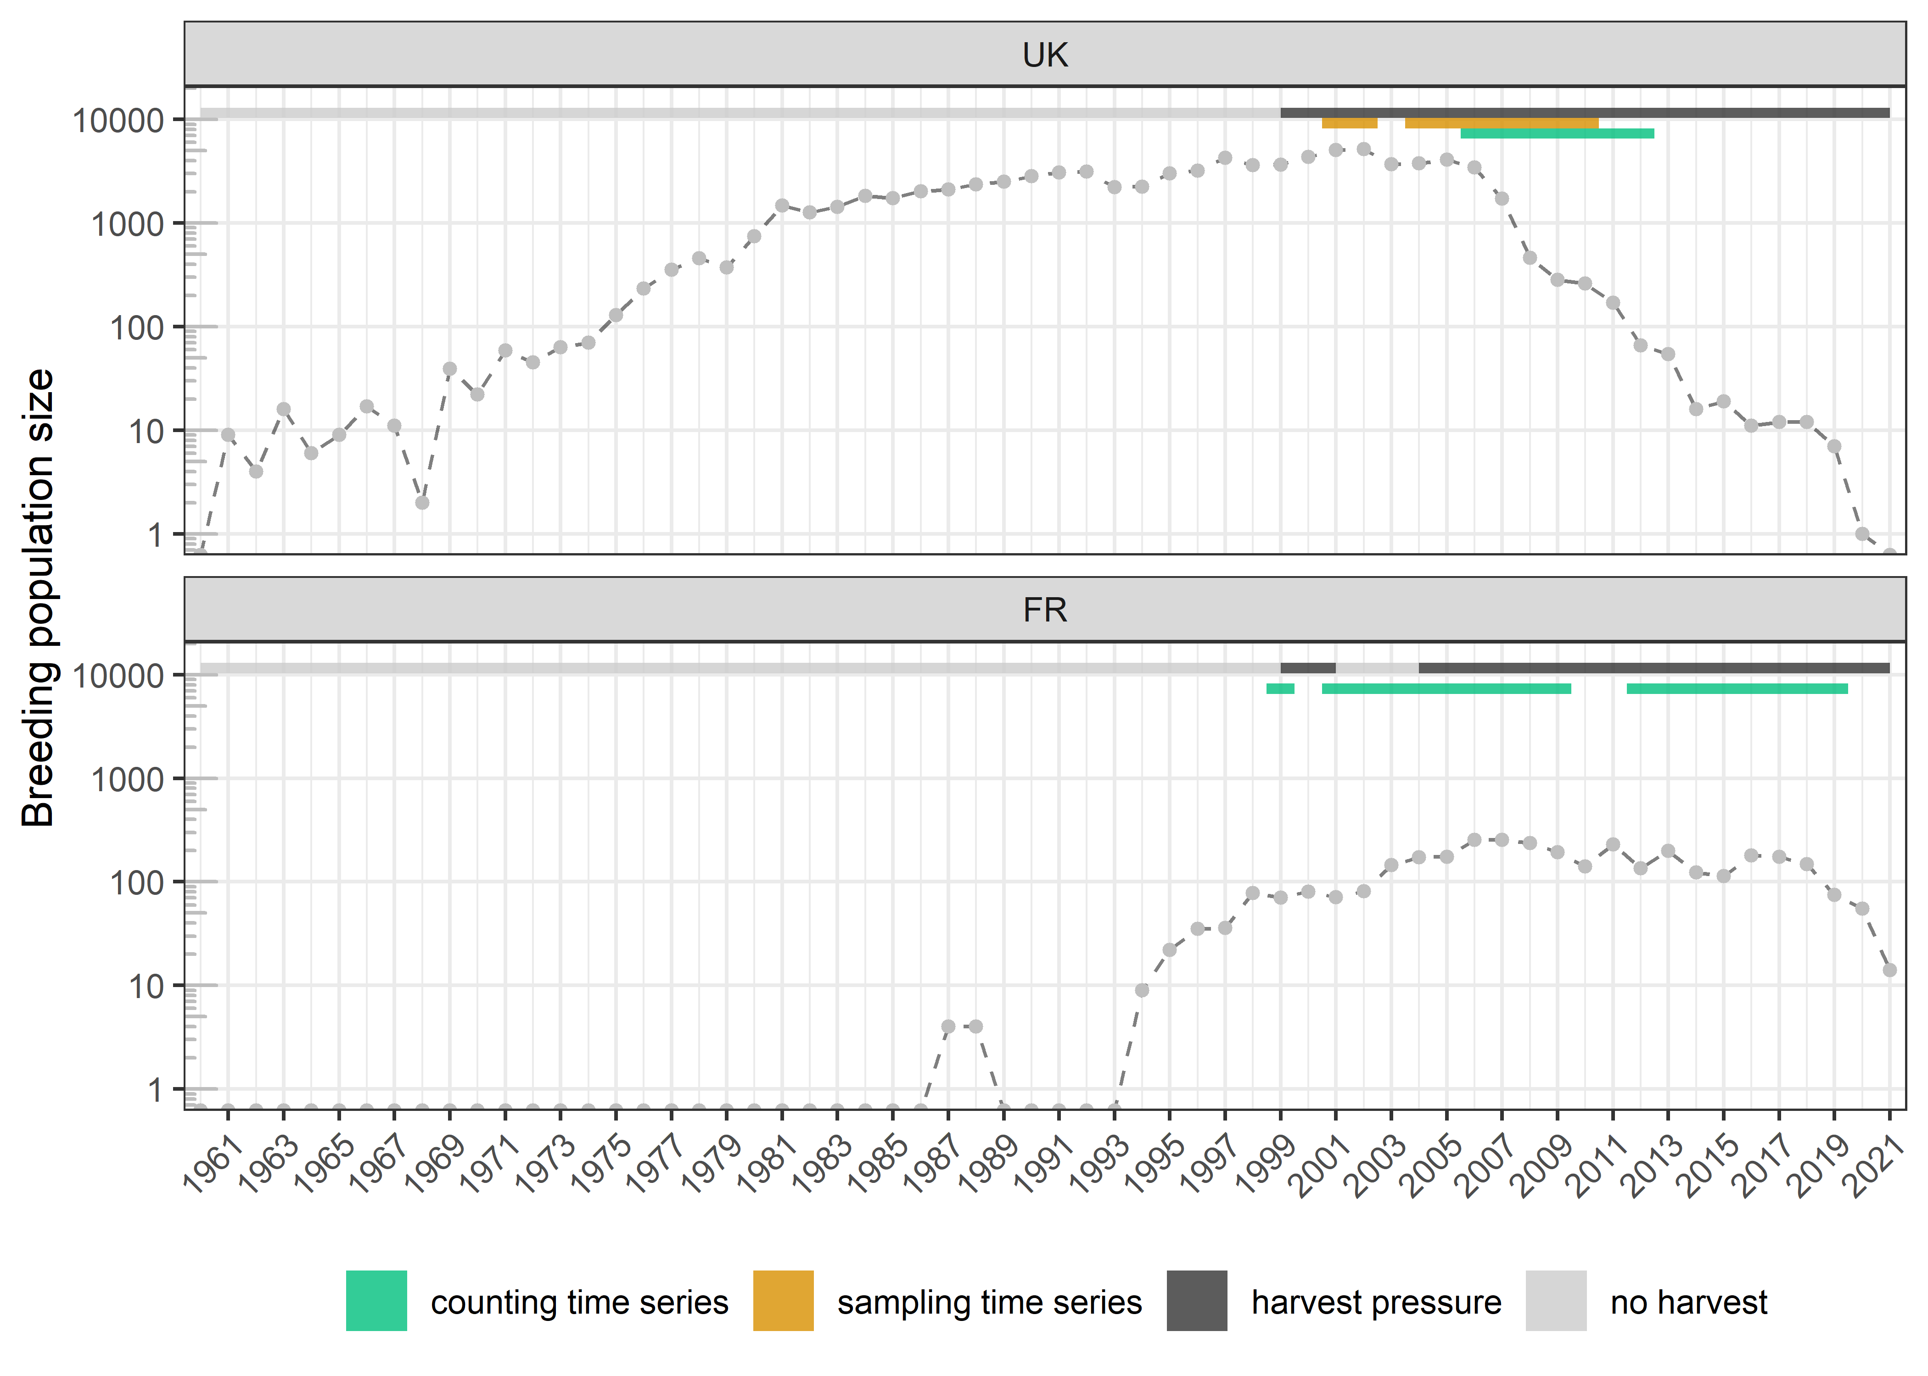

Figure 2.3: Evolution of the size of the two Ruddy duck populations in light of the data time series;

Such biological model is thus suited to study the response of the harvest pressure on productivity.

## 2.2 Data time series

The best picture stands just before the breeding period, so generally in winter for waterfowl.

The French and the UK wintering populations have been monitored since the presence of the first individuals was validated.

estimation by the counting method

## 2.3 Modelling

|  |  |  |
| --- | --- | --- |
| Name | Class | Description |
|  | Data | Total number of adult males sampled |
|  | Data | Total number of adult females sampled |
|  | Parameter | Proportion of males in the adult part of population at its equilibrium |
|  | Data | Number of individuals sampled in population in year |
|  | Data | Number of juveniles sampled in population in year |
|  | Data | Cumulated number of type-male individuals counted in population in year |
|  | Data | Cumulated number of individuals counted in population in year |
|  | Data | Maximum number of individuals counted in population in year |
|  | Parameter | Proportion of recruits in population in year |
|  | Parameter | Number of recruits in population in year |
|  | Parameter | Number of recruits in population in year per breeder in year |
|  | Parameter | Intercept of the regression model, the index refers to a restricted time period for a single population |
|  | Parameter | Standard deviation of the regression model, the index refers to a restricted time period for a single population |
|  | Parameter | Population growth rate (in ), the index refers to a restricted time period for a single population |
|  | Parameter | Adult survival rate (in ), the index refers to a restricted time period for a single population |

The proportion of males in the adult part of a population at its equilibrium is inferred from the samples.

Indeed, the available French samples were insufficient to get Since the . Age in samples to 2003 to 2020 for the United Kingdom and

$$\begin{equation}
PM \sim {\sf Beta}(SM, SF)
\qquad(2.1)
\end{equation}$$

estimation by the counting method

$$\begin{equation}
CM_{i, t} \sim {\sf Binom}(PM.(1 - PR_{i, t}), C_{i, t})
\qquad(2.2)
\end{equation}$$

estimation by the sampling method

$$\begin{equation}
SJ_{i, t} \sim {\sf Binom}(PR_{i, t}, S_{i, t})
\qquad(2.3)
\end{equation}$$

From estimates, and are expressed as:

The index refers to a single population and a restricted time period for . The evolution of the population size can be related to the time to infer the population growth rate. It is a linear regression on the logarithm scale:

$$\begin{equation}
log(Cmax_{i, t}) \sim {\sf Norm}(N0_{j} + log(\lambda_{j}).t, SD_{j})
\qquad(2.6)
\end{equation}$$

(R Core Team, 2020) R package Nimble (de Valpine et al., 2017)

## 2.4 Comparison with the sampling method

# 3 Result validation using survival analysis

The adult survival is commonly assessed by capture mark recapture and published in the literature. Since the survival can also be estimated from both the counting and the sampling methods, the consistency of the two approaches is discussed by comparing the survival estimates with the literature values.

|  |  |
| --- | --- |
| Name | Description |
|  | Number of breeders in year |
|  | Number of breeders dead after reproduction in year |
|  | Number of recruits in year |
|  | Adult survival rate, i.e. proportion of breeder in year still alive in year |
|  | Number of recruits in year produced per breeder in year |
|  | Growth rate of the population between the reproduction period of year and year |

$$

The population size in year is equal to the number of breeders that survived over year plus the offspring produced in year that survived until the reproduction period of year , i.e. the recruitment in year . The growth rate of a population is thus the sum of the productivity and the adult survival rate.

The proportion of males in the adult part of a population at its equilibrium is inferred from the samples.

Indeed, the available French samples were insufficient to get Since the . Age in samples to 2003 to 2020 for the United Kingdom and

develop the counting method :

2 ways to check the method :

sampling method? Ok but few data as poorly harvested

realistic survival? if > 1, estimated productivity is too low to support the maximum growth rate in the range of similar species in litterature -> satisfying

blabla

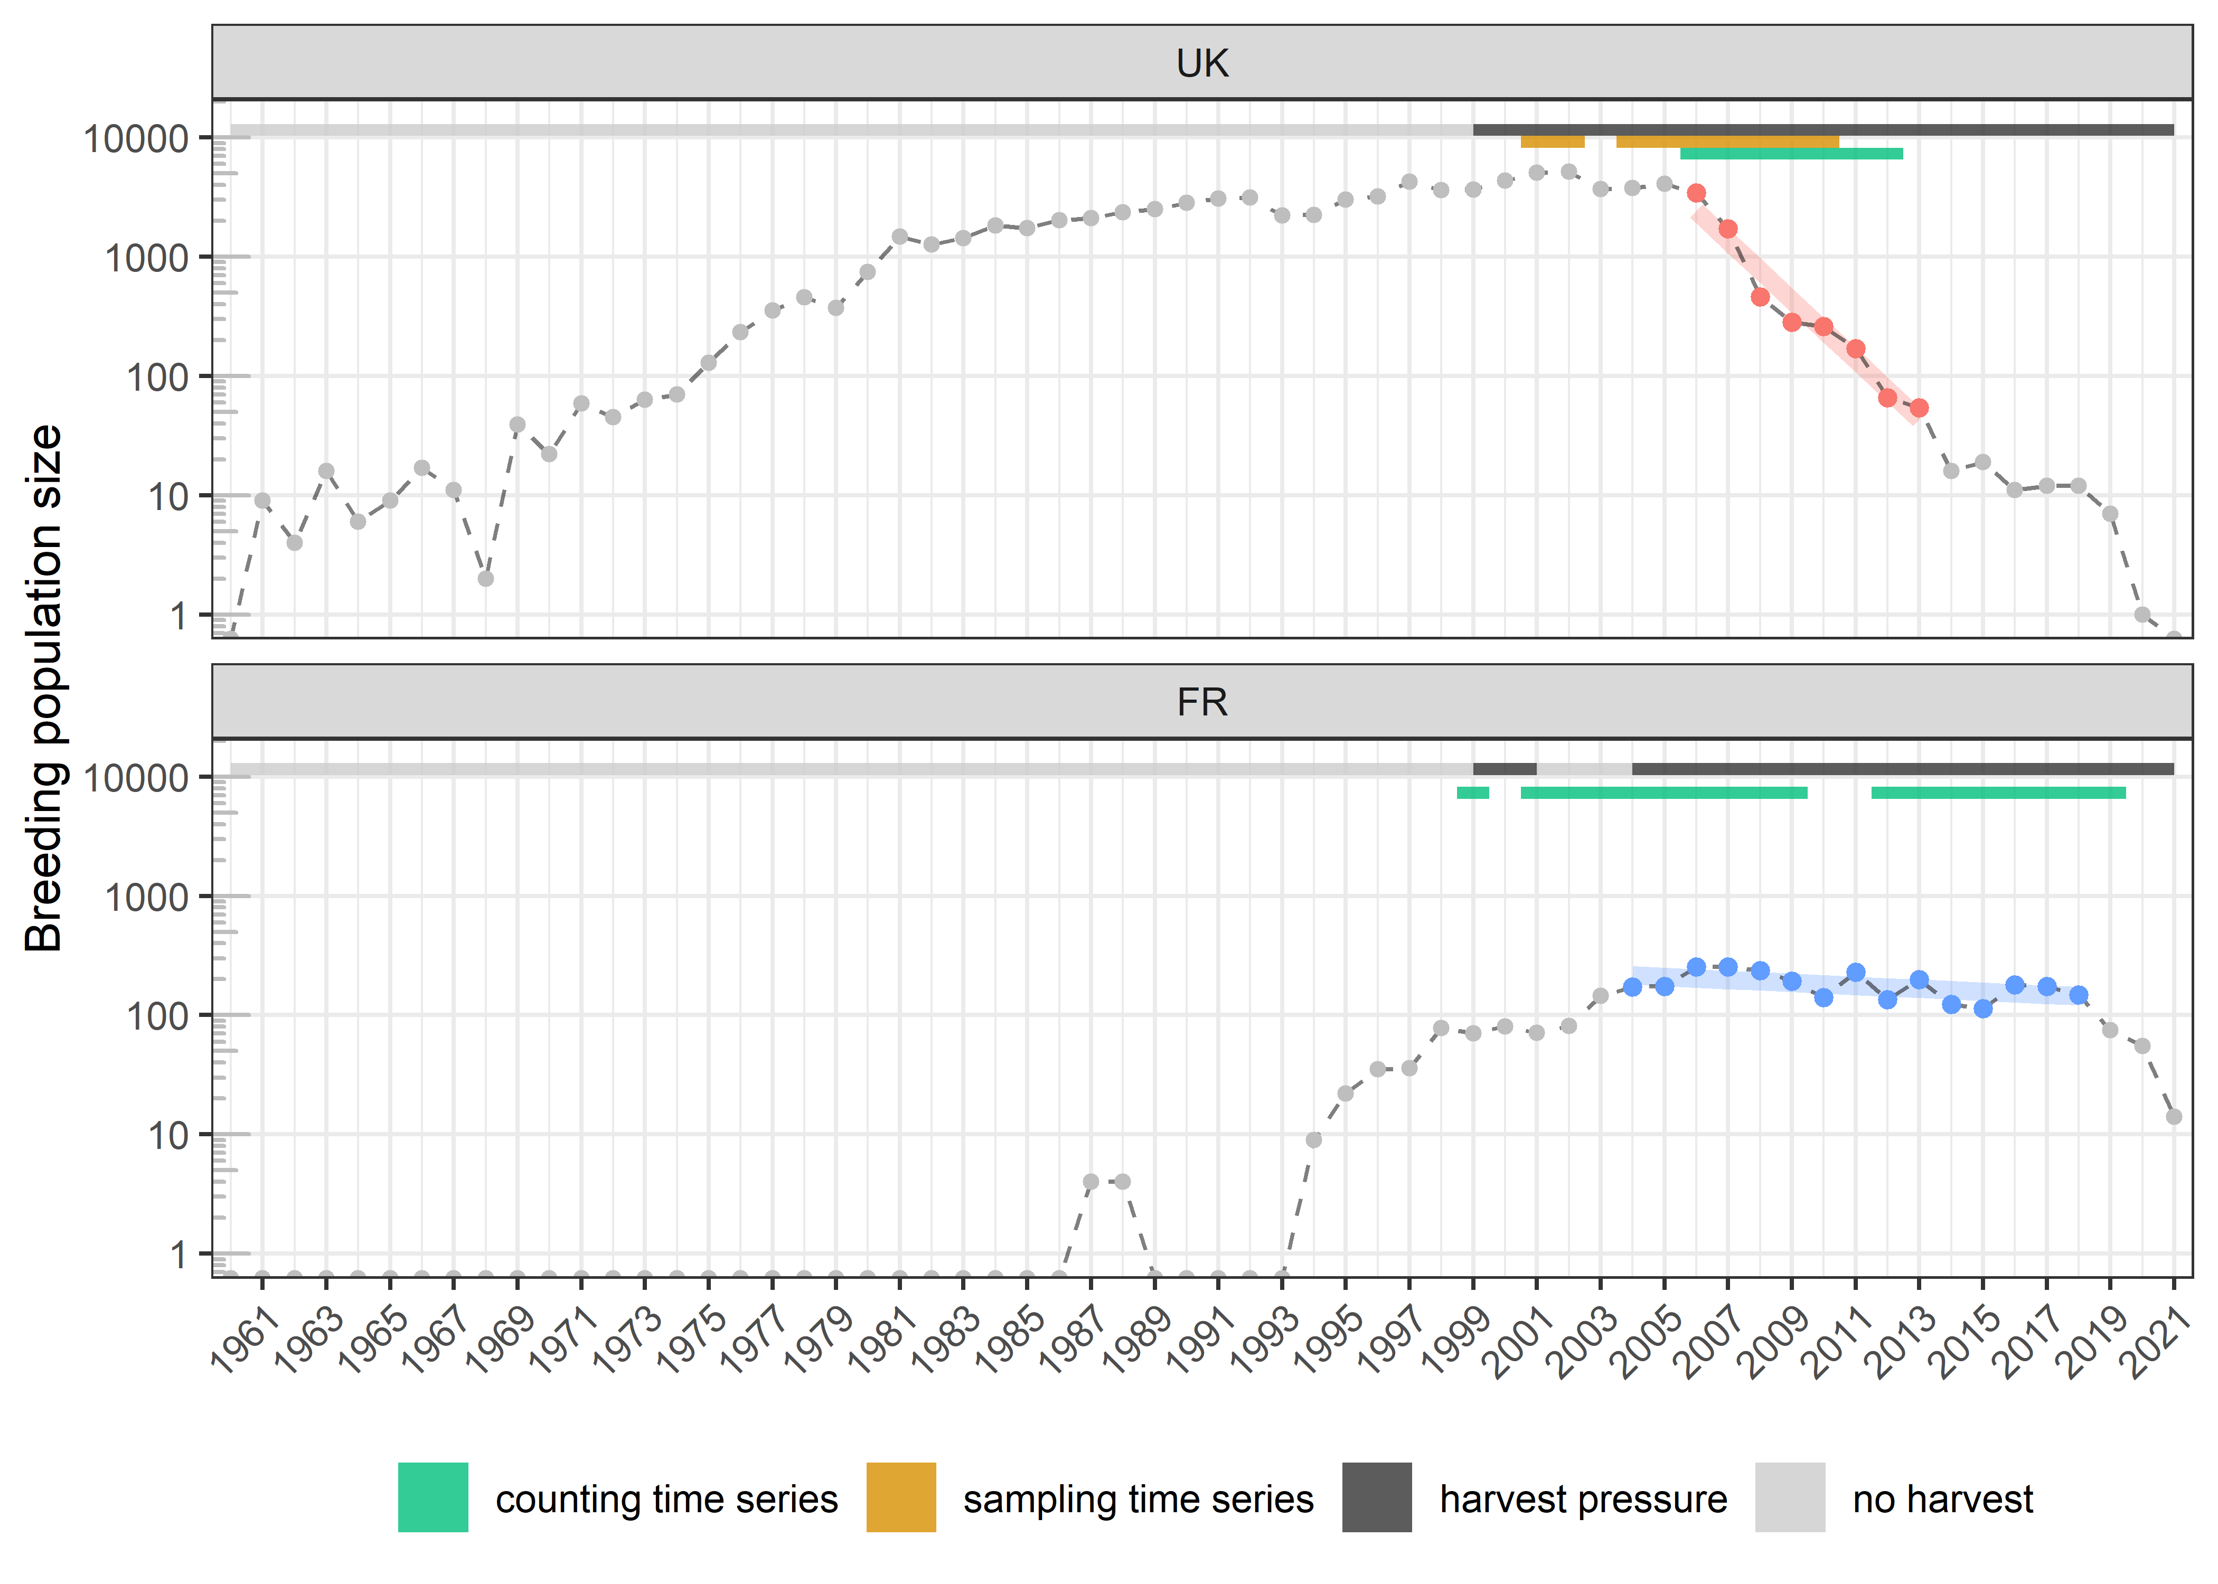

Figure 3.1: Evolution of the size of the two Ruddy duck populations in light of the harvest pressure; on time periods with data time series, population growth rates can be estimated (slopes in red for the UK and in blue for France)

## 3.1 Result validation using maximum productivity proxy

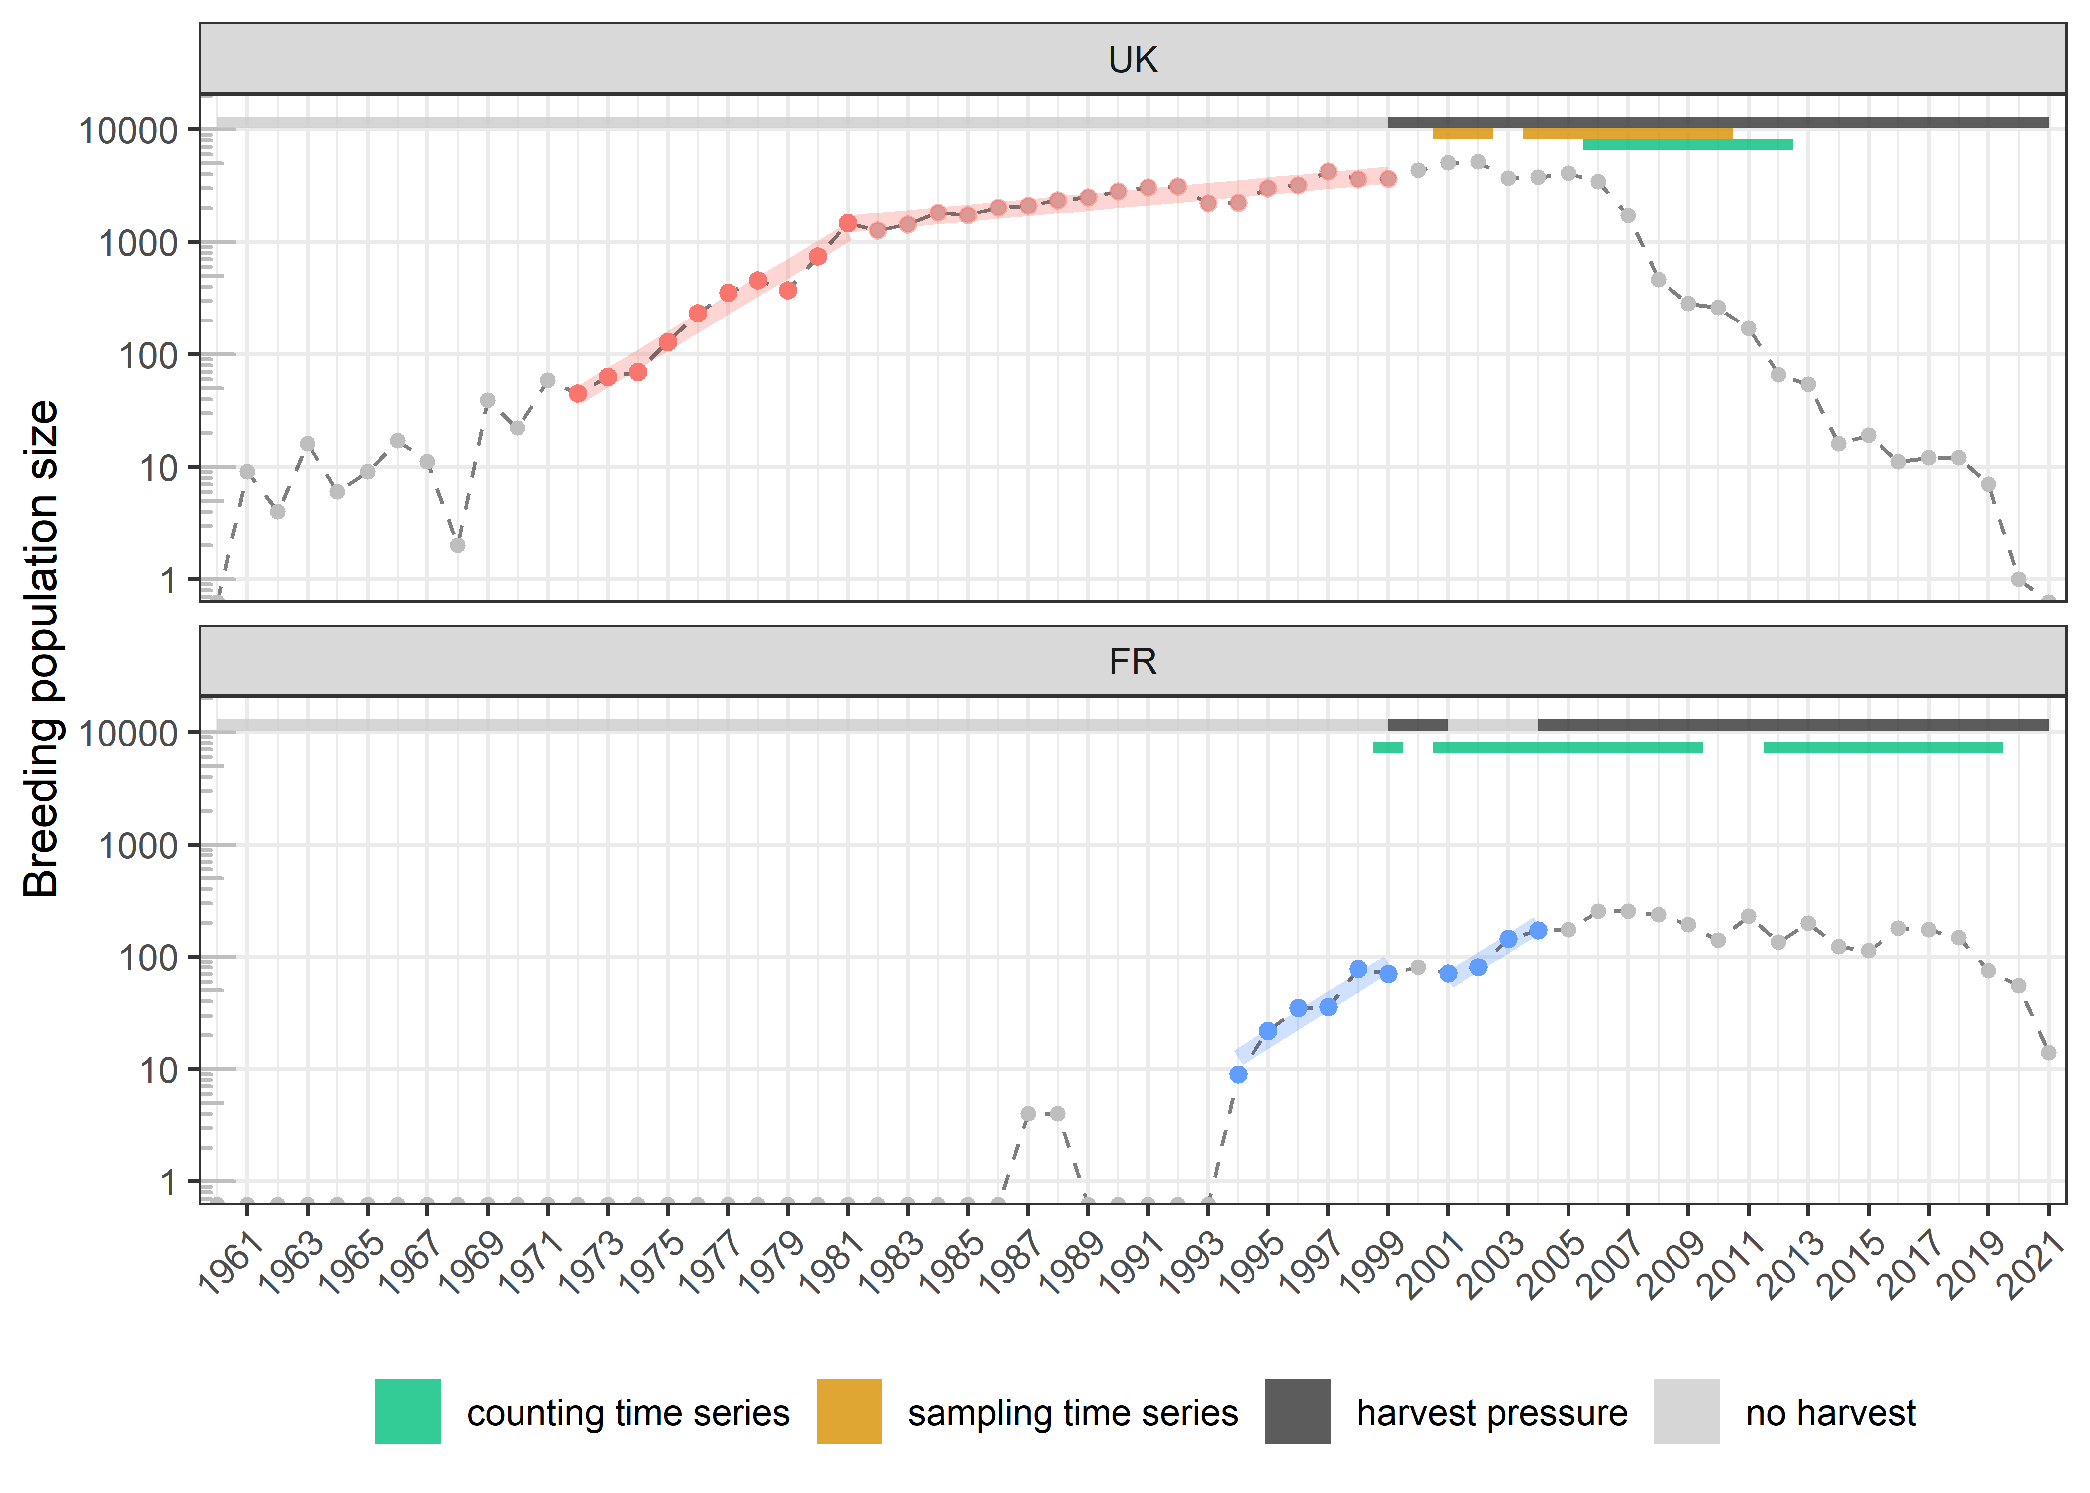

Figure 3.2: Evolution of the size of the two Ruddy duck populations in light of the harvest pressure; on time periods without harvest, maximum population growth rates can be estimated (slopes in red for the UK and in blue for France)

# 4 Results

## 4.1 Productivity variability

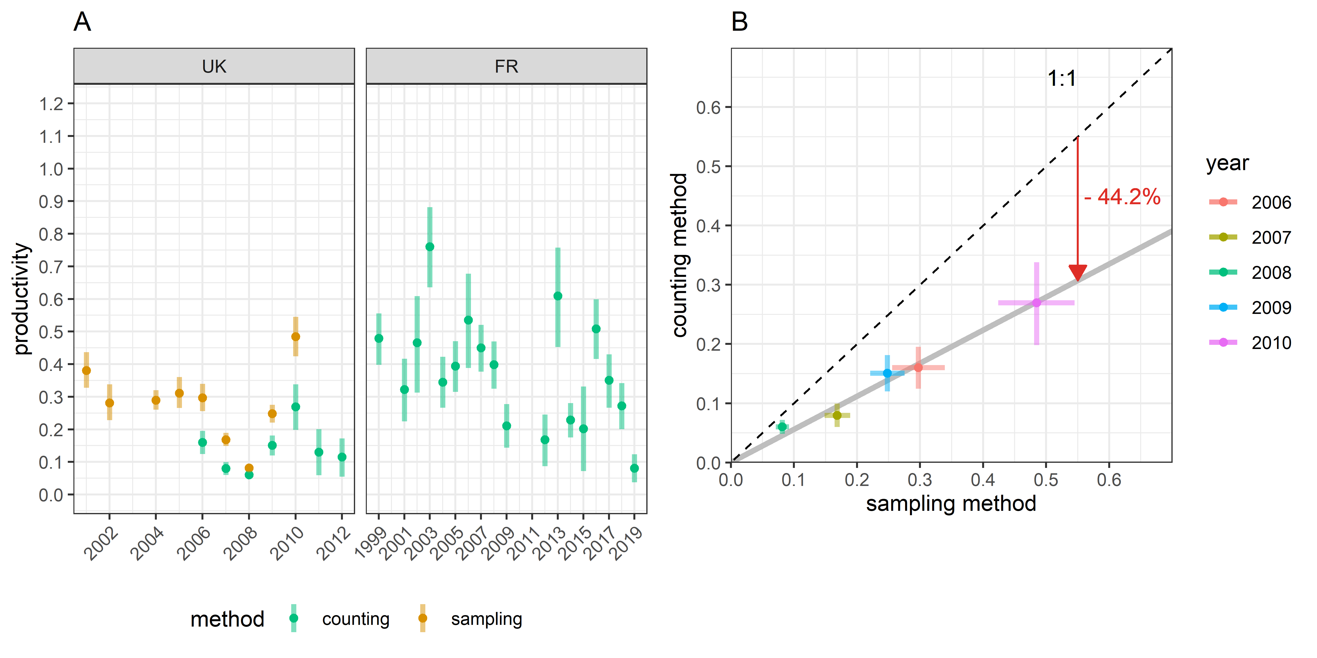

Figure 4.1: (A) Estimates of productivity, i.e. average number of recruits produced per breeder; (B) Comparison of the productivity values between the two estimation methods; bars define the 95% confidence intervals

quite stable when harvest rate is limited (France 2000), but is lower and noisy when harvest rate is huge and the population depleted.

## 4.2 Result validation using survival analysis

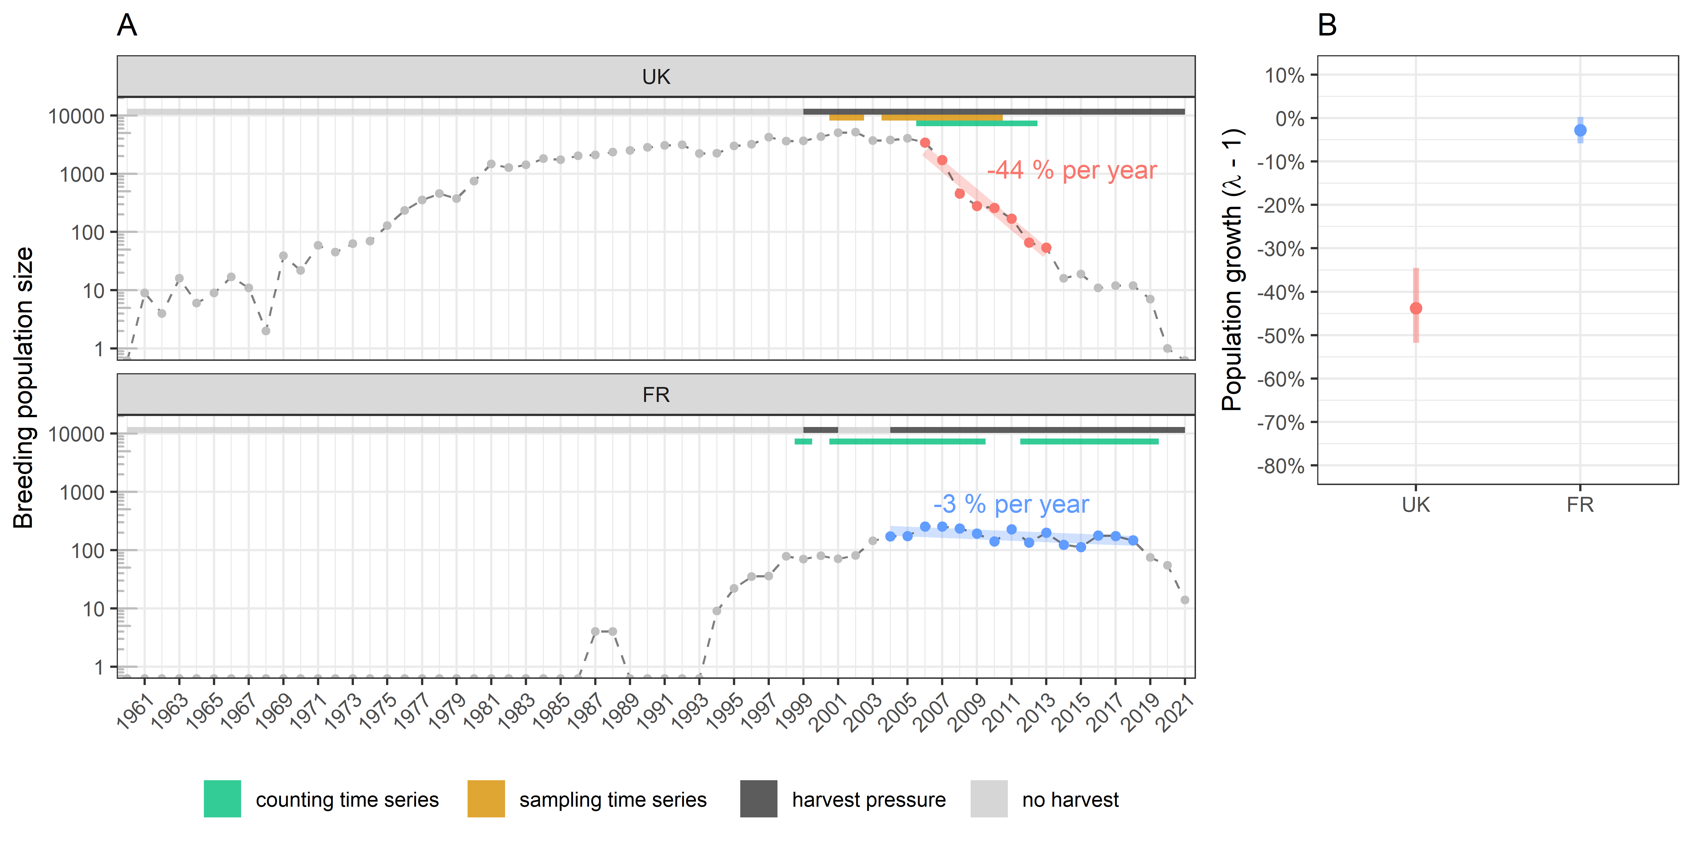

Figure 4.2: (A) Estimates of the population growth rate on time intervals with data availability. This aims at producing survival estimates to discuss the reliability of the methods to estimate productivity; (B) Growth rate estimates; bars define the 95% confidence intervals

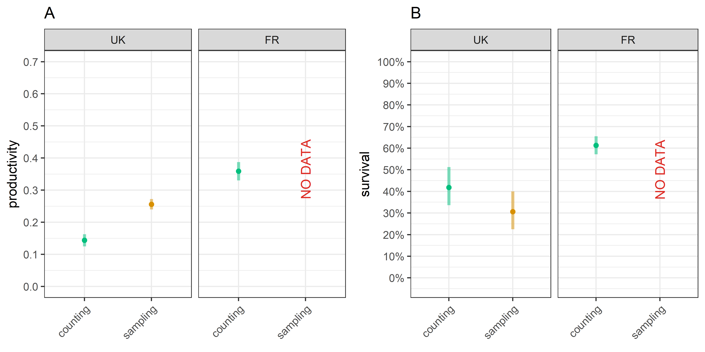

Figure 4.3: (A) Average productivity estimates on the time intervals defined for survival analysis; (B) Average survival estimates deduced from growth rate and productivity estimates on the time intervals; bars define the 95% confidence intervals

## 4.3 Result validation using maximum productivity proxy

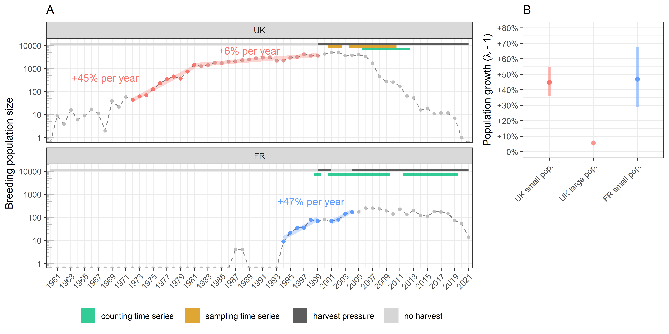

Figure 4.4: (A) Estimates of the population growth rate without harvest; two estimates were produced for the UK population because the growth rate dropped significantly when its size reached more than 1000 individuals; (B) Growth rate estimates; bars define the 95% confidence intervals

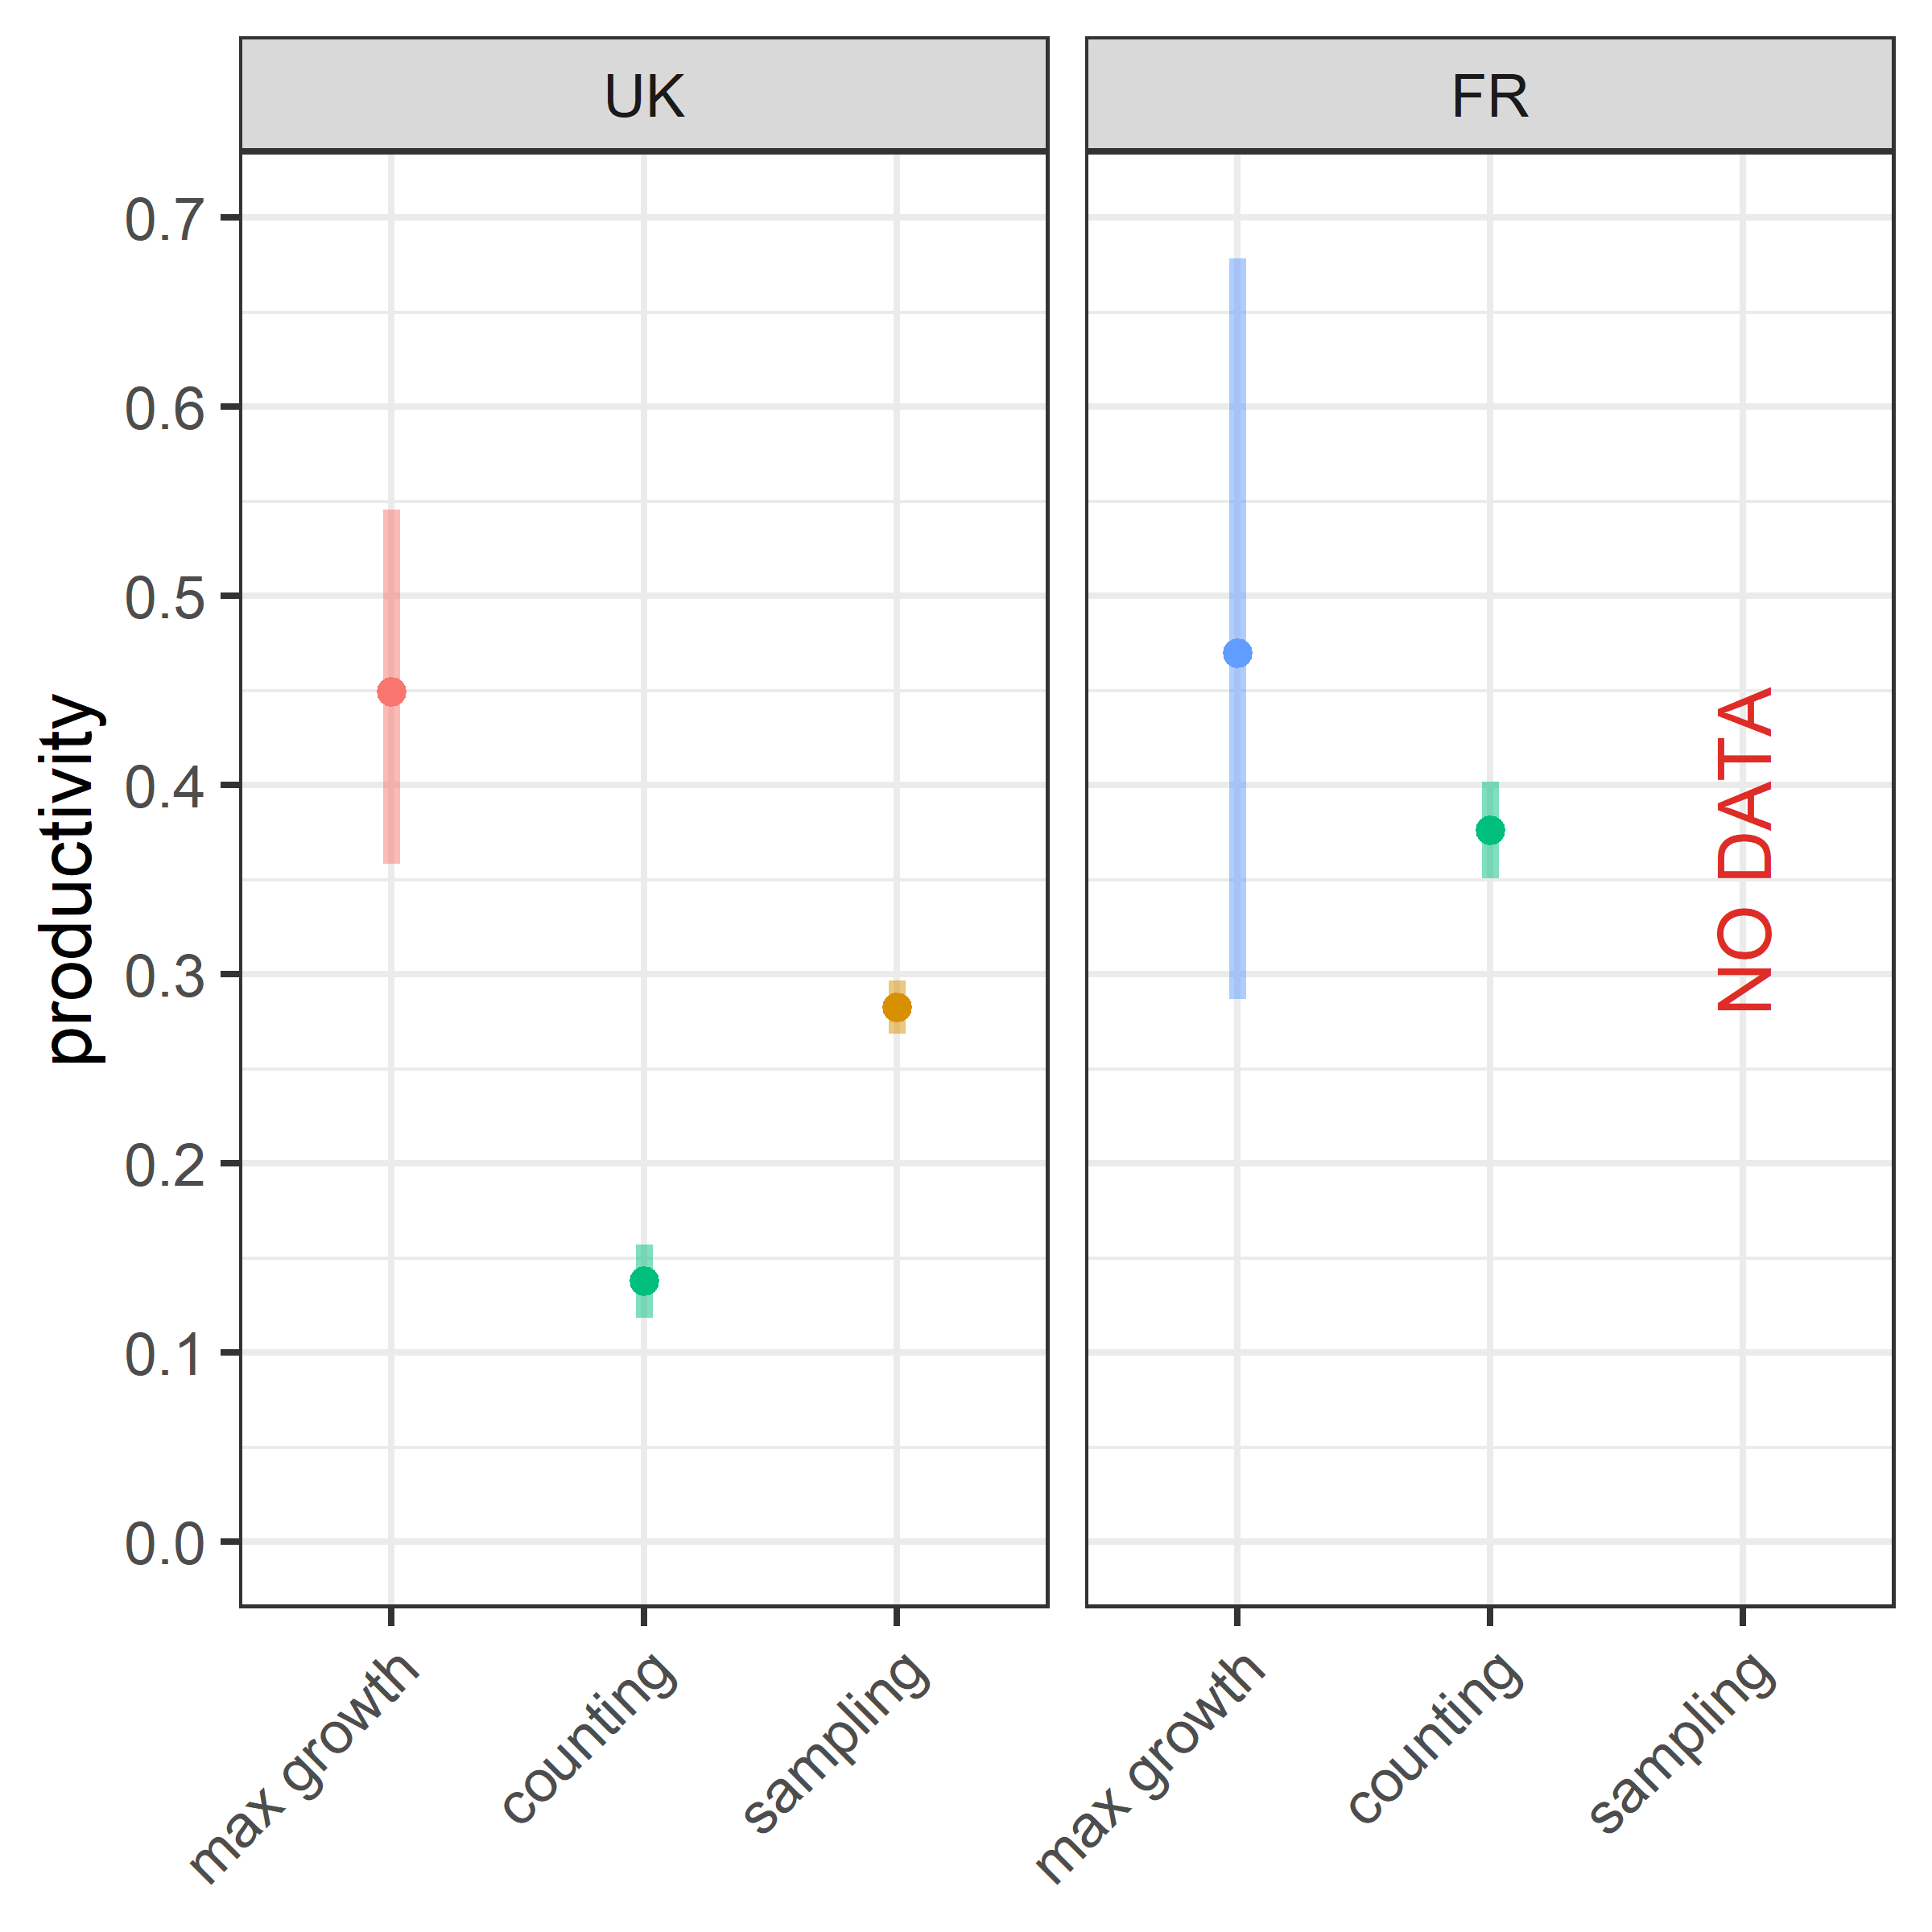

Figure 4.5: Comparison between a proxy of maximum productivity and the average productivity estimated following *counting* and *sampling* methods; the proxy is estimated during the maximum growth periods by combining the growth rate to the hypothesis of a 100% adult survival (*max growth*); this hypothesis implies that the true maximum of productivity is likely higher; bars define the 95% confidence intervals

# 5 Discussion

prodctivity the most sensitive parameter to density dependent effect (**???**)

Hypothesis of time invariant sex ratios in immature and adult: limits

For hunted duck species in North America, the mortality rate on first-year immatures compared to adults is higher by a factor ranging from 1.4 to 2 (Bellrose 1980).

Productivité: Stabilité grosse pop, variabilité petite pop.

Au dela du fait que la croissance de la pop est la somme de la survie et de la productivité, intéressant de parler de la variability de la survie vs variabilité de la productivity pour parler de risk management.

Productivity: drop from 2009

one considers harvest as an impact only adult survival, not on age structure, but we should, oversimplistics

blabla

Nichols & Williams (2006) -> il faut compter de la façon dont on demande

Taper des jeunes c’est pas forcément très utile car density dependence

If the maximum productivity is not reached under optimal conditions (maximum population size not reached, and limited harvest pressure), it is a signal that one should explore the intermediate life stages before recruitment to provide a diagnostic on the changes of the environment conditions that have affected the productivity.

Condition of application to other species.

# Aknowledgements

This work was partly funded by the LIFE Oxyura project (LIFE17 NAT/FR/000942) through the LIFE program. This work was carried on with the impulse of Jean-François Maillard, and Jean-Baptiste Mouronval from the *Office Français de la Biodiversité*, and Jean-Marc Gillier from the *Société Nationale pour la Protection de la Nature*. The authors aknowledge all the contributors of the data collection in the UK and in France, especially: **UK names**, Vincent Fontaine, Denis Lacourpaille, Jules Joly, Justin Potier, Valentin Boniface, Alexis Laroche, and Médéric Lortion, **other names**.

# References

Bellrose, F. C. (1980). *Ducks, geese & swans of North America: 3rd. Ed*. Stackpole Books. <https://books.google.fr/books?id=VpcWzgEACAAJ>

Bellrose, F. C., Scott, T. G., Hawkins, A. S., & Low, J. B. (1961). Sex ratios and age ratios in North American ducks. *Illinois Natural History Survey Bulletin*, *27*(6), 391–486.

Blums, P., & Clark, R. G. (2004). Correlates of lifetime reproductive success in three species of European ducks. *Oecologia*, *140*(1), 61–67. <https://doi.org/10.1007/s00442-004-1573-8>

Blums, P., & Mednis, A. (1996). Secondary sex ratio in Anatinae. *The Auk*, *113*(2), 505–511. <https://doi.org/10.2307/4088920>

de Valpine, P., Turek, D., Paciorek, C. J., Anderson-Bergman, C., Lang, D. T., & Bodik, R. (2017). Programming with models: Writing statistical algorithms for general model structures with NIMBLE. *Journal of Computational and Graphical Statistics*, *26*(2), 403–413. <https://doi.org/10.1080/10618600.2016.1172487>

Folliot, B., Caizergues, A., Barbotin, A., & Guillemain, M. (2017). *Environmental and individual correlates of common pochard (*Aythya ferina*) nesting success*. *63*(4). <https://doi.org/10.1007/s10344-017-1126-1>

Gunnarsson, G., Elmberg, J., Pöysä, H., Nummi, P., Sjöberg, K., Dessborn, L., & Arzel, C. (2013). Density dependence in ducks: A review of the evidence. *European Journal of Wildlife Research*, *59*(3), 305–321. <https://doi.org/10.1007/s10344-013-0716-9>

Gutiérrez-Expósito, C., Pernollet, C., Adriaens, T., & Henderson, I. (2020). Ruddy duck (*Oxyura jamaicensis* Gmelin, 1789). In *Invasive birds: Global trends and impacts* (pp. 200–205). CABI.

Johnson, D. H., Sparling, D. W., & Cowardin, L. M. (1987). A model of the productivity of the mallard duck. *Ecological Modelling*, *38*(3-4), 257–275. <https://doi.org/10.1016/0304-3800(87)90100-1>

Koons, D. N., Gunnarsson, G., Schmutz, J. A., & Rotella, J. J. (2014). Drivers of waterfowl population dynamics : From teal to swans. *Wildfowl*, *Special Issue 4*, 169–191. <http://wildfowl.wwt.org.uk/index.php/wildfowl/article/view/2606>

Malthus, T. R. (1872). *An essay on the principle of population*.

Muñoz-Fuentes, V., Vilà, C., Green, A. J., Negro, J. J., & Sorenson, M. D. (2007). Hybridization between white-headed ducks and introduced ruddy ducks in Spain. *Molecular Ecology*, *16*(3), 629–638. <https://doi.org/10.1111/j.1365-294x.2006.03170.x>

Nichols, J. D. (2000). Volution of harvest management for North American waterfowl: Selective pressures and preadaptations for adaptive harvest management. *Transactions of the North American Wildlife and Natural Resources Conference*, *65*, 65–77.

Nichols, J. D., & Williams, B. K. (2006). Monitoring for conservation. *Trends in Ecology & Evolution*, *21*(12), 668–673. <https://doi.org/10.1016/j.tree.2006.08.007>

Nummi, P., Holopainen, S., Rintala, J., & Pöysä, H. (2015). Mechanisms of density dependence in ducks: Importance of space and per capita food. *Oecologia*, *177*(3), 679–688.

R Core Team, (2020). *R: A language and environment for statistical computing*. R Foundation for Statistical Computing. <https://www.R-project.org/>

Sayre, N. F. (2008). The genesis, history, and limits of carrying capacity. *Annals of the Association of American Geographers*, *98*(1), 120–134. <https://doi.org/10.1080/00045600701734356>

Smith, G. C., Henderson, I. S., & Robertson, P. A. (2005). A model of ruddy duck *Oxyura jamaicensis* eradication for the UK. *Journal of Applied Ecology*, *42*(3), 546–555. <https://doi.org/10.1111/j.1365-2664.2005.00977.x>

Wood, K. A., Brides, K., Durham, M. E., & Hearn, R. D. (2021). Adults have more male-biased sex ratios than first-winter juveniles in wintering duck populations. *Avian Research*, *12*(1). <https://doi.org/10.1186/s40657-021-00286-1>

# (APPENDIX) Supplement

# 6 Supplement

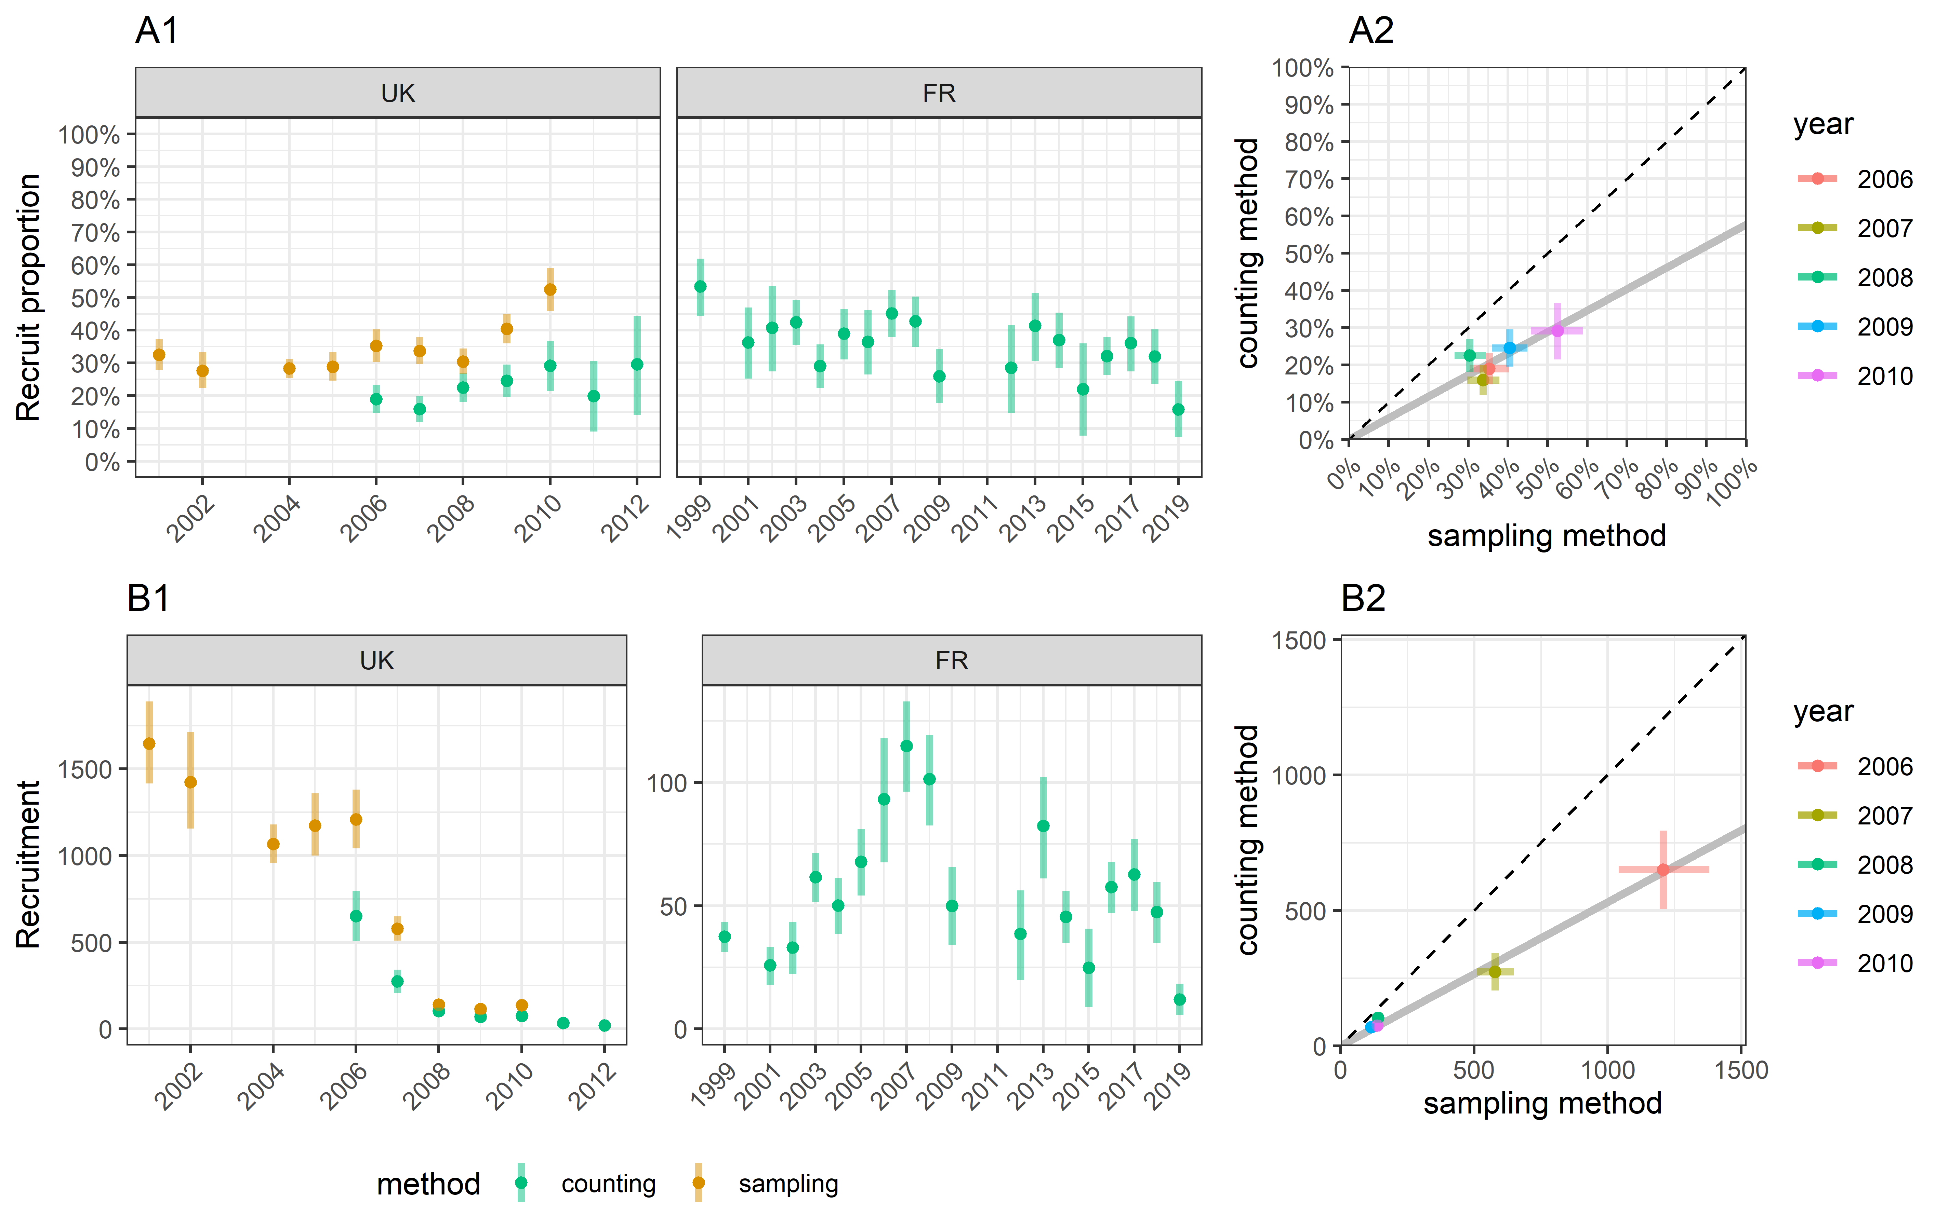

Figure 6.1: (A1) Estimates of the number of recruits, i.e. the young adults reproducing for their first time; (B1) estimates of the proportion of recruits in the population at the reproduction period; (A2) & (B2) comparison of the values between the two estimation methods; bars define the 95% confidence intervals

1. Office Français de la Biodiversité, France - [adrien.tableau@ofb.gouv.fr](mailto:adrien.tableau@ofb.gouv.fr) - contribution in data analyses & writing
2. Office Français de la Biodiversité, France - [alain.caizergues@ofb.gouv.fr](mailto:alain.caizergues@ofb.gouv.fr) - contribution in writing
3. Animal and Plant Health Agency, United Kingdom - [iain.henderson@apha.gov.uk](mailto:iain.henderson@apha.gov.uk) - contribution in data collection
4. Société Nationale pour la Protection de la Nature, France - [sebastien.reeber@snpn.fr](mailto:sebastien.reeber@snpn.fr) - contribution in data collection
5. Office Français de la Biodiversité, France - [matthieu.guillemain@ofb.gouv.fr](mailto:matthieu.guillemain@ofb.gouv.fr) - contribution in writing