Estimating waterfowl recruitment rate using a non-invasive method

Adrien Tableau[1]

Iain Henderson[2]

Sébastien Reeber[3]

07 January, 2022

The response of a waterfowl population to a given harvest pressure depends on its capacity to renew. Recruitment, i.e. the number of young adults reproducing for the first time, is a key indicator to describe the renewal of a population, and therefore an essential tool in population management. Recruitment rate, defined here as the number of recruits produced per breeder, is even more informative because it is independent of breeding population size and allows comparisons over time and between species. The proportion of young adults in a waterfowl population, which is a key feature to evaluating recruitment rate, is often estimated from game-hunting samples. However, this proportion is not accessible in years without harvest, or with a low harvest rate. Moreover, the age-structure in the harvest samples does not necessarily reflect the underlying age-structure of the population : it is often skewed towards immatures and can lead to an overestimation of recruitment rate. In waterfowl, adult males usually display brighter colours than females and immatures from both sexes. This dichromatism can be characterized and monitored from count surveys, a non-invasive method. Such information can be used to infer the proportion of immatures, and consequently the recruitment rate. Using two populations of ruddy duck, *Oxyura oxyura*, this study introduces a model to estimate recruitment rate from count data. To test the accuracy of the method, the results are compared to estimates of recruitment rate using dissection samples. We also tested the consistency of recruitment rates to support observed population growth rates. The results suggest that the counting method is a versatile tool to estimate the recruitment rate if the species is monitored during the appropriate time window. We call for considering a two-category count protocol in winter surveys of waterfowl species for which adult males can be differentiated from other individuals.

**Keywords**: fecundity - productivity - reproductive success - age ratio - juvenile - duck

# 1 Introduction

*Recruitment rate* of a breeding population can be defined as the average number of recruits produced per each breeder over a given time window (Flint, 2015). This parameter is sometimes called *annual fertility* (Koons et al., 2014), *reproductive rate* (Cooch et al., 2014), *reproductive success* (Etterson et al., 2011), or *productivity* (Hagen & Loughin, 2008; D. H. Johnson et al., 1987). If one considers a species reaching its sexual maturity as early as at one year of age, all individuals are mature during any reproduction season. Recruitment rate is then the ratio of the number of young adults breeding in year , i.e. the number of recruits, to the total number of breeding individuals during the previous year, . The declination for species with delayed maturity follows the same process (see Robertson, 2008). Recruitment rate is a complex parameter because it is composed of two main sub-parameters: annual fecundity, followed by juvenile survival (Arnold, 2018; Etterson et al., 2011). Both sub-parameters can be split into other sub-parameters. Fecundity can be defined as the product of nesting success, average clutch size, and hatching success. Juvenile survival can be defined as the product of post-hatching survival and post-fledging survival, both being critical life periods (Blums & Clark, 2004; Hill & Ellis, 2008). Recruitment rate as defined in the present study is therefore a parameter integrating multiple life steps from egg production year t-1 to young adults attempting to breed for its first time in year t (Koons et al., 2017).

Population conservation, harvesting, and control require tools in population management in order to reach quantitative targets, such as a preset population size for example ( Johnson et al., 2021; Shea & NCEAS Working Group on Population Management, 1998). To do so, a first blind strategy is to test management rules iteratively, in order to progressively reach an optimum. Such approach can be time-consuming given the intrinsic variability of the population response to its changing environment. It might also suffer from a rejection of the stakeholders because of the lack of transparency of an arbitrary process (Williams & Madsen, 2013). Another approach is to try to predict the growth rate of the population as a function of the harvest rate and other environment inputs. Such a modelling approach can provide clues on the recovering time of a population upon a variety of management rules (Otis, 2006). These decision-support tools are then key inputs to decide on the best management rules to implement. The growth rate of a population depends on both adult survival rate and recruitment rate, see Equation (2.6) in Section 2.4. Adult survival is generally estimated by mark recapture/recovery methods (Lebreton, 2001). If harvest pressure leads to an additive mortality to the natural mortality for adults (e.g. Iverson et al., 2013), it is quite straightforward to predict its impact on adult survival. The recruitment rate is thus a key parameter to build management scenarios. According to Blums & Clark (2004), recruitment rate is poorly related to fecundity in diving ducks, but depends mostly on juvenile survival, which is mostly driven by weather conditions. Studies on other birds also conclude on the weak correlation between fecundity and recruitment (e.g. Murray, 2000). The difficulty to track juvenile survival (Schmidt et al., 2008) demonstrates the interest to focus on recruitment rate directly when accessible. The key to predict the growth rate of a population is then to estimate the value of the recruitment rate and its variability, potentially influenced by the harvest pressure (Anders & Marshall, 2005).

*The variability of the recruitment rate*

A waterfowl species that is released in a favourable habitat will naturally expand (Malthus, 1872). The growth of such a population reflects that the recruitment rate parameter is higher than the adult mortality rate. This expansion is limited by the carrying capacity of the habitat (Sayre, 2008). When a waterfowl species is endemic to an ecosystem and evolves in stable environmental conditions, population size varies around the carrying capacity because the individuals compete for space or/and food (Nummi et al., 2015), which prevents the population from expanding indefinitely. Such competition commonly induces a lower fecundity or/and a higher juvenile mortality. Population renewal is slowed down because recruitment rate is limited by density-dependent feedback (Gunnarsson et al., 2013). For an endemic species evolving in stable environmental conditions, the recruitment rate compensates on average the adult mortality rate, which explains the stabilization of the number of individuals (Flint, 2015).

Waterfowl hunting induces adult and juvenile mortality (Bellrose, 1980). Intuitively, one expects that such a hunted population would show lower adult survival and recruitment rate and then would rapidly deplete to its extinction. However, hunting waterfowl has a long history, and most of these species have persisted over time (Cooch et al., 2014). So paradoxically, hunting immature individuals does not always induce a decrease of recruitment rate. Heterogeneity in quality among immature individuals might explain this by inducing a compensation process if harvest mostly selects individuals with a low reproductive potential (Gimenez et al., 2017; Lindberg et al., 2013). Recruitment rate can even increase because the harvest pressure reduces the densities and potentially the competition for space and food (Nummi et al., 2015; Péron et al., 2012). In conclusion, a limited exploitation of a population observing heterogeneity and/or density-dependent process might paradoxically increase or at least not affect the recruitment rate. Under moderate exploitation, a new balance between recruitment rate and adult mortality can theoretically be reached (Tsikliras & Froese, 2018). The size of a newly exploited population in stable environmental conditions should thus reach a different equilibrium, which is expected to be lower than the size without exploitation. This process explains why the exploitation of many waterfowl species is sustainable and has been lasting over a long time.

Fecundity and juvenile survival, the two components of recruitment rate, are very sensitive to weather conditions in waterfowl (Blums & Clark, 2004; Folliot et al., 2017). Environment conditions are thus an additional source of variability of the recruitment rate. It also depends directly on the intensity of harvest on the immature individuals and indirectly on the mitigation of the density-dependent effects.

In population management, a common question for a threaten or an invasive species is to determine the management measures that will allow reaching a targeted population size/density in a limited time period (Shea & NCEAS Working Group on Population Management, 1998). Any manager should then mostly focus on collecting knowledge on the maximum recruitment rate and its variability by removing the potential density-dependent effects occurring only for the highest theoretical densities (Eraud et al., 2021; Péron, 2013).

Waterfowl hunting has a long history, but the biological effects of long-term moratorium have been poorly surveyed (Martínez-Abraín et al., 2013). So there are few opportunities to explore the response of recruitment rate to a gradient of hunting pressures for such species. Alien vertebrate species are commonly introduced during release events (Saul et al., 2016) and usually experience a first period of colonisation on new territories without management measures. Since their presence might impact the balance of the colonized ecosystem, it happens that managers take strong control measures to restrict the growth of these populations or to eradicate them (Oficialdegui et al., 2020). Such species are then a good biological model to overcome density-dependent effects and explore the effects of a harvest gradient on recruitment rate.

The recruitment rate of a population can first be assessed by evaluating the fecundity of the breeding population and then monitoring survival from egg stage to the first-breeding event. To do so, it is necessary to monitor nests in habitats representative of the considered population (Blums & Clark, 2004). The survival of a chick to its recruitment can be assessed by capture mark recapture methods that are quite tricky to set up (Arnold, 2018; Blums & Clark, 2004; Schmidt et al., 2008). Even if such an approach provides valuable information on the dynamics of the recruitment and can highlight the bottlenecks of survival, the fieldwork required to estimate both components is too time-consuming to generalize such approach to waterfowl population management on a long-term horizon.

In waterfowl, it is generally impossible to differentiate immatures from adults without examining birds at hand. Aging individuals from samples coming from hunting bags is thus another opportunity to estimate the proportion of recruits. Such an approach suffers from two caveats. First, it is impossible to assess recruitment rate when there is no harvest, whereas it is necessary to predict what would happen if a moratorium is set up, or to a priori calibrate the harvest effort necessary to control an invasive species (G. C. Smith et al., 2005). Secondly, like any predation action, hunting is selective and provides a biased picture of the population age structure in favour of the immatures (Bellrose, 1980; A. D. Fox et al., 2014). The analysis of hunting bags might then lead to overestimate recruitment rate and consequently the maximum sustainable harvest rate, with adverse consequences on population conservation (A. D. Fox et al., 2014). Inferring recruitment rate from the proportion of immature birds trapped during tagging studies is also promising (Arnold, 2018), but the author admits that immatures might be more naïve and then more likely to be caught in traps (Rguibi-Idrissi et al., 2003).

In waterfowl, it is common that adult males display brighter colours than adult females and immatures of both sexes, which display cover-up plumage similar to adult females (K. P. Johnson, 1999). This discrepancy is valuable because it can be observed and the proportions of the various plumages be quantified from a distance. Knowing adult sex ratio, such an approach is promising because it requires only to count the proportion of birds of the two plumage categories to infer recruitment rate (C. M. Smith et al., 2001). Unlike the two previous methods, this one is non-invasive and requires an acceptable time investment, which allows to collecting long time series and consequently to track recruitment rate variability over years.

From two populations of ruddy duck (*Oxyura jamaicensis*), a species introduced in Europe in the 40’s, this study introduces a simple Bayesian model to infer recruitment rate from count data. A large part of this study focuses on assessing the viability of such an approach. The comparison between two populations is a first step in testing the consistency of the method. A comparison to the common approach using samples from hunting bags aims at checking if recruitment rate variability, which is easily assessed from birds in the hand, is well tracked by long distance bird counts, and if the hypothesis stating that recruitment rate is overestimated when using sample data is consistent with the results. Using two other approaches based on population growth rates, we also tested the consistency of the order of magnitude of recruitment rate estimated from the counting method. Studying two populations is also an opportunity to discuss the response of the recruitment rate to a gradient of harvest pressure.

# 2 Materials & methods

## 2.1 Biological model

The ruddy duck is a diving duck species introduced to the United Kingdom in the 40’s (Gutiérrez-Expósito et al., 2020). The first reproduction was observed in the UK in the 60’s. The population rapidly grew to reach more than 5,000 individuals spread over the entire country. A new population set up in France from the 90’s, likely originating from the arrival of a few individuals from the UK. Unlike the UK population, the French population set up around a single wintering spot, the Grand Lieu Lake (47.09°N, 1.67°W), which facilitates its monitoring. Since this species is considered as a threat to the endangered White-headed duck (*Oxyura leucocephala*) because of the risk of a genetic introgression (Muñoz-Fuentes et al., 2007), a European plan of eradication has been adopted and control measures taken in both countries (Gutiérrez-Expósito et al., 2020).

Just before the reproduction period on wintering spots, it is easy to distinguish individuals with male-like plumage from female-like individuals from a distance (Figure 2.1).

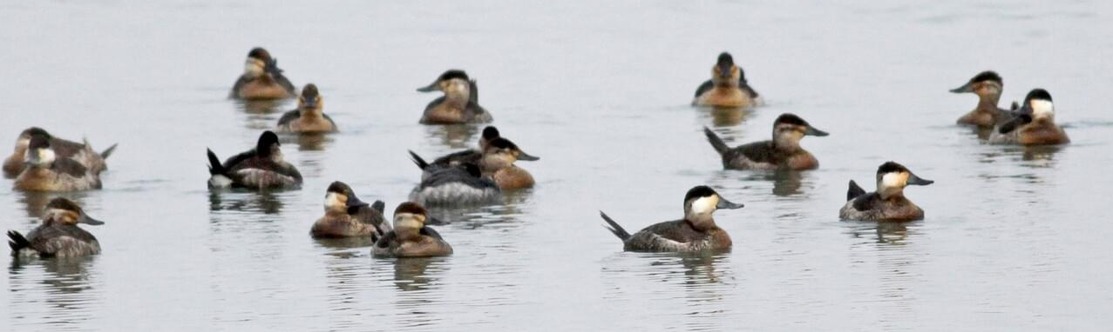

Figure 2.1: Typical observation of a ruddy duck flock in winter: 4 male-like individuals with a white cheek and a black cap, 10 female-like individuals with a pale cheek and a dark stripe across it, 3 unidentified individuals © Jay McGowan - 3 February 2013 - Tompkins, New York, United States

It is noticeable that the apparent proportion of males in the counts is far below the proportion of males in the samples from hunting bags (Figure 2.2). Assuming sex identification of shot birds is accurate, such observation demonstrates that the counting method misses the identification of a significant proportion of males in the population. In many waterfowl species, immature individuals of both sexes may display cover-up plumage similar to adult females for a long part of the winter (Reeber, 2015). Consequently, the counts in winter allows adult males to be distinguished from all other individuals (adult females, immature females, and immature males). This feature can be valuable to estimate the recruitment with two conditions. The season when adult males can be distinguished from all other individuals is sufficiently close to the breeding period to consider this age structure picture to be representative of the age structure of the breeding population. The adult sex ratio is known and stable over the considered time period.

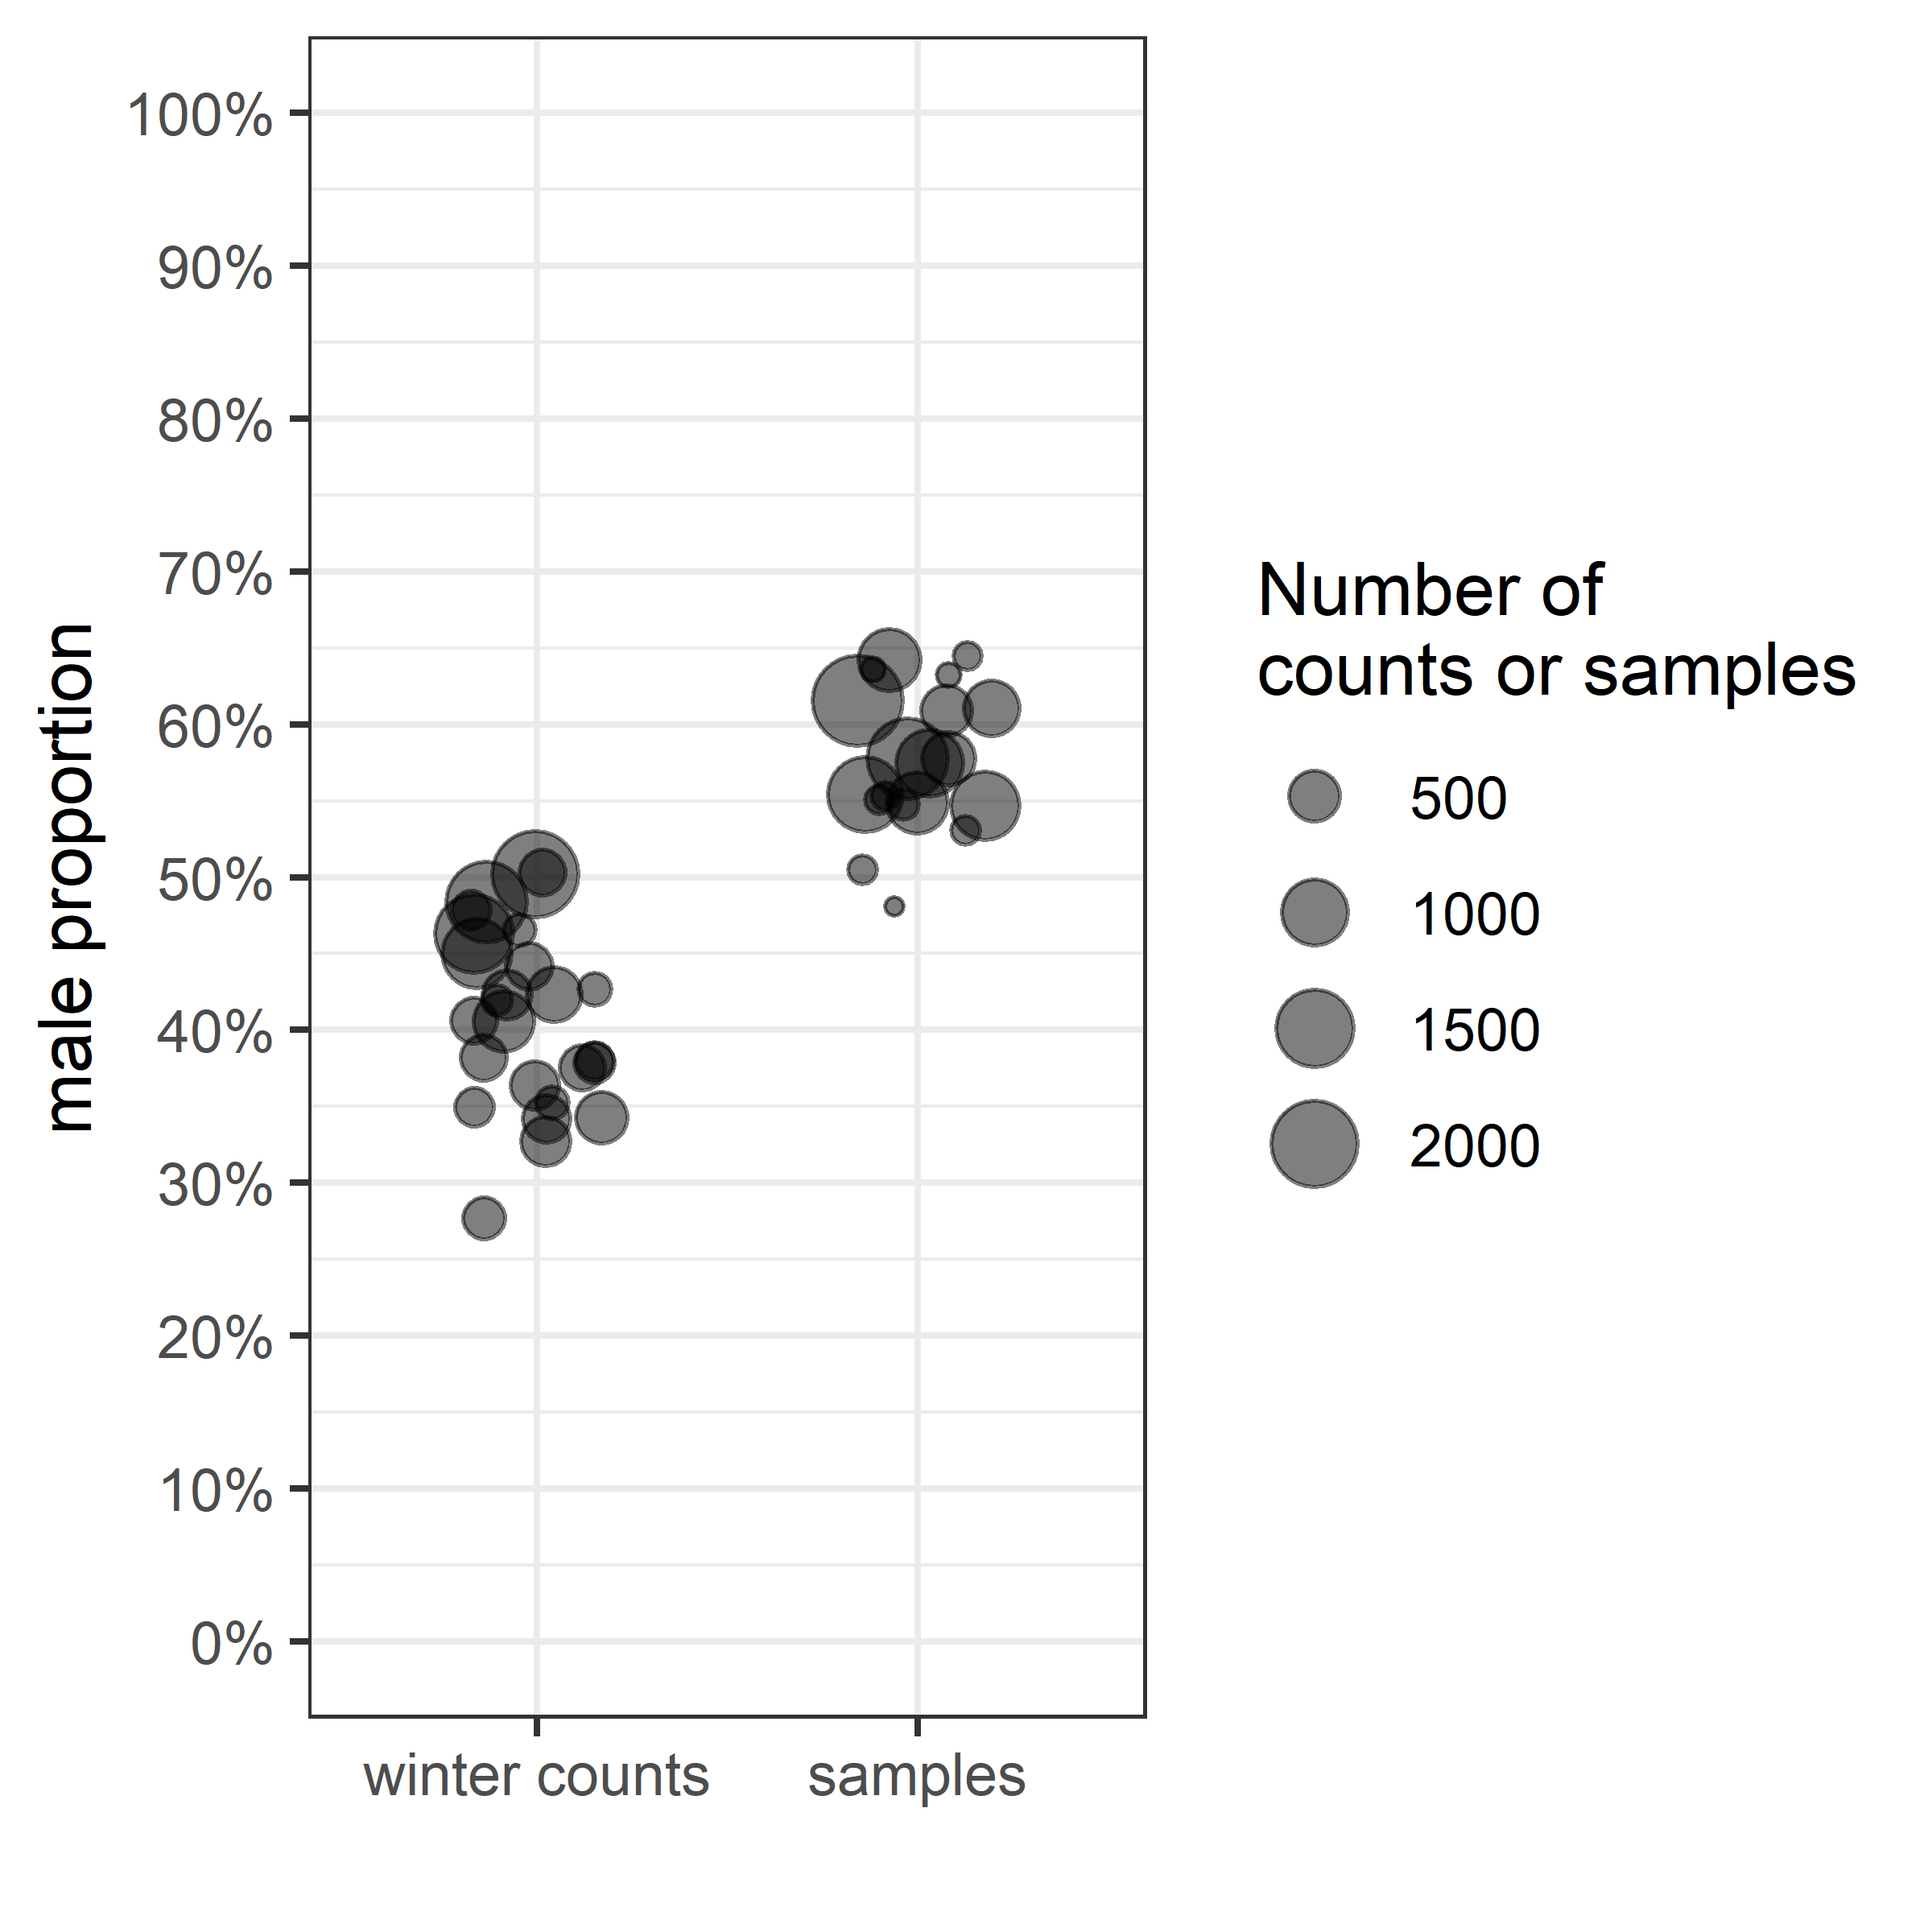

Figure 2.2: Apparent male percentage in winter counts vs in shot samples; for the first category, one point corresponds to the percentage of male-like plumages in a population counted in winter; for the second category, the percentage of males is estimated from all ruddy ducks shot over one year

The demography of both ruddy duck populations has been tracked thanks to exhaustive counts on the wintering spots during the period between December 1 and January 31. Controlled individuals between the counting date and the beginning of the reproduction period (set up to May 1 upon field observations of nests and Bellrose (1980)) were subtracted from the winter count to get a proxy of the breeding population size. Time series show that the two populations followed similar demographic histories (Figure 2.3). They grew freely in both countries until 1999. Control measures have then been applied from 1999 to 2005 in the UK and from 1999 to 2018 in France. In both countries, these management measures led to a halt in the expansion of the ruddy ducks. From 2005 in the UK and from 2018 in France, higher control effort led to a rapid depletion in both populations. This history underlines that both populations experienced a large spectrum of harvest effort, from no to very high pressure. For the sake of interpretation, the time period 2001-2004 was classified in the *no harvest* category in France because the harvest pressure applied over this period was very limited with no effect on population growth.

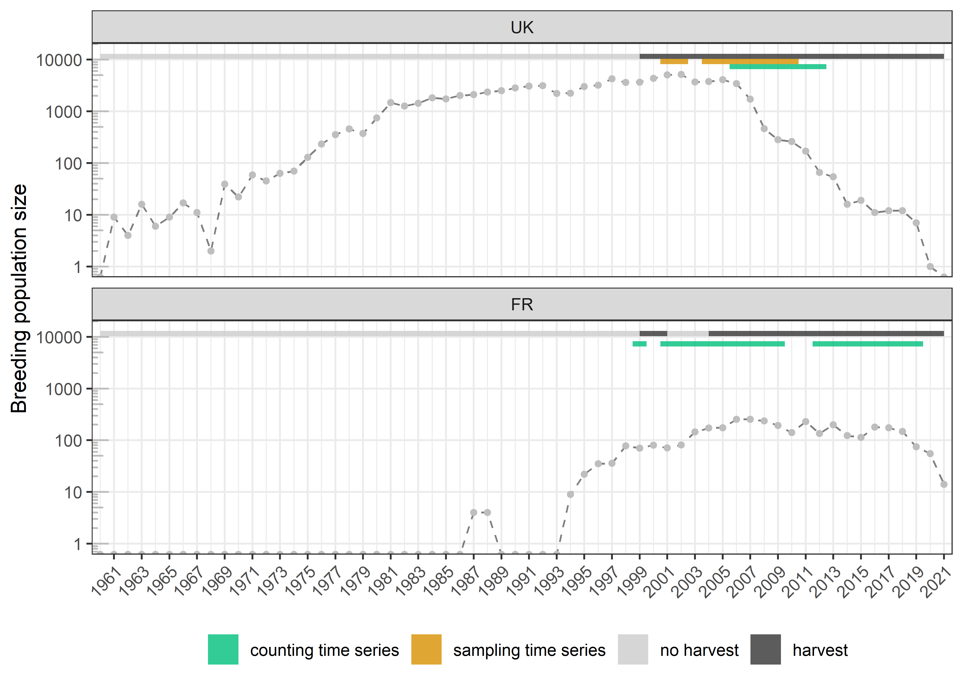

Figure 2.3: Evolution of the size of the two ruddy duck populations in light of the harvest pressure and the data time series

The counting dataset, which differentiates the male-like from the female-like individuals in winter, covers 7 years and 19 years in UK and France, respectively (Figure 2.3). Combined together, the counting datasets cover different population dynamics corresponding to a gradient of harvest pressure. In France, data before 2004 correspond to a period of population growth with (almost) no harvest pressure, whereas data in the following years correspond to a stabilized population size with a significant level of harvest pressure (Figure 2.3). In the UK, the counting data correspond to a quick population depletion associated with a high level of harvest pressure, especially before the reproduction period. In parallel, the sampling dataset, which corresponds to individuals shot in winter during control operations, covers 9 years only in UK, with 5 years in common with the corresponding counting time series.

## 2.2 Recruitment rate inference from count data

Adult sex ratio in waterfowl is generally biased towards males (Figure 2.2, Wood et al. (2021)). As a consequence, deducing the proportion of immatures from the proportion of adult males is not straightforward because the proportion of adults is not just twice as much as the proportion of male-like individuals. Even if the adult sex ratio may vary over a long time range, it is relatively stable over a few years (Wood et al., 2021). Sex identification in adult samples from hunting bags was available for both ruddy duck populations. However, the small population size in France prevents from getting precise adult sex ratios. A comparison over months in the UK showed no difference in the proportion of males, so adult samples collected over the whole year were used to estimate the proportion of males. A comparison of male proportion among years with more than 500 samples did not show significant interannual differences. As a consequence, all adult samples were pooled to estimate the proportion of male in adults, see Equation (2.1).

Assuming the additive property of the binomial distribution, the proportion of immature individuals can be deduced from the cumulated counts of male-like individuals in the wintering population, see Equation (2.2). Only years with more than 100 individuals were selected. From this proportion and abundance index of breeding population sizes, the recruitment rate is straightforward, see Equation (2.3). If the absolute value of the breeding population size is accessible, the recruitment can be estimated, see Equation (2.4).

| Name | Class | Description |
| --- | --- | --- |
|  | Data | Total number of adult males in samples |
|  | Data | Total number of adult females in samples |
|  | Parameter | Proportion of males in adults (or probability to be a male knowing it is an adult) |
|  | Data | Cumulated number of type-male individuals counted in population in year , which are assumed to be adult males |
|  | Data | Cumulated number of individuals counted in population in year |
|  | Parameter | Proportion of adult males in population in year |
|  | Parameter | Proportion adults in population in year |
|  | Parameter | Proportion of immatures in population in year |
|  | Data | Proxy of the size of the breeding population in year (maximum number of individuals counted in the wintering population minus removals before reproduction) |
|  | Parameter | Recruitment rate, i.e. number of recruits in population in year per breeder in year |
|  | Parameter | Number of recruits in population in year |

$$\begin{equation} p(m|a) \sim {\sf Beta}(SAM, SAF) \qquad(2.1) \end{equation}$$

$$\begin{align} CAM_{i, t} & \sim {\sf Binom}(p(a \cap m)_{i, t}, C_{i, t}) \notag \\ & \sim {\sf Binom}(p(m|a).p(a)_{i, t}, C_{i, t}) \notag \\ & \sim {\sf Binom}(p(m|a).(1 - p(i)_{i, t}), C_{i, t}) \qquad(2.2) \end{align}$$

## 2.3 Comparison with the sampling method

A direct estimation of the proportion of immatures can be obtained using samples from hunting bags, see Equation (2.5). By combining estimates of the proportion of immatures and Equation (2.3), recruitment rates from samples were estimated to check the consistency of the counting method to track the recruitment variability. Only years with more than 100 individuals controlled in winter were selected, which corresponds to a 9-year period in UK. This sampling time series covers 5 years of the UK counting time series.

| Name | Class | Description |
| --- | --- | --- |
|  | Data | Number of immatures sampled in the wintering population in year |
|  | Data | Number of individuals sampled in the wintering population in year |

$$\begin{equation} SI_{i, t} \sim {\sf Binom}(p(i)_{i, t}, S_{i, t}) \qquad(2.5) \end{equation}$$

## 2.4 Result validation using population growth rates

The simple relationship (a bit more complex if a species with delayed maturity is considered, see Robertson (2008)) between population growth rate, adult survival, and recruitment rate can be used to test the accuracy of the order of magnitude of recruitment rates estimated from the counting and the sampling methods, see Equation (2.6). This relationship comes from a simple reasoning for a closed population: the population size in year is equal to the number of breeders that survived since year plus the offspring produced in year that survived until the reproduction period of year , i.e. the recruitment in year . The growth rate of a population is thus the sum of the adult survival rate and the recruitment rate (Flint, 2015).

| Name | Description |
| --- | --- |
|  | Number of breeders in year |
|  | Number of breeders dead after reproduction in year |
|  | Number of recruits in year |
|  | Adult survival rate, i.e. proportion of breeders in year still alive in year |
|  | Recruitment rate, i.e. number of recruits in year produced per breeder in year |
|  | Growth rate of the population between the reproduction periods of year and year |

$$

From the evolution of the breeding population size, population growth rate can be assessed every year to catch the variability range (2.6), or can be smoothed over a consistent time period to provide average population growth rate, see Equation (2.7), which is a linear regression on the logarithm scale.

| Name | Class | Description |
| --- | --- | --- |
|  | Parameter | Intercept of the regression model |
|  | Parameter | Average population growth rate over a restricted time interval for a population (in ) |
|  | Index | Year index within the time interval |
|  | Parameter | Standard deviation of the regression model |

$$\begin{equation} log(N_{i, t}) \sim {\sf Norm}(N0_{i, J} + log(\lambda_{i, J}).t, \sigma_{i, J}) \qquad(2.7) \end{equation}$$

### 2.4.1 Analysis of the adult survival

Adult survival rate is commonly assessed by capture mark recapture (Lebreton, 2001). Combined with annual population growth rate, adult survival rate allows recruitment rate to be estimated each year, and then compared with the outputs of the counting method. Unfortunately, no tagging study was performed on the two ruddy duck populations. However, the relationship (2.6) could still produce annual adult survival estimates that can be discussed. To do so, annual population growth rates overlapping the counting time series were estimated.

Inconsistency on recruitment rate output, which is defined on , would either lead to survival output , which points out an overestimation of the recruitment rate, or , which reflects that the recruitment rate cannot support the observed population growth and is thus underestimated. In between the two limit values, one still discuss the survival outputs by comparison with survival values published in the literature.

### 2.4.2 Comparison to a proxy of maximum recruitment rate

When population growth is not limited by a harvest pressure and/or by density-dependent effects, both recruitment rate and adult survival are close to their maximum potential. Given a conservative assumption on the maximum adult survival of ruddy ducks and maximum population growth rate estimated during no harvest time periods, a proxy of the maximum recruitment rate can be obtained. If the recruitment rate outputs of the model are significantly superior to this proxy, this means that the method overestimates recruitment rate, which may reflect that some adult males are not detected during count surveys. By splitting the recruitment rate outputs upon populations and harvest categories, one can discuss of the impact of the harvest on the recruitment rate.

To do so, one estimates maximum population growth rates over time periods observing no harvest using Equation (2.7). Since the estimate of the UK population size is noisy below 500 individuals, data before 1972 were discarded (Figure 2.4). After reaching the threshold of 1000 individuals, the UK population growth showed a strong inflexion whereas no harvest pressure was applied. This observation led to split the analysis into two time series for the time periods used in the maximum growth rate inference in UK (Figure 2.4).

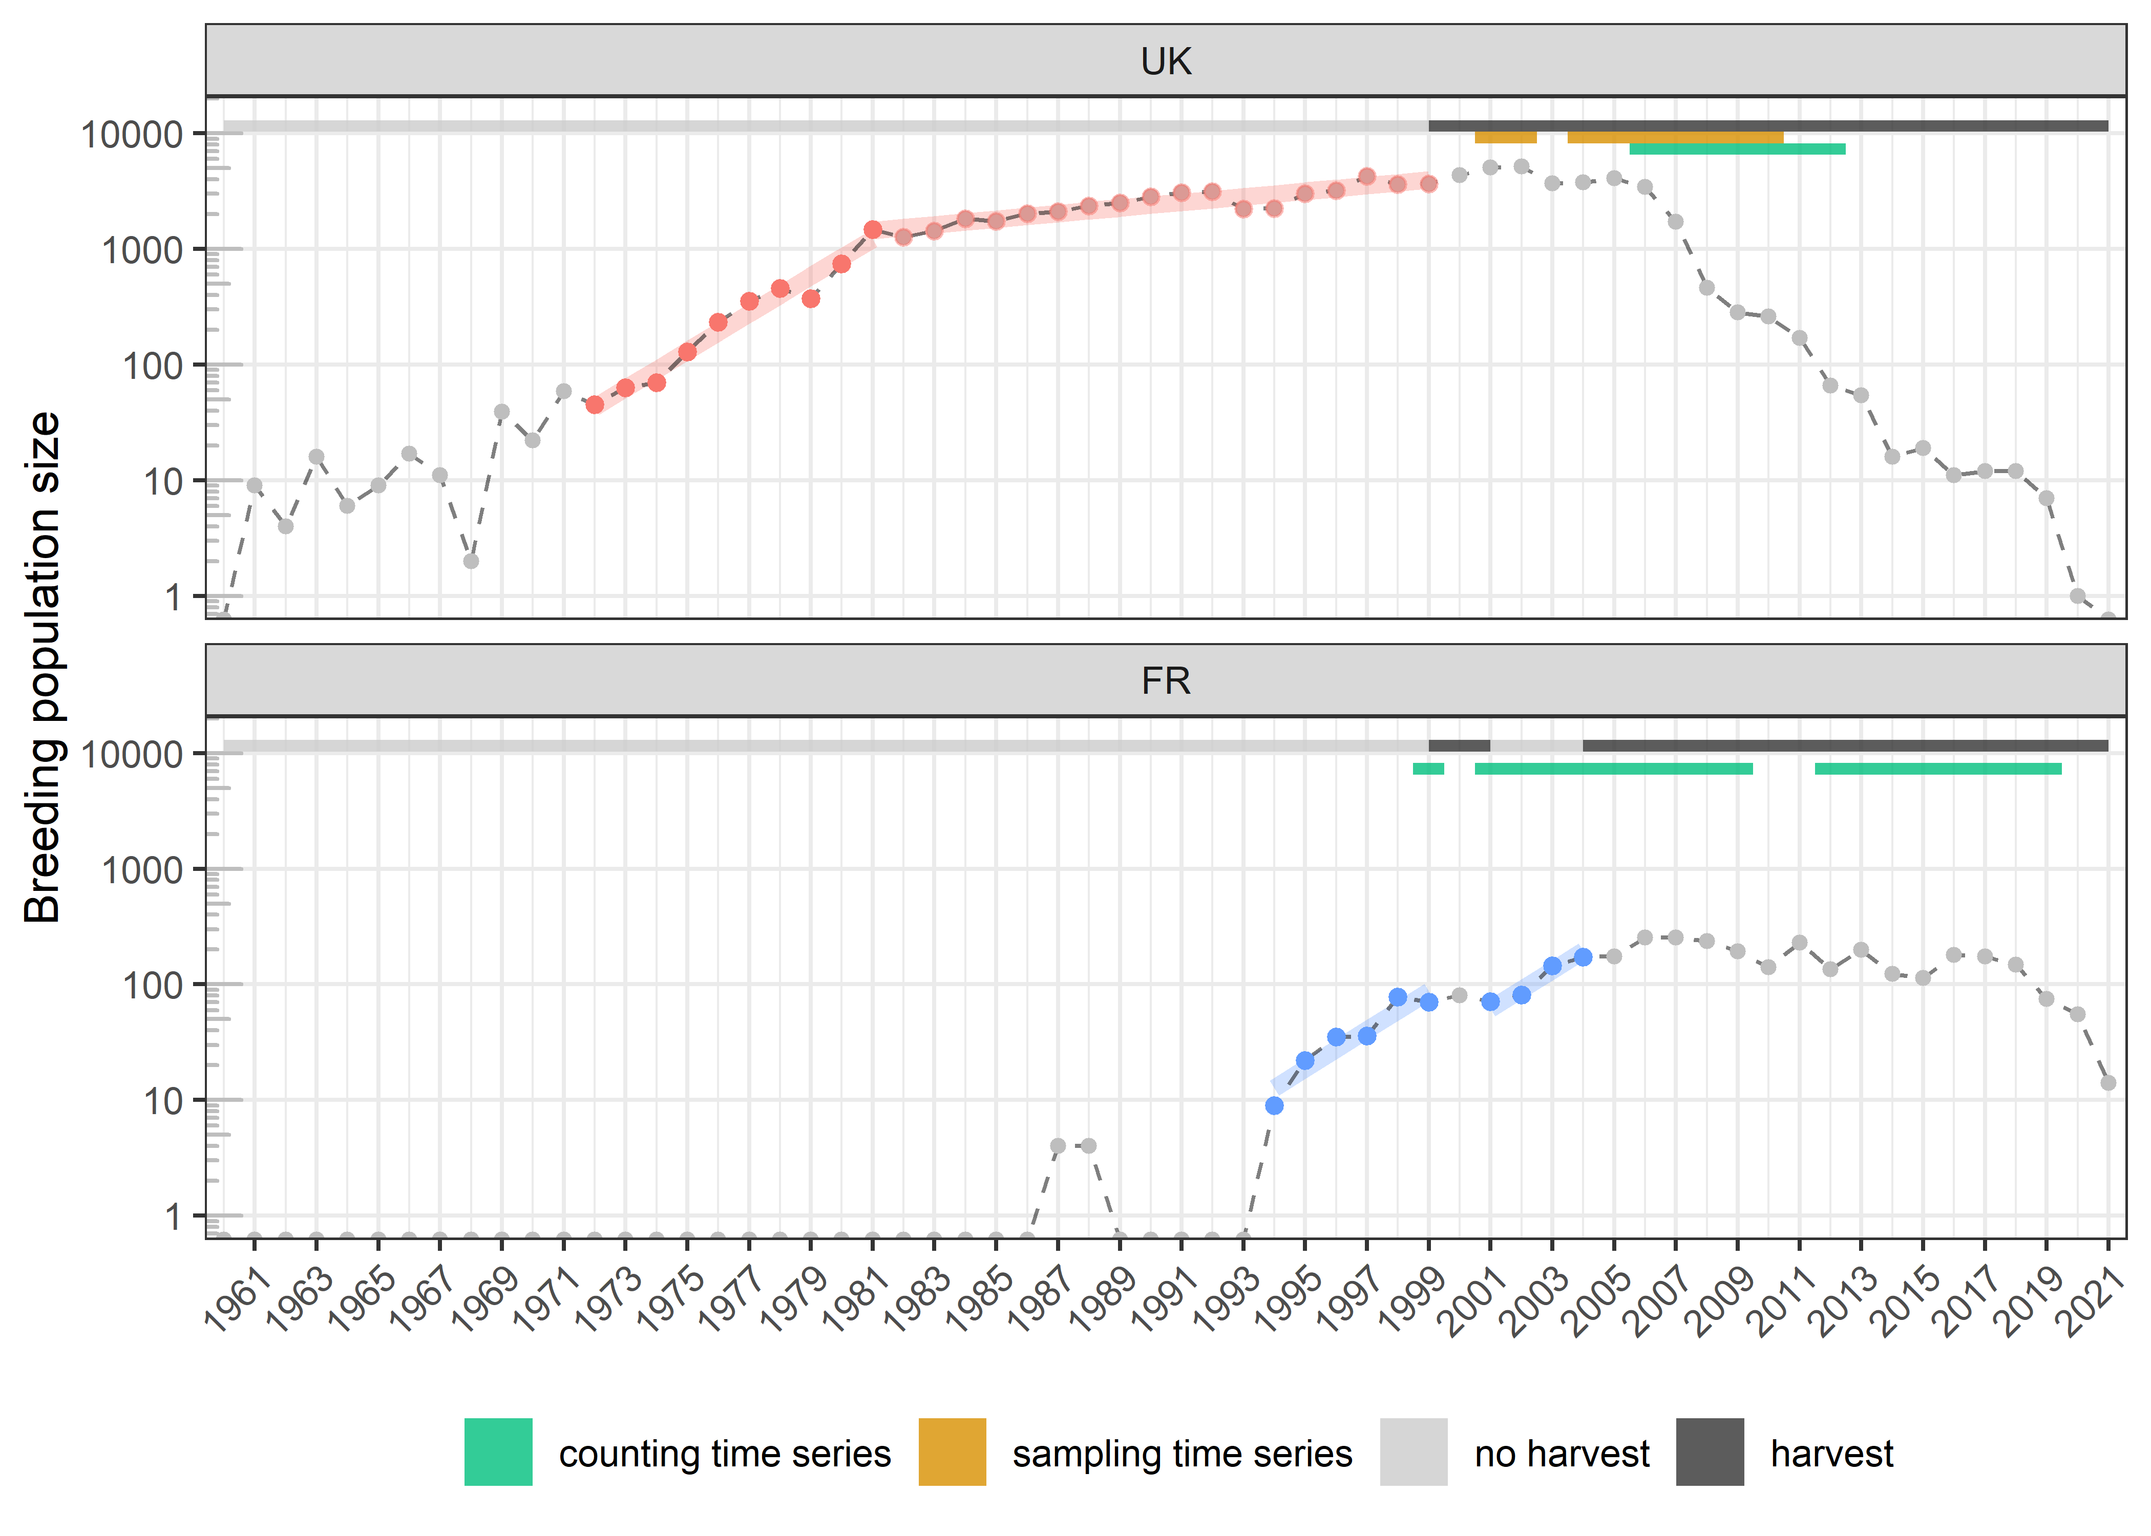

Figure 2.4: Changes in the size of the two ruddy duck populations in light of the harvest pressure; on time periods without harvest, maximum population growth rates can be estimated (slopes in red for the UK and in blue for France)

To get proxies of maximum recruitment rate from Equation (2.6), a very conservative prior on the adult survival was used, by setting a uniform distribution on (Buxton et al., 2004; Krementz et al., 1997; the lower limit corresponds to the upper range of survival rates observed in the literature for species of similar weight, the upper limit corresponds to the range of survival rates of long-life species, Nichols et al., 1997). The average recruitment rates from the count data are estimated for each population and for each harvest category and compared to the maximum recruitment rates.

For all the sub-models in Section 2, the Bayesian framework was used for its efficiency and simplicity to propagate error through the parameters. Uninformative priors were used on all parameters. Three chains of length 500000 were generated, with a thinning of 10 to avoid autocorrelation in the samples, and the first 2000 samples were discarded as burn-in. Chain convergence was assessed using the Gelman and Rubin convergence diagnostic (R<1.1, Gelman & Rubin (1992)). Models were fitted using NIMBLE (de Valpine et al., 2017) run from R (R Core Team, 2020). Data and code are available at: <https://github.com/adri-tab/Ruddy_duck_recruitment_rate>. The values **X[Y; Z]** reported in the results are the medians and the associated boundaries of the 95% confidence interval of posterior distributions. The median was preferred to the mean because of its robustness to skewed distribution.

# 3 Results

## 3.1 Recruitment rate variability

The proportion of males in adults, which is necessary to infer on the recruitment rate from count data, was estimated at 0.60 [0.59; 0.61]. The counting method provided estimations of the recruitment rate, see Figure 3.1A. In the UK, values vary from 0.06 [0.05; 0.07] to 0.27 [0.20; 0.34] recruits per breeder, and in France, 0.08 [0.04; 0.12] to 0.76 [0.64; 0.88] recruits per breeder. There are significant year-to-year variations with a maximum amplitude of 0.68 recruits per breeder in France (9.5-times variability). On the available period, recruitment rate in UK is smaller than in France. Recruitment rates are estimated in both populations over 5 years, and no correlation is observed between the two populations. The lowest recruitment rate observed in France, in year 2019, corresponds to the beginning of the depletion of the population. It is noticeable that it is in the same range than the UK values, also estimated during a strong population depletion.

Recruitment rates estimated from UK sample data are consistently higher than estimates from the corresponding count data, Figure 3.1A. The correlation between the two methods is strong and points out that the sampling method overestimates the recruitment rate by 44% compared to the counting method, Figure 3.1B. Estimation precision is similar for the two methods. The UK population started to deplete from 2006, but no significant shift is observed between the two periods.

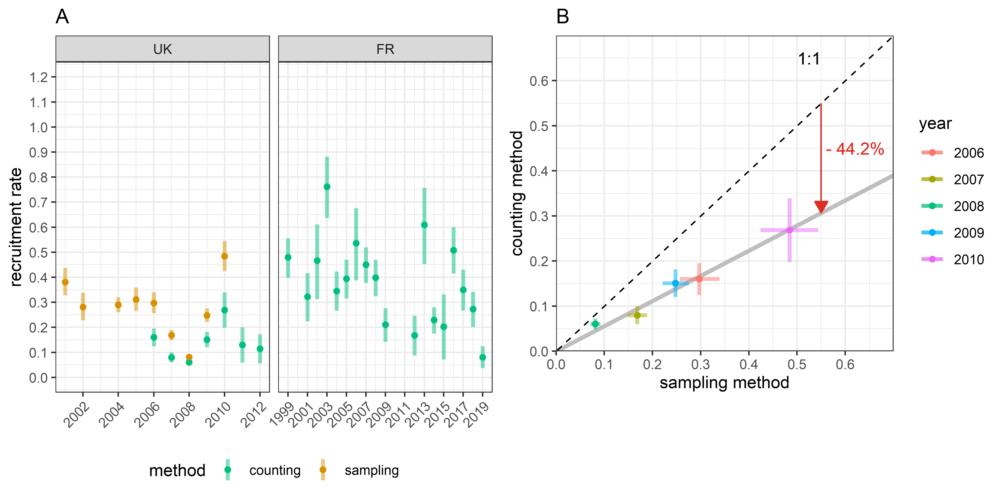

Figure 3.1: (A) Estimates of recruitment rate, i.e. average number of recruits produced per breeder; (B) Comparison of the recruitment rate values between the two estimation methods; bars define the 95% confidence intervals

## 3.2 Consistency of the corresponding adult survival

Adult survival rates were deduced from the recruitment rate estimates and the observed population growth rates, see Figure 3.2A. In the UK, values that are obtained from the counting method ranged from 0.21 [0.20; 0.22] to 0.68 [0.65; 0.72]. In France, survival rates vary from 0.39 [0.34; 0.44] to 1.08 [0.98; 1.17]. Like recruitment rates, there is significant year-to-year variability without clear temporal structure in both populations with a maximum amplitude of 0.69 in France (2.8-times variability). Unlike recruitment rate, survival rate in 2019 in France is not a low outlier.

As expected, survival rates estimated from UK sample data are consistently lower than estimates from the corresponding count data, Figure 3.2A. The correlation between the two methods points out that the sampling method underestimates survival rate by 32% compared to the counting method, Figure 3.2B. Estimation precision is similar for the two methods. The sample time series shows that adult survival is significantly lower after 2006, which corresponds to the beginning of the depletion of the UK population.

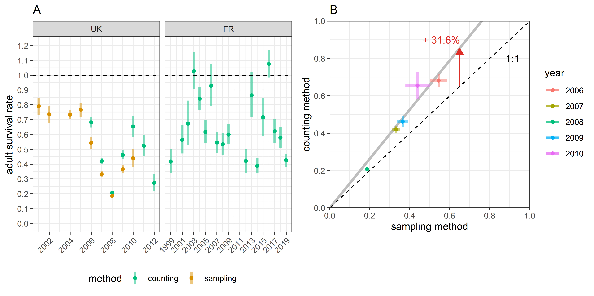

Figure 3.2: (A) Estimates of adult survival rate using population growth rates; (B) Comparison of the survival rate values between the two estimation methods; bars define the 95% confidence intervals

## 3.3 Comparison to maximum recruitment rate

Maximum population growth rates are similar for the two populations, 1.45 [1.36; 1.55] and 1.47 [1.29; 1.68] for UK and France, respectively, which corresponds to an increase of about 45% per year (Figure 3.3). After reaching a certain size (~ 1000 individuals), the UK population growth rate falls to 1.06 [1.04; 1.07], which corresponds to an increase of 6% per year, even though no harvest pressure was applied on it.

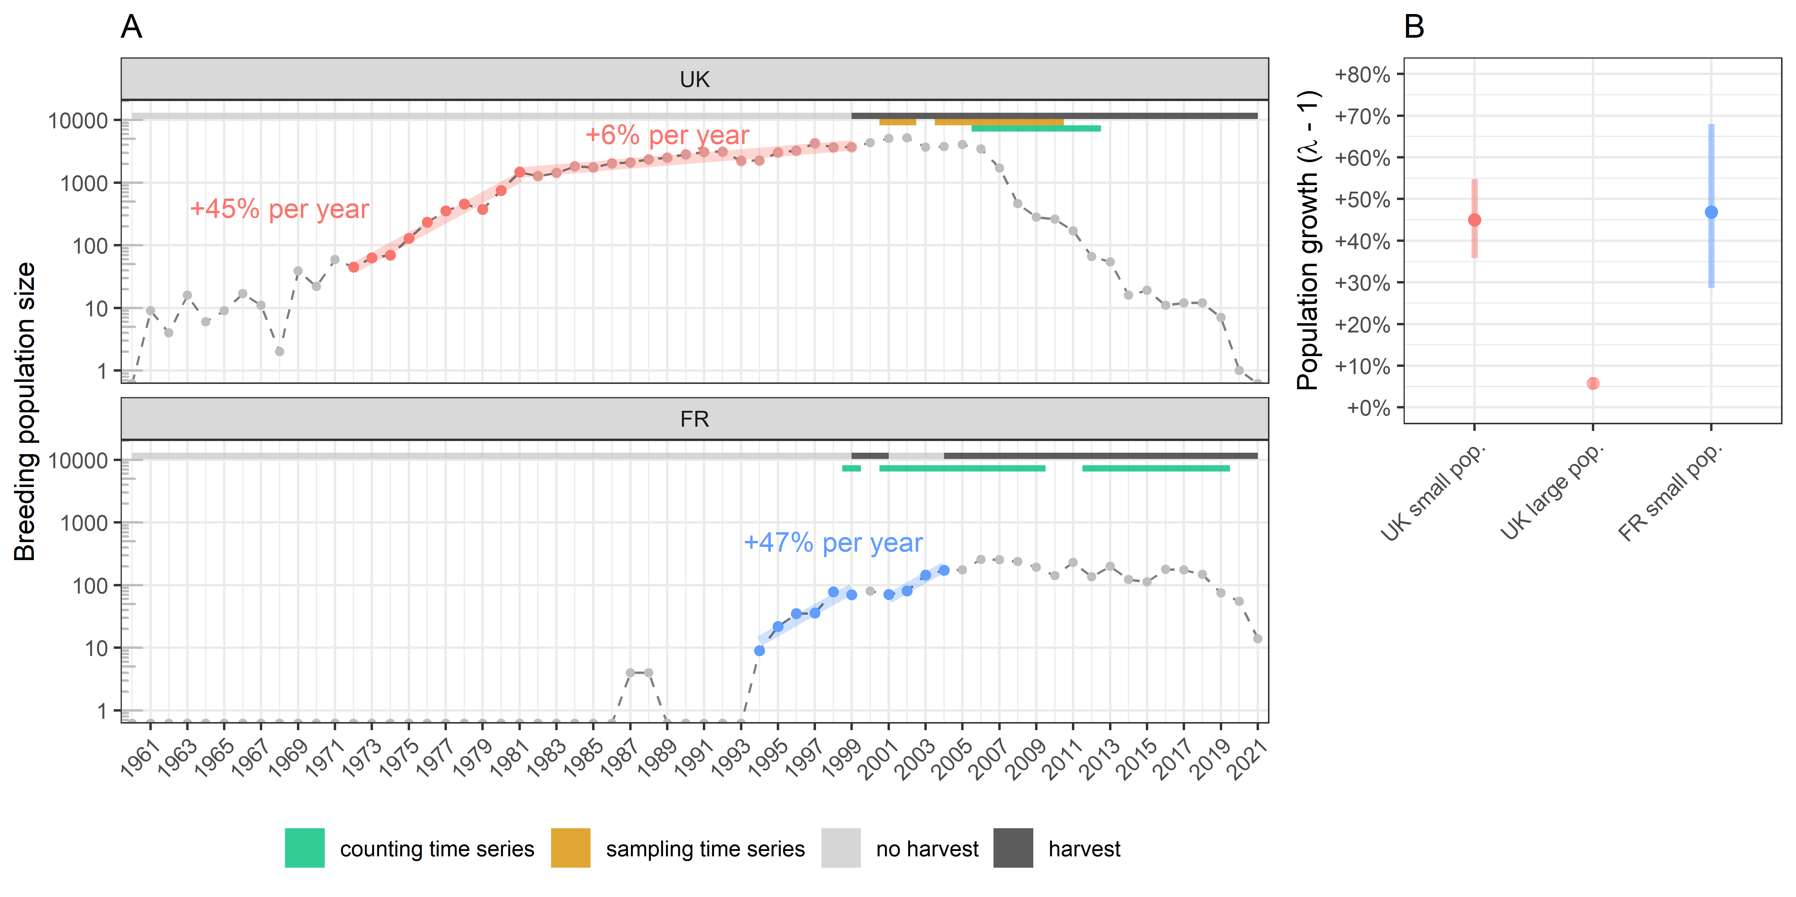

Figure 3.3: (A) Estimates of the maximum population growth without harvest ; two estimates were produced for the UK population because the growth rate dropped significantly when its size reached more than 1000 individuals; (B) Growth rate estimates; bars define the 95% confidence intervals

Upon the conservative assumption of a maximum adult survival uniformly distributed over 0.70 to 0.90, the maximum recruitment rate reaches 0.65 [0.51; 0.75] and 0.66 [0.45; 0.90] recruits per breeder for UK and France, respectively (Figure 3.4). When there is no harvest, the estimated average recruitment rate of the French population is in the range of the proxy of the maximum recruitment rate, 0.51 [0.46; 0.57] recruits per breeder. When there is harvest, the average recruitment rates are 0.14 [0.12; 0.16] and 0.33 [0.31; 0.36] recruits per breeder for the UK and France respectively. Both values are significantly lower than the maximum recruitment rate, and it is noticeable that the average recruitment rate is lower for the UK population, which is in depletion over the count time series, than for the French population, of which the dynamic is mostly stable over the monitored period.

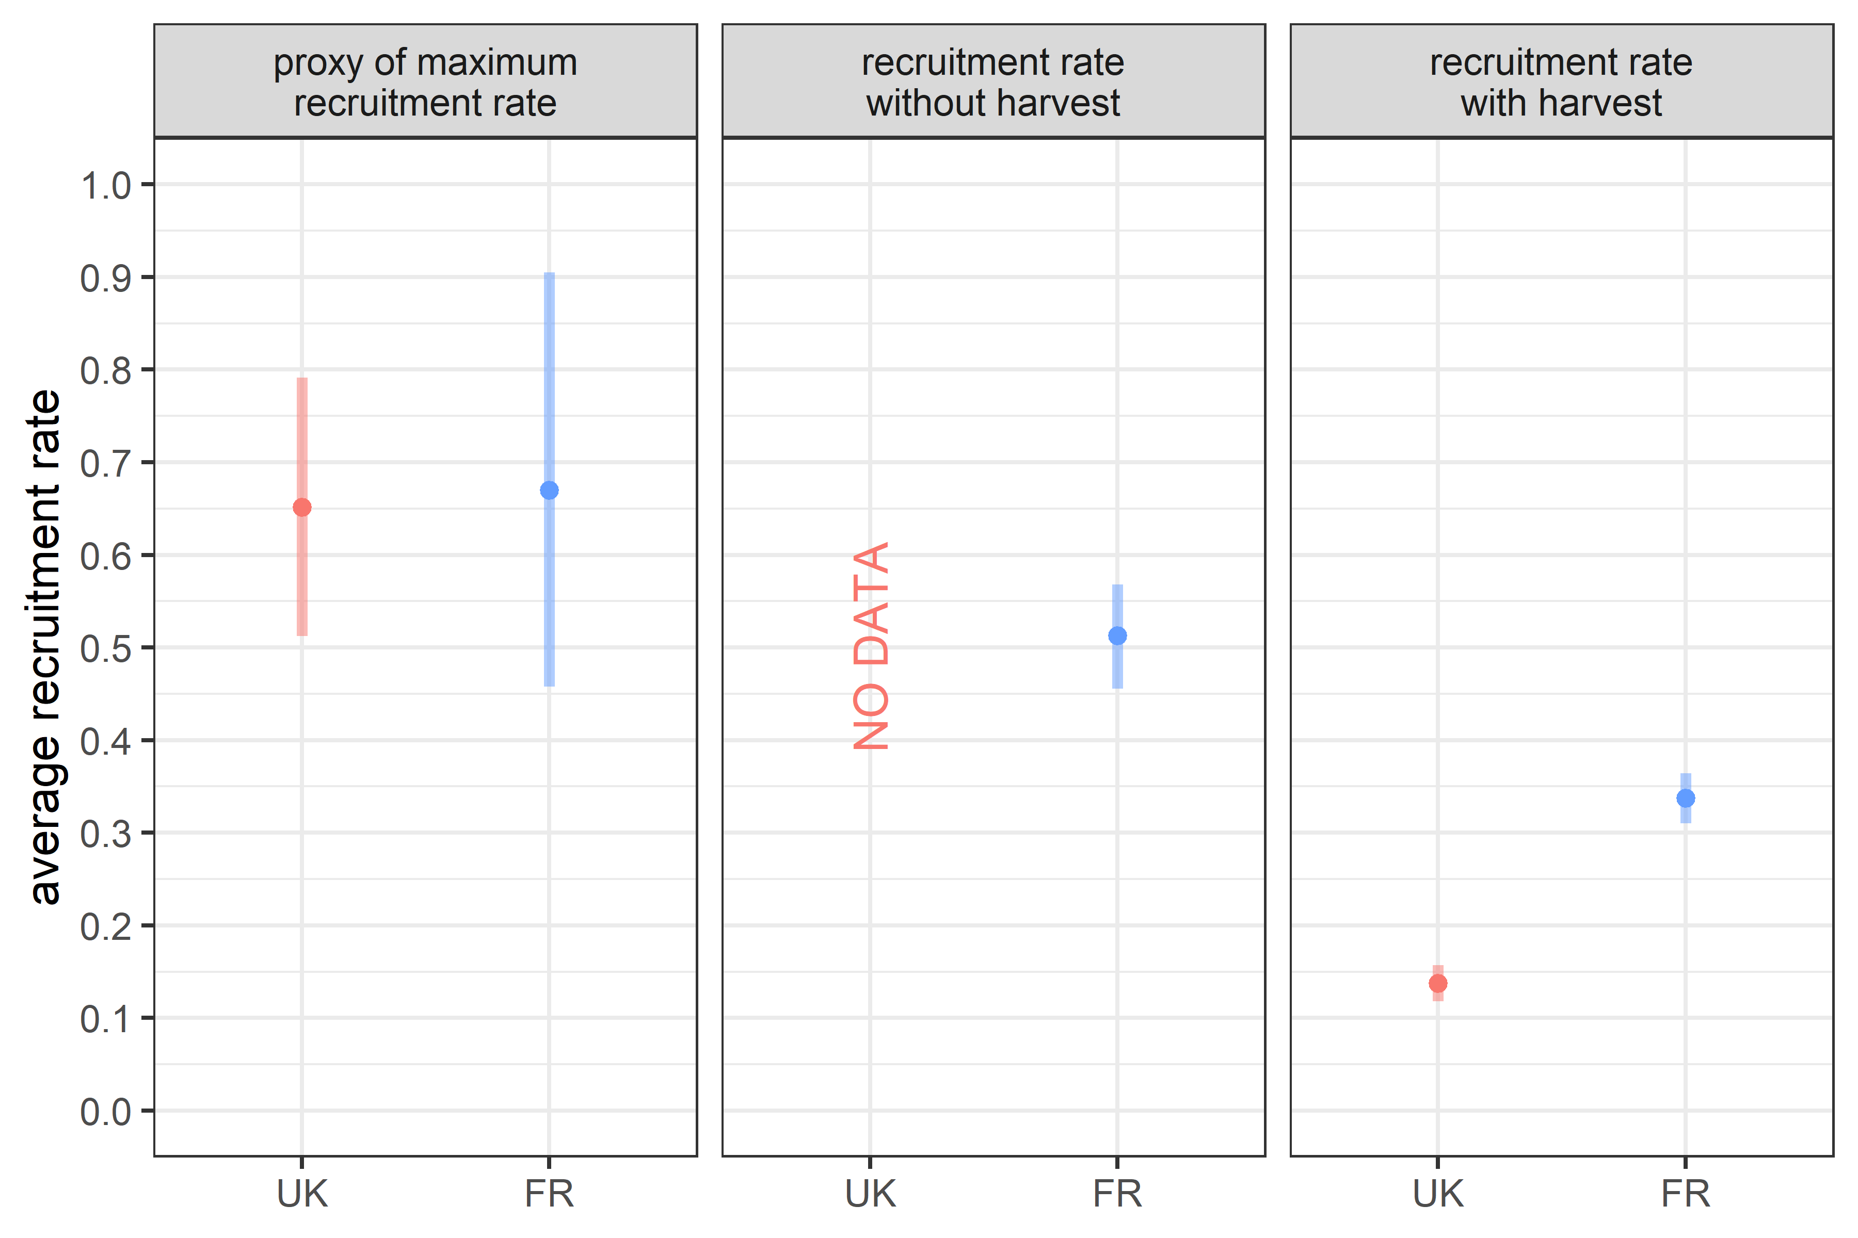

Figure 3.4: Comparison between proxies of maximum recruitment rate and average recruitment rates estimated with and without harvest (counting method only); proxies are estimated by using the maximum growth rates; bars define the 95% confidence intervals

# 4 Discussion

Count data in waterfowl that differentiate adult males from other individuals are successfully used in this study to infer estimations of recruitment rates. Since this parameter usually explains mostly the population growth in waterfowl (e.g. Arnold, 2018), the non-invasive method introduced in this study might be considered as a candidate tool to monitor at low cost waterfowl populations. In the following section, one checks the accuracy of the method from indicators that were developed for this purpose. From the outputs on the two populations of ruddy duck, we discuss the effects of harvest on the recruitment rate and its implications for waterfowl management.

## 4.1 Accuracy of the counting method

The recruitment rates from the counting method are in the same range for the two populations, which demonstrate a certain consistency in the results obtained from the method. The higher variability observed in France is not unexpected because the French time series is longer and covers a wider spectrum of harvest pressures than the in UK. There was no temporal correlation between the two populations, suggesting that fluctuations in recruitment rate are more likely influenced by regional factors than large-scale ones. This is consistent with the literature because both nesting/hatching success and juvenile survival are conditional to the onset of laying, which is tightly related to local weather parameters, e.g.  spring temperature, cumulative rainfall, and water levels (Blums & Clark, 2004; Dzus & Clark, 1998; Folliot et al., 2017).

Assuming that the sample data provide a good picture of the interannual variability of recruitment rate, the strong correlation with the outputs of the counting method demonstrates the ability of this method to track variability in recruitment rate. This result is quite robust because such correlation is obvious despite being based on only a five-year time series. The assumption of a constant adult sex ratio over time is then acceptable because a significant change in adult sex ratio among years would have biased the changes in recruitment rate. Since this ratio integrates many age-cohorts, the temporal autocorrelation is structurally strong. Significant variations can then occur only every multiple years, especially if the species is long-lived. Consequently, it is not necessary to monitor and update the adult sex ratio on a yearly base. The adult sex ratio found here over a restricted time period is in line with the ruddy duck in its native area (0.62 in Bellrose, 1980) and with other duck species (Wood et al., 2021). The robustness of the correlation between the two methods might be overrated because two successive population size values are parts of the recruitment rate, which mechanically scales the outputs. This explains why the correlation on the proportion of immatures, the other component of the recruitment rate, is somewhat noisier than for recruitment rate (Figure 5.1A). The uncertainty around the estimates is similar for the two methods even though the counting method is more indirect to infer the recruitment rate, which is satisfying.

The counting method always provides recruitment rates significantly lower than the sampling method by a factor close to two, a result that is in line with the hypothesis that the harvest is generally selective towards immature individuals in waterfowl because they are more vulnerable than adults to hunters (Bellrose, 1980; A. D. Fox et al., 2014). For hunted duck species in North America, the harvest-induced mortality on first-year immatures compared to adults is higher by a factor ranging from 1.3 to 2.6 (Bellrose, 1980). This is a robust result because the approach used to control ruddy duck populations differs strongly from usual hunting practices and is apriori less selective. It is especially clear in the UK, for which control operations occurred in winter using long-range rifles that prevents the bird from escaping from the threat. The assumption on the accuracy of the counting method is then not excluded from the consistency of this result.

Annual adult survival rates deduced from observed population growth rates and recruitment rate estimates are on average in line with the literature on species of similar weight (Buxton et al., 2004; Krementz et al., 1997; Nichols et al., 1997), which reflects that there is no apparent scaling issue. The assumption that male-like individuals corresponds only to adult males is then acceptable. This result supports that the counting method is poorly biased if it is. However, some adult survival rate values are outside the range of expected values even if they never significantly exceed the maximum possible value of one. A likely reason to these extreme values is a corruption of the closed population assumption on some years. Indeed, if there is an arrival from another ruddy duck population, true recruitment cannot explain by itself the apparent population growth and indirectly leads to an overestimation of adult survival.

Proxies of maximum recruitment rate are very close for the two populations. This strengthens that the ruddy duck species reached its intrinsic biological reproduction limit, at least given the environmental conditions of the western Palearctic. The consistency of this intermediate result suggests that the population size estimation is quite good for both populations and demonstrates that their changes are well tracked even with a few individuals. The average recruitment rates estimated from the counting method, with and without harvest, are never higher to the proxies of maximum recruitment rate for both populations. The assumption on the accuracy of the counting method is then again not excluded from the consistency of this result.

Overall, even if the true values of recruitment rates are not known to test the accuracy of the counting method, a beam of arguments support that the method is not heavily biased. This consists in a big difference with the sampling method as demonstrated in A. D. Fox et al. (2014), even when one considers an age structure picture that is limited to the end of the hunting season to limit the bias (A. Fox et al., 2016).

## 4.2 Influence of harvest on recruitment rate

Only the French population was monitored over a period covering years without and with harvest. Harvest pressure, that was defined here as a binary variable (no harvest / harvest), negatively affects both recruitment rate and adult survival for this population, as expected. If it explains only 4.6% of the variance in adult survival, this value raises to 19.3% for the recruitment rate of the French population. The harvest pressure applied in France is thus a factor that likely induces a strong juvenile mortality that impacts the recruitment rate, but a negligible mortality onto the adults. This conclusion is obviously opposed to the hypothesis that the heterogeneity in immature individuals would dampen the effect of the harvest pressure on the resulting recruitment rate. Two points can however explain this apparent discrepancy. Since management targeted the eradication of this ruddy duck population, the harvest of immatures might simply be far greater than what the population could compensate, and finally affects the recruitment rate. Also, the population started to be controlled when it was still growing at a high rate, so immature individuals were not suffering from density-dependent effects and were consequently sensitive to any additional mortality sources, like the new harvest pressure for instance. The low impact of harvest on adult survival compared to recruitment rate might be due to the timing of the management strategy adopted in France. Since the culling efficiency is poor on the wintering spot, most control operations occured in summer just after breeding, when the proportion of immature birds is the largest in the population.

The UK population depleted from 2005, which also corresponds to a significant increase of the harvest effort. Even if only a few data from the sampling method are available before and after this year, it seems that the recruitment rate is not affected by this increase of harvest, but was already in the lower range of the recruitment rate of the French population when it was exploited. On the other hand, adult survival dropped significantly from 2005. This differs strongly from the response of the French population to harvest. Unlike in France, a significant part of the control operations in UK occured in winter, which could explain this difference. Indeed, winter corresponds to the season just before the breeding period, when the proportion of immatures in the population is the lowest, natural juvenile survival being far lower than that of adults (e.g. Arnold, 2018). The adult survival seems then mostly affected by the harvest pressure applied in winter.

The different responses to the harvest pressure of the two ruddy duck populations demonstrate that it is necessary to account for the time window over which harvest occurs to produce proper predictions. Controlling a waterfowl population is then not only a question about how big should be the harvest effort, but also mostly when this effort should focus within a year to be efficient. These first insights suggest that further investigation on this topic would be valuable to calibrate the response of the population to different harvest regimes.

## 4.3 Implication in waterfowl management

Age ratio, or indifferently recruit proportion, is commonly used to describe the renewal capacity of a waterfowl population and to track the changes of its productivity (Bellrose, 1980; Robertson, 2008; Rodway et al., 2015; C. M. Smith et al., 2001; Zimmerman et al., 2010). Recruitment rate is however a better indicator than age ratio, the latter only having the advantage of being more directly accessible. Indeed, the age ratio/recruit proportion does not account for the dynamics of the population and reflects the population productivity only if population growth is steady. For instance, for a breeding population of 100 individuals reaching the next year 100 individuals and then 60 individuals the second year, a 1:1 age ratio, or a 50% recruit proportion, for both years reflects actually a strong decrease of the recruitment rate, respectively 0.5 recruits per breeder and 0.3 recruits per breeder. This demonstrates that the age ratio/recruit proportion suffers from caveats that can be misleading for a manager. According to Blums & Clark (2004), recruitment for diving ducks is not related to fecundity, but depends mostly on juvenile survival, the other component of recruitment that is mostly driven by weather conditions. Studies on other birds also conclude about the poor correlation between fecundity and recruitment (e.g. Murray, 2000). Fecundity alone does not provide all knowledge that is required for a manager to understand the dynamics of a population.

Adult survival and recruitment rate equally influence the growth rate variability of the studied ruddy duck populations, but the relative variability of adult survival is more than three times smaller than recruitment rate. This observation is in line with the demographic buffering, or canalization hypothesis, on adult survival parameter (Gaillard & Yoccoz, 2003; Lenzi et al., 2021). Arnold (2018) even demonstrates that recruitment rate can be the most influencing factor on the population growth in some waterfowl species. Population management in waterfowl cannot neglect a careful monitoring of recruitment rate, even if this parameter might be more difficult to track compared to adult survival. A drop in the recruitment rate points out that a population renewal is affected but does not show the causation. It is however a signal that intermediate life stages before recruitment must be investigated to provide a diagnostic on the changes of the environment conditions that have affected recruitment rate.

Immatures are more prone to die naturally than adults and are submitted to density dependent processes, which explains why recruitment rate is the most sensitive parameter to density dependent effect (Koons et al., 2014). The evolution of the UK population size seems to show first sights of density dependence from 1000 individuals, but the process was obviously not strong enough to fully curb the population growth. Since there is a strong correlation between the number of birds observed and the number of sites occupied by the birds, this inflexion may simply be due to a limited number of new favourable sites to be colonized. Such density dependent process implies that culling mostly immatures could have only a limited effect on the population dynamics if the harvest pressure remains moderate. Considering that the harvest effort occurring in winter impacted mostly adult survival, and led to the strong depletion of the UK ruddy duck population, harvesting early in the season should be favoured if the objective is to maximize the catch in preserving the resources. Conversely, if the goal is to eradicate a population, a strong effort should be made especially in the late season just before reproduction, as done in the UK. These hypotheses still require to be tested thanks to a population model linking harvest rate to state variables describing the population. Such tool is valuable to assess precisely the impact of the harvest pressure and to test hypotheses on the functioning of the harvest mortality (Plard et al., 2019).

Applying the method implemented in this study to any other waterfowl species implies that the adult males can be distinguished from the other individuals at distance. The latter in the season the dichromatism is observable, the better it is to ensure a relevant picture of the age structure of the population and then good estimates of the recruitment rate. Modifying standard monitoring protocols to distinguish male-like from female-like individuals is almost costless but provides substantial increases in the efficiency and usefulness of monitoring results in conservation (Nichols & Williams, 2006).

# Acknowledgments

This work was partly funded by the LIFE Oxyura project (LIFE17 NAT/FR/000942) through the LIFE program. This work was carried on with the impulse of Jean-François Maillard, and Jean-Baptiste Mouronval from the *Office Français de la Biodiversité*, and Jean-Marc Gillier from the *Société Nationale pour la Protection de la Nature*. The authors acknowledge all the contributors of the data collection in the UK and in France, especially: **UK names**, Vincent Fontaine, Denis Lacourpaille, Justin Potier, Alexis Laroche, Médéric Lortion, Jules Joly, and Valentin Boniface.

# References

Anders, A. D., & Marshall, M. R. (2005). Increasing the accuracy of productivity and survival estimates in assessing landbird population status. *Conservation Biology*, *19*(1), 66–74.

Arnold, T. W. (2018). Using ring-recovery and within-season recapture data to estimate fecundity and population growth. *Ecology and Evolution*, *8*(20), 10298–10305. <https://doi.org/10.1002/ece3.4506>

Bellrose, F. C. (1980). *Ducks, geese & swans of North America: 3rd. ed*. Stackpole Books.

Blums, P., & Clark, R. G. (2004). Correlates of lifetime reproductive success in three species of European ducks. *Oecologia*, *140*(1), 61–67. <https://doi.org/10.1007/s00442-004-1573-8>

Buxton, N. E., Summers, R. W., & Peach, W. J. (2004). Survival rate of female *Boldeneye bucephala* clangula. *Bird Study*, *51*(3), 280–281. <https://doi.org/10.1080/00063650409461365>

Cooch, E. G., Guillemain, M., Boomer, G. S., Lebreton, J.-D., & Nichols, J. D. (2014). The effects of harvest on waterfowl populations. *Wildfowl*, 220–276.

de Valpine, P., Turek, D., Paciorek, C. J., Anderson-Bergman, C., Lang, D. T., & Bodik, R. (2017). Programming with models: Writing statistical algorithms for general model structures with NIMBLE. *Journal of Computational and Graphical Statistics*, *26*(2), 403–413. <https://doi.org/10.1080/10618600.2016.1172487>

Dzus, E. H., & Clark, R. G. (1998). Brood survival and recruitment of mallards in relation to wetland density and hatching date. *The Auk*, *115*(2), 311–318. <https://doi.org/10.2307/4089189>

Eraud, C., Devaux, T., Villers, A., Johnson, F. A., & Francesiaz, C. (2021). Popharvest: An R package to assess the sustainability of harvesting regimes of bird populations. *Ecology and Evolution*. <https://doi.org/10.1002/ece3.8212>

Etterson, M. A., Ellis-Felege, S. N., Evers, D., Gauthier, G., Grzybowski, J. A., Mattsson, B. J., Nagy, L. R., Olsen, B. J., Pease, C. M., Burg, M. P. van der, & Potvien, A. (2011). Modeling fecundity in birds: Conceptual overview, current models, and considerations for future developments. *Ecological Modelling*, *222*(14), 2178–2190. <https://doi.org/10.1016/j.ecolmodel.2010.10.013>

Flint, P. (2015). Population dynamics of sea ducks: Using models to understand the causes, consequences, evolution, and management of variation in life history characteristics. In J.-P. L. Savard, D. V. Derksen, D. Esler, & J. M. Eadie (Eds.), *Ecology and conservation of North American sea ducks* (Vol. 46, pp. 63–96). CRC Press.

Folliot, B., Caizergues, A., Barbotin, A., & Guillemain, M. (2017). Environmental and individual correlates of common pochard (*Aythya ferina*) nesting success. *European Journal of Wildlife Research*, *63*(4). <https://doi.org/10.1007/s10344-017-1126-1>

Fox, A. D., Clausen, K. K., Dalby, L., Christensen, T. K., & Sunde, P. (2014). Age-ratio bias among hunter-based surveys of Eurasian wigeon *Anas penelope* based on wing vs. Field samples. *Ibis*, *157*(2), 391–395. <https://doi.org/10.1111/ibi.12229>

Fox, A., Clausen, K., Dalby, L., Christensen, T., & Sunde, P. (2016). Between-year variations in sex/age ratio bias in hunter wings of eurasian wigeon (*Anas penelope*) compared to field samples. *Ornis Fennica*, *93*(1), 26.

Gaillard, J.-M., & Yoccoz, N. G. (2003). TEMPORAL VARIATION IN SURVIVAL OF MAMMALS: A CASE OF ENVIRONMENTAL CANALIZATION? *Ecology*, *84*(12), 3294–3306. <https://doi.org/10.1890/02-0409>

Gelman, A., & Rubin, D. B. (1992). Inference from iterative simulation using multiple sequences. *Statistical Science*, *7*(4). <https://doi.org/10.1214/ss/1177011136>

Gimenez, O., Cam, E., & Gaillard, J.-M. (2017). Individual heterogeneity and capture-recapture models: What, why and how? *Oikos*, *127*(5), 664–686. <https://doi.org/10.1111/oik.04532>

Gunnarsson, G., Elmberg, J., Pöysä, H., Nummi, P., Sjöberg, K., Dessborn, L., & Arzel, C. (2013). Density dependence in ducks: A review of the evidence. *European Journal of Wildlife Research*, *59*(3), 305–321. <https://doi.org/10.1007/s10344-013-0716-9>

Gutiérrez-Expósito, C., Pernollet, C., Adriaens, T., & Henderson, I. (2020). Ruddy duck (*Oxyura jamaicensis* Gmelin, 1789). In *Invasive birds: Global trends and impacts* (pp. 200–205). CABI.

Hagen, C. A., & Loughin, T. M. (2008). Productivity estimates from upland bird harvests: Estimating variance and necessary sample sizes. *Journal of Wildlife Management*, *72*(6), 1369–1375. <https://doi.org/10.2193/2007-390>

Hill, D. A., & Ellis, N. (2008). Survival and age related changes in the foraging behaviour and time budget of tufted ducklings aythya fuligula. *Ibis*, *126*(4), 544–550. <https://doi.org/10.1111/j.1474-919x.1984.tb02079.x>

Iverson, S. A., Reed, E. T., Hughes, R. J., & Forbes, M. R. (2013). Age and breeding stage-related variation in the survival and harvest of temperate-breeding Canada geese in Ontario. *The Journal of Wildlife Management*, *78*(1), 24–34. <https://doi.org/10.1002/jwmg.636>

Johnson, D. H., Sparling, D. W., & Cowardin, L. M. (1987). A model of the productivity of the mallard duck. *Ecological Modelling*, *38*(3-4), 257–275. <https://doi.org/10.1016/0304-3800(87)90100-1>

Johnson, F. A., Heldbjerg, H., Nagy, S., & Madsen, J. (2021). Setting population-size targets for geese causing socio-economic conflicts. *Ambio*, *51*(1), 209–225. <https://doi.org/10.1007/s13280-021-01539-5>

Johnson, K. P. (1999). The evolution of bill coloration and plumage dimorphism supports the transference hypothesis in dabbling ducks. *Behavioral Ecology*, *10*(1), 63–67. <https://doi.org/10.1093/beheco/10.1.63>

Koons, D. N., Arnold, T. W., & Schaub, M. (2017). Understanding the demographic drivers of realized population growth rates. *Ecological Applications*, *27*(7), 2102–2115. <https://doi.org/10.1002/eap.1594>

Koons, D. N., Gunnarsson, G., Schmutz, J. A., & Rotella, J. J. (2014). Drivers of waterfowl population dynamics : From teal to swans. *Wildfowl*, *Special Issue 4*, 169–191. <http://wildfowl.wwt.org.uk/index.php/wildfowl/article/view/2606>

Krementz, D. G., Barker, R. J., & Nichols, J. D. (1997). Sources of variation in waterfowl survival rates. *The Auk*, *114*(1), 93–102. <https://doi.org/10.2307/4089068>

Lebreton, J.-D. (2001). The use of bird rings in the study of survival. *Ardea*, *89*(1), 85–100.

Lenzi, O., Ozgul, A., Salguero-Gómez, R., & Paniw, M. (2021). Beyond demographic buffering: Context dependence in demographic strategies across animals. *BioRxiv*. <https://doi.org/10.1101/2021.06.08.447594>

Lindberg, M. S., Sedinger, J. S., & Lebreton, J.-D. (2013). Individual heterogeneity in black brant survival and recruitment with implications for harvest dynamics. *Ecology and Evolution*, *3*(12), 4045–4056. <https://doi.org/10.1002/ece3.767>

Malthus, T. R. (1872). *An essay on the principle of population*.

Martínez-Abraín, A., Viedma, C., Gómez, J. A., Bartolomé, M. A., Jiménez, J., Genovart, M., & Tenan, S. (2013). Assessing the effectiveness of a hunting moratorium on target and non-target species. *Biological Conservation*, *165*, 171–178. <https://doi.org/10.1016/j.biocon.2013.06.009>

Muñoz-Fuentes, V., Vilà, C., Green, A. J., Negro, J. J., & Sorenson, M. D. (2007). Hybridization between white-headed ducks and introduced ruddy ducks in Spain. *Molecular Ecology*, *16*(3), 629–638. <https://doi.org/10.1111/j.1365-294x.2006.03170.x>

Murray, B. G. (2000). Measuring annual reproductive success in birds. *The Condor*, *102*(2), 470–473. <https://doi.org/10.1093/condor/102.2.470>

Nichols, J. D., Hines, J. E., & Blums, P. (1997). TESTS FOR SENESCENT DECLINE IN ANNUAL SURVIVAL PROBABILITIES OF COMMON POCHARDS, AYTHYA FERINA. *Ecology*, *78*(4), 1009–1018. [https://doi.org/10.1890/0012-9658(1997)078[1009:tfsdia]2.0.co;2](https://doi.org/10.1890/0012-9658(1997)078%5b1009:tfsdia%5d2.0.co;2)

Nichols, J. D., & Williams, B. K. (2006). Monitoring for conservation. *Trends in Ecology & Evolution*, *21*(12), 668–673. <https://doi.org/10.1016/j.tree.2006.08.007>

Nummi, P., Holopainen, S., Rintala, J., & Pöysä, H. (2015). Mechanisms of density dependence in ducks: Importance of space and per capita food. *Oecologia*, *177*(3), 679–688. <https://doi.org/10.1007/s00442-014-3133-1>

Oficialdegui, F. J., Delibes-Mateos, M., Green, A. J., Sánchez, M. I., Boyero, L., & Clavero, M. (2020). Rigid laws and invasive species management. *Conservation Biology*. <https://doi.org/10.1111/cobi.13481>

Otis, D. L. (2006). Mourning dove hunting regulation strategy based on annual harvest statistics and banding data. *The Journal of Wildlife Management*, *70*(5), 1302–1307. [https://doi.org/10.2193/0022-541x(2006)70[1302:mdhrsb]2.0.co;2](https://doi.org/10.2193/0022-541x(2006)70%5b1302:mdhrsb%5d2.0.co;2)

Péron, G. (2013). Compensation and additivity of anthropogenic mortality: Life-history effects and review of methods. *Journal of Animal Ecology*, *82*(2), 408–417. <https://doi.org/10.1111/1365-2656.12014>

Péron, G., Nicolai, C. A., & Koons, D. N. (2012). Demographic response to perturbations: The role of compensatory density dependence in a north american duck under variable harvest regulations and changing habitat. *Journal of Animal Ecology*, *81*(5), 960–969. <https://doi.org/10.1111/j.1365-2656.2012.01980.x>

Plard, F., Turek, D., Grüebler, M. U., & Schaub, M. (2019). IPM 2 : Toward better understanding and forecasting of population dynamics. *Ecological Monographs*, *89*(3). <https://doi.org/10.1002/ecm.1364>

R Core Team,. (2020). *R: A language and environment for statistical computing*. R Foundation for Statistical Computing. <https://www.R-project.org/>

Reeber, S. (2015). *Wildfowl of Europe, Asia and North America* (C. Helm, Ed.).

Rguibi-Idrissi, H., Julliard, R., & Bairlein, F. (2003). Variation in the stopover duration of reed warblers acrocephalus scirpaceus in Morocco: Effects of season, age and site. *Ibis*, *145*(4), 650–656. <https://doi.org/10.1046/j.1474-919x.2003.00208.x>

Robertson, G. J. (2008). Using winter juvenile/adult ratios as indices of recruitment in population models. *Waterbirds*, *31*(sp2), 152–158. <https://doi.org/10.1675/1524-4695-31.sp2.152>

Rodway, M. S., Regehr, H. M., Boyd, W. S., & Iverson, S. A. (2015). Age and sex ratios of sea ducks wintering in the Strait of Georgia, British Columbia: Implications for monitoring. *Marine Ornithology*, *43*, 141–150.

Saul, W.-C., Roy, H. E., Booy, O., Carnevali, L., Chen, H.-J., Genovesi, P., Harrower, C. A., Hulme, P. E., Pagad, S., Pergl, J., & Jeschke, J. M. (2016). Assessing patterns in introduction pathways of alien species by linking major invasion data bases. *Journal of Applied Ecology*, *54*(2), 657–669. <https://doi.org/10.1111/1365-2664.12819>

Sayre, N. F. (2008). The genesis, history, and limits of carrying capacity. *Annals of the Association of American Geographers*, *98*(1), 120–134. <https://doi.org/10.1080/00045600701734356>

Schmidt, K. A., Rush, S. A., & Ostfeld, R. S. (2008). Wood thrush nest success and post-fledging survival across a temporal pulse of small mammal abundance in an oak forest. *Journal of Animal Ecology*, *77*(4), 830–837. <https://doi.org/10.1111/j.1365-2656.2008.01378.x>

Shea, K., & NCEAS Working Group on Population Management, the. (1998). Management of populations in conservation, harvesting and control. *Trends in Ecology & Evolution*, *13*(9), 371–375. <https://doi.org/10.1016/s0169-5347(98)01381-0>

Smith, C. M., Goudie, R. I., & Cooke, F. (2001). Winter age ratios and the assessment of recruitment of harlequin ducks. *Waterbirds: The International Journal of Waterbird Biology*, *24*(1), 39. <https://doi.org/10.2307/1522241>

Smith, G. C., Henderson, I. S., & Robertson, P. A. (2005). A model of ruddy duck *Oxyura jamaicensis* eradication for the UK. *Journal of Applied Ecology*, *42*(3), 546–555. <https://doi.org/10.1111/j.1365-2664.2005.00977.x>

Tsikliras, A. C., & Froese, R. (2018). Maximum sustainable yield. In *Encyclopedia of ecology (second edition)* (Vol. 1, pp. 108–115). Elsevier. <https://doi.org/10.1016/b978-0-12-409548-9.10601-3>

Williams, J. H., & Madsen, J. (2013). Stakeholder perspectives and values when setting waterbird population targets: Implications for flyway management planning in a european context. *PLOS ONE*, *8*(11), e81836. <https://doi.org/10.1371/journal.pone.0081836>

Wood, K. A., Brides, K., Durham, M. E., & Hearn, R. D. (2021). Adults have more male-biased sex ratios than first-winter juveniles in wintering duck populations. *Avian Research*, *12*(1). <https://doi.org/10.1186/s40657-021-00286-1>

Zimmerman, G. S., Link, W. A., Conroy, M. J., Sauer, J. R., Richkus, K. D., & Boomer, G. S. (2010). Estimating migratory game-bird productivity by integrating age ratio and banding data. *Wildlife Research*, *37*(7), 612. <https://doi.org/10.1071/wr10062>

# sup

# 5 Supplement

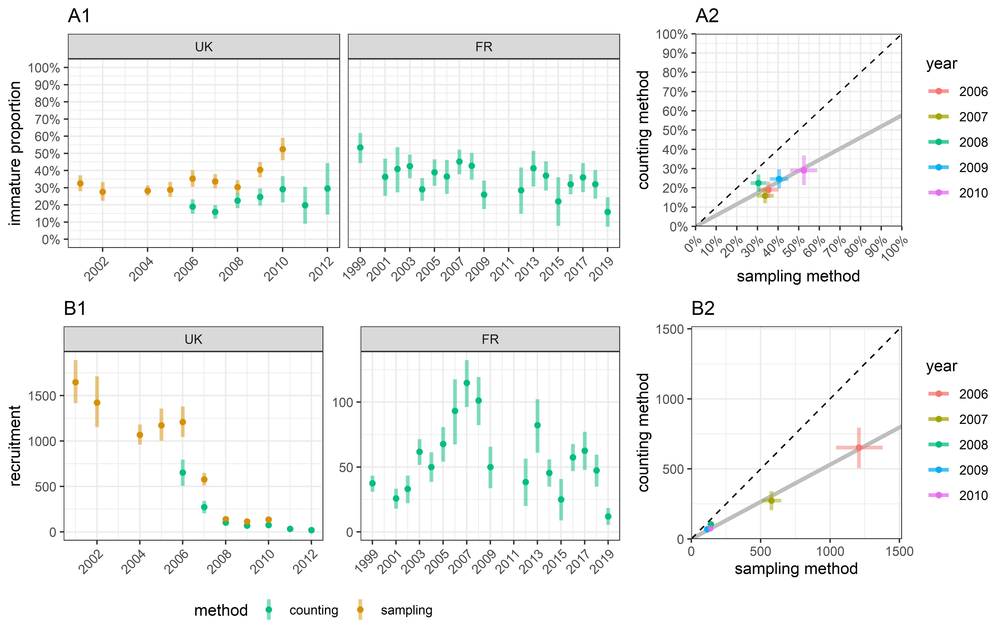

Figure 5.1: (A1) Estimates of the proportion of the immature individuals in the wintering population; (B1) estimates of the number of recruits, i.e. the young adults reproducing for their first time; (A2) & (B2) comparison of the values between the two estimation methods; bars define the 95% confidence intervals

1. Office Français de la Biodiversité, France - [adrien.tableau@ofb.gouv.fr](mailto:adrien.tableau@ofb.gouv.fr)
2. Animal and Plant Health Agency, United Kingdom - [iain.henderson@apha.gov.uk](mailto:iain.henderson@apha.gov.uk)
3. Société Nationale pour la Protection de la Nature, France - [sebastien.reeber@snpn.fr](mailto:sebastien.reeber@snpn.fr)