Delayed dichromatism as a convenient tool to disentangle the effects of survival and productivity on the population dynamics of waterfowl

Adrien Tableau[1]

Iain Henderson[2]

Sébastien Reeber[3]

Matthieu Guillemain[4]

Jean-François Maillard[5]

Alain Caizergues[6]

02 June, 2023

Monitoring the number of individuals is by far the most popular strategy for investigating the environmental factors ruling the population dynamics and for measuring the efficacy of management actions targeting population recovery, control or eradication. Monitoring number, is unfortunately inefficient for assessing the mechanisms underlying demographic processes and more specifically to assess the extent to which population growth rate is affected by changes in adult survival rather than for example variations in reproductive parameters. Usual methods to inform survival and recruitment, e.g. capture-mark-recapture and game-hunting bag, rely on catching animals which suffers from three main drawbacks. Firstly, the selectivity of the catching methods can lead to a biased representation of the underlying population structure. Secondly, catching and releasing animals is quite invasive generating stress and hence additional threat to often already endangered species. Thirdly, releasing may simply be impossible especially for invasive alien species representing a threat for native taxa. In many waterfowl species, a sexual dichromatism is observed in adults whereas immatures of both sexes display a cover-up plumage similar to adult females. Using the case of alien Ruddy duck populations of Western Europe (a species displaying this pattern), we introduces a non-invasive method based on count data that allow estimating the respective contribution of recruitment and adult survival to population growth rate. We exemplify how, based on counts survey, one can, by monitoring changes in apparent sex ratio (due to female like young males progressively acquiring adult male plumage) can be exploited to decompose population growth rate into adult survival and recruitment, greatly helping to understand the demographic impact of two different eradications strategies.

**Keywords**: population dynamics - invasive species - survival - reproductive success - productivity – age-ratio - duck - *Oxyura jamaicensis*

# 1 Introduction

Assessing population growth rate is a key step towards a better understanding of factors underlying the dynamics of natural populations (e.g. Niel, 2005). It is also crucial for measuring the efficacy of management actions potentially undertaken to help population recovery, control, or eradication (Shea & NCEAS Working Group on Population Management, 1998). Among the approaches available to managers for reaching these goals, those relying on the monitoring of the number of individuals (counts) are by far the most popular (Rintala et al., 2022). In many instances, these methods enable investigating environmental factors underlying changes in population size, and hence help implementing mitigating actions (Faillettaz et al., 2019). Unfortunately, relying on the monitoring of numbers of individuals alone generally hinders basic understanding of the demographic mechanisms underlying changes in population growth rates. More specifically, based on counts only, it is nearly impossible to assess the extent to which population growth rate is affected by change in survival rather than to variations in productivity (Austin et al., 2000). To assess the relative sensitivity of population growth rate to factors affecting survival or reproductive parameters, demographers most often rely on the monitoring of individuals by capture-mark-recapture (CMR, Lebreton et al., 1992). In practice, however, one cannot always rely on the capture and release of individuals owing to the legal status of the species that precludes any additional disturbance (critically endangered species) or forbid the release of alive individuals (invasive species or pests). Furthermore, although highly efficient for assessing demographic parameters, CMR methods suffer from potential drawbacks such as being invasive (and may affect behaviour and hence survival or breeding success) and hardly affordable when time and money are limiting. Genetic monitoring is a non-invasive alternative to capture-mark-recapture, but it suffers from being costly and requires large samples (Caniglia et al., 2011).

Most of the time therefore, managers do the best of a bad job using counts as a viable option for tracking population growth rates and assessing the relevance of management actions. Counting the number of immatures in addition to live adults may enable estimating adult survival and recruitment (proportion of young in the pre-breeding population), and hence allow assessing the relative influence of breeding success and adult survival on population growth rate. Alternatively, assessing the sex and age structure in hunting bags has been used to infer the role of decreasing reproductive success in population declines in a number of games species including ducks and geese but suffer from intractable biases (Fox et al 2018, . Fox & Cristensen, 2018). Of course, this approach is not suited for protected/endangered species. The recruitment rate, defined as the average number of immatures per breeder reaching the sexual maturity, is the product of two main sub-parameters: the fecundity followed by the juvenile survival (Arnold, 2018; Etterson et al., 2011). The recruitment rate is sometimes also called annual fertility (e.g. Koons et al., 2014), reproductive rate (e.g. Cooch et al., 2014), reproductive success (e.g. Etterson et al., 2011), or productivity (e.g. Hagen & Loughin, 2008; Johnson et al., 1987).

Here we exemplify how, in dimorphic species, delayed maturity of males can be used for estimating adult survival and recruitment rate by differentiating male-like from female-like individuals in repeated winter counts. We used two non-native Ruddy duck (*Oxyura jamaicensis*) populations introduced in Europe as a study model. As numerous duck species, the Ruddy duck is dimorphic, with newly born males looking like females until the pre-nuptial moult, which occurs in late winter. As a results of this late prenuptial moult of juveniles, the apparent proportion of males increases over the course of the wintering season. These changes in apparent proportions of males during this period are therefore directly related to the proportion of immatures into the populations and hence to reproductive success of the previous breeding season and recruitment rate of the next one. We estimated adult survival and recruitment rates and assessed the impact of two different eradication strategies deployed in Great Britain and in France, respectively.

# 2 Materials & methods

The Ruddy duck is a stiff-tailed duck native from the Americas. From seven individuals initially acclimated in the Slimbridge Wetland Centre in the 1940’s (Gutiérrez-Expósito et al., 2020), a feral population began to establish in Great Britain with the first observed reproductive attempts in the wild in the 1960s (Figure 2.1). This feral population rapidly grew and spread to the entire country to reach more than 5,000 individuals in the early 2000s. By the end of the 1980s, a feral population began to establish also on the continent, especially in France, supposedly owing to the arrival of individuals born in Great Britain. But contrary to what was observed in Great Britain, Ruddy ducks did not spread much in France, with the vast majority of observations and breeding attempts clustering in North-West parts of the territory. In France, during winter, almost no Ruddy duck is observed outside the lake of Grand Lieu (47.09°N, 1.67°W), which greatly facilitates the monitoring of this population. Ruddy ducks are considered as a major threat to the endangered native White-headed duck, *Oxyura leucocephala* of the South-Western Mediterranean, because of hybridization and thus an elevated risk for genetic pollution and genetic assimilation of the latter by the former (Muñoz-Fuentes et al., 2007). In order to mitigate the risks of genetic pollution of the White-headed duck by Ruddy ducks, eradication measures were implemented the late 1990s both in Great Britain and in France (Gutiérrez-Expósito et al., 2020), (Figure 2.1) followed by an European Ruddy duck eradication plan in 1999 (Hughes et al., 1999).

The trends and status of populations of both White headed duck and Ruddy duck are being assessed through population censuses only. It is thus impossible to assess the factors that impair recovery of the former and the efficacy of the eradication programme for the latter. More particularly, based on censuses alone one cannot assess of the relative effects of changes in adult survival and breeding success or recruitment rates on population growth rates which are prerequisites to identifying limiting factors.

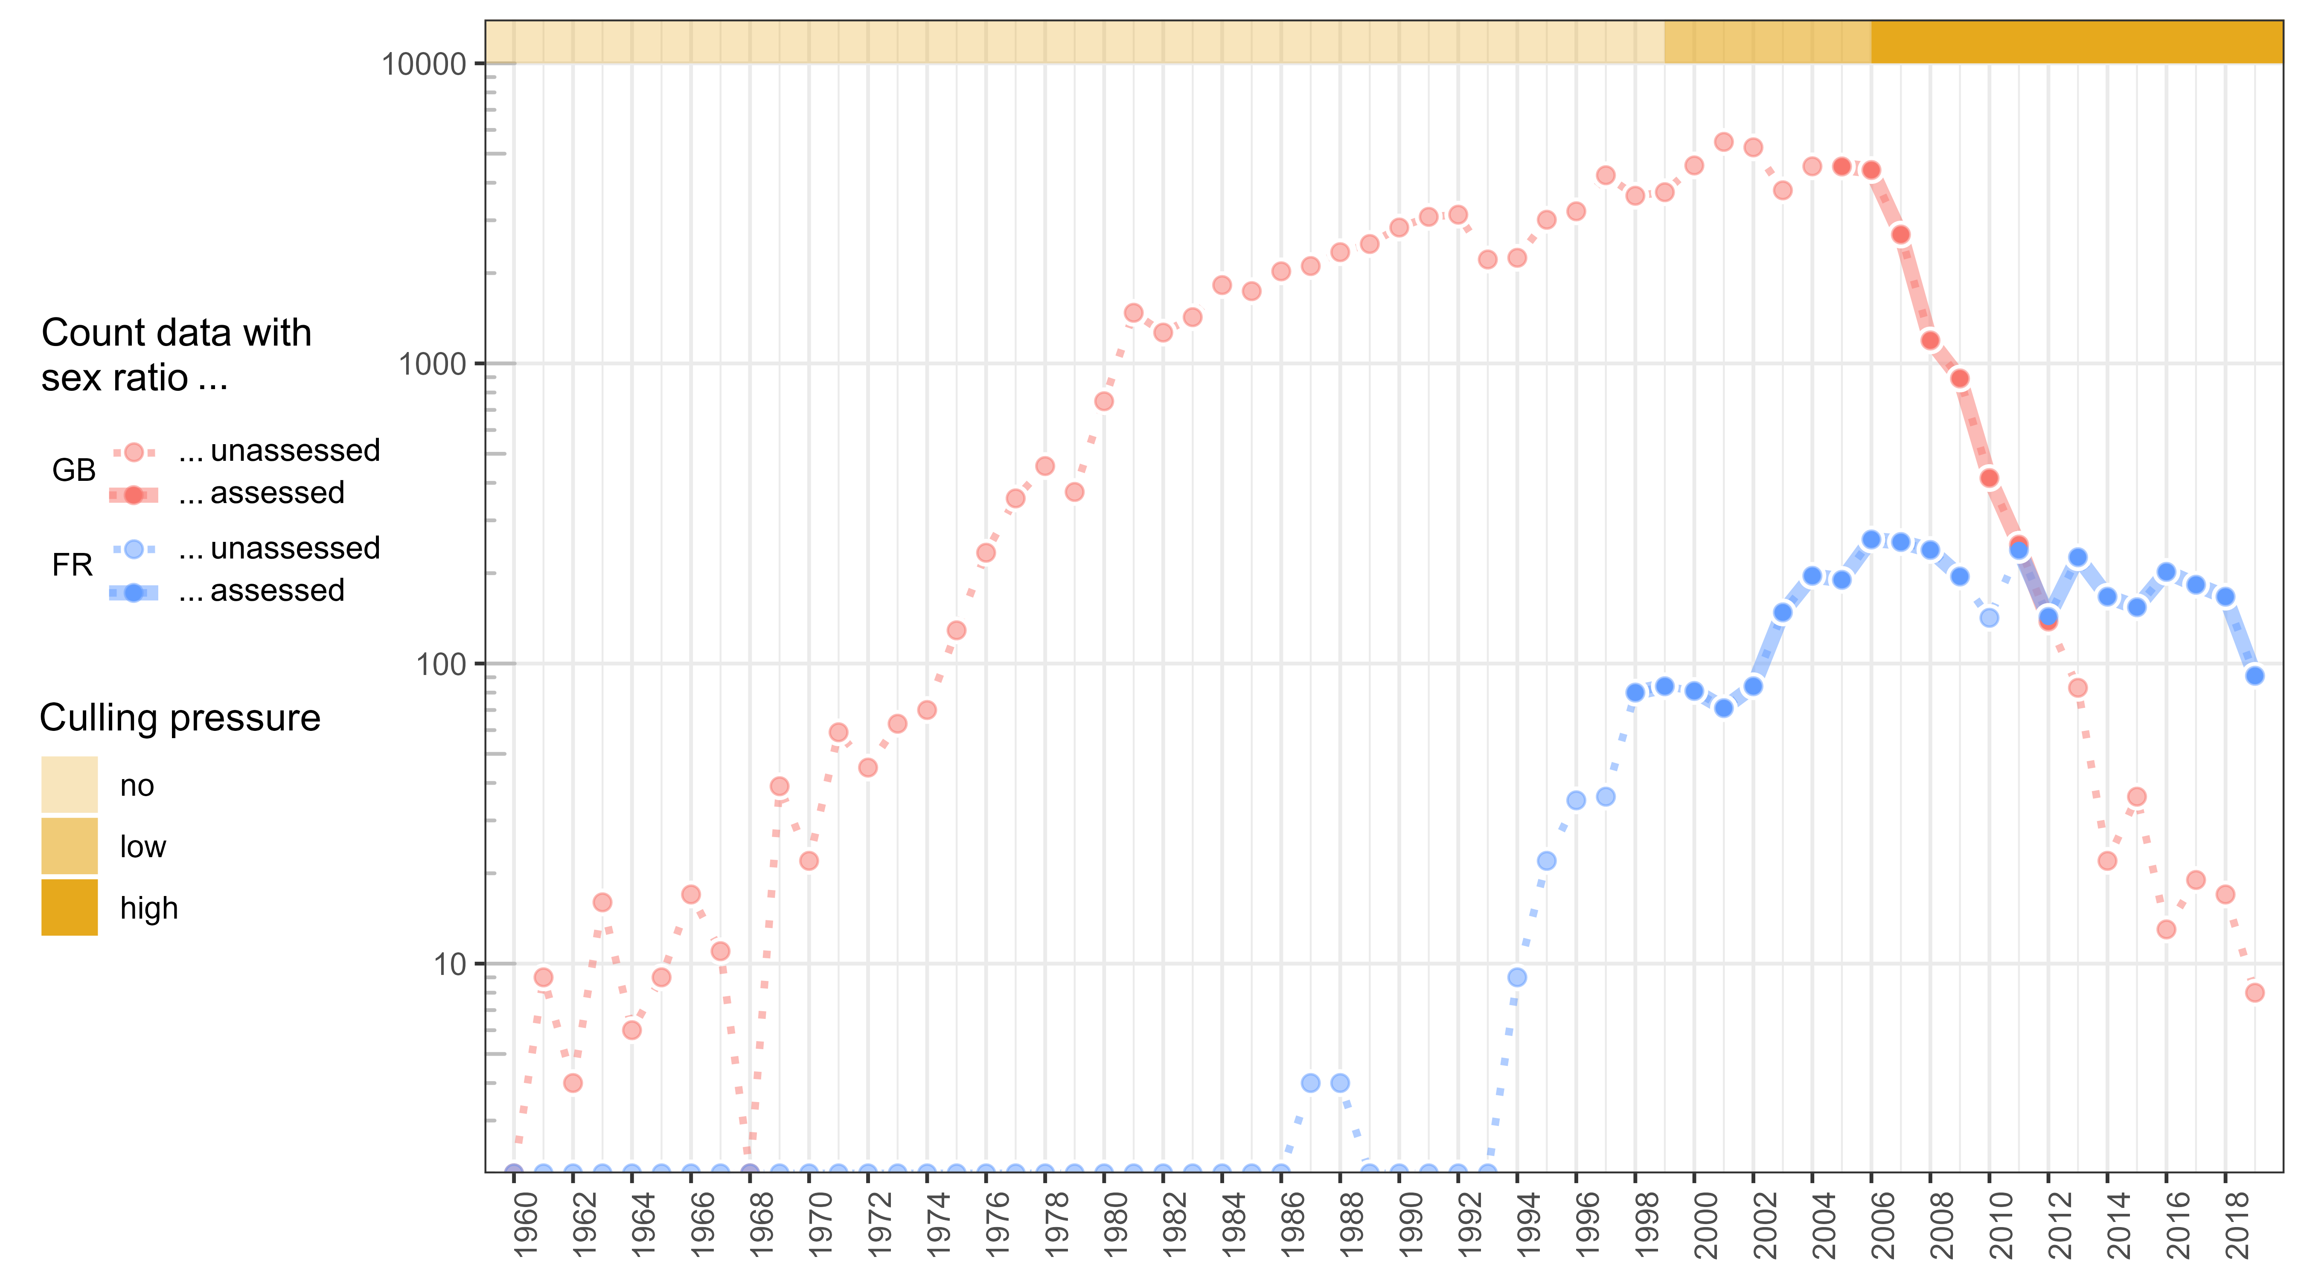

Figure 2.1: Temporal evolution of the number of Ruddy ducks (log scale) in Great Britain (GB) and France (FR) from 1960 to 2019, with indications of periods when apparent sex-ratios were also recorded.

Like many other ducks, Ruddy ducks and White-headed ducks both display delayed dichromatism thereby young males acquire the typical colourful plumage of their kind (and hence can be distinguished from females) over the course of the interbreeding season (typically by mid-winter for the earliest individuals, Baldassare 2014). Delayed dichromatism generally explains the discrepancies in the estimates of proportions of females in winter vs spring or between winters counts and hunting bags (Figures 2.2 & 2.3).

Interestingly, delayed dichromatism allow estimating recruitment/productivity and adult survival by monitoring the seasonal evolution of apparent sex ratio and by making few and reasonable assumption (see below).

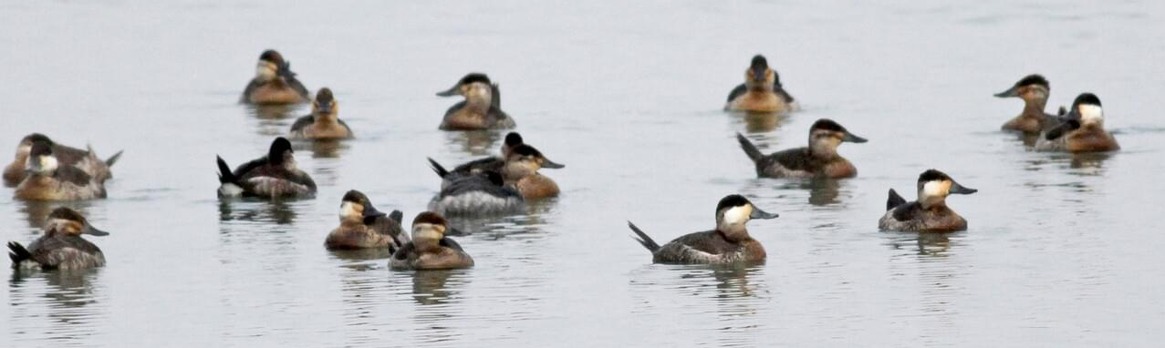

Figure 2.2: Typical Ruddy duck flock during winter including ten female-like individuals with a whitish striped cheek (some of which are immature males), four male-like individuals with a white cheek and a black cap, three probable males (1st, 4th, and 10th from left) © Jay McGowan - 3 February 2013 - Tompkins, New York, United States

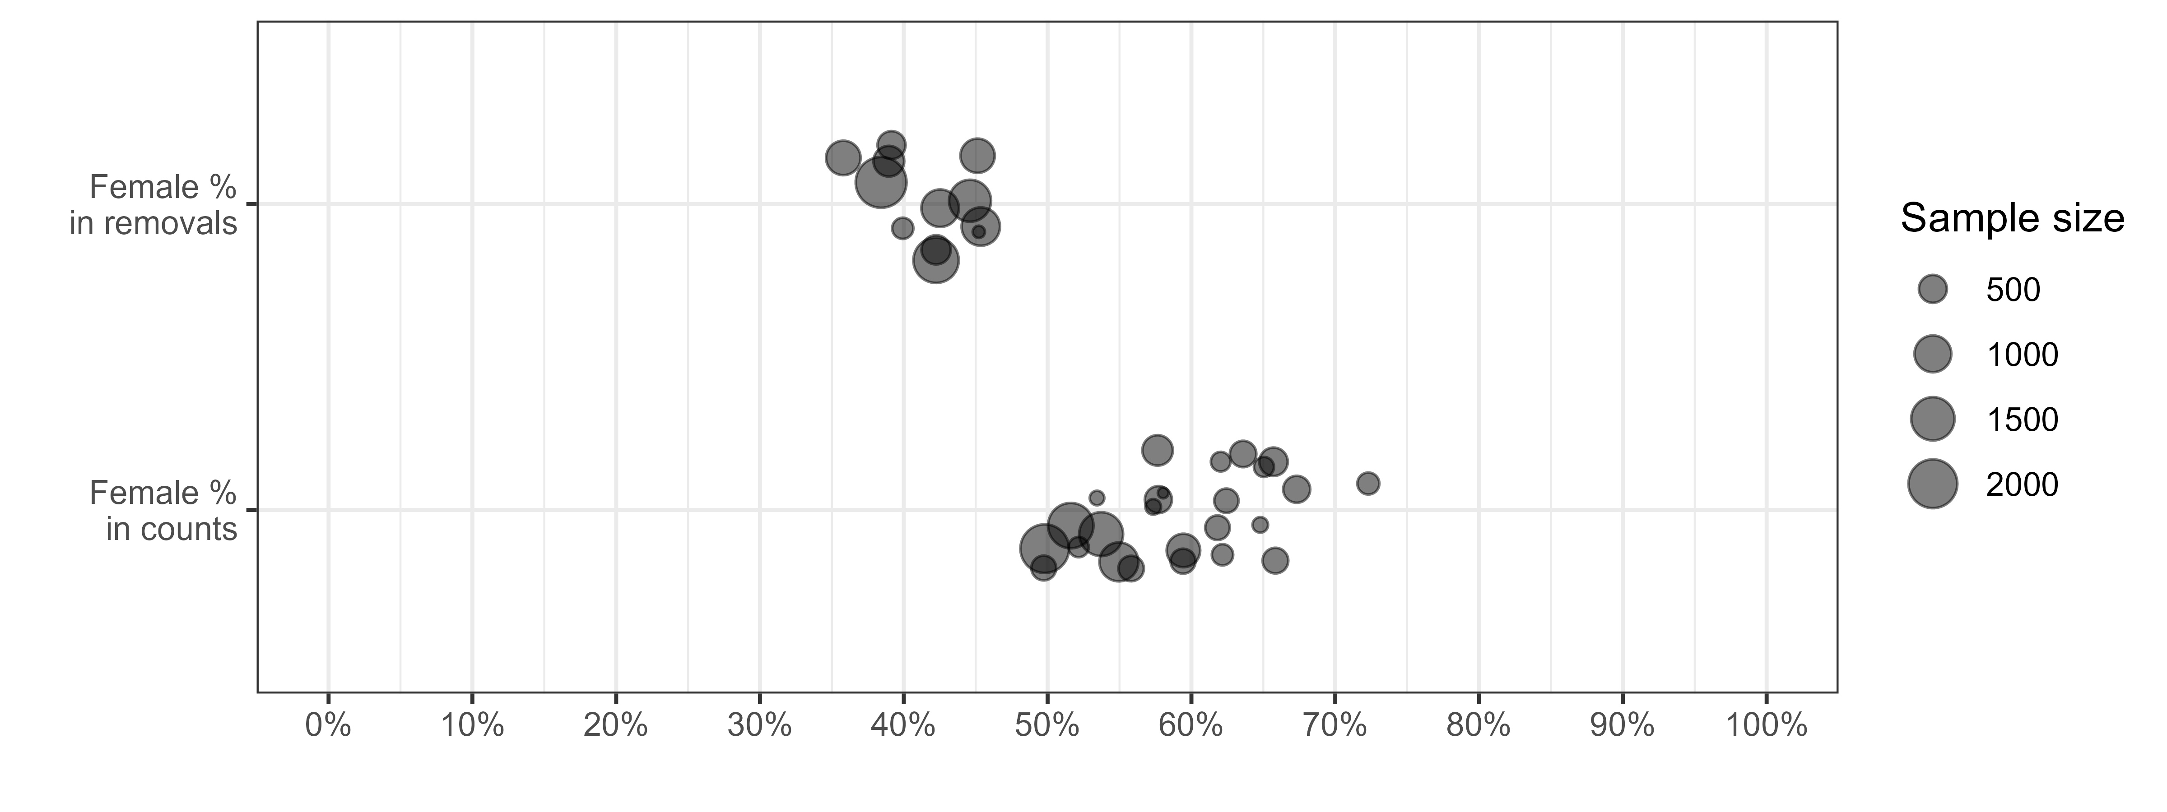

Figure 2.3: Proportions of females estimated through the internal examination of individuals shot as part of the eradication programme over one year in a population (% females in removal) and proportions of individuals displaying a female-like plumage in a population counted in winter (% females in counts). Discrepancies between the two estimates are due to delayed dichromatism in young (immature males looking like females before moulting). We exploited these discrepancies for estimating recruitment/productivity and survival.

We monitored the demography of Ruddy duck populations in both Great Britain (GB) and France (FR) using exhaustive counts on the wintering grounds during the period between December 1 and January 31. In addition, counts that distinguished female-like from male-like individuals were performed from 2006 to 2012 in Great Britain, which corresponds to a period of strong decline of the population (Figure 2.1). In France, Ruddy ducks, which were monitored in 1999, 2001-2009, and 2012-2019, grew rapidly during the first years monitoring and levelled-off from 2006 onwards as a result of a high culling effort. In both countries, shooting was performed under the strict control of the authorities meaning that the exact number of individuals removed was known. Therefore, despite the age-ratio of birds shot was not ascertained before 2009 in France, it is possible to grossly qualify the culling pressure in three categories for both countries: “no culling” before 1999, “low culling” between 1999 and 2005, and “high culling” from 2006 (see Figure 5.1 in Supplementary Material).

## 2.1 Inferring adult survival and recruitment/productivity from population size estimates and changes in age-ratio

We did not sought to assess the sex-ratio of breeding adults through counts, but we determined the sex of each adult that was shot as part of the eradication programme both in Great Britain and in France. Nevertheless, the small population size in France prevented from getting robusts adult sex-ratios estimates. In Great Britain, the sex ratio of adults did not differ among months, so data from adults collected over the whole biological cycle were pooled to estimate adult sex-ratios. Among samples of more than 500 adults, proportion of males in did not statistically differ between years. This is consistent with previous finding showing that in ducks, despite variations in adults sex-ratios can occur over the long-term, they usually displays a high stability over the short-term (Wood et al., 2021). Therefore, we pooled data from all adults shot as part as the control programme to estimate the sex-ratio, see Equation (2.1).

Our modelling exercise was based upon the following assumptions : 1) an even sex-ratio at birth (Bellrose et al., 1961; Blums & Mednis, 1996), 2) comparable survival rates between males and females among juvenile, 3) similar survival rates between males and females among adults (unchanging sex-ratio among adults) during the monitoring season (Devineau et al., 2010).

Assuming the additive property of the binomial distribution, the proportion of immatures can be deduced from the cumulated of male-like individuals in the wintering population, see Equation (2.2). Using the estimate of the proportion of males together with the interannual variation of an index of abundance of population size, one can derive adult survival, and the recruitment rate (see Equation 2.3). The key concept is that if the absolute value of population size can be estimated (from counts), numbers of adults and recruits can be estimated, see Equation (2.4).

| Variable/Parameter Name | Description |
| --- | --- |
|  |  |
| Model inputs (observed variables) |  |
|  | Total number of adult males among individuals shots as part of the eradication programme |
|  | Total number of adult females among individuals shots as part of the eradication programme |
|  | Number of male-like individuals counted in population in year |
|  | Number of individuals counted in population in year |
|  | Size of the population in year (maximum number of individuals counted in the wintering population) |
| Model outputs (estimated parameters) |  |
|  | Proportion of males in adults (or probability of being a male knowing it is an adult) |
|  | Proportion of adult males in population in year |
|  | Proportion of adults in population in year |
|  | Proportion of immatures in population in year |
|  | Adult survival rate, i.e. proportion of individuals in year still alive in year |
|  | Recruitment rate, i.e. number of recruits in population in year per individual in year |
|  | Number of adults in population in year |
|  | Number of recruits in population in year |

$$\begin{equation} p(m|a) \sim {\sf Beta}(AM, AF) \qquad(2.1) \end{equation}$$

$$\begin{align} CML_{i, t} & \sim {\sf Binom}(p(a \cap m)_{i, t}, C_{i, t}) \notag \\ & \sim {\sf Binom}(p(m|a).p(a)_{i, t}, C_{i, t}) \notag \\ & \sim {\sf Binom}(p(m|a).(1 - p(i)_{i, t}), C_{i, t}) \qquad(2.2) \end{align}$$

## 2.2 Validating the method

The relevance of the method was assessed by testing the likelihood of the estimates of both vital rates. For adult survival, we checked if the values were included in the interval, and compared our estimates to those of the literature (as suggested by Lebreton, 2001). Maximum adult survival is defined as a uniform distribution on the interval. The lower limit corresponds to the range of survival rates observed in waterfowl species of similar weight, the upper limit was set to 1 because survival rates of long-lived waterfowl species can be very high (Buxton et al., 2004; Krementz et al., 1997; Nichols et al., 1992, 1997, Koons 2014). The validation of recruitment rate was trickier both, because the parameter is bounded only by fecundity (clutch-size) and rarely computed. Some components of the recruitment rates such as nesting rate, nesting success, clutch-size, hatching success, early stage survival… are generally estimated (réfs), while others such as survival between the juvenile stage and the first breeding season are never mentioned (e.g. Baldassarre, 2014). Nevertheless, we then developed an approach to estimate the maximum expected recruitment rate without exploitation (and assuming that the observed density levels did not affect components of recruitment). Estimated values above that maximum recruitment rate were interpreted as reflecting failure to detect (count) adult males. On the overhand, null or negative recruitment rates could reflect, either that immature males had acquired the male plumage before the survey, or, violation of the assumption about the stability of the adult sex-ratio.

Practically, the maximum recruitment rate ***rt*** is estimated from the difference between the maximum growth rate ***λ*** and the maximum adult survival rate ***S***, see Equation (2.5), assuming a closed populations (population size in year is equal to the number of adults that survived over year plus the offspring produced in year that survived until the reproduction period of year , i.e. the recruitment in year see Flint, 2015). For an open population, adult survival and recruitment rates are confounded with immigration of adult and recruit migrations, respectively. This relationship becomes more complex if a species with delayed maturity is considered, see Robertson (2008).

| Name | Description |
| --- | --- |
|  | Number of adults in year |
|  | Number of adults dead during year |
|  | Number of recruits in year |
|  | Adult survival rate, i.e. proportion of individuals in year still alive in year |
|  | Recruitment rate, i.e. number of recruits in year produced per individual in year |
|  | Growth rate of the population between year and year |

$$

In both populations, the maximum growth rates occurred before shooting occurred and during their geographical expansion phase (figure 3.3). To estimate robust maximum population growth rates for both populations, we smoothed annual growth rate values over a consistent time-period by using a linear regression on the logarithm scale, see Equation (2.6). We discarded Great Britain data before 1972 since the low population size estimates (below 50 individuals) were probably noisy (Figure 2.1). After reaching the threshold of 1,000 individuals, the Great Britain (GB) population growth showed a strong inflexion despite culling had not begun (figure 3.3). This observation suggests that a negative density-dependence process might occur beyond 1,000 individuals and led to consider only the first sequence of the time series to infer on the maximum growth rate in Great Britain, i.e. 1972-1981. For the French (FR) population, the sequence without culling effort spread over the period 1994-1999.

| Name | Class | Description |
| --- | --- | --- |
|  | Parameter | Intercept of the regression model |
|  | Parameter | Average population growth rate over a restricted time interval for a population (in ) |
|  | Index | Year index within the time interval |
|  | Parameter | Standard deviation of the regression model |

$$\begin{equation} log(N_{i, t}) \sim {\sf Norm}(N0_{i, J} + log(\lambda_{i, J}).t, \sigma_{i, J}) \qquad(2.6) \end{equation}$$

Estimating vital rates within an acceptable range as defined above, would not prove that out modelling approach correctly tracked their inter-annual variability. In order to ascertain this aspect, we compared proportion of immatures and both survival and recruitment derived from counts, to estimates derived from individuals shot as part of the eradication programme. To address this question, we removed the data from years when less than 100 individuals were shot in winter. Thus, this analysis covers only 5 years of the census series of the GB population. Proportions of juveniles could be estimated from culled individuals by checking the presence of the bursa of Fabricius (which is present in immature only, Hochbaum, 1942 ; see Equation (2.7). Adult survival and recruitment rates were then estimated by combining this proportion and Equation (2.3).

| Name | Class | Description |
| --- | --- | --- |
|  | Data | Number of immatures sampled in the wintering population in year |
|  | Data | Number of individuals sampled in the wintering population in year |

$$\begin{equation} SI_{i, t} \sim {\sf Binom}(p(i)_{i, t}, S_{i, t}) \qquad(2.7) \end{equation}$$

## 2.3 Assessing the impact of culling strategies

During period when culling effort was high (i.e. from 2006 onwards), eradication strategies differed between Great Britain to France. In Great Britain, culling mostly occurred in winter (53.4% of adults were shot before the 30th May), whereas it was mostly done during the breeding period in France (81.6% of adults were shot after the 30th May). We assessed whether or not these different strategies had a different impact on populations by comparing growth rates and the relative effects of both recruitment and survival on them (by comparing the average values over the high culling effort period to proxies of maximum vital rates estimated when both populations reached their maximum growth, see Section 2.2). In France, a LIFE project was implemented by early 2019 to intensify the culling effort, especially during winter and spring. We therefore excluded the FR time series from 2019 onward in order to provide a comparison of homogeneous culling strategies.

## 2.4 Statistical framework

We used the bayesian framework to implement all sub-models presented in Section 2. The Bayesian framework is both straightforward and efficient to propagate error through the parameters. We used uninformative priors on all parameters. As, for a given species, the maximum growth rate is a life history trait expected to be stable among populations, we used an uninformative hierarchical prior for this parameter. We generated three chains of length 500,000, with a thinning of 10 to avoid autocorrelation in the samples, discarding the first 2,000 samples as burn-in. We assessed chain convergence using the Gelman and Rubin convergence diagnostic (R<1.1, Gelman & Rubin (1992)). Models were fitted using NIMBLE (de Valpine et al., 2017) run from R (R Core Team, 2022). Data and code are available here: <https://github.com/adri-tab/Ruddy_duck_vital_rates>. The values **X[Y; Z]** reported in Section 3 are the medians and the associated boundaries of the 95% confidence interval of posterior distributions. We preferred the median to the mean because of its robustness to skewed distribution.

# 3 Results

## 3.1 Estimating vital rates

The method successfully provided estimates and associated uncertainty for the proportion of immatures in both wintering populations. Similarly, adult survival and recruitment rates, i.e. the two components accounting for population growth rate, derived from our model were compatible with expected values (values observed in natural conditions) (Figure 3.1).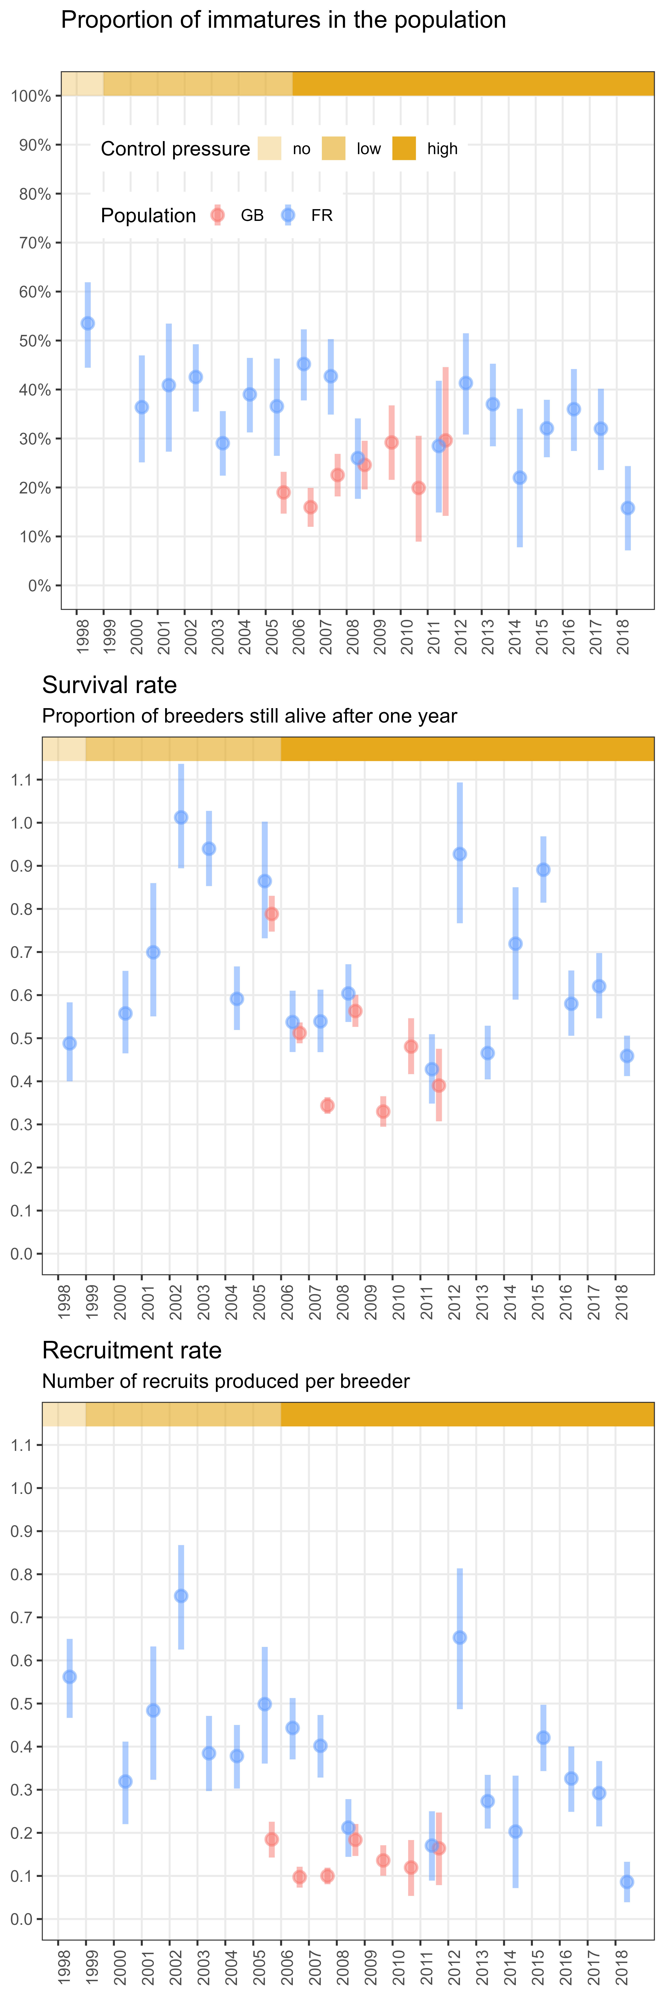

Figure 3.1: Temporal changes in the proportions of immatures and the vital rates depending on the culling pressure Ruddy duck populations of Great-Britain (GB) and France (FR) as derived from our “changes in apparent sex-ratio model of population dynamics” (vertical bars represents the 95% confidence intervals).

Observed proportions of males in adults, which is a prerequisite to infer the median proportion of immatures, was estimated at 0.60 [0.59; 0.61], ranging from 0.16 [0.07; 0.24] to 0.54 [0.44; 0.62] depending on population (country) and year. The lowest values were similar for the two populations, but the range in the median proportions of immatures in the GB population was far more limited (upper value GB: 0.30 [0.14; 0.45], FR: 0.?? [0.XX; 0.YY]).

Between-years changes in male proportions were significant in FR but not in GB. Similarly, the proportions of immatures derived from the model were relatively stable over years in the GB population, while it decreased slightly in FR (Fig. 3.1).

Adult survival rate derived from the model ranged from 0.33 [0.29; 0.37] to 1 [0.89; 1]. None estimates was significantly outside the range of a survival rates defined without immigration [0; 1]. No trend in adult survival rate could be evidenced in any of the two populations, but patterns differed: survival in GB was both lower and displayed a weaker inter-annual variability than in FR.

Recruitment rate (median numbers of recruit per breeder) ranged from 0.09 [0.04; 0.13] to 0.75 [0.63; 0.87]. All estimates were above 0, that is not incompatible with reality. Moreover, the maximum median recruitment rate was 0.68 [0.36; 0.78] (see Section 3.3), and estimates were significantly outside the range of recruitment rates defined without immigration [0; 0.78]. No trend was observed for the GB population, but recruitment rate decreased for the FR population, although the pattern was noisier than for the immature proportions. Like for survival, the GB population had lower values of recruitment rate with weaker variability than the FR one.

Lower values and weaker variability of both adult survival and recruitment rates estimated in GB than in FR likely explained the differing trajectories of the two Ruddy duck populations (sharp and constant decline for the former vs slow and variable decline ofr the last, Figure 2.1). In the FR population, the range in recruitment rates (min/max difference: 0.66) was higher than the range of survival rates (min/max difference: 0.58). Conversely, the range of survival rates (min/max difference: 0.46) in the GB population was far higher than the range of recruitment rate (min/max difference: 0.08). This suggests that the variability of population growth rate was mostly driven by recruitment in France whereas it was mainly driven by changes in adult survival in Great Britain.

## 3.2 Examining the reliability of the estimates

In Great Britain, proportions of immatures derived from the count-based method were positively correlated to those observed in culled individuals (Figure 3.2). Therefore, this result support the hypothesis that the proportion of female-like individuals in the wintering populations is efficient for assessing age structure and hence reproductive output. The correlation between was even stronger when considering vital rates (Figure 3.2), but this was expected because the two methods estimating these vital rates had share a component (the growth rate of the population, see Equation 2.3). Interestingly, the correlation never reached the value of 1, with proportion of immatures derived from counts being always lower than those observed in culled individuals. The discrepancy between these two estimates is due to the fact that immature are probably more vulnerable to culling than adults and might then be over-represented in culling samples. As a consequence, the correlation coefficients for both vital rates also differed. However, the differences between the two approaches do not question the ability of the count method to track the interannual variability of the vital rates.

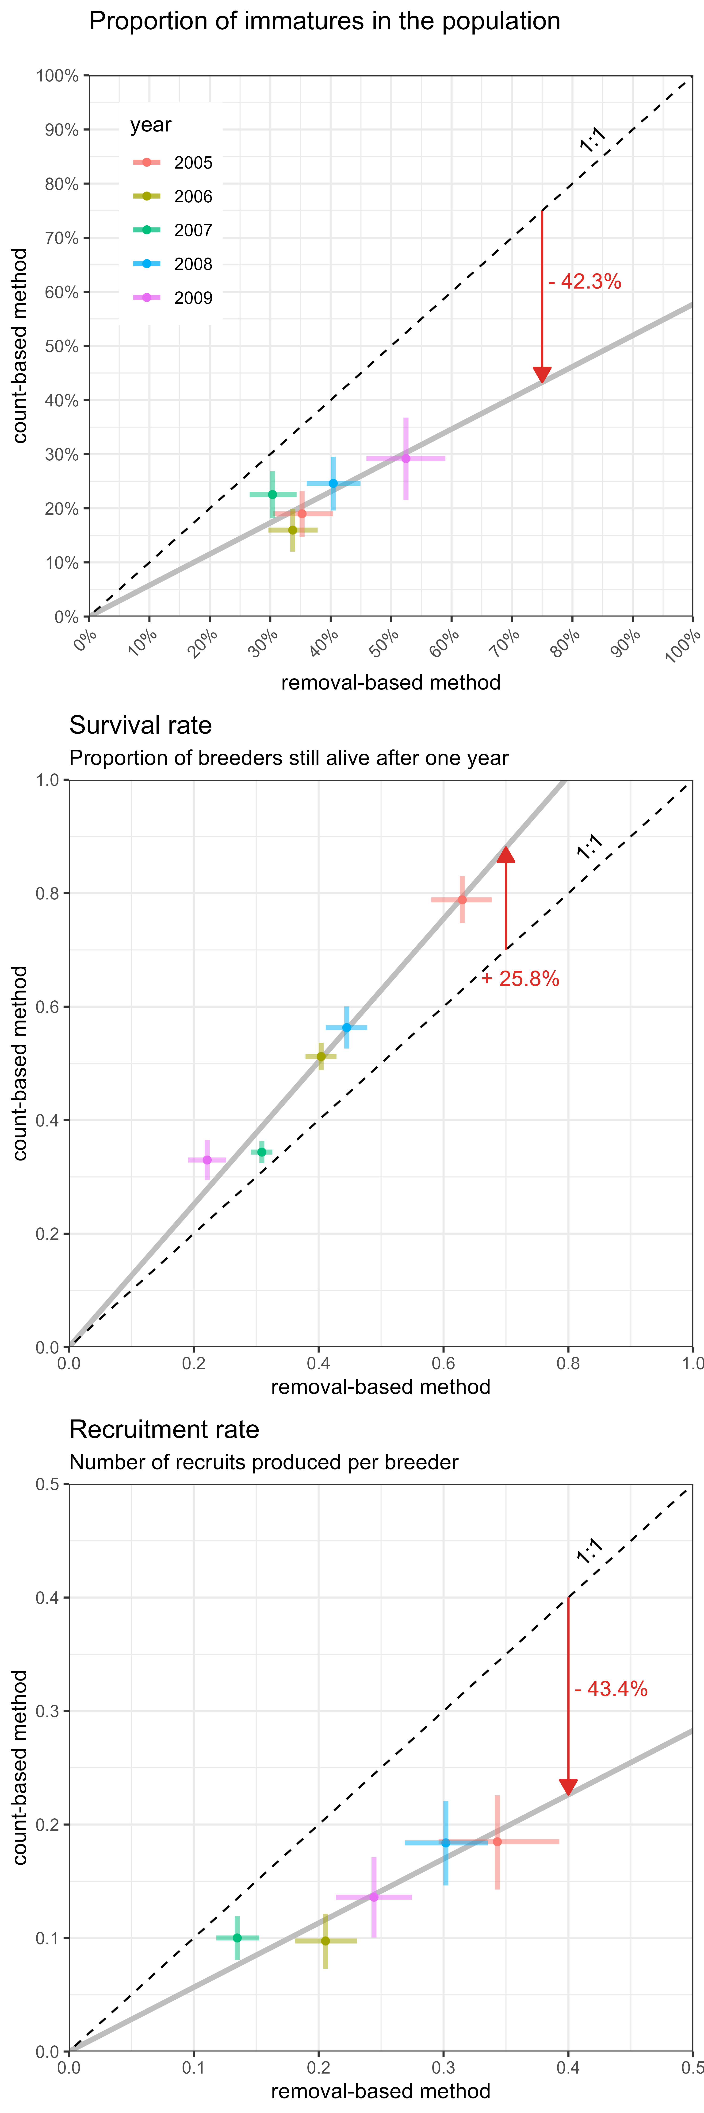

Figure 3.2: Relationship between parameter estimates derived from counts and those obtained from culling (hunting bags). Only five years were available for the GB population. Bars represent 95% confidence intervals and the red arrow indicates the direction and average differences between the two methods.

## 3.3 Assessing the demographic response to culling strategies

When culling pressure was nil, maximum growth rates were very similar for the two populations (Figure 3.3), respectively 1.45 [1.36; 1.55] and 1.52 [1.25; 1.88] for GB and FR. These values correspond to a population increase of 45% and 52% per year, respectively. Assuming a maximum adult survival rate of 0.85 [0.7; 1] identical for both populations, we deduced maximum recruitments rates of 0.60 [0.42; 0.78] and 0.68 [0.36; 1.06] respectively for GB and FR.

Despite low sample sizes of sexed and aged culled individuals, proxies of the culling pressure exhibited significant changes over time (Figure 5.1). We thus ranked the culling pressure according to this intensity (high vs low). High culling pressure occurred from 2006 onwards in both populations (although the signal was noisy). However, despite similar levels of culling pressure, the culling strategies differed significantly between the two populations, see Section 2.3. Under high culling pressure, the growth rate dropped to 0.56 [0.53; 0.59] and 0.97 [0.94; 1.00] for the GB and the FR population, respectively, which corresponded to a decrease of 44% per year and 3% per year. This result showed that the GB population significantly decreased during the high culling pressure, whereas the FR population could just be stabilized.

Adult survival rate under high culling pressure was 0.44 [0.42; 0.46] and 0.62 [0.59; 0.64] for the GB and FR populations, respectively and recruitment rates decreased to 0.13 [0.11; 0.15] and 0.32 [0.29; 0.34], respectively. The resulting drop in growth rate of the GB population corresponded to a similar average drop in adult survival rate (-0.41) and in recruitment rate (-0.47), whereas the stabilisation of the FR population was caused by a more to a decrease of recruitment rate (-0.36) than to a drop in adult survival (-0.23). Overall, culling strategy adopted in GB was more effective in affecting both adult survival and recruitment rates than that adopted in FR.



Figure 3.3: Effects of culling effort and different culling strategies (GB vs FR) on Ruddy duck average populations growth rates derived from counts and on adult survival and recruitment rates estimated from the “changes in adult sex-ratio population dynamics model”. Under high culling pressure; the culling effort for the GB population moslty occurred during the prebreeding period, whereas it mostly focused during and after the breeding period for the FR population (see 2.3 for details). Survival and recruitment rates under high culling pressure were averaged over a time-period observing a consistent culling pressure (vertical bars show 95% confidence intervals)

# 4 Discussion

Disentangling the contribution of these two vital rates to population growth rate is a key step towards a better understanding of the response of a population to management actions (in the present case culling strategies, Williams et al., 2002). We exploited delayed sexual dichromatism to develop a new approach based on counts to breakdown the apparent growth rate (Lambda) of a population into two of its main structural components: adult survival and recruitment. The development of our method holds on a unique dataset of two comparable populations (in France or FR and Great Britain or GB) of the same species, the Ruddy duck. Both populations were monitored in a similar way from their introduction to a period of intense culling pressure, but the culling strategies differed sharply. The very similar demographic trajectories and properties of both populations in similar ecological setup enabled evaluating the response to both culling pressure and culling strategies.

## 4.1 Monitoring adult survival and recruitment

The vital rate estimates of the two populations were within the same range, which demonstrates a certain consistency in the results obtained from the method. The greater variability observed in France was expected because the FR time-series covered a larger spectrum of culling pressure than the GB ones. We detected not temporal correlation in the dynamics and demographic parameters between the two populations, suggesting that regional (e.g., weather) rather than large-scale factors (e.g., climate) prevailed. This is consistent with previous findings showing for example that in waterfowl, both breeding success and juvenile survival are conditional to the onset of laying, which is tightly related to local weather (e.g. spring temperature, cumulative rainfall), water levels, changes in predation pressure (Blums & Clark, 2004; Dzus & Clark, 1998; Folliot et al., 2017) rather than to large-scale phenomena (climate disruption).

Count surveys used to implement our model occurred in mid-winter, that is when some immature males had already initiated their moult, partially violating the assumption that male-like individuals were adult males only, and hence potentially biasing our estimates. Nevertheless, survival estimates are within the range of those reported for similar species (Buxton et al., 2004; Krementz et al., 1997; Nichols et al., 1997, Buderman et al. 2023). Moreover, the results support that there were no major scaling issues using count data from mid-winter. The best time window of the count surveys corresponds to the time preceding the initiation of moult of immature males. In some years, the estimated values of adult survival were outside the range of expected values even if they were never significantly exceed 1. One possible explanation for these discrepancies is a violation of the “closed population” assumption. Indeed, despite ringing data suggest that Ruddy ducks do not undertake long-distance seasonal movements (citer les anglais), one cannot totally rule out that immigration occurred, variations in recruitment cannot explain by itself the population growth and leads to an adult survival combining true adult survival and adult immigration. Concerning the FR population, out of range outliers of both recruitment and survival rates were observed in 2002 and 2012, suggesting significant immigration events during these years.

The theoretical maximum population growth rate is an inherent trait related to the demographic characteristics of a species (Dmitriew, 2010; Niel, 2005). This trait is expected to be similar in all Ruddy duck populations anywhere in the world. In our study, we observed maximum growth rates that were very close for the two populations, which was expected because both populations experienced similar ecological conditions (absence of harvesting and similar breeding conditions). Moreover, before the initiation eradication programmes the two populations also expressed a population dynamics much closer to the maximum expected values (λ max) than any other native ducks species at the same period in the same areas. In the absence of culling, both populations expressed survival rates in upper range of those observed in other diving ducks species (i.e., ca 0.8 for Common pochards, see Folliot et al. 2020, Buderman et al. 2023). Ruddy ducks tend to breed latter than both Common pochards and Tufted duck, yet nest predation has been found to decrease over the breeding success in a French fishponds complex (Bourdais et al. 2015). Therefore, both, increased survival and nesting success may have accounted for high population growth rates of Ruddy duck populations in the absence of culling. Finally, it should be noted that similar population growth rates were recorded for Common pochards breeding on Grand-lieu lake (western France) during the initial increasing phase of a population that was harvested (Reeber ). Besides providing estimates (of λ, survival, and recruitment) consistent with observed increasing population sizes, our method also provided estimates consistent with both, the decreasing phases of the time series (i.e., after the implementation of eradication programmes) and the observed differences in populations growth rates between under differing culling strategies. As expected, higher values of λ, survival and recruitment were observed when the culling strategy focused on post-rather than pre-breeding.

Assuming that removal data provide a good picture of the year-to-year variability of age structure (réfs), the strong correlation between estimates derived from counts and those derived from hunting bags demonstrates the ability of the count approach to properly track inter-annual fluctuations in demographic parameters such as survival and recruitment. The fact that the observed correlation was strong despite being based on a short time series strengthen its robustness. Furthermore, the strength of the relationship between parameters obtained through the two approaches also support that important assumptions of our model (e.g., constant adult sex ratio) were met. The temporal autocorrelation of the adult sex ratio might be explained by the fact that it integrates many age-cohorts, which makes it structurally strong. Significant variations of the adult sex ratio can occur over the long term, but our results suggests that it is not necessary to monitor and update it on a yearly basis. Proportions of males in adults estimated in the present paper (i.e., ) are within the range of those observed in native Ruddy duck populations of North America (0.62 in Bellrose, 1980) and in other duck species (Wood et al., 2021). The “count-changing sex ratio” method presented here always provided recruitment rates significantly lower than the method based on removal data (hunting bags) by a factor close to two, a result that is compatible with a higher vulnerability of immatures than adults to shooting (see Bellrose, 1980; Fox et al., 2014). In North America, immatures have been found to be 1.3 to 2.6 times more vulnerable to hunting than adults in waterfowl (Bellrose, 1980).

Because, estimated of survival were not available in the literature (see Buderman et al. 2023), we could not properly assess the accuracy of the “count- changing sex ratio” method for estimating this parameter. Nevertheless, circumstantial evidence support that the method is not heavily biased (see above). Thus the “count-changing sex ratio” method would be much more efficient for monitoring key demographic parameters than alternative methods such as those based on hunting bag data that proved unreliable (Fox et al. (2014) even when they focused on the end the hunting season to limit possible biases (Fox et al., 2016).

## 4.2 Assessing eradication strategies

Both populations responded to culling pressure by a significant decrease in λ, meaning that increasing mortality due to culling was neither compensated by increasing natural survival nor by improved breeding success. The culling effort was therefore efficient to affect the demographic trajectory of Ruddy ducks in both contexts. However, the decrease in λ was much stronger in GB, where the population displayed a sharp decrease, than in FR where the increase was stopped and population size remained more or less stable. The greater decline in λ observed in GB compared to FR was due to greater decline in both adult survival and recruitment rates. Overall, in both countries, adult survival and recruitment rates seemed significantly affected by culling. However, the culling pressure occurring before the breeding (GB culling strategy), that affected future breeders, seemed much more efficient in limiting both survival and recruitment that the culling pressure targeting breeders and newly born individuals (occurring during nesting and young raising, FR culling strategy). As expected, in FR were culling targeted the breeding season, recruitment rates were more affected than adult survival compared to GB. One could have expected that the GB strategies targeting pre-breeding had much more impact on adult survival than on recruitment, which was not the case. This was probably due to immature being much more vulnerable to shooting than adults (see Bellrose, 1980; Fox et al., 2014). On the over hand, the higher harvesting mortality of immatures might be compensated by increasing natural survival (Cooch et al., 2014). Overall, there was no evidence for any compensation mechanism in either context. This might result from the fact that both populations were far of reaching carrying capacity meaning that competition for resources was relaxed (Péron, 2013).

For more or less comparable culling efforts, the GB strategy proved much more effective. This does not mean however, that the FR strategy was not so. On the contrary, it proved rather efficient, in a first time for stopping both the population increase and range expansion, and in second time to trigger a significant population decline by slightly increasing culling pressure. Thus when winter culling is not possible (which was the case in FR during winter), culling during breeding is effective for stopping or reversing populations increases in such species. The breeding culling strategy is also affected by the highly variable detectability of immatures, as these individuals colonise new ponds. The winter culling strategy do not face such problem because of the habit of Ruddy ducks to gather in a limited number of sites during winter (Johnsgard & Carbonell, 1996).

The response of the two Ruddy duck populations to culling pressure demonstrates the necessity to account for the culling season to produce proper predictions. Predicting the impact of a harvest pressure on a waterfowl population is then not only a question about how big is the harvesting effort, but also when harvesting occurs (Kokko et al., 1998). Counterintuitively, our results suggest that harvesting waterfowl during breeding has far less impact on population growth rate than harvesting during winter. As a result, a target for effective management of harvested waterfowl should be earlier onsets and endings of breeding seasons.

## 4.3 Management implications

One major implication of our study concerns the timing of harvesting for limiting its impact on populations growth rate. Counterintuitively, our results show that the persistence of waterfowl populations should benefit from earlier openings and closings of the hunting seasons (see above).

Tracking variations in abundance is a common tool to determine the conservation status of a population (e.g Folliot et al., 2022). But tracking abundance alone does not provide enough information for assessing the underlying changes numbers (Williams et al., 2002). In order to do that, one must “dig deeper” (e.g. Austin et al., 2000), for example by monitoring individuals to assess parameters like survival and recruitment (Arnold, 2018). However, monitoring individuals is time consuming (e.g. Souchay & Schaub, 2016) and not always possible in endangered species. The method proposed here allows circumventing these drawbacks in dichromatic species with delayed maturity of adult males. Among these species, one can mention the Tufted ducks which, beside the fact it is much more abundant than Ruddy ducks (at least in Europe), closely resemble the Ruddy duck, and of course, the White headed duck in Southern Spain. The latter is highly endangered and cannot be safely monitored through capture-mark-recapture. Thus by improving census strategies and teasing apart the effects of variation of adult survival and productivity/recruitment on population growth through the approach presented here, one could gather much more invaluable information about the pertinence of management strategies.

Finally, we want to stress the fact that the main aim of our approach was to decompose λ into two of its mains components and not to provide unbiased estimates of adult survival or recruitment probabilities. However, if needed censuses could be designed/improved in such a way that would make this possible, at least in theory and in species presenting the required properties. These required properties concern most stiff tailed duck species (Johnsgard & Carbonell, 1996), as well as numerous other duck species, among which Tufted duck, *Aythya fuligula*, Black scotter, *Melanitta nigra americana*, Common Goldeneye, *Bucephala clangula americana* (Bellrose, 1980; Johnsgard, 1978). Modifying standard monitoring protocols to distinguish male-like from female-like individuals is almost costless but worth the bet because it would provide substantial increases in the efficiency of conservation/management actions (Nichols & Williams, 2006).

# Acknowledgments

This work was partly funded by the LIFE Oxyura project (LIFE17 NAT/FR/000942) through the LIFE program. This work was carried on with the impulse of Jean-François Maillard, and Jean-Baptiste Mouronval from the *Office Français de la Biodiversité*, and Jean-Marc Gillier from the *Société Nationale pour la Protection de la Nature*. The authors acknowledge all the contributors of the data collection; in Great Britain, Wildfowl & Wetlands Trust staff past and present, particularly Baz Hughes, Peter Cranswick and Colette Hall, and all the project workers at the Animal and Plant Health Agency and its predecessors; in France, Office Français de la Biodiversité staff past and present, especially Vincent Fontaine, Denis Lacourpaille, Justin Potier, Alexis Laroche, Médéric Lortion, Jules Joly, and Valentin Boniface, and the whole team of the Société Nationale pour la Protection de la Nature of the Grand Lieu lake.

# References

Arnold, T. W. (2018). Using ring-recovery and within-season recapture data to estimate fecundity and population growth. *Ecology and Evolution*, *8*(20), 10298–10305. <https://doi.org/10.1002/ece3.4506>

Austin, J. E., Afton, A. D., Anderson, M. G., Clark, R. G., Custer, C. M., Lawrence, J. S., Pollard, J. B., & Ringelman, J. K. (2000). Declining scaup populations: Issues, hypotheses, and research needs. *Wildlife Society Bulletin*, 254–263.

Baldassarre, G. A. (2014). *Ducks, geese, and swans of North America*. Johns Hopkins University Press. <https://www.ebook.de/de/product/22517628/guy_a_baldassarre_ducks_geese_and_swans_of_north_america.html>

Bellrose, F. C. (1980). *Ducks, geese & swans of North America: 3rd. ed*. Stackpole Books.

Bellrose, F. C., Scott, T. G., Hawkins, A. S., & Low, J. B. (1961). Sex ratios and age ratios in North American ducks. *Illinois Natural History Survey Bulletin*, *27*(6), 391–486.

Blums, P., & Clark, R. G. (2004). Correlates of lifetime reproductive success in three species of European ducks. *Oecologia*, *140*(1), 61–67. <https://doi.org/10.1007/s00442-004-1573-8>

Blums, P., & Mednis, A. (1996). Secondary sex ratio in Anatinae. *The Auk*, *113*(2), 505–511. <https://doi.org/10.2307/4088920>

Bourdais, S., Caizergues, A., & BARBOTIN, A. (2015). Suivi de la nidification des fuligules milouins et morillons en zone d’étangs piscicoles. *Faune Sauvage*, 2015, vol. 307, p. 4-11.

Buderman, F. E., Devries, J. H., & Koons, D. N. (2023). A life‐history spectrum of population responses to simultaneous change in climate and land use. *Journal of Animal Ecology* 92: 1267-1284. <https://doi.org/10.1111/1365-2656.13919>

Buxton, N. E., Summers, R. W., & Peach, W. J. (2004). Survival rate of female *Boldeneye bucephala* clangula. *Bird Study*, *51*(3), 280–281. <https://doi.org/10.1080/00063650409461365>

Caniglia, R., Fabbri, E., Cubaynes, S., Gimenez, O., Lebreton, J.-D., & Randi, E. (2011). An improved procedure to estimate wolf abundance using non-invasive genetic sampling and capturerecapture mixture models. *Conservation Genetics*, *13*(1), 53–64. <https://doi.org/10.1007/s10592-011-0266-1>

Cooch, E. G., Guillemain, M., Boomer, G. S., Lebreton, J.-D., & Nichols, J. D. (2014). The effects of harvest on waterfowl populations. *Wildfowl*, 220–276.

de Valpine, P., Turek, D., Paciorek, C. J., Anderson-Bergman, C., Lang, D. T., & Bodik, R. (2017). Programming with models: Writing statistical algorithms for general model structures with NIMBLE. *Journal of Computational and Graphical Statistics*, *26*(2), 403–413. <https://doi.org/10.1080/10618600.2016.1172487>

Devineau, O., Guillemain, M., Johnson, A. R., & Lebreton, J.-D. (2010). A comparison of green-winged teal anas crecca survival and harvest between europe and north america. *Wildlife Biology*, *16*(1), 12–24. <https://doi.org/10.2981/08-071>

Dmitriew, C. M. (2010). The evolution of growth trajectories: What limits growth rate? *Biological Reviews*, *86*(1), 97–116. <https://doi.org/10.1111/j.1469-185x.2010.00136.x>

Dzus, E. H., & Clark, R. G. (1998). Brood survival and recruitment of mallards in relation to wetland density and hatching date. *The Auk*, *115*(2), 311–318. <https://doi.org/10.2307/4089189>

Etterson, M. A., Ellis-Felege, S. N., Evers, D., Gauthier, G., Grzybowski, J. A., Mattsson, B. J., Nagy, L. R., Olsen, B. J., Pease, C. M., Burg, M. P. van der, & Potvien, A. (2011). Modeling fecundity in birds: Conceptual overview, current models, and considerations for future developments. *Ecological Modelling*, *222*(14), 2178–2190. <https://doi.org/10.1016/j.ecolmodel.2010.10.013>

Faillettaz, R., Beaugrand, G., Goberville, E., & Kirby, R. R. (2019). Atlantic multidecadal oscillations drive the basin-scale distribution of atlantic bluefin tuna. *Science Advances*, *5*(1). <https://doi.org/10.1126/sciadv.aar6993>

Flint, P. (2015). Population dynamics of sea ducks: Using models to understand the causes, consequences, evolution, and management of variation in life history characteristics. In J.-P. L. Savard, D. V. Derksen, D. Esler, & J. M. Eadie (Eds.), *Ecology and conservation of North American sea ducks* (Vol. 46, pp. 63–96). CRC Press.

Folliot, B., Caizergues, A., Barbotin, A., & Guillemain, M. (2017). Environmental and individual correlates of common pochard (*Aythya ferina*) nesting success. *European Journal of Wildlife Research*, *63*(4). <https://doi.org/10.1007/s10344-017-1126-1>

Folliot, B., Caizergues, A., Tableau, A., Souchay, G., Guillemain, M., Champagnon, J., & Calenge, C. (2022). Assessing spatiotemporal variation in abundance: A flexible framework accounting for sampling bias with an application to common pochard ( iaythya ferina/i ). *Ecology and Evolution*, *12*(4). <https://doi.org/10.1002/ece3.8835>

Fox, A. D., Clausen, K. K., Dalby, L., Christensen, T. K., & Sunde, P. (2014). Age-ratio bias among hunter-based surveys of Eurasian wigeon *Anas penelope* based on wing vs. Field samples. *Ibis*, *157*(2), 391–395. <https://doi.org/10.1111/ibi.12229>

Fox, A. D., Clausen, K., Dalby, L., Christensen, T., & Sunde, P. (2016). Between-year variations in sex/age ratio bias in hunter wings of eurasian wigeon (*Anas penelope*) compared to field samples. *Ornis Fennica*, *93*(1), 26.

Fox, A. D., & Cristensen, T. K. (2018). Could falling female sex ratios among first-winter northwest european duck populations contribute to skewed adult sex ratios and overall population declines? *Ibis*, *160*(4), 929–935. <https://doi.org/10.1111/ibi.12649>

Gelman, A., & Rubin, D. B. (1992). Inference from iterative simulation using multiple sequences. *Statistical Science*, *7*(4). <https://doi.org/10.1214/ss/1177011136>

Gutiérrez-Expósito, C., Pernollet, C., Adriaens, T., & Henderson, I. (2020). Ruddy duck (*Oxyura jamaicensis* Gmelin, 1789). In *Invasive birds: Global trends and impacts* (pp. 200–205). CABI.

Hagen, C. A., & Loughin, T. M. (2008). Productivity estimates from upland bird harvests: Estimating variance and necessary sample sizes. *Journal of Wildlife Management*, *72*(6), 1369–1375. <https://doi.org/10.2193/2007-390>

Hochbaum, H. A. (1942). Sex and age determination of waterfowl by cloacal examination. *Transactions of the North American Wildlife Conference*, *7*, 299–307.

Hughes, B., Criado, J., Delany, S., Gallo-Orsi, U., Green, A., Grussu, M., Perennou, C., & Torres, J. (1999). The status of the north american ruddy duck *Oxyura jamaicensis* in the western palearctic: Towards an action plan for eradication. *Council of Europe Publication T-PVS/Birds (99)*, *9*.

Johnsgard, P. A. (1978). *Ducks, geese, and swans of the world* (p. 404). University of Nebraska Press.

Johnsgard, P. A., & Carbonell, M. (1996). *Ruddy ducks & other stifftails: Their behavior and biology (animal natural history series)*. Univ of Oklahoma Pr.

Johnson, D. H., Sparling, D. W., & Cowardin, L. M. (1987). A model of the productivity of the mallard duck. *Ecological Modelling*, *38*(3-4), 257–275. <https://doi.org/10.1016/0304-3800(87)90100-1>

Kokko, H., Pöysä, H., Lindström, J., & Ranta, E. (1998). Assessing the impact of spring hunting on waterfowl populations. *Annales Zoologici Fennici*, 195–204.

Koons, D. N., Gunnarsson, G., Schmutz, J. A., & Rotella, J. J. (2014). Drivers of waterfowl population dynamics : From teal to swans. *Wildfowl*, *Special Issue 4*, 169–191. <http://wildfowl.wwt.org.uk/index.php/wildfowl/article/view/2606>

Krementz, D. G., Barker, R. J., & Nichols, J. D. (1997). Sources of variation in waterfowl survival rates. *The Auk*, *114*(1), 93–102. <https://doi.org/10.2307/4089068>

Lebreton, J.-D. (2001). The use of bird rings in the study of survival. *Ardea*, *89*(1), 85–100.

Lebreton, J.-D., Burnham, K. P., Clobert, J., & Anderson, D. R. (1992). Modeling survival and testing biological hypotheses using marked animals: A unified approach with case studies. *Ecological Monographs*, *62*(1), 67–118. <https://doi.org/10.2307/2937171>

Muñoz-Fuentes, V., Vilà, C., Green, A. J., Negro, J. J., & Sorenson, M. D. (2007). Hybridization between white-headed ducks and introduced ruddy ducks in Spain. *Molecular Ecology*, *16*(3), 629–638. <https://doi.org/10.1111/j.1365-294x.2006.03170.x>

Murray, B. G. (2000). Measuring annual reproductive success in birds. *The Condor*, *102*(2), 470–473. <https://doi.org/10.1093/condor/102.2.470>

Nichols, J. D., Bart, J., Limpert, R. J., Sladen, W. J. L., & Hines, J. E. (1992). Annual survival rates of adult and immature eastern population tundra swans. *The Journal of Wildlife Management*, *56*(3), 485. <https://doi.org/10.2307/3808863>

Nichols, J. D., Hines, J. E., & Blums, P. (1997). TESTS FOR SENESCENT DECLINE IN ANNUAL SURVIVAL PROBABILITIES OF COMMON POCHARDS, AYTHYA FERINA. *Ecology*, *78*(4), 1009–1018. [https://doi.org/10.1890/0012-9658(1997)078[1009:tfsdia]2.0.co;2](https://doi.org/10.1890/0012-9658(1997)078%5b1009:tfsdia%5d2.0.co;2)

Nichols, J. D., & Williams, B. K. (2006). Monitoring for conservation. *Trends in Ecology & Evolution*, *21*(12), 668–673. <https://doi.org/10.1016/j.tree.2006.08.007>

Niel, J.-D., Colin & Lebreton. (2005). Using demographic invariants to detect overharvested bird populations from incomplete data. *Conservation Biology*, *19*(3), 826–835. <https://doi.org/10.1111/j.1523-1739.2005.00310.x>

Péron, G. (2013). Compensation and additivity of anthropogenic mortality: Life-history effects and review of methods. *Journal of Animal Ecology*, *82*(2), 408–417. <https://doi.org/10.1111/1365-2656.12014>

R Core Team. (2022). *R: A language and environment for statistical computing*. R Foundation for Statistical Computing. <https://www.R-project.org/>

Ramula, S., Öst, M., Lindén, A., Karell, P., & Kilpi, M. (2018). Increased male bias in eider ducks can be explained by sex-specific survival of prime-age breeders. *PLOS ONE*, *13*(4), e0195415. <https://doi.org/10.1371/journal.pone.0195415>

Rintala, J., Hario, M., Laursen, K., & Møller, A. P. (2022). Large-scale changes in marine and terrestrial environments drive the population dynamics of long-tailed ducks breeding in siberia. *Scientific Reports*, *12*(1). <https://doi.org/10.1038/s41598-022-16166-7>

Robertson, G. J. (2008). Using winter juvenile/adult ratios as indices of recruitment in population models. *Waterbirds*, *31*(sp2), 152–158. <https://doi.org/10.1675/1524-4695-31.sp2.152>

Rodway, M. S., Regehr, H. M., Boyd, W. S., & Iverson, S. A. (2015). Age and sex ratios of sea ducks wintering in the Strait of Georgia, British Columbia: Implications for monitoring. *Marine Ornithology*, *43*, 141–150.

Shea, K., & NCEAS Working Group on Population Management, the. (1998). Management of populations in conservation, harvesting and control. *Trends in Ecology & Evolution*, *13*(9), 371–375. <https://doi.org/10.1016/s0169-5347(98)01381-0>

Smith, C. M., Goudie, R. I., & Cooke, F. (2001). Winter age ratios and the assessment of recruitment of harlequin ducks. *Waterbirds: The International Journal of Waterbird Biology*, *24*(1), 39. <https://doi.org/10.2307/1522241>

Souchay, G., & Schaub, M. (2016). Investigating rates of hunting and survival in declining european lapwing populations. *PLOS ONE*, *11*(9), e0163850. <https://doi.org/10.1371/journal.pone.0163850>

Székely, T., Liker, A., Freckleton, R. P., Fichtel, C., & Kappeler, P. M. (2014). Sex-biased survival predicts adult sex ratio variation in wild birds. *Proceedings of the Royal Society B: Biological Sciences*, *281*(1788), 20140342. <https://doi.org/10.1098/rspb.2014.0342>

Williams, B. K., Nichols, J. D., & Conroy, M. J. (2002). *Analysis and management of animal populations* (p. 1040). Academic Press.

Wood, K. A., Brides, K., Durham, M. E., & Hearn, R. D. (2021). Adults have more male-biased sex ratios than first-winter juveniles in wintering duck populations. *Avian Research*, *12*(1). <https://doi.org/10.1186/s40657-021-00286-1>

Zimmerman, G. S., Link, W. A., Conroy, M. J., Sauer, J. R., Richkus, K. D., & Boomer, G. S. (2010). Estimating migratory game-bird productivity by integrating age ratio and banding data. *Wildlife Research*, *37*(7), 612. <https://doi.org/10.1071/wr10062>

# sup

# 5 Supplementary Materials

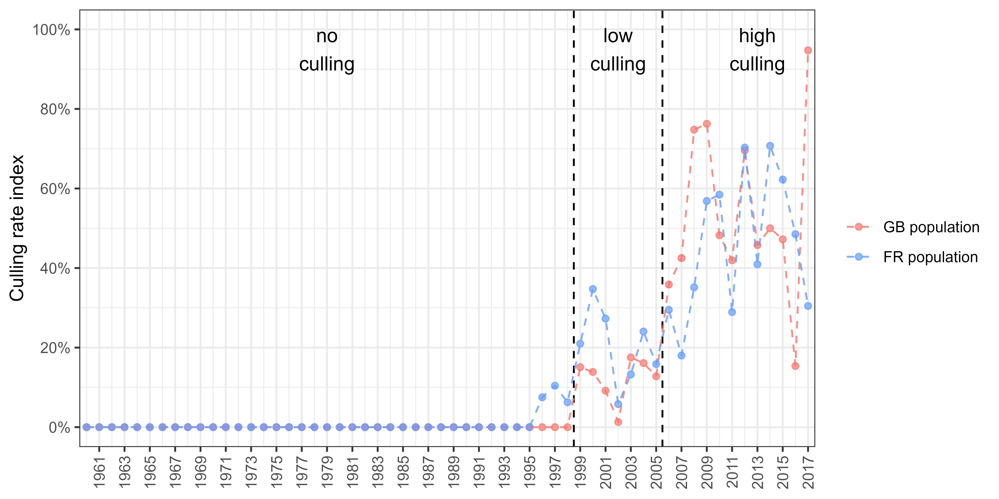

Figure 5.1: Definition of three periods of different culling pressures from an index based on an estimation of adult culling rate; as only half of the culled individuals were aged in France before 2009, we applied the average age ratio over 2009-2019 on unaged individuals to provide an estimate of the number of adults in removals before 2009; culling rate increased over time, we therefore split the time series in three categories : we defined a “no culling” period before 1999 because the culling rate for both countries was mostly null and always below 10%, we defined a “low culling” between 1999 and 2005 because the culling rate varied around 20% for both countries, the culling rate then raised significantly for both countries, so we defined a “high culling” period from 2006 onwards

1. Office Français de la Biodiversité, France - [adrien.tableau@ofb.gouv.fr](mailto:adrien.tableau@ofb.gouv.fr)
2. Animal and Plant Health Agency, United Kingdom - [iain.henderson@apha.gov.uk](mailto:iain.henderson@apha.gov.uk)
3. Société Nationale pour la Protection de la Nature, France - [sebastien.reeber@snpn.fr](mailto:sebastien.reeber@snpn.fr)
4. Office Français de la Biodiversité, France - [matthieu.guillemain@ofb.gouv.fr](mailto:matthieu.guillemain@ofb.gouv.fr)
5. Office Français de la Biodiversité, France - [jean-francois.maillard@ofb.gouv.fr](mailto:jean-francois.maillard@ofb.gouv.fr)
6. Office Français de la Biodiversité, France - [alain.caizergues@ofb.gouv.fr](mailto:alain.caizergues@ofb.gouv.fr)