Game Design Document

## Team MKEA

Contents

Team MKEA 1

Title: 3

Target Audience: 3

Core Gameplay: 3

Avoid hazards: 3

Solving puzzles: 3

Mechanics: 3

Physics: 3

Projectiles: 3

Object interaction: 3

Goals: 4

Player activities: 4

Game flow: 4

Game world: 4

Game Objects: 4

Algorithms: 4

Interfaces: 4

Assets required: 4

Title:  
Genre:   
Platformer, Puzzle

Target Audience:   
The game should be rated PG as it is likely to include minor violence such as shooting/attacking enemies and hazards, which won’t be too graphic. However, the dark atmosphere may be unsuitable for unattended younger audiences.

Core Gameplay:

Avoid hazards:  
The player will have to traverse across the map while avoiding the several types of hazards which will either damage or slow the player. Avoiding these hazards, is mostly possible but sometimes hazards that slowing the player may not be avoidable and can add to the challenge.

Solving puzzles:  
To make the game stand out a little there will be minor puzzles which players will have to solve in order to progress through the level. These puzzles will mostly be based on the flashlight mechanic such that the player should use the flashlight if they wish to easily clear it. These puzzles may include hidden objects that are only visible when the flashlight is on and focused on the object or hidden paths that are only seen when the flashlight is on.  
  
Dealing with enemies:  
Enemies will consist on one or two types depending on the time schedule, enemies are yet to be given a theme but one will run at the player to melee attack, while another enemy type will have a ranged attack, which can be dodged by the player. These enemies may or may not be visible based on the light level. The flashlight, when on will freeze the enemy if it shines upon it.

Mechanics:

## Physics:

The player, enemies, objects and projectiles will have basic physics including gravity, some such as interactable objects will also be destroyed, pushed or picked up/dropped.

Projectiles:   
Players will have to avoid most projectiles, which some will be more effect by gravity then others, just as some may be faster. Some of these can destroy game objects or parts of a level, causing the player to be unable to interact with the broken object until it respawns.

Object interaction:  
There will be several interactable objects in the game that the player may use to try and solve puzzles.

Goals:   
Complete objectives and reach the end of the level

Player activities:   
Exploration, combat, puzzle solving, platforming

Game flow:   
You will start with just your flashlight but you may find pickups that will modify the flashlight as the level progresses. These upgrades are reset between levels.

Game world:   
The game will be a 2d side-scroller filled with puzzles.

Include draft images here

Game Objects:   
Player, NPC’s, maps, traps, enemies and interactable objects.

# Controls:

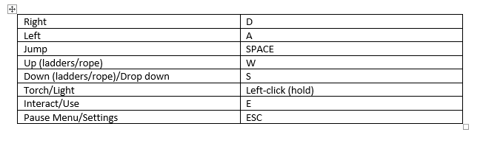

# Menu Systems:

Pause menu:  
Containing sound and music settings as well as fullscreen

Settings Menu:  
containing sound, fullscreen, vsync on/off,

Algorithms:   
These will be the main ones needed in this game, there may be some smaller ones that we have not planned for.

Pathfinding:  
Enemies will use pathfinding to attack/ evade the player, each enemy may have a different pathfinding algorithm and act differently from each other depending on how far through development we get.

Targeting:   
Same as above some of these will be used for ranged enemies, traps and if the player picks up an item that targets.

## Projectiles:

Projectiles might require basic arcing/ gravity calculated trajectories.

Interfaces:

The following features will be included in the main user interface of the game:

* Lives/health
* Score/timer
* Pause button
* Flashlight battery

The game and its interfaces shall have a dark theme to create a dark atmosphere. However, it is currently not intended to be scary.

Assets required:   
2D character and enemy assets, object assets, map assets, sound & music assets, animation

Potential assets for character

https://maaot.itch.io/mossy-cavern

<https://trixelized.itch.io/starstring-fields>

<https://0x72.itch.io/16x16-industrial-tileset>

potential torch

<https://corwin-zx.itch.io/dungeon-tileset>

enemies:

[**https://v3x3d.itch.io/deep-night**](https://v3x3d.itch.io/deep-night)