Adrian Azan & Keegan Burnett

DBMS

Prog 3

User manual

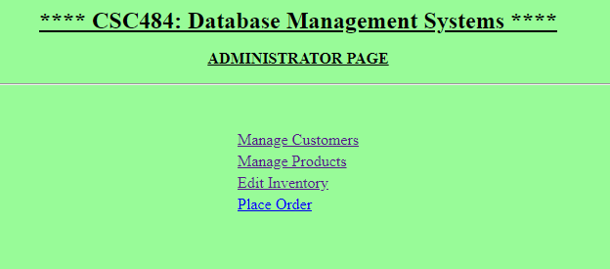

This is the main page for the program. There are four links to choose from as shown in the picture above.

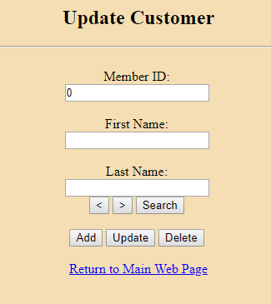

On the update customers page you have four main options to choose from.

* Add – Add a new customer to the database
* Update – update customer information
* Delete – Delete a customer from the database.
* Search – Search for a Customer using one of any of the fields to the left.

When you are done you can return to the main webpage by clicking the link below.

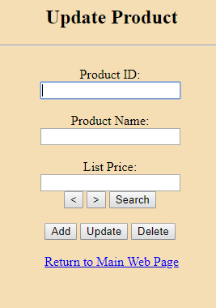

On the update products page you have four main options to choose from.

* Add – Add a new product to the database
* Update – update product information
* Delete – Delete a product from the database.
* Search – Search for a Product using one of either the top two fields to the left.

When you are done you can return to the main webpage by clicking the link below.

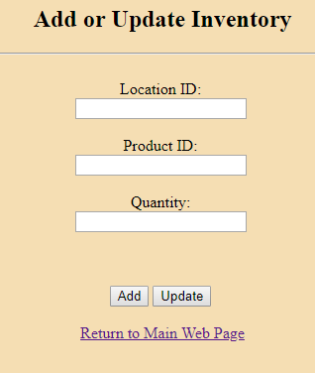

On the add or update inventory page you have two main options to choose from.

* Add – Add a new inventory information
* Update – update inventory information

When you are done you can return to the main webpage by clicking the link below.