|  |  |  |
| --- | --- | --- |
| |  |  | | --- | --- | | What is this resource?  An introduction to Bloom’s Taxonomy and its use in designing course learning objectives and assessments. | How do I use it?  Refer to the chart when composing course learning objectives and selecting appropriate assessment types. For assistance, please contact CET instructional designers at [usccet@usc.edu](mailto:usccet@usc.edu) | |

Bloom’s taxonomy is a very useful classification model for learning objectives. It was first proposed by Benjamin Bloom in 1956 and slightly revised in 2001.

Bloom’s taxonomy organizes learning objectives according to the type of learning that is being developed. It also has types of learning ranked from low to high, with the lowest level of learning being the recall of facts and basic concepts, and the highest level being creation of original work. The skills toward the top of the pyramid involve what we call higher-level thinking.

Note that there is no implication that learning at the top of the pyramid is more valid or valuable than at the bottom. In some cases, simple remembering skills are exactly what’s needed in a situation, sometimes it’s creation. It depends on the goals being achieved. Below is a diagram of Bloom’s Taxonomy.

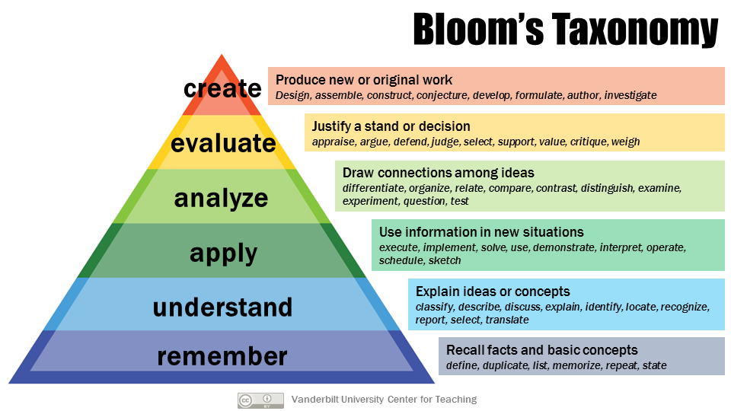

Bloom’s Taxonomy is frequently used in course design. Once the taxonomic level of desired learning is decided, the chart below suggests relevant action verbs that can be used in written learning objectives. The chart also suggests appropriate types of assessments or assignments.

### Verbs & Assessments for Each Level of Bloom’s Taxonomy

|  |  |  |  |
| --- | --- | --- | --- |
| Remember | | | |
| **Action verbs for learning objectives** | | | **Appropriate assessment types** |
| Define  Identify  Describe  Label  List  Match  Select  Recall  Name | State  Quote  Reproduce  Tabulate  Tell  Copy  Duplicate  Arrange  Underline | Enumerate  Omit  Recite  Record  Repeat  Retell  Outline  Recognize  Locate | Fill-in-the-blank  Multiple choice  Labeling  Matching  Short written response  Worksheet  Workbook |

|  |  |  |  |
| --- | --- | --- | --- |
| Understand | | | |
| **Action verbs for learning objectives** | | | **Appropriate assessment types** |
| Explain  Describe  Paraphrase  Summarize  Compare  Discuss  Predict  Convert  Give examples  Order | Interpret  Classify  Distinguish  Associate  Demonstrate  Express  Indicate  Estimate  Translate | Infer  Relate  Cite  Generalize  Rewrite  Trace  Transform  Group  Illustrate | Essay  Exam  Problem set  Class discussion  Concept map  Oral report  Outline  Story problem  Dramatization  Debate |

|  |  |  |  |
| --- | --- | --- | --- |
| Apply | | | |
| **Action verbs for learning objectives** | | | **Appropriate assessment types** |
| Solve  Apply  Use  Calculate  Relate  Complete  Construct  Produce  Chart  Collect  Illustrate  Modify | Experiment  Dramatize  Manipulate  Paint  Prepare  Act  Administer  Compute  Develop  Change  Demonstrate | Employ  Explain  Interview  Operate  Practice  Predict  Simulate  Sketch  Discover  Schedule  Write | Problem set  Performance  Lab experiment  Simulation  Clinical work  Role play  Demonstration  Map  Diagram  Prediction  Model  Illustration |

|  |  |  |  |
| --- | --- | --- | --- |
| Analyze | | | |
| **Action verbs for learning objectives** | | | **Appropriate assessment types** |
| Analyze  Compare  Infer  Differentiate  Categorize  Correlate  Diagram  Organize  Plan  Test  Investigate | Classify  Contrast  Separate  Discriminate  Divide  Order  Subdivide  Survey  Dissect  Estimate  interpret | Advertise  Conclude  Deduce  Devise  Outline  Plan  Troubleshoot  Illustrate  Deconstruct  Diagram  Group | Case study  Critique  Lab experiment  Essay  Project  Debate  Concept map  Reflection  Data analysis  Spreadsheet  Graph |

|  |  |  |  |
| --- | --- | --- | --- |
| Evaluate | | | |
| **Action verbs for learning objectives** | | | **Appropriate assessment types** |
| Critique  Evaluate  Appraise  Decide  Recommend  Convince  Defend  Find errors  Score  Argue | Judge  Support  Discriminate  Assess  Measure  Grade  Rank  Select  Rate  Weigh | Conclude  Consider  Debate  Justify  Persuade  Appraise  Monitor  Detect  Validate | Journal  Diary  Critique  Problem set  Product review  Study  Peer review  Revision  Survey  Editorial |

|  |  |  |  |
| --- | --- | --- | --- |
| Create | | | |
| **Action verbs for learning objectives** | | | **Appropriate assessment types** |
| Design  Compose  Create  Formulate  Hypothesize  Compile  Modify  Rewrite  Generate  Improve  Revise | Plan  Write  Compile  Construct  Develop  Integrate  Organize  Structure  Act  Arrange | Prepare  Assemble  Collaborate  Devise  Make  Negotiate  Facilitate  Propose  Show  Invent | Research project  Musical composition  Performance  Essay  Business plan  Product design  Job aid  Infographic  Portfolio  Poem  Advertisement  Video  Blueprint |

References:

<http://www.fresnostate.edu/academics/oie/documents/assesments/Blooms%20Level.pdf>  
[www.literacychick.com/uploads/7/7/4/0/7740257/200+_blooms_verbs.docx](http://www.literacychick.com/uploads/7/7/4/0/7740257/200+_blooms_verbs.docx)  
<http://www.cmu.edu/teaching/assessment/basics/alignment.html>   
<https://www.cloud.edu/Assets/PDFs/assessment/revised-blooms-chart.pdf>