PLANNING AND EXECUTION OF THE PROJECT BY USING UDP

At the end of this document, we will be able to answer these three questions:

**1 How long will the project take?**

**2 When will the project will finish?**

**3 How much will the project cost?**

Firstly, we have to be prepared to develop the project. We need some software and technology to start:

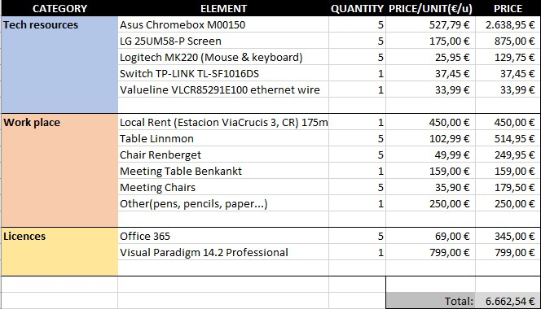

Then, we have noted down the functional requirements for the client and the server we are going to implement.

|  |  |
| --- | --- |
| CFR.#. | Functional Requirement |
| CFR.1. | It should allow the management and the creation and login of users. |
| CFR.2. | It should support the acquisition of songs or albums, implying also manage payments. |
| CFR.3. | It should support playback of songs and albums, in streaming, from files stored on the device when this allows storage. |
| CFR.4. | It should support deletion and modification of lists of songs. |

|  |  |
| --- | --- |
| SFR.#. | Functional Requirement |
| SFR.01. | It should support the addition of new songs and albums with their corresponding prices to be purchased individually as in the album in which have been published. |
| SFR.02. | It should support the modification of the metadata of the songs, as well as the price. |
| SFR.03. | It should support the deletion of songs and albums. |
| SFR.04. | It should support the search for songs by albums, artists, or title. |
| SFR.05. | It should support the automatic and manual creation of users. |
| SFR.06. | It should support the purchase of products (albums or songs) by users, keeping a list of who bought what, and allow payments through payment networks (PayP type * l) |
| SFR.07. | It should support the Elimination of users. |
| SFR.08. | It should support sending messages to users. |

For simplicity, one functional requirement will be mapped into one use case:

**FR-----UC**

**1-----1**

1-----n

n-----1

n-----m

|  |  |  |
| --- | --- | --- |
| **CFR.#.** | **CUC.#.** | **Use Case** |
| CFR.1. | CUC.1. | Manage, create and login of users |
| CFR.2. | CUC.2. | Obtain songs or albums managing payments. |
| CFR.3. | CUC.3. | Playback of songs and albums, in streaming, from files stored on the device when this allows storage. |
| CFR.4. | CUC.4. | Delete and modify lists of songs. |

|  |  |  |
| --- | --- | --- |
| **SFR.#.** | **SUC.#.** | **Use Case** |
| SFR.01. | SUC.1. | Add songs and albums with their prices. |
| SFR.02. | SUC.2. | Modify metadata and price of the songs. |
| SFR.03. | SUC.3. | Delete songs and albums. |
| SFR.04. | SUC.4. | Search for songs by albums, artists or title. |
| SFR.05. | SUC.5. | Automatic and manual creation of users. |
| SFR.06. | SUC.6. | Purchase of products (albums or songs) by users, keeping a list of who bought what, and allow payments through payment networks (PayP type * l) |
| SFR.07. | SUC.7. | Delete users. |
| SFR.08. | SUC.8. | Send messages to users. |

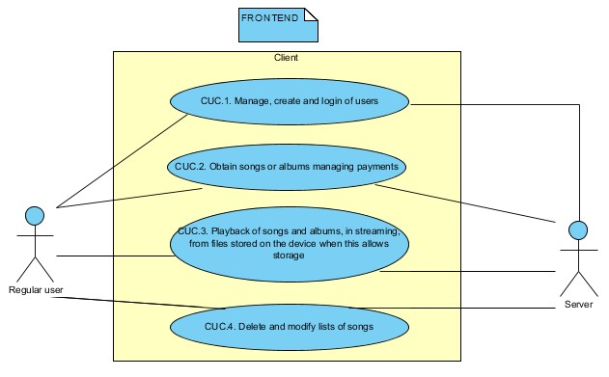

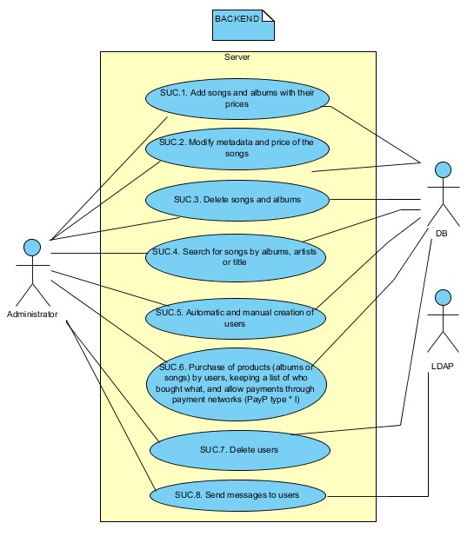

|  |  |
| --- | --- |
| P | SUC.#. |
| 1 | SUC.1. |
| 2 | SUC.5. |
| 3 | SUC.2. |
| 4 | SUC.6. |
| 5 | SUC.3. |
| 6 | SUC.7. |
| 7 | SUC.4. |
| 8 | SUC.8. |

The use of cases are established in a priority order due to there are functionalities which can’t be generated until another one has been completed before because it depends on this.

|  |  |
| --- | --- |
| P | CUC.#. |
| 1 | CUC.1. |
| 2 | CUC.2. |
| 3 | CUC.4. |
| 4 | CUC.3. |