This is a Guido created for GeoDevelopers to concrete the way that our teams should work with git repositories and direct commits with eclipse.

1.- Open eclipse and go to the tab of: Help >> Install new software

2.- In the box of work with write EGit, selecta ll the boxes and next.

3.- Keep installing the plugin until it asks to restart eclipse.

4.- Importing a new git:

4.1.- Right click in the package explorer and import

4.2.- Select Git >> Projects from Git >> Next >> Clone with URI >> Next

4.3.- A new window will appear, there u have to paste the link of the git, but this one and click next

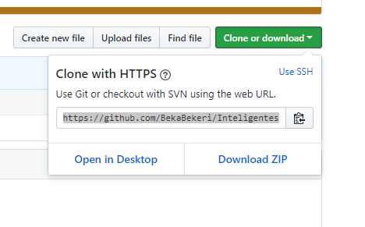

4.4.- Keep installing, select the path and here select this option:

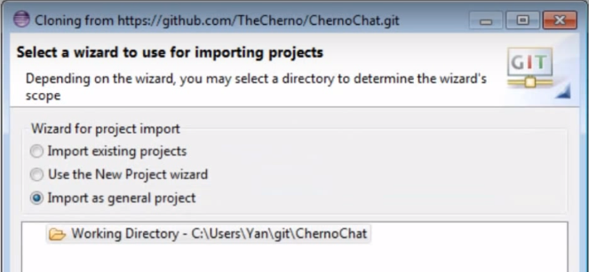

4.5.- Then next, and finish.

5.- To submit changes to the git, its needed to follow this steps:

5.1 Work normaly on the Project (always the one that contains NAME[NAME master]}

5.2 When everything is finished, sabe the Project and right clock on it.

5.3 Select Team >> Commit

5.4 From “Unstaged Changes” drag the files that u need to update to the window “Staged Changes”

5.5 Also a comment has to be added as a description of the commit.

5.6 Finally, press commit and push button and finich the commit.

