**Sichuan cuisine**, **Szechwan cuisine**, or **Szechuan cuisine** is a style of [Chinese cuisine](https://en.wikipedia.org/wiki/Chinese_cuisine) originating from [Sichuan Province](https://en.wikipedia.org/wiki/Sichuan). It has bold flavours, particularly the pungency and spiciness resulting from liberal use of [garlic](https://en.wikipedia.org/wiki/Garlic) and [chili peppers](https://en.wikipedia.org/wiki/Chili_pepper), as well as the unique flavour of [Sichuan pepper](https://en.wikipedia.org/wiki/Sichuan_pepper). There are many local variations within Sichuan Province and the neighbouring [Chongqing Municipality](https://en.wikipedia.org/wiki/Chongqing), which was part of Sichuan Province until 1997. Four sub-styles of Sichuan cuisine include Chongqing, [Chengdu](https://en.wikipedia.org/wiki/Chengdu), [Zigong](https://en.wikipedia.org/wiki/Zigong) and [Buddhist](https://en.wikipedia.org/wiki/Buddhist) [vegetarian](https://en.wikipedia.org/wiki/Vegetarian) style。

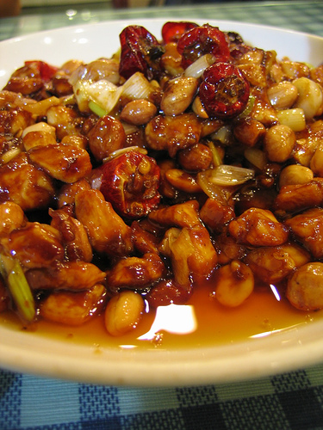

Hot pot

视频

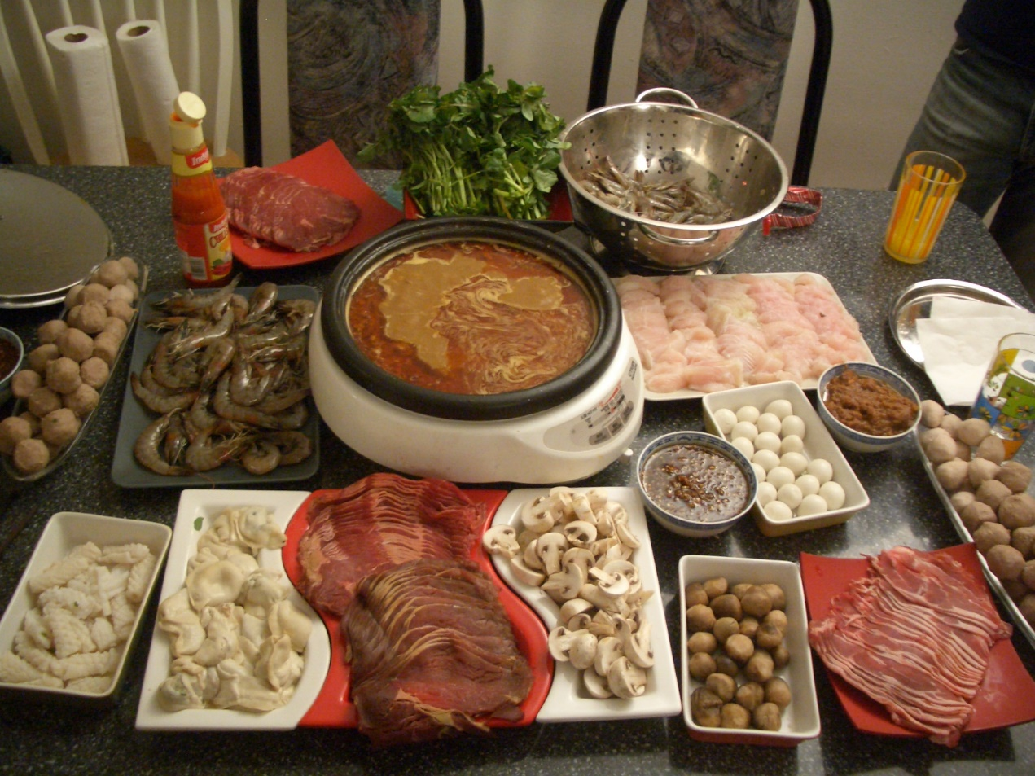s

Kung Pao chicken

**Kung Pao chicken** ([Chinese](https://en.wikipedia.org/wiki/Simplified_Chinese_characters): 宫保鸡丁), also [transcribed](https://en.wikipedia.org/wiki/Romanization_of_Chinese) as **Gong Bao** or **Kung Po**, is a [spicy](https://en.wikipedia.org/wiki/Spicy), [stir-fried](https://en.wikipedia.org/wiki/Stir_frying) Chinese dish made with chicken, peanuts, vegetables, and [chili peppers](https://en.wikipedia.org/wiki/Chili_pepper). The classic dish in [Sichuan cuisine](https://en.wikipedia.org/wiki/Sichuan_cuisine) originated in the [Sichuan Province](https://en.wikipedia.org/wiki/Sichuan) of south-western China and includes [Sichuan peppercorns](https://en.wikipedia.org/wiki/Sichuan_pepper). Although the dish is found throughout China, there are regional variations that are typically less spicy than the Sichuan serving. Kung Pao chicken is also a staple of westernized Chinese cuisine.

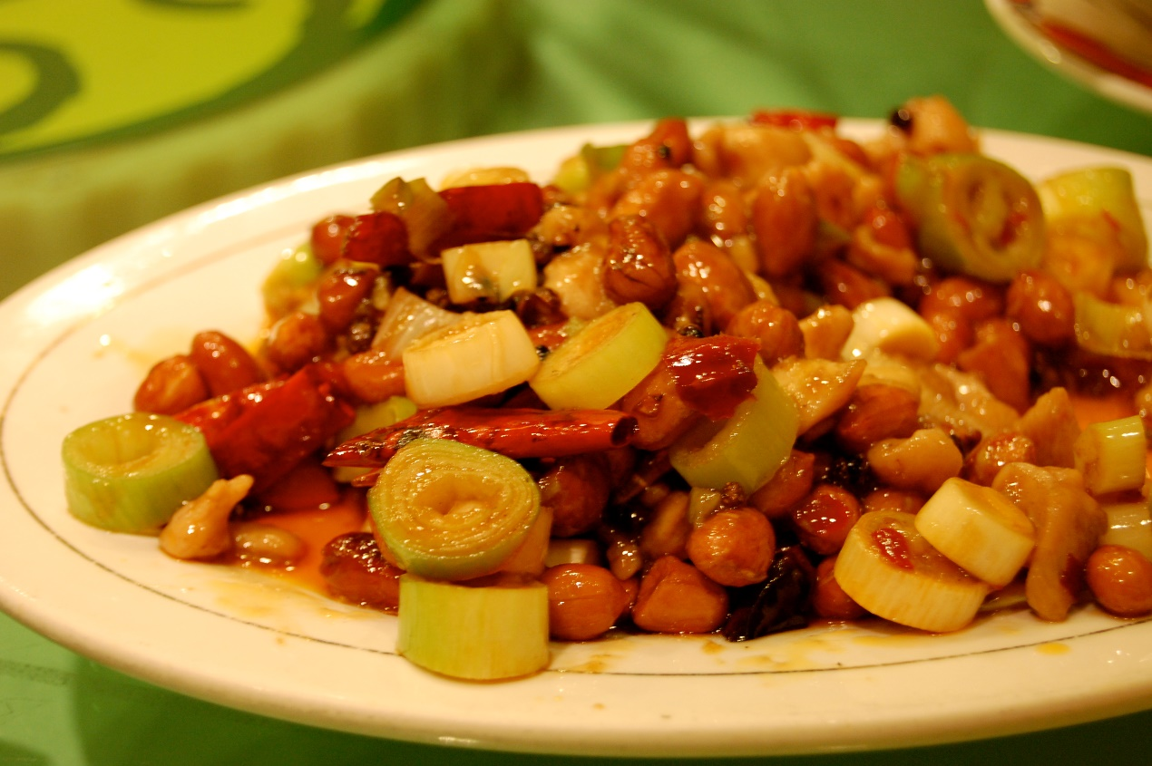

Dandan noodles

**Dandan noodles** or ***dandanmian*** is a [noodle](https://en.wikipedia.org/wiki/Noodle) dish originating from [Chinese](https://en.wikipedia.org/wiki/China) [Sichuan cuisine](https://en.wikipedia.org/wiki/Szechuan_cuisine). It consists of a spicy sauce usually containing preserved vegetables (often including [*zha cai*](https://en.wikipedia.org/wiki/Zha_cai), lower enlarged [mustard](https://en.wikipedia.org/wiki/Mustard_(plant)) stems, or [*ya cai*](https://en.wikipedia.org/wiki/Ya_cai) (芽菜), upper mustard stems), [chili oil](https://en.wikipedia.org/wiki/Chili_oil), [Sichuan pepper](https://en.wikipedia.org/wiki/Sichuan_pepper), minced pork, and [scallions](https://en.wikipedia.org/wiki/Scallion) served over noodles.

[Sesame paste](https://en.wikipedia.org/wiki/Sesame_paste) and/or [peanut butter](https://en.wikipedia.org/wiki/Peanut_butter) is sometimes added, and occasionally replaces the spicy sauce, usually in the [Taiwanese](https://en.wikipedia.org/wiki/Taiwan) and [American Chinese](https://en.wikipedia.org/wiki/Chinese_American_cuisine) style of the dish.[[1]](https://en.wikipedia.org/wiki/Dandan_noodles#cite_note-1) In this case, *dandanmian* is considered as a variation of *ma jiang mian* (麻醬麵), sesame sauce noodles. In American Chinese cuisine, *dandanmian* is often sweeter, less spicy, and less soupy than its Sichuan counterpart.

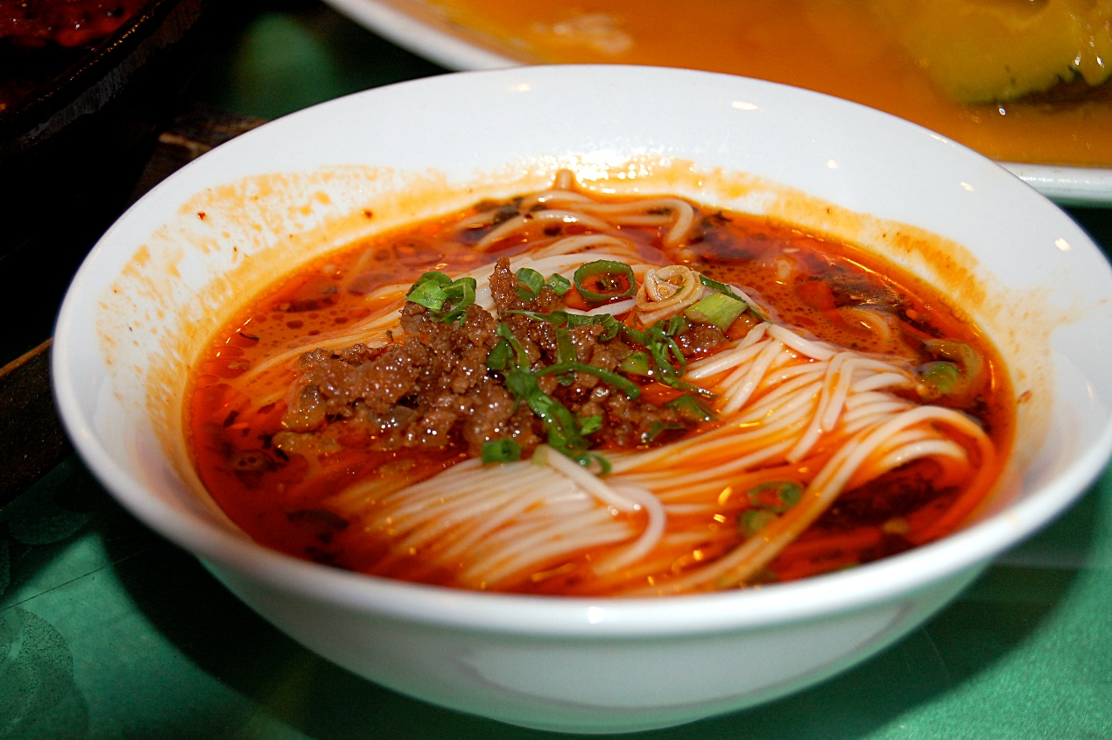

Bon bon chicken

**Bon bon chicken** is a popular dish in [Chinese cuisine](https://en.wikipedia.org/wiki/Chinese_cuisine). The name *bang bang chicken* is derived from the manner in which the meat is [tenderized](https://en.wikipedia.org/wiki/Tenderize) using a stick or hammer.

Someone came up with a strategy: cut the whole chicken into thin slices and sell it by slice. This strategy proved to be very effective, and "chicken slices" gained a good reputation. However, another problem occurred: a [kitchen knife](https://en.wikipedia.org/wiki/Kitchen_knife) could not cut a whole chicken into slices evenly, and customers are often picky when making purchases. However, it was found that beating the chicken into pieces with a giant stick would solve this problem. At the same time, juice broth infuses into the chicken and adds flavor. When preparing the dish, one holds a stick and another holds a knife; the sound made by the stick and the knife striking each other has a rhythmic, almost musical quality, hence the name *bang bang chicken*.

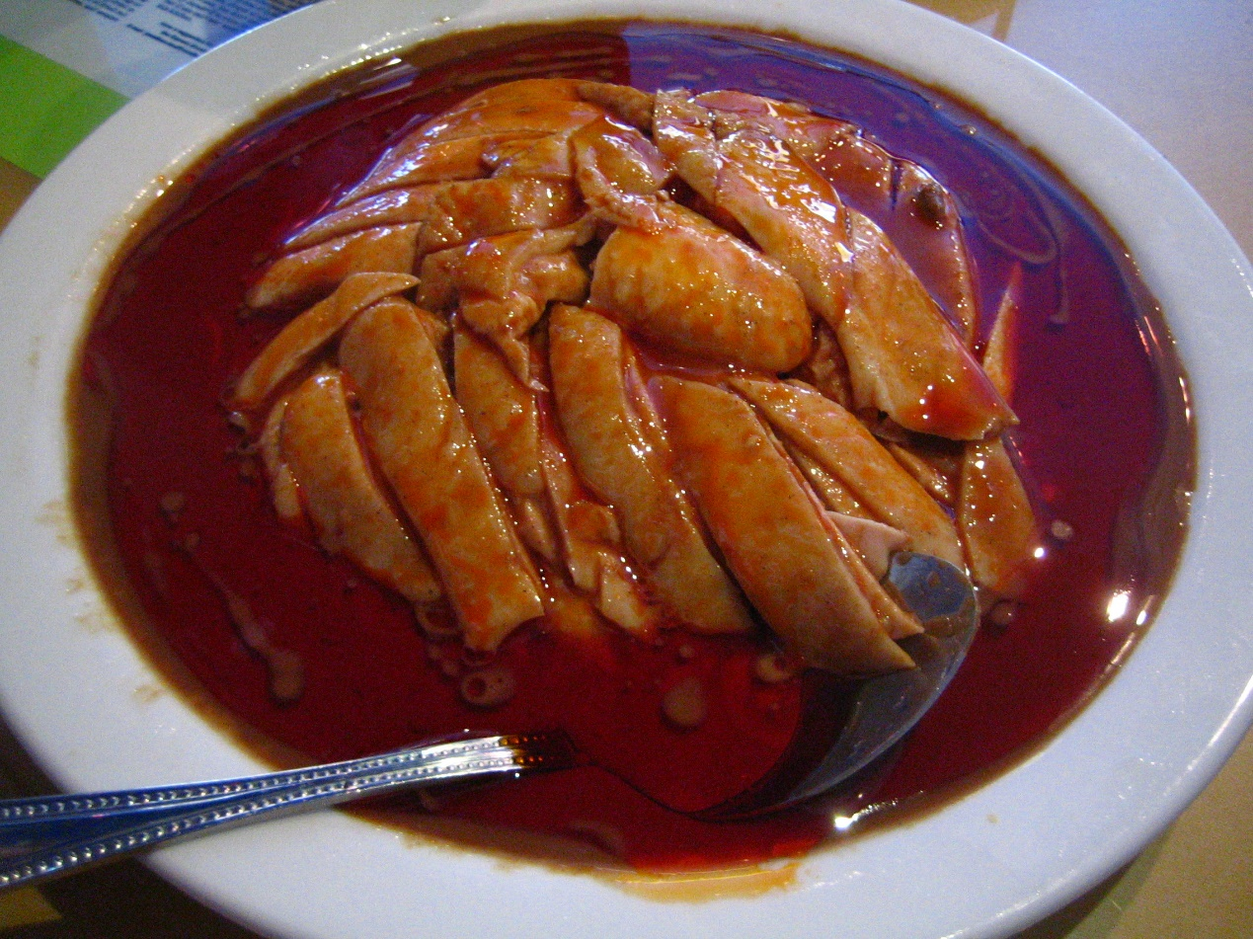

Twice-cooked pork

**Twice-cooked pork** or **double-cooked pork** is a [Sichuan-style](https://en.wikipedia.org/wiki/Sichuan_cuisine) Chinese dish. The dish's ingredients include [pork](https://en.wikipedia.org/wiki/Pork), which is simmered, sliced, and stir-fried; commonly stir-fried vegetables such as cabbage, bell peppers, onions, or scallions; and a sauce that may include Shaoxing rice wine, [hoisin sauce](https://en.wikipedia.org/wiki/Hoisin_sauce), soy sauce, sugar, ginger, chili bean paste, and [tianmianjiang bean paste](https://en.wikipedia.org/wiki/Tianmianjiang_bean_paste).

