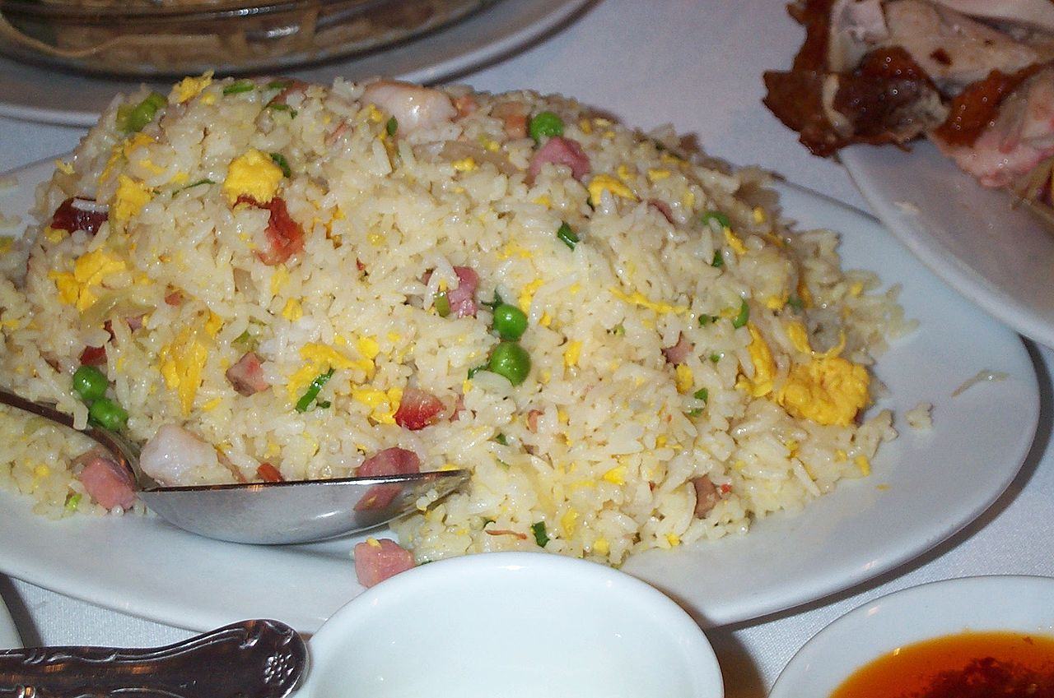

**Yangzhou fried rice or Yeung Chow fried rice**

**Yangzhou fried rice or Yeung Chow fried rice** is a popular Chinese-style wok fried rice dish in many Chinese restaurants throughout the world. It is commonly sold in the UK as special fried rice and in the US as house fried rice.

**Ingredients:**

The ingredients vary, but some of its staple items include:

Cooked rice (preferably day old because freshly cooked rice is too sticky due to higher water content)

Cooked shrimp

Diced cha shao/char siu pork or lap cheong

Scallions (spring onions or green onions), chopped, including green end

fresh vegetables such as kai-lan, carrots, peas, corn, bamboo shoots, etc.

Egg

Bits of sea cucumber and crab meat

The peas may be a replacement for the green onions. Some recipes include Shaoxing wine. Some western Chinese restaurants also use soy sauce to flavor the rice, and add meat such as chicken.

**History:**

Yangzhou fried rice is a perhaps the most well-known dish of the city of Yangzhou, Jiangsu province. The recipe was invented by Qing China's Yi Bingshou (1754-1815) and the dish was named Yangzhou fried rice since Yi was once the regional magistrate of Yangzhou. It is often served with thousand fish soup. There are two ways of cooking the dish in terms of the preparation of the egg scrambled. The first variation is known as "silver covered gold", in which the egg is scrambled separately before mixing with the rice. The alternative "gold covered silver" method is described as pouring the liquid egg over the rice and vegetables mix and frying the two together. Various traditions call for a rice–egg ratio of 5:1 or 3:1.

**Controversy regarding world record:**

Controversy regarding world record[edit]

In October 2015, as part of the 2500-year anniversary of the town of Yangzhou, an attempt was made in Yangzhou at beating the previous world record for fried rice set in 2014 by the Turkey culinary federation. The attempt, made by the World Association of Chinese Cuisine resulted in 4,192 kilograms (9,242 lb) of Yangzhou fried rice being produced by a team of 300 cooks.[2] The organisers initially planned to send the end product to five companies for consumption by their staff. However, about 150 kilograms (330 lb) of it ended up as pig swill as it had been cooked for four hours and was felt unsuitable for human consumption. As per organisers, the rest was sent to local canteens.[3] However, due to a part of it being sent to feed animals, the world record attempt was disqualified, as a Guinness World Records spokesman said that it had become obvious that the dish was not fit for human consumption.

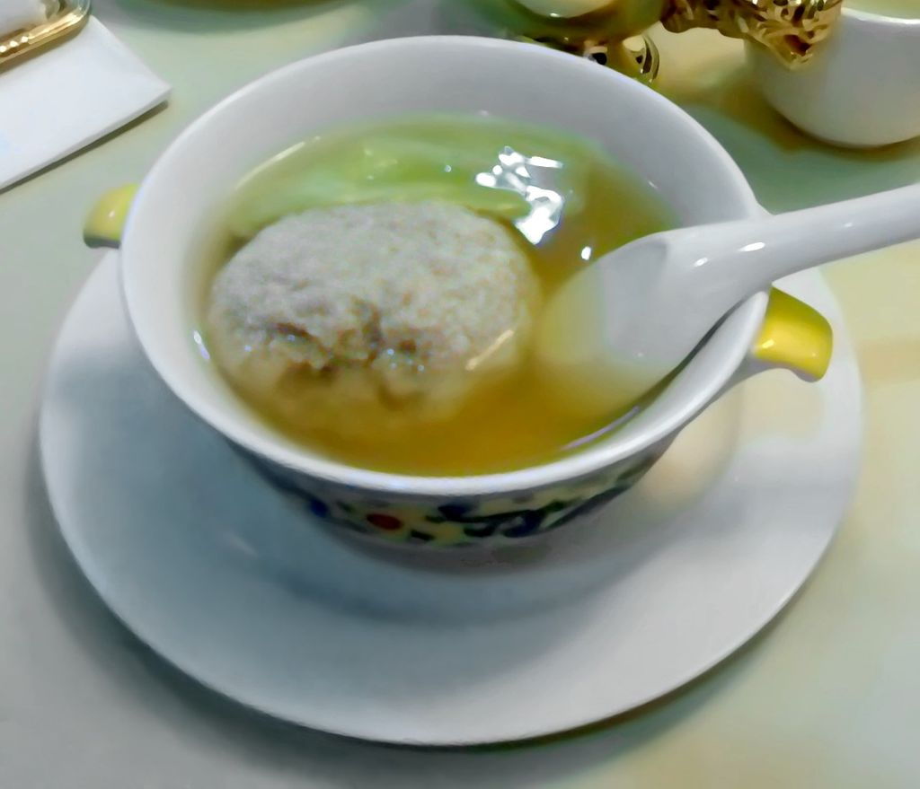

**Lion’s Head**

**Lion's Head or stewed meatball** is a dish from the Huaiyang cuisine of eastern China, consisting of large pork meatballs stewed with vegetables. There are two varieties: white (or plain), and red (红烧, cooked with soy sauce). The plain variety is usually stewed or steamed with napa cabbage. The red variety can be stewed with cabbage or cooked with bamboo shoots and tofu derivatives. The minced meat rich in fat is more likely to bring better texture, addition of chopped water chestnut also works.

The name "lion's head", derives from the shape of the meatball which is supposed to resemble the head of the Chinese guardian lion, specifically.

The dish originated in Yangzhou and Zhenjiang, to a lesser degree, Huai'an. While the plain variety more common in Yangzhou and the red variety more common in Zhenjiang. The dish became a part of Shanghai cuisine with the influx of migrants in the 19th and early 20th century.

The dish can also be prepared with beef or be made as a vegetarian dish.

**History:**

The dish has been well known since the late Qing, as the recipe extracted from Xu Ke's Qing bai lei chao attests:

Lion's head, is a pork meatball, its shape just as its name implies. The proportion of fat to lean pork is fifty-fifty, chop up them, then mix them with egg whites so that the mixture can coagulate easily. The shrimp meat or crab powder is an optional ingredient to mix. Put napa cabbage or bamboo shoots on the bottom of a clay pot, pour a little water and dissolve the salt in it. Make the meatballs as big as possible, put them in, then put leaves above the meatballs and put the lid on the pot. Place the pot in a wok filled with salt water, to avoid cracking in this way, cook over a gentle heat. stoke enough firewood at intervals, when the meat is medium, burn the wok fiercely until the meat is well done.

Earlier, a salt merchant from Yangzhou called Tong Yuejian who lived in the mid-Qing recorded a dish, dadian rouyuan , in his concise cookbook Tiaoding ji

The significant resemblance between the both dished indicates that the latter may be the prototype of the former, which is acceptable. It is said to date back to Sui dynasty in myth and folklore, but there is no evidence to support such a theory so far.

**Types:**

Stewed Meatballs with Crab Powder

This type is deemed to be the traditional one, its ingredients and procedure changed a little from the dish which mentioned above.

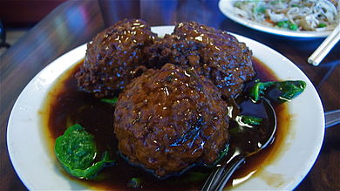

**Red-cooked (soy-braised) lion's head meatballs**

ribs of pork (proportion of fat and lean pork: 7:3)

crab roe

crab meat

napa cabbage

shrimp

Shaoxing wine

salt

infusion of garlic and scallions

starch

pork stock

lard