**Min cuisine**

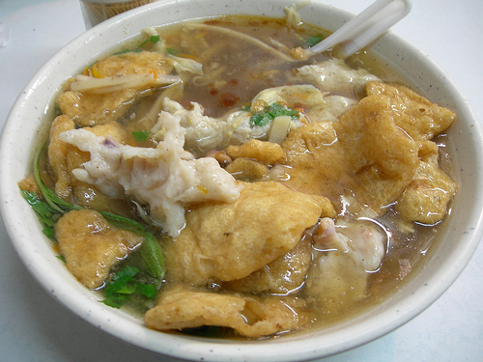

**Min cuisine**, also known as **Fujian cuisine**.

Fujian cuisine is known to be light but flavourful, soft, and tender, with particular emphasis on [umami](https://en.wikipedia.org/wiki/Umami) taste, known in Chinese cooking as *xianwei* (鲜味), as well as retaining the original flavour of the main ingredients instead of masking them.

Many diverse seafood and woodland delicacies are used, including a myriad variety of local fish, shellfish and turtles, or indigenous [edible mushrooms](https://en.wikipedia.org/wiki/Edible_mushroom) and [bamboo shoots](https://en.wikipedia.org/wiki/Bamboo_shoot), provided by the coastal and mountainous regions of Fujian. The most commonly employed [cooking techniques](https://en.wikipedia.org/wiki/Chinese_cooking_techniques) in the region's cuisine include [braising](https://en.wikipedia.org/wiki/Braising), stewing, steaming and boiling.

Particular attention is paid on the finesse of knife skills and cooking technique of the chefs, which is used to enhance the flavour, aroma and texture of seafood and other foods.[[2]](https://en.wikipedia.org/wiki/Fujian_cuisine#cite_note-zgds-2) Strong emphasis is put on the making and utilising of broth and soups.[[3]](https://en.wikipedia.org/wiki/Fujian_cuisine#cite_note-grigson-3) There are sayings in the region's cuisine: "One broth can be changed into numerous (ten) forms" (一汤十变) and "It is unacceptable for a meal to not have soup" (不汤不行).

(黄色字部分可删减)

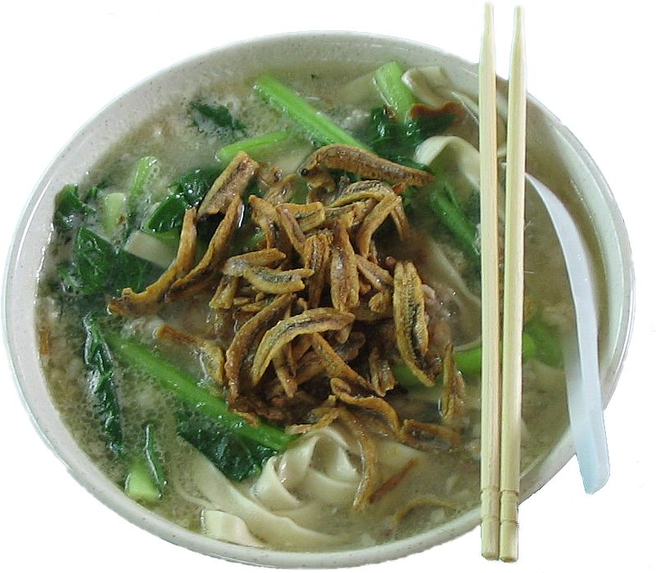

**Banmian** (板麵) is a popular Chinese noodle dish, consisting of handmade noodles served in soup.

The name *banmian* (board/block noodle) came from the Hakka's method of cutting the noodle into straight strands using a wooden block as ruler.

It consists of egg noodles served in a flavorful soup, often with some type of meat or fish, vegetables and various spices. The base of the entire meal is a soup, so there are numerous variations in ingredients, stocks and noodle shapes. In many instances, the completed soup is topped with an egg that is cooked in the hot liquid above the noodles.

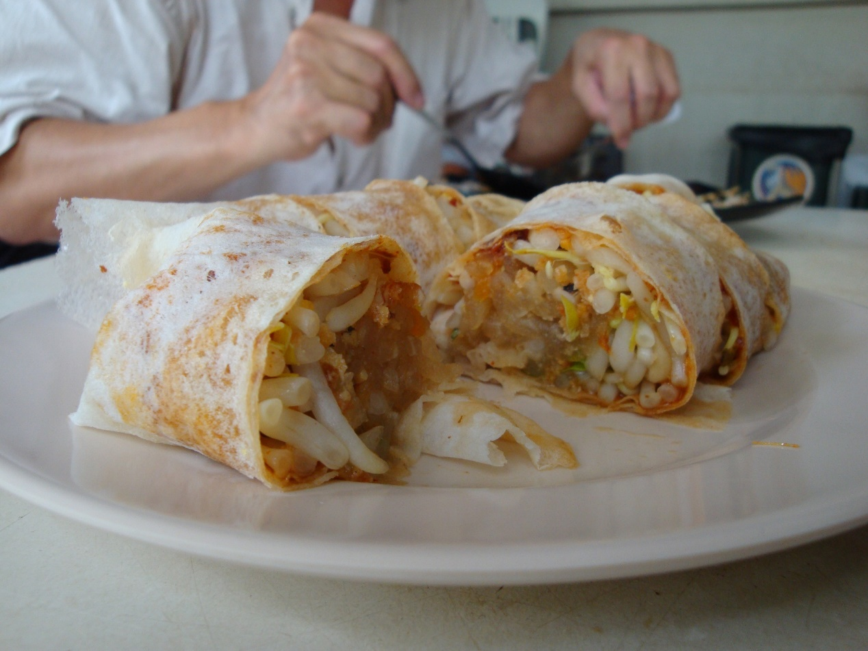

**Popiah** ([Pe̍h-ōe-jī](https://en.wikipedia.org/wiki/Pe%CC%8Dh-%C5%8De-j%C4%AB" \o "Pe̍h-ōe-jī): *po͘h-piáⁿ*) is a [Fujianese](https://en.wikipedia.org/wiki/Fujianese_cuisine)/[Chaoshan-style](https://en.wikipedia.org/wiki/Chaozhou_cuisine) fresh [spring roll](https://en.wikipedia.org/wiki/Spring_roll) common in [South East Asia](https://en.wikipedia.org/wiki/South_East_Asia).

A *popiah* "skin" (薄餅皮) is a soft, thin paper-like crepe or pancake made from wheat flour.

It is eaten in accompaniment with a sweet sauce, along with grated [carrots](https://en.wikipedia.org/wiki/Carrots), slices of [Chinese sausage](https://en.wikipedia.org/wiki/Chinese_sausage), thinly sliced fried [tofu](https://en.wikipedia.org/wiki/Tofu), chopped peanuts or peanut powder, fried shallots, and shredded [omelette](https://en.wikipedia.org/wiki/Omelette).

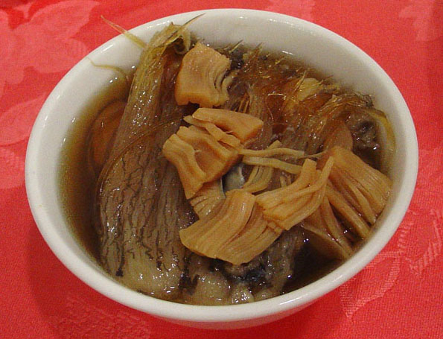

Buddha Jumps Over the Wall, also known as Buddha's Temptation, is a variety of shark fin soup in Fujian cuisine.It was created by Zheng Chunfa, celebrated chef and proprietor of the Ju Chun Yuan Restaurant in Fuzhou, Fujian Province. Zheng was private chef of a senior local official in his early years. Since its creation during the Qing dynasty (1644–1912),[1] the dish has been regarded as a Chinese delicacy known for its rich taste, and special manner of cooking. The dish's name is an allusion to the dish's ability to entice the vegetarian monks from their temples to partake in the meat-based dish.It is high in protein and calcium.

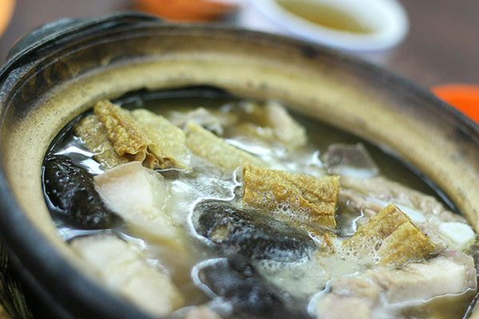

The name literally translates from hokkien(as "meat bone tea", and at its simplest, consists of meaty ribs simmered in a complex broth of herbs and spices (including star anise, cinnamon, cloves, dang gui, fennel seeds and garlic) for hours. Despite its name, there is in fact no tea in the dish itself; the name refers to a strong oolong Chinese tea which is usually served alongside the soup in the belief that it dilutes or dissolves the copious amount of fat consumed in this pork-laden dish.

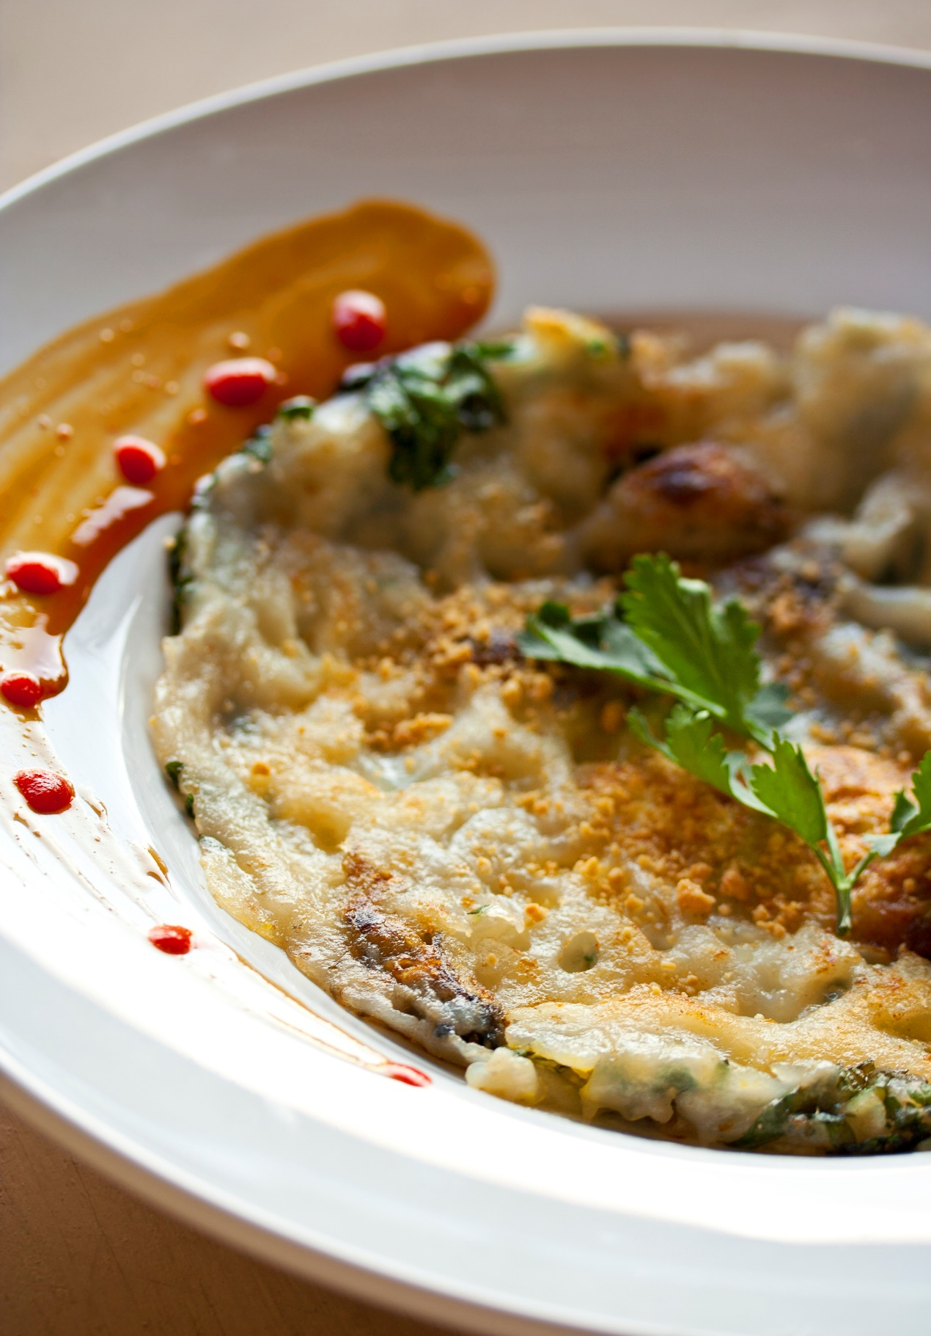

The oyster omelette (Chinese: 蚵仔煎; Pe̍h-ōe-jī: ô-á-chian) is a dish of Teochew origin that is widely known for its savoury taste in its native Chaoshan along with Taiwan, Fujian, and many parts of Southeast Asia due to the influence of the Chinese diaspora. Variations of the dish preside in some southern regions of China, although the taste and appearance of these can vary by a lot from the Taiwanese version. The oyster omelette is a Taiwanese "night market favorite", and has constantly been ranked by many foreigners as the top dish from Taiwan. Its generous proportions and affordable price demonstrates the trait of night market cuisines. It is also popular in other places with Chaoshan and Fujianese influences, such as in Hong Kong, Macau, Singapore, Thailand, Malaysia, Indonesia and Philippines.