Introduction:Hui cuisine, also known as "hui bang", is one of the eight major cuisines in China. Hui cuisine originated in the southern song dynasty period of huizhou mansion and Hui cuisine is ancient huizhou local characteristics. Its unique geography humanities environment gives Hui cuisine unique taste. Representative dishes: Sugar Taro,Braised scalpfish,Smelly mandarin fish,Huangshan hairy tofu etc.

As a famous dish in anhui province and the most representative dish of anhui cuisine, the selected taro root is rich in protein and various trace elements, which has certain benefits for the stomach and intestines, as well as purging and detoxifying effects. This taro root is crunchy and sweet in taste and bright in color.
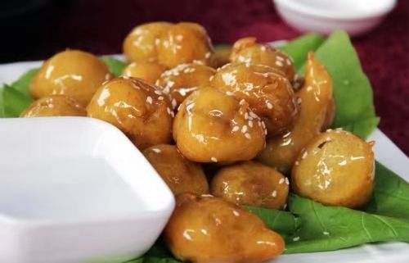

Braised braised skinless fish is a very delicious dish of hui cuisine. The meat of fish is tender, which, together with exquisite cooking techniques, does not taste fishy, and the more it is eaten, the more fragrant it is. Even fish soup can be eaten.
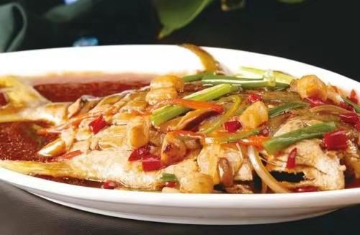

Now prevailing in northern anhui area, features: the ground chicken is very tender, and maintain the unique flavor of chicken. In the old rural POTS, bricks were often used to build clay POTS and add wood to the ground for cooking. Ground pan chicken is characterized by the use of charcoal, large iron pot to maintain the flavor of native dishes, pot paste a circle of dead pan. Crispy chicken cake when cooking.
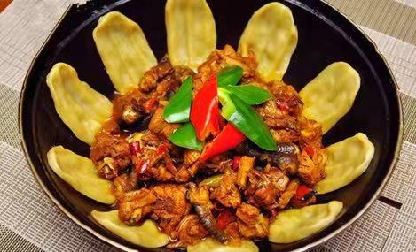

A popular dish named after Li Hongzhang, a prominent Qing dynasty statesman from Anhui Province. The dish, a complex soup, is somewhat salty with a taste of sweetness. Many ingredients are used in the soup but the most common ones include sea cucumber, fish, squid, bamboo, dry bean curd, chicken, ham and assorted vegetables.
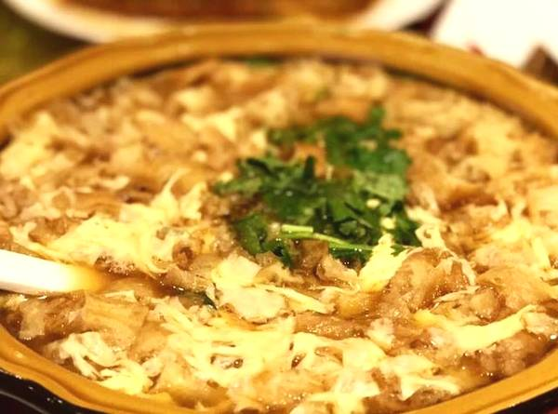
A popular dish from Hefei which first gained recognition when it was offered as tribute to the imperial court. While not as well known internationally as Peking duck, Luzhou roast duck has won awards and distinction within China.
