

**College of Science, Technology & Applied Arts of Trinidad & Tobago**

**DEPARTMENT OF INFORMATION TECHNOLOGY**

**GROUP ASSIGNMENT COVER PAGE**

**ASSIGNMENT TITLE: WEAKEST LINK**

**ASSIGNMENT SUBTITLE: SCRIPTING FINAL PROJECT**

**COURSE CODE: ITEC 245**

**COURSE TITLE: INTRODUCTION TO SCRIPTING LANGUAGES**

**CRN: 22020 SEMESTERS: 2**

**STUDENT NAME STUDENT I.D. PROGRAMME**

**ADRIAN JOHN 00061686 BSC. INTERNET TECHNOLOGY**

**AJAY CHAITOO 00063030 BSC. INTERNET TECHNOLOGY**

**AVISH RAMPERSAD 00054684 AAS. INTERNET TECHNOLOGY**

**DATE OF SUBMISSION: 24-05-2017**

**LECTURER’S NAME: KADEEM BEST**

**Table of contents**

**Project Functions……………………………………………………………………………………… 1 – 5**

**Group Members Contributions…………………………………………………………………… 6**

**Source Code (HTML)…………………………………………………………………………………7-14**

**Source Code (JavaScript)………………………………………………………………………….15-31**

**Source Code (CSS)……………………………………………….……………………………………32-35**

http://weakestlink.freeasphost.net/Final_Project_Group_2/html/index.html

**PROJECT FUNCTIONS**

**The homepage:**

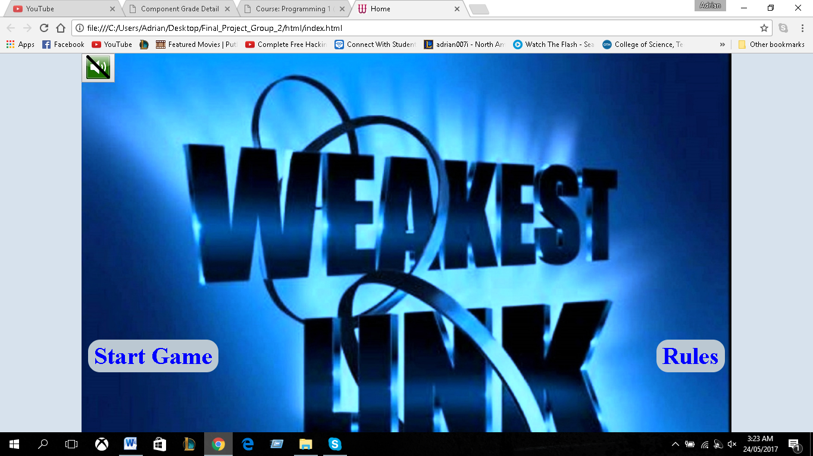

When the user visits the web application, they will get the option to start the game or view the rules of the game. At the top left corner, a button was used to for the user to turn on and off the audio.

**The rules page:**

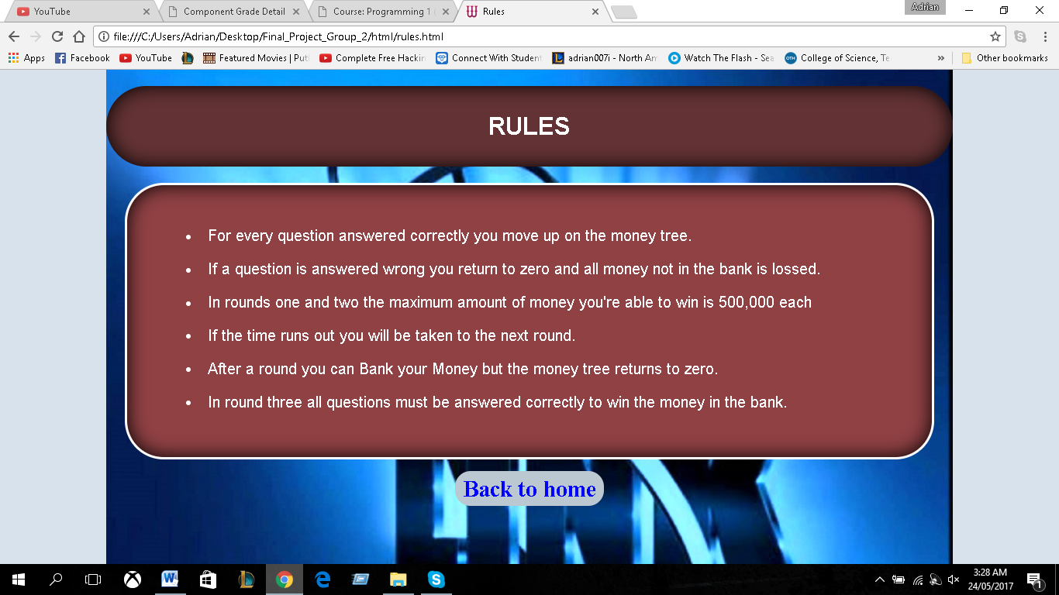

Asdaaaaaaaaaaaaaaa If the player isn’t sure about the game, then they could go the rules page, by clicking the hyperlink Here the user will view the rules and upon finishing, they would be provided with another hyperlink to take the user back to the home page.

**Player Information**

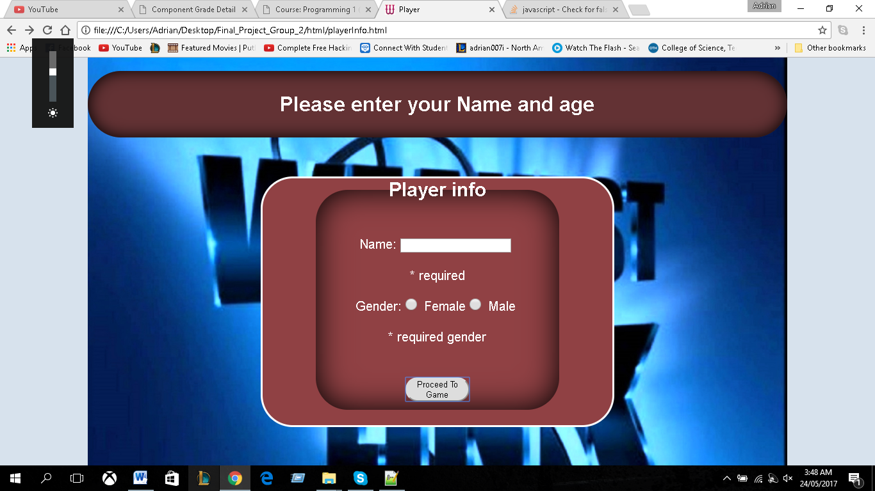

After the user is finish viewing the rules of the game, they could click the button to start playing. When the user clicks “click to play” on the homepage, they will be sent to this page where we will capture the users name and gender. Both form controls is validated to ensure the user enters accurate data. When the user fills out the form correctly they could now begin the game.

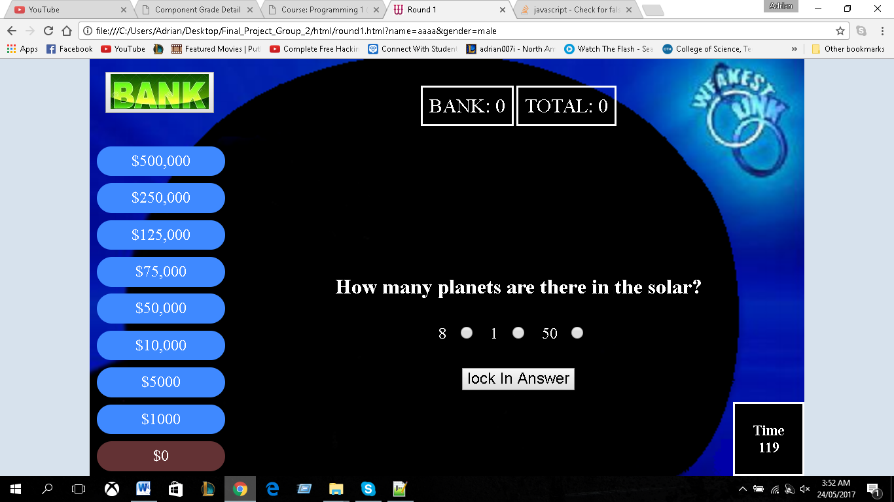**Round 1:**

//jjjjjjjjjjjj////////////////////;l The user will be given 120 seconds for this round where they will be asked a series of questions. If the user answers the question correctly, the background colour of the present position in the money tree will turn to blue and the position above will turn to brown. As shown below.

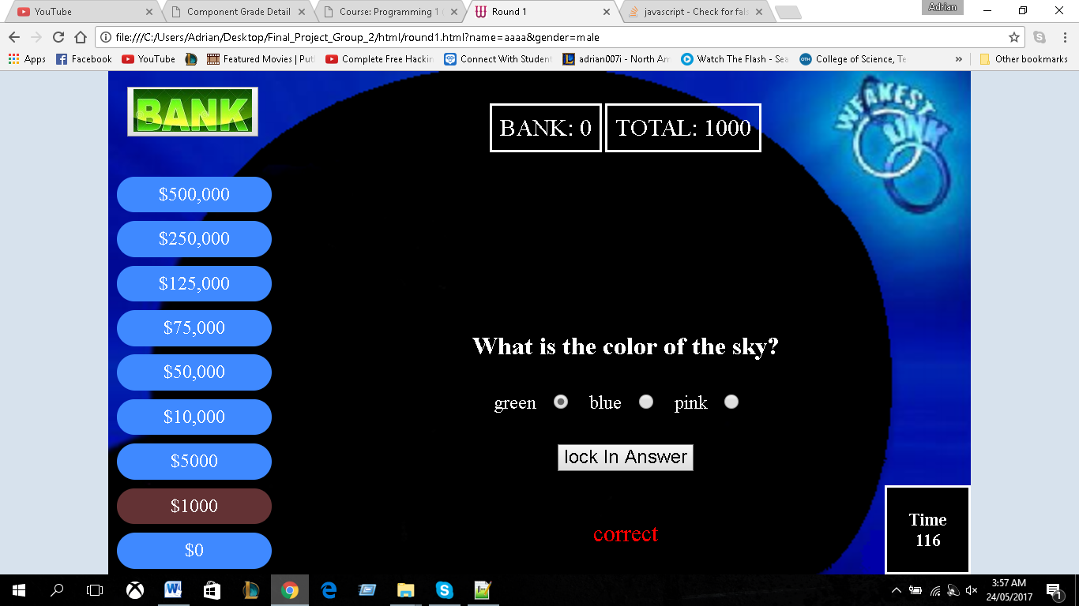

At the top-centre of the page, the money won and the bank amount will be displayed. As demonstrated above the user won $1000. so it is displayed in the cell. A simple message is also displayed, informing the user if they got the question right or wrong. The message is only displayed for 2 seconds.

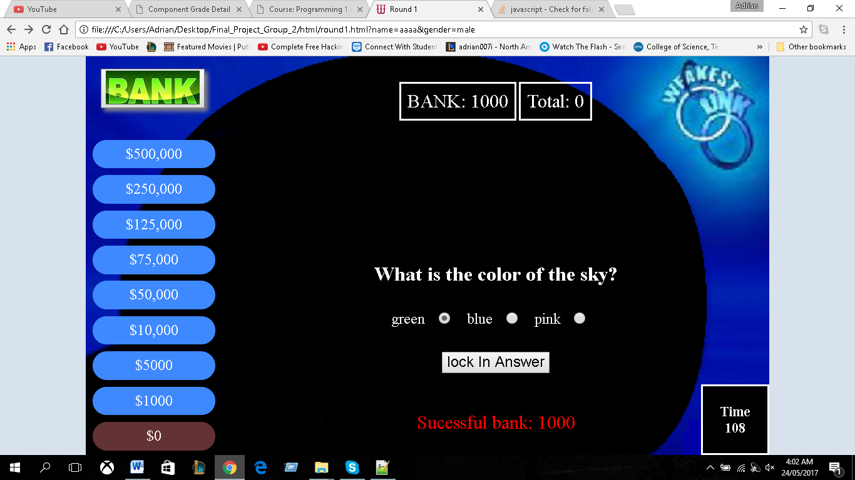

If the user decides to hit the bank button, they would be greeted with a message of the bank status; in this case it was successful. The money tree goes back to 0 and the amount won goes back to 0. The bank cell now has $1000.

**Round 2:**

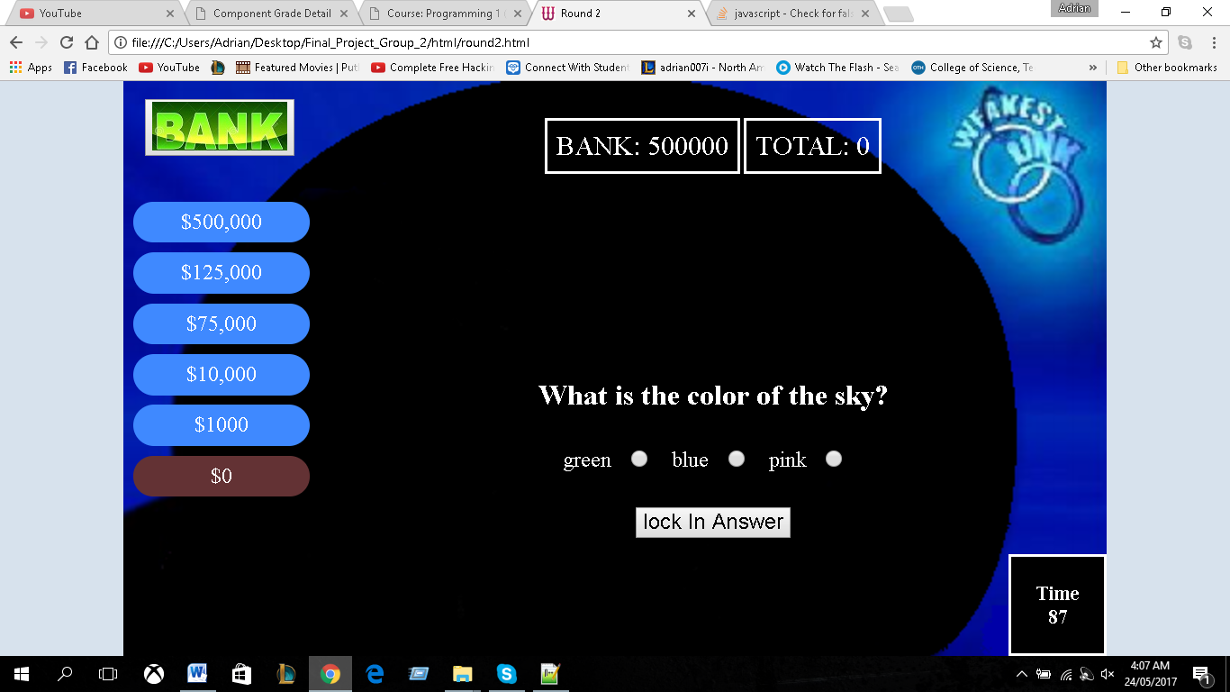

Round 2 functions the same as round with the exception of the money tree and the timer. The user gets 90 seconds on this round. As displayed in the bank area, the user banked 500,000 with was then send to this round and displayed to the user in the cell. If the user banks more money, the value will be added to the 500,000. To access the bank value from multiple pages, we utilize local storage.

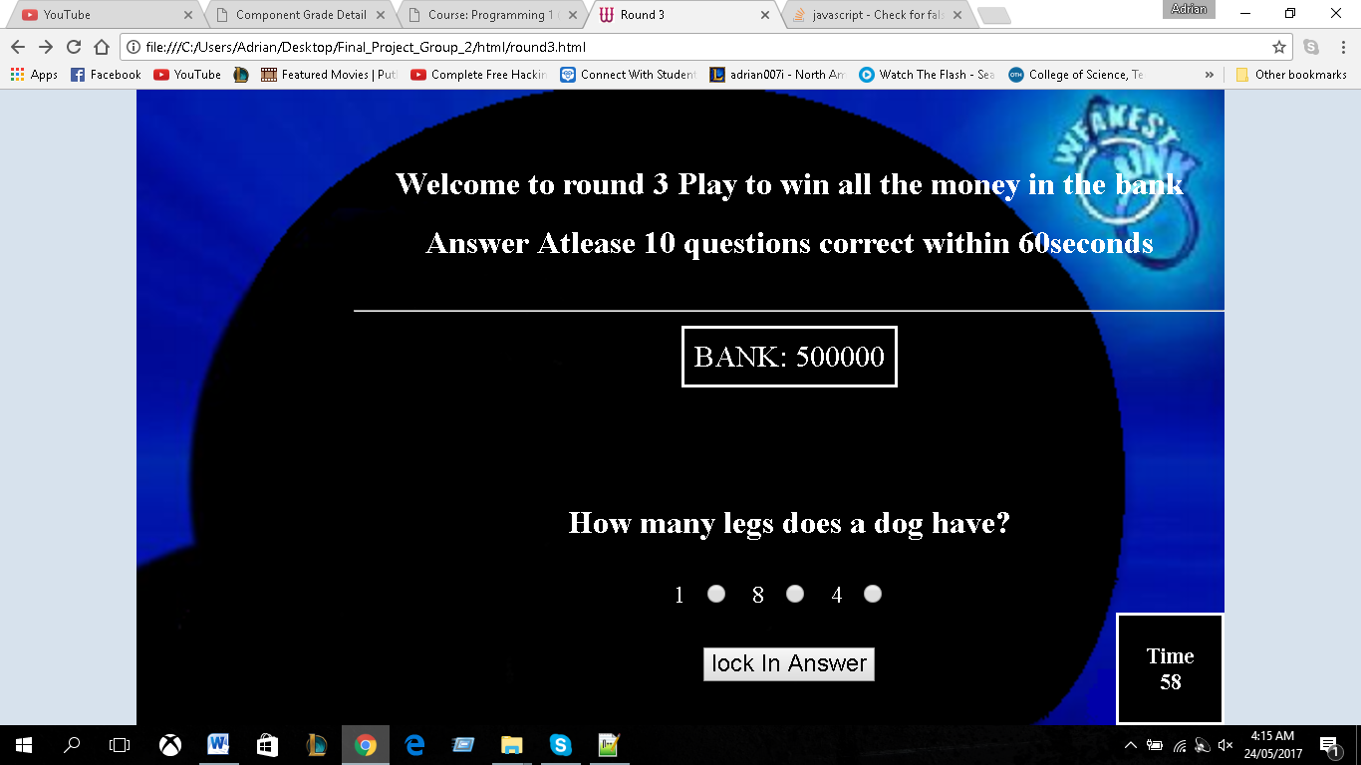**Round 3:**

For round 3, only if the user has money in the bank they would be taken to this round. As shown the user must answer at least 10 questions within one minute in order to win the money in the bank. If the user answers one question wrong, they would lose the game.

**If user wins:**

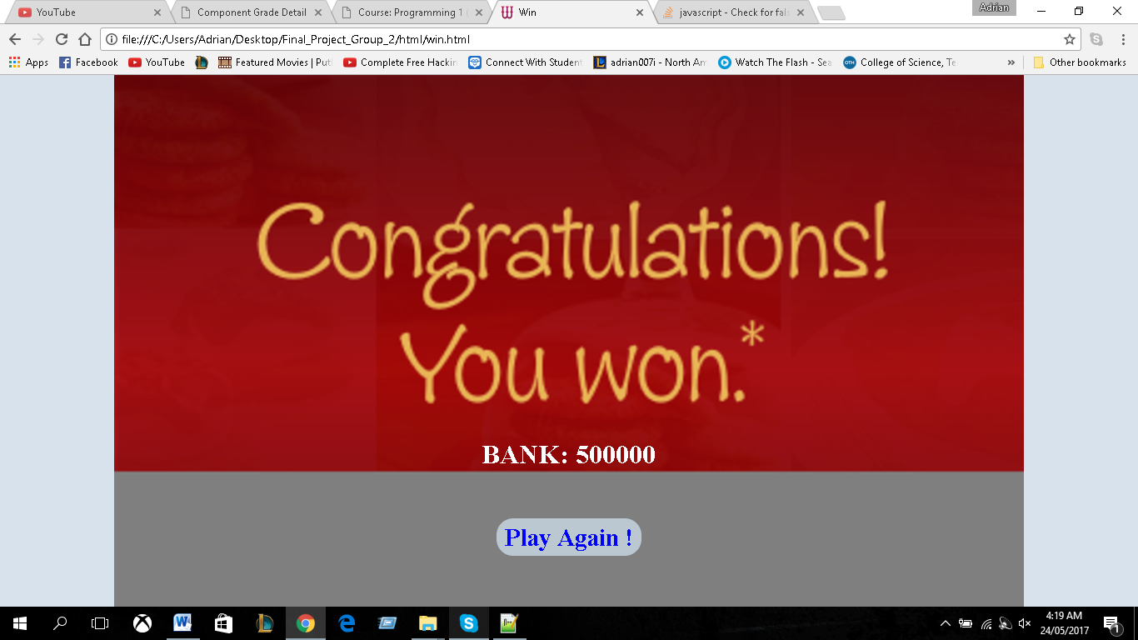

If the user wins the game, they would be taken to this page and will show the amount of money the player has won. The user then has the option to play again via the hyper link.

**If the play lose.**

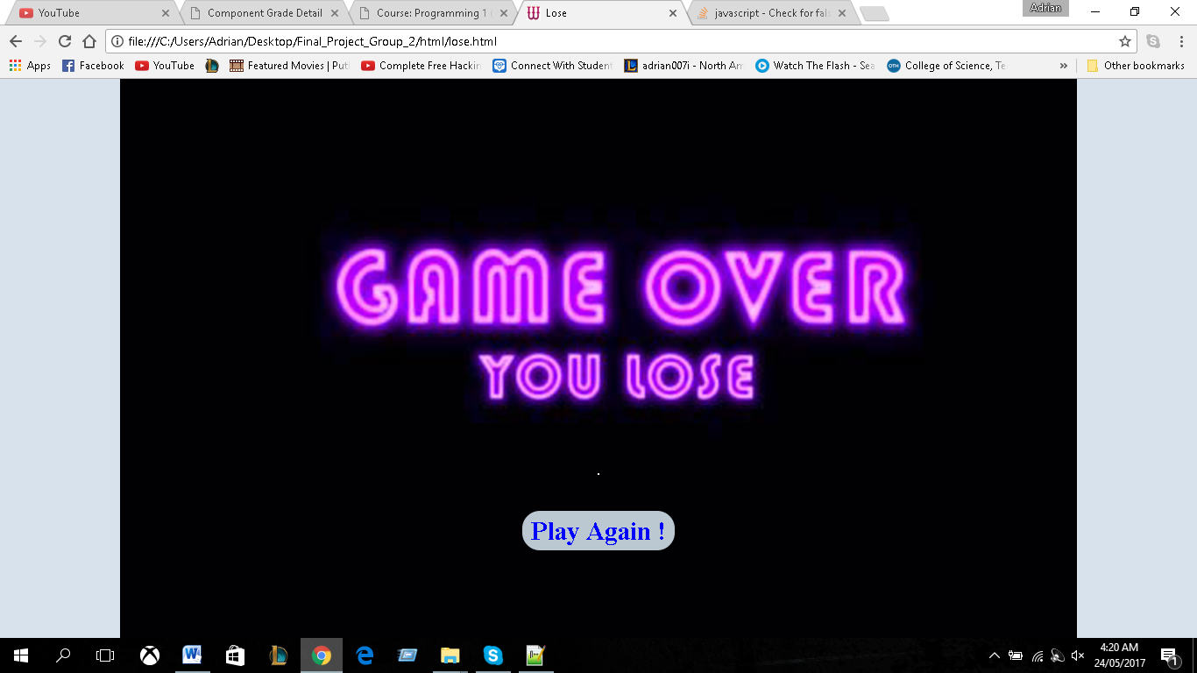

If the play lose the game they will be taken to this page where they would be given the option to play again via a hyperlink.

**Group Members Contribution**

**ADRIAN JOHN**

* Validated and created the forms of the document.
* Developed the structure and styled the website using html and CSS.
* All Local Storage
* Coded round1 together
* Random Question Generator

**AJAY CHAITOO**

* Implemented Audio throughout the program
* Gather questions and their respective answers.
* Wrote the all scripts for round 3
* Implemented the timer with Avish
* Coded round1 together

**AVISH RAMPERSAD**

* Altered the code from round 1 to the meet its requirements of round 2.
* Gather questions and their respective answers.
* Implemented the timer with Ajay
* Coded round1 together
* Hosted

**Source Code –HTML**

**Homepage**

<!DOCTYPE HTML>

<html lang=**"en"**>

<head>

<meta charset=**"UTF-8"**>

<link rel = **"stylesheet"** type = **"text/css"** href = **"../css/styles.css"**/>

<link rel=**"shortcut icon"** href=**"../images/logo.jpg"**/>

<title>**Home**</title>

</head>

<body>

<script>

***function*** storages**(){**

***var*** round**=**localStorage.getItem**(**"round"**);**

***if*(**round **!=** ***null*){**

***if*(**round**==**"round1"**){**

document.location**=**"round1.html"**;**

**}**

***else*** ***if*(**round**==**"round2"**){**

document.location**=**"round2.html"**;**

**}**

***else*{**

document.location**=**"round3.html"**;**

**}**

**}**

**}**window.onload **=** storages**;**

</script>

<div id=**"container"**>

<button type=**"button"** id=**"audio"**><img src=**"../images/audioOn.png"** id=**"on"**/></button>

<div id=**"content"** style=**"margin-top:40%;"**>

<div style=**"float:left; margin-left:1%;"**><a href=**"playerInfo.html"** >**Start Game**</a></div>

<div style=**"float:right; margin-right:1%;"**><a href=**"rules.html"**>**Rules**</a></div>

</div>

</div>

</body>

<script type=**"text/javascript"** src=**"../js/audio.js"**></script>

</html>

**Player information Page**

<!DOCTYPE HTML>

<html lang=**"en"**>

<head>

<meta charset=**"UTF-8"**>

<link rel = **"stylesheet"** type = **"text/css"** href = **"../css/styles.css"**/>

<title>**Player**</title>

<link rel=**"shortcut icon"** href=**"../images/logo.jpg"**/>

</head>

<body>

<div id=**"container"**>

<button type=**"button"** id=**"audio"**><img src=**"../images/audioOn.png"** id=**"on"**/></button>

<div id=**"content"**>

<h1> **Please enter your Name and age**</h1>

<center>

<br/><br/>

<div id=**"playerinfo"**>

<form name=**"message"** method=**"get"** action=**"round1.html"**>

<fieldset>

<br/>

<legend>

<h2>**Player info**</h2>

</legend>

<br/>

**Name:** <input type=**"text"** name=**"name"** id=**"name"**/>

<br/><br/>

<span class=**"errors"**></span><br/><br/>

**Gender:**

<input type=**"radio"** name=**"gender"** value=**"female"**/>

**Female**

<input type=**"radio"** name=**"gender"** value=**"male"**/> **Male**

<br/><br/>

<span class=**"errors"**></span><br/>

<button id=**"submit"** type=**"submit"**>**Proceed To**

**Game**</button>

</fieldset>

</form>

<br/>

</div>

</center>

<br/>

</div>

</div>

</body>

<script src=**"../js/validation.js"**> </script>

<script type=**"text/javascript"** src=**"../js/audio.js"**></script>

</html>

**Rules Page**

<!DOCTYPE HTML>

<html lang=**"en"**>

<head>

<meta charset=**"UTF-8"**>

<link rel = **"stylesheet"** type = **"text/css"** href = **"../css/styles.css"**/>

<link rel=**"shortcut icon"** href=**"../images/logo.jpg"**/>

<title>**Rules**</title>

</head>

<body>

<div id=**"container"**>

<button type=**"button"** id=**"audio"**><img src=**"../images/audioOn.png"** id=**"on"**/></button>

<div id=**"content"**>

<h1>**RULES**</h1>

<div id=**"rules"**>

<br />

<ul>

<li>**For every question answered correctly you**

**move up on the money tree.**</li>

<li>**If a question is answered wrong you return to**

**zero and all money not in the bank is**

**lossed.**</li>

<li>**In rounds one and two the maximum amount of**

**money you're able to win is 500,000 each**</li>

<li>**If the time runs out you will be taken to the**

**next round.**</li>

<li>**After a round you can Bank your Money but the**

**money tree returns to zero.**</li>

<li>**In round three all questions must be answered**

**correctly to win the money in the bank.**</li>

</ul>

</div>

<br/>

<a href=**"index.html"**>**Back to home**</a>

</div>

</div>

</body>

<script type=**"text/javascript"** src=**"../js/audio.js"**></script>

</html>

**Round 1 Page**

<!DOCTYPE HTML>

<html lang=**"en"**>

<head>

<meta charset=**"UTF-8"**>

<link rel = **"stylesheet"** type = **"text/css"** href = **"../css/styles.css"**/>

<link rel=**"shortcut icon"** href=**"../images/logo.jpg"**/>

<title>**Round 1**</title>

</head>

<body>

<div id=**"container"**>

<div id=**"content"** style=**"background-image:url('../images/gameBackground.png'); background-size:cover;"**>

<div id=**"moneyTree"**>

<br/>

<button type=**"button"** id=**"bank"**/><img src=**"../images/bank.jpg"**/></button>

<br/><br/><br/>

<ul>

<li class=**"money"**>**$500,000**</li>

<li class=**"money"**>**$250,000** </li>

<li class=**"money"**>**$125,000** </li>

<li class=**"money"**>**$75,000** </li>

<li class=**"money"**>**$50,000** </li>

<li class=**"money"**>**$10,000** </li>

<li class=**"money"**>**$5000** </li>

<li class=**"money"**>**$1000** </li>

<li class=**"money"** style=**"background-color:#633234"**>**$0** </li>

</ul>

</div>

<div id=**"questionArea"** style=**"padding-top:5%;"**>

<button type=**"button"** id=**"audio"** style=**"float:right;"**><img

src=**"../images/audioOn.png"** id=**"on"**/></button>

<br/>

<span style=**"border:solid white; padding:1%; color:white;**

**font-size:30px; "** id=**"bankDisplay"**>**BANK: 0**</span>

<span style=**"border:solid white; padding:1%;color:white; font-**

**size:30px; "** id=**"totalDisplay"**>**TOTAL: 0**</span>

<h1>

<div id=**"question"** style=**"padding-top:15%;"**></div>

</h1>

<div id=**"ans"**>

<span class=**"ans"**></span><input type=**"radio"** id=**"ans1"**

name=**"answer"** value=**""**/>

<span class=**"ans"**></span><input type=**"radio"** id=**"ans2"**

name=**"answer"** value=**""**/>

<span class=**"ans"**></span><input type=**"radio"** id=**"ans3"**

name=**"answer"** value=**""**/><br/>

<input type=**"button"** id=**"submit_answer"** value=**"lock In**

**Answer"**/>

</div>

<br/><br/>

<span style=**"color:red; font-size:30px;"** id=**"msg"**></span>

<h3 id=**"rem"**>

**Time**

<div id=**"time"**></div>

</h3>

</div>

</div>

</div>

</body>

<script src=**"../js/gameRound1.js"**></script>

<script type=**"text/javascript"** src=**"../js/audio.js"**></script>

</html>

**Round 2 page**

<!DOCTYPE HTML>

<html lang=**"en"**>

<head>

<meta charset=**"UTF-8"**>

<link rel = **"stylesheet"** type = **"text/css"** href = **"../css/styles.css"**/>

<link rel=**"shortcut icon"** href=**"../images/logo.jpg"**/>

<title>**Round 2**</title>

</head>

<body>

<div id=**"container"**>

<div id=**"content"** style=**"background-image:url('../images/gameBackground.png'); background-size:cover;"**>

<div id=**"moneyTree"**>

<br/>

<button type=**"button"** id=**"bank"**/><img src=**"../images/bank.jpg"**/></button>

<br/><br/><br/>

<ul>

<li class=**"money"**>**$500,000**</li>

<li class=**"money"**>**$125,000** </li>

<li class=**"money"**>**$75,000** </li>

<li class=**"money"**>**$10,000** </li>

<li class=**"money"**>**$1000** </li>

<li class=**"money"** style=**"background-color:#633234"**>**$0** </li>

</ul>

</div>

<div id=**"questionArea"** style=**"padding-top:5%;"**>

<button type=**"button"** id=**"audio"** style=**"float:right;"**><img src=**"../images/audioOn.png"** id=**"on"**/></button>

<br/>

<span style=**"border:solid white; padding:1%; color:white; font-size:30px; "** id=**"bankDisplay"**>**BANK: 0**</span>

<span style=**"border:solid white; padding:1%;color:white; font-size:30px; "** id=**"totalDisplay"**>**TOTAL: 0**</span>

<h1>

<div id=**"question"** style=**"padding-top:15%;"**></div>

</h1>

<div id=**"ans"**>

<span class=**"ans"**></span><input type=**"radio"** id=**"ans1"** name=**"answer"** value=**""**/>

<span class=**"ans"**></span><input type=**"radio"** id=**"ans2"** name=**"answer"** value=**""**/>

<span class=**"ans"**></span><input type=**"radio"** id=**"ans3"** name=**"answer"** value=**""**/><br/>

<input type=**"button"** id=**"submit_answer"** value=**"lock In Answer"**/>

</div>

<br/><br/>

<span style=**"color:red; font-size:30px;"** id=**"msg"**></span>

<h3 id=**"rem"**>

**Time**

<div id=**"time"**></div>

</h3>

</div>

</div>

</div>

</body>

<script src=**"../js/gameRound2.js"**></script>

<script type=**"text/javascript"** src=**"../js/audio.js"**></script>

</html>

**Round 3 page**

<!DOCTYPE HTML>

<html lang=**"en"**>

<head>

<meta charset=**"UTF-8"**>

<link rel = **"stylesheet"** type = **"text/css"** href = **"../css/styles.css"**/>

<link rel=**"shortcut icon"** href=**"../images/logo.jpg"**/>

<title>**Round 3**</title>

</head>

<body>

<div id=**"container"**>

<div id=**"content"** style=**"background-image:url('../images/gameBackground.png'); background-size:cover;"**>

<div id=**"moneyTree"**>

<br/>

</div>

<div id=**"questionArea"** style=**"padding-top:5%;"**>

<button type=**"button"** id=**"audio"** style=**"float:right;"**><img src=**"../images/audioOn.png"** id=**"on"**/></button>

<br/>

<h1>**Welcome to round 3 Play to win all the money in the bank**</h1>

<h1>**Answer Atlease 10 questions correct within 60seconds**</h1>

<br/>

<hr/>

<br/>

<span style=**"border:solid white; padding:1%; color:white; font-size:30px; "** id=**"bankDisplay"**>**BANK: 0**</span>

<h1>

<div id=**"question"** style=**"padding-top:5%;"**></div>

</h1>

<div id=**"ans"**>

<span class=**"ans"**></span><input type=**"radio"** id=**"ans1"** name=**"answer"** value=**""**/>

<span class=**"ans"**></span><input type=**"radio"** id=**"ans2"** name=**"answer"** value=**""**/>

<span class=**"ans"**></span><input type=**"radio"** id=**"ans3"** name=**"answer"** value=**""**/><br/>

<input type=**"button"** id=**"submit_answer"** value=**"lock In Answer"**/>

</div>

<br/>

<span style=**"color:red; font-size:30px;"** id=**"msg"**></span>

<h3 id=**"rem"**>

**Time**

<div id=**"time"**></div>

</h3>

</div>

</div>

</div>

</body>

<script src=**"../js/gameRound3.js"**></script>

<script type=**"text/javascript"** src=**"../js/audio.js"**></script>

</html>

**Win page**

<!DOCTYPE HTML>

<html lang=**"en"**>

<head>

<meta charset=**"UTF-8"**>

<link rel = **"stylesheet"** type = **"text/css"** href = **"../css/styles.css"**/>

<link rel=**"shortcut icon"** href=**"../images/logo.jpg"**/>

<title>**Win**</title>

</head>

<body>

<div id=**"container"**>

<div id=**"content"** style=**"margin:auto auto; background-image:url('../images/win.png'); background-size:cover;"**>

<h4 style=**"margin-top:40%; font-size:200%;"** id=**"bankDisplay"**>**bank**</h4>

<br/>

<a href=**"index.html"**>**Play Again !**</a>

</div>

</div>

<script>

***var*** moneyBank**=**localStorage.getItem**(**"bank"**);**

***var*** bankDisplay**=**document.getElementById**(**'bankDisplay'**).**innerHTML**=**"BANK: "**+**moneyBank**;**

localStorage.clear**();**

</script>

</body>

</html>

Lose page

<!DOCTYPE HTML>

<html lang=**"en"**>

<head>

<meta charset=**"UTF-8"**>

<link rel = **"stylesheet"** type = **"text/css"** href = **"../css/styles.css"**/>

<link rel=**"shortcut icon"** href=**"../images/logo.jpg"**/>

<title>**Lose**</title>

</head>

<body>

<div id=**"container"**>

<div id=**"content"** style=**"margin:auto auto; background-image:url('../images/lose.jpg'); background-size:cover;"**>

<h4 style=**"margin-top:40%;"**>**.**</h4>

<br/>

<a href=**"index.html"**>**Play Again !**</a>

</div>

</div>

<script >localStorage.clear**();**</script>

</body>

</html>

**Javascript -Audio**

**var** audioBtn**=document.**getElementById**(**'audio'**);**

**var** audio**=**"on"**;**

**var** audioMusic **=** **new** Audio**();**

audioMusic**.**src**=**"1.mp3"**;**

audioMusic**.**play**();**

audioMusic**.**loop**=true;**

**function** icon**(){**

**if(**audio**==**"on"**){**

audioBtn**.**innerHTML**=**"<img src='../images/audioOff.png'/>"**;**

audio**=**"off"

audioMusic**.**pause**();**

**}else{**

audioBtn**.**innerHTML**=**"<img src='../images/audioOn.png'/>"**;**

audio**=**"on"

audioMusic**.**play**();**

audioMusic**.**loop**=true;**

**}**

**}**

audioBtn**.**onclick**=**icon**;**

**var** bleep**=** **new** Audio**();**

**var** swit**=** **false;**

**function** play**(){**

**if** **(**swit**==false){**

bleep**.**src**=**"1.mp3"**;**

bleep**.**play**();**

swit**=true;**

**}**

**else** **if** **(**swit**==true){**

bleep**.**src**=**""**;**

bleep**.**play**();**

swit**=false;}**

**}**

**Round 1**

**var** presentlyAsked**;**

**var** rightArea**=document.**getElementById**(**'questionArea'**);**

**var** questionArea**=document.**getElementById**(**'question'**);**

**var** answerAreas**=document.**getElementsByClassName**(**'ans'**);**

**var** submitbtn**=document.**getElementById**(**'submit_answer'**);**

**var** answerValue**=document.**getElementsByName**(**'answer'**);**

**var** money **=document.**getElementsByClassName**(**'money'**);**

**var** bankbtn**=document.**getElementById**(**'bank'**);**

**var** bankDisplay**=document.**getElementById**(**'bankDisplay'**);**

**var** totalDisplay**=document.**getElementById**(**'totalDisplay'**);**

**var** moneyTreeValuesRound1**=new** Array**(**1000**,**5000**,**10000**,**50000**,**75000**,**125000**,**250000**,**500000**);**

**if(**localStorage**.**getItem**(**"bankAmount"**)==null){**

**var** moneyBank**=**0**;**

**var** amountWon**=**0**;**

**var** moneyPosition **=document.**getElementsByClassName**(**'money'**).**length**-**1**;**

**var** time**=**120

**var** moneyTreeIndex**=**0**;**

**}**

**else** **{**

**var** moneyBank**=parseInt(**localStorage**.**getItem**(**"bankAmount"**));**

**var** amountWon**=parseInt(**localStorage**.**getItem**(**"amountWon"**));**

**var** moneyPosition**=** **parseInt(**localStorage**.**getItem**(**"moneyPosition"**));**

**var** moneyTreeIndex**=parseInt(**localStorage**.**getItem**(**"moneyTreeIndex"**));;**

**var** time**=parseInt(**localStorage**.**getItem**(**"time"**));**

bankDisplay**.**innerHTML**=**"BANK: "**+**moneyBank**;**

totalDisplay**.**innerHTML**=**"Total: "**+**amountWon**;**

money**[**8**].**style**.**backgroundColor**=**"#3f89ff"**;**

money**[parseInt(**localStorage**.**getItem**(**"moneyPosition"**))].**style**.**backgroundColor**=**"#633234"**;**

**}**

**var** tempMessage**;**

localStorage**.**setItem**(**"round"**,**"round1"**);**

**function** Question**(**question**,**ans1**,**ans2**,**ans3**,**correctAns**){**

**this.**question**=**question**;**

**this.**ans1**=**ans1**;**

**this.**ans2**=**ans2**;**

**this.**ans3**=**ans3**;**

**this.**correctAns**=**correctAns**;**

**}**

**var** questionsArray**=new** Array**();**

questionsArray**[**0**]=** **new** Question**(**"What is the color of the sky?"**,**"green"**,**"blue"**,**"pink"**,**"blue"**);**

questionsArray**[**1**]=** **new** Question**(**"How many legs does a dog have?"**,**"1"**,**"8"**,**"4"**,**"4"**);**

questionsArray**[**2**]=** **new** Question**(**"How many planets are there in the solar?"**,**"8"**,**"1"**,**"50"**,**"8"**);**

questionsArray**[**3**]=** **new** Question**(**"Who is the prime minister of Trinidad and Tobago"**,**"Rowley"**,**"Kamla"**,**"SpongeBob"**,**"Rowley"**);**

questionsArray**[**4**]=** **new** Question**(**"Who lives in a pineapple under the sea?"**,**"Patrick"**,**"SpongeBob"**,**"Sandy"**,**"SpongeBob"**);**

questionsArray**[**5**]=** **new** Question**(**"What does 2 + 4 equal?"**,**"5"**,**"8"**,**"6"**,**"6"**);**

questionsArray**[**6**]=** **new** Question**(**"What year did the animated series Hunter x Hunter 2011 air?"**,**"1999"**,**"2014"**,**"2011"**,**"2011"**);**

questionsArray**[**7**]=** **new** Question**(**"What year did Trinidad and Tobago gain independence ?"**,**"1962"**,**"1972"**,**"1963"**,**"1963"**);**

questionsArray**[**8**]=** **new** Question**(**"Who is the greates Pot?"**,**"PotPot"**,**"Sir Potington"**,**"Pot X Machina"**,**"PotPot"**);**

questionsArray**[**9**]=** **new** Question**(**"In the bible verse John 3:16 who loves the world?"**,**"Jesus"**,**"God"**,**"Spagetti Monster"**,**"God"**);**

questionsArray**[**10**]=** **new** Question**(**"In the mobile app Yugioh-Duel-Link how many tributes are needed to summon a monster of lvl 7 or higher?"**,**"2"**,**"1"**,**"0"**,**"2"**);**

questionsArray**[**11**]=** **new** Question**(**"In the energy system from the animated series Naruto what chakra nature beats lightning?"**,**"Earth"**,**"Wind"**,**"Fire"**,**"Wind"**);**

questionsArray**[**12**]=** **new** Question**(**"Who is Savitar?"**,**"Roney"**,**"Barry"**,**"Walle"**,**"Barry"**);**

questionsArray**[**13**]=** **new** Question**(**"What is the best MOBA game?"**,**"Dota2"**,**"League of Ledgends"**,**"Smite"**,**"Dota2"**);**

questionsArray**[**14**]=** **new** Question**(**"What is the freezing temperature of water?"**,**"0"**,**"-273"**,**"100"**,**"0"**);**

questionsArray**[**15**]=** **new** Question**(**"Which is the cheepest?"**,**"Super"**,**"Premium"**,**"Diesel"**,**"Diesel"**);**

//this function will display a question and the associate answers to the user

**function** displayQuestion**(){**

//random index

presentlyAsked **=** questionsArray**[**randomGenerator**()];**

//displaying random question

questionArea**.**innerHTML**=**presentlyAsked**.**question**;**

//display of answers

answerAreas**[**0**].**innerHTML**=**presentlyAsked**.**ans1**;**

answerAreas**[**1**].**innerHTML**=**presentlyAsked**.**ans2**;**

answerAreas**[**2**].**innerHTML**=**presentlyAsked**.**ans3**;**

//changing the values

answerValue**[**0**].**value**=**presentlyAsked**.**ans1**;**

answerValue**[**1**].**value**=**presentlyAsked**.**ans2**;**

answerValue**[**2**].**value**=**presentlyAsked**.**ans3**;**

**}**

**var** questionsPreviouslyAsked**=** **new** Array**();**

**var** rand**;**

**function** randomGenerator**(){**

rand**=**Math**.**floor**(**Math**.**random**()\***questionsArray**.**length**);**

**if(**questionsPreviouslyAsked**.**length**==**0**){**

questionsPreviouslyAsked**.**push**(**rand**);**

**return** rand**;**

**}**

**for(**i**=**0**;**i**<**questionsPreviouslyAsked**.**length**;**i**++){**

**if(**questionsPreviouslyAsked**[**i**]==**rand**){**

rand**=**Math**.**floor**(**Math**.**random**()\***questionsArray**.**length**);**

i**=**0**;**

**}**

**}**

questionsPreviouslyAsked**.**push**(**rand**);**

**return** rand**;**

**}**

displayQuestion**();**

// this function will determine which raido button is checked to tester the answer

**function** testAnswer**(){**

**var** message**=**""**;**

**var** correctAnswer**=**presentlyAsked**.**correctAns**;**

**var** userAnswer**;**

**if(**answerValue**[**0**].**checked**==true){**

userAnswer**=** answerValue**[**0**].**value**;**

**}**

**else** **if(**answerValue**[**1**].**checked**==true){**

userAnswer**=** answerValue**[**1**].**value**;**

**}**

**else** **if(**answerValue**[**2**].**checked**==true){**

userAnswer**=** answerValue**[**2**].**value**;**

**}**

//checks if the user answer is the same as the correct answer

**if(**correctAnswer**==**userAnswer**){**

//if user completely wins round 1

**if(**moneyTreeValuesRound1**[**moneyTreeIndex**]==**500000**){**

amountWon**=**moneyTreeValuesRound1**[**moneyTreeIndex**];**

storage**();**

localStorage**.**removeItem**(**"time"**);**

localStorage**.**removeItem**(**"question"**);**

localStorage**.**removeItem**(**"moneyPosition"**);**

localStorage**.**removeItem**(**"moneyTreeIndex"**);**

localStorage**.**removeItem**(**"bankAmount"**);**

localStorage**.**removeItem**(**"amountWon"**);**

**document.location=**"round2.html"**;**

**}**

**else{**

displayQuestion**();**

moneyTree**();**

amountWon**=**moneyTreeValuesRound1**[**moneyTreeIndex**];**

moneyTreeIndex**++;**

message**=**"correct"**;**

**}**

**}**

**else{**

displayQuestion**();**

clearingMoneyTree**();**

moneyTreeIndex**=**0**;**

amountWon**=**0**;**

message**=**"Incorrect"**;**

**}**

tempMessage**=setInterval(function()** **{**messageDisplay**(**message**);** **},**300**);**

totalDisplay**.**innerHTML**=**"TOTAL: "**+**amountWon**;**

**}**

**function** clearingMoneyTree**(){**

moneyPosition **=document.**getElementsByClassName**(**'money'**).**length**-**1**;**

**for(**index**=**0**;** index**<**money**.**length**;**index**++)**

**{**

money**[**index**].**style**.**backgroundColor**=**"#3f89ff"**;**

**}**

money**[**moneyPosition**].**style**.**backgroundColor**=**"#633234"**;**

**}**

**function** moneyTree**(){**

**var** money **=document.**getElementsByClassName**(**'money'**);**

money**[**moneyPosition**].**style**.**backgroundColor**=**"#3f89ff"**;**

moneyPosition**--;**

money**[**moneyPosition**].**style**.**backgroundColor**=**"#633234"**;**

**}**

submitbtn**.**onclick**=**testAnswer**;**

**var** tempMessage**;**

**function** bank**(){**

**var** message**=**""**;**

**if(**moneyBank**+**amountWon**>=**500000**){**

moneyBank**=**500000**;**

storage**();**

localStorage**.**removeItem**(**"time"**);**

localStorage**.**removeItem**(**"question"**);**

localStorage**.**removeItem**(**"moneyPosition"**);**

localStorage**.**removeItem**(**"moneyTreeIndex"**);**

localStorage**.**removeItem**(**"bankAmount"**);**

localStorage**.**removeItem**(**"amountWon"**);**

**document.location=**"round2.html"**;**

**}**

**else** **if(**amountWon**==**0**){**

message**=**"you didnt win any money"**;**

**}**

**else{**

message**=**"money banked"**;**

displayQuestion**();**

clearingMoneyTree**();**

moneyBank**+=**amountWon**;**

moneyTreeIndex**=**0**;**

amountWon**=**0**;**

message**=**"Sucessful bank: "**+**moneyBank**;**

**}**

tempMessage**=setInterval(function()** **{**messageDisplay**(**message**);** **},**1000**);**

bankDisplay**.**innerHTML**=**"BANK: "**+**moneyBank**;**

totalDisplay**.**innerHTML**=**"Total: "**+**amountWon**;**

**}**

bankbtn**.**onclick**=**bank**;**

**var** x**=**1**;**

**function** messageDisplay**(**msg**){**

**var** message**=document.**getElementById**(**'msg'**);**

message**.**innerHTML**=**msg**;**

**if(**x**==**5**){**

**clearInterval(**tempMessage**);**

message**.**innerHTML**=**""**;**

x**=**0**;**

**}**

x**++;**

**}**

**function** reduceTime**(){**

**var** display**=** **document.**getElementById**(**"time"**);**

localStorage**.**setItem**(**"time"**,**time**);**

localStorage**.**setItem**(**"question"**,**rand**);**

//on the html

localStorage**.**setItem**(**"moneyPosition"**,**moneyPosition**);**

//on the array

localStorage**.**setItem**(**"moneyTreeIndex"**,**moneyTreeIndex**);**

localStorage**.**setItem**(**"bankAmount"**,**moneyBank**);**

localStorage**.**setItem**(**"amountWon"**,**amountWon**);**

**if(**time**==**0**){**

**document.location=**"round2.html"**;**

storage**();**

localStorage**.**removeItem**(**"time"**);**

localStorage**.**removeItem**(**"question"**);**

localStorage**.**removeItem**(**"moneyPosition"**);**

localStorage**.**removeItem**(**"moneyTreeIndex"**);**

localStorage**.**removeItem**(**"bankAmount"**);**

localStorage**.**removeItem**(**"amountWon"**);**

**clearInterval(**roundTimer**);**

**}**

display**.**innerHTML**=**""**;**

display**.**innerHTML**=** time**--** **+**""**;**

**}**

**var** roundTimer**=setInterval(**reduceTime**,**1000**);**

**function** storage **(){**

**var** carry**=**amountWon**+**moneyBank**;**

**if(**carry**>=**500000**){**

carry**=**500000**;**

localStorage**.**setItem**(**"bank"**,**carry**);**

**}else{**

localStorage**.**setItem**(**"bank"**,**carry**);**

**}**

**}**

**Round 2**

**var** presentlyAsked**;**

**var** rightArea**=document.**getElementById**(**'questionArea'**);**

**var** questionArea**=document.**getElementById**(**'question'**);**

**var** answerAreas**=document.**getElementsByClassName**(**'ans'**);**

**var** submitbtn**=document.**getElementById**(**'submit_answer'**);**

**var** answerValue**=document.**getElementsByName**(**'answer'**);**

**var** money **=document.**getElementsByClassName**(**'money'**);**

**var** bankbtn**=document.**getElementById**(**'bank'**);**

**var** bankDisplay**=document.**getElementById**(**'bankDisplay'**);**

**var** totalDisplay**=document.**getElementById**(**'totalDisplay'**);**

**var** moneyTreeValuesRound**=** **new** Array**(**1000**,**10000**,**75000**,**125000**,**500000**);**

**if(**localStorage**.**getItem**(**"bankAmount"**)==null){**

**var** moneyBank**=parseInt(**localStorage**.**getItem**(**"bank"**));**

**var** amountWon**=**0**;**

**var** moneyPosition **=document.**getElementsByClassName**(**'money'**).**length**-**1**;**

**var** time**=**120

**var** moneyTreeIndex**=**0**;**

**}**

**else** **{**

**var** moneyBank**=parseInt(**localStorage**.**getItem**(**"bankAmount"**));**

**var** amountWon**=parseInt(**localStorage**.**getItem**(**"amountWon"**));**

**var** moneyPosition**=** **parseInt(**localStorage**.**getItem**(**"moneyPosition"**));**

**var** moneyTreeIndex**=parseInt(**localStorage**.**getItem**(**"moneyTreeIndex"**));;**

**var** time**=parseInt(**localStorage**.**getItem**(**"time"**));**

bankDisplay**.**innerHTML**=**"BANK: "**+**moneyBank**;**

totalDisplay**.**innerHTML**=**"Total: "**+**amountWon**;**

money**[**5**].**style**.**backgroundColor**=**"#3f89ff"**;**

money**[parseInt(**localStorage**.**getItem**(**"moneyPosition"**))].**style**.**backgroundColor**=**"#633234"**;**

**}**

bankDisplay**.**innerHTML**=**"BANK: "**+**moneyBank**;**

**var** tempMessage**;**

**function** Question**(**question**,**ans1**,**ans2**,**ans3**,**correctAns**){**

**this.**question**=**question**;**

**this.**ans1**=**ans1**;**

**this.**ans2**=**ans2**;**

**this.**ans3**=**ans3**;**

**this.**correctAns**=**correctAns**;**

**}**

**var** questionsArray**=new** Array**();**

questionsArray**[**0**]=** **new** Question**(**"what does 3*3 equal?"**,**"6"**,**"9"**,**"27"**,**"9"**);**

questionsArray**[**1**]=** **new** Question**(**"which thing does not belong?"**,**"Sheep"**,**"Goat"**,**"Chicken"**,**"Chicken"**);**

questionsArray**[**2**]=** **new** Question**(**"what is the japanese equivalent to Mikey Mouse?"**,**"Pikachu"**,**"Naruto"**,**"Luffy"**,**"Pikachu"**);**

questionsArray**[**3**]=** **new** Question**(**"What is 24/4?"**,**"8"**,**"6"**,**"9"**,**"6"**);**

questionsArray**[**4**]=** **new** Question**(**"What does the letters NP stand for in terms of fossi-fuel in Trinidad?"**,**"National Petrolium"**,**"No Problem"**,**"No Power"**,**"National Ptrolium"**);**

questionsArray**[**5**]=** **new** Question**(**"Which GPU is faster?"**,**"GTX650"**,**"GTX750"**,**"GTX980"**,**"GTX980"**);**

questionsArray**[**6**]=** **new** Question**(**"What is the most common limiter on today GUP?"**,**"Temperature"**,**"Voltage"**,**"PCIE Ports"**,**"Voltage"**);**

questionsArray**[**7**]=** **new** Question**(**"What is the ideal type of communcation?"**,**"comunication of Ideas"**,**"Prefabricate communication"**,**"Communication of emotion"**,**" Communication of emotion"**);**

questionsArray**[**8**]=** **new** Question**(**"What is 15+9?"**,**"159"**,**"6"**,**"24"**,**"24"**);**

questionsArray**[**9**]=** **new** Question**(**"Which of these can normally be seen?"**,**"Air"**,**"Hail"**,**"sound"**,**"sound"**);**

questionsArray**[**10**]=** **new** Question**(**"What si the state of planet Earth?"**,**"Spinning"**,**"Stationary"**,**"Drifting"**,**"Spinning"**);**

questionsArray**[**11**]=** **new** Question**(**"What is a tomato?"**,**"Fruit"**,**"Seed"**,**"Vegetable"**,**"Fruit"**);**

questionsArray**[**12**]=** **new** Question**(**"What is the best for of contraseptive?"**,**"Abstinence"**,**"Condom"**,**"Pill"**,**"Abstinence"**);**

questionsArray**[**13**]=** **new** Question**(**"What is the most internationally accepted Language?"**,**"Hindi"**,**"Spanish"**,**"English"**,**"English"**);**

questionsArray**[**14**]=** **new** Question**(**"Which is the most popular sport?"**,**"Cricket"**,**"Football"**,**"Baseball"**,**"Football"**);**

questionsArray**[**15**]=** **new** Question**(**"How many players does a cricket team have?"**,**"11"**,**"5"**,**"9"**,**"11"**);**

//this function will display a question and the associate answers to the user

**function** displayQuestion**(){**

//random index

presentlyAsked **=** questionsArray**[**randomGenerator**()];**

//displaying random question

questionArea**.**innerHTML**=**presentlyAsked**.**question**;**

//display of answers

answerAreas**[**0**].**innerHTML**=**presentlyAsked**.**ans1**;**

answerAreas**[**1**].**innerHTML**=**presentlyAsked**.**ans2**;**

answerAreas**[**2**].**innerHTML**=**presentlyAsked**.**ans3**;**

//changing the values

answerValue**[**0**].**value**=**presentlyAsked**.**ans1**;**

answerValue**[**1**].**value**=**presentlyAsked**.**ans2**;**

answerValue**[**2**].**value**=**presentlyAsked**.**ans3**;**

**}**

**var** questionsPreviouslyAsked**=** **new** Array**();**

**var** rand**;**

**function** randomGenerator**(){**

rand**=**Math**.**floor**(**Math**.**random**()\***questionsArray**.**length**);**

**if(**questionsPreviouslyAsked**.**length**==**0**){**

questionsPreviouslyAsked**.**push**(**rand**);**

**return** rand**;**

**}**

**for(**i**=**0**;**i**<**questionsPreviouslyAsked**.**length**;**i**++){**

**if(**questionsPreviouslyAsked**[**i**]==**rand**){**

rand**=**Math**.**floor**(**Math**.**random**()\***questionsArray**.**length**);**

i**=**0**;**

**}**

**}**

questionsPreviouslyAsked**.**push**(**rand**);**

**return** rand**;**

**}**

displayQuestion**();**

// this function will determine which raido button is checked to tester the answer

**function** testAnswer**(){**

**var** message**=**""**;**

**var** correctAnswer**=**presentlyAsked**.**correctAns**;**

**var** userAnswer**;**

**if(**answerValue**[**0**].**checked**==true){**

userAnswer**=** answerValue**[**0**].**value**;**

**}**

**else** **if(**answerValue**[**1**].**checked**==true){**

userAnswer**=** answerValue**[**1**].**value**;**

**}**

**else** **if(**answerValue**[**2**].**checked**==true){**

userAnswer**=** answerValue**[**2**].**value**;**

**}**

//checks if the user answer is the same as the correct answer

**if(**correctAnswer**==**userAnswer**){**

//if user completely wins round 1

**if(**moneyTreeValuesRound**[**moneyTreeIndex**]==**500000**){**

amountWon**=**moneyTreeValuesRound**[**moneyTreeIndex**];**

storage **();**

localStorage**.**removeItem**(**"time"**);**

localStorage**.**removeItem**(**"question"**);**

localStorage**.**removeItem**(**"moneyPosition"**);**

localStorage**.**removeItem**(**"moneyTreeIndex"**);**

localStorage**.**removeItem**(**"bankAmount"**);**

localStorage**.**removeItem**(**"amountWon"**);**

**document.location=**"round3.html"**;**

**}**

**else{**

displayQuestion**();**

moneyTree**();**

amountWon**=**moneyTreeValuesRound**[**moneyTreeIndex**];**

moneyTreeIndex**++;**

message**=**"correct"**;**

**}**

**}**

**else{**

displayQuestion**();**

clearingMoneyTree**();**

moneyTreeIndex**=**0**;**

amountWon**=**0**;**

message**=**"Incorrect"**;**

**}**

tempMessage**=setInterval(function()** **{**messageDisplay**(**message**);** **},**300**);**

totalDisplay**.**innerHTML**=**"TOTAL: "**+**amountWon**;**

**}**

**function** clearingMoneyTree**(){**

moneyPosition **=document.**getElementsByClassName**(**'money'**).**length**-**1**;**

**for(**index**=**0**;** index**<**money**.**length**;**index**++)**

**{**

money**[**index**].**style**.**backgroundColor**=**"#3f89ff"**;**

**}**

money**[**moneyPosition**].**style**.**backgroundColor**=**"#633234"**;**

**}**

**function** moneyTree**(){**

**var** money **=document.**getElementsByClassName**(**'money'**);**

money**[**moneyPosition**].**style**.**backgroundColor**=**"#3f89ff"**;**

moneyPosition**--;**

money**[**moneyPosition**].**style**.**backgroundColor**=**"#633234"**;**

**}**

submitbtn**.**onclick**=**testAnswer**;**

**var** tempMessage**;**

**function** bank**(){**

**var** message**=**""**;**

**if((**moneyBank**+**amountWon**)>=**1000000**){**

moneyBank**=**1000000**;**

storage **();**

localStorage**.**removeItem**(**"time"**);**

localStorage**.**removeItem**(**"question"**);**

localStorage**.**removeItem**(**"moneyPosition"**);**

localStorage**.**removeItem**(**"moneyTreeIndex"**);**

localStorage**.**removeItem**(**"bankAmount"**);**

localStorage**.**removeItem**(**"amountWon"**);**

**document.location=**"round3.html"**;**

**}**

**else** **if(**amountWon**==**0**){**

message**=**"you didnt win any money"**;**

**}**

**else{**

message**=**"money banked"**;**

displayQuestion**();**

clearingMoneyTree**();**

moneyBank**+=**amountWon**;**

moneyTreeIndex**=**0**;**

amountWon**=**0**;**

message**=**"Sucessful bank: "**+**moneyBank**;**

**}**

tempMessage**=setInterval(function()** **{**messageDisplay**(**message**);** **},**1000**);**

bankDisplay**.**innerHTML**=**"BANK: "**+**moneyBank**;**

totalDisplay**.**innerHTML**=**"Total: "**+**amountWon**;**

**}**

bankbtn**.**onclick**=**bank**;**

**var** x**=**1**;**

**function** messageDisplay**(**msg**){**

**var** message**=document.**getElementById**(**'msg'**);**

message**.**innerHTML**=**msg**;**

**if(**x**==**5**){**

**clearInterval(**tempMessage**);**

message**.**innerHTML**=**""**;**

x**=**0**;**

**}**

x**++;**

**}**

**function** reduceTime**(){**

**var** display**=** **document.**getElementById**(**"time"**);**

localStorage**.**setItem**(**"time"**,**time**);**

localStorage**.**setItem**(**"question"**,**rand**);**

//on the html

localStorage**.**setItem**(**"moneyPosition"**,**moneyPosition**);**

//on the array

localStorage**.**setItem**(**"moneyTreeIndex"**,**moneyTreeIndex**);**

localStorage**.**setItem**(**"bankAmount"**,**moneyBank**);**

localStorage**.**setItem**(**"amountWon"**,**amountWon**);**

**if(**time**==**0**){**

**if(**moneyBank**==**0**){**

**document.location=**"lose.html"**;**

**return;**

**}**

storage **();**

localStorage**.**removeItem**(**"time"**);**

localStorage**.**removeItem**(**"question"**);**

localStorage**.**removeItem**(**"moneyPosition"**);**

localStorage**.**removeItem**(**"moneyTreeIndex"**);**

localStorage**.**removeItem**(**"bankAmount"**);**

localStorage**.**removeItem**(**"amountWon"**);**

**document.location=**"round3.html"**;**

**clearInterval(**roundTimer**);**

**}**

display**.**innerHTML**=**""**;**

display**.**innerHTML**=** time**--** **+**""**;**

**}**

**var** roundTimer**=setInterval(**reduceTime**,**1000**);**

**function** storage **(){**

**var** carry**=**amountWon**+**moneyBank**;**

**if(**carry**>=**1000000**){**

carry**=**1000000**;**

localStorage**.**setItem**(**"bank"**,**carry**);**

**}**

**else{**

localStorage**.**setItem**(**"bank"**,**carry**);**

**}**

**}**

**Round 3**

**var** presentlyAsked**;**

**var** questionArea**=document.**getElementById**(**'question'**);**

**var** answerAreas**=document.**getElementsByClassName**(**'ans'**);**

**var** submitbtn**=document.**getElementById**(**'submit_answer'**);**

**var** answerValue**=document.**getElementsByName**(**'answer'**);**

**var** money **=document.**getElementsByClassName**(**'money'**);**

**var** timeArea**=document.**getElementById**(**'rem'**);**

//localstorage from previous rounds

**var** moneyBank**=parseInt(**localStorage**.**getItem**(**"bank"**));**

**if(**moneyBank**==**0**)document.location=**"round3.html"**;**

**var** bankDisplay**=document.**getElementById**(**'bankDisplay'**).**innerHTML**=**"BANK: "**+**moneyBank**;**

**if(**localStorage**.**getItem**(**"amountOfQuestionAnswered"**)==null){**

**var** amountOfQuestionAnswered**=**0**;**

**var** time**=**60**;**

**}**

**else** **{**

**var** amountOfQuestionAnswered**=parseInt(**localStorage**.**getItem**(**"amountOfQuestionAnswered"**));**

**var** time**=parseInt(**localStorage**.**getItem**(**"time"**));**

**}**

localStorage**.**setItem**(**"round"**,**"round3"**);**

**var** winTheGame**=false;**

**var** answerDiv**=document.**getElementById**(**'ans'**);**

**var** questionsArray**=new** Array**();**

questionsArray**[**0**]=** **new** Question**(**"What has a foot but no legs?"**,**"snail"**,**"dog"**,**"bird"**,**"snail"**);**

questionsArray**[**1**]=** **new** Question**(**"Poor people have it. Rich people need it. If you eat it you die. What is it?"**,**"money"**,**"power"**,**"notting"**,**"notting"**);**

questionsArray**[**2**]=** **new** Question**(**"What comes down but never goes up?"**,**"ball"**,**"rain"**,**"smoke"**,**"rain"**);**

questionsArray**[**3**]=** **new** Question**(**" I’m tall when I’m young and I’m short when I’m old. What am I?"**,**"candle"**,**"tree"**,**"man"**,**"candle"**);**

questionsArray**[**4**]=** **new** Question**(**"Mary’s father has 5 daughters – Nana, Nene, Nini, Nono. What is the fifth daughters name?"**,**"Un-named"**,**"Mary"**,**"Nana"**,**"Mary"**);**

questionsArray**[**5**]=** **new** Question**(**"What goes up when rain comes down?"**,**"sun"**,**"umbrella"**,**"air"**,**"umbrella"**);**

questionsArray**[**6**]=** **new** Question**(**"What travels around the world but stays in one spot?"**,**"person"**,**"stamp"**,**"plane"**,**"stamp"**);**

questionsArray**[**7**]=** **new** Question**(**"What has 4 eyes but can’t see?"**,**"mississippi"**,**"harry potter"**,**"master yi"**,**"mississippi"**);**

questionsArray**[**8**]=** **new** Question**(**"What has hands but can not clap?"**,**"dog"**,**"clock"**,**"human"**,**"clock"**);**

questionsArray**[**9**]=** **new** Question**(**"What can you catch but not throw?"**,**"cold"**,**"ball"**,**"money"**,**"cold"**);**

questionsArray**[**10**]=** **new** Question**(**"What has one eye but cannot see?"**,**"ben"**,**"needle"**,**"fish"**,**"needle"**);**

questionsArray**[**11**]=** **new** Question**(**"What is so delicate that saying its name breaks it?"**,**"silence"**,**"computer"**,**"feather"**,**"silence"**);**

questionsArray**[**12**]=** **new** Question**(**"What kind of tree can you carry in your hand?"**,**"coconut"**,**"palm"**,**"mango"**,**"palm"**);**

questionsArray**[**13**]=** **new** Question**(**"How many months have 28 days?"**,**"12"**,**"1"**,**"2"**,**"12"**);**

questionsArray**[**14**]=** **new** Question**(**"What goes up but never comes down?"**,**"age"**,**"rain"**,**"pizza"**,**"age"**);**

**function** Question**(**question**,**ans1**,**ans2**,**ans3**,**correctAns**){**

**this.**question**=**question**;**

**this.**ans1**=**ans1**;**

**this.**ans2**=**ans2**;**

**this.**ans3**=**ans3**;**

**this.**correctAns**=**correctAns**;**

**}**

**function** displayQuestion**(){**

presentlyAsked **=** questionsArray**[**randomGenerator**()];**

questionArea**.**innerHTML**=**presentlyAsked**.**question**;**

//display of answers

answerAreas**[**0**].**innerHTML**=**presentlyAsked**.**ans1**;**

answerAreas**[**1**].**innerHTML**=**presentlyAsked**.**ans2**;**

answerAreas**[**2**].**innerHTML**=**presentlyAsked**.**ans3**;**

//changing the values

answerValue**[**0**].**value**=**presentlyAsked**.**ans1**;**

answerValue**[**1**].**value**=**presentlyAsked**.**ans2**;**

answerValue**[**2**].**value**=**presentlyAsked**.**ans3**;**

**}**

**var** questionsPreviouslyAsked**=** **new** Array**();**

**function** randomGenerator**(){**

**var** rand**=**Math**.**floor**(**Math**.**random**()\***questionsArray**.**length**);**

**if(**questionsPreviouslyAsked**.**length**==**0**){**

questionsPreviouslyAsked**.**push**(**rand**);**

**return** rand**;**

**}**

**for(**i**=**0**;**i**<**questionsPreviouslyAsked**.**length**;**i**++){**

**if(**questionsPreviouslyAsked**[**i**]==**rand**){**

rand**=**Math**.**floor**(**Math**.**random**()\***questionsArray**.**length**);**

i**=**0**;**

**}**

**}**

questionsPreviouslyAsked**.**push**(**rand**);**

**return** rand**;**

**}**

displayQuestion**();**

**function** testAnswer**(){**

**var** correctAnswer**=**presentlyAsked**.**correctAns**;**

**var** userAnswer**;**

**if(**answerValue**[**0**].**checked**==true){**

userAnswer**=** answerValue**[**0**].**value**;**

**}**

**else** **if(**answerValue**[**1**].**checked**==true){**

userAnswer**=** answerValue**[**1**].**value**;**

**}**

**else** **if(**answerValue**[**2**].**checked**==true){**

userAnswer**=** answerValue**[**2**].**value**;**

**}**

**if(**correctAnswer**==**userAnswer**){**

tempMessage**=setInterval(function()** **{**messageDisplay**(**"correct"**);** **},**1000**);**

amountOfQuestionAnswered**++;**

displayQuestion**();**

**}**

**else{**

**document.location=**"lose.html"**;**

**}**

**}**

submitbtn**.**onclick**=**testAnswer**;**

**function** reduceTime**(){**

**var** display**=** **document.**getElementById**(**"time"**);**

localStorage**.**setItem**(**"time"**,**time**);**

localStorage**.**setItem**(**"amountOfQuestionAnswered"**,**amountOfQuestionAnswered**)**

**if(**time**==**0**){**

**if(**amountOfQuestionAnswered **>=**10**){**

**document.location=**"win.html"**;**

**}**

**else{**

**document.location=**"lose.html"**;**

**}**

**}**

display**.**innerHTML**=**""**;**

display**.**innerHTML**=** time**--** **+**""**;**

**}**

**var** roundTimer**=setInterval(**reduceTime**,**1000**);**

**var** x**=**1**;**

**function** messageDisplay**(**msg**){**

**var** message**=document.**getElementById**(**'msg'**);**

message**.**innerHTML**=**msg**;**

**if(**x**==**5**){**

**clearInterval(**tempMessage**);**

message**.**innerHTML**=**""**;**

x**=**0**;**

**}**

x**++;**

**}**

**Validation**

**function** validate**(){**

**var** name**,**age**;**

**var** errorMessages**=document.**getElementsByClassName**(**'errors'**);**

name**=document.**getElementById**(**'name'**).**value**.**trim**();**

gender**=document.**getElementsByName**(**'gender'**);**

**var** name_regex**=/^[a-zA-Z ]{2,40}$/;**

// clears every innerHTML error message

**for(var** i**=**0**;**i**<**errorMessages**.**length**;**i**++)**

**{**

errorMessages**[**i**].**innerHTML**=**""**;**

**}**

**var** hasError**=true;**

**if(**name**==**""**)**

**{**

errorMessages**[**0**].**innerHTML**=**"* required"**;**

hasError**=false;**

**}**

**else**

**{**

**if(!**name_regex**.**test**(**name**))**

**{**

errorMessages**[**0**].**innerHTML**=**"* invalid name"**;**

hasError**=false;**

**}**

**}**

**if(**gender**[**0**].**checked**==false** **&&** gender**[**1**].**checked**==false)**

**{**

errorMessages**[**1**].**innerHTML**=**"* required"**;**

hasError**=false;**

**}**

**if(**hasError**==true){**

localStorage**.**setItem**(**"Name"**,**name**);**

localStorage**.**setItem**(**"gender"**,**gender**);**

**}else{**

**return** **false**

**}**

**}**

**document.**getElementById**(**'submit'**).**onclick**=**validate**;**

**CSS**

html**,**body

**{**

**margin: 0px;**

**padding: 0px;**

**height:100%;**

**background-color: #D7E2ED;**

**}**

**#container{**

**padding:0px;**

**margin: 0px;**

**height:100%;**

**width:80%;**

**margin:auto auto;**

**border:0px;**

**max-height:100%;**

**overflow:hidden;**

**background-image:url(**"background.jpg"**);**

**background-size:cover;**

**}**

**#content{**

**float:left;**

**margin: 0px;**

**padding: 0px;**

**height:100%;**

**width:100%;**

**text-align:center;**

**border:0px;**

**}**

**#container>#content>**h1**{**

**background-color:#633234;**

**padding:3%;**

**border-radius:100px;**

**font-family:arial,san-serif;**

**box-shadow: inset 0 0 40px #000;**

**}**

button**:hover,**a**:hover{**

**box-shadow: 5px 5px 10px #888888;**

**}**

**#content** a**{**

**background-color:white;**

**padding-right:10px;**

**padding-left:10px;**

**padding-top:5px;**

**padding-bottom:5px;**

**border-radius:20px;**

**text-decoration:none;**

**font-size:40px;**

**font-weight:bold;**

**background-color:#BBC8D2 ;**

**color:blue;**

**}**

**#content** a**:hover{**

**background-color:#904144 ;**

**color:white;**

**}**

**#content** **{color:white;}**

**#content** fieldset**{**

**border-radius:50px;**

**width:80%;**

**color:white;**

**box-shadow: inset 0 0 80px #000;**

**border:none;**

**}**

**#content** form**{**

**width:80%;**

**margin:auto auto;**

**}**

**#content** **>**a**{**

**background-color:white;**

**padding-right:10px;**

**padding-left:10px;**

**padding-top:5px;**

**padding-bottom:5px;**

**border-radius:20px;**

**text-decoration:none;**

**font-size:30px;**

**font-weight:bold;**

**background-color:#BBC8D2 ;**

**color:blue;**

**}**

**#playerinfo,#rules{**

**background-color:#904144;**

**font-size:20px;**

**height:70%;**

**width:50%;**

**border: solid white;**

**border-radius:50px;**

**font-family:arial,san-serif;**

**}**

**#rules{**

**margin:auto auto;**

**width:90%;**

**height:55%;**

**padding-left:5%;**

**box-shadow: inset 0 0 40px #000;**

**}**

**#rules** li**{float:left;**

**padding:1%;**

**}**

**#content** **#submit,** **#content** **#cancel{**

**width:100px;**

**border-radius:50px;**

**}**

**#moneyTree{**

**width:20%;**

**float:left;**

**padding:0px;**

**margin:0px;**

**height:100%;**

**}**

**#rem{**

**position:absolute;**

**bottom:0;**

**right:10%;**

**padding:2%;**

**margin-bottom:0px;**

**font-size:140%;**

**background-color:black;**

**border:solid white;**

**}**

**#moneyTree** li**{**

**font-size:150%;**

**border-radius: 400px;**

**background-color:#3f89ff;**

**padding-left:5%;**

**padding-right:5%;**

**padding-top:4%;**

**padding-bottom:4%;**

**list-style-type:none;**

**margin:5%;**

**}**

**#moneyTree** ul**{**

**margin:0px;**

**padding:0px;**

**}**

**#moneyTree** button**{**

**margin:auto auto;**

**}**

**#questions{**

**float:left;**

**width:80%;**

**height:100%;**

**background-color:lightgrey;**

**opacity:.3;**

**}**

**#rem{float:right;}**

**#questionArea** input**{**

**margin:2%;**

**font-size:150%;**

**}**

input**[**type="radio"**]{**

**display:inline-block;**

**width:19px;**

**height:19px;**

**margin:-1px 4px 0 0;**

**cursor:pointer;**

**-moz-border-radius: 50%;**

**border-radius: 50%;**

**}**

**.**ans**{font-size:150%;}**