Game Instructions

**The homepage:**

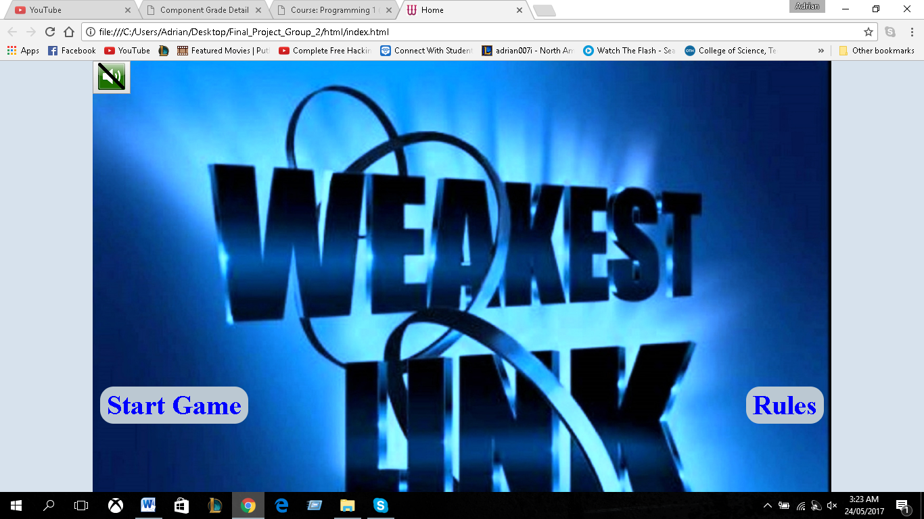

When the user visits the web application, they will get the option to start the game or view the rules of the game. At the top left corner, a button was used to for the user to turn on and off the audio.

**The rules page:**

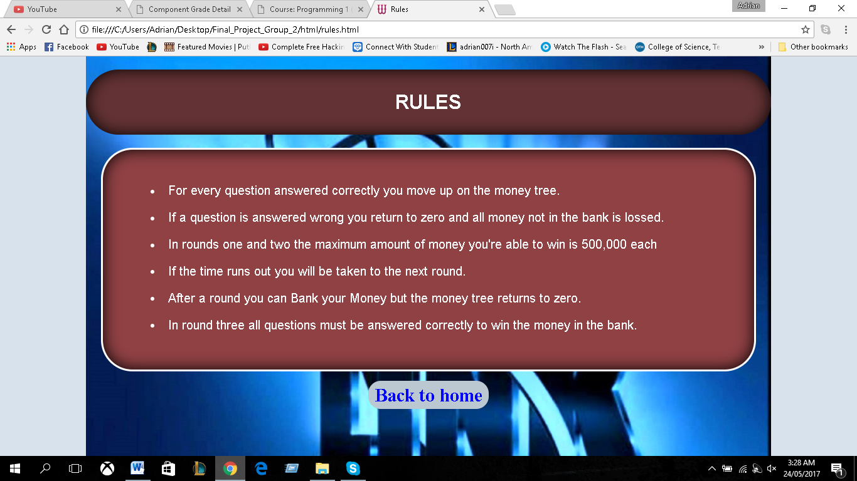

Asdaaaaaaaaaaaaaaa If the player isn’t sure about the game, then they could go the rules page, by clicking the hyperlink Here the user will view the rules and upon finishing, they would be provided with another hyperlink to take the user back to the home page.

**Player Information**

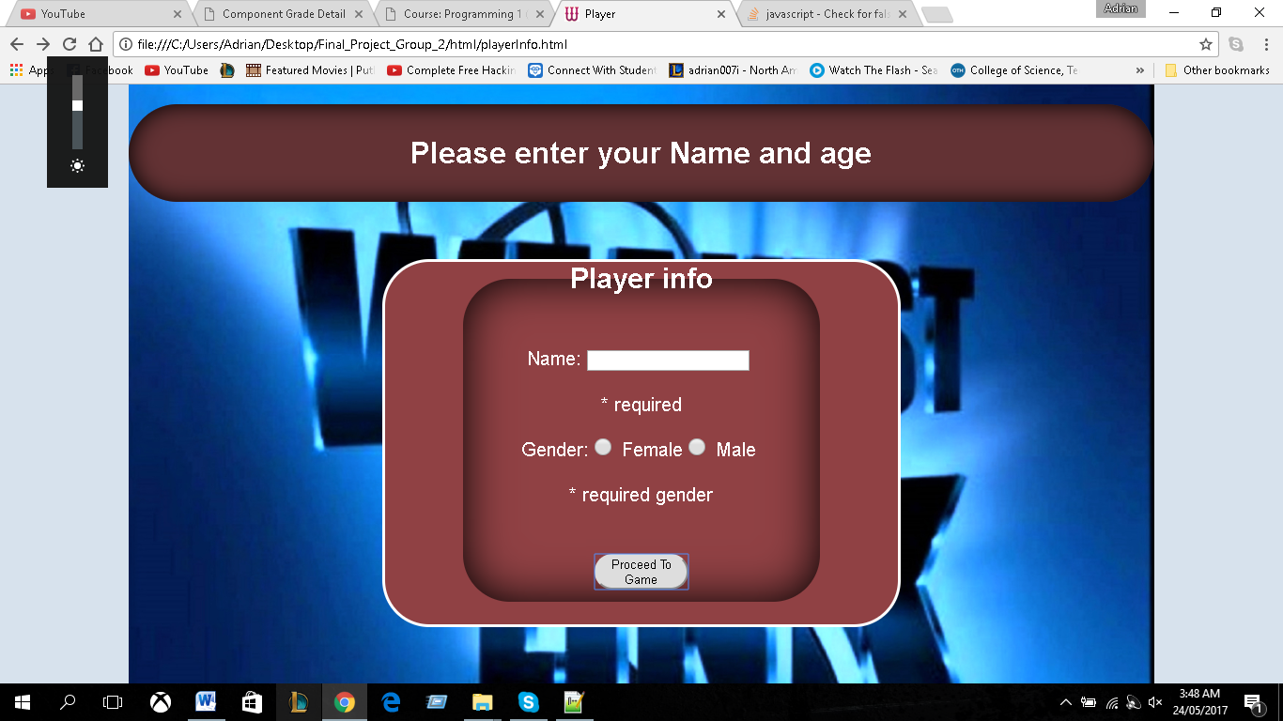

After the user is finish viewing the rules of the game, they could click the button to start playing. When the user clicks “click to play” on the homepage, they will be sent to this page where we will capture the users name and gender. Both form controls is validated to ensure the user enters accurate data. When the user fills out the form correctly they could now begin the game.

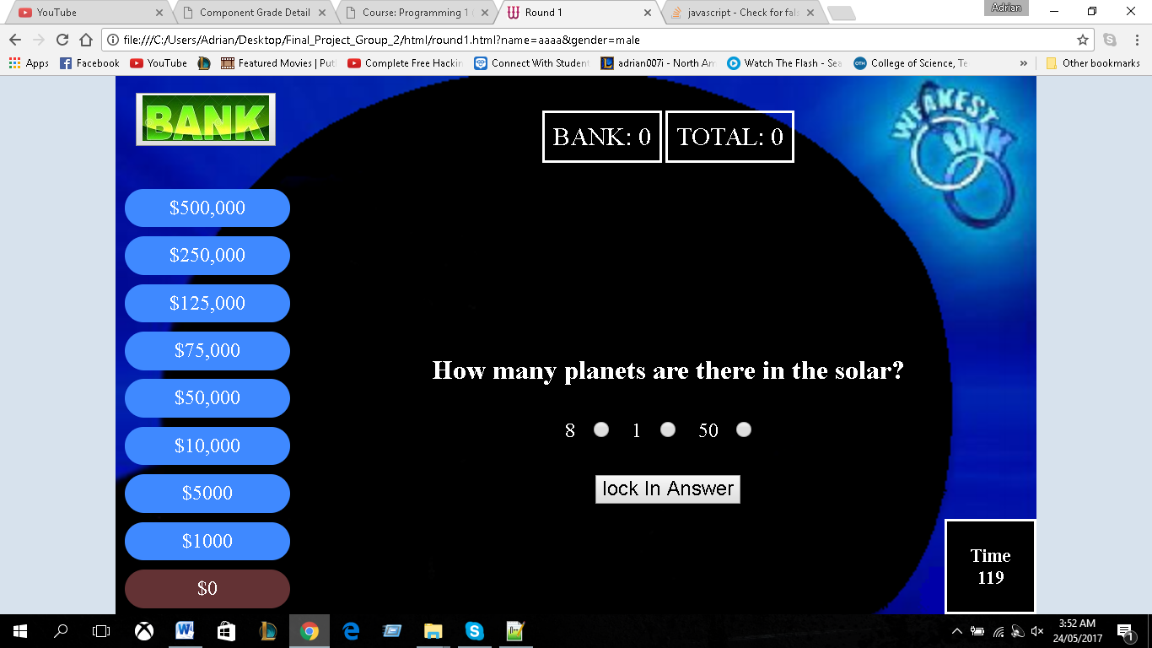**Round 1:**

//jjjjjjjjjjjj////////////////////;l The user will be given 120 seconds for this round where they will be asked a series of questions. If the user answers the question correctly, the background colour of the present position in the money tree will turn to blue and the position above will turn to brown. As shown below.

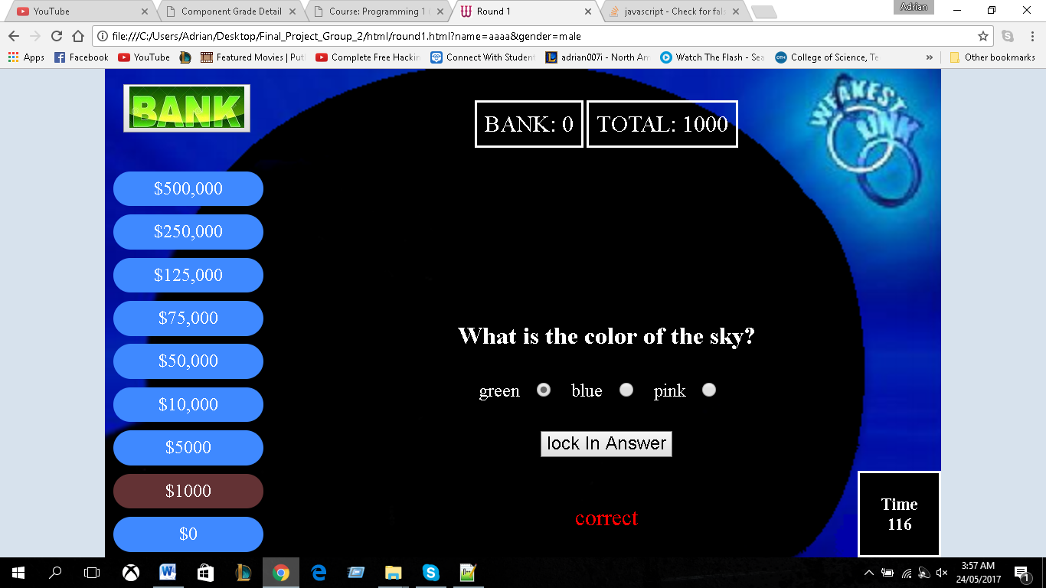

At the top-centre of the page, the money won and the bank amount will be displayed. As demonstrated above the user won $1000. so it is displayed in the cell. A simple message is also displayed, informing the user if they got the question right or wrong. The message is only displayed for 2 seconds.

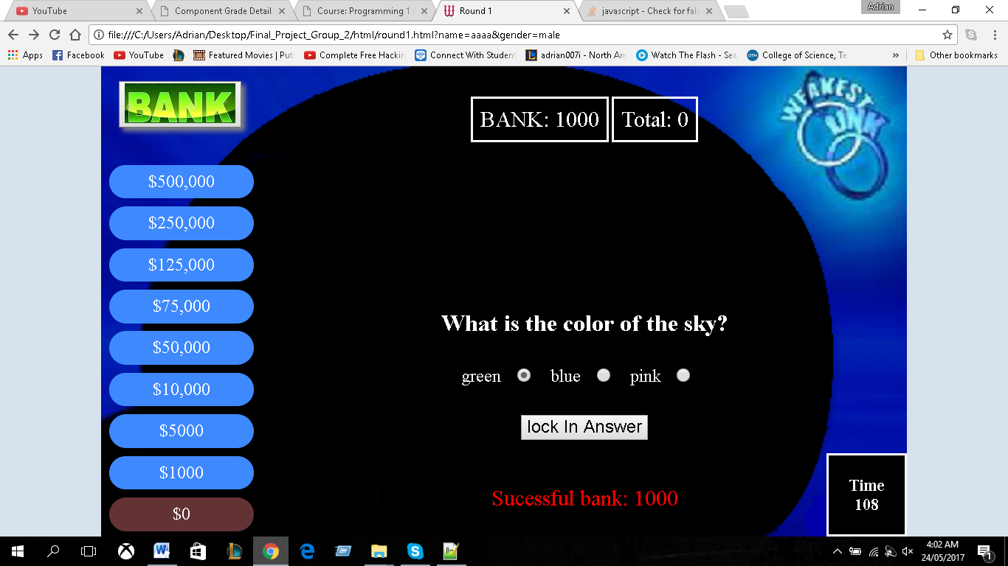

If the user decides to hit the bank button, they would be greeted with a message of the bank status; in this case it was successful. The money tree goes back to 0 and the amount won goes back to 0. The bank cell now has $1000.

**Round 2:**

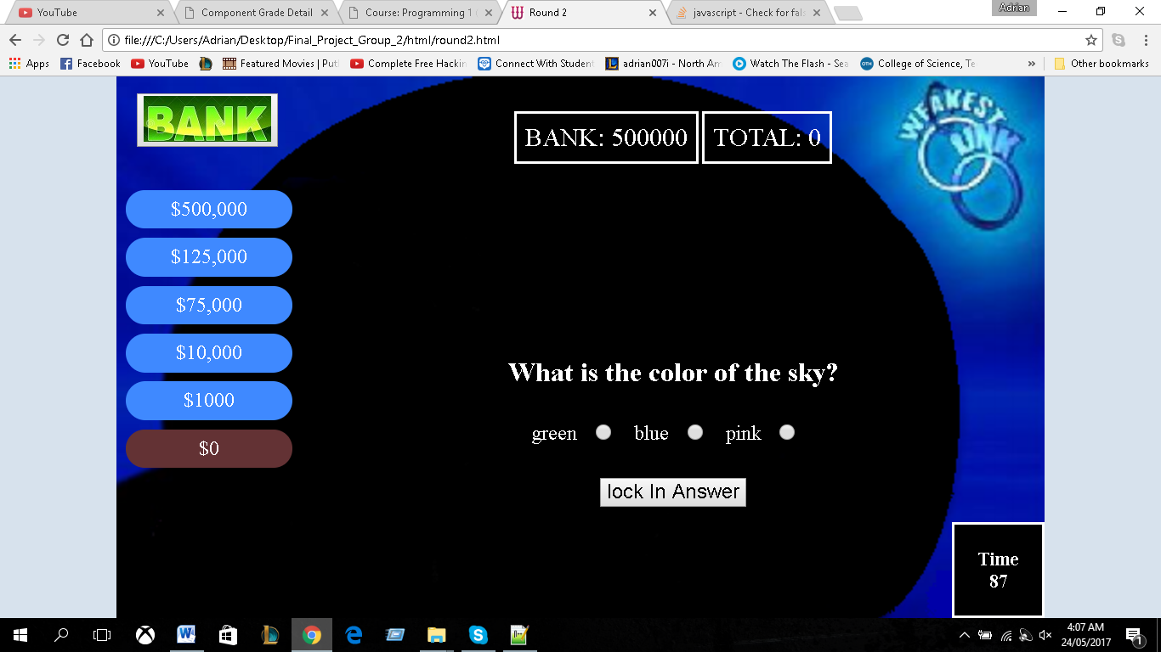

Round 2 functions the same as round with the exception of the money tree and the timer. The user gets 90 seconds on this round. As displayed in the bank area, the user banked 500,000 with was then send to this round and displayed to the user in the cell. If the user banks more money, the value will be added to the 500,000. To access the bank value from multiple pages, we utilize local storage.

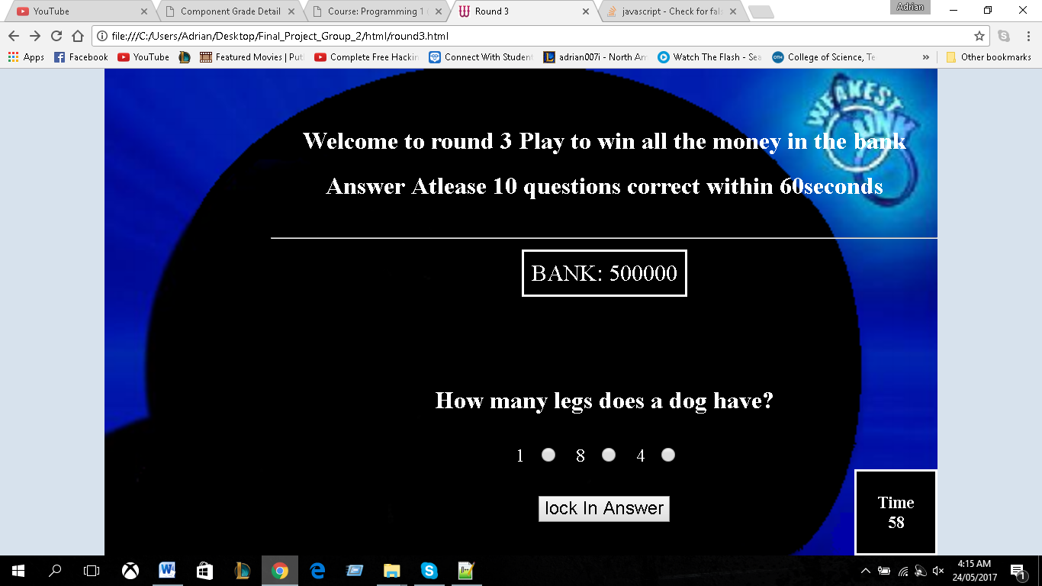**Round 3:**

For round 3, only if the user has money in the bank they would be taken to this round. As shown the user must answer at least 10 questions within one minute in order to win the money in the bank. If the user answers one question wrong, they would lose the game.

**If user wins:**

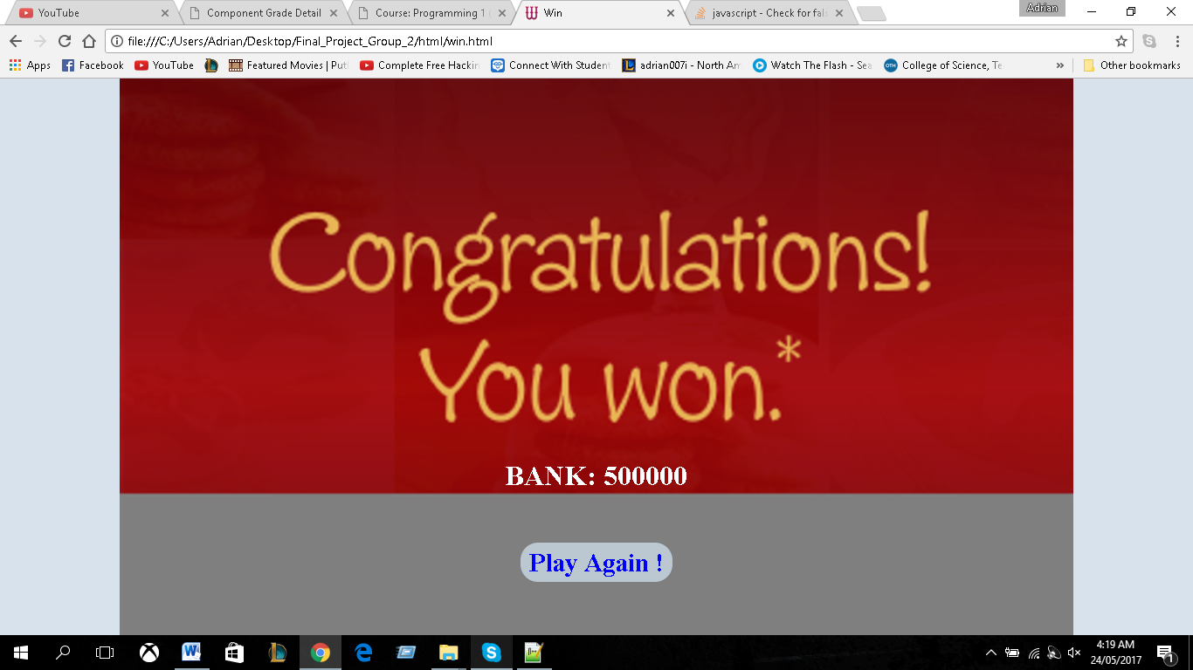

If the user wins the game, they would be taken to this page and will show the amount of money the player has won. The user then has the option to play again via the hyper link.

**If the play lose.**

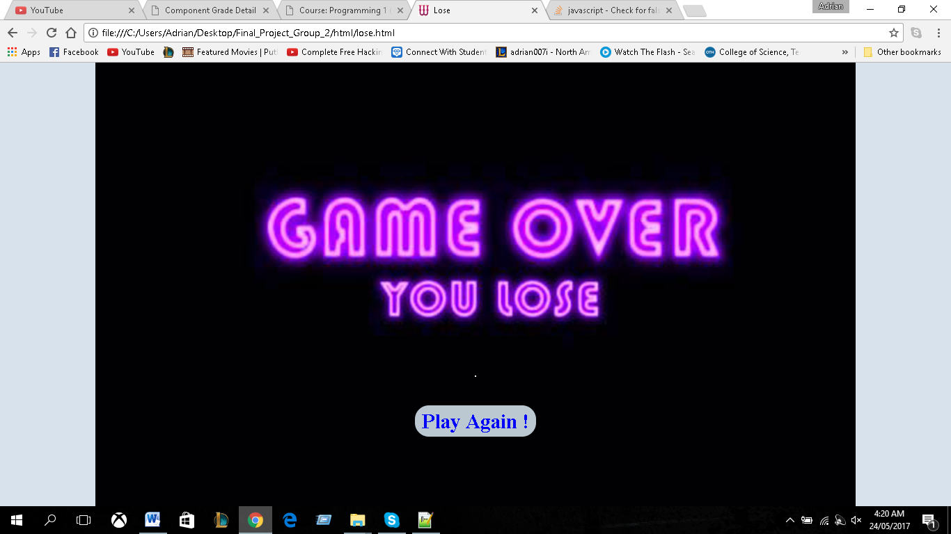

If the play lose the game they will be taken to this page where they would be given the option to play again via a hyperlink.