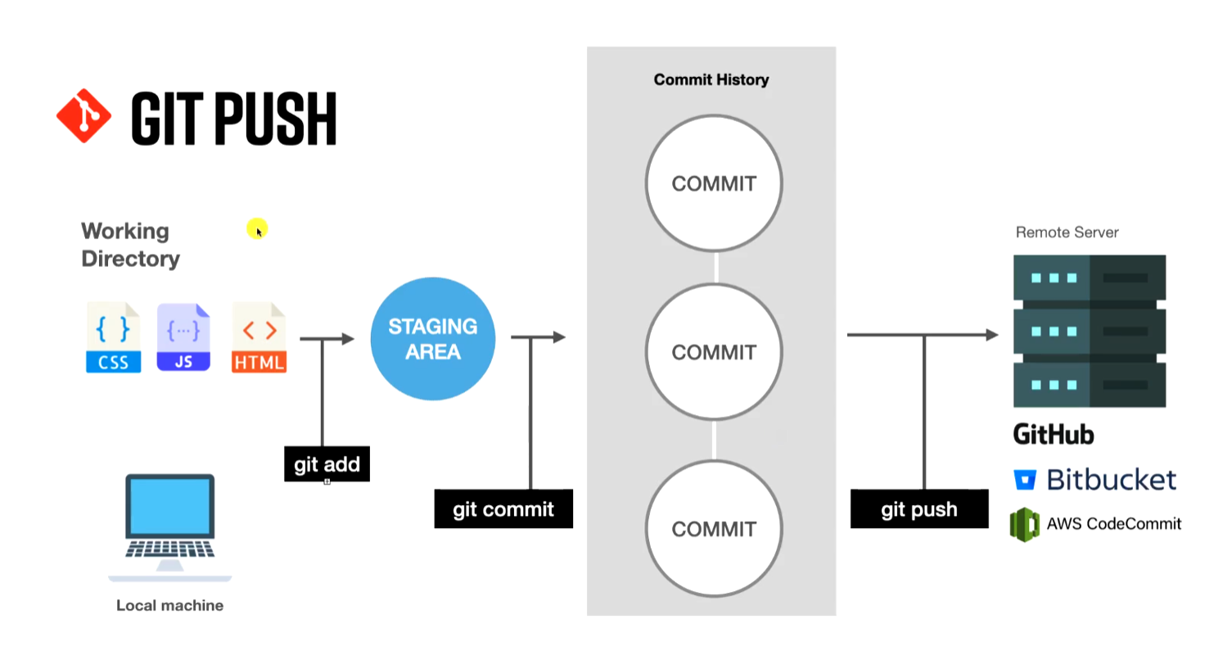

GIT PULL
Bring changes from server to local machine, we cam make changes and commit in gitHub
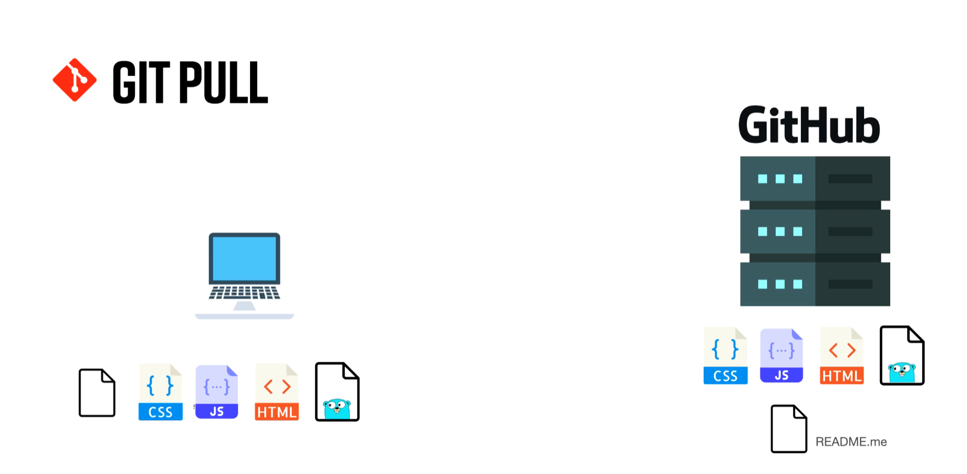

BRANCHES

Each commit is identified by the hash (a86a2a8a063906b91be80f5993e3635ffd5a0917)
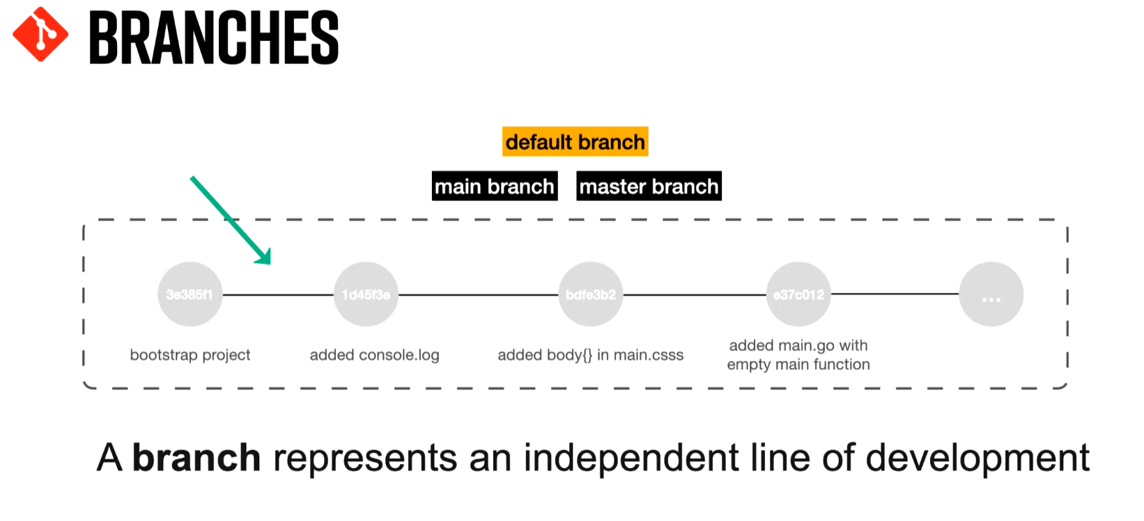
_____________________________________________________________________________________
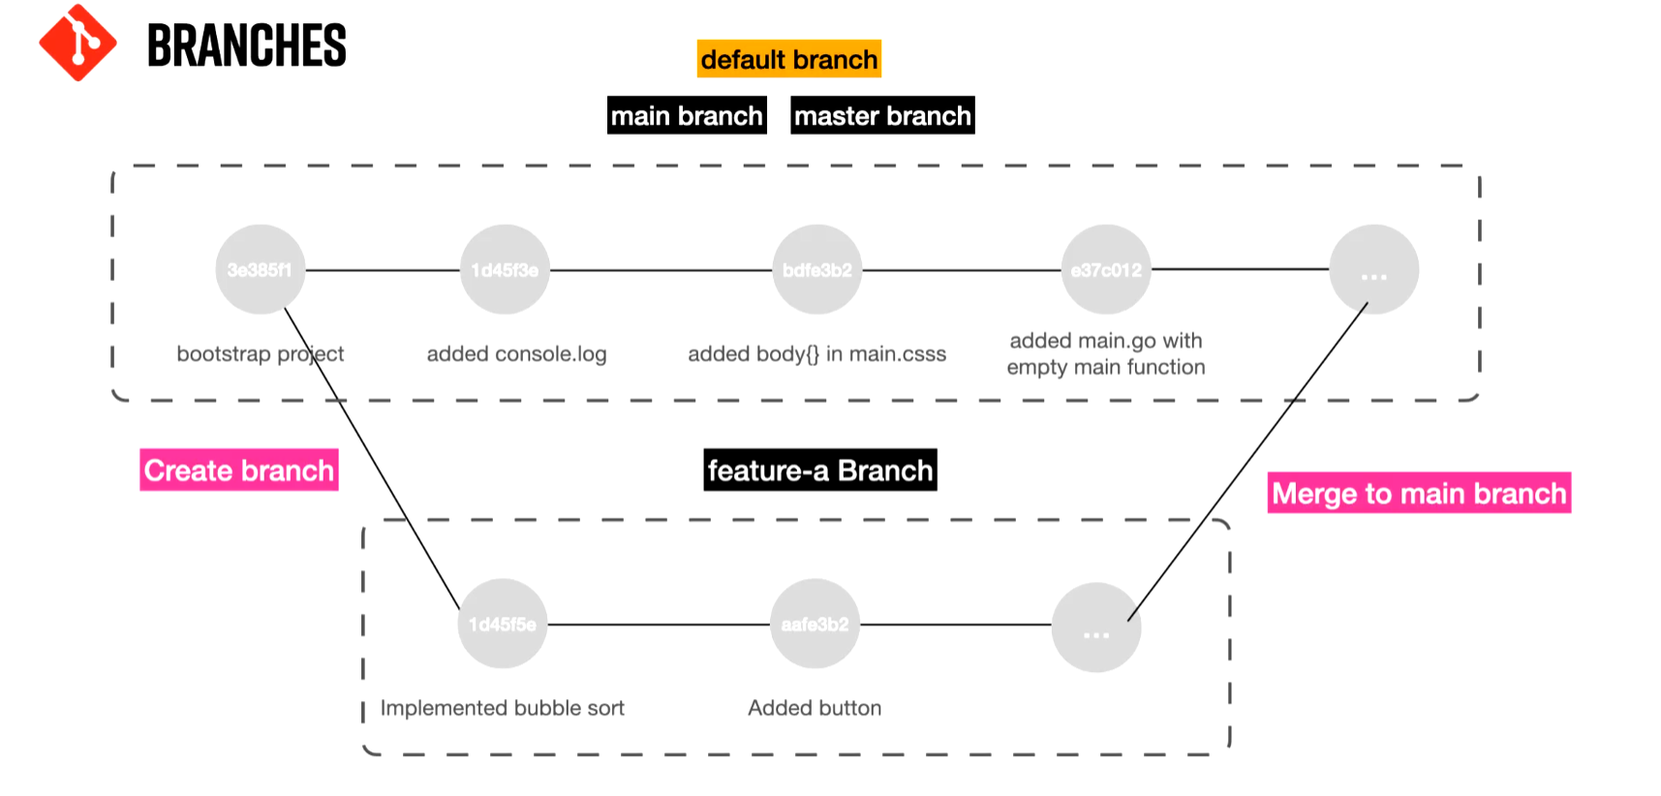

Working with Branches
- git branch
  - shows which branch you are locally
- git branch -r
  - shows which branch you are remotely – server
- git branch -a
  - shows all branches
when making a branch we are making a copy of main

Creating a branch
- git branch branchName

Switching from main to branch
- git checkout feature-a
  - switch to branch feature-a
- git checkout –
  - switch to previous branch

Creating a switching a branch
- git checkout -b branchName
  - creates branch and switch at the same time
Deleting a branch
- Switch to main branch
  - git branch -d branchName
    - deletes the branch

MAIN & MASTER ARE THE EXACT SAME THING

PULL REQUEST

When merging two branches it is best practice to do it through a pull request.
We NEVER merge the two branches directly without verification of changes made.
- git merge feature-a
  - this will directly merge the two branches
What we do we create a pull request and assign reviewers to approve the changes.

Conflicts

