**2nd Semester 2nd Interdisciplinary Project**

**AP Computer Science (dat20i)**

**SWD, SWC & ITO**

**Spring 2021**

Total pages: *****

# **“4 People” group:**

Adrian Enachi

Dominic Smith

Mahfuzur Rahman Shawon

Mădălin Petru Loghin

Index

|  |  |
| --- | --- |
| Inception |  |
| Introduction | 1 |
|  |  |
| Phase plan | 2 |
| Problem statement | 3 |
| Problem analyses | 4 |
| Project limitations | 5 |
| List of requirements | 6 |
| Feasibility Study | 7 |
| Risk analysis | 8 |
| SWOT analysis | 9 |
| Stakeholder analysis | 10 |
| Use Case diagram | 11 |

|  |  |
| --- | --- |
| Elaboration |  |
| Interation 1 | 13 |
| Domain Model | 14 |
| ER- diagram | 15 |
| Use Case description | 16 |
| Class Diagram | 17 |
| Data Base | 18 |
| Glossary | 19 |

|  |  |
| --- | --- |
| Quality Concepts |  |
| Quality of design | 38 |
| Quality of conformance | 39 |
| Software Testing Techniques |  |
| Unit testing | 41 |
| Integration testing | 42 |
| Debugging | 43 |
| Normalization of your tables | 44 |
| Construction |  |
| Code | 45 |
| Transition |  |
| Hand In | 46 |

|  |  |
| --- | --- |
| Extra Specifications |  |
| Gathering |  |
| FURPS | 21 |
| UML | 22 |
| Activity Diagram | 23 |
| System Sequence Diagram | 24 |
| Sequence Diagram | 25 |
| State Diagrams | 26 |
| Package Diagram | 27 |
| Grasp |  |
| Information Expert | 29 |
| Creator | 30 |
| Low Coupling | 31 |
| High Cohesion | 32 |
| Controller | 33 |
| Polymorphism | 34 |
| Pure Fabrication | 35 |
| Indirection | 36 |

Inception

Introduction

Purpose

The purpose of this project is to detail the requirements of the covid-19 test center website for the Sundhedsstyrelsen (The Danish Health Department) ,to design a solution and to implement it into working software.

Scope

This document focuses on covid-19 test center website which will be developed by the “4 People” group from AP Computer Science (dat20i) at KEA. The team will develop this system to digitally manage the required activities.

Product perspective

The covid-19 test center website will be available to users online and will provide them services to book and see their corona virus tests and at the same time will give the ability to read, create and update tests and search users names and locations of taken tests to the secretary and plus the possibility to delete tests to the Administrator.

Phase plan

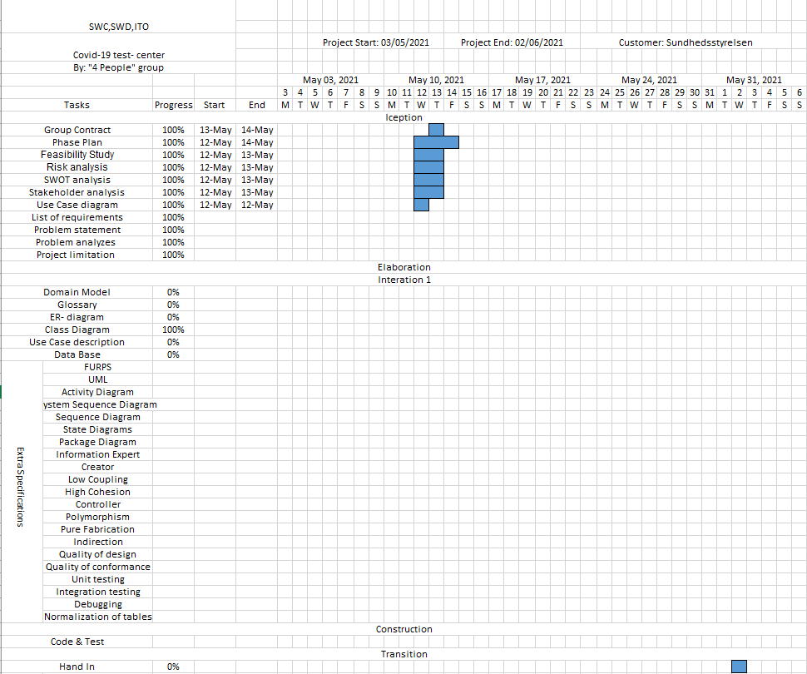

Problem statement

Problem analyses

Project limitations

List of requirements

Feasibility Study

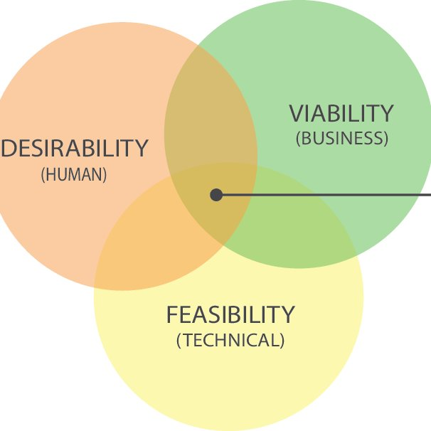1

**Desirability:**

(Do they want this?)

After doing the research of how dangerous can be Covid-19, we realized that people must take a coronavirus test if they have symptoms or have been in contact with an infected person in the last days. It is important for people to take a coronavirus test just to make sure that they are not spreading the virus to the others and it can be prevented. There is also a possibility to get vaccinated after the vaccine is approved by the government and the appointment to it can easily be booked on our online system. People will accept to get tested and vaccinated because it is for free.

The ideal response is for public health officials to begin testing for it early and here we come to the aid with our digital system that will organize and increase the number of people tested. That leads to quick identification of cases, quick treatment for those people and immediate isolation to prevent spread. Early testing also helps to identify anyone who came into contact with infected people so they too can be quickly treated.

**Viability:**

(Should we do this?)

In order to figure it out how many infections are in the world, people with and without symptoms will get tested. By making the online booking system for Covid-19 we help the government to get the right numbers of positive and negative people for their statistics. Due this, the country will have fully control on spreading the virus and can apply the best restrictions for population.

Our online booking system will be beneficial for country when people will be vaccinated as a large number as possible. According to that the population can forget about quarantine period and get back to their past routine: going to work, school, travelling and so on.

**Feasibility:**

(Can we do this?)

By doing this project, we are not expecting any income or profit from it. Our team have the right tools in order to fulfil the tasks and we are not in need of any financial resources. If it is the case, then we have the help of the government.

Risk analysis

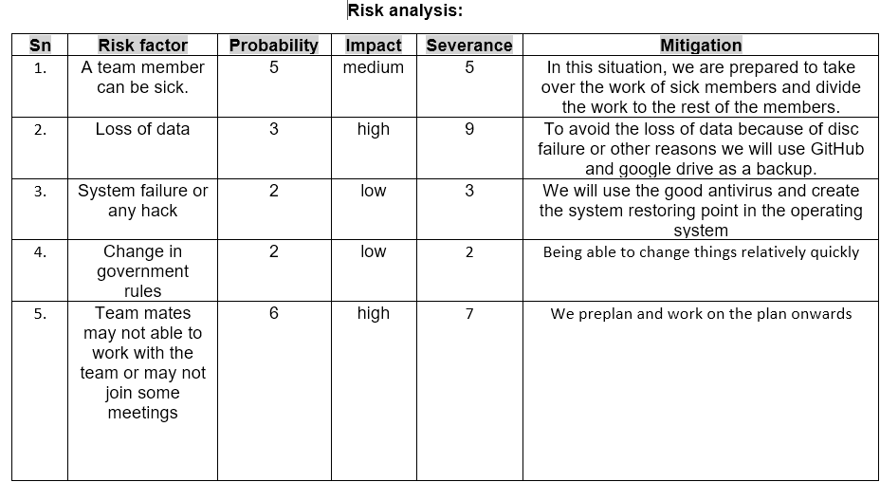

SWOT analysis

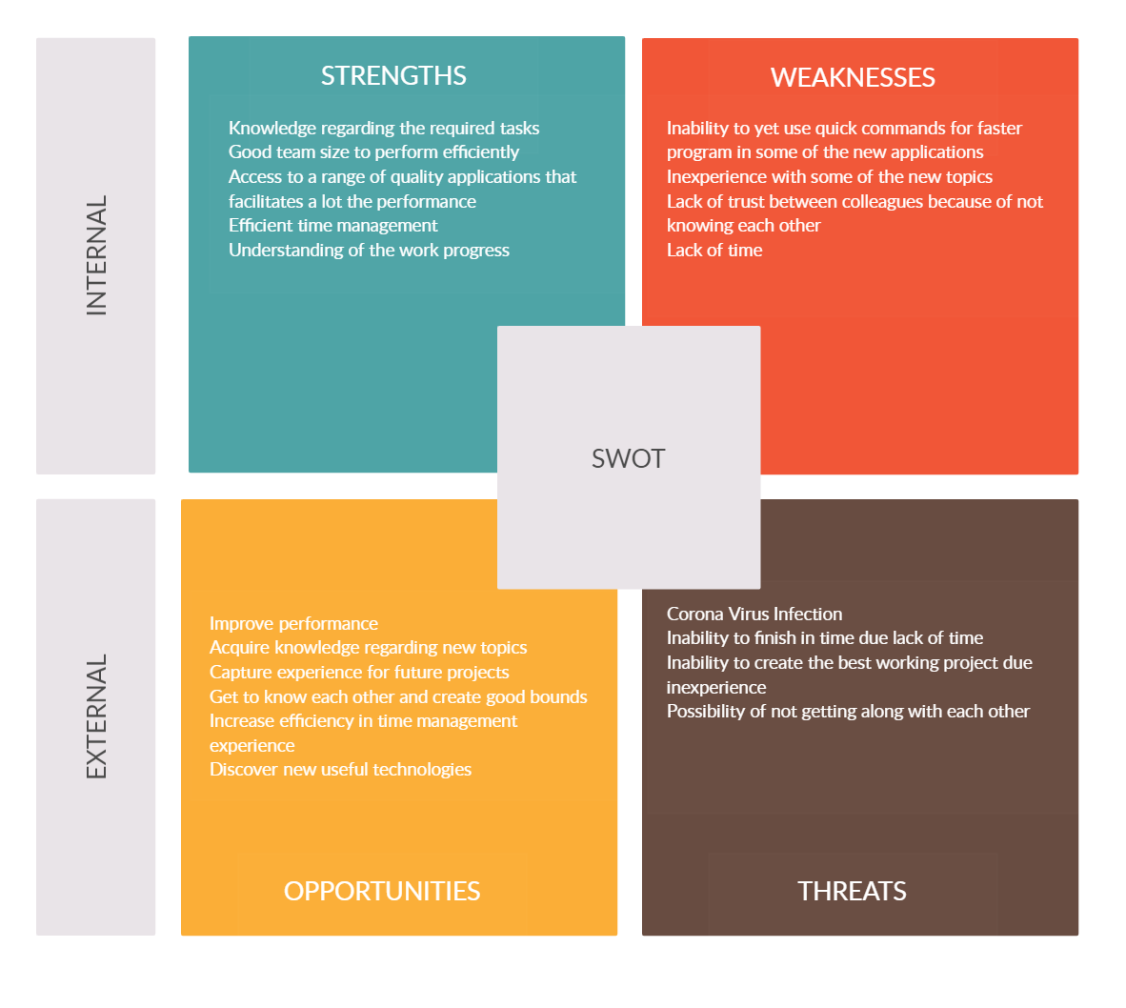

Stakeholder analysis

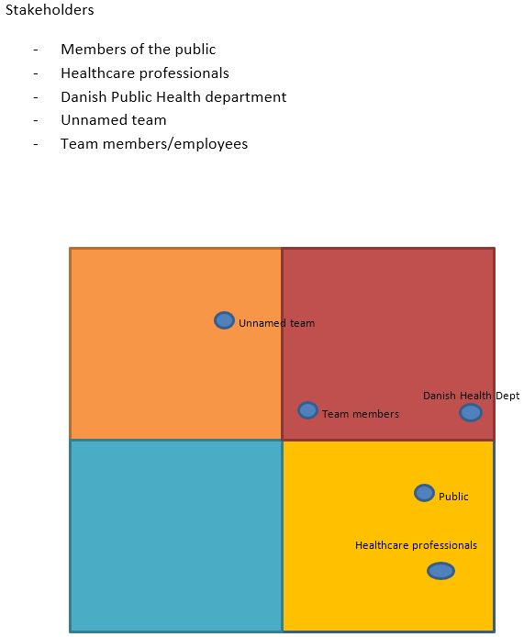

Use Case Diagram

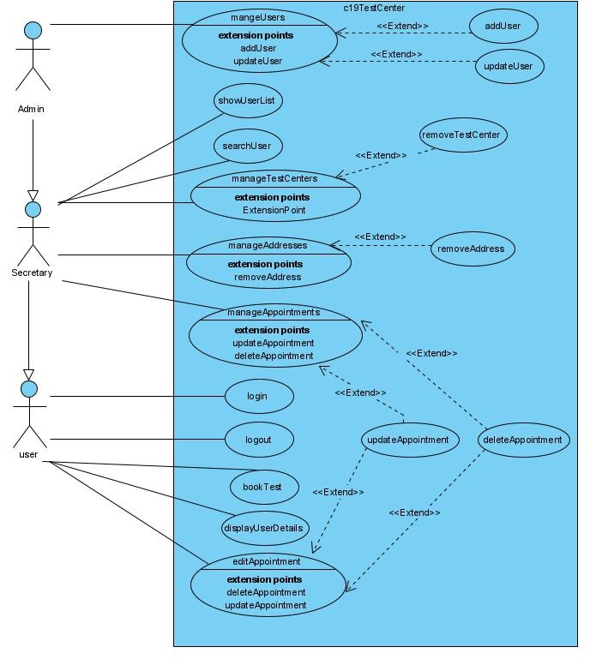

Figure 1 - Use Case Diagram

Elaboration

Domain Model

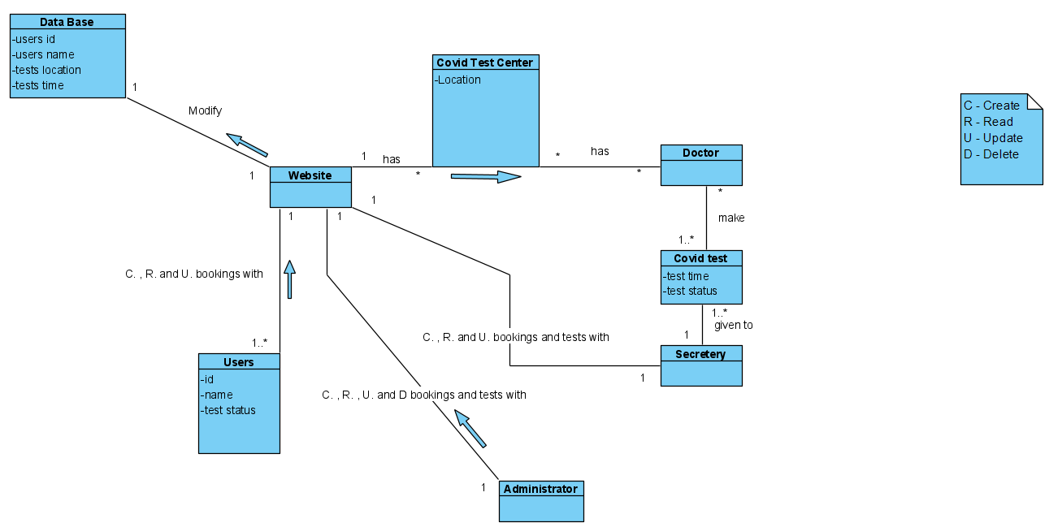

ER- diagram

Use Case description

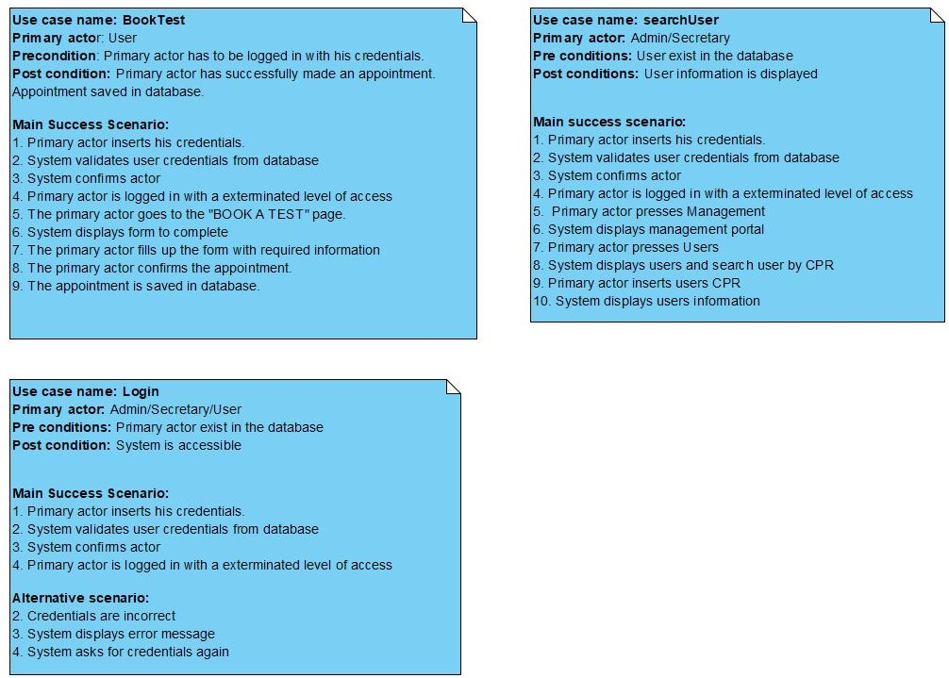

Class Diagram

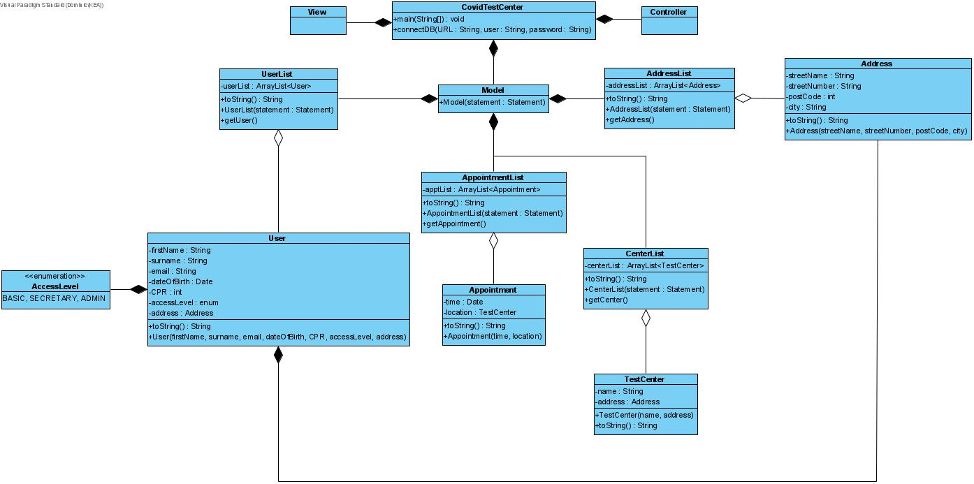

Data Base

Glossary

Extra Specifications

Group Contract

Contract of Group

Contract created on 13/05/2021

Group Members:

Dominic Smith, Adrian Enachi, Madalin Petru Loghin, Mahfuzur Rahman Shawon

The aforementioned group members agree to the following:

1. Assumption of duties.

* Completion of the Covid-19 Test Center Project no later than 02/06/2021 @ 09:59:59am

1. Description of work, including work activities and working hours

* All members are expected and hereby agree to contribute equally to the best of their ability to the completion of the project. This includes work for all aspects of the provided narrative, and all requirements of the system, as well as any additional functionality that the group deems to be necessary or desired.
* Group meetings are to be held upon commonly agreed upon times and dates. Any deviations or alterations should be cleared with the other group members. Consideration must be given to all group members to account for work and social life, as well as with regards to requirements for mental and physical health.
* Tasks and workload will be divided equally among all team members, but there will be an emphasis on collaborative work and working together where possible to ensure an equal level of understanding.
* Meetings and study is to take place on either Teams or Discord.
* Work should be undertaken while group meetings are taking place. However, work can be completed in their own time, provided that a coherent and understandable explanation can and is given to the other members of the team.

1. Rules and guidelines surrounding work/study

* Group members are expected to maintain high work ethic during meeting times and working times.
* Punctuality is expected from all group members.
* Collaboration and communication is heavily encouraged for the group. All group members should be comfortable speaking up and sharing their ideas, whether these be in regards to the project itself, or if they have issues with another team members punctuality, work ethic, or anything else.

I hereby agree to work to the best of my ability while in this group and in accordance to the terms set out in this contract. I agree to contribute to the project with my best work so that the group may submit a full and complete project on or before 02/06/2021.

__________________________________________________________________________

Construction

Code

The code for the use cases was fully developed according to the design and fully commented for easy understanding. Git and GitHub were the main tools for versioning control and sharing the code between developers.

Transition

Hand In

Wednesday, June 2, 2021 10 am hand-in to WiseFlow.

The code both will be handed in as a link to GitHub and a zip file.