# Compositions

1. Create an audio-only composition.  
 **CJ0c0eeb32a8ba95806a4482880b144404**

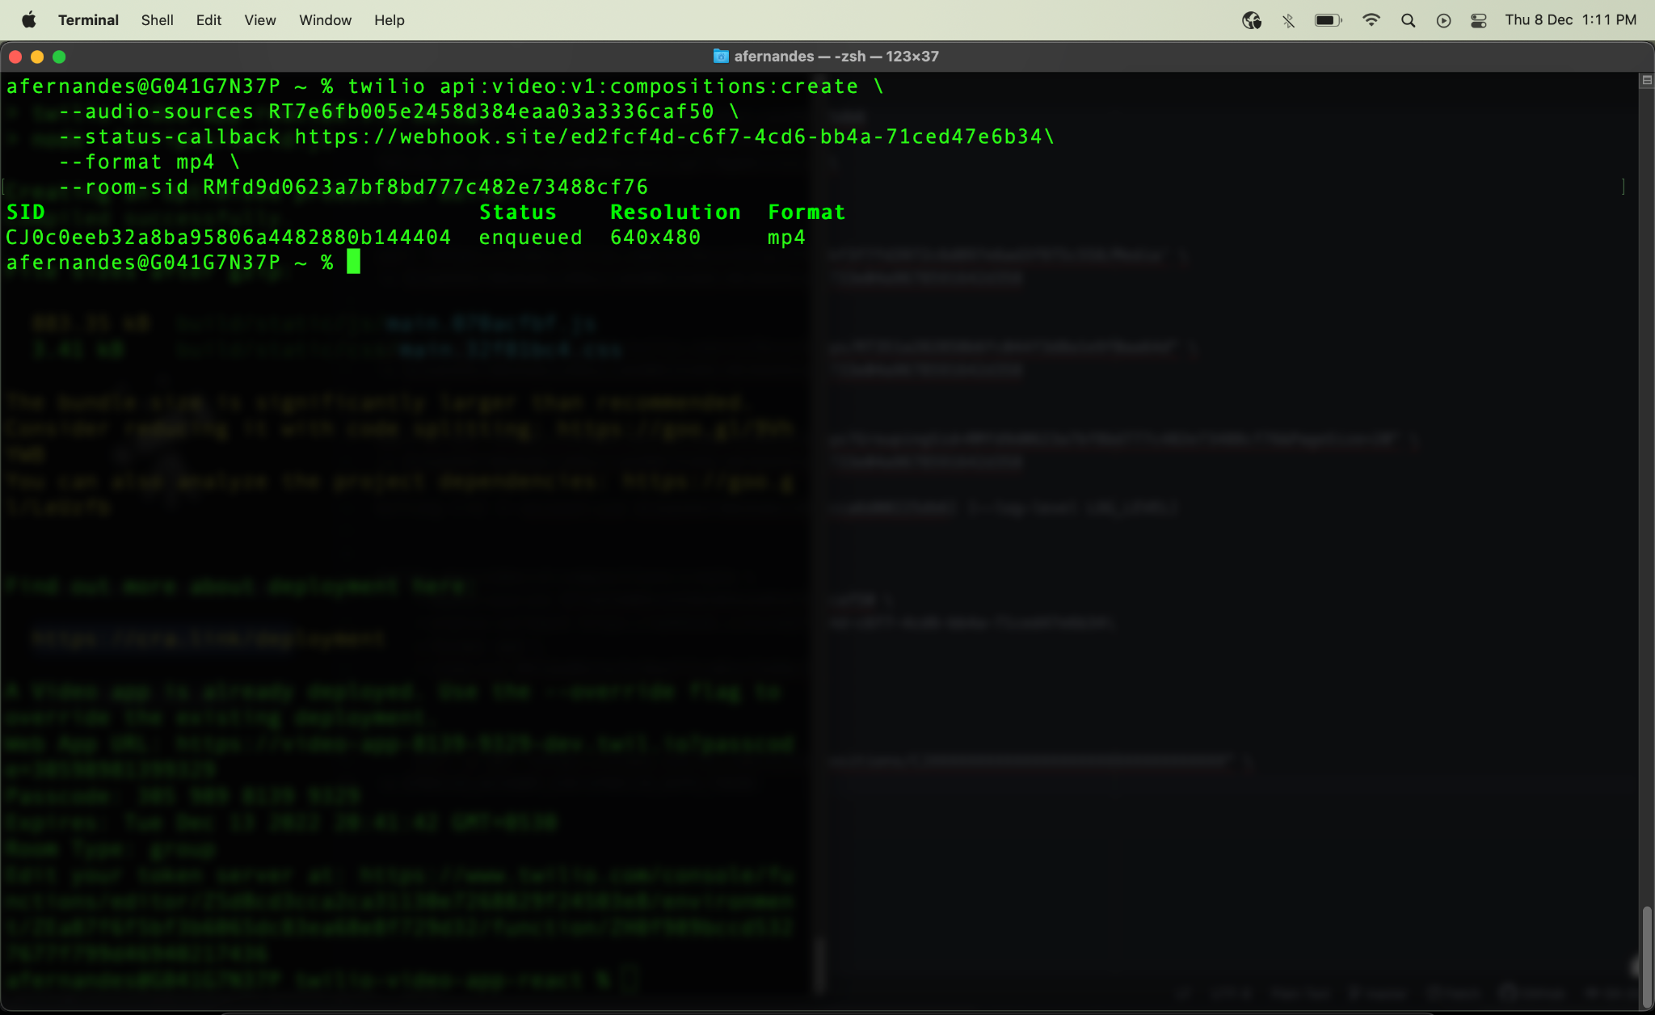

2. Create a video grid composition  
**CJedf740eadd8db19f264fea14e0be9533**

