**Name:** Adrian Raszkiewicz

**Student ID:** 7128671

**Module:** 310CT Intelligent Agents

**Coursework:** Paper presentation and Agent navigation

*06/12/2018*

Design Documentation

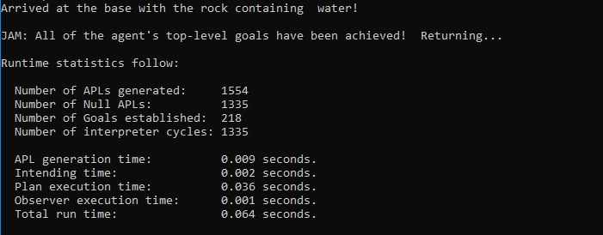

Firstly I inputted all the rocks with their coordinates into jam agent as facts, including the rock with water.

I have also set the map grid as shown in the coursework specification.

The rover will firstly travel to the very right side of the grid along the x axis, after this it will move one space up on the y axis, and again travel to the very left side along the x axis. This is how the rover will navigate around the entire 7x6 grid.

Once the rover encounters a rock on it’s path it will check it for water against the information given, if no water is found it will keep on searching.

The are two main WHILE loops to make the rover navigate around the map with the above explained method, it will do so WHILE it doesn’t each the end on the x and y axis.

There is a condition that the jam agents check against and decides which one of the two main while loops to use, this condition is set to 1 (z=1) so while z is less than ‘2’ the rover will move up on the ‘y’ axis by one and keep on moving to the right untill it reaches the end of the grid or finds a rock. Loop terminated when its reached the end to the of the grid to the right.

While the condition is more than ‘2’ (manually set it to 3) the while loop responsible for moving to the left will be executed untill it reaches the end of the grid or finds a rock. Loop terminates when its reached the end of the grid to the left.

The are also different while loops for encountering the different rocks, which are included in the main two loops so the rover know where each rock is and how to respond. Once it reaches the rock with the water it will return to base.

I also have a while loop that tells the rover how to return to base, simply firstly moving to ‘0’ on the y axis and after moving to ‘0’ on the x axis.

**Test Results**

Test 1: Does the agent succesfully complete its goal.

Goal: Retrieve rock 5 with water and move it to base.

Result: Rock 5 retrieved and rover returned to base successfuly.

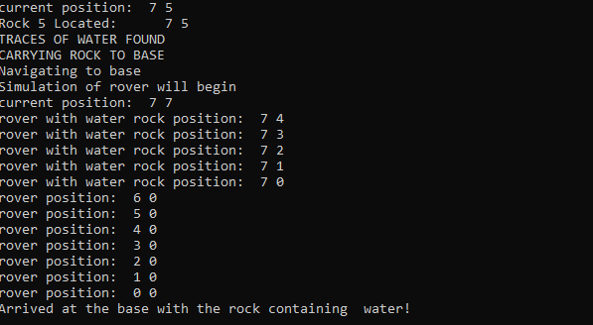

Test 2: Will the rover navigate around the whole grid to find the last rocks if rock (7,5) doesnt contain water

Goal: The rover will keep looking to find the last rock (2,6)

Result: The rover navigates and located the last rock on the top of the grid,

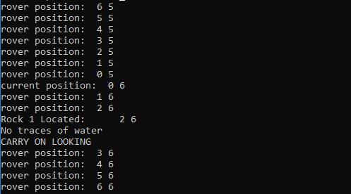

Test 3:Will the rover acheive its top goals if the first rock contains the water, did this by switching the coordinate of the first rock and the rock containig water.

Goal: The rover will reach rock and and carry it back to base

Result: The rover succesfully caried rock 1 to base.

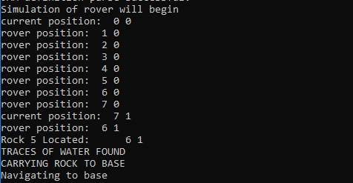

Test 4: Will the rover acheive its goals with more rocks on the grid, added rock 6 (4,4) and rock 7 (6,1)

Goal: The rover will find the additional rocks if they are located before the water rock, and pass over them

Result: The rover finds both rock 7 and 6 as they are before the water, then proceeds as expected.

