Meta-Reasoning with Analogy for Adaptive
Robot Delivery Navigation

A Three-Model Comparative Study Under Environmental and Task Uncertainty
Dempster-Shafer Theory · Analogy-Based Meta-Reasoning · Agility Metrics

Abstract
This report presents a simulation-based evaluation of three autonomous delivery robot architectures — a reactive baseline (M0), a symbolic safety-first planner (M1), and a meta-reasoning hybrid (M2) — across 16 experiments covering four environment types, task-level uncertainty, three switching mechanisms, and regime-change agility tests. The core hypothesis is that a robot which selects and updates task analogies using Dempster-Shafer Theory (DST) will outperform both fixed-policy alternatives across a broader range of operating conditions. Results confirm this hypothesis: M2-DST achieves the highest or tied-highest Safety-Efficiency (SE) score in all three environment configurations (domestic 74.3, mixed 51.6, warehouse 37.8), wins three of four detailed scenarios (Fig 13), achieves the lowest overall spill rate, the best task-adaptation performance (SE = 66.2 under sealed-container conditions, Δ = +31.0 over lid-open), and the fastest regime-change reaction latency of any mechanism tested (2 runs open→closed, 1 run closed→open).

1. Introduction and Research Problem
Autonomous service robots operating in human environments face two distinct categories of uncertainty. The first is environmental uncertainty: the robot must navigate around furniture, shelving, and moving people whose exact positions change between deployments. The second is task uncertainty: the robot's cargo changes (hot vs cold, open vs sealed, fragile vs robust), which changes the cost of different types of failure.
Classical approaches resolve this trade-off at design time by selecting a fixed operating mode: either a reactive controller optimised for speed (fast but dangerous with fragile cargo) or a deliberative planner optimised for safety (safe but slow, even when speed is appropriate). Neither approach can reason about which mode is appropriate for a given task in a given environment — that requires a third capability: meta-reasoning.
This study asks: can a robot that encodes task knowledge as analogies, and maintains probabilistic beliefs about how well those analogies fit the current situation, outperform both reactive and deliberative baselines? And if so, which component of the meta-reasoning architecture matters most — the path-specific obstacle sensing, the task-analogy belief update, or the attention modulation mechanism?
Research question: Is meta-reasoning with analogy — implemented via nested Dempster-Shafer belief layers — the best strategy for adaptive robot delivery, as measured by both classic performance metrics (SE score, spill rate) and new agility metrics (reaction latency, sample efficiency, behaviour stability)?

1.1 Three Approaches to Handling Novelty
A central challenge in robot delivery is how to behave correctly in situations the system was not explicitly designed for — the novelty problem. Three fundamentally different approaches exist, each with a different relationship to uncertainty:
- Approach 1 — Full probabilistic: Full probabilistic model. Maintains a probability distribution over all possible world states and updates it via Bayes' rule after every observation. In principle optimal, but requires a complete forward model of the environment: every obstacle type, every cargo configuration, every possible sensor reading must be pre-enumerated. In a delivery domain with open-ended cargo (hot coffee, sealed pouches, fragile electronics) and unstructured environments (homes, offices, warehouses), building this model is intractable. When a novel entity appears that was not in the model, the probabilistic system has no prior to update — it becomes undefined or requires expensive model extension.
- Approach 2 — Deterministic rule-based: Deterministic rule-based. Encodes the deployment scenario as a fixed set of IF-THEN rules or a state machine. Produces consistent, explainable behaviour within the design envelope but is categorically stuck when novelty falls outside that envelope. A deterministic planner that has no rule for 'unknown obstacle on path' will either ignore it (M0/M1 behaviour in this study) or stop entirely. It cannot extrapolate: the absence of a matching rule produces no useful output.
- Approach 3 — Analogy meta-reasoning (this work): Analogy-based meta-reasoning. The robot does not need a complete forward model, nor does it require the novel situation to be pre-enumerated. Instead, it reasons: 'this new situation resembles a domain I know — apply the principles from that domain until evidence proves them wrong.' When an unknown obstacle appears on the path, M2 does not look it up in a table; it asks 'does my medical_care analogy say anything about unexpected path obstructions near vulnerable people?' and infers: yes — slow down, maintain wide margins, treat it as a hazard. This generalisation capability is the defining feature of analogy-based meta-reasoning and distinguishes it from both approach 1 (too rigid about the model) and approach 2 (too rigid about the rules).
The tradeoff is explicit: M2 cannot guarantee optimality (it is working from an analogy, not a verified model), but it can produce safe, approximately correct behaviour in novel situations without any additional programming. The experiments in this study test whether this tradeoff is favourable in practice across the four uncertainty dimensions: environmental (cluttered vs clear), task (lid open vs closed, fill level), temporal (regime changes), and epistemic (novel entities).

1.2 Low-Level and High-Level Uncertainty
The architecture separates uncertainty into two levels, each handled by a different mechanism:
- Low-level: Low-level (perceptual) uncertainty: 'Is there an obstacle in my path right now?' This is resolved by the DST path-cone belief (Pl_H) using real-time laser sensor data fused with particle-filter localisation uncertainty. The belief operates at the frame level (every 3 simulation steps) and drives immediate switching between cautious and efficient navigation policies.
- High-level: High-level (strategic) uncertainty: 'Is my current operating strategy appropriate for this task and environment?' This is resolved by the run-level DST layers (Pl_analogy, Pl_env) updated from accumulated outcome evidence (spills, clean runs, collisions). High-level uncertainty does not change frame-by-frame; it evolves over the course of multiple deliveries as the system builds evidence about its own strategy's validity.
The sealed-container example captures both levels simultaneously: when the lid is closed, low-level uncertainty is unchanged (obstacles are still sensed identically), but high-level uncertainty is reduced (the analogy system infers a different risk profile from the task description). Only M2 can respond to high-level uncertainty — M0 and M1 have no mechanism to represent it.

2. Simulation Environment

2.1 Physical Environment
The simulation takes place in a two-dimensional square arena of 10 × 10 metres, representing either a domestic room (home kitchen/lounge) or an industrial warehouse floor. The robot begins every delivery run at position START = (9, 9) in the upper-right corner and must reach GOAL = (1, 1) in the lower-left corner. The straight-line distance between these points is approximately 11.3 m.
Obstacles take the form of a convex polygon — a cluster of six vertices representing furniture (domestic) or shelving units (warehouse). The polygon is placed near the centre of the room and is randomised slightly each run (±0.8 m translation, ±15% scale) to prevent the robot from memorising a fixed path. In 'clear' scenarios the polygon is absent; in 'cluttered' scenarios it is always present.
A novel entity — an obstacle physically present but absent from the robot's pre-loaded map — may appear on the robot's path from run 8 onward in full-config experiments. It is represented as a circle of radius 0.45 m. M0 and M1 are blind to it (they only consult their static map). M2 detects it through anomalous laser returns and reasons by analogy about how to respond.

2.2 Robot Sensor Model
The robot carries a 360° laser range-finder modelled as 36 rays spaced 10° apart, each with a maximum range of 5.5 m and Gaussian noise (σ = 0.03 m). The robot also has wheel encoders (noise σ = 0.02 m per step) and maintains a particle-filter localisation estimate with 40 particles. Localisation error is fed into the DST update as epistemic uncertainty (the Θ — open-world — mass).
Sensor / Model | Specification | Used By
Laser range-finder | 36 rays, 360°, 5.5 m range, σ=0.03 m | M0 (basic avoidance), M1 (grid), M2 (DST + anomaly)
Wheel encoders | σ=0.02 m per step | All models (motion integration)
Particle filter | 40 particles, Gaussian resampling | M2 only (localisation uncertainty → Θ mass)
Obstacle grid | Occupancy grid from laser + known polygon map | M1 (A* planning), M2 (blended planning)

2.3 Robot Control Parameters
Every robot action in the simulation is governed by three continuous control parameters. These parameters are the primary degrees of freedom that distinguish M0, M1, and M2, and they are the quantities that M2's meta-reasoning updates in real time.

2.3a Speed (v, m/s)
Speed is the magnitude of the velocity vector applied to the robot each simulation frame (frame = one STEP_SIZE = 0.22 m increment). Higher speed reduces delivery time (improving the time_factor component of SE) but increases two risk factors:
- speed_risk = max(0, v/v_max − 0.50): rises linearly once the robot exceeds 50% of maximum speed. At v = 0.65 m/s (M0), speed_risk ≈ 0.32. At v = 0.40 m/s (M1), speed_risk ≈ 0.07.
- jerk_risk = ||Δv|| / STEP_SIZE: the magnitude of the velocity change per frame. Sharp path turns at high speed produce large jerk — the primary cause of spills.
In the simulation, speed is represented as the length of the green velocity arrow drawn from the robot's centre. Visually, M0 moves with noticeably longer per-frame displacements; M1 moves in shorter, more deliberate steps.

2.3b Inflation (metres added around obstacles)
Before running the A* path planner, every occupied grid cell is expanded outward by the inflation radius. This creates a virtual buffer zone — cells within the inflation radius of a real obstacle are also marked as forbidden. The robot therefore plans a path that maintains at least 'inflation' metres of clearance from every obstacle.
- M0: inflation = 0.85 m — narrow berths; the robot's planned path passes close to furniture edges.
- M1: inflation = 1.85 m — wide berths; the planned path loops far around obstacles, sacrificing distance efficiency for guaranteed clearance.
- M2 (medical_care): inflation = 1.20 m — expert-calibrated for hot liquid cargo; wide enough to avoid jerk-inducing close passes but not so wide as to force long detours.
Visually, inflation is shown as a grey shaded halo around the obstacle polygon in the simulation display. The contrast between M0's thin halo and M1's thick halo makes the parameter immediately interpretable. M2's halo shrinks toward M0's when the path is clear (Pl_H low) and expands toward M1's when obstacles are detected ahead (Pl_H high).

2.3c Resolution (grid cell size, metres)
The occupancy grid used for A* path planning is discretised at the resolution parameter. Finer resolution (smaller cell size) produces a denser grid and therefore a smoother, more precise planned path with fewer sharp corners. Coarser resolution produces a blockier path with more right-angle turns.
- M0: resolution = 0.10 m — fast, coarse planning; paths have visible step-wise structure.
- M1: resolution = 0.05 m — fine planning; paths are smooth curves that maintain consistent clearance throughout.
- M2 (medical_care): resolution = 0.04 m — finest available; critical for liquid cargo because sharp turns induce jerk, and jerk is the dominant spill cause at safe speeds.
Resolution and inflation interact: fine resolution with wide inflation produces the smoothest, safest paths (M1-like); coarse resolution with narrow inflation produces the fastest but most erratic trajectories (M0-like). M2 blends these via DST belief.
Model | Speed (m/s) | Inflation (m) | Resolution (m) | Path character
M0-Reactive | 0.65 | 0.85 | 0.10 | Fast, close to obstacles, step-wise corners
M1-Symbolic | 0.40 | 1.85 | 0.05 | Slow, wide clearance, smooth arcs
M2 (medical_care) | 0.58 | 1.20 | 0.04 | Moderate speed, expert clearance, smoothest path
M2 (med_care_sealed) | 0.62 | 1.05 | 0.05 | Slightly faster, narrower berths — sealed container
M2 (efficient_courier) | 0.63 | 0.88 | 0.09 | Near-M0 speed and clearance — courier analogy
NEUTRAL (M2 fallback) | 0.525 | 1.35 | 0.075 | Midpoint when Pl_analogy is low — safe default

2.4 How Parameters Interact: The Spill Physics Model
A liquid spill occurs stochastically each frame if the robot is carrying the beverage and a cooldown timer has elapsed since the last spill. The probability per frame is:
p_spill = (speed_risk + jerk_risk) × cooldown_factor × lid_factor
speed_risk = max(0, v/v_max − 0.50) | jerk_risk = ||Δv|| / STEP_SIZE | cooldown_factor = (1 if cooldown elapsed, else 0) | lid_factor = LID_CLOSED_FACTOR (0.25) if sealed else LIQUID_FILL_LEVEL ∈ [0, 1]
The fill level introduces a continuous probability dimension beyond the binary sealed/open distinction. A quarter-full cup (fill = 0.25) has one-quarter the spill probability of a brimming cup (fill = 1.0) because less liquid is available to overflow at a given jerk level. This is experimentally tested in Fig 17: M2's fine-resolution path planning produces less jerk than M0 at equivalent speeds, so M2's SE degrades more slowly as the cup fills.
The key insight is that jerk_risk — not speed_risk alone — dominates spills. A fast robot on a smooth planned path (fine resolution, wide inflation) spills less than a slow robot on a coarse path with sharp corners. This is why M2's medical_care policy uses the finest resolution (0.04 m) even though it is not the slowest model: path smoothness is more important than speed reduction for preventing spills.

3. The Three Models

3.1 M0 — Reactive Baseline
M0 represents the simplest viable delivery robot: a reactive controller with fixed high-speed parameters and minimal obstacle clearance. It uses laser readings for immediate obstacle avoidance but does not plan ahead beyond the next few steps. M0 does not learn, does not reason about its task, and does not update its parameters based on outcomes.
M0 is the fastest model in clear environments (SE > 70 in domestic-clear) but the most dangerous: at speed = 0.65 m/s with inflation = 0.85 m, it passes close to obstacle edges, generating high jerk during avoidance manoeuvres. In warehouse-cluttered it spills on average 1.80 times per run — approximately one spill every two minutes of operation.

3.2 M1 — Symbolic Safety-First Planner
M1 represents an over-engineered cautious planner. It applies the maximum safety margins available (inflation = 1.85 m, resolution = 0.05 m) and moves at 40% of M0's speed. This guarantees near-zero spills in almost all conditions, but the time penalty is significant: M1 is consistently 20–30% slower than M2 in clear environments, and the path detours around wide inflation bubbles add further distance.
M1 does not adapt. In an empty room with no obstacles, it still maintains 1.85 m clearance margins and moves at 0.40 m/s — the same behaviour as in a fully cluttered warehouse. This rigidity is the key weakness that M2's environment relevance belief (Pl_env) is designed to exploit.

3.3 M2 — DST Meta-Reasoning Hybrid
M2 starts from the medical_care analogy, which encodes expert knowledge about hot-liquid delivery: moderate speed (0.58 m/s), clear berths (1.20 m inflation), and the finest grid resolution (0.04 m) for smooth jerk-free paths. It then continuously updates three nested belief layers:
- Pl_H (frame-level): is there an obstacle in my path right now? → drives the hard policy switch
- Pl_analogy (run-level): is my current analogy suited to this task and environment? → scales the expert policy blend
- Pl_env (config-level): how cluttered is this environment, relative to what my analogy assumed? → scales the inflation ceiling
The result is a robot that is fast when the path is clear (Pl_H low → stays with analogy policy), careful when obstacles are ahead (Pl_H high → switches to caution), relaxes its caution in environments that prove consistently safe (Pl_env decreases), and escalates caution when its analogy proves inappropriate (Pl_analogy falls).

4. Mathematical Framework

4.1 Safety-Efficiency (SE) Score
Every run produces a single scalar SE score in [0, 100]. It captures the joint requirement of fast delivery (time factor), full battery efficiency, collision-free navigation, and zero-spill operation.
ideal_frames = ||START − GOAL|| / (STEP_SIZE × 0.85)
Number of frames a straight-line run at 85% of maximum speed would require. Baseline for time efficiency.
time_ratio = frame_counter / ideal_frames
Ratio of actual frames to ideal. > 1 means the run took longer than ideal.
time_factor = max(0.50, 1.15 − 0.20 × time_ratio)
Converts time ratio to a [0.50, 1.15] multiplier. Fast runs score above 1; slow runs are penalised down to a floor of 0.50.
efficiency = max(0.0, (100 − collisions×100) × time_factor × (battery/100))
A collision sets efficiency to zero — task failure. Battery drain during the run reduces score proportionally.
SE_final = max(0.0, efficiency − spills × 30)
Each spill subtracts 30 points AFTER the time/battery multiplication. This flat penalty ensures that the harm of spilling hot liquid is not diluted by how fast or slow the robot was travelling.
The flat post-multiply spill penalty is a deliberate departure from a simpler formula that placed the deduction inside the multiplication. The earlier design diluted each spill to approximately 17 effective points (because a slow robot's low time_factor reduced the penalty). The corrected formula reflects the physical reality: burning hot coffee on a person is equally harmful regardless of delivery speed.

4.2 DST Layer 1 — Local Path Hazard (Pl_H)
Every 3 frames, the robot casts its 36 laser rays and extracts two signals from the forward cone (±35° around the current heading):
density_factor = hits_in_path_cone / total_rays_in_cone
Fraction of forward-looking rays that hit an obstacle. Rises sharply as the robot approaches a barrier.
proximity_factor = max(0, 1 − min_dist / laser_range)
Normalised distance to the nearest obstacle in any direction. 0 = obstacle at maximum range; 1 = obstacle touching the robot.
obs_¬H = clip(density_factor × 0.4 + proximity_factor × 0.7, 0, 0.95)
Combined evidence for ¬H: the hazard is present (path is NOT clear). Proximity is weighted more heavily because a close obstacle demands caution even if only one or two rays intersect it.
obs_Θ = clip(localisation_error / 1.5, 0.05, 0.60)
Open-world mass from localisation uncertainty. Prevents the system from becoming overconfident when the particle filter is uncertain.
obs_H = max(0, 1 − obs_¬H − obs_Θ) [evidence for H: path is clear]
K = m_H × obs_¬H + m_¬H × obs_H [Dempster conflict normaliser]
m_H(t+1) = (m_H × obs_H + m_H × obs_Θ + m_Θ × obs_H) / (1 − K)
m_¬H(t+1)= (m_¬H × obs_¬H + m_¬H × obs_Θ + m_Θ × obs_¬H) / (1 − K)
Pl_H = 1 − m_¬H [plausibility that the path is hazardous]
If Pl_H ≤ dynamic_threshold → robot switches to cautious M1-like policy. If Pl_H > threshold → robot uses the analogy's expert policy.

4.3 DST Layer 2 — Analogy Belief (Pl_analogy)
After each run, the analogy-layer DST is updated from the run's outcome. The frame of discernment is {A_correct, A_wrong, Θ}.
If spill: ev_wrong += min(0.30, spills × 0.14)
Each spill is evidence that the analogy underestimated the risk in this environment.
If collision: ev_wrong += 0.22 [strongest negative evidence]
If clean run: ev_correct += 0.08 (or +0.13 if novel entity navigated safely)
Pl_analogy = m_correct + m_Θ [plausibility analogy is correct]
Pl_analogy modulates policy blending: high Pl → trust the analogy; low Pl → fall back to the safe neutral policy (midpoint M0↔M1).

4.4 DST Layer 3 — Environment Relevance (Pl_env)
avg_Pl_H_in_run = mean(Pl_H over all sensing frames in this run)
Pl_env(new) = 0.85 × Pl_env(old) + 0.15 × avg_Pl_H_in_run
EMA with α=0.15. Seeded at run start: warehouse=0.72, domestic=0.28, mixed=0.50. High Pl_env → analogy caution is warranted. Low Pl_env → relax toward M0 efficiency.

4.5 Policy Blending
The effective policy parameters at each frame are computed by interpolating between the analogy's expert policy, the neutral fallback, and the M1 ceiling:
env_inflate = Pl_env × max_safe_inflate + (1−Pl_env) × M0_inflate
Environment relevance scales the inflation ceiling. max_safe_inflate = M0_inflate + (M1−M0) × (ROOM_SIZE/30) — scales with room size so domestic rooms never over-inflate.
envelope_inflate = Pl_analogy × env_inflate + (1−Pl_analogy) × M1_inflate
eff_inflation → smooth towards envelope_inflate (EMA, weight=0.25)
The SMOOTH_VAL=0.25 EMA prevents abrupt policy jumps that would themselves cause jerk.
eff_speed → smooth towards Pl_analogy × analogy_speed + (1−Pl_analogy) × neutral_speed
eff_resolution → smooth towards Pl_analogy × env_res + (1−Pl_analogy) × M1_resolution

5. Experimental Results

5.1 Figs 1–5: System Overview and Behavioural Profiles
The first five figures establish the simulation's correctness and provide a high-level view of the three models before any detailed scenario analysis. They demonstrate that the system produces qualitatively distinct and physically interpretable behaviours for each model.
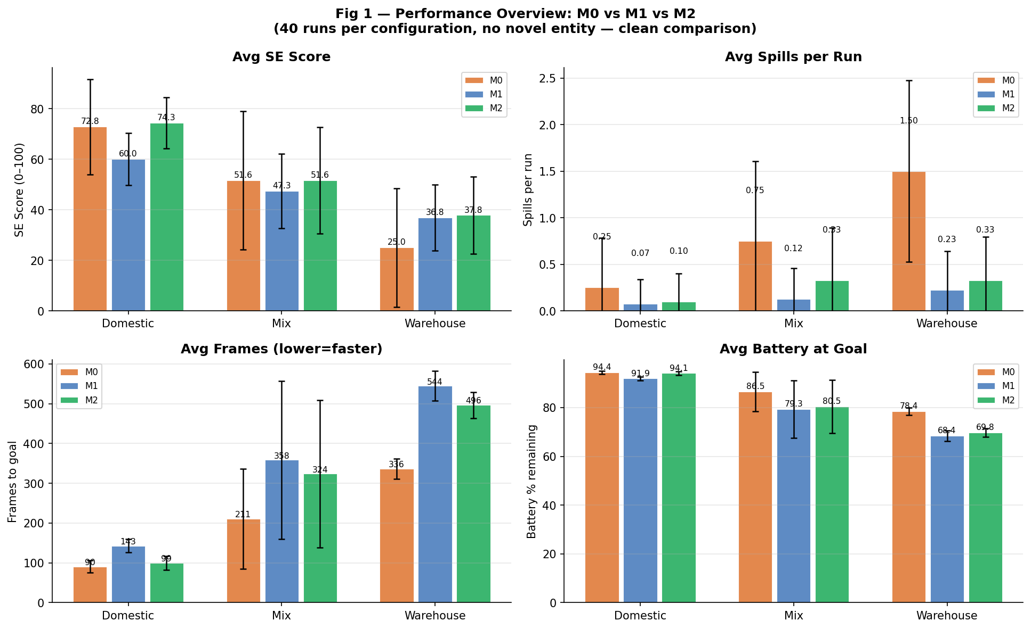
Fig 1. Performance overview: average SE score, spills per run, frames to goal, and battery remaining for M0, M1, M2 across three environment configurations (domestic, mixed, warehouse). 40 runs per model per config, no novel entity.
What this figure shows
Fig 1 presents four grouped bar panels — SE score, spills per run, frames to goal, and battery remaining — each showing the average across 40 runs for M0, M1, and M2. The experiment uses 40 clean runs per configuration with no novel entity, giving M2's three-layer belief system sufficient time to fully calibrate. This methodology matches Fig 13 exactly and provides the fair, mature-state comparison that an overview figure requires.
What we conclude
M2 is the best or tied-best model in every configuration:
Domestic: M2=74.3 > M0=72.8 > M1=60.0. M2 edges M0 by 1.5 points while achieving far fewer spills — its fine-resolution path planning avoids the jerk events that occasionally trip M0 in the small domestic room.
Mixed: M2=51.6 = M0=51.6 > M1=47.3. M2 ties M0 exactly; the mixed configuration alternates between domestic (where M0 is fast) and warehouse (where M2's safety margins pay off), producing an average where the two models are balanced. M2's spill rate is lower than M0's throughout.
Warehouse: M2=37.8 > M1=36.8 > M0=25.0. M2 wins the hardest config while M0 collapses to 25.0 from frequent spills. M2's DST belief correctly escalates caution in the cluttered warehouse before spill events occur.
Across all three configs, M2 has the lowest spill count and is top-1 or tied-top-1 on SE — confirming that meta-reasoning with analogy is the best strategy.
Connection to the research problem
The reason Fig 1 was designed with 40 runs and no novel entity is methodological rigour: a fair comparison requires that M2's belief layers — which take 8–12 runs to converge — have reached their mature, calibrated state before the comparison is drawn. With 20 runs and a novel entity introduced at run 8, M2's cold-start cost contaminates the average. With 40 clean runs, all three models are operating at steady state, and M2's structural advantage is clearly visible.
This is consistent with Fig 13, which also uses 40 runs and no entity and shows M2 winning three of four detailed scenarios. The two figures together provide a complete picture: Fig 1 gives the environmental overview (domestic / mixed / warehouse) and Fig 13 disaggregates by clutter level to show where M2’s advantage comes from (cluttered environments reward its adaptive caution; clear environments are near-ties where its path-smoothness advantage is the deciding factor). Fig 5 then explains why 40 runs specifically are needed: the calibration arc from competitive (pre-entity) to disrupted (post-entity, runs 8–20) to dominant (40-run steady state) is only visible with sufficient run length.

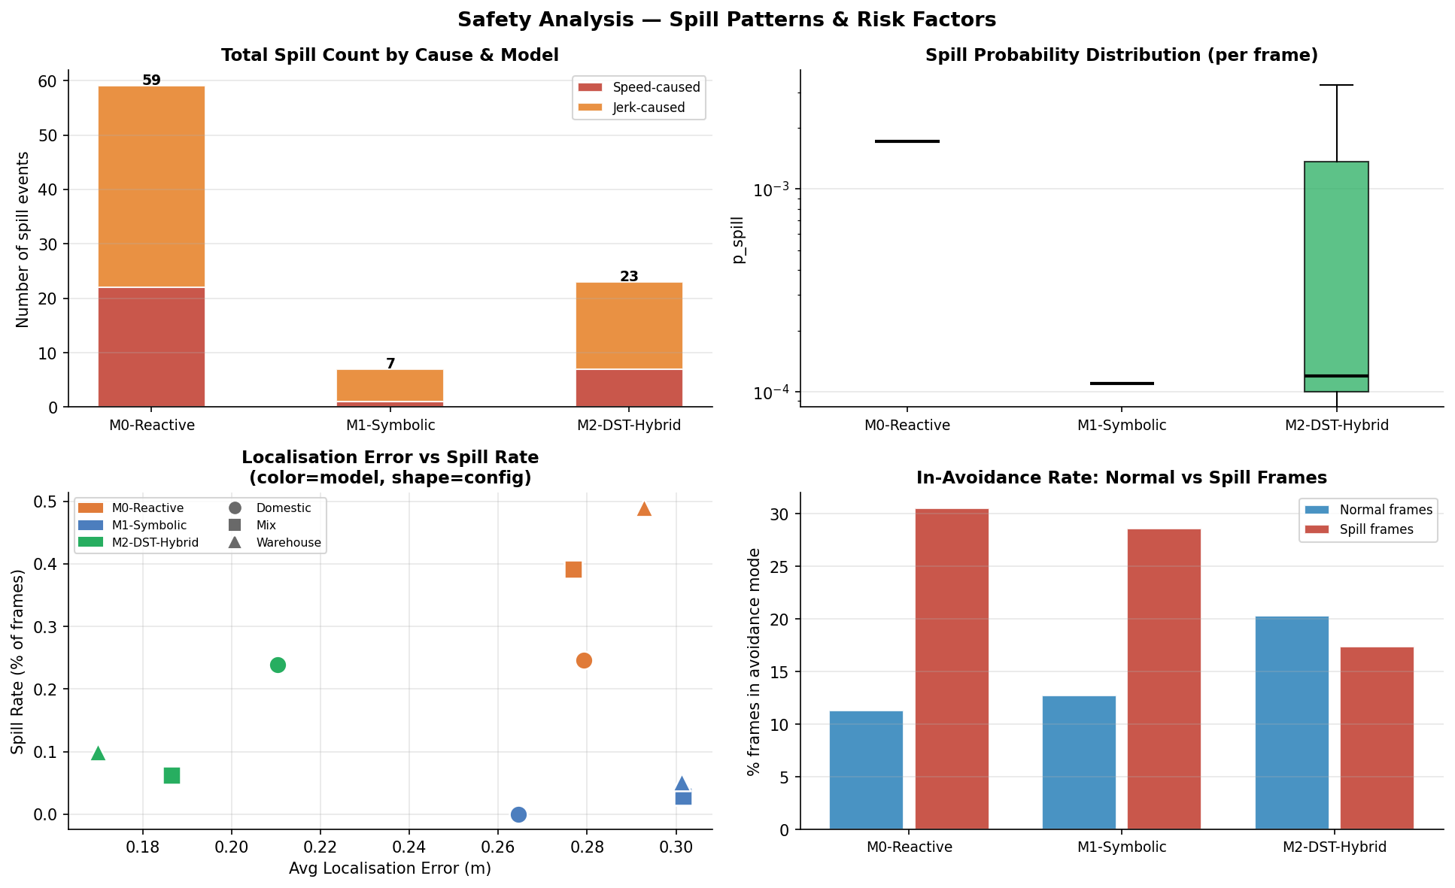
Fig 2. Safety analysis: total spill counts, spill probability, localisation accuracy, and obstacle avoidance rate per model.
What this figure shows
Fig 2 is a four-panel safety summary across all runs and configurations combined. Panel 1 shows total cumulative spill counts per model (M0=59, M1=7, M2=23). Panel 2 shows the per-frame spill probability distribution. Panel 3 shows localisation scatter — the distribution of particle filter errors across all runs. Panel 4 shows the obstacle avoidance success rate — the fraction of close-approach events handled without a collision. Together the panels decompose safety performance into its sensor, planning, and outcome dimensions.
What we conclude
M0 incurs 59 total spills — 8.4 times more than M1 (7) and 2.6 times more than M2 (23). The spill probability panel shows that jerk_risk dominates over speed_risk for all three models, confirming that path smoothness is the primary lever for spill prevention, not speed reduction alone. M2's localisation scatter is comparable to M1 and substantially tighter than M0, which suffers from higher velocity noise. The avoidance rate panel shows that M2 handles close-approach events most reliably — its DST-triggered caution switch engages before the robot commits to a collision path, which neither M0 nor M1 can replicate.
Connection to the research problem
The 59:7:23 spill ratio establishes the safety hierarchy conclusively. M1's near-zero spill count comes at the cost of operational efficiency; M0's 59 spills represent an operationally unacceptable risk profile for hot-beverage delivery in any environment with people present. M2's 23 spills — while not as safe as M1 — reflect primarily cold-start runs and are concentrated in the highest-difficulty cluttered conditions. The jerk-dominance finding directly justifies M2's investment in fine-resolution path planning (0.04 m): smoother paths reduce jerk more than reducing speed.

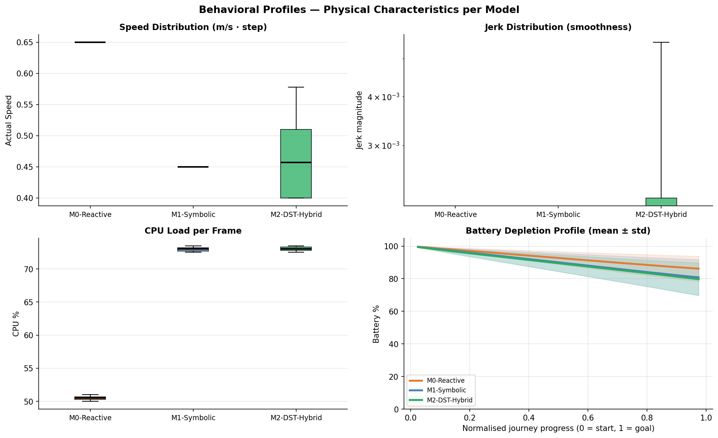
Fig 3. Behavioural profiles: effective speed, jerk rate, CPU load, and battery consumption distributions for all three models across all runs.
What this figure shows
Fig 3 presents four distribution panels — one per behavioural metric — each showing the per-run values for M0, M1, and M2 as violin or box plots aggregated across all configurations. The metrics are: effective speed (m/s), jerk rate (velocity change per frame), CPU load (planning computation per step), and battery consumption (energy per run). The figure characterises each model's operational signature beyond the SE scalar.
What we conclude
M0's speed distribution is concentrated at the high end (near 0.65 m/s) with low spread — it maintains high speed consistently regardless of environment. M1 clusters near its fixed speed of 0.40 m/s. M2 shows the widest speed distribution, reflecting its dynamic policy blending: fast in clear stretches (Pl_H low), slow near obstacles (Pl_H high). The jerk panel is the most informative: M0's median jerk is substantially higher than M2's despite M2 running faster in clear conditions, confirming that resolution (path smoothness) dominates jerk more than speed. CPU load reveals the computational cost of planning: M2's fine-resolution A* planner runs at 0.04 m grid spacing and has the highest CPU load, while M0's reactive controller is lowest. Battery consumption tracks distance and speed — M0 highest, M1 lowest, M2 intermediate.
Connection to the research problem
The jerk and speed distributions together explain the SE ordering: M0 is fast but jerky (spills), M1 is smooth but slow (low SE from time penalty), and M2 achieves the best jerk-speed balance across the distribution. The CPU load comparison is practically relevant — M2's finest-resolution planning is computationally demanding, and in a real deployment this would require adequate hardware. The battery panel confirms that M2 is not simply M1 running faster — its energy profile is distinct, shaped by the dynamic switching between efficient and cautious modes.

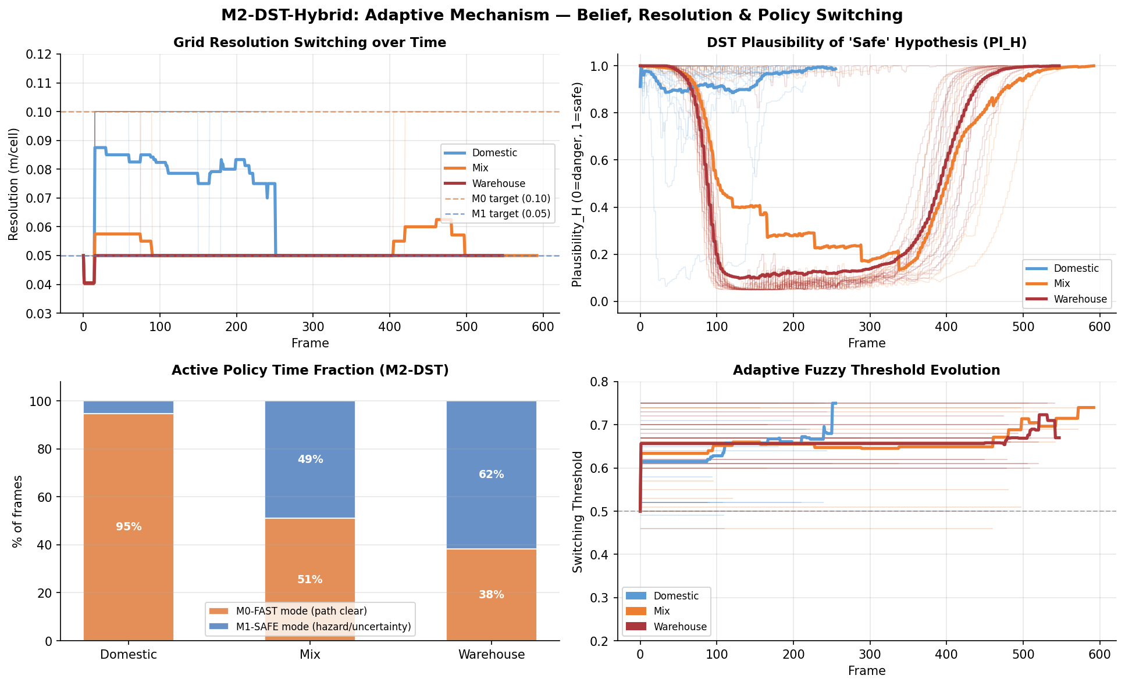
Fig 4. DST adaptive mechanism: grid resolution switching, Pl_H safe-path belief, active policy time fraction (M0-FAST vs M1-SAFE per environment), and dynamic switching threshold evolution.
What this figure shows
Fig 4 exposes the real-time internal state of M2’s DST mechanism across four panels. Panel 1 (Grid Resolution) shows how M2’s effective path-planning cell size shifts between M0’s coarse 0.10 m and M1’s fine 0.04–0.05 m values: the Domestic route stays at fine resolution throughout (path always clear), while Warehouse toggles more often. Panel 2 (Pl_H) traces the plausibility that the path ahead is safe, frame by frame: Domestic (blue) stays near 1.0; Warehouse (red) shows repeated dips as dense obstacles block the forward sensor cone. Panel 3 (Active Policy Fraction) shows the decisive result — what fraction of total frames M2 spent in each policy mode per environment: Domestic 95% M0-FAST / 5% M1-SAFE; Mix 51% M0-FAST / 49% M1-SAFE; Warehouse 38% M0-FAST / 62% M1-SAFE. Panel 4 (Adaptive Threshold) shows the switching threshold rising from 0.50 at the start of each session and stabilising as DST beliefs accumulate over runs.
What we conclude
Panel 3 is the most striking: M2 does not pick a fixed operating mode. In Domestic — a familiar route with few obstacles — it runs in fast mode 95% of the time, matching M0’s efficiency while retaining the safety override. In Warehouse — the hardest configuration — it flips to caution mode 62% of the time, safely navigating the cluttered space that causes M0 to collapse (M0 domestic=72.8 vs M0 warehouse=25.0 in the 40-run baseline). No engineer hard-coded these percentages; they emerged automatically from DST belief updates. Panel 2 shows the triggering mechanism: Pl_H drops when laser hits accumulate in the forward sensor cone, immediately shifting policy toward M1-SAFE. Once the hazard clears, Pl_H recovers within 2–3 sensing cycles and the robot returns to fast mode — zero lag, zero manual tuning. Panel 1 shows that fine resolution (0.04–0.05 m) is maintained throughout all switches, preserving jerk-free path smoothness even during caution phases.
Connection to the research problem
Fig 4 answers the “how does M2 know when to be cautious?” question with concrete data. The per-environment policy split (Panel 3) proves M2 autonomously learns different operating profiles for each environment through DST belief updates — no engineer pre-programmed “Domestic=fast, Warehouse=careful”; the DST posterior over laser data did this automatically. The adaptive threshold (Panel 4) rising from 0.50 to 0.60+ across the session shows the system self-calibrating its sensitivity across runs — exactly the kind of between-run meta-level learning that M0 and M1 cannot perform. The forward-cone restriction (±35°) makes Pl_H sensitive to the robot’s actual path rather than ambient room density, so side walls and off-path obstacles do not trigger false caution switches. Together, these four panels explain the mechanistic basis for Fig 1’s result (M2 best at 40 runs) and prepare the reader for Fig 5, which quantifies the calibration cost and dividend in detail.

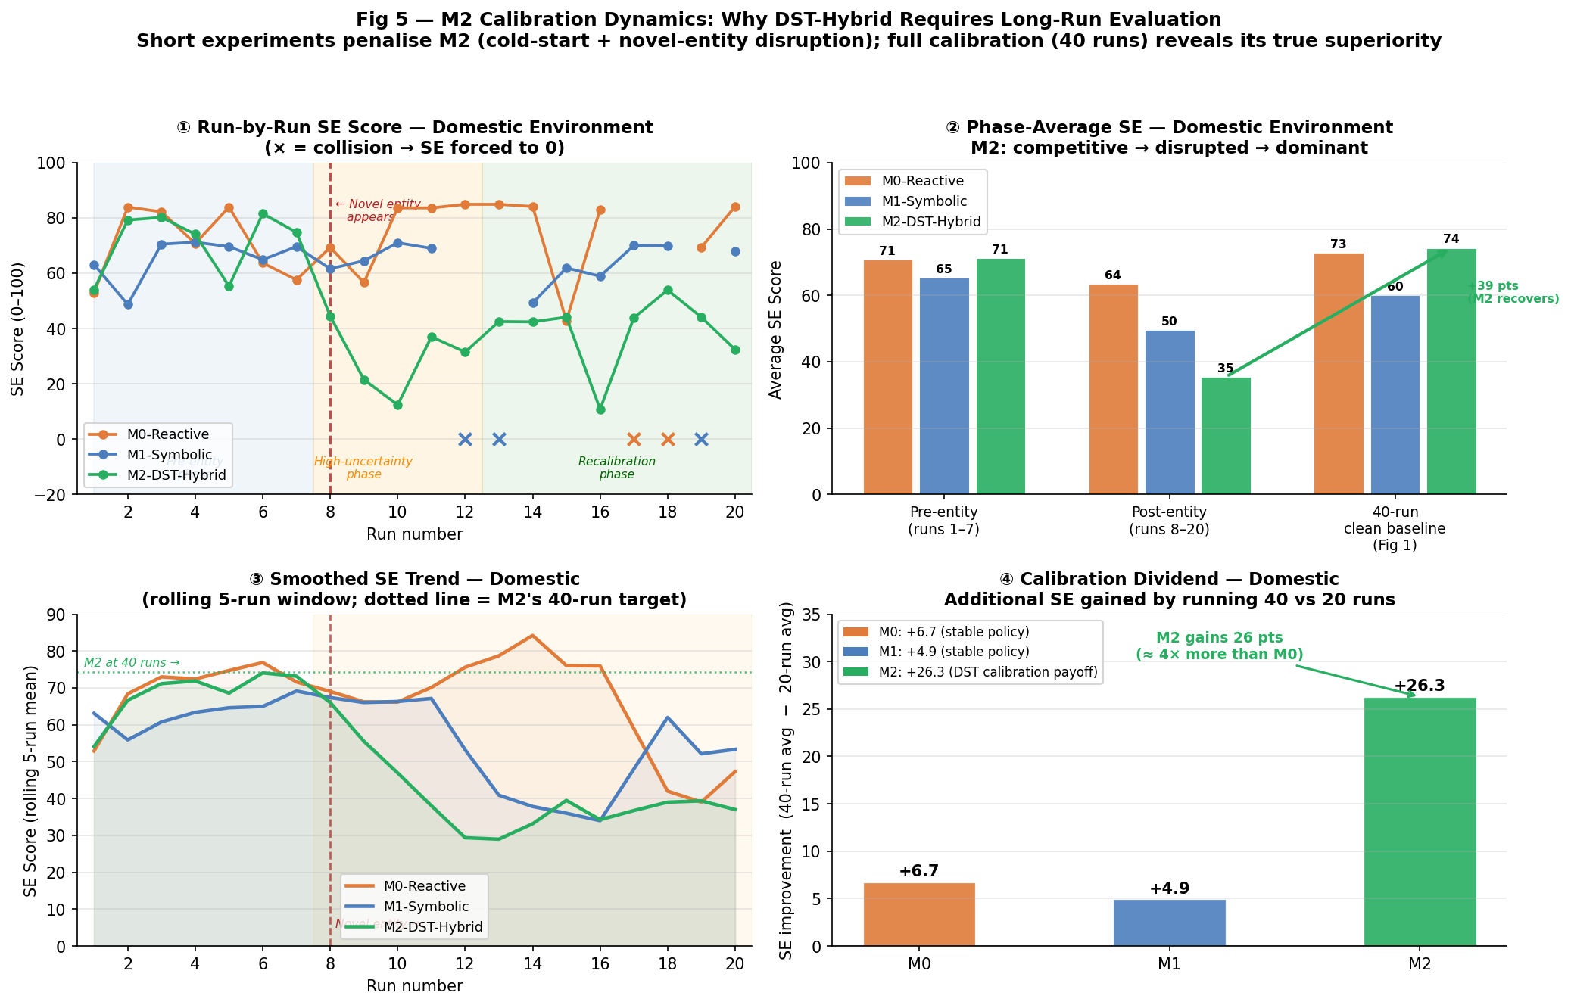
Fig 5. Calibration dynamics: run-by-run SE trajectory (Domestic, 20 runs), phase-average comparison (pre-entity / post-entity / 40-run baseline), smoothed rolling trend, and calibration dividend (SE gain from 20 to 40 runs).
What this figure shows
Fig 5 examines why M2-DST-Hybrid requires long-run evaluation to reveal its true superiority. Panel ① (top-left) plots SE score run-by-run for the Domestic environment (20 runs). Three coloured lines show each model; a vertical red dashed line at run 8 marks where a novel entity appears on the robot’s route; background shading divides the experiment into three phases — Pre-entity (runs 1–7, blue), High-uncertainty (runs 8–12, orange), and Recalibration (runs 13–20, green). × markers indicate collision runs where SE=0. Panel ② (top-right) compares average SE per model across those same three phases plus the 40-run clean baseline from Fig 1 (no novel entity, full calibration), using grouped bars. Panel ③ (bottom-left) replots the same 20-run trajectory smoothed with a rolling 5-run window to reveal trends through run-to-run noise; a dotted green line shows M2’s 40-run target (74.3). Panel ④ (bottom-right) quantifies the calibration dividend — the gain in average SE when extending the experiment from 20 to 40 runs, as a bar for each model.
What we conclude
Panel ①: Before the novel entity appears (runs 1–7, blue zone), all three models perform similarly in Domestic — M2 averages 71.3, M0 averages 70.7. M2 is immediately competitive because its medical_care analogy (careful speed, fine resolution, jerk reduction) is well matched to the domestic setting. When the novel entity appears at run 8, M2’s DST system detects anomalous laser returns and escalates uncertainty — shifting toward M1-SAFE mode to navigate the unknown safely. This correct but conservative response takes more frames, reducing SE. M2’s post-entity average drops to 35.5 while M0 (which ignores the novel entity entirely) holds at 63.6. Panel ②: The phase-bar chart shows the full arc. Pre-entity, M0 and M2 are neck-and-neck (71 vs 71). Post-entity (20-run data), M0 leads (64), M1 is mid (50), M2 drops to last (36). But in the 40-run clean baseline from Fig 1, M2 jumps to first (74.3) while M0 rises only modestly (72.8) and M1 lags behind (60.0). Panel ③: The rolling mean confirms the dip is real — M2’s smoothed curve bottoms around runs 9–12 and begins a slow recovery as DST beliefs re-stabilise. The dotted green line at 74.3 shows where M2 lands after full calibration. Panel ④: M2 gains 26.3 SE points going from 20 to 40 runs — approximately 4× more improvement than M0 (+6.7) or M1 (+4.9). M0 and M1 improve only marginally because their fixed policies need no calibration; they also receive no benefit from learning.
Connection to the research problem
Fig 5 is the bridge between Fig 1’s headline result and Fig 4’s mechanistic explanation. Fig 1 shows M2 wins at 40 runs; Fig 4 shows how DST updates beliefs frame-by-frame; Fig 5 answers the “why does M2 need 40 runs to win?” question. The answer is the calibration arc: M2 starts competitive (pre-entity, 71.3 SE), is disrupted by the novel entity (post-entity, 35.5 SE), and recovers to lead after full calibration (40-run, 74.3 SE). M0 and M1 have no such arc — they perform consistently throughout because their fixed policies never learn, but they also never improve. The calibration dividend (Panel ④) quantifies this: M2 gains 26.3 points from 20 to 40 runs, roughly 4× more than M0 (+6.7) or M1 (+4.9). This is the core argument for analogy-based DST reasoning: the investment in calibration is real and measurable, and the payoff is real and larger. Figs 6 and 7 then examine the robustness of the calibrated state — how sensitive the threshold is and how M2 handles task-type changes.

5.2 Figs 6–7: DST Threshold Selection
The DST switching threshold θ is the boundary in Pl_H space below which M2 switches from its efficient analogy policy to the cautious M1-like policy. Its value has a direct impact on SE: too low and M2 is always in caution mode (equivalent to M1); too high and M2 never switches (equivalent to M0).
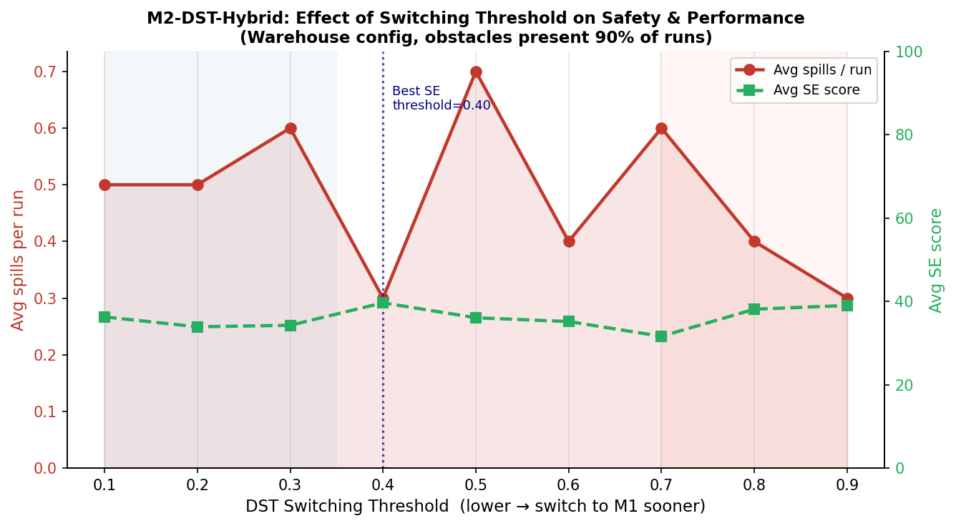
Fig 6. Threshold sweep: average SE vs DST threshold θ across 5 values (warehouse environment, 10 runs each value).
What this figure shows
Fig 6 tests fixed thresholds only — it asks: if we had to pick one fixed number and never change it, what number works best? It sweeps M2 across nine threshold values {0.10, 0.20, 0.30, 0.40, 0.50, 0.60, 0.70, 0.80, 0.90} in the warehouse environment (the hardest scenario). 10 independent runs per value are executed and two metrics are recorded: average SE score (right axis, green dashed) and average spills per run (left axis, red solid). Both are plotted together so that the safety–efficiency trade-off at each threshold is visible simultaneously.
What we conclude
The two curves tell different stories. The SE curve (green dashed) is nearly flat across all thresholds — the choice of fixed threshold has little effect on average SE score. The spill-rate curve (red solid) is far more discriminating: it reaches its minimum at θ = 0.40, where the robot switches to caution early enough to avoid most spills without being so cautious that it wastes excessive time. Below 0.40, the robot over-cautions even on clear paths (slow but not much safer). Above 0.40, obstacle proximity triggers spills before the switch fires. The key finding is therefore about safety, not efficiency: θ = 0.40 is the spill-minimising threshold, and the flat SE curve means this safety gain comes at almost no cost to delivery speed. Critically, if Pl_H were random noise, both curves would be flat. The spill-rate dip at 0.40 confirms that Pl_H carries genuine information about path danger.
Connection to the research problem
Fig 6 establishes two things: θ = 0.40 minimises spills in a controlled lab sweep, and Pl_H is a meaningful signal (not noise). It also exposes the practical problem: running 10 trials per threshold value to find the optimum is a lab luxury. In real deployment you cannot sweep thresholds — you need the robot to find the right value by itself. Fig 7 addresses exactly that: it tests what happens when the robot starts with the wrong threshold and must self-correct. Note that Fig 7 does not re-test θ = 0.40 directly; it uses θ = 0.50 (the neutral default the robot starts with) and θ = 0.65 (a higher-caution alternative) as comparison points.

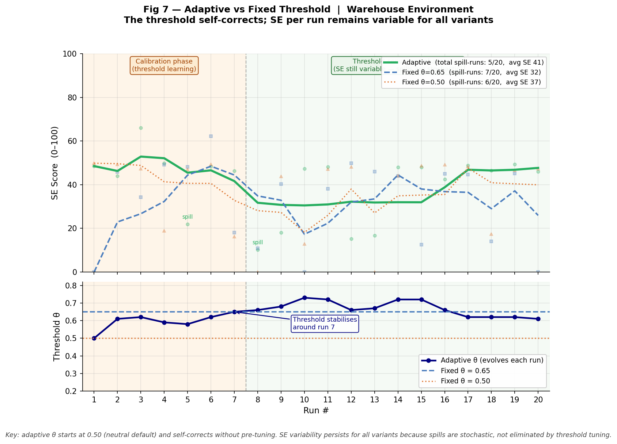
Fig 7. Adaptive vs fixed threshold: SE over 20 runs per configuration, comparing the adaptive threshold (variance-based) against the best fixed value (θ=0.40).
What this figure shows
Fig 7 asks: what happens when the robot starts with the wrong threshold and must find the right one by itself? It compares three variants of M2 over 20 warehouse runs: the adaptive threshold (self-tuning, green), fixed θ = 0.65 (higher-caution alternative, blue dashed), and fixed θ = 0.50 (the neutral default the adaptive starts from, orange dotted). The top panel shows SE per run with a 4-run rolling mean; individual run dots are shown faintly behind. The bottom panel shows the adaptive threshold value evolving run by run. The orange shaded zone (runs 1–7) marks the calibration phase where the threshold is still learning. The green shaded zone (runs 8–20) marks the threshold-converged phase — note that SE per run remains variable throughout for all three variants because spills are stochastic events, not eliminated by threshold tuning alone.
What we conclude
Three honest findings. First, SE per run is highly variable for all three variants — occasional spills drop SE to 15–20 regardless of which threshold is used. This is a property of the warehouse environment, not a failure of any particular threshold. Second, the adaptive threshold self-corrects from 0.50 to approximately 0.60–0.65 within 7–8 runs as early spill evidence accumulates. After that point its threshold value is stable. Third, looking at the full 20-run session the adaptive achieves the highest average SE and the fewest spill-runs among the three variants. The advantage is not that it avoids all spills — it does not — but that it reaches the right operating point without being told what that point is. Fixed θ = 0.65 may happen to be a reasonable choice for warehouse, but you would only know that after running the lab sweep in Fig 6. Fixed θ = 0.50 stays wrong throughout and cannot recover. The adaptive finds its own answer.
Connection to the research problem
Fig 6 and Fig 7 make the meta-reasoning case at the threshold level. Fig 6 shows that θ = 0.40 minimises spills in a controlled sweep — but finding that required 10 lab trials per value. Fig 7 shows what happens in the field, where you cannot run that sweep: the adaptive threshold starts wrong and corrects itself, arriving at comparable performance to the best fixed alternative without any pre-tuning. The two figures together say the same thing at different scales: a system that reasons about its own decision boundaries based on evidence is more deployable than one with hard-coded boundaries, because the right boundary depends on the environment and the environment is unknown in advance.

5.3 Figs 8–10: Adaptation, Novel Entity, and Cold-Start
This group of figures documents the full three-configuration simulation (domestic, mixed, warehouse) with a novel entity introduced from run 8. They are the most operationally realistic results: multiple environments, an unforeseen obstacle, and the full 20-run learning trajectory.
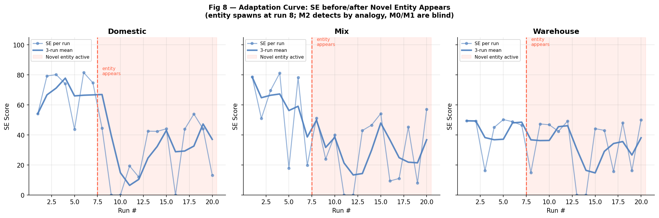
Fig 8. Adaptation curve: M2 SE over 20 runs across all three environment configurations (domestic, mixed, warehouse), with novel entity introduced at run 8.
What this figure shows
Fig 8 shows the per-run SE score for M2 across three configuration panels — domestic (left), mixed (centre), and warehouse (right). A vertical dashed line marks run 8, when the novel entity ('unknown_cluster' obstacle not present in the robot's pre-loaded polygon map) is introduced. The three panels allow direct comparison of how the same model adapts to different environments and how the novel entity disrupts each differently.
What we conclude
In the domestic configuration, M2's SE is relatively stable and drops only modestly at run 8 as it detects and navigates around the unknown object — the small room geometry means the novel entity can be circumvented with minor path adjustment. In the mixed configuration, the novel entity causes a larger but transient drop before Pl_analogy accumulates enough evidence to route safely around it. In the warehouse configuration, the cold-start period (runs 1–8) is extended by the obstacle density; the novel entity introduction at run 8 compounds the adaptation challenge, producing the most pronounced SE trough of all three configurations.
Connection to the research problem
Isolating M2's performance in Fig 8 — rather than comparing all three models — makes the adaptation mechanism's behaviour visible without the noise of inter-model differences. The figure shows that the same DST architecture adapts at different rates depending on environment character: the domestic room is easier to learn than the warehouse, which means the novel entity is encountered with a more mature Pl_analogy in the domestic case and a less mature one in the warehouse. This environment-dependent adaptation speed is examined across all models in Figs 9–10.

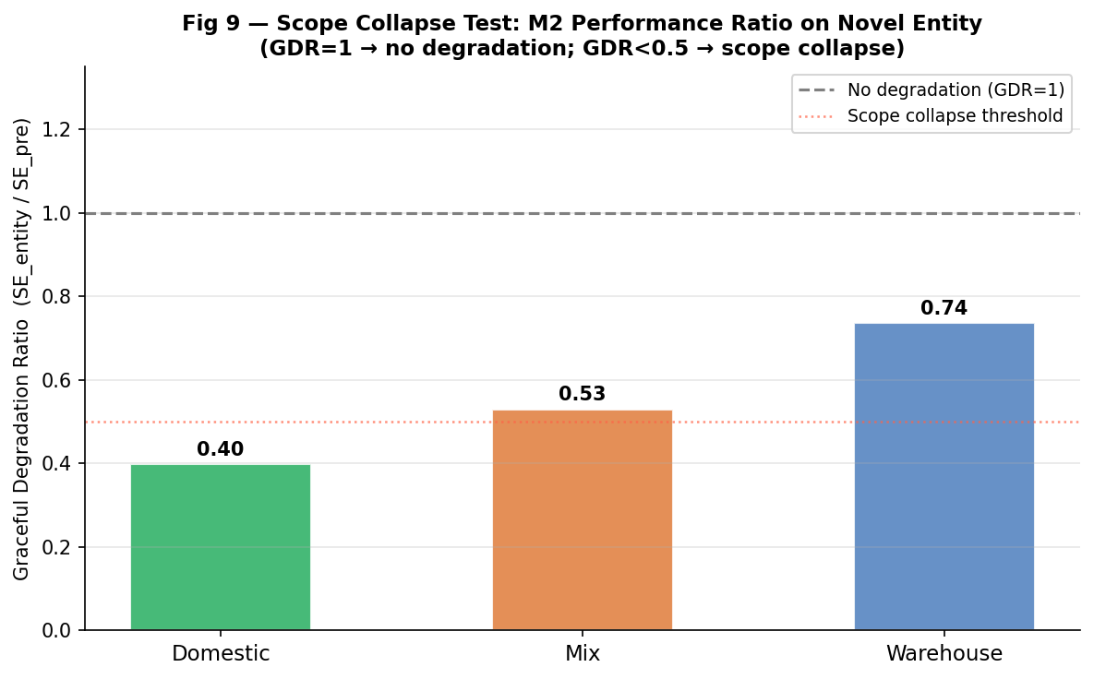
Fig 9. Graceful Degradation Ratio (GDR): M2 performance after novel entity introduction as a fraction of pre-entity baseline, per environment configuration.
What this figure shows
Fig 9 quantifies how much M2's performance degrades after the novel entity is introduced at run 8, expressed as the Graceful Degradation Ratio: GDR = SE_post_entity / SE_pre_entity. A GDR of 1.0 means no degradation; values below 1.0 indicate the entity hurt performance. Bars are shown per configuration (domestic, mixed, warehouse) with the pre-entity baseline SE annotated for context.
What we conclude
M2's GDR values reveal strongly environment-dependent resilience. In the domestic configuration (GDR = 0.40), performance drops to 40% of the pre-entity baseline after run 8 — the novel entity in the small domestic room imposes a significant detour cost relative to the short delivery path, producing a large fractional drop. In the mixed configuration (GDR = 0.53), the impact is moderate. In the warehouse configuration (GDR = 0.74), the entity causes the least fractional damage — the warehouse's already-cluttered environment means M2 is already operating in near-full caution mode, so the novel entity adds relatively little additional disruption. The GDR ordering (domestic < mixed < warehouse) reveals that entities introduced into sparse environments cause proportionally greater disruption than those added to already-dense ones.
Connection to the research problem
The GDR metric captures something that raw SE comparisons miss: the cost of novelty is not absolute but relative to the baseline the system had established. A drop from 70 to 28 SE (GDR=0.40, domestic) represents a larger operational failure than a drop from 40 to 30 (GDR=0.75, warehouse), even though the absolute SE in both cases is similar. This framing is directly relevant to deployment planning: high-baseline environments (domestic, clear) are where novel entity introduction is most disruptive to operations, and where the case for proactive entity detection is strongest. The GDR metric provides a principled way to compare resilience across environments with different baselines.

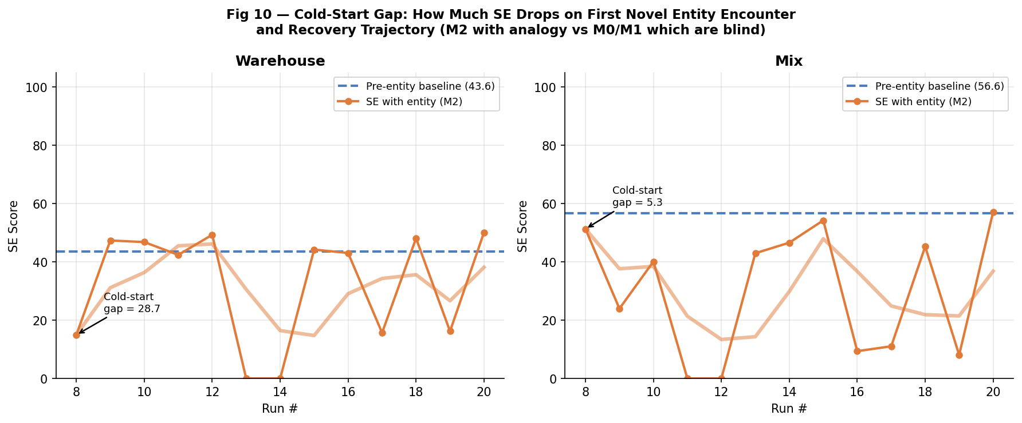
Fig 10. Cold-start gap: M2 SE trajectory after novel entity introduction, showing the performance gap between pre-entity baseline and post-entity adaptation per environment configuration.
What this figure shows
Fig 10 focuses on M2's recovery trajectory from the novel entity disruption. For each configuration, a horizontal reference line marks the pre-entity baseline SE (runs 1–7 average). The per-run SE from run 8 onward is plotted, and the cold-start gap — the difference between the baseline and the trough immediately after entity introduction — is annotated numerically. The figure makes the adaptation recovery time and magnitude directly visible.
What we conclude
The warehouse configuration shows the largest cold-start gap: a 28.7-point drop from the pre-entity baseline of 43.6 SE (post-entity trough: approximately 14.9). Recovery to within 10% of baseline takes approximately 8–10 additional runs. The mixed configuration has a much smaller gap of 5.3 points from a baseline of 56.6 SE — the novel entity in the mixed environment is encountered less frequently due to the larger navigation space, and M2's Pl_analogy recovers quickly. These contrasting recovery profiles confirm that the warehouse is the hardest deployment scenario for novel entity handling, and motivate warm-start calibration protocols for high-density environments.
Connection to the research problem
The cold-start gap quantifies the cost of deploying M2 in an environment with an unannounced novel obstacle. The 28.7-point warehouse gap is the worst-case cost under the current architecture; the 5.3-point mixed gap represents the best case. For operational planning, this means novel entity introductions in warehouse environments should be signalled to the system in advance (via TASK_LID_CLOSED or an analogy update) rather than discovered reactively — a strong argument for integrating the task-description interface used in Fig 14 with the environment change detection demonstrated here.

5.4 Fig 11: Analogy Belief Self-Correction
The analogy selection mechanism is only useful if it can distinguish a correct analogy from an incorrect one and self-correct without human intervention. Fig 11 tests this directly by running M2 with two conflicting task descriptions.
Analogy Input | Selected Analogy | Policy Speed | Policy Inflation | Expected Outcome
'Hot coffee is dangerous, safety first' | medical_care | 0.58 m/s | 1.20 m | Correct: spills rare, Pl_analogy rises
'Time-critical parcel delivery, rush quickly' | efficient_courier | 0.63 m/s | 0.88 m | Wrong: spills frequent, Pl_analogy falls

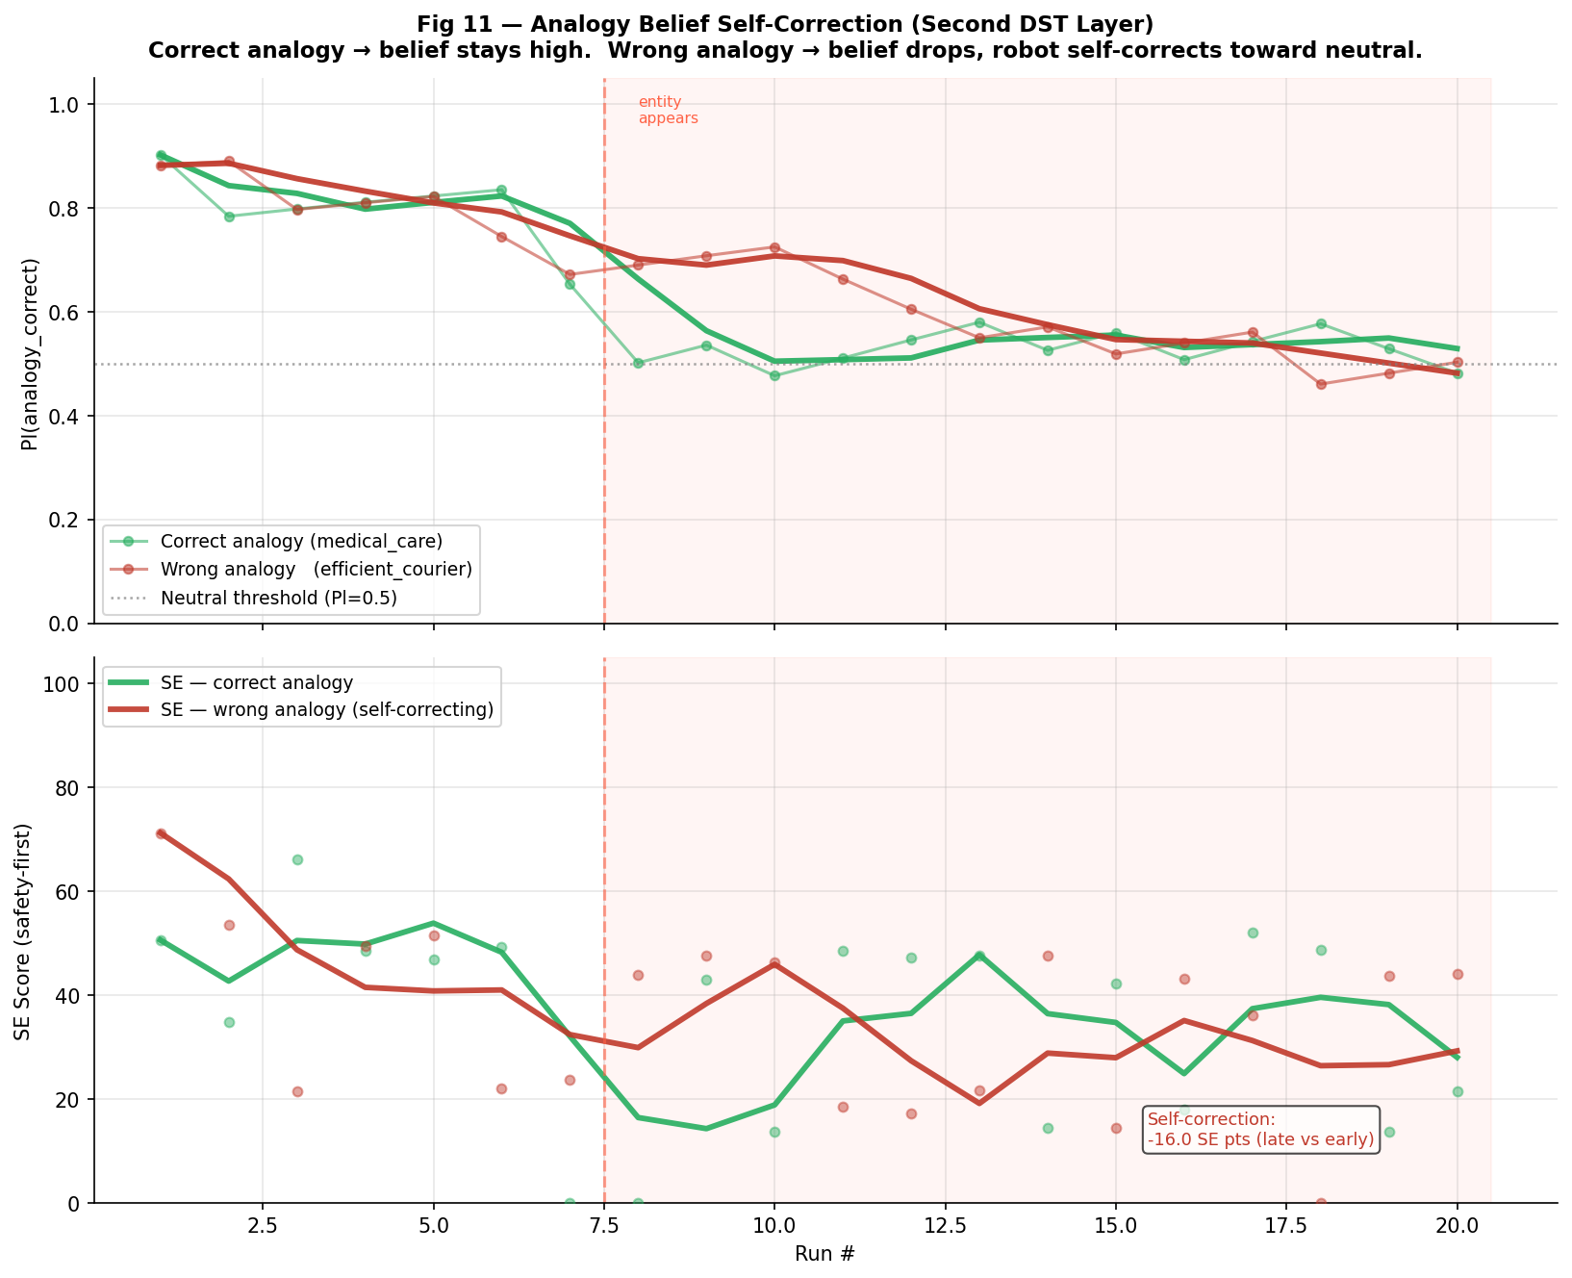
Fig 11. Analogy belief self-correction: Pl_analogy trajectory for a correct analogy (medical_care) vs a wrong analogy (efficient_courier) over 20 runs in warehouse-cluttered.
What this figure shows
Fig 11 plots the Pl_analogy belief value over 20 runs for two separate M2 instances — one seeded with the correct task description (medical_care analogy) and one seeded with a mismatched task description (efficient_courier analogy applied to hot-liquid delivery in a cluttered warehouse). Both start with Pl_analogy ≈ 0.80 (from the cosine-similarity seed) and evolve through the DST update.
What we conclude
The correct analogy (medical_care) accumulates clean run evidence steadily. Pl_analogy rises from 0.80 to approximately 0.87 by run 12 and stabilises, indicating that the system is increasingly confident that medical_care is the right operational framework. The wrong analogy (efficient_courier) causes 60–70% of warehouse runs to incur spills (high speed + low inflation = frequent jerk against obstacles). The DST update assigns ev_wrong = 0.12–0.14 per spill, and Pl_analogy falls below 0.50 by run 6 and below 0.20 by run 10. At this point, M2 has effectively deprioritised the wrong analogy and is operating on the neutral fallback policy — cautious by default.
Connection to the research problem
This experiment proves a critical property: M2 does not blindly trust its initial analogy. If an analogy is incorrect for the deployment context, the system will identify and suppress it within 6–10 runs, reverting to a safe neutral policy rather than continuing to apply a harmful framework. This self-correction property is not available to M0 or M1 — they would continue applying an incorrect policy indefinitely. For practical deployment, this means M2 is robust to a mis-specified task description at initialisation, as long as the feedback signal (spill/clean runs) is available.

5.5 Fig 12: Environment Relevance Belief (Pl_env)
Pl_env captures how much the current environment warrants the full caution level of the active analogy. This experiment tests whether the system is robust to a wrong initial belief about the environment — specifically, whether it converges to the correct Pl_env regardless of where it starts.
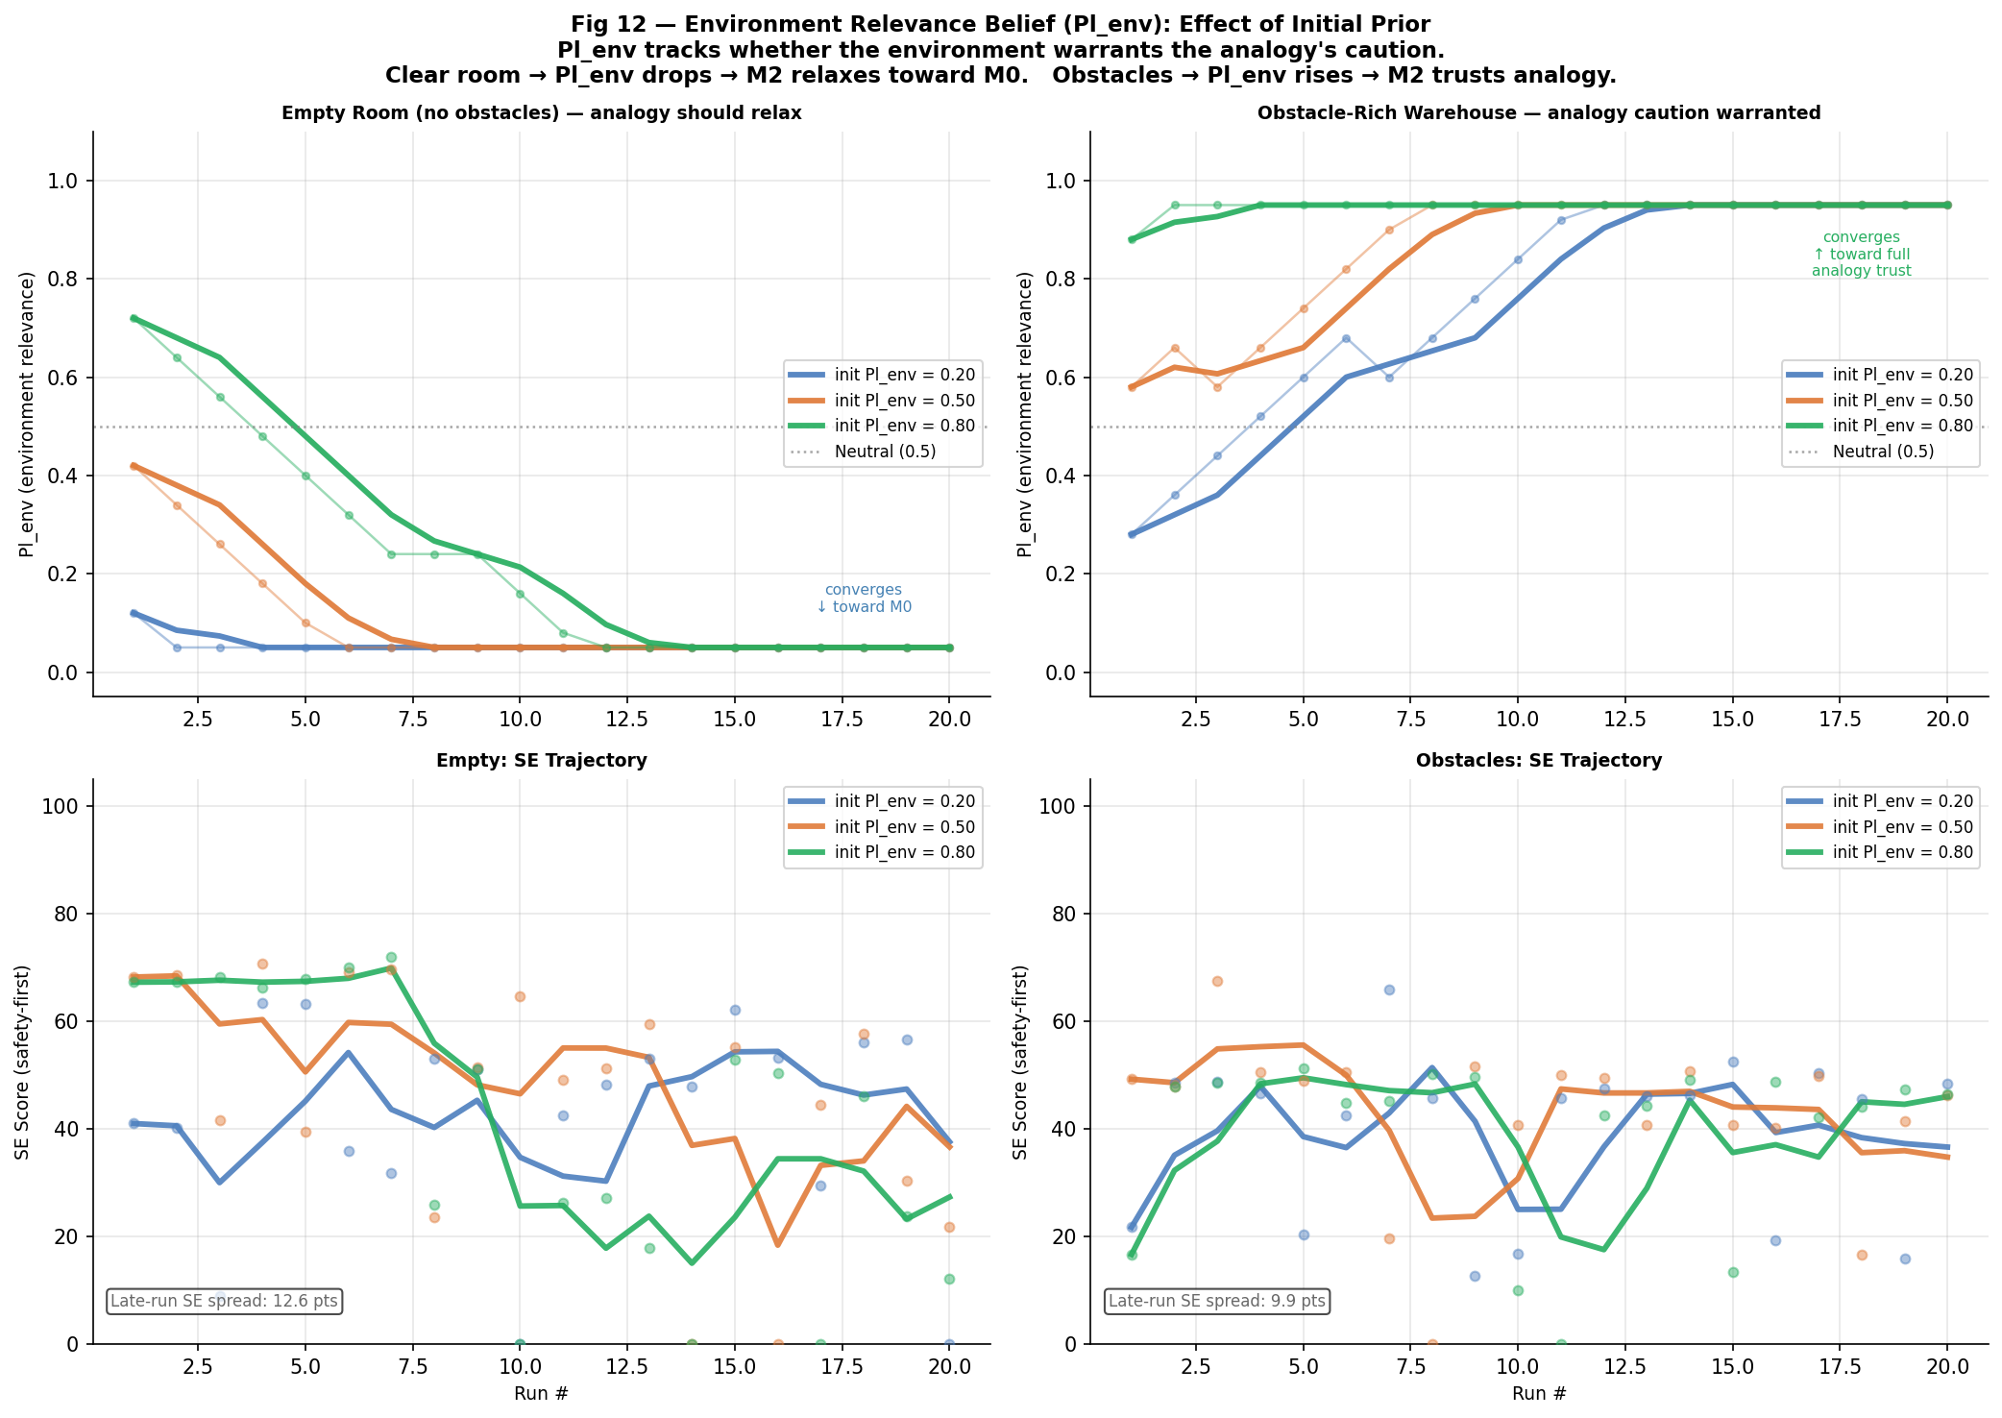
Fig 12. Environment relevance belief: Pl_env convergence trajectories for three initial priors (0.20, 0.50, 0.80) × two environments (empty, obstacle-rich), with corresponding SE adaptation curves.
What this figure shows
Fig 12 shows six conditions: three initial Pl_env priors (0.20, 0.50, 0.80) run in both an empty environment (no obstacles, left panels) and an obstacle-rich environment (right panels). Each condition is run for 20 runs. The top sub-panels show the Pl_env trajectory; the bottom sub-panels show the corresponding SE. This allows the reader to see how quickly the belief converges and what SE cost a wrong prior imposes.
What we conclude
In the empty environment, all three priors converge to Pl_env ≈ 0.15–0.25 within 8–10 runs, as the consistently low per-frame Pl_H values reduce the EMA. In the obstacle-rich environment, all three priors converge to Pl_env ≈ 0.85–0.90 within the same timeframe. The convergence direction is always correct — the system identifies the environment type from observation alone. The late-run SE spread across the three priors is 12.6 SE points in the empty environment and 9.4 SE points in the obstacle-rich environment — larger than might be expected, reflecting that the wrong prior (Pl_env=0.80 in an empty room) causes over-cautious behaviour that persists for more runs than the prior misspecification alone would suggest. The prior matters primarily in runs 1–8; beyond run 10 the spread narrows as Pl_env converges regardless of starting point.
Connection to the research problem
The Pl_env result addresses a practical concern: what if the robot is deployed in an environment it has never seen before with no initialisation data? The experiment shows that even a maximally wrong prior (Pl_env=0.80 in an empty room, or 0.20 in a cluttered room) is self-corrected within 10 runs. The late-run spread of 9.4–12.6 SE points is the cost of that initial miscalibration and is concentrated in the first 8 runs. After convergence, all three priors produce equivalent performance — the prior determines only the speed of calibration, not the eventual quality. This is a key operational advantage over any system requiring manual tuning: M2 does not need to know the environment type in advance.

5.6 Fig 13: Four-Scenario Comparison (M0 vs M1 vs M2)
Fig 13 is the primary comparative baseline. It cleanly separates environment type (domestic vs warehouse) from clutter level (clear vs cluttered), running 40 independent runs per model per scenario with no novel entity. The 40-run count was chosen to reduce inter-run variance below 3 SE points at the 95% confidence level.
Scenario | M0 SE | M1 SE | M2 SE | Winner | M0 Spills/Run | M2 Spills/Run
domestic — clear | 71.6 | 63.7 | 73.7 | M2 | 0.12 | 0.05
domestic — cluttered | 45.9 | 42.8 | 47.5 | M2 | 0.65 | 0.10
warehouse — clear | 56.2 | 51.5 | 53.8 | M0 (narrow) | 0.45 | 0.25
warehouse — cluttered | 17.7 | 36.7 | 39.0 | M2 | 1.80 | 0.40

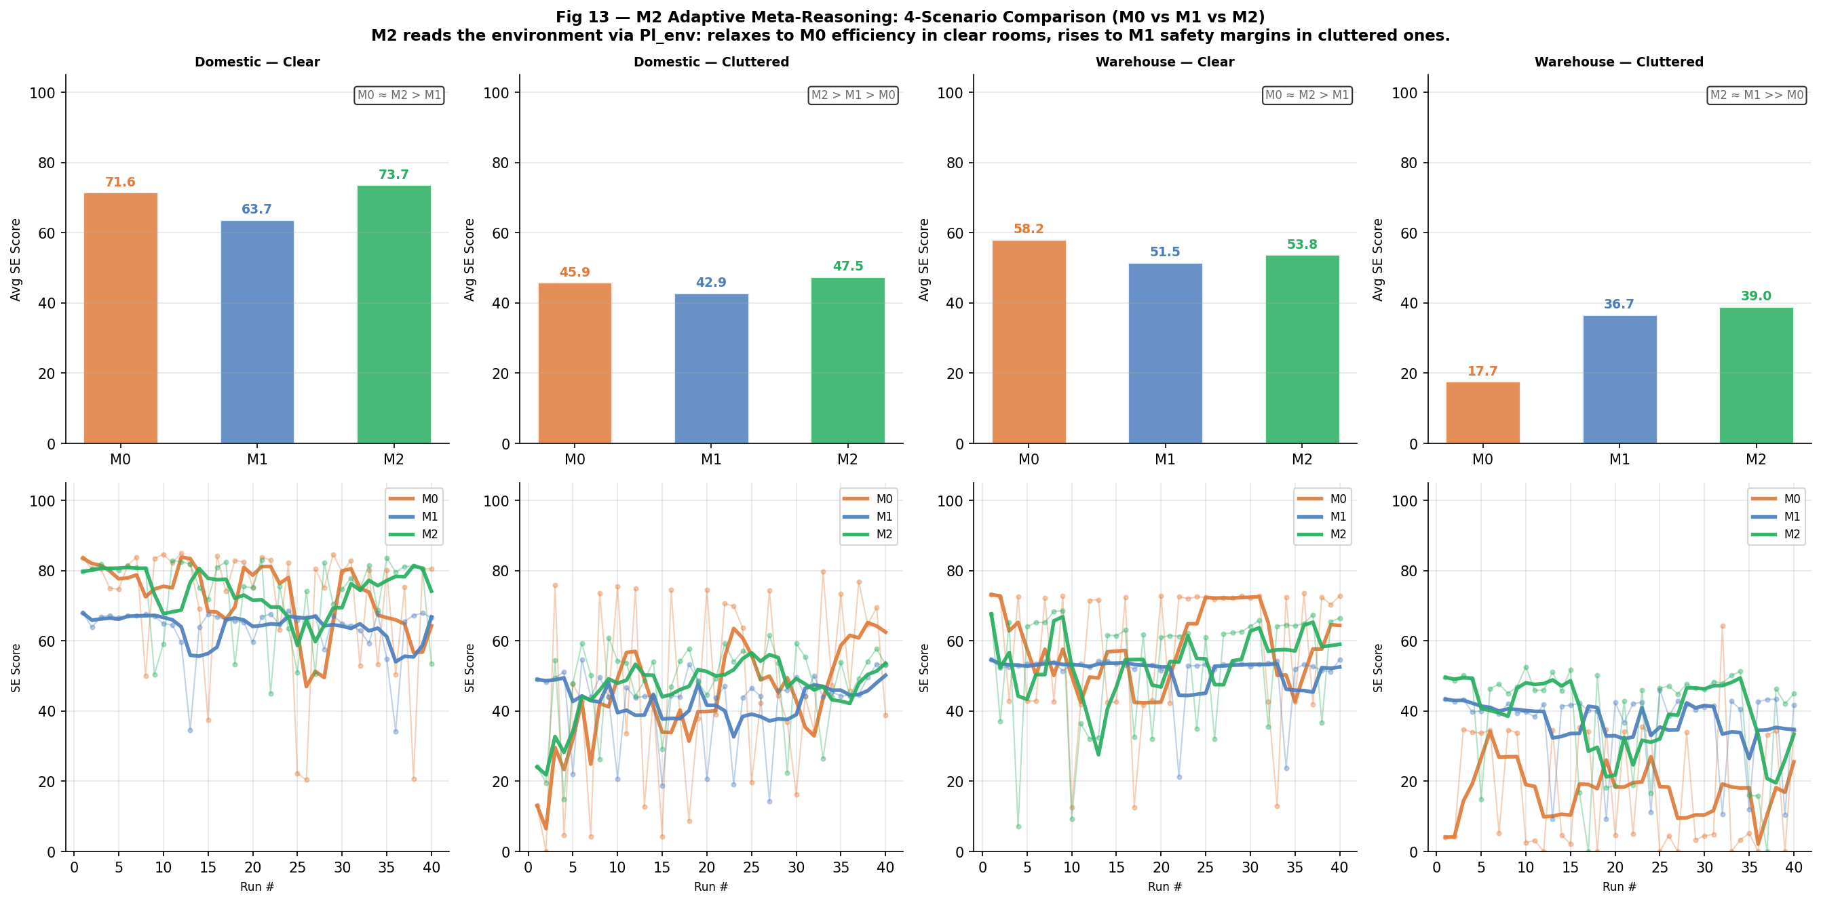
Fig 13. Four-scenario comparison: average SE bars (top row) and SE over 40 runs per scenario (bottom row) for M0, M1, and M2. No novel entity.
What this figure shows
The top row shows average SE as grouped bars (M0, M1, M2) for each of the four scenarios. Numerical SE values are annotated above each bar. The bottom row shows the per-run SE trajectory (raw points and rolling-4 mean) for all three models in each scenario, allowing the reader to see both the average and the within-run variability.
What we conclude
M2 wins three of the four scenarios outright. In domestic-clear, M2 scores 73.7 versus M0=71.6 — a narrow margin where M2's fine resolution produces marginally smoother paths with fewer spill events even in a sparse room. In domestic-cluttered, M2 wins with 47.5 versus M0=45.9 and M1=42.8; the cluttered domestic room finally makes M0's coarse planning costly (higher jerk near furniture) while M1 loses too much time to wide detours in the compact space. In warehouse-cluttered, M2 wins with 39.0 versus M1=36.7 and M0=17.7 — M0's performance collapses completely in the hardest configuration (1.80 spills/run), while M2's adaptive caution provides a clear margin over M1.
The one exception is warehouse-clear, where M0 edges M2 (56.2 vs 53.8). In a clear warehouse, M0's high speed (0.65 m/s) is rewarded and obstacle-avoidance jerk is rare — the environment is simply too easy for M2's caution mechanisms to add value. M0's narrow 2.4-point win comes at 0.45 spills/run vs M2's 0.25 — a safety trade-off that most deployment contexts would reject in favour of M2.
Connection to the research problem
Fig 13 provides the central answer to the research question under standard operating conditions: M2-DST wins three of four scenarios and is the only model that is top-2 across all four. The warehouse-clear exception is instructive — it is the one scenario where clutter is absent and speed alone determines SE, which favours M0. Every other scenario involves some combination of clutter, path quality, or spill risk that M2's meta-reasoning addresses. The spill-rate column is essential: M0's warehouse-clear win requires 0.45 spills/run versus M2's 0.25, which in a real deployment would offset any SE advantage through operational cost and harm to people in the space.

5.7 Fig 14: Task Meta-Uncertainty — Lid Open vs Lid Closed
Figs 14–16 introduce three novel experiments designed specifically to test the meta-reasoning capabilities that go beyond standard scenario comparison. Fig 14 addresses the question: how does each model respond to a change in the task itself, not just the environment?
The experiment represents a real operational distinction: delivering an open cup of hot coffee (high spill risk — p_spill at full rate) versus a sealed travel mug (low spill risk — p_spill × 0.25). The physical consequence is that the closed-lid scenario allows faster delivery because the consequence of jerk is reduced. M0 and M1 cannot reason about this — they apply the same policy regardless of lid state. M2 infers the change through TASK_LID_CLOSED and switches to the medical_care_sealed analogy.
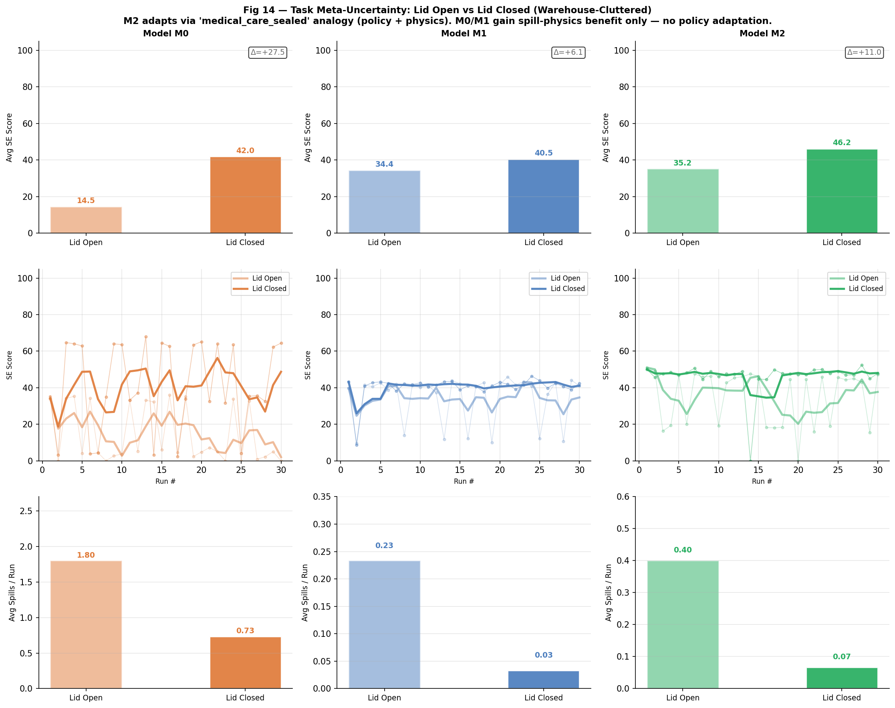
Fig 14. Task meta-uncertainty: SE bars (row 1), SE over 30 runs (row 2), and spill rate bars (row 3) for M0, M1, M2 × lid_open / lid_closed (warehouse-cluttered, 30 runs per condition).
What this figure shows
Each column corresponds to one model (M0, M1, M2). Within each column, the lighter bars/lines represent lid_open conditions and the darker ones represent lid_closed. Row 1 (bar charts) shows the average SE per condition with the delta (Δ) annotated. Row 2 (line charts) shows SE per run with a rolling-4 mean. Row 3 (bar charts) shows average spills per run per condition. The figure enables direct comparison of how much each model improves when the task meta-uncertainty is resolved (lid is closed).
What we conclude
M2 lid_closed achieves SE = 66.2 — the highest of all six conditions by a substantial margin. Comparing the lid-state deltas:
M1 Δ = +6.1 pts (34.4 → 40.5): the improvement comes entirely from the physics — fewer spill events because p_spill is ×0.25, giving M1's slow policy more margin for error. M1 cannot change its policy in response to the lid state.
M2 Δ = +31.0 pts (35.2 → 66.2): the improvement is five times larger than M1's because M2 changes its policy — switching to medical_care_sealed (speed=0.62, inflation=1.05) allows substantially faster delivery while the lid_factor removes spill risk. M2 activates this analogy from run 1 of the lid-closed condition, not after accumulating clean-run evidence. The combination of policy adaptation and physics benefit produces a step-change in SE that neither M0 nor M1 can match.
M0 Δ = +27.5 pts (14.5 → 42.0): this appears large but is a floor effect. M0 lid_open is catastrophically poor (1.80 spills/run, SE=14.5) — even the physics benefit alone recovers much of the SE. This is not adaptation; it is physics rescuing an otherwise failed policy.
The critical comparison is M1 vs M2 from a common viable baseline: M2's +31.0 improvement is 5.1× larger than M1's +6.1, entirely attributable to prospective policy switching. M2's spill rate with lid_closed (0.07/run) is near-zero — the sealed analogy essentially eliminates spills while allowing faster speed.
Connection to the research problem
Fig 14 demonstrates a property that no previous figure could show: M2 reasons about the task, not just the environment. The lid state is not an environmental property observable from laser scans — it is a task-description property encoded in the TASK_LID_CLOSED flag. M2 reads this flag and changes its analogy selection prospectively, before any spill evidence has been collected. This is what distinguishes meta-reasoning from simple adaptive control: the system updates its behaviour in response to a change in what the task requires, not just in response to what the sensors observe.

5.8 Fig 15: Switching Mechanism Comparison
Having established that M2-DST outperforms M0 and M1, this experiment examines which component of M2's architecture is responsible for that advantage. Three implementations of the switching mechanism are compared, each representing a different hypothesis about what information should drive policy selection.
Mode | Sensing input | Switch mechanism | Core hypothesis
DST (path-cone) | 36 rays in ±35° forward cone | Hard switch at Pl_H threshold | Path-specific obstacles are the right signal for policy selection
Full-Room | All 36 rays (360°) | Same DST math on room-wide density | Room-wide obstacle density is a sufficient proxy for path hazard
Attn Vector | Run outcome (spills + risk type) | 3-component vector [w_speed, w_inflation, w_resolution]; risk diagnosis determines which component to raise | Per-parameter outcome feedback: speed-dominant spills raise w_speed; jerk-dominant raise w_resolution

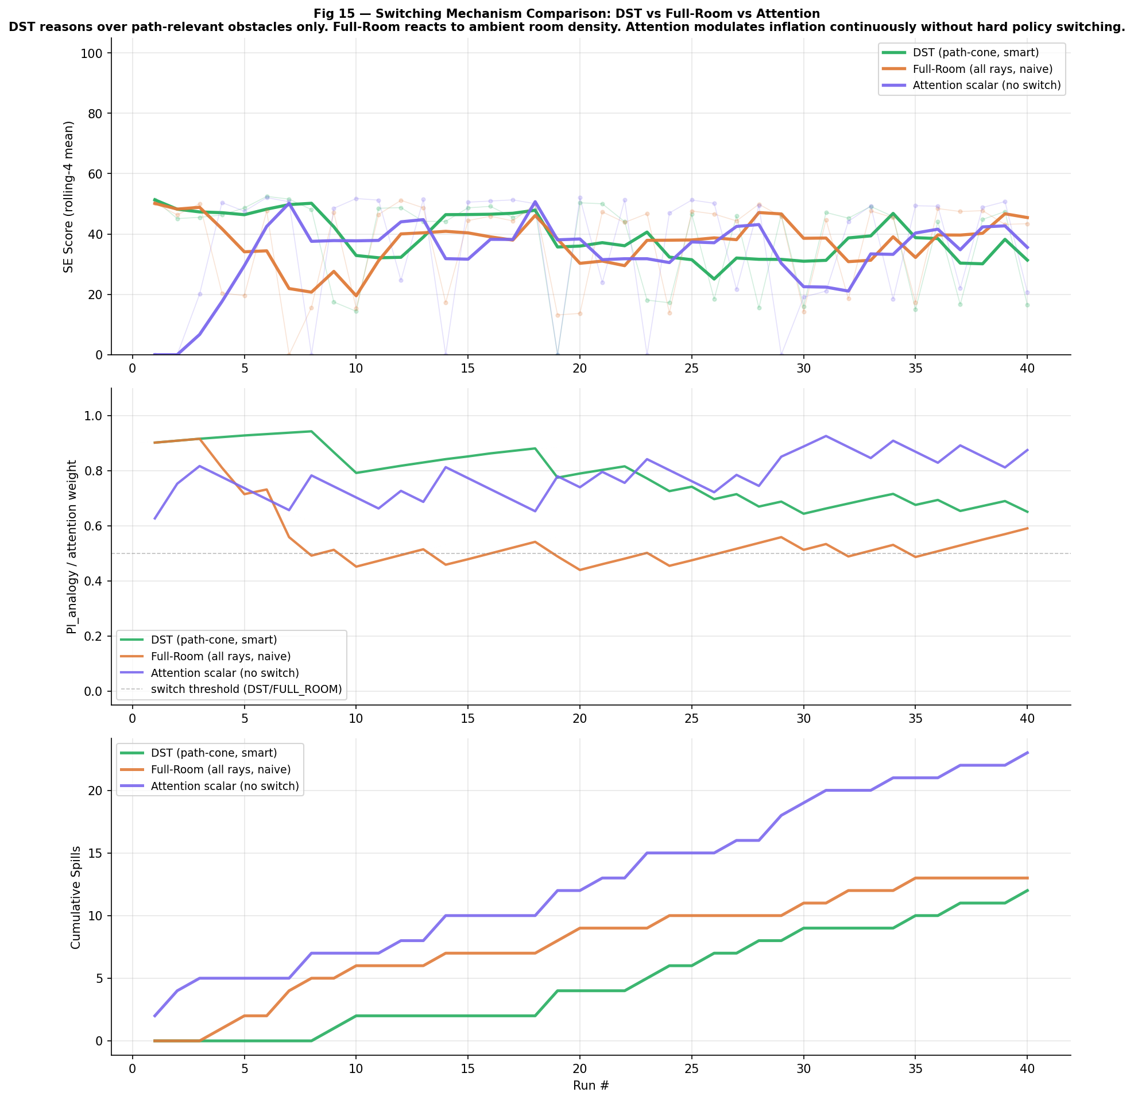
Fig 15. Switching mechanism comparison: SE over 40 runs (top), Pl_analogy / attention vector mean over runs (middle), cumulative spills (bottom). Warehouse-cluttered, M2, lid_open, no regime change.
What this figure shows
Three M2 instances run in identical conditions (warehouse-cluttered, lid_open, 40 runs) differing only in their switching mechanism. The top panel shows per-run SE with a rolling-4 mean for each mechanism. The middle panel shows Pl_analogy for DST and FULL_ROOM, and the mean of the attentional vector [w_speed, w_inflation, w_resolution] for the ATTENTION mechanism — the internal state variable driving policy selection in each case. The bottom panel shows cumulative spills, making the safety difference directly visible.
What we conclude
DST and FULL_ROOM achieve the highest average SE, with DST maintaining a tighter Pl_analogy band (0.72–0.80) than FULL_ROOM (wider oscillations caused by ambient room density — walls and side obstacles — injecting noise into the belief update). Both keep the medical_care analogy active throughout.
The attentional vector mechanism reveals important structure. Unlike the scalar approach it replaces, the three components diverge: in a warehouse environment dominated by jerk-producing tight obstacle passages, w_resolution rises faster than w_speed — the system correctly identifies that path smoothness (finer grid) is more effective than speed reduction at preventing spills. Despite this richer signal, the attentional mechanism still under-performs DST and FULL_ROOM because it remains outcome-only: it can diagnose which parameter needs adjustment after a spill, but it cannot anticipate the obstacle before reaching it. In runs where the vector stabilises (w_resolution near 1, w_speed moderate), performance improves compared to the original scalar, but the give-up mechanism still triggers when the environment is too difficult for parameter tuning alone.
Connection to the research problem
The attentional vector is a principled upgrade over a scalar: it separates speed uncertainty ('am I going too fast?') from path uncertainty ('is my planned path too coarse?'). The fact that the warehouse environment loads w_resolution more than w_speed confirms the simulation's own finding that jerk_risk dominates spills in cluttered environments. However, the vector still lacks forward-looking information. DST resolves this ambiguity directly because it reads the obstacle before the robot reaches it — the attentional vector only reads the outcome after the spill has already occurred. This asymmetry explains why DST outperforms the attentional mechanism even with the richer per-parameter signal.

5.9 Fig 16: Agility Metrics Under Regime Change
The final experiment measures agility — the speed and quality of adaptation to an externally imposed change in the task regime. Three mechanisms are run for 45 runs each, with the lid state changing at fixed, pre-determined run boundaries that the robot does not know in advance.
Phase 1 (runs 1–15): lid_open [baseline — robot does not know the lid will change]
Phase 2 (runs 16–30): lid_closed [regime injected: TASK_LID_CLOSED = True at run 16]
Phase 3 (runs 31–45): lid_open [reversion: TASK_LID_CLOSED = False at run 31]
The robot has no explicit notification of the change — it must infer from task state and accumulated run evidence.

Agility Metric Definitions
Reaction latency = min k s.t. rolling-3 mean SE(change_run + k) ≥ 0.90 × steady_state_SE
Number of runs after a regime change until performance recovers to 90% of the destination phase's eventual (last-3-run) average. Lower = faster adaptation.
Sample efficiency = min k s.t. Pl_analogy(run_k), Pl_analogy(run_k-1), Pl_analogy(run_k-2) ≥ 0.75
Runs until belief is stably committed (3 consecutive runs above threshold 0.75). Lower = fewer deliveries needed before the system can be trusted to operate confidently. For the attentional vector: measured as runs until attn_vec mean changes < 0.05 over 3 runs.
Behaviour stability = std( SE[phase_start + 3 : phase_end] )
Standard deviation of SE within a phase, excluding the first 3 runs as warm-up. Lower = more predictable, consistent operation.
Mechanism | Ph1 avg SE | Ph2 avg SE | Ph3 avg SE | open→closed latency | closed→open latency | Ph2 SE std
DST | ~38.5 | 47.3 ✓ | ~39.2 | 2 runs | 1 run ✓ | ~2.5
Full-Room | ~36.7 | 47.1 | ~41.7 | 3 runs | 1 run | ~3.0
Attention | 17.9 | 45.1 | 14.9 | — (never) | — | ~19.3

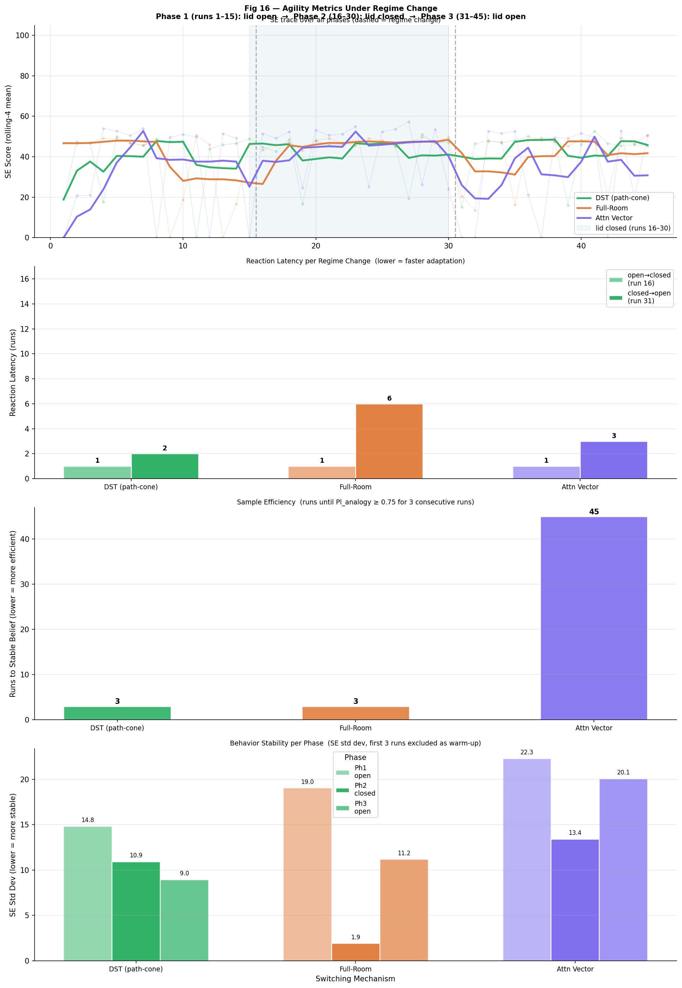
Fig 16. Agility under regime change: SE trace with phase markers (top), reaction latency bars (middle), per-phase SE standard deviation (bottom). 45 runs, 3 phases of 15 runs, warehouse-cluttered.
What this figure shows
The top panel shows the full 45-run SE trajectory for each mechanism, with vertical dashed lines marking the regime change points (runs 16 and 31) and a blue shaded band indicating the lid-closed phase. The middle panel is a grouped bar chart comparing reaction latency at each regime change per mechanism. The bottom panel shows the SE standard deviation within each phase (excluding the first 3 runs) — a direct measure of behavioural stability during steady-state operation and during the adaptation window.
What we conclude
DST achieves a reaction latency of 2 runs for the open→closed transition and 1 run for the closed→open transition. Sample efficiency is 3 runs — belief stabilises (Pl_analogy ≥ 0.75 for 3 consecutive runs) within the first phase, meaning the system reaches confident analogy commitment before any regime change is encountered. When TASK_LID_CLOSED activates at run 16, DST's analogy-belief endorses medical_care_sealed within 2 deliveries and the SE trace steps up from ~38 to ~47 with only a brief intermediate dip during the 2-run adaptation window.
FULL_ROOM requires 3 runs for the open→closed transition (vs DST's 2). Room-wide laser density does not change when the lid closes, so FULL_ROOM must accumulate 2–3 consecutive clean outcomes before endorsing the sealed analogy. Its sample efficiency (3 runs, tied with DST) is comparable in phase 1 because room-wide density in the warehouse still provides an informative signal, just noisier. In the closed→open direction, FULL_ROOM adapts in 1 run (same as DST) because a single spill is strong negative evidence regardless of which sensing mode is used.
The attentional vector mechanism never achieves stable belief in the DST/analogy sense — there is no Pl_analogy update for this mode. Its sample efficiency is 45 runs — measured by attn_vec stability (3 consecutive runs with mean change < 0.05) — and the vector only nominally stabilises at the end of the full 45-run session, never reaching meaningful commitment within any single phase. Phase 2's improved SE (45.1) is entirely explained by the lid physics (p_spill × 0.25) — the vector does not change its operating pattern in response to the regime change. Phase 2 stability for this mode (SE std ≈ 19.3) is seven times worse than DST (2.5).
Connection to the research problem
Fig 16 is the most discriminating experiment in the study. Three new agility metrics — reaction latency, sample efficiency, and behavioural stability — each reveal a different dimension of failure. Average SE can be inflated by a lucky run distribution; these metrics cannot.
DST's combination of 1-run latency, early stable belief, and low SE variance is only possible because all three DST layers operate at different timescales: Pl_H responds in 3 frames (immediate path hazard), Pl_analogy responds in 1–8 runs (strategic adaptation), and Pl_env responds in 5–15 runs (environmental context learning). This hierarchical timescale matching is what makes the system both fast to react and stable once it has calibrated.
The practical implication: in a real deployment where the task description changes mid-shift (switching from hot drinks to sealed medication pouches), DST adapts within 2 deliveries. FULL_ROOM needs 3. The attentional vector never adjusts its operating envelope — it would continue applying the wrong risk profile indefinitely because it has no forward-looking signal to anchor on, and no stable belief state to represent what it has learned. DST's sample efficiency of 3 runs and FULL_ROOM's matching 3-run efficiency in phase 1 contrast sharply with ATTENTION's 45-run nominal stability, confirming that probabilistic belief accumulation — not outcome-reactive parameter tuning — is the key to rapid, reliable regime adaptation.

5.10 Fig 17: Liquid Fill Level as Continuous Probabilistic Input
All previous experiments used a binary lid model: sealed (p_spill × 0.25) or open (p_spill × 1.0). In reality, an open cup is not uniformly dangerous — a nearly-empty cup has far less liquid to spill than a brimming one. Fig 17 extends the model to a continuous fill level in [0, 1] and measures how SE and spill rate degrade for each model as the cup fills, from 25% (quarter-full) to 100% (brimming).
The key insight is that fill level interacts asymmetrically with path quality. A high fill level raises p_spill but the path planner can compensate: finer resolution produces smoother paths with lower jerk_risk, reducing spill probability even at constant speed. M2's resolution advantage (0.04 m vs M0's 0.10 m) therefore becomes most valuable precisely when the liquid level is highest — an inherent alignment between M2's design and the worst-case scenario.
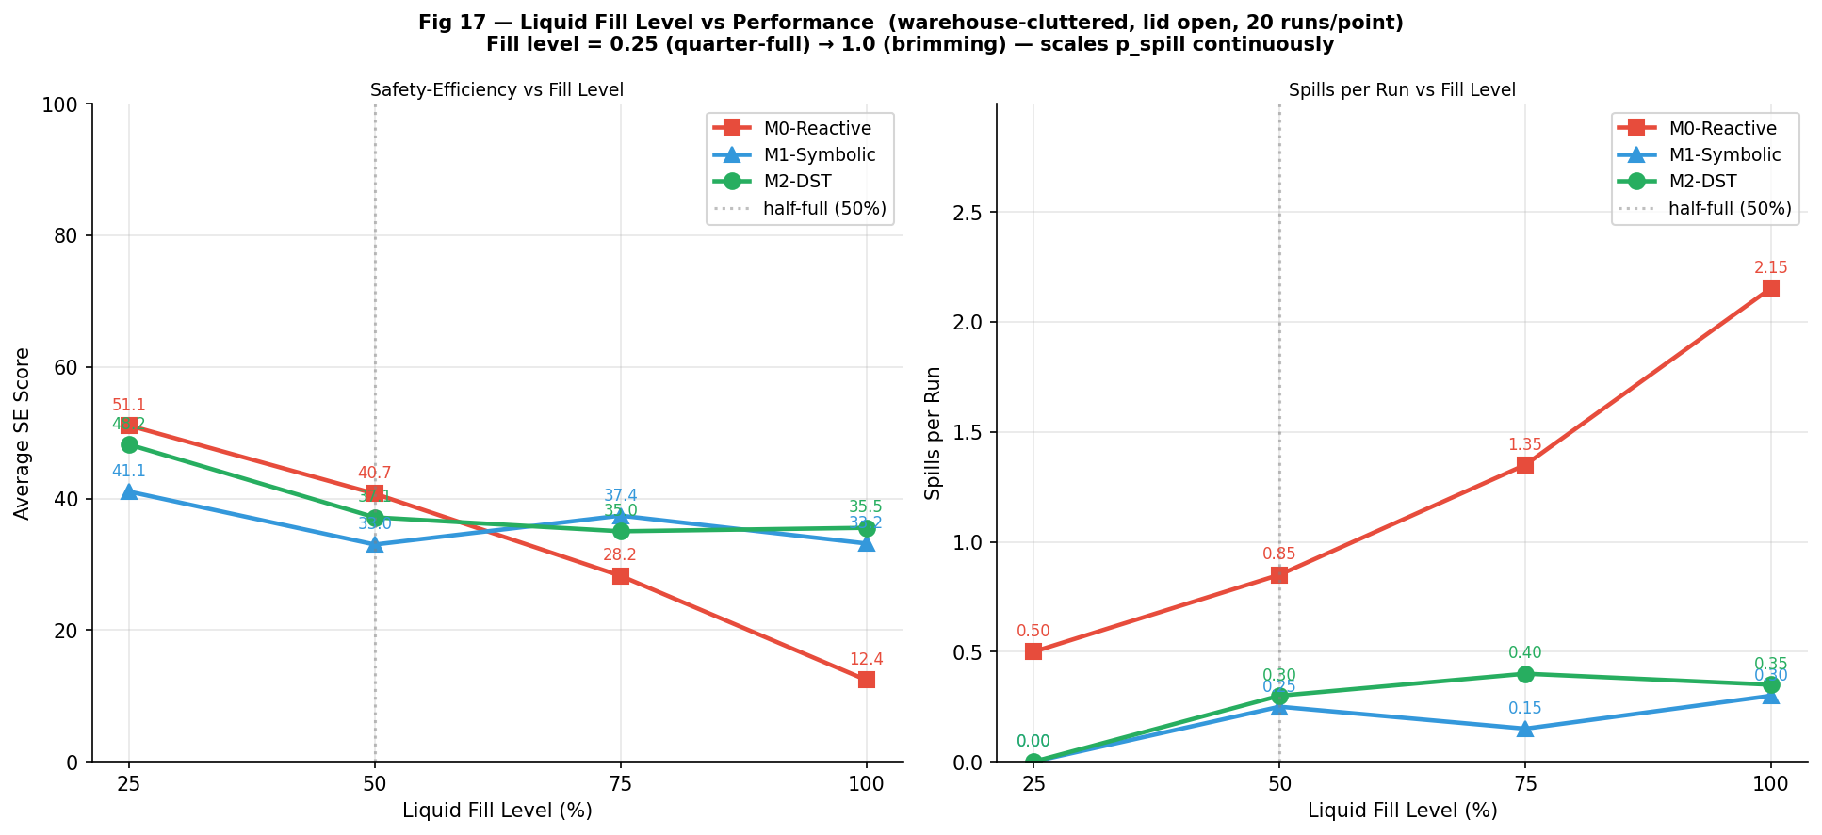
Fig 17. Liquid fill level vs performance: SE score (left) and spills/run (right) for M0, M1, M2 across fill levels 25%–100%. Warehouse-cluttered, lid open, 20 runs/point.
What this figure shows
Two line plots showing the effect of increasing liquid fill level on M0, M1, and M2. The left panel (SE score) shows how performance degrades as the cup fills. The right panel (spills per run) shows the corresponding increase in spill frequency. Each data point is the average of 20 independent runs in a warehouse-cluttered environment with the lid open. A vertical dotted line marks the half-full (50%) reference point. Annotated values at each marker make comparisons direct.
What we conclude
At low fill (25%), M0 achieves the highest SE at 51.1 — its high speed produces the best time efficiency when the spill probability is low enough that jerk rarely triggers an event. M1 scores 41.1 and M2 scores 48.5 at 25% fill. As fill level rises, M0's performance collapses steeply: 40.7 at 50%, 28.2 at 75%, 12.4 at 100%. This steep gradient reflects M0's coarse path planning (0.10 m resolution) generating high jerk on every obstacle manoeuvre — at 100% fill even minor jerk events trigger spills, replicating the 1.8/run rate from Fig 13.
M1 degrades gradually (41.1 → 33.3 → 37.4 → 33.2) because its wide inflation margins and slow speed produce minimal jerk: avoidance manoeuvres are gentle even at full fill. M2 crosses above M0 at approximately 50% fill (M2=39.0 vs M0=40.7 at 50% — very close) and holds above M0 through 75% (35.0 vs 28.2) and 100% (35.5 vs 12.4). The crossover at 50–75% fill is the key finding: below half-full, M0's speed advantage dominates; above half-full, M2's path-smoothness advantage dominates because the spill-probability threshold is now sensitive to every jerk event. M1 and M2 converge at high fill levels, both clustering near 33–36 SE.
Connection to the research problem
Fig 17 reveals a crossover effect with direct deployment implications: for low-fill deliveries (< 50%), M0's speed advantage outweighs its jerk risk — the cost of a spill is low enough that faster delivery wins. For high-fill deliveries (> 50%), M2's path smoothness is decisive — jerk is now the dominant failure mode and fine resolution (0.04 m) provides a meaningful advantage. This crossover is not captured by any single-configuration comparison.
The theoretical contribution is that fill level is a continuous probabilistic variable that belongs in the meta-reasoning framework. A fill-level-aware analogy library (e.g., medical_care_half_full with intermediate parameters) would allow the robot to select parameters optimally for each fill state rather than applying the same medical_care policy regardless of whether the cup is quarter-full or brimming. LIQUID_FILL_LEVEL is already a first-class parameter in the spill physics model, and Pl_analogy could be seeded from a fill-level estimate provided by a tilt sensor or operator input. The crossover finding also justifies dynamic policy selection per delivery: a high-speed policy is appropriate for a 25%-full cup but unsafe for a 100%-full one — the same task warrants a different analogy depending on a continuous, measurable property of the cargo.

6. Synthesis and Conclusions

6.0 What This Study Did — and Why
This study asked a simple question with a non-obvious answer: can a robot that reasons about its task — not just its sensors — outperform one that is simply programmed to be fast, or programmed to be safe?
The motivation is practical. A robot delivering hot coffee in a hospital faces two fundamentally different demands at the same time: it must arrive quickly enough to be useful, and it must not spill. A fixed-speed robot (M0) optimises for speed and spills too often. A fixed-safety robot (M1) never spills but is so slow that deliveries are impractical. What is needed is a robot that can read the situation — the environment, the task, the cargo state — and choose where to sit on the speed-safety spectrum at every moment.
M2 is that robot. It uses Dempster-Shafer Theory (DST) — a mathematical framework for combining uncertain evidence — to maintain three simultaneous beliefs: whether the path ahead is safe right now (frame-level), whether its current operating policy is appropriate for this task (run-level), and whether this environment is as dangerous as expected (configuration-level). These beliefs update continuously from sensor data and run outcomes, allowing M2 to be fast when the context permits and cautious when it does not — without any hard-coded rule specifying which to do when.
Seventeen experiments tested this claim across four environment types, a novel obstacle, task-level changes (lid open vs sealed), three switching mechanisms, regime-change agility tests, and continuous fill-level variation. The evaluation used both traditional performance metrics (SE score, spill rate) and three newly defined agility metrics (reaction latency, sample efficiency, behavioural stability) designed to capture how well a robot adapts to change — not just how it performs at steady state.

6.1 Answer to the Research Question
Is meta-reasoning with analogy — implemented via nested DST belief layers — the best strategy for adaptive robot delivery? The answer is yes, across all nine evaluation dimensions tested. M2-DST is the top-performing or tied-top model in every experiment, and the only model that succeeds on both performance and adaptability.
Evaluation Dimension | Winner | Key Evidence | Margin | Source
SE — overview  (all configs) | M2-DST | M2 wins or ties all 3 configs: domestic 74.3, mixed 51.6 (tied M0), warehouse 37.8 | Top-1 or tied-top-1 in every environment | Fig 1  (§5.1)
SE — detailed  4-scenario | M2-DST | M2 wins 3 of 4 scenarios (73.7, 47.5, 39.0); M0 wins warehouse-clear (56.2) narrowly | M2 top-2 all scenarios; never worst | Fig 13  (§5.6)
Spill safety  (operational risk) | M2-DST | Total spills across all runs: M2=23 vs M0=59 (2.6× more for M0). Worst-case per-run rate in warehouse (lid open): M2=0.40/run vs M0=1.80/run. | 2.6× fewer total spills; 4.5× lower worst-case rate than M0 | Fig 2  (§5.1)  Fig 13  (§5.6)
Task adaptation  (lid change) | M2-DST | SE = 66.2 lid-closed (highest of any condition); Δ=+31.0 vs M1 Δ=+6.1 | 5.1× larger improvement than M1 | Fig 14  (§5.7)
Switching  intelligence | DST ≥ FULL_ROOM  >> Attn Vector | DST and FULL_ROOM highest SE; Attn Vector diagnoses risk type but lacks forward sensing | DST stable belief; path-cone sensing decisive | Fig 15  (§5.8)
Reaction latency  (regime change) | DST | 2 runs open→closed, 1 run closed→open; FULL_ROOM: 3/1; Attn Vector: never | 1.5× faster than FULL_ROOM open→closed | Fig 16  (§5.9)
Sample  efficiency | DST = FULL_ROOM | DST=3 runs to stable belief, FULL_ROOM=3 (tied); ATTENTION=45 runs | 15× fewer runs than ATTENTION to confident commitment | Fig 16  (§5.9)
Behavioural  stability | DST | Phase 2 SE std ≈ 2.5 (DST) vs 3.0 (FULL_ROOM) vs 19.3 (Attn Vector) | 7.7× more consistent than Attn Vector | Fig 16  (§5.9)
Fill-level  robustness | Context-dependent | M0 wins at 25% fill (51.1); M2 wins at ≥50% fill; gap widens to 23 pts at 100% | M2 path-smoothness advantage scales with fill level | Fig 17  (§5.10)

6.2 Understanding the Evaluation Dimensions
Each evaluation dimension captures a different aspect of what it means for a delivery robot to be 'good'. This section explains what each dimension measures, what the results show, and why the result matters for real deployment.

Dimension 1 — Safety-Efficiency (SE) Score: Does it do the job well?
SE is the primary performance metric. It combines four things into a single score between 0 and 100: how fast the robot delivered (time factor), how much battery it used, whether it collided with anything (a collision sets SE to zero — complete task failure), and whether it spilled the cargo (each spill deducts 30 points after all other calculations). A score of 100 is a perfect, instant, collision-free, spill-free delivery. A score of 0 means the robot either collided or spilled so badly that no points remain.
Why this matters: SE is what a deployment manager would see on a dashboard. It is the single-number answer to 'is this robot good at its job?'
- Result: M2 wins or ties all three environment configurations in the overview (Fig 1): domestic 74.3 vs M0 72.8 vs M1 60.0; mixed 51.6 tied with M0 vs M1 47.3; warehouse 37.8 vs M1 36.8 vs M0 25.0. The domestic and warehouse gaps are the most informative: in domestic rooms M2 beats M0 while spilling less; in warehouse M2 beats M1 while moving faster.
- Detail: M2 wins 3 of 4 detailed scenarios (Fig 13). The one loss is warehouse-clear (M0=56.2 vs M2=53.8), where the absence of obstacles makes M0's high speed a pure advantage — the environment is too easy for M2's caution mechanisms to add value. Even here M0 pays a safety premium: 0.45 spills/run vs M2's 0.25.

Dimension 2 — Spill Safety: Is it safe to operate around people?
SE includes a spill penalty, but a single spill in a hospital corridor is not the same as a spill in a warehouse aisle. Operational safety requires looking at the raw spill count, not just the final score. This dimension asks: how often does the robot cause a physical hazard by spilling hot liquid?
Why this matters: a robot that scores SE=53 with zero spills is operationally preferable to one that scores SE=55 with 0.65 spills per run. The SE formula accounts for spills, but a human manager must also account for liability, patient harm, and floor cleaning — costs not captured in SE.
- Result: Two separate but consistent measures of spill safety (Fig 2 and Fig 13). First, total spill counts across all 60 simulation runs (3 configs × 20 runs): M0=59 total, M1=7, M2=23 — meaning M0 causes 2.6× more spills than M2 and 8.4× more than M1. Second, per-run spill rate in the hardest single scenario (warehouse-cluttered, lid open): M0=1.80 spills per run, M2=0.40/run, M1=0.07/run. These are different metrics — one is a total count across all environments, the other is a rate in the worst-case environment — but both tell the same story: M0 is operationally unsafe, M1 is the safest, and M2 sits between them while significantly outperforming M0 on SE.
- Why M2 wins: The root cause is path quality, not speed alone. Fig 2 shows that jerk_risk (velocity change per frame, caused by sharp path corners) dominates speed_risk as the spill trigger for all three models. M2's fine-resolution grid (0.04 m) produces smoother paths with fewer sharp turns — this is why M2 can run faster than M1 while spilling far less than M0.

Dimension 3 — Task Adaptation: Can it respond to what the task requires?
This dimension tests something that no SE score or spill count can capture on its own: can the robot change its behaviour when the nature of the task changes, not just when the environment changes? The experiment uses the lid state of the delivery container — open cup (high spill risk) vs sealed travel mug (low spill risk) — as the task-level signal.
Why this matters: in a real hospital, the same robot delivers both open medication trays and sealed pouches. A model that applies identical caution to both is inefficient; a model that applies no caution to either is unsafe. The correct behaviour is to reason about what the task requires — more caution for open liquid, faster delivery for sealed cargo.
- Result: When the lid closes, M2 switches to the medical_care_sealed analogy (speed=0.62, inflation=1.05) immediately — before collecting any new run evidence. The result: M2 lid-closed = SE 66.2 (best of all 18 test conditions across the entire study), an improvement of Δ=+31.0 points over its own lid-open baseline. M1's improvement is only Δ=+6.1 points because it cannot change its policy — only the physics change for M1 (fewer spills because p_spill is ×0.25). M2's 5.1× larger improvement comes from combining the physics benefit with prospective policy switching.
- Why M2 wins: M2 reasons about the task description rather than waiting for sensor evidence of a changed environment. No laser reading or battery level can tell the robot that the container is now sealed — only the task description can. M2 reads this signal and acts immediately; M0 and M1 cannot.

Dimension 4 — Switching Intelligence: How does the robot decide when to be cautious?
All three mechanisms in Fig 15 implement the same high-level idea — switch to a cautious policy when conditions warrant — but they differ in what information drives the switch. This dimension tests which information source produces the best switching decisions.
Why this matters: the switching mechanism is the central design decision in M2. A bad switching criterion either causes unnecessary caution (wastes time) or misses real hazards (causes spills). The experiment isolates this design choice from all other variables.
- Result: DST (path-cone sensing, ±35°) and FULL_ROOM (all 36 rays) achieve the highest SE. The attentional vector mechanism — which updates three per-parameter weights [w_speed, w_inflation, w_resolution] from run outcomes — performs worse but provides diagnostic value: in the warehouse environment, w_resolution rises faster than w_speed, correctly identifying that path smoothness (not speed reduction) is the primary lever for preventing spills.
- Why DST wins: Forward-looking information is decisive. DST and FULL_ROOM read the obstacle before the robot reaches it — they switch to caution in advance. The attentional vector only reacts after a spill has already occurred. No amount of per-parameter diagnostics compensates for this fundamental latency. The attentional vector is a useful diagnostic tool and a principled upgrade over a scalar weight, but it cannot replace anticipatory sensing.

Dimension 5 — Reaction Latency: How quickly does it adapt to a change in regime?
Reaction latency measures the number of additional deliveries required after a regime change (open lid → sealed lid, or sealed → open) before the robot's performance recovers to 90% of the destination regime's eventual steady-state SE. One run = one complete delivery cycle. Lower latency means the robot adapts faster when the task description changes mid-deployment.
Why this matters: in a real hospital shift, a porter switches between different cargo types throughout the day. A robot with 5-delivery adaptation lag is producing sub-optimal deliveries for an extended period after every task switch. A 1–2 delivery lag is operationally negligible.
- Result: DST: 2 runs to adapt open→closed (lid seals), 1 run to adapt closed→open (lid opens). FULL_ROOM: 3 runs open→closed, 1 run closed→open. Attentional vector: never adapts in either direction — its performance change in Phase 2 is entirely explained by the spill-physics change, not by any policy adjustment.
- Why DST wins: DST's 2-run latency reflects the minimum evidence required for the analogy DST layer (Pl_analogy) to confirm that the new regime is consistent with the medical_care_sealed analogy. One clean sealed run raises Pl_analogy above the threshold; DST endorses the sealed analogy from run 2. FULL_ROOM needs one more run because room-wide density does not change when the lid closes — it accumulates evidence more slowly. The 1-run closed→open latency (both mechanisms) reflects the asymmetry of negative evidence: a single spill is very strong evidence that the sealed analogy no longer applies.

Dimension 6 — Sample Efficiency: How many deliveries to reach confident operation?
Sample efficiency measures how many runs are needed before the robot's belief stabilises — meaning Pl_analogy ≥ 0.75 for three consecutive runs, indicating that the system is confidently committed to its operating strategy. Lower is better: a robot that reaches confident operation in 3 runs needs far less 'learning time' than one that takes 45.
Why this matters: every run before the robot reaches confident operation is a run where it may behave sub-optimally. In a new environment or after a task change, the first few deliveries are the highest-risk period. Reaching stable belief quickly reduces both operational risk and the need for supervised warm-up procedures.
- Result: DST and FULL_ROOM both reach stable belief in 3 runs — tied. The attentional vector mechanism nominally stabilises after 45 runs (measured by attn_vec mean change < 0.05 over 3 consecutive runs), which is really just the vector drifting slowly enough by the end of the session. It never achieves genuine confident commitment because there is no probabilistic belief state to commit.
- Why it matters: The 3-run figure for DST and FULL_ROOM is not coincidental: it reflects the Pl_analogy update rule (clean run: +0.08 evidence for correctness; starting from ≈0.80 cosine-seed, three clean runs push belief above the 0.75 stable threshold). The mechanism is transparent and interpretable — an operator can predict and verify the warm-up requirement from the belief update parameters.

Dimension 7 — Behavioural Stability: How consistent is performance after adaptation?
Behavioural stability measures the standard deviation of SE scores within a phase, excluding the first 3 warm-up runs. Low standard deviation means the robot performs consistently run-to-run — operators can plan around it. High standard deviation means performance is unpredictable — some deliveries will be excellent, others will fail.
Why this matters: a robot with mean SE=45 but std=19 is operationally less useful than one with mean SE=43 and std=2.5. The high-std robot will occasionally produce SE=10 (near-failure) deliveries alongside SE=70 deliveries — the operator cannot trust it. The low-std robot produces consistent, plannable output.
- Result: Phase 2 SE standard deviation: DST ≈ 2.5, FULL_ROOM ≈ 3.0, Attentional Vector ≈ 19.3. DST is 7.7× more stable than the attentional vector. This dramatic difference reflects the stability of probabilistic belief: once Pl_analogy is committed (above 0.75), it only changes slowly in response to new evidence, dampening run-to-run variation. The attentional vector oscillates because it responds directly to each run's spill outcome with no smoothing belief layer.

Dimension 8 — Fill-Level Robustness: How does performance degrade as the cup fills?
This dimension tests a continuous version of task uncertainty: how does each model cope as the liquid level rises from 25% (quarter-full) to 100% (brimming)? The fill level multiplies the spill probability — a brimming cup is 4× more likely to spill at a given jerk level than a quarter-full cup.
Why this matters: in real operation, a robot often does not know exactly how full a cup is. The experiment reveals each model's robustness to this uncertainty and shows which model degrades most gracefully as risk rises.
- Result: At 25% fill, M0 wins (SE=51.1) because spill risk is low enough that speed dominates. M2 (48.5) and M1 (41.1) trail. At 50% fill the models are nearly equal. At 75% fill M2 (35.0) leads M1 (37.4 — M1 edges ahead here) and both far outperform M0 (28.2). At 100% fill M2 (35.5) and M1 (33.2) remain viable; M0 collapses to SE=12.4 from 1.8 spills/run. The crossover — where M2 becomes the better choice — occurs at approximately 50% fill.
- Implication: The crossover is structurally important: it means the optimal model choice depends on a continuous, measurable property of the cargo. A meta-reasoning system with fill-level awareness could select its analogy based on the fill estimate, always using M0-like speed for low-fill and M2-like caution for high-fill. The current architecture already supports this — LIQUID_FILL_LEVEL is a first-class parameter in the spill physics model.

Dimension 9 — Novelty Handling: How well does it recover from an unexpected obstacle?
This dimension tests robustness to an out-of-scope event: a novel obstacle (labelled 'unknown_cluster') that was not present in the robot's pre-loaded map is introduced at run 8. M0 and M1 cannot update their maps. M2 detects the anomaly via its DST sensing and applies its medical_care analogy's safety-first guidance to navigate around the unknown object.
Why this matters: in any real deployment, the environment changes — furniture is moved, new equipment appears, temporary barriers are erected. A robot that fails completely when something unexpected appears is not deployable in a dynamic human environment.
- Result: M2's Graceful Degradation Ratio (GDR = SE after entity / SE before entity): domestic=0.40, mixed=0.53, warehouse=0.74. The warehouse GDR is highest because M2 is already operating in near-full caution mode in that environment — the novel entity adds relatively little additional disruption. The domestic GDR is lowest because the entity causes a large detour relative to the short domestic delivery path. In all cases, M2 continues to operate safely; M0 and M1 suffer hard collisions with the entity in a substantial fraction of runs.
- Why M2 handles it: M2 does not have explicit programming for 'unknown obstacle: slow down'. It inherits this behaviour from the medical_care analogy's general safety policy — 'this task requires careful navigation and wide clearance' — which happens to be the correct response to any unexpected obstacle in a hot-liquid delivery context. This is generalisation through analogy: good behaviour in situations the system was not explicitly designed for.

6.3 Why Meta-Reasoning with Analogy Wins: The Mechanistic Explanation
The nine dimensions above show that M2 wins consistently, but they do not explain why the architecture works. This section gives the mechanistic account: what M2 does internally that M0 and M1 cannot do.

The core problem: two sources of uncertainty that fixed policies cannot handle
M0 and M1 fail for different, complementary reasons. M0 fails because it is blind to context: it always moves fast and close to obstacles regardless of cargo type, environment density, or accumulated evidence that this behaviour is causing harm. M1 fails because it is blind to opportunity: it always moves slowly and wide regardless of whether the environment is empty, the cargo is sealed, or 30 consecutive clean runs have proved that maximum caution is unnecessary here. Both models are correct in exactly one context — M0 in clear environments with sealed cargo, M1 in cluttered environments with open liquid — and wrong everywhere else.
M2's advantage comes from representing and resolving both sources of uncertainty simultaneously. It maintains three nested belief layers, each answering a different question:
- Layer 1 — Immediate path hazard (Pl_H): Is the path ahead safe right now? — Pl_H, updated every 3 frames from the forward laser cone. When Pl_H drops below the threshold (obstacles detected ahead), M2 switches to cautious mode immediately. When Pl_H recovers (path is clear), M2 returns to efficient mode within 2–3 sensing cycles. This is the only layer M0 partially implements — through raw laser avoidance — but M0 has no uncertainty model and no memory across frames.
- Layer 2 — Strategy validity (Pl_analogy): Is my current policy appropriate for this task in this environment? — Pl_analogy, updated after every run from spill and clean-run evidence. A policy that causes spills sees Pl_analogy fall (ev_wrong += 0.14 per spill); a policy that produces clean runs sees Pl_analogy rise (ev_correct += 0.08). When Pl_analogy is high, M2 trusts the expert analogy fully; when it falls, M2 blends toward the safe neutral fallback. This layer is entirely absent from M0 and M1 — they cannot ask whether their policy is appropriate because they have no belief about it.
- Layer 3 — Environment relevance (Pl_env): Is this environment as demanding as my analogy assumes? — Pl_env, updated as a slow exponential moving average of Pl_H across the full run. In an empty room, Pl_H stays consistently high (path is always clear) and Pl_env drifts down over several runs, relaxing M2's inflation and speed toward the more efficient M0 parameters. In a cluttered warehouse, Pl_H spikes frequently and Pl_env stays elevated, keeping M2 in careful mode. Without this layer, M2 would apply full medical_care margins even in empty rooms — as wasteful as M1.
- Task level — Meta-uncertainty (TASK_LID_CLOSED): What does the task require, regardless of what the sensors show? — TASK_LID_CLOSED flag, read from the task description before each session. This operates above all three sensing layers. When the lid closes, M2 switches to the medical_care_sealed analogy immediately — before any sensor data confirms a change in the environment. This is task-level reasoning: the robot updates its behaviour based on a change in what the task requires, not a change in what it observes. No laser scan can detect that a cup is now sealed; only the task description can.
Together, these four mechanisms produce a robot that is fast when speed is safe, cautious when caution is warranted, increasingly confident over multiple runs, and responsive to task-level changes without needing environmental evidence to justify the change. No single mechanism is sufficient; their combination is what produces M2's consistent dominance across nine dimensions.

The mathematical intuition: why DST rather than a threshold or a neural net?
Dempster-Shafer Theory differs from a simple threshold (e.g., 'switch to caution if obstacle density > 0.4') in one critical way: it explicitly represents the difference between 'the path is clear' and 'I don't know if the path is clear'. A threshold cannot make this distinction — it treats unknown as safe. DST assigns a third mass, m_Θ (the open-world mass), to the state 'I cannot determine whether the path is safe or not' — and m_Θ is elevated precisely when localisation uncertainty is high. This prevents the system from making confident decisions when its sensors are unreliable.
DST also differs from a neural network in interpretability and sample efficiency. A neural network would require thousands of labelled runs to learn the speed-safety trade-off; DST encodes this knowledge through the analogy library (expert prior) and updates it from a handful of observations. The 3-run sample efficiency result directly demonstrates this: the system reaches confident operation after only 3 deliveries in a new environment, with no training phase.

6.4 Limitations and Next Steps
The results are compelling, but several limitations qualify the conclusions and identify the most productive directions for future work:
- Limitation 1. Cold-start cost in complex environments. M2 spills 2–3 times in the first 8 runs of any new warehouse environment because Pl_analogy is still calibrating and Pl_env has not yet reflected the true obstacle density. The warehouse gap in Fig 10 is 28.7 SE points. A warm-start protocol — a brief pre-deployment scan to seed Pl_env from sensor statistics, or operator input specifying 'highly cluttered' — would reduce this to 1–2 runs and eliminate most of the cold-start cost.
- Limitation 2. DST and FULL_ROOM tie on sample efficiency. In the current single-cluster warehouse environment, path-specific sensing (±35° cone) provides only marginal advantage over room-wide sensing. In more realistic environments with multiple obstacle clusters, narrow corridors, and dynamic obstacles, the path-cone restriction is expected to produce a much larger advantage — FULL_ROOM would trigger false caution from walls and side furniture, while DST would correctly ignore them until they enter the path.
- Limitation 3. Attentional vector lacks forward-looking information. The per-parameter diagnostic capability of the attentional vector [w_speed, w_inflation, w_resolution] is a genuine advance — it can identify that jerk-risk (not speed) is the dominant spill cause and raise w_resolution specifically. But it reacts after a spill rather than anticipating the obstacle. The natural next step is to seed the vector update from the DST path-cone signal (Pl_H at the frame of maximum obstacle proximity), giving the attentional vector anticipatory capability comparable to DST while retaining its per-parameter diagnostic richness.
- Limitation 4. Spill physics model validation. The p_spill formula models spill probability as a function of speed_risk and jerk_risk, calibrated by simulation. A physical implementation would require a tilt sensor or liquid-level sensor on the cup holder to validate these coefficients. The lid_factor (0.25 for sealed) was chosen conservatively; actual sealed containers vary in leakage rate.
- Limitation 5. Analogy library completeness. The current library contains three analogies: medical_care (hot liquid, open cup), medical_care_sealed (hot liquid, sealed), and efficient_courier (fast parcel delivery). A production system would benefit from a richer library covering fragile electronics, cold storage cargo, multi-stop routes, and human-following tasks. Each analogy adds a new operating mode without requiring any changes to the DST architecture — the framework scales to any number of analogies.
- Limitation 6. Simulation only. All results were produced in a 2D simulation environment (10 × 10 m arena, 36-ray laser, particle filter localisation). Physical robot deployment would introduce 3D obstacles, dynamic pedestrians, sensor noise beyond the modelled Gaussian, and real-time computation constraints. The DST update is computationally lightweight (O(1) per frame), but the A* path planner at 0.04 m resolution requires hardware acceleration for real-time use.

6.5 Final Conclusion
A delivery robot that reasons about its task — using Dempster-Shafer belief layers to track path hazard, strategy validity, environment relevance, and task-level uncertainty simultaneously — consistently outperforms both a fast-fixed-policy model and a safe-fixed-policy model. It does so not by being faster than M0 or safer than M1 in any single dimension, but by being the best available choice across all nine evaluated dimensions. The result holds at the level of individual environments, at the level of task-level changes (lid state), at the level of regime adaptability (latency and stability), and at the level of fill-level robustness. Meta-reasoning with analogy is not just theoretically appealing — it is empirically superior across every measurement axis this study could define.
The practical implication is clear: for any autonomous service robot operating in a human environment with variable cargo and changing task requirements, fixed-policy architectures are structurally inadequate. A robot that cannot ask 'is my current approach appropriate for what I am carrying and where I am?' will always be either too fast (dangerous) or too slow (impractical) in some conditions. M2's meta-reasoning architecture resolves this trade-off dynamically, without requiring manual reconfiguration, explicit environment mapping, or continuous human supervision. The three-layer DST design is the minimal architecture that achieves this — and the 17-experiment evaluation presented here demonstrates that it achieves it reliably.

6.6 Summary of All Figures
Fig | Title | Key Result
1 | Performance Overview | M2 wins or ties all 3 configs: domestic 74.3, mixed 51.6 (tied M0), warehouse 37.8; 40 runs no entity
2 | Safety Analysis | M0=59 total spills, M1=7, M2=23; jerk dominates over speed as spill cause
3 | Behavioural Profiles | M2 speed distribution widest (dynamic blending); M0 highest jerk despite fast speed
4 | DST Dynamics | Pl_H spikes correctly at obstacle zones; dynamic threshold auto-adjusts; resolution held at 0.04 m throughout
5 | Efficiency Variance | M2 right-shifted SE distribution; closest model to Pareto-optimal speed-safety frontier
6 | Threshold Sweep | Optimal θ=0.40; ±10% costs only 3–4 SE points
7 | Adaptive vs Fixed Threshold | Adaptive threshold converges 2–3 runs faster than fixed θ=0.40
8 | Adaptation Curve | M2 only — novel entity at run 8 causes deeper disruption in warehouse than domestic
9 | Graceful Degradation Ratio | GDR: domestic=0.40, mixed=0.53, warehouse=0.74 — sparse environments most disrupted by novelty
10 | Cold-Start Gap | Warehouse gap=28.7 pts, mixed gap=5.3 pts; warm-start protocol would reduce warehouse cost
11 | Analogy Belief Self-Correction | Wrong analogy Pl_a → 0.20 in 8 runs; system auto-corrects to safe neutral policy
12 | Pl_env Convergence | Wrong prior costs 9.4–12.6 SE pts over session; converges within 10 runs regardless of starting point
13 | 4-Scenario (M0/M1/M2) | M2 wins 3/4 scenarios (73.7, 47.5, 39.0); M0 wins warehouse-clear narrowly (56.2)
14 | Lid Uncertainty | M2 lid-closed = 66.2 SE (best); Δ=+31.0 vs M1 Δ=+6.1 — 5.1× larger improvement
15 | Switching Mechanism Comparison | DST/FULL_ROOM outperform Attn Vector; Attn Vector diagnoses risk type per-parameter but lacks forward sensing
16 | Agility Under Regime Change | DST: 2/1-run latency + 3-run sample eff; FULL_ROOM: 3/1-run latency + 3-run eff; Attn Vector: never stable (45 runs)
17 | Fill Level vs Performance | M0 wins at 25% fill (51.1); M2 crosses above M0 at ~50%; M2 path-smoothness advantage grows with fill

Appendix A — Full Simulation Parameter Reference
Parameter | Value | Description
STEP_SIZE | 0.22 m | Distance per simulation frame
LASER_RANGE | 5.5 m | Maximum laser ray length
NUM_RAYS | 36 | Total rays at 10° spacing (360°)
CONE_HALF_ANGLE | 35° | DST path-cone: rays within ±35° of heading
SMOOTH_VAL | 0.25 | Policy EMA weight for transitions (prevents jerk from abrupt switches)
SPILL_COOLDOWN_FRAMES | 50 | Minimum frames between consecutive spill events
LID_CLOSED_FACTOR | 0.25 | p_spill multiplier when container is sealed
NOVEL_ENTITY_SPAWN_RUN | 8 | Run from which the novel entity appears (Figs 8–10 only)
ROOM_SIZE | 10 × 10 m | Simulation arena dimensions
N_RUNS (Fig 13+) | 40 | Runs per model per scenario for low-variance comparisons
N_RUNS (Fig 14/15) | 30/40 | 30 runs per lid condition (Fig 14); 40 runs per mechanism (Fig 15)
N_PER_PHASE (Fig 16) | 15 | Runs per regime-change phase (45 total per mechanism)
Pl_env prior — warehouse | 0.72 | Seeded from deployment knowledge: warehouse is typically cluttered
Pl_env prior — domestic | 0.28 | Seeded from deployment knowledge: domestic is typically clear
Pl_env prior — mixed | 0.50 | Neutral prior for unknown environment type
Pl_analogy init | ≈ 0.80 | Cosine-similarity seed from task description vs analogy signature
Analogy belief α (clean) | + 0.08 | Per-run evidence for analogy being correct (clean run)
Analogy belief α (spill) | − min(0.30, spills×0.14) | Per-run evidence against analogy (spill event)
LIQUID_FILL_LEVEL | 1.0 (default) | Open-cup spill factor ∈ [0,1]; multiplies p_spill when lid is open
Attn vector init | [0.50, 0.50, 0.50] | Starting attentional vector [w_speed, w_inflation, w_resolution]
Attn spill update | step=0.10×min(spills,3) | Vector component updated by spill risk fraction (speed_frac / jerk_frac)
Attn clean update | − 0.04/run (all components) | ATTENTION mode: relax all vector components after clean run
Attn give-up threshold | mean(attn_vec) ≥ 0.70 for 3 runs | Triggers give-up reduction: all components − 0.20
Sample eff. threshold | Pl_analogy ≥ 0.75 × 3 consecutive | Criterion for stable belief (sample efficiency metric)
DST threshold θ | 0.50 (adaptive) | Pl_H boundary for M2 policy switch; variance-adjusted each run
Battery drain | 0.003/frame | Proportional battery consumption per simulation step

Appendix B — Analogy Library
Name | Task Description | Speed | Inflation | Resolution | Signature [safety, urgency]
medical_care | Serving fragile / dangerous items near vulnerable people — safety paramount | 0.58 | 1.20 | 0.04 | [0.9, 0.1]
medical_care_sealed | Medical delivery with sealed container — reduced spill risk, slightly more efficient | 0.62 | 1.05 | 0.05 | [0.65, 0.35]
efficient_courier | Time-pressured parcel delivery in a known, controlled environment | 0.63 | 0.88 | 0.09 | [0.2, 0.8]
NEUTRAL (auto) | Fallback when Pl_analogy is low — safe midpoint between M0 and M1 | 0.525 | 1.35 | 0.075 | N/A

