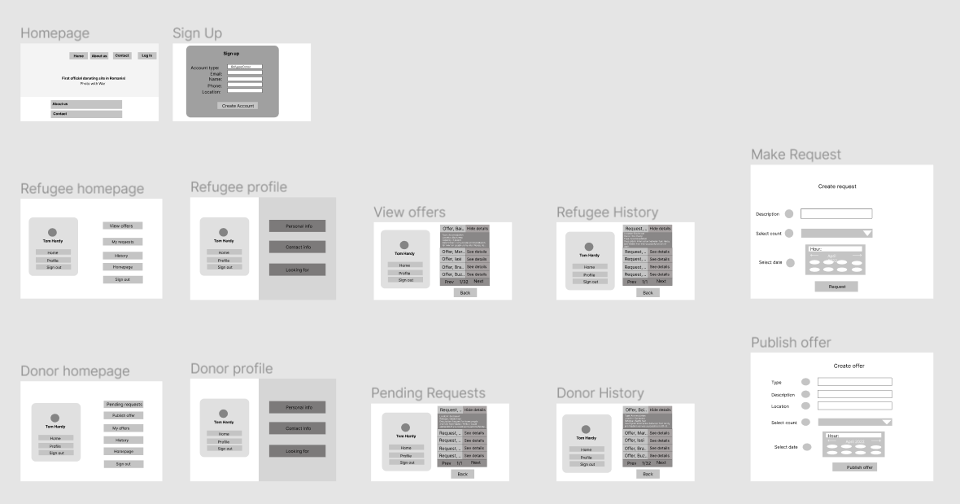

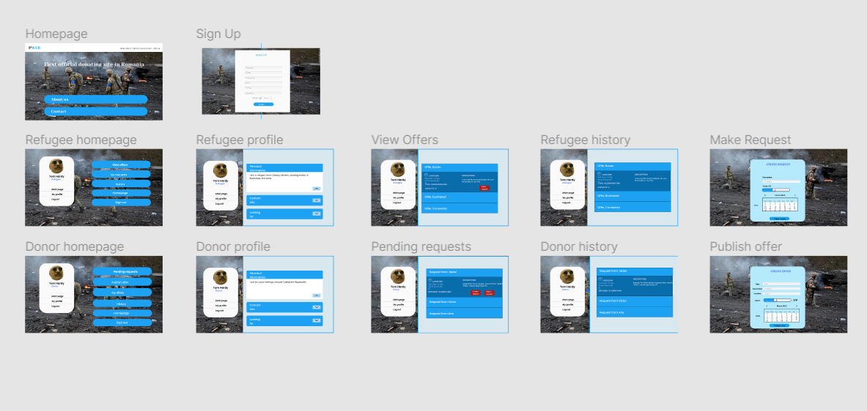

Wireframe: https://www.figma.com/file/QPbcXcHEPDeL7ijx00ddnW/PWEB-DESIGN?node-id=0%3A1

Prototype: https://www.figma.com/file/QPbcXcHEPDeL7ijx00ddnW/PWEB-DESIGN?node-id=13%3A4