**Final Documentation Note:**

All required documentation: requirements document, object-oriented design, object-oriented analysis, testing document, and user manual, are all within one Word document within the Kollab file folder. The document is called Kollab – Final Documentation.

How to Run Kollab

Step 1:

Ensure node.js is installed(if not it can be installed from the following link: (<https://nodejs.org/en/download/>)

Step 2:

First you should ensure mongodb is installed (if not it can be installed from <https://www.mongodb.com/download-center>)

Secondly, we will install the driver into our app (we have already done so but just in case):



Step 3:

*For this step we will need 2 separate terminal windows.

First, we will run mongod:



Secondly, in another terminal window we will run mongo:



*We will leave these terminal windows open in order to get our app’s sign up and login components to work.

Step 4:

2. Clone/Download the Kollab project repository to your computer from GitHub the following link:( <https://github.com/adriana-abella/kollab>)

3. Using command line cd into the Kollab program folder



4. Use the following command to install required node modules: npm install



5. After npm install has executed, run npm start and this will connect you to the local host server



6.Once you see node ./bin/www it means that the host is listening and you can go ahead and type <http://localhost:3000/> into your browser to start using Kollab!

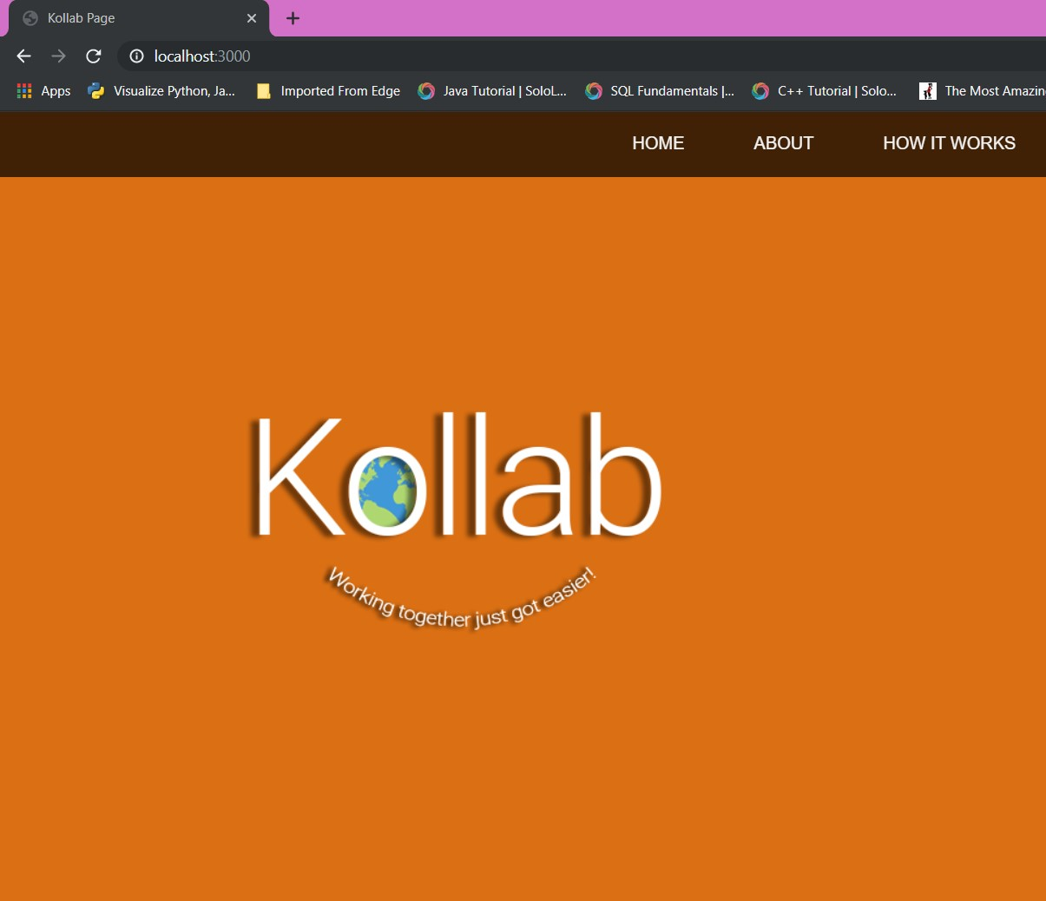

7. To close the local host go back to command line and use Ctrl-C you will be prompted to end batch job and you can type in y to end the session.