**SUMMARY**

Kickstarter is a popular platform for music and film loves to discover unique and innovative films and music. Certain campaign attributes may lead to higher success rates. Documentary and rock music campaigns have zero failure rate, while plays campaigns have a higher failure rate than success rate; therefore, plays campaigns may benefit from more targeted marketing assistance from Kickstarter.

1. **Kickstarter is a popular resource for music and film lovers in the US, Canada and UK.** The top three most successful categories are in the Theater, Music and Film & Video categories. Within those categories, the top three most successful sub-categories are plays, documentary and rock music.
2. **Optimal campaign attributes based on 2185 successful campaigns** 
   1. **Campaigns launched in May have the highest success.** While the other months have similar number of successful campaigns, the Month of May have a slightly higher success rate than other months.
   2. **The median campaign duration is 30 days.** The duration of successful campaigns varied between 2 to 90 days; however, the average duration is 30 days.
   3. **The median goal amount is $3,500.** The goal amount ranged from $1 to $400,000. However, the median goal amount is $3,500, and the upper bound for outlier is $22,750.
   4. **The median percent pledged is 112% of goal.** The upper bound for outlier is 189% of goal meaning it is highly unlikely for the pledge amount to go beyond the said percentage.
   5. **The lower the goal amount the higher likelihood of success.** Goal set between $15,000 and 19,999 has a 47% of chance of success, 45% of failure and 8% of cancelation, meaning there is only a 2% gap in the chance of success and failure.

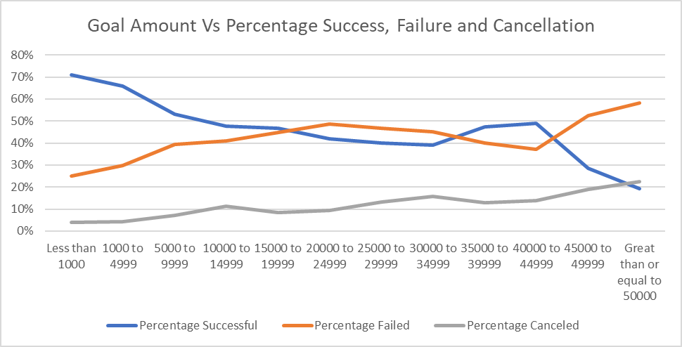

1. **Fundraisers for plays may benefit more targeted marketing assistance from Kickstarter.** Kickstarter is a popular place for fundraisers to start campaigns. While many succeed, there are also many failed campaigns. Plays have higher dollars in failed campaigns than successful campaigns. All documentary and rock campaigns were successful with zero canceled or failed.

Limitation of Dataset

1. There are very limited successful datapoints. At only ~4000 data points, it is hard to get an accurate analysis and create meaningful trendlines.
2. The data doesn’t show if any money was spent on efforts spent on advertising or marketing help from Kickstarter such as BoostYourCampaign services or other professional Kickstarter marketing companies.
3. There are various outliers that make it challenging to analyze the data. For example, the campaigns with goal amounts of $1 to $50 are outliers, but they skew the data for successful campaigns

Potential Additional Tables/Graphs

1. A scatter plot of campaigns on a map
2. A table of failed campaigns and spotlight attribute to analyze the impact of the spotlight feature. Did not having it possible cause the failure? Did having it not make an impact at all?
3. Pie charts of categories and sub-categories

Bonus Statistical

1. The dataset has many extremes. For example, the number of backers for successful campaigns has a minimum of 1 and a maximum of 26457. The average of this range which is 194.42 would not be representative of the population. Therefore, the median being the middle of the data would summarize more meaningfully.
2. The variance of successful campaigns is much higher than the failed ones. This makes sense because there is no limitation as to how many backers can back a campaign. If it is popular it can have as little as 1 or as many backers there are to support the campaign. Failed campaign is likely to have 0 to a number of backers that tends to be low; therefore, there is less variability in the smaller range.