* The only way that is needed for a user to access an in company CT is starting from the Project Overview. (navigate from the Project -> CI -> PG –> CT)

All other ways are redundant (will not be used).

The following screen shall be used.

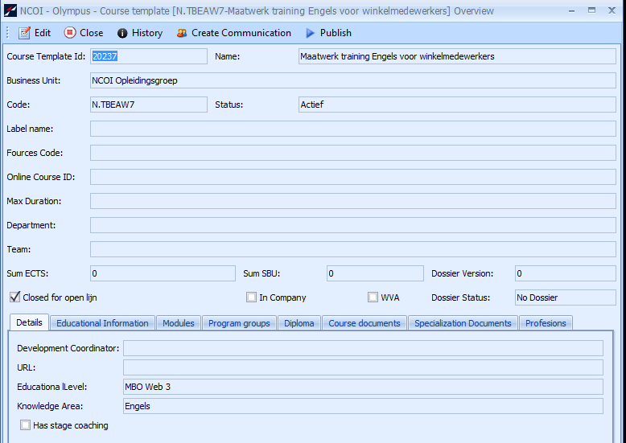

1. Currently when creating a new template, the course code is generated a ProjID_7. When creating another template the new code will be ProjID_71. When the user wants to generate another course structure from the same template the name will be ProjID_711. Do you agree with this automatic way of numbering the templates?

Sounds good.

6875 [FUNC] As a user I can create a new e-mail from the Project Overview.

* Use the existing Send email button for sending mails.
* Load the list of recipients directly in the email screen.

63127:  As a project manager I can distribute projects amongst collegues

* This should be a working list “Projects to distribute” in the Incompany Project menu.
* We’ll use the same columns and filter as in the projects list
* When assigning an employee to a project role does this employee have to be a team member in that project?  
  The intention of this list is to assign employees to a role so that they become members of the project team (I hope there are not 2 different types of teams on the project)

68753: As a user I can have an overview of all accounts i am involved in

* Do you agree with the following columns: AccountId, Name, AccountType, Lead AccountManager, AccountCompany, NoCompanies (what is this?), Account Type,   
  Role
* Filter for all columns