GLOBO — AI report
Practice 1 · CUNEF Universidad | Authors: Adriana Acebal and María Cuadrado

1. How we used AI
Tools. Our main tool was Claude Code, an AI coding agent inside Visual Studio Code that reads the whole repository, runs commands (npm test, npm start), calls the API and edits files, with two project skills: globo-brand (our page style) and run-globo (start the server and take screenshots).
Part A – API Development
- Generating the other resources (riders, coupons, orders, reviews, complaints, messages) with our router → controller → validator pattern, and the shared validator common.js.
- As a tutor for our main resource: we deleted the restaurants route, controller and validator on the branch learn-restaurants and rebuilt them ourselves, one file at a time (section 3).
- For the Postman section, we used the integrated Postman AI to learn how to use the platform and generate the required collection for testing our API.
Part B – Front End Development
- public/js/api.js with apiRequest(), the only file that calls fetch, and crud.js, shared by the eight admin pages: loading, error and empty states and 400 messages under each field.
- Reviewing Part B against the brief: it found the hard-coded copy of the restaurants and menus in order.js (see the table).

What we kept, changed and rejected
Decision | What the agent produced | What we did and why
Kept | The shared validator in common.js that collects all errors before answering. | It matches our status-code contract (400 with the full errors array) and removed duplicated code from eight validators.
Changed | README examples for restaurants: /stats with a pickupOnly field and a search for "gran via" returning 2 restaurants. | We had the agent check the README against the running API: the real /stats has no pickupOnly and the search returns 4. We replaced them with the real responses.
Rejected | In order.js, a hard-coded copy of the restaurants and menus used when the server is off. | The brief says the data of our resources must always come from the API. When we asked the agent to check Part B it flagged this copy, and we removed it: the page now uses GET /api/restaurants and GET /menu.
Rejected | The complete restaurants route, controller and validator. | Restaurants is our main resource and we must explain every line, so we deleted the three files on a branch and rebuilt them ourselves, with the agent only explaining (section 3).

2. Advantages of the agent
- Explaining errors. npm test showed 14 failing tests. The agent traced all of them to one cause: restaurants.js only wired POST, so the other routes fell through to the JSON 404.
- Checking docs against the code. It started the server and compared each README example with the real answer: /stats had no pickupOnly field and the search returned 4 restaurants, not 2.
- Generating tests. It wrote the Jest + Supertest tests (74). While we rebuilt restaurants they were our checker: they told us exactly which routes were still missing.
- Speed on repetitive code. Once dishes existed, the other resources took minutes, so we spent our time on the rules that differ: unique coupon codes (409) and no rider on a pickup order.
The limit we learned. The agent writes wrong answers with the same confidence as right ones (the pickupOnly example looked perfectly plausible). We only trust its output after running it: the tests, the API call or the page in the browser.

3. A good prompt
We had trouble understanding how to build an API, so we rebuilt the restaurants API ourselves with Claude as a tutor: we turned off automatic edits, so it only explained the steps, and we used our riders API as a model.

First version (weak)
okay so im doing the CRUD api for restaurants
Why it is weak: It only describes the task, not what we wanted from the agent. There is no clear goal, audience, or expected format, so Claude had to guess what kind of help was needed
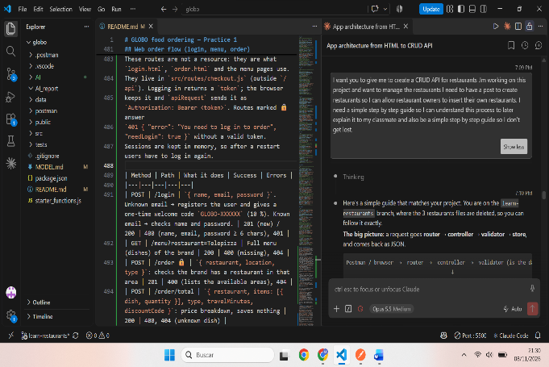
Improved version
I want you to give me to create a CRUD API for restaurants .Im working on this project and want to manage the restaurants I need to have a post to
create restaurants so I can allow restaurant owners to insert their own restaurants. I need a simple step by step guide so I can understand this
process to later explain it to my classmate and also be a simple step by
step guide so I don't get lost.
Why it works:
- Context: it names the resource (restaurants), the project we were working in and the real use case: restaurant owners inserting their own restaurants. The agent already had the repository open, so it took the resource shape (name, brand, area, type, delivery, lat, lon) from our code.
- Priority: it says the first thing we need is POST. The agent started with creating a restaurant (validator → controller → route) instead of all seven endpoints at once.
- Audience and goal: "so I can understand this process to later explain it to my classmate" tells the agent this is for learning, not for finished code, so it explained why each piece exists.
- Output format: "a simple step by step guide so I don't get lost" made it answer in numbered steps, one file per step, with the request flow drawn as router → controller → validator → store.

What we improved after that
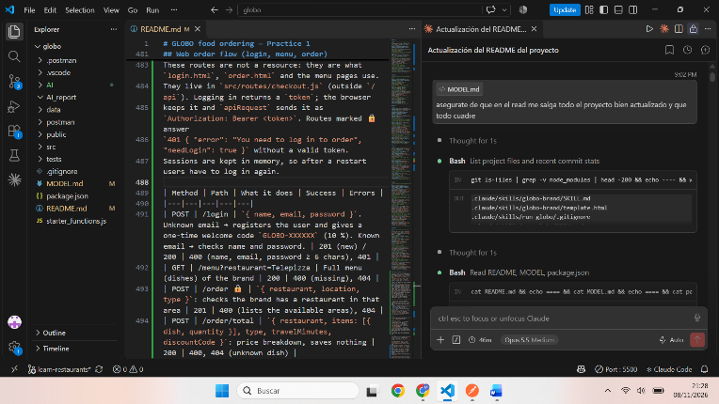
The answer to the improved prompt still contained the finished code for each file. So we added a follow-up:
okay so dont do the work for me just help me do it myself. I have created a
file called resturantsValidator.js what do I do know and what will we do
with this page
From then on the agent explained one file at a time and we wrote the code ourselves (for example "explicame que tengo que poner en el restaurantsController paso por paso"). Our tests were the checker: 14 still failed after the POST step, and all 74 pass once we wired the other routes. Next time we would put in the first prompt the status-code contract (201 + Location, 400 with an errors array) and the rule "explain, do not write the code for me".

