GLOBO — AI report
Practice 1 · CUNEF Universidad | Authors: Adriana Acebal and María Cuadrado

1. How we used AI
Tools. Our main tool was Claude Code, an AI coding agent that runs inside Visual Studio Code. It can read the whole repository, run commands (npm test, npm start), call the API and edit files. We also gave it two project skills in .claude/skills/: globo-brand (our colours, header and side menu, so new pages match the site) and run-globo (start the server and take screenshots of the pages).
Part A – API Development
- We used Claude Code to understand API concepts and implement CRUD operations. It provided step by step guidance when creating resources such as orders and helped us identify and fix programming errors.
- Claude also helped us understand and work with JSON files, explaining their structure and assisting with the implementation of JSON-based functions in our application.
- For the Postman section, we used the integrated Postman AI to learn how to use the platform and generate the required collection for testing our API.
Part B – Front End Development
- We used Claude Code to develop and improve the frontend connection to the API through reusable JavaScript modules.
- It assisted with validation, error handling, loading states, and dynamic rendering of data received from the API.
- We also used it to compare the implementation against the project requirements and verify that all required information was being retrieved from the API.

What we kept, changed and rejected
Decision | What the agent produced | What we did and why
Kept | The shared validator in common.js that collects all errors before answering. | It matches our status-code contract (400 with the full errors array) and removed duplicated code from eight validators.
Changed | README examples for restaurants: /stats with a pickupOnly field and a search for "gran via" returning 2 restaurants. | We asked the agent to check the README against the code by calling the API. The real /stats has no pickupOnly, and the search returns 4 restaurants. We replaced the examples with the real responses.
Rejected | In order.js, a hard-coded copy of the restaurants and menus used when the server is off. | The brief says the data of our resources must always come from the API. When we asked the agent to check Part B, it flagged this copy itself.

2. Advantages of the agent

• Faster debugging of API errors.

• Automatic generation of realistic test cases.

• Support creating Postman collections and Newman tests.

• Faster documentation and project review.
The limit we learned. The agent writes wrong answers with the same confidence as right ones (the pickupOnly example looked perfectly plausible). We only trust its output after running it: the tests, the API call or the page in the browser.

3. A good prompt
We used this prompt because as we said in part 1 we were having a lot of problems understanding how to build the API , so we took the restaurant API and made Claude explain how to built it step by step for this part we unabled the automatic AI writing so Claude gave us the steps and used the riders API as a template so we could ourselves built this API.

First version (weak)
okay so im doing the CRUD api for restaurants
Why it is weak: It only describes the task, not what we wanted from the agent. There is no clear goal, audience, or expected format, so Claude had to guess what kind of help was needed
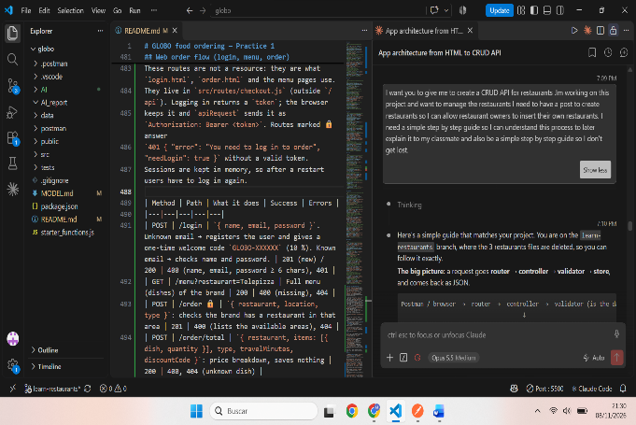
Improved version
I want you to give me to create a CRUD API for restaurants .Im working on this project and want to manage the restaurants I need to have a post to
create restaurants so I can allow restaurant owners to insert their own restaurants. I need a simple step by step guide so I can understand this
process to later explain it to my classmate and also be a simple step by
step guide so I don't get lost.
Why it works:
- Context: it names the resource (restaurants), the project we were working in and the real use case: restaurant owners inserting their own restaurants. The agent already had the repository open, so it took the resource shape (name, brand, area, type, delivery, lat, lon) from our code and the existing store with the 30 seed restaurants.
- Priority: it says the first thing we need is POST. The agent started with creating a restaurant (validator → controller → route) instead of all seven endpoints at once.
- Audience and goal: "so I can understand this process to later explain it to my classmate" tells the agent this is for learning, not for finished code, so it explained why each piece exists.
- Output format: "a simple step by step guide so I don't get lost" made it answer in numbered steps, one file per step, with the request flow drawn as router → controller → validator → store.

What we improved after that
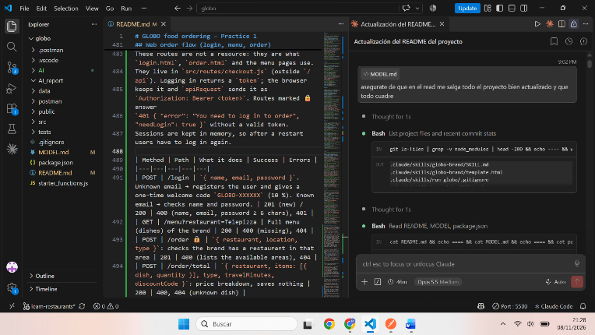
The answer to the improved prompt still contained the finished code for each file. So we added a follow-up:
okay so dont do the work for me just help me do it myself. I have created a
file called resturantsValidator.js what do I do know and what will we do
with this page
From then on the agent explained one file at a time and we wrote the code ourselves (for example "explicame que tengo que poner en el restaurantsController paso por paso"). Our existing tests worked as the checker: after deleting the restaurants files 16 tests failed, and after we wrote the validator, the controller and the POST route, 14 still fail; they are the routes we have not rebuilt yet. Next time we would also put in the first prompt the status-code contract (201 + Location on create, 400 with { errors: [ { field, message } ] }) and the rule "explain, do not write the code for me", so the first answer would already be right.

