**PSET1 Q4**

**PSET2 Part One**

**1) Calculate the crude death rate in each population.**

USA CDR: 0,0084625275213

Russia CDR: 0,0143868047557

**2) Calculate age-specific death rates (ASDR) in each population. Prepare a figure comparing ASDR’s in these two populations (with age in the X axis and ASDRs in the Y axis, using a logarithmic scale for the Y axis).**

See Excel Sheet “Graph #2”

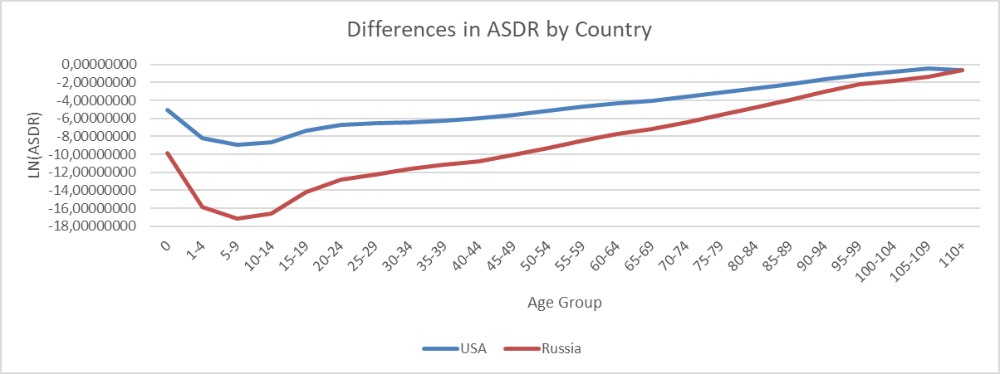

**3) Specify your assumption(s) for calculating person-years in (1) and (2).**

Using the midpoint estimate for person-years assumes population growth is linear.

**4) Calculate the proportionate age distribution in the U.S. and Russia. Prepare a figure comparing proportionate age distributions in these two populations (with age in the X axis and population proportions in the Y axis). Merge the first two age groups (0, 1-4) into one five-year age group (0-4), so that each age class in the graph has a same width (5 years).**

See Excel Sheet “Graph #4”

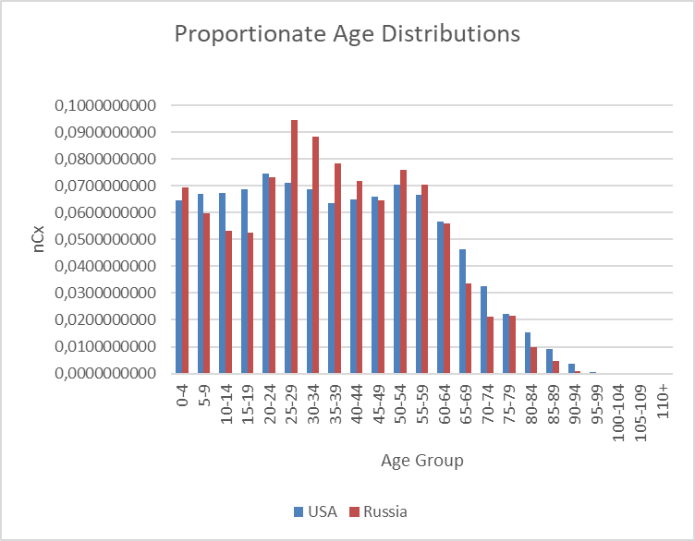

**5) Verify numerically that the CDR in each country is also a weighted average of ASDRs, where the weights are the population age distribution.**

See Excel Sheet “CDR #5” compared to “CDR #1” for both U.S. and Russia – the CDRs are the same.

**6) Calculate the age-standardized crude death rate for the U.S., using the Russian age distribution as a standard. How do you interpret the difference between the CDR for Russia and the age-standardized CDR for the U.S.?**

Since the Russian population has fewer old people proportionate to the total population than the U.S., the ASCDR for the U.S. using the Russian age distribution is an underestimate: in actuality, there are more people aged 65 and up in the U.S. population and that is where mortality rates are relatively high.

**7) Suppose that you do not have the age distribution of deaths in Russia, but only the total number of deaths. Calculate the comparative mortality ratio for Russia vs. the U.S. Verify that your result is equal to the ratio of the CDR for Russia calculated in (1) to the aged-standardized CDR for the U.S. calculated in (6).**

CMR: 2,22926507797905

**8) Decompose the difference between crude death rates in the U.S. and Russia into a component attributable to differences in age-specific death rates and a component attributable to differences in age composition. Interpret these components. Be sure that they add up to the observed difference between the crude deaths rates for the two countries.**

See Excel Sheet CDR #8 calculations.

Consider CDR_Russia = CDR_USA = 0,005924277234405

Age Effect: -0,002531749473301

Mortality Effect: 0,008456026707706

**9) When standardizing CDRs in the US and Russia, would the choice of the age standard affect the direction of the difference between standardized rates? Why, or why not?**

Since the mortality curves (looking at ASDRs) for these countries do not intersect, standardizing CDR by US age standard does not affect the direction of difference, as Russia still experiences a greater CDR than the U.S. regardless of choice of standardization for age, however, the gap is widened when using USA as the standard of age distribution.