# TT5L_G8 - Context Objects and Sources of Requirements

Project Title: Student Club Management System with Budget and Venue Integration

Tutorial Section: TT5L

Group: G8

Document Version: v1.0

Created by: Adriana

Last Updated: 14/5/2025

## Note

All team discussions were held via Microsoft Teams chat. This document summarizes key decisions and contributions from chat conversations. Screenshots have been included where applicable.

## Team Chat Discussion Log

|  |  |  |  |  |  |
| --- | --- | --- | --- | --- | --- |
| Date | Type | Attendees | Key Points Discussed | Decisions Made | Action Items |
| 19 Apr 2025 | Teams Chat | All members | Discussed context objects and sources of requirements for the Student Club Management System. | Finalized context objects and sources of requirements. | Rafida to write context objects and sources of requirements section. |

## Screenshot of Team Chat

Screenshot1: Confirmation of Context Objects and Sources of Requirements.

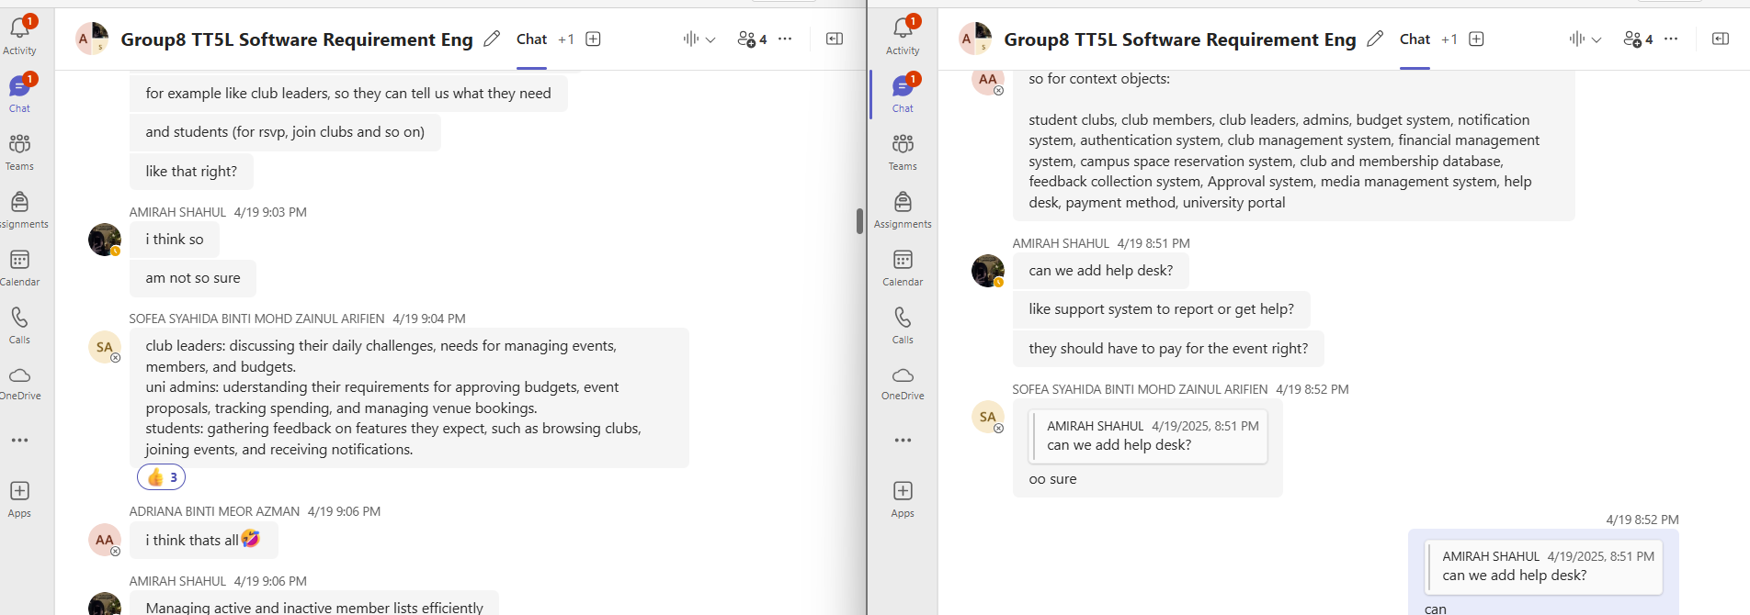

## 1. Context Objects

Context objects are systems, databases, or entities that interact with or influence the system. Identifying these helps us understand integration points and dependencies. Below are the context objects for the Student Club Management System:

|  |  |
| --- | --- |
| Context Object | Description / Role |
| Student club | Main entities using the system to organize activities and manage members. |
| Club member | Users who join clubs and participate in events or activities. |
| Admin | Oversee all clubs, approve events and budgets, and manage overall system governance. |
| Club leaders | Manage their own club's members, events, budgets, and documents. |
| Budget system | Used to submit and review budget proposals and track spending. |
| Authentication system | Verifies user identity for secure login and role-based access. |
| Notification system | Sends announcements, reminders, and updates to users via email or in-app alerts. |
| Club management system | The central platform that integrates all features for club operations. |
| Financial management system | Tracks and audits financial records linked to club expenditures. |
| Campus space reservation system | Allows booking and checking availability of venues for club events. |
| Club and membership database | Stores club profiles, member lists, and related data. |
| Feedback collection system | Gathers user ratings and suggestions after events for improvement. |
| Approval system | Handles the approval workflow for event and budget proposals. |
| Media management system | It stores and displays posters, itineraries, certificates, and other uploaded files. |
| Help desk | Supports users with technical issues or questions about the system. |
| Payment method | Enables or records club-related payments, if applicable. |
| University portal | Acts as a central access point where students can link to the club system. |

## 2. Sources of Requirements

Sources of requirements include stakeholders, documents, and systems that provide input or expectations for system behavior. Below are the identified sources:

|  |  |  |
| --- | --- | --- |
| Context Object | Source (Type) | Explanation |
| Student club | Student affairs division  (Stakeholder) | The Student Affairs Division oversees and recognizes official student clubs. |
| Club member | Registered student list (Document) | The latest registration records that hold all information of current member |
| Admin | Staff (Stakeholder) | They manage the club operation and give approval to any club activities |
| Club leader | High committee list (Documentation) | Document that holds information of current leadership roles |
| Budget system | University budget management system (System) | This system allocates and tracks club budgets and spending. |
| Authentication system | IAM System (System) | This system is used to verify the identity of users that access the club system. |
| Notification system | University notification system (System) | This system is used to send reminders or announcements to the club members or leaders. |
| Club management system | University club management system  (System) | The platform is used to manage club profiles, events, and membership. |
| Financial management system | University financial management system  (System) | Tracks income and expenses for financial reporting. |
| Campus space reservation system | University facility booking system (System) | The system is used to book available venue for club meetings and events |
| Club and membership database | Club and membership database (System) | Database that stores club information and membership data. |
| Feedback collection system | Online survey (System) | Survey to collect feedback from club members and event participants. |
| Approval system | Club request approval system (System) | System that handles approval for club activities, funding, and event proposals. |
| Media management system | University media management system  (System) | System that stores and organizes photos, videos, and digital posters related to club events. |
| Help desk | Student support system (System) | System that manages club-related technical and administrative support requests. |
| Payment method | Online payment gateway system (System) | Facilitates payment for club fees, merchandise, or event tickets. |
| University portal | University main portal (System) | Centralized portal for student services including club access and notifications. |