Successful Order

Here is the initial “inventory” in the database prior to setting up a possible customer order. I have highlight item_id #3 so we can keep track of the changes and the order as it is processed. It is “Dish Sponge (3 Pack)” with a price of $2.49 and quantity of 45.

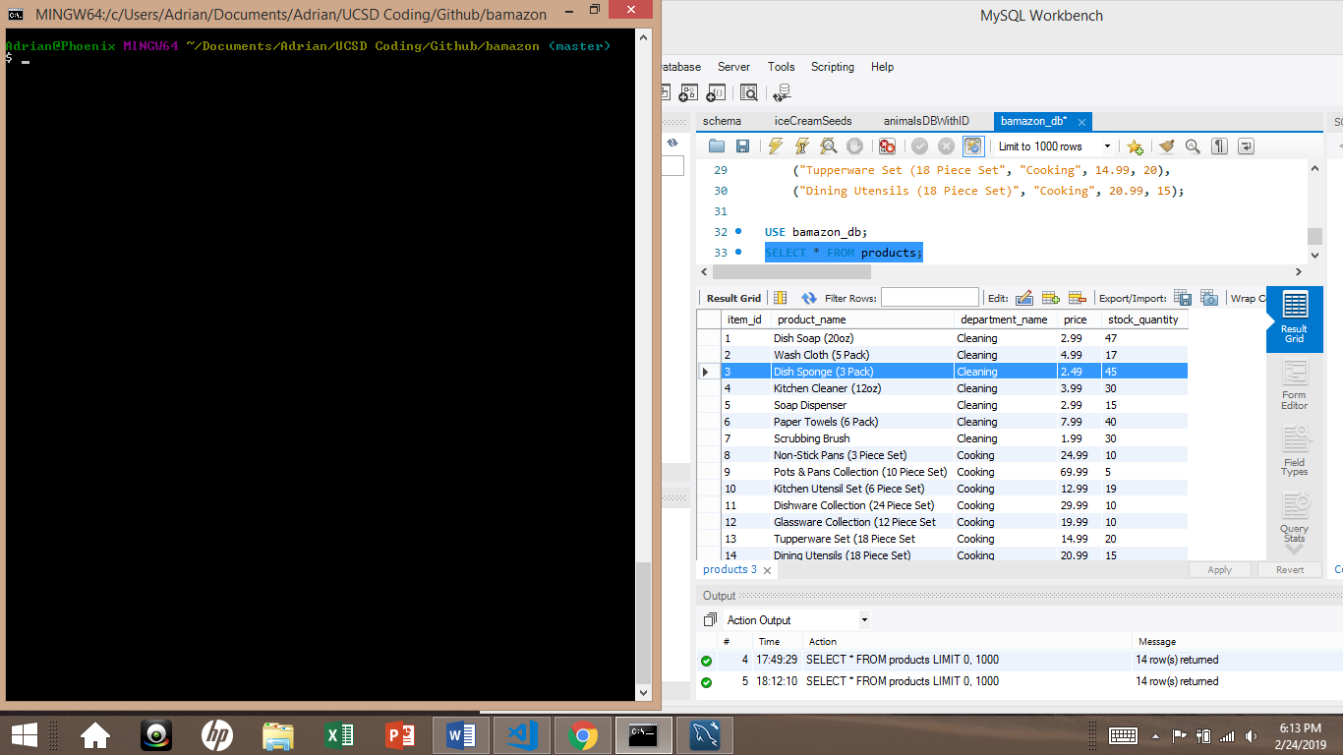

As the file (bamazonCustomer.js) is called, you are welcomed to the ordering database and presented with the items available for purchase.

You are then asked to enter the “Item ID” from the presented table. We will choose item #3 as presented previously.

It will then proceed to ask the “quantity” you would like to purchase. We will purchase 5 of this item. Once you hit enter to finalize the quantity, it will process the order if there is enough inventory.

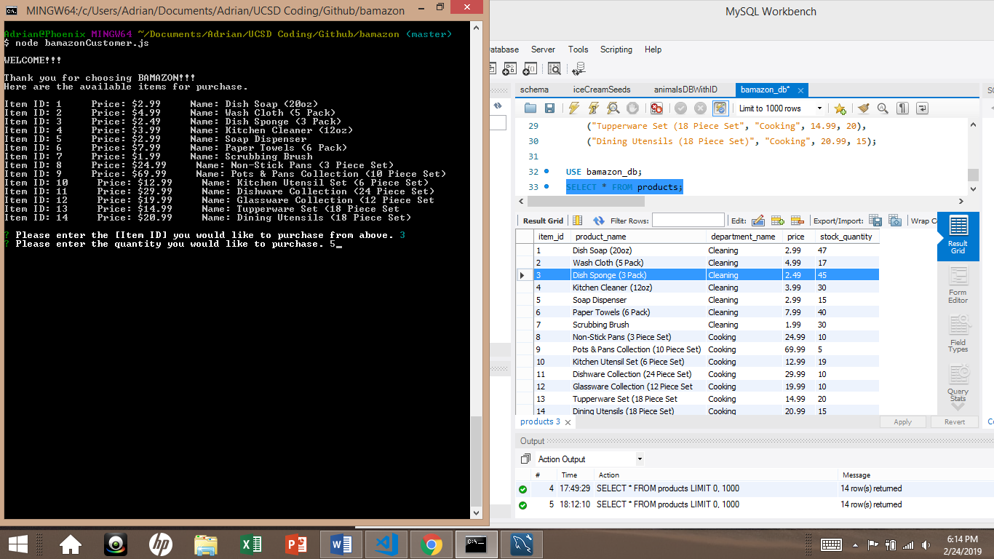

In this situation, there is enough inventory available since we have established there was previously 45 in stock prior to the order. It confirms our order of “item #3 – Dish Sponge (3 pack)” and we wanted 5 of them. Now that the order has been processed, it shows the total of $12.45 since they were $2.49 each. It confirms the order has been placed, and it thanks you for your purchase.

As you can see the inventory was also updated. It went from showing the original 45 in stock down to now 40 since 5 were purchased.

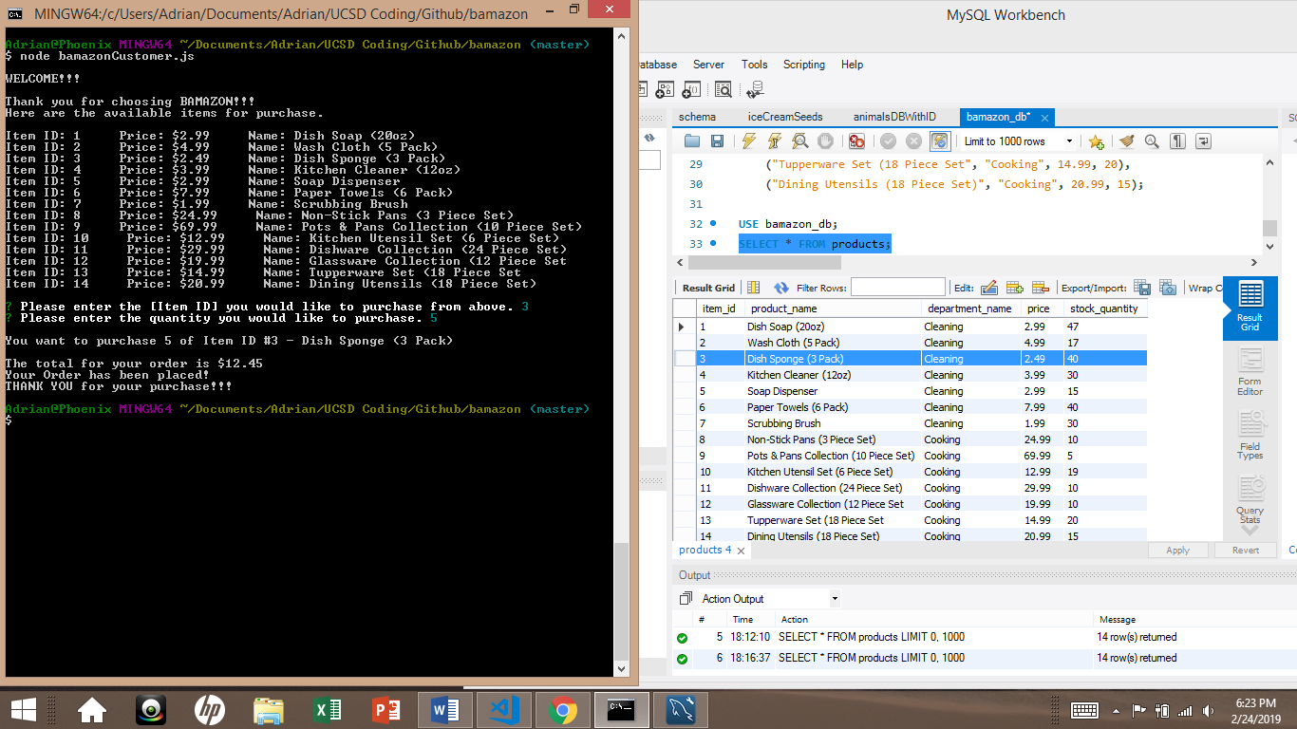

See below for a rejected order due to insufficient inventory.

.

.

.

.

.

.

.

.

.

.

.

Insufficient Inventory

For the sake of running the database and having insufficient inventory, you will see below that it will tell you that you are trying to order more than is available. It will tell you there is not enough in stock and show you the amount you are able to purchase at this time. It will then return the previous prompt so you can modify your order appropriately.

For this example, I used the same item #3 as ordered previously but requested 1000 quantity. We already know there was only 40 available, so we would get the rejected order and be asked to modify our order.

