**Liri Node App**

Screenshot #1: Using Bands In Town API

Using the “concert-this” command followed by the band/artist name returns up to 10 upcoming concerts/events for that particular band/artist. It details the “venue,” “location,” and “date” of the event. (Note: quotes are not needed around the search command and artist/band name)

In the example below, we are using “concert-this” and the artist/DJ “zedd” . It returns the following results. The cmd window is on the left and the code is on the right.

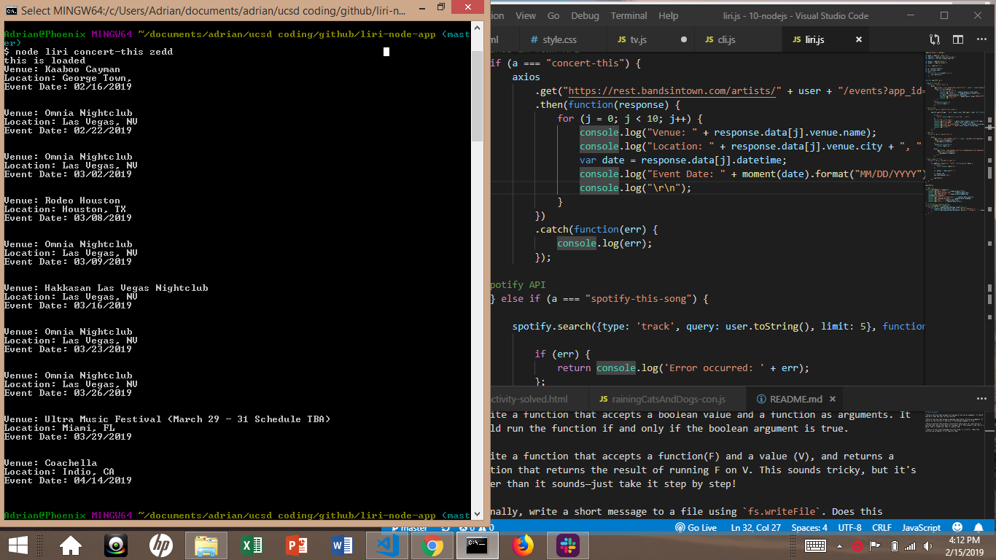

.

.

.

.

.

.

.

.

.

.

.

.

.

.

.

.

Screenshot 2: Using Spotify API

The next command “spotify-this-song” followed by the song title you are searching will return up to 5 songs that match your search. If shows the “artist,” “track/song name,” “a link for you to preview the song on your browser,” and the “album” the song is from. (Note: quotes are not needed around the search command and song)

In this example, we searched “spotify-this-song” “never gonna give you up”

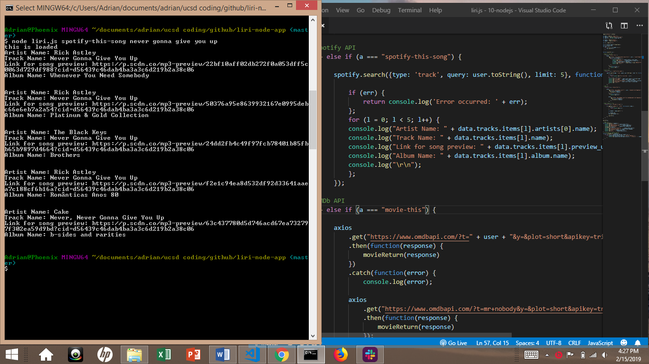

By default, if no song is provide. Ace Of Base – “The Sign” info is provided.

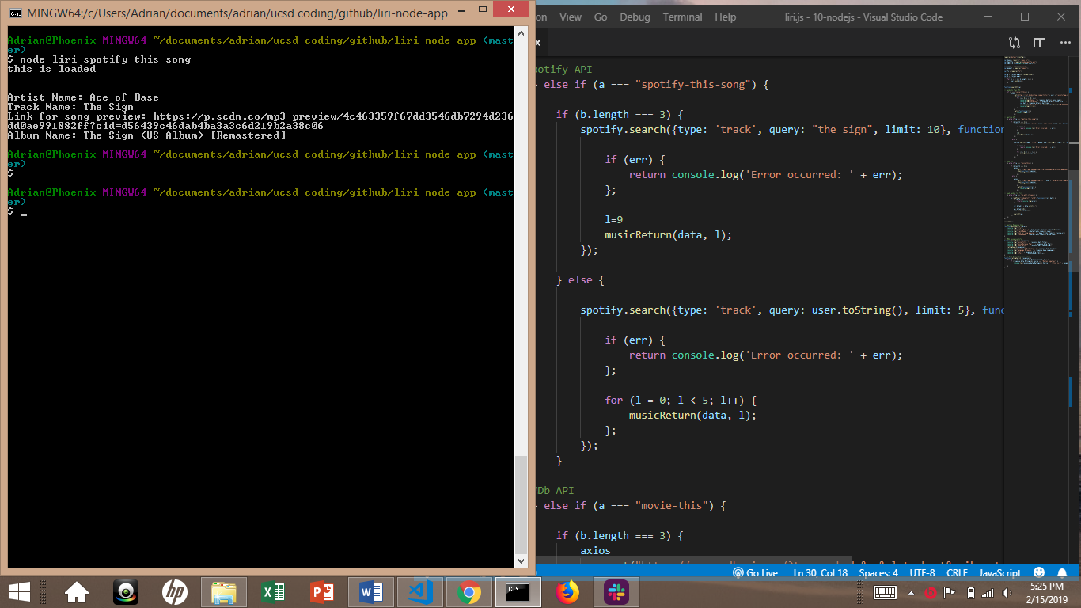

Screenshot #3: Using the IMDb API

By entering the “movie-this” command followed by the movie title you want to search, it will return that movie with it’s “movie title,” “release date,” “imdb rating,” “rotten tomatoes rating (if available),” “country it was produced in,” “languages it was released in,” “a plot summary,” and “the starring cast.” (Note: quotes are not needed around the search command and movie)

In this example we searched “movie-this” and “the matrix” return all the movie info listed above.

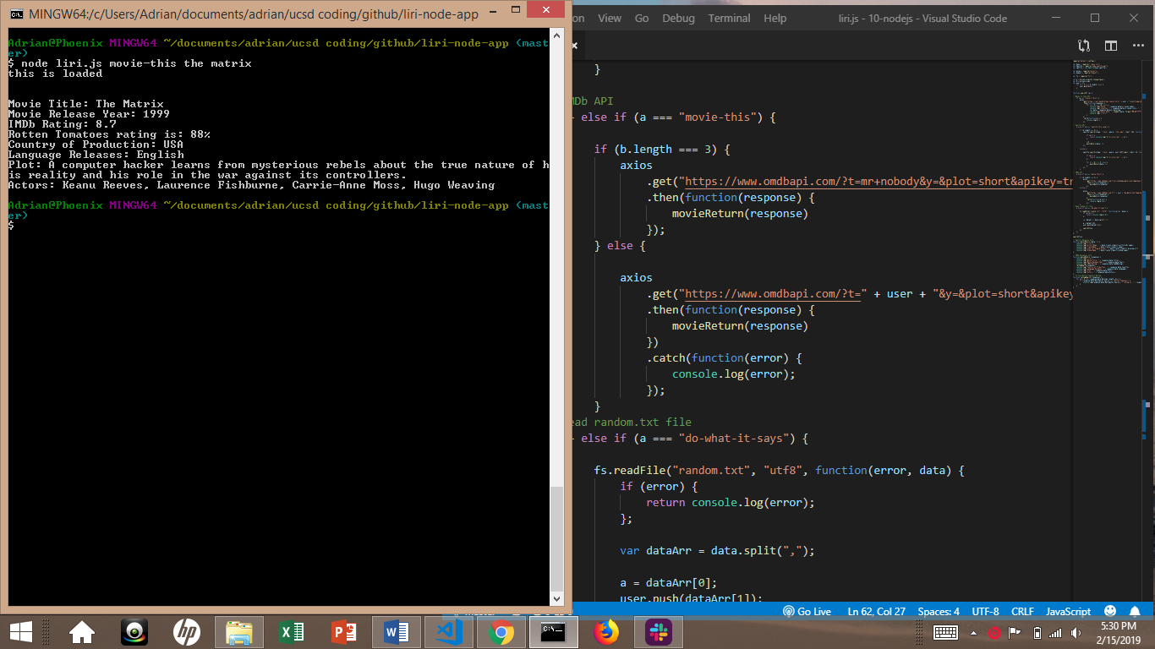

By default, if no movie name is provided “Mr. Nobody” movie info is returned.

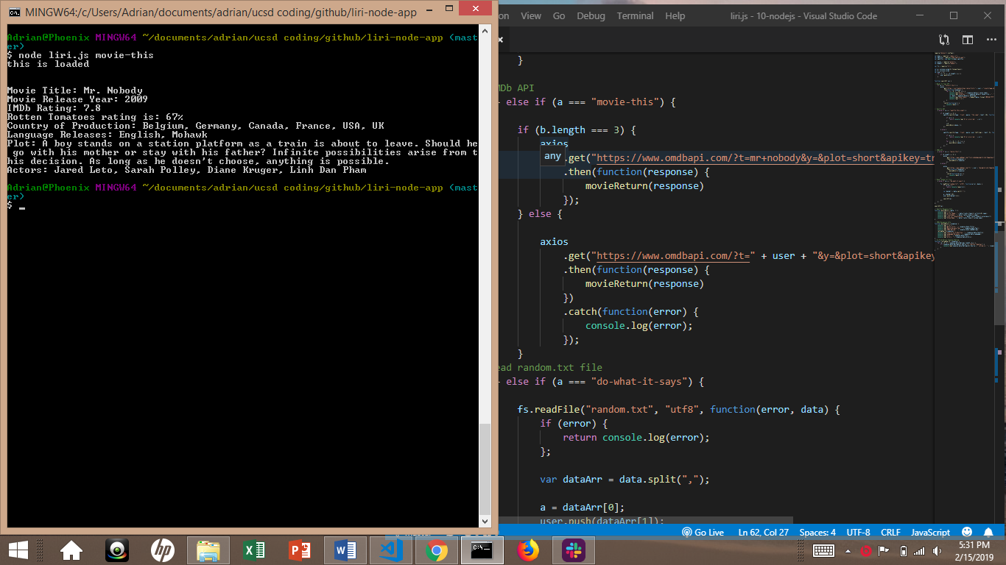

Screenshot #4: Reading a Text File to run one of the above three commands

In this case, the text file being read wants to “spotify-this-song, ‘I want it that way’”. By using the “do-what-it-says” command, it does what the text file literally says. We get returned, the spotify search of “I want it that way.” We get 5 songs returned that could be a match for what it is looking for.

