Pathlib
Table of Contents
installation 1
Import 1
Creating Paths (The Setup) 1
Reading the Path (The "Parts") 2
What can it do 2
Check things 2
Write /read 2
Check for folder / file if exists 3
File searching (Globbing) 3
Move / rename/delete 4
Useful Edge Cases 5

installation
Since pathlib is built into Python, you don't need to install it

Import
from pathlib import Path

Creating Paths (The Setup)
Think of the / symbol as the "glue" that joins folders together safely.
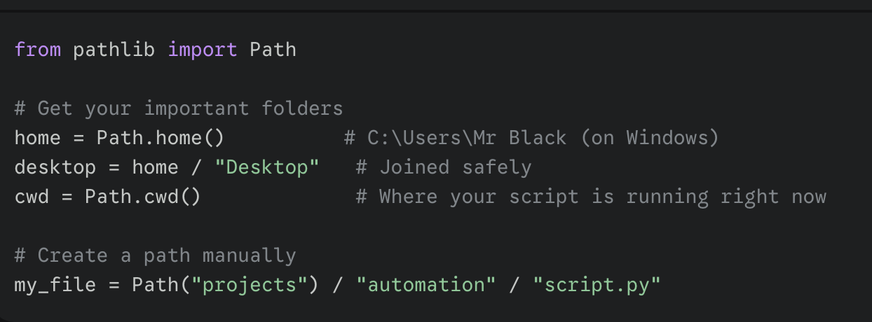

# save the screenshot to images folder in the project root
output_path = Path(__file__).parent.parent / "images" / file_name

Path(__file__)
- __file__ is a built-in Python variable that holds the absolute path to the script you are currently running (in this case, capture_element.py).
- Wrapping it in Path() turns that string into a "smart" object that understands folders and parents.

.parent.parent
- .parent: This moves one folder up (the directory where capture_element.py lives).
- .parent (again): This moves another folder up.
- Based on your error message earlier, if your file is in .../utils/capture_element.py, the first .parent takes you to utils, and the second one takes you to my_packages.

Reading the Path (The "Parts")
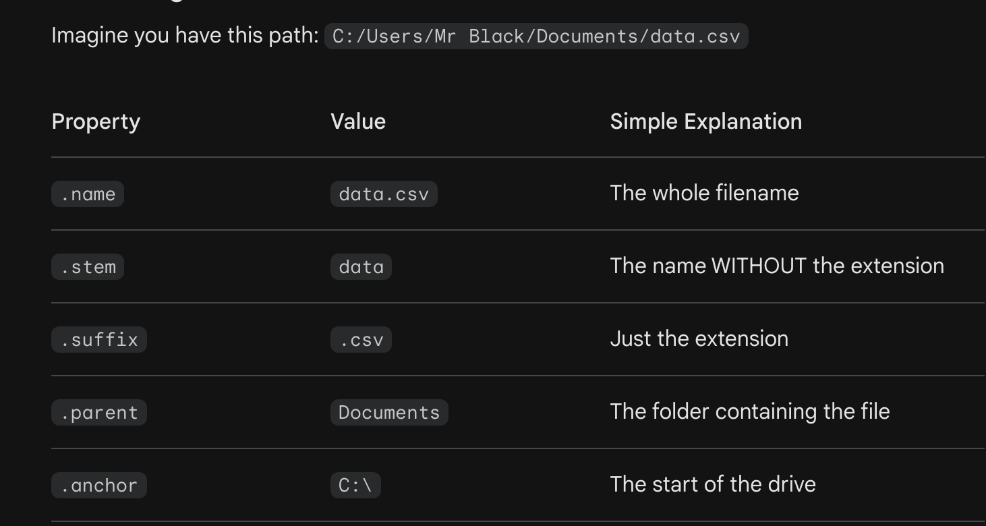

What can it do

Check things
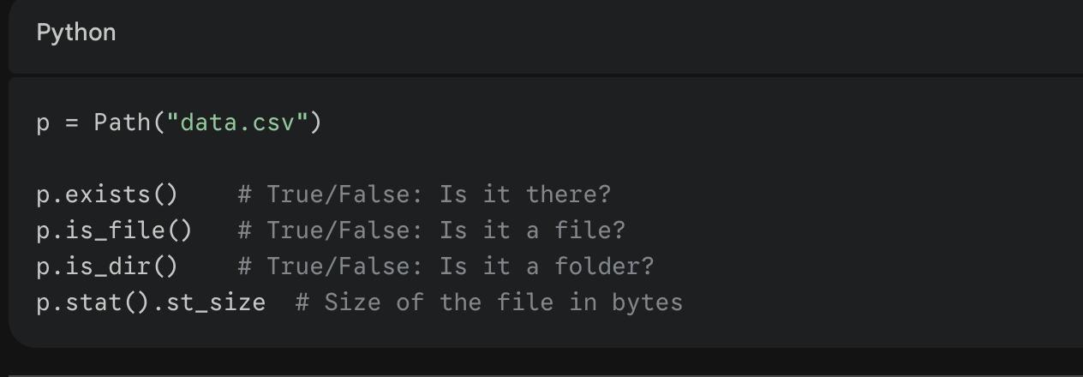

Write /read
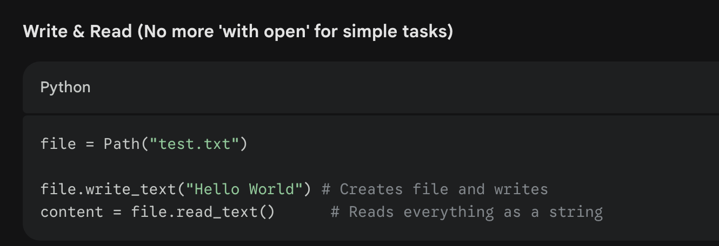
Check for folder / file if exists
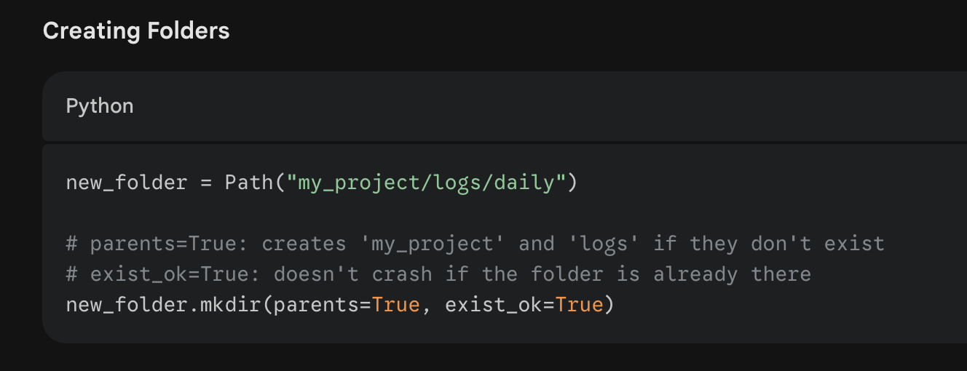

File searching (Globbing)
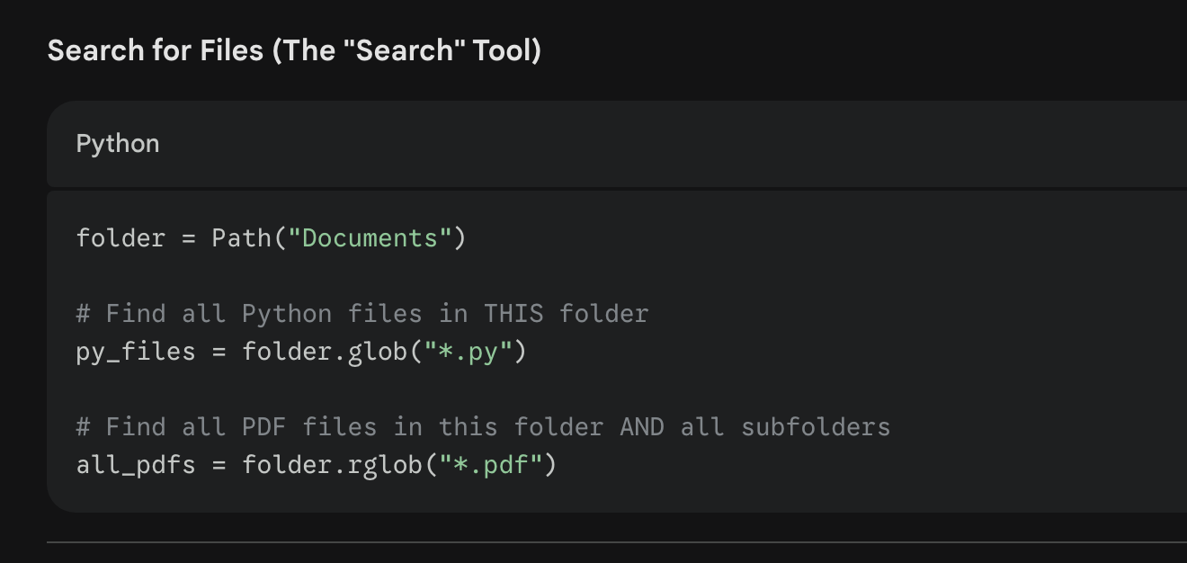

Move / rename/delete
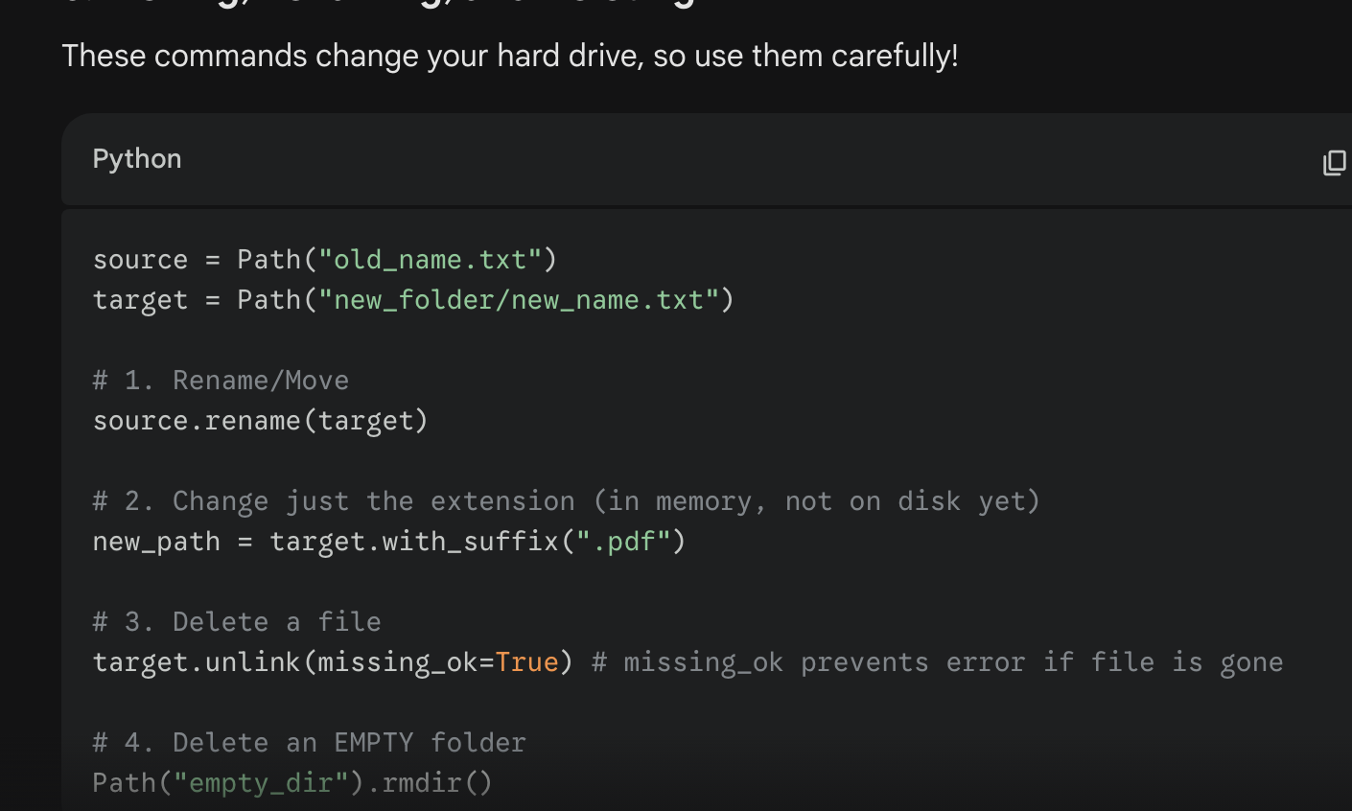

Useful Edge Cases
