Selenium

Table of Contents
1.Installation & Environment 1
2. The "Essentials" Imports 1
3. Deep Dive: Arguments & Startup 2
4. Deep Dive: Locators & Finders 2
The "Big Three" Strategies 2
Finding vs. Collecting 2
5. Timing 4
6. Information & Navigation 6
7. Cookies & Cache (Session Memory) 7
8. Frames & Iframes 8
9. Deep Dive: JavaScript (The Backdoor) 9
10. Stealth Mode 10
11. Taking Screenshots 10

1.Installation & Environment
uv add selenium selenium-stealth # specialized "plugin" or helper for Selenium designed to prevent bot detection.

2. The "Essentials" Imports
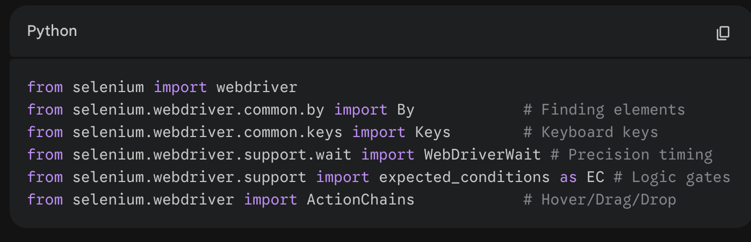

3. Deep Dive: Arguments & Startup
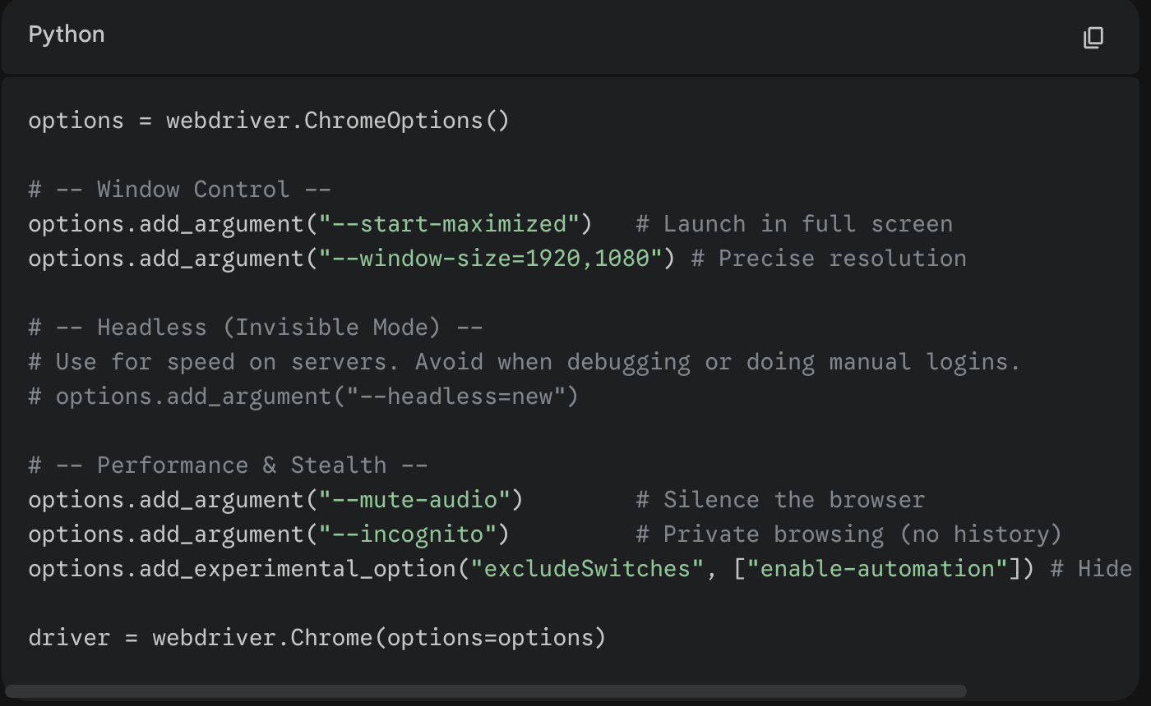
options.add_experimental_option("excludeSwitches", ["enable-automation"]) # Hide 'bot' banner

4. Deep Dive: Locators & Finders
Locators are the "coordinates" you use to find a specific target.

The "Big Three" Strategies
- ID: The fastest. Use it if it exists. driver.find_element(By.ID, "login_button")
- CSS Selector: The most flexible for modern apps (React/Vue). driver.find_element(By.CSS_SELECTOR, "button.primary[type='submit']")
- XPath: Use for text-based searches or navigating "up" to a parent. driver.find_element(By.XPATH, "//div[contains(text(), 'Account Settings')]")

Finding vs. Collecting
- .find_element(...): Returns a single object. Throws error if not found.
- .find_elements(...): Returns a list. Returns an empty list [] if not found (good for checking if an element exists without crashing).
- 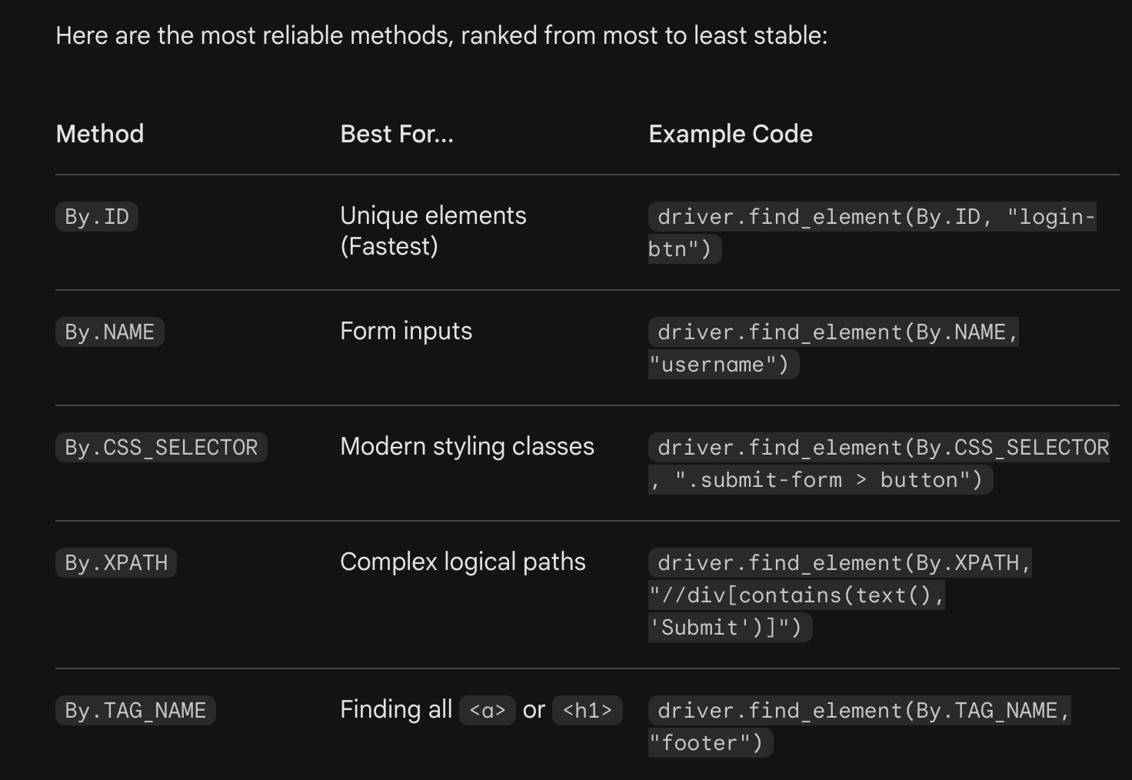

5. Timing
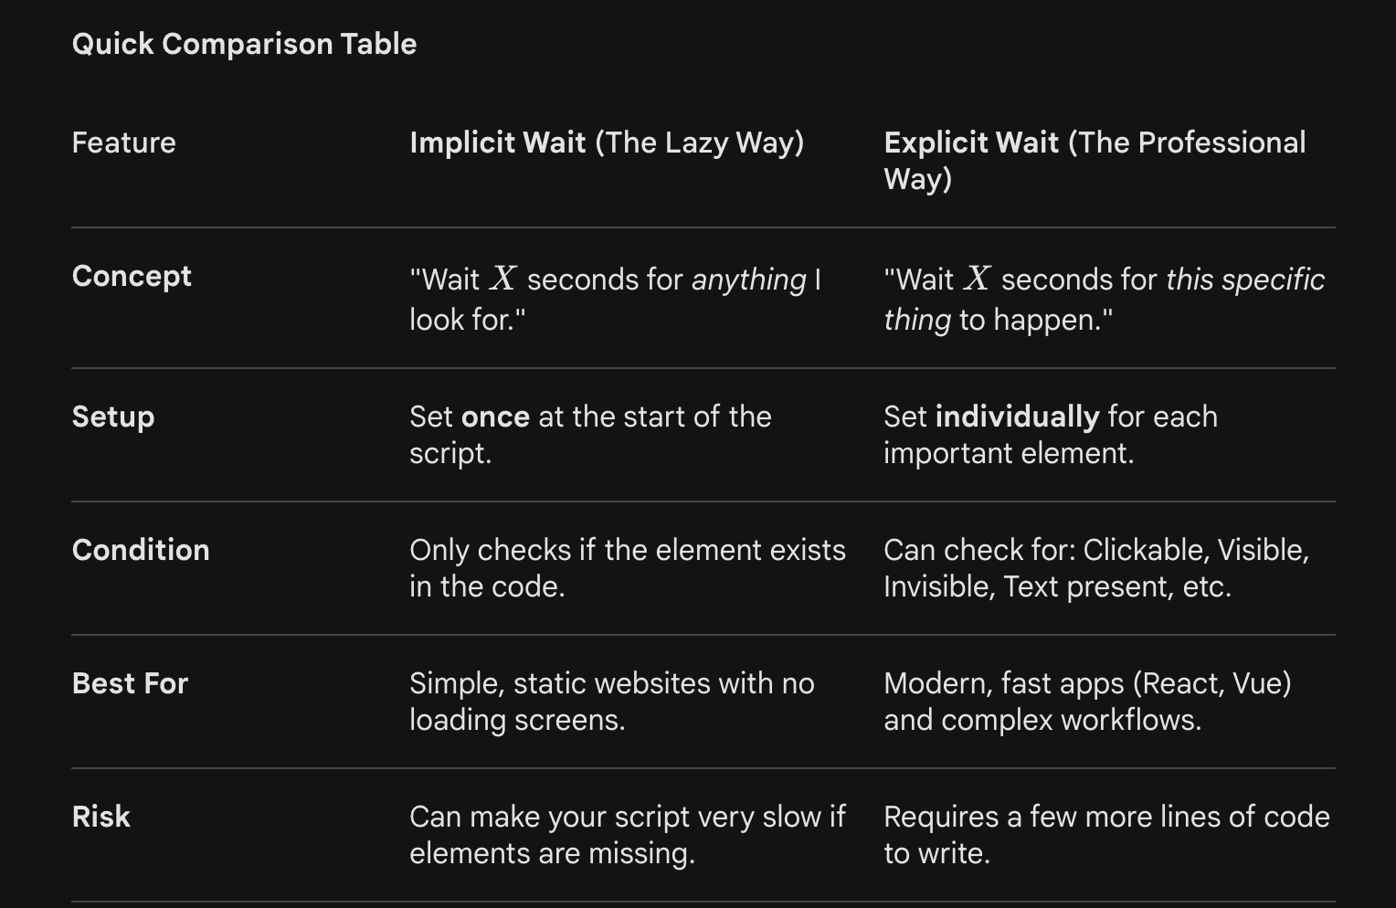
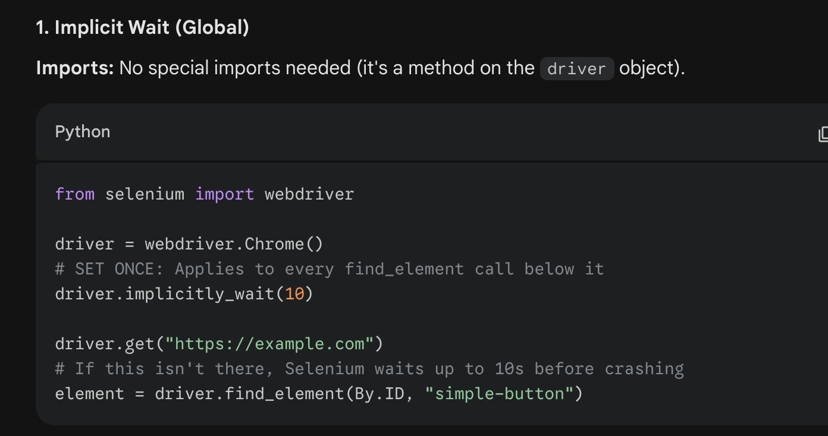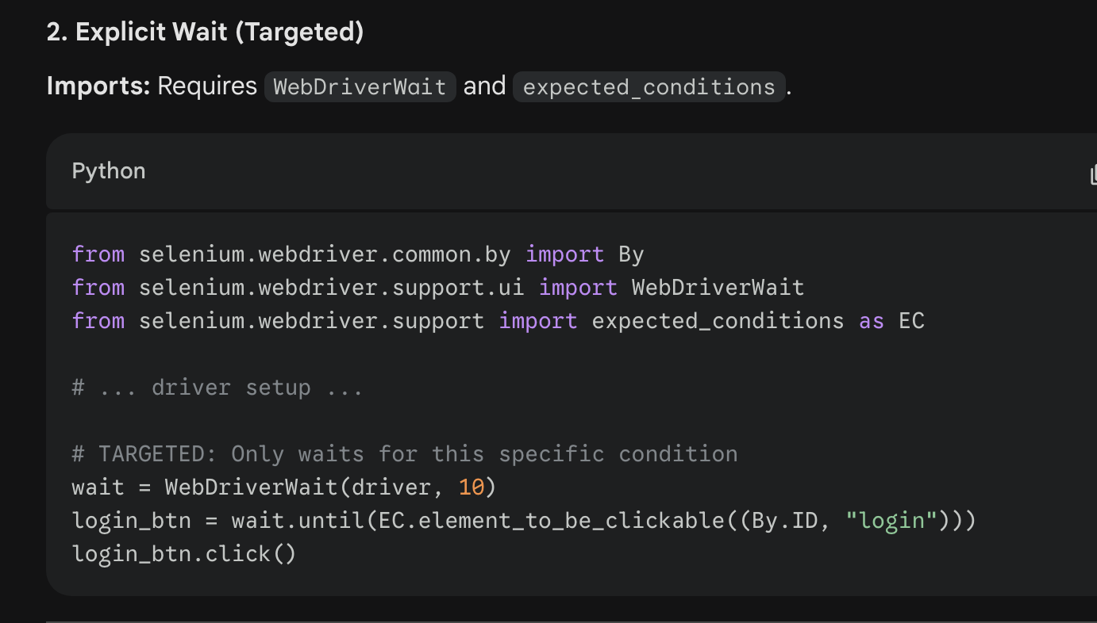

6. Information & Navigation
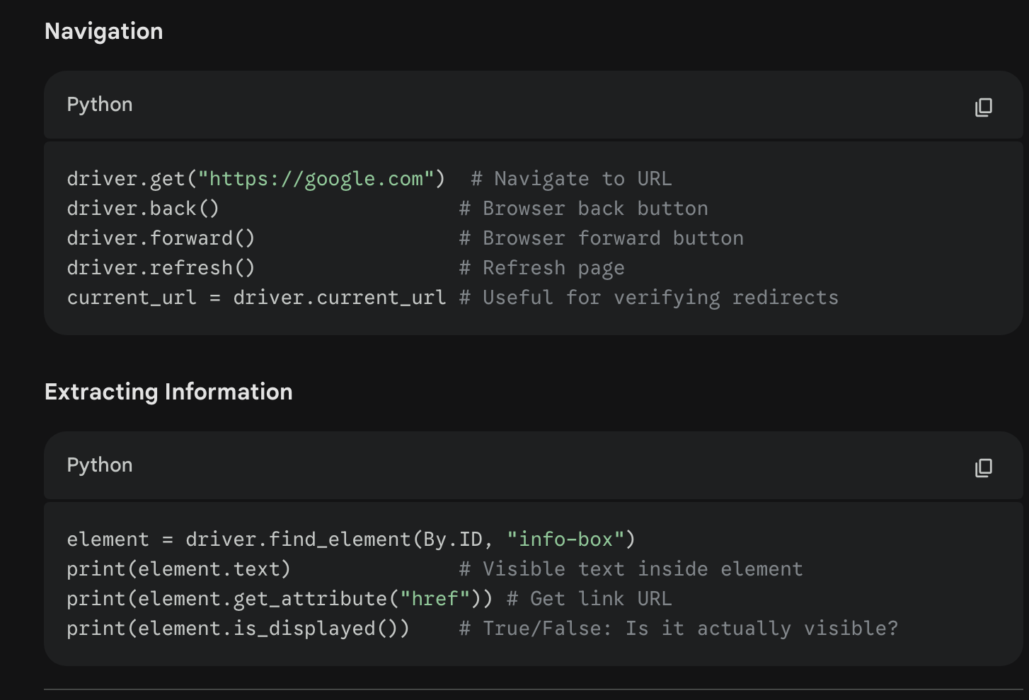

7. Cookies & Cache (Session Memory)
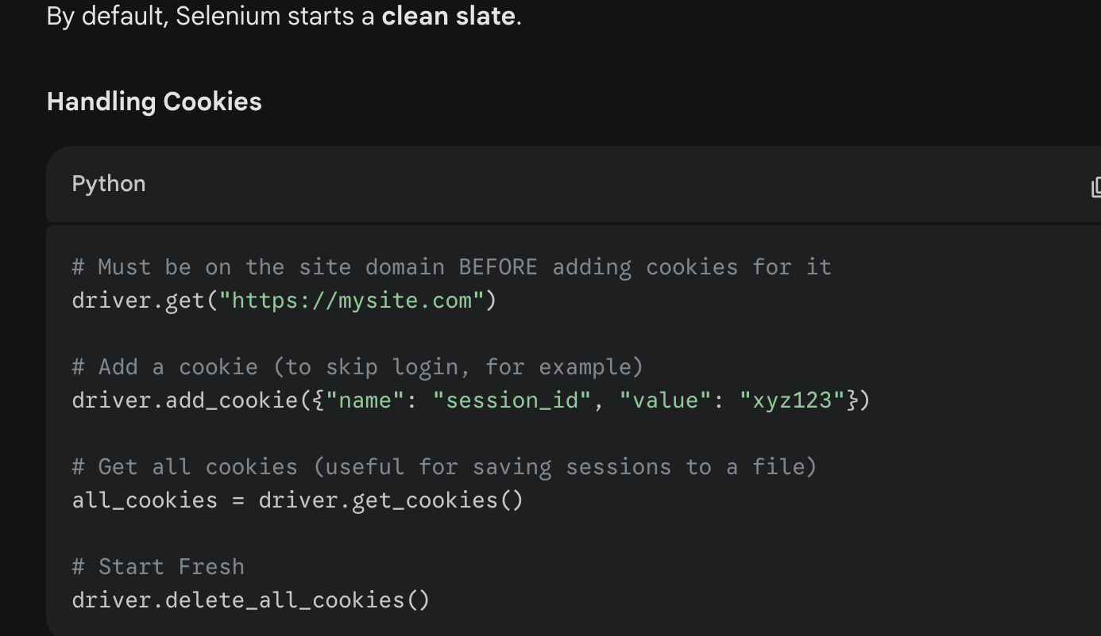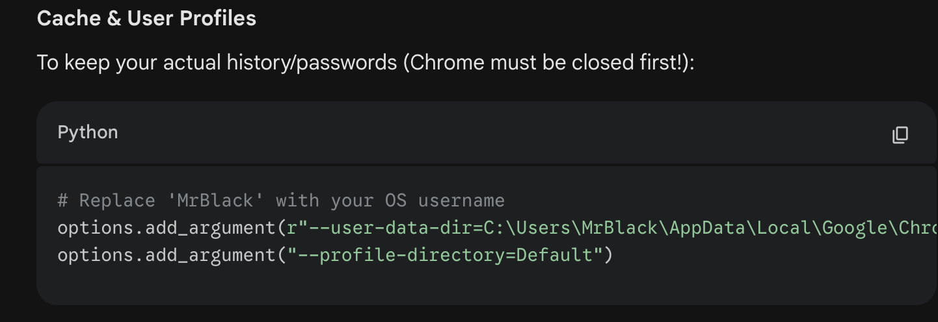

8. Frames & Iframes
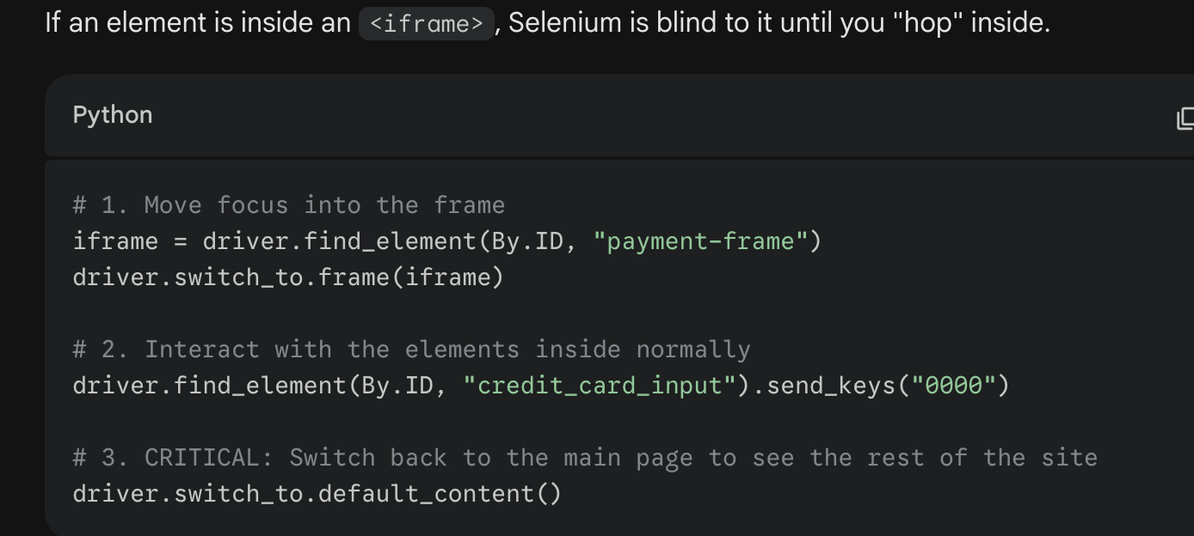

9. Deep Dive: JavaScript (The Backdoor)
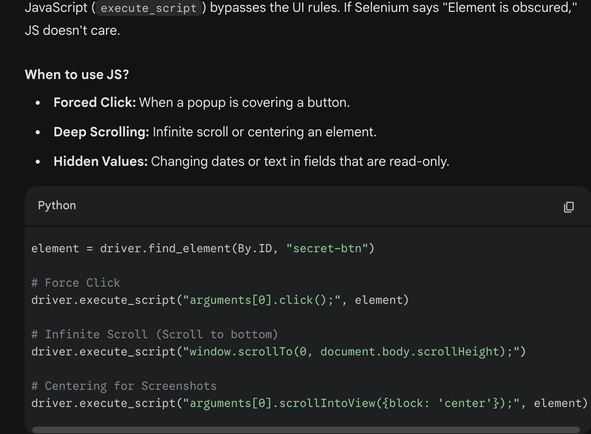

10. Stealth Mode
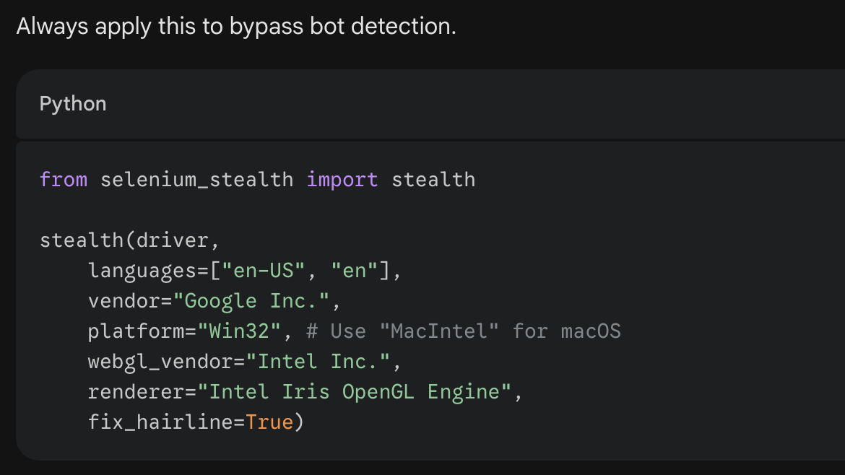

11. Taking Screenshots
