DOCUMENTATION

ASSIGNMENT #1

STUDENT NAME: Bărăian Adrian-Călin
GROUP: 30422

CONTENTS

1. Assignment Objective 3
2. Problem Analysis, Modeling, Scenarios, Use Cases 4
3. Design 5
4. Implementation 12
5. Results 20
6. Conclusions 23
7. Bibliography 23

Assignment Objective
Main Objective

- Implementation of a Polynomial Calculator with a dedicated GUI through which a user can insert polynomials and can perform the following operations: addition, subtraction, multiplication, division, calculating the derivative of a polynomial, integration.
Sub-objectives
- Analyze the problem and identify requirements;
- Design the polynomial calculator;
- Implement the polynomial calculator;
- Test the polynomial calculator.

Problem Analysis, Modeling, Scenarios, Use Cases

Use Cases
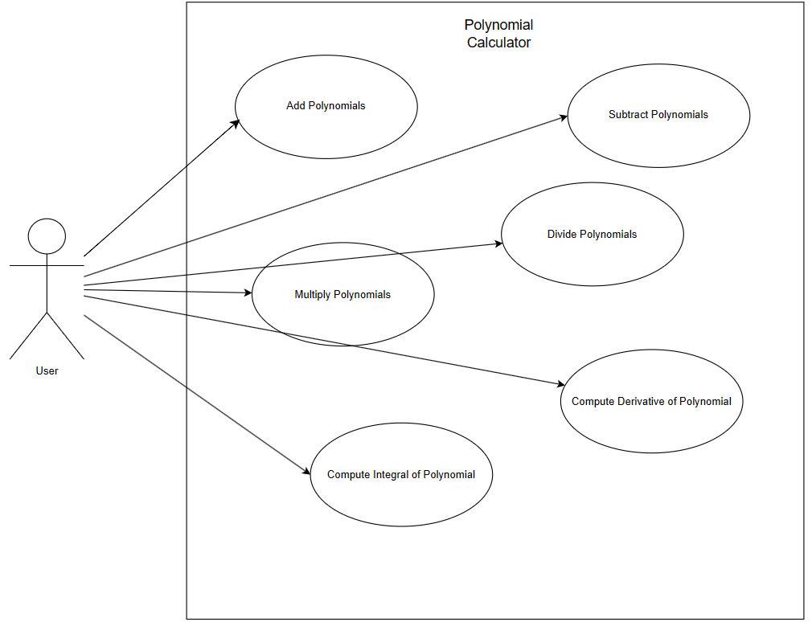
Figure 1. Use Case Diagram

- Use Case: Add Polynomials
Primary Actor: User
Main Success Scenario:
    - The user correctly inserts the 2 polynomials in the graphical user interface
    - The user selects the “addition” operation
    - The user clicks on the “Compute” button
    - The polynomial calculator performs the addition of the two polynomials and displays the result
Alternative Sequence: Incorrect polynomials
- The user inserts incorrect polynomials (with respect to the format)
- The scenario returns to step 1

- Use case: Subtract polynomials
Primary Actor: User
Main Success Scenario:
    - The user correctly inserts the 2 polynomials in the graphical user interface
    - The user selects the “subtraction” operation
    - The user clicks on the “Compute” button
    - The polynomial calculator performs the subtraction of the two polynomials and displays the result

Alternative Sequence: Incorrect polynomials
- The user inserts incorrect polynomials (with respect to the format)
- The scenario returns to step 1

- Use Case: multiply polynomials
Primary Actor: User
Main Success Scenario:
- The user correctly inserts the 2 polynomials in the graphical user interface
- The user selects the “multiplication” operation
- The user clicks on the “Compute” button
- The polynomial calculator performs the multiplication of the two polynomials and displays the result
Alternative Sequence: Incorrect polynomials
- The user inserts incorrect polynomials (with respect to the format)
- The scenario returns to step 1

- Use Case: divide polynomials
Primary Actor: User
Main Success Scenario:
- The user correctly inserts the 2 polynomials in the graphical user interface
- The user selects the “division” operation
- The user clicks on the “Compute” button
- The polynomial calculator performs the division of the two polynomials and displays the result
Alternative Sequence: Incorrect polynomials
-The user inserts incorrect polynomials (with respect to the format)
-The scenario returns to step 1

- Use case: compute derivative of polynomial
Primary Actor: User
Main Success Scenario:
- The user correctly inserts the “First Polynomial” and inserts a valid format polynomial in the “Second Polynomial” in the graphical user interface
- The user selects the “derivative” operation
- The user clicks on the “Compute” button
- The polynomial calculator computes the derivative of the “First Polynomial” and displays the result
Alternative Sequence: Incorrect polynomials
-The user inserts incorrect polynomials (with respect to the format)
-The scenario returns to step 1

- Use case: compute integral of polynomial
Primary Actor: User
Main Success Scenario:
- The user correctly inserts the “First Polynomial” and inserts a valid format in the “Second polynomial” in the graphical user interface
- The user selects the “integrate” operation
- The user clicks on the “Compute” button
- The polynomial calculator computes the integral of the “First Polynomial” and displays the result
Alternative Sequence: Incorrect polynomials
-The user inserts incorrect polynomials (with respect to the format)
-The scenario returns to step 1

Functional Requirements
- Polynomial Representation:
- Allow for user input of polynomials in a standard form (coeff * x ^ power +- free term );
- Display the polynomials in a standard form which is clear and understandable.
- Perform basic operations:
- The calculator should be able to perform the addition of two polynomials;
- The calculator should be able to perform the subtraction of two polynomials;
- The calculator should be able to perform the multiplication of two polynomials;
- The calculator should be able to perform the division of the first polynomial to the second polynomial;
- The calculator should be able to compute the derivative of the first polynomial;
- The calculator should be able to compute the integral of the first polynomial.
Non-Functional Requirements
- Intuitiveness:
  - The GUI should be intuitive and easy to use by the user;
- Stability:
  - The calculator should be stable and reliable;
- Input validation:
  - The calculator should validate user inputs to prevent erroneous calculations.

Design
Level 1: Overall System Design

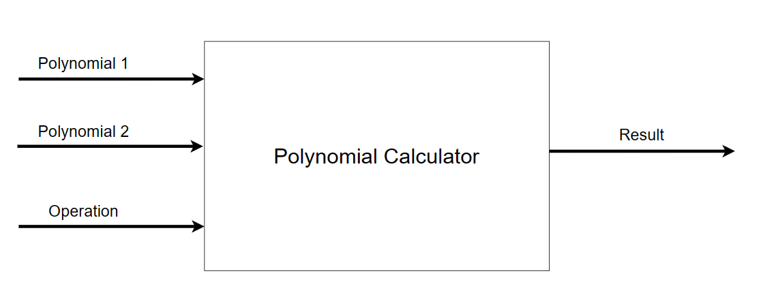
Figure 2. Block Diagram of the Application

Level 2: Division into sub-systems/packages
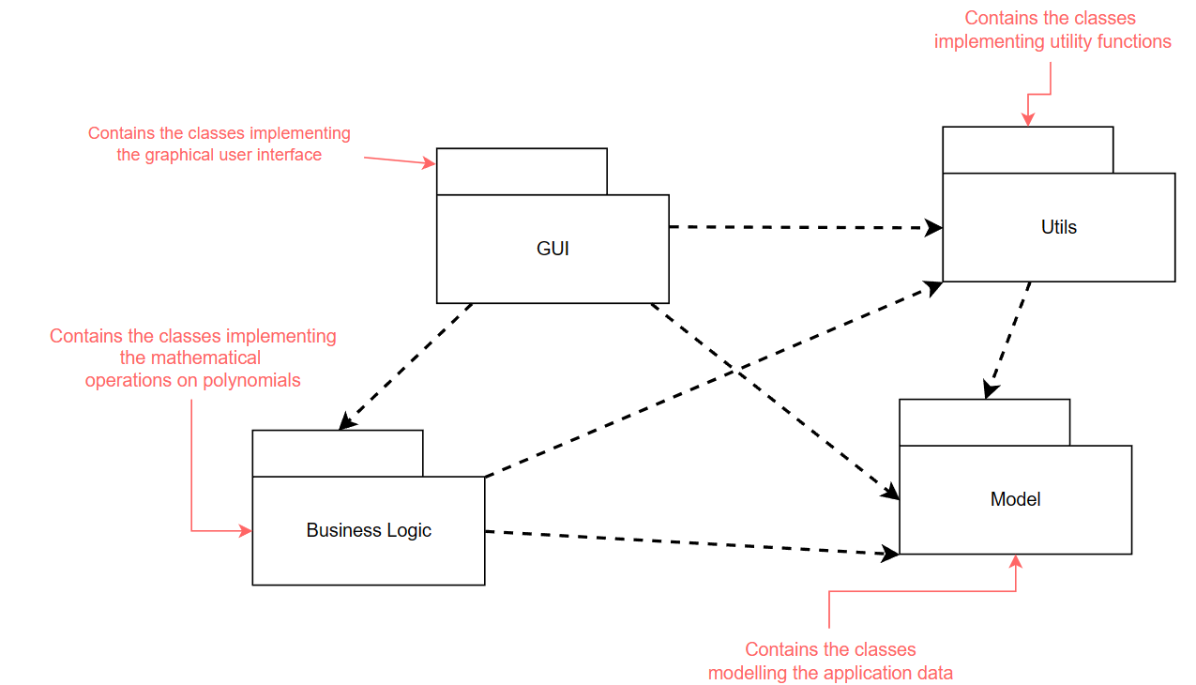
Figure 3. Package Diagram of the Application

Level 3: Division into classes
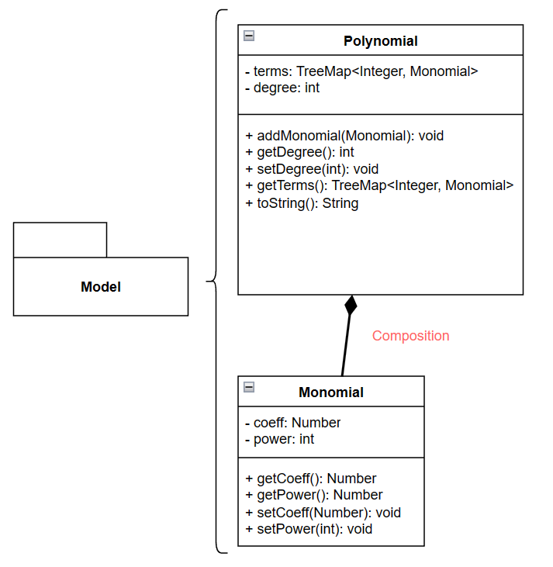

Figure 4. Classes Of Model Package
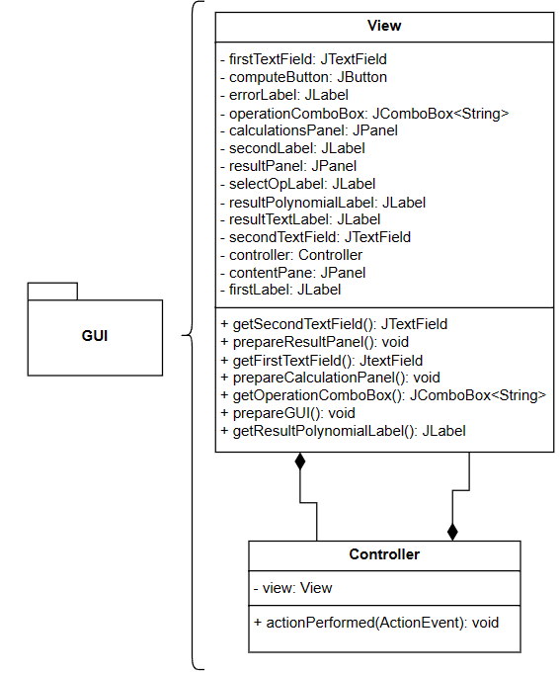
Figure 5. Classes Of GUI Package

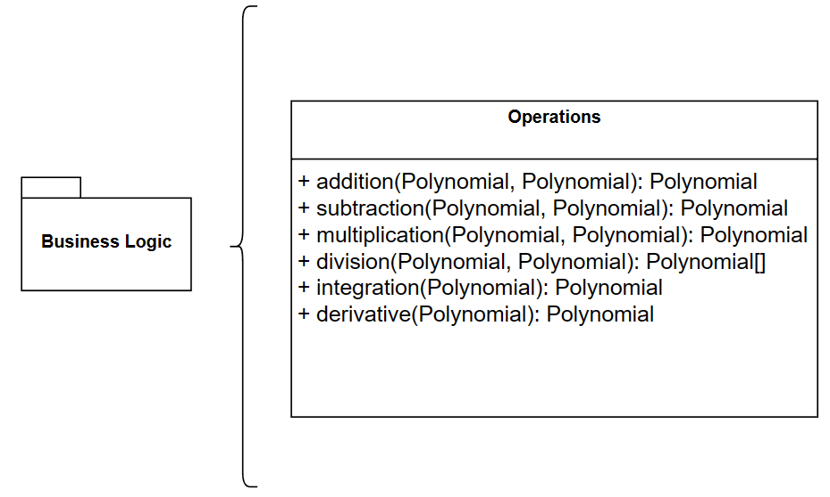
Figure 6. Classes Of Business Logic Package

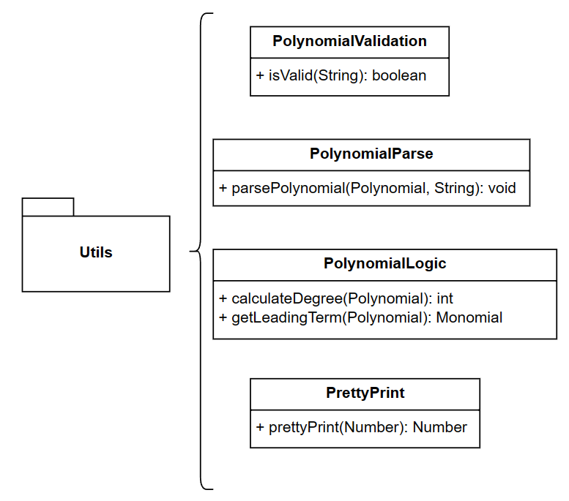
Figure 7. Classes of Utils Package
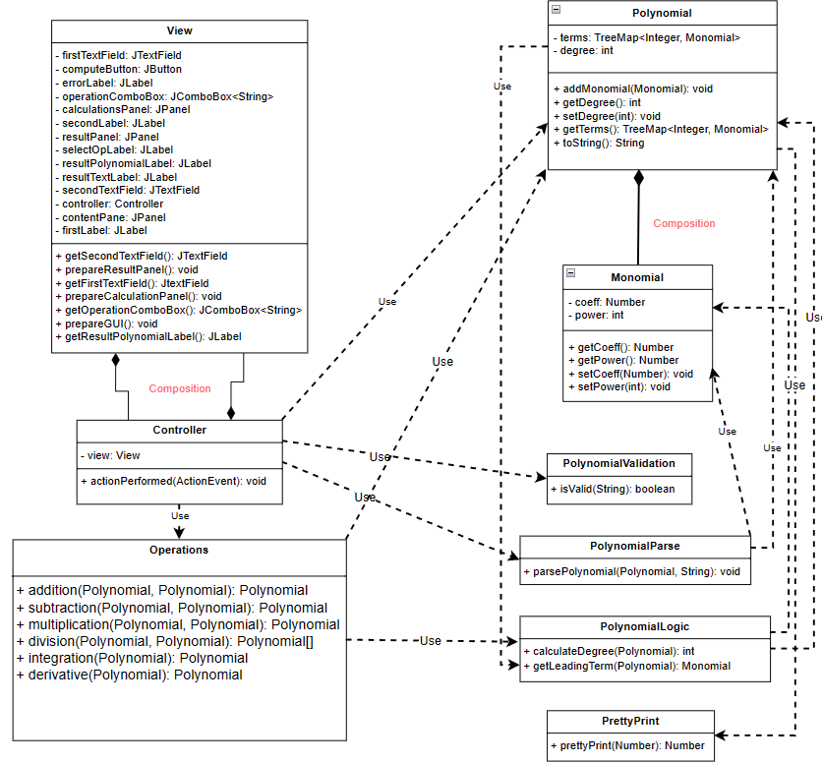
Figure 8. Class Diagram of the Application

Data Structures used: TreeMap, for the implementation of the polynomial structure, in which each key is represented by the power of a monomial and each entry is the Monomial object.

The reason why I chose TreeMap is the easiness of implementing all the polynomial mathematical operations as well as the printing given the fact that a TreeMap is ordered by key value.

Implementation
- Monomial Class:
Fields:
- - coeff: Number (the coefficient of a monomial. Integer for input polynomials but can be double type for the polynomial result);
- - power: int (the power of the monomial).
Public Methods:
- Getters for the coeff and power fields (used for obtaining the data stored in the private fields coeff and power);
- Setters for the coeff and power fields (used to set data to the private fields coeff and power).

- Polynomial Class:
Fields:
- - terms: TreeMap<Integer, Monomial> (Ordered Map by key <<power>> in which we store each monomial part of a certain polynomial)
- - degree: int (degree of the polynomial)
Public Methods:
- + addMonomial(Monomial): void (Method for adding a monomial to the terms field of the polynomial class)
- Getters for the terms and degree fields (used to get the reference to the private terms map and the data from the private degree field)
- Setter for degree (used to set data to the private field degree)
- Overriding of the toString method for the polynomial format.
- Operations Class:
No Fields
Public Methods:
- + addition(Polynomial p1, Polynomial p2): Polynomial (Method that implements the addition of two polynomials. First, we add the terms of the first polynomial with the common terms from the second polynomial if they exist, if not we place the term from the first polynomial. Then we complete with the remaining terms of the second polynomial that haven’t yet been added)

- public static Polynomial addition(Polynomial p1, Polynomial p2) {
Polynomial result = new Polynomial();
for (Map.Entry<Integer, Monomial> entry : p1.getTerms().entrySet()) {
result.addMonomial(new Monomial(entry.getValue().getCoeff().floatValue() + ((p2.getTerms().get(entry.getKey()) != null) ? p2.getTerms().get(entry.getKey()).getCoeff().floatValue() : 0), entry.getValue().getPower()));
}
for (Map.Entry<Integer, Monomial> entry : p2.getTerms().entrySet()) {
if (!result.getTerms().containsKey(entry.getValue().getPower())) {
result.addMonomial(new Monomial(entry.getValue().getCoeff().floatValue(), entry.getValue().getPower()));
}
}
result.setDegree(PolynomialLogic.calculateDegree(result));
return result;
}

- + subtraction(Polynomial p1, Polynomial p2): Polynomial (Method that implements the subtraction of two polynomials. Similar to the addition method, we first subtract the common terms and put them in the resulting polynomial. Then iterating through the terms that haven’t yet been added from the second polynomial, we place them in the resulting polynomial but with negative sign)

- public static Polynomial subtraction(Polynomial p1, Polynomial p2) {
Polynomial result = new Polynomial();
for (Map.Entry<Integer, Monomial> entry : p1.getTerms().entrySet()) {
result.addMonomial(new Monomial(entry.getValue().getCoeff().floatValue() - ((p2.getTerms().get(entry.getKey()) != null) ? p2.getTerms().get(entry.getKey()).getCoeff().floatValue() : 0), entry.getValue().getPower()));
}
for (Map.Entry<Integer, Monomial> entry : p2.getTerms().entrySet()) {
if (!result.getTerms().containsKey(entry.getValue().getPower())) {
result.addMonomial(new Monomial((-1) * entry.getValue().getCoeff().floatValue(), entry.getValue().getPower()));
}
}
result.setDegree(PolynomialLogic.calculateDegree(result));
return result;
}

- + multiplication(Polynomial p1, Polynomial p2): Polynomial (Method that implements the multiplication of two polynomials. Iterating through the terms map of the first polynomial, we multiply each monomial with each monomial of the second polynomial. At each multiplication between terms we could obtain a term with a power <<key>> that doesn’t yet exist in the result, thus we just place it in the result polynomial, or we obtain a term with a power <<key>> that has already been obtained before, thus we will add the coefficients of this term s in the resulting polynomial)

- public static Polynomial multiplication(Polynomial p1, Polynomial p2) {
Polynomial result = new Polynomial();
for (Map.Entry<Integer, Monomial> entry1 : p1.getTerms().descendingMap().entrySet()) {
for (Map.Entry<Integer, Monomial> entry2 : p2.getTerms().descendingMap().entrySet()) {
if (result.getTerms().containsKey(entry1.getValue().getPower() + entry2.getValue().getPower())) {
result.addMonomial(new Monomial(entry1.getValue().getCoeff().floatValue() * entry2.getValue().getCoeff().floatValue() + result.getTerms().get(entry1.getValue().getPower() + entry2.getValue().getPower()).getCoeff().floatValue(), entry1.getValue().getPower() + entry2.getValue().getPower()));
} else {
result.addMonomial(new Monomial(entry1.getValue().getCoeff().floatValue() * entry2.getValue().getCoeff().floatValue(), entry1.getValue().getPower() + entry2.getValue().getPower()));
}
}
}
result.setDegree(PolynomialLogic.calculateDegree(result));
return result;
}

- + derivative(Polynomial p): Polynomial (Method that implements the computation of the derivative of a polynomial. Considering the steps of obtaining the derivative, first multiplying the coefficient with the power, then decreasing the power of the monomial, we will do this to each term in terms map and add them to the result polynomial)

- public static Polynomial derivative(Polynomial p) {
Polynomial result = new Polynomial();
for(Map.Entry<Integer, Monomial> entry : p.getTerms().descendingMap().entrySet()) {
result.addMonomial(new Monomial(entry.getValue().getCoeff().floatValue() * entry.getValue().getPower(), entry.getValue().getPower() - 1));
}
result.setDegree(PolynomialLogic.calculateDegree(result));
return result;
}

- + integration(Polynomial p): Polynomial (Method that implements the computation of the integral of a polynomial. Considering the mathematical formulas for integration of a monomial, we will place in the result, the coefficient divided by the value of the power + 1, and increasing the power of the monomial by 1.

- public static Polynomial integration(Polynomial p) {
Polynomial result = new Polynomial();
for(Map.Entry<Integer, Monomial> entry : p.getTerms().descendingMap().entrySet()) {
result.addMonomial(new Monomial(entry.getValue().getCoeff().floatValue() / (entry.getValue().getPower() + 1), entry.getValue().getPower() + 1));
}
result.setDegree(PolynomialLogic.calculateDegree(result));
return result;
}

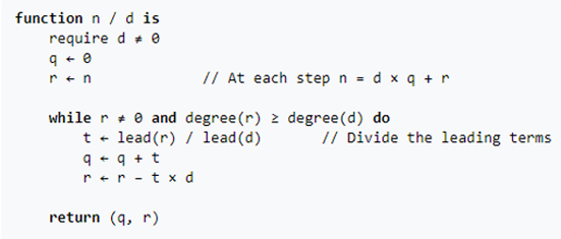
- + division(Polynomial p1, Polynomial p2): Polynomial[] (Method that implements the division operation of p1 divided by p2. The following algorithm has been implemented in the application <<provided in the laboratory help material>>

public static Polynomial[] division(Polynomial p1, Polynomial p2) {
Polynomial[] result = new Polynomial[2];
result[0] = new Polynomial();
result[1] = new Polynomial();
if (PolynomialLogic.calculateDegree(p2) == 0 && PolynomialLogic.getLeadingTerm(p2).getCoeff().floatValue() == 0) {
throw new IllegalArgumentException("Division by ZERO!!!");
}
Polynomial Q = new Polynomial();
Polynomial R = new Polynomial();
PolynomialParse.parsePolynomial(R, p1.toString());
PolynomialParse.parsePolynomial(Q, "0");
while (R.getDegree() >= p2.getDegree() && R.getDegree() > 0){
Monomial t = new Monomial((PolynomialLogic.getLeadingTerm(R).getCoeff().floatValue() / PolynomialLogic.getLeadingTerm(p2).getCoeff().floatValue()), PolynomialLogic.getLeadingTerm(R).getPower() - PolynomialLogic.getLeadingTerm(p2).getPower());
Polynomial tP = new Polynomial();
tP.addMonomial(t);
Q.addMonomial(t);
R = subtraction(R, multiplication(tP, p2));
}
Q.setDegree(PolynomialLogic.calculateDegree(Q));
R.setDegree(PolynomialLogic.calculateDegree(R));
result[0] = Q;
result[1] = R;
return result;
}

- Utils Classes:
Utility classes that contain static methods that are used on the data types that model the application (e.g. Polynomial and Monomial), but aren’t directly related to their classes.
- PolynomialLogic Class:
- + getLeadingTerm(Polynomial p): Monomial (Method used to obtain the leading term of a polynomial, meaning the term that has the highest power and a coefficient different of 0)
- + calculateDegree(Polynomial p): int (Method used to compute the degree of a polynomial given as parameter. It returns the power of the leading term of the polynomial)
- PolynomialValidation Class:
- + isValid(String p): Boolean (Method that returns the validity of a polynomial taken as input. If the polynomial is valid with respect to the pattern provided, the method returns true, false otherwise)
- PolynomialParse Class:
- + parsePolynomial(Polynomial p, String sPolynomial): void (Method that takes as input a string representing a polynomial. The string is then parsed such that we obtain the coefficient and power of each monomial and add them in the polynomial p that is also taken as input)
public static void parsePolynomial(Polynomial p, String sPolynomial) {
String patternRegex = "(([+-]?\\s*\\d*)?\\*?x(\\^(\\d+))?\\s*)|([+-]?\\s*\\d+\\s*)?"; // Monomial pattern + FreeTerm
Pattern pattern = Pattern.compile(patternRegex);
Matcher matcher = pattern.matcher(sPolynomial);
while(matcher.find()) {
String sCoeff = matcher.group(2);
String sPower = matcher.group(4);
if(sCoeff != null) {
Number coeff = 0;
int power = 0;
if(!Objects.equals(sCoeff, "-") && !Objects.equals(sCoeff, "+")) {
coeff = (sCoeff.isEmpty()) ? 1 : Integer.parseInt(sCoeff);
} else if(Objects.equals(sCoeff, "-")) {
coeff = -1;
} else if(Objects.equals(sCoeff, "+")) {
coeff = 1;
}
power = (sPower == null) ? 1 : Integer.parseInt(sPower);
p.addMonomial(new Monomial(coeff, power));
} else {
if(matcher.group(5) != null) {
int freeTerm = Integer.parseInt(matcher.group(5));
p.addMonomial(new Monomial(freeTerm, 0));
}
}
}
p.setDegree(PolynomialLogic.calculateDegree(p));
}

Besides using a regular expression to match the groups in the polynomial string, I have also added some extra logic such that the input is more flexible and less prone to errors.

- PrettyPrint Class:
- + prettyPrint(Number): Number (Method that implements a simple logic to make the printing of the result prettier <<if a monomial has integer coefficient, it will be printed without a decimal point, if it is a double it will be printed with a decimal point)
- GUI related classes:
- View Class:
The class that implements the visual part of the application, the way the content is displayed to the user. The entire application content is placed in the conentPane which is actually a grid of 2 rows by 2 columns. This contentPane is in turn divided into 2 parts, the calculation panel(contains the fields, the operations combo box, the compute button and specific labels) and the result panel that contains the result label and the actual result in form of a polynomial.
Fields:
- All the fields representing JSwing components (e.g. labels, textfields, buttons, panels);
- The controller field for which we set as view the current view
- Controller controller = new Controller(this);

Methods:
- + prepareGUI(): void (Method that “prepares” the base of the window, setting the dimensions, the exit_on_close operation and calls the methods that prepare the actual content of the GUI)
- + prepareCalculationPanel(): void (Method that “prepares” the superior part of the window, where the input happens <<the input of the polynomials, the choice of operation, the press of compute button>>)
- + prepareResultPanel(): void (Method that “prepares” the inferior part of the window, where the output happens <<the result label, plus the output of the computed operation)
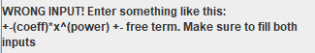
If the wrong input is provided, the user gets a message specifying that something is wrong with the format of the input.
- Controller Class:
Class which implements all the actions triggered by the interaction of the user with the GUI. In this case, the application has a button, which when pressed computes the operation selected in the combo box.
Fields:
- - view: View (private field of type View representing the view being “controlled” by the controller)
Methods:
- + actionPerformed(actionEvent e): void (When the button is pressed, the input string of the text fields is captured and first is validated to check if the polynomial format is correct. If it is, then the polynomials are parsed term by term. The operation selected from the checkbox is then computed and the result is printed in the application’s window. If the input is not valid, an error message will be displayed notifying the user that the input is incorrect)

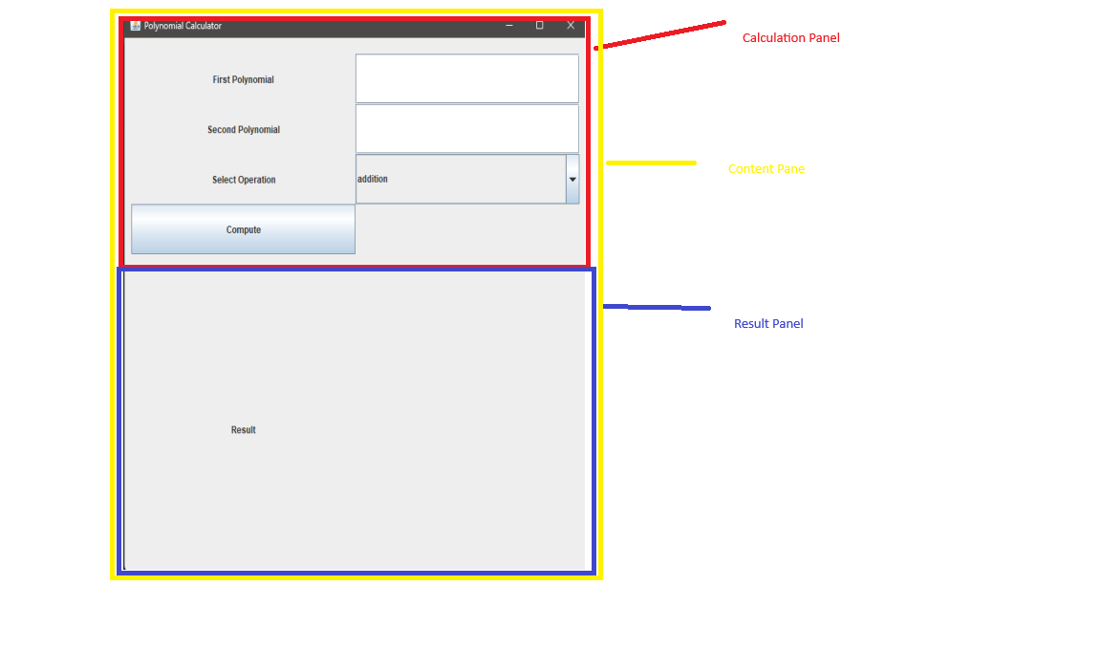

Results

JUnit is a software testing framework that helps developers test their applications. It allows developers to write tests in Java and run them on the Java platform. JUnit also has a built-in reporter that can print out the results of the tests.
For testing we must create a test class that will implement the test methods. For the output test, we use assertEquals() method provided by Junit.

The following test cases have been used in this section:

    - Addition

public void additionTest() {
Polynomial p1 = new Polynomial();
p1.addMonomial(new Monomial(4, 5));
p1.addMonomial(new Monomial(-3, 4));
p1.addMonomial(new Monomial(1, 2));
p1.addMonomial(new Monomial(-8, 1));
p1.addMonomial(new Monomial(1, 0));
Polynomial p2 = new Polynomial();
p2.addMonomial(new Monomial(3, 4));
p2.addMonomial(new Monomial(-1, 3));
p2.addMonomial(new Monomial(1, 2));
p2.addMonomial(new Monomial(2, 1));
p2.addMonomial(new Monomial(-1, 0));
assertEquals(Operations.addition(p1, p2).toString(), "4*x^5-1*x^3+2*x^2-6*x^1");
}

The test case is the one provided in the laboratory paper:
P1 = 4x⁵ – 3x⁴ + x² -8x + 1
P2 = 3x⁴ – x³ + x² + 2x – 1
Res = 4x⁵ – x³ + 2x² - 6x

    - Subtraction
public void subtractionTest() {
Polynomial p1 = new Polynomial();
p1.addMonomial(new Monomial(4, 5));
p1.addMonomial(new Monomial(-3, 4));
p1.addMonomial(new Monomial(1, 2));
p1.addMonomial(new Monomial(-8, 1));
p1.addMonomial(new Monomial(1, 0));
Polynomial p2 = new Polynomial();
p2.addMonomial(new Monomial(3, 4));
p2.addMonomial(new Monomial(-1, 3));
p2.addMonomial(new Monomial(1, 2));
p2.addMonomial(new Monomial(2, 1));
p2.addMonomial(new Monomial(-1, 0));
assertEquals(Operations.subtraction(p1, p2).toString(), "4*x^5-6*x^4+1*x^3-10*x^1+2");
}

P1 = 4x⁵ – 3x⁴ + x² -8x + 1
P2 = 3x⁴ – x³ + x² + 2x – 1
Res = 4x⁵ – 6x⁴ + x³ – 10x + 2

    - Multiplication
public void multiplicationTest() {
Polynomial p1 = new Polynomial();
p1.addMonomial(new Monomial(3, 2));
p1.addMonomial(new Monomial(-1, 1));
p1.addMonomial(new Monomial(1, 0));
Polynomial p2 = new Polynomial();
p2.addMonomial(new Monomial(1, 1));
p2.addMonomial(new Monomial(-2, 0));
assertEquals(Operations.multiplication(p1, p2).toString(), "3*x^3-7*x^2+3*x^1-2");
}

P1 = 3x² – x + 1
P2 = x – 2
Res = 3x³ – 7x² + 3x – 2

    - Division
public void divisionTest() {
Polynomial p1 = new Polynomial();
p1.addMonomial(new Monomial(1, 3));
p1.addMonomial(new Monomial(-2, 2));
p1.addMonomial(new Monomial(6, 1));
p1.addMonomial(new Monomial(-5, 0));
p1.setDegree(PolynomialLogic.calculateDegree(p1));
Polynomial p2 = new Polynomial();
p2.addMonomial(new Monomial(1, 2));
p2.addMonomial(new Monomial(-1, 0));
p2.setDegree(PolynomialLogic.calculateDegree(p2));
Polynomial[] res = Operations.division(p1, p2);
Polynomial Q = new Polynomial();
Q.addMonomial(new Monomial(1, 1));
Q.addMonomial(new Monomial(-2, 0));
Polynomial R = new Polynomial();
R.addMonomial(new Monomial(7, 1));
R.addMonomial(new Monomial(-7, 0));
assertEquals(res[0].toString(), Q.toString());
assertEquals(res[1].toString(), R.toString());
}

P1 = x³ – 2x² + 6x – 5
P2 = x² - 1
Q = x – 2
R = 7x – 7
5. Derivative
public void derivativeTest() {
Polynomial p = new Polynomial();
p.addMonomial(new Monomial(1, 3));
p.addMonomial(new Monomial(-2, 2));
p.addMonomial(new Monomial(6, 1));
p.addMonomial(new Monomial(-5, 0));
assertEquals(Operations.derivative(p).toString(), "3*x^2-4*x^1+6");
}

P = x³ – 2x² +6x – 5
Res = 3x² - 4x + 6

- Integration
public void integrationTest() {
Polynomial p = new Polynomial();
p.addMonomial(new Monomial(1, 3));
p.addMonomial(new Monomial(4, 2));
p.addMonomial(new Monomial(5, 0));
Polynomial res = new Polynomial();
res.addMonomial(new Monomial(1.0/4, 4));
res.addMonomial(new Monomial(4.0/3, 3));
res.addMonomial(new Monomial(5, 1));
assertEquals(Operations.integration(p).toString(), res.toString());
}

P = x³ + 4x² + 5
Res = 1/4x⁴ + 4/3x³ + 5x
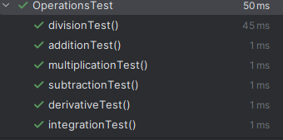

Conclusions
The polynomial calculator assignment is a good way of better understanding the concepts of object-oriented programming and the designing of applications.
I have first learned to analyze the requirements, make a schematic and only then start implementing the actual application.
I have learned to organize my code better, how to use testing APIs to test my application’s logic as well as implementing graphical interfaces using Java Swing.
Future developments of the application could be related to the visual aspect of the user interface, such as adding a digital keyboard, as well as adding several functionalities e.g. calculating higher order derivatives, the possibility of plotting graphs of the polynomial functions.

Bibliography
- Fundamental Programming Techniques (dsrl.eu) – Laboratory Assignment Guide + Lectures
- TreeMap in Java - GeeksforGeeks – For learning how to work with TreeMap data structure

