PSU Clamp Test Waveforms & Calculations
April & May 2025
Table of Contents
Setup 1
Method 1
Supply rail voltages & mosfet gate voltage 2
currents 3
Mosfet Safe Operating Area (SOA) & Thermal considerations 6

Setup
Motor: EMAX ECO 1106, K_{v} = 6000, 12 magnets, with flywheel
Connections: Separate connection from power supply to Remora & from power supply to the clamp circuit
Clamp Circuit Schematic   | Q1: the prototype used SQJ140ELP mounted on a copper sheet 15mm × 8mm × 0.5mm  A few other possible mosfet candidates:  Part Number Package  SQJ140ELP PowerPAK (5x6)  SQJ160EP PowerPAK (5x6)  IRFS7437 D²PAK  SQM40016EM D²PAK 7 lead  RFP50N06 TO-220  SUP50020EL TO-220  IRLB3034 TO-220  Q2: the prototype used KSA733, but almost any small PNP transistor would work.

Method
In the ESC32 menu move slider right then left, this rapidly stops the motor sending energy back to the power supply (PSU), as power supplies only source current this raises the PSU voltage.
The clamp is designed to start operating at about 12.5V preventing damage to the WiFi and Remora.
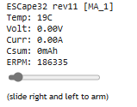
ERPM = rpm × pole pairs ∴ rpm = ERPM ÷ pole pairs ∴ rpm = 186335 ÷ 6 = 31056rpm
From Kv value: rpm ≈ 5V × 6000Kv = 30000rpm, so in reasonable agreement with ERPM reading from ESC32.
Commutation frequency, Fc = (rpm / 60) × pole pairs = ERPM / 60 = 186335/60 = 3106Hz
Measured Fc from oscilloscope is 3003Hz

Supply rail voltages & mosfet gate voltage
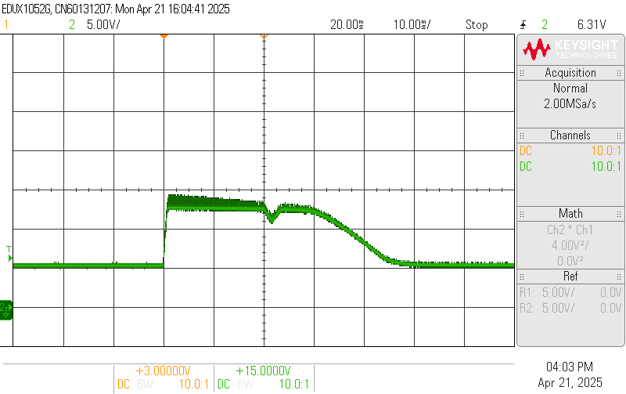 | 1  5V supply  green = supply at Remora, 5V/div, 10ms/div  Supply starts at 5V, then when the slider is moved left it rapidly rises to the clamp level of about 12.5V.  The clamp successfully holds the voltage at below 15V.
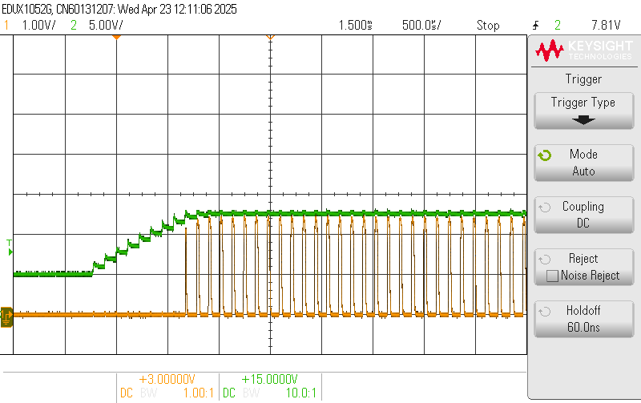 | 2  5V supply  yellow = mosfet gate, 1V/div, 500µs/div  green = supply at clamp, 5V/div, 500µs/div  The pulses occur at 3× the commutation frequency.  Initially at ≈115µs period ≈ 9kHz  Therefore one pulse for each of the ecom 3 phases.  See waveform 4 for an individual phase.
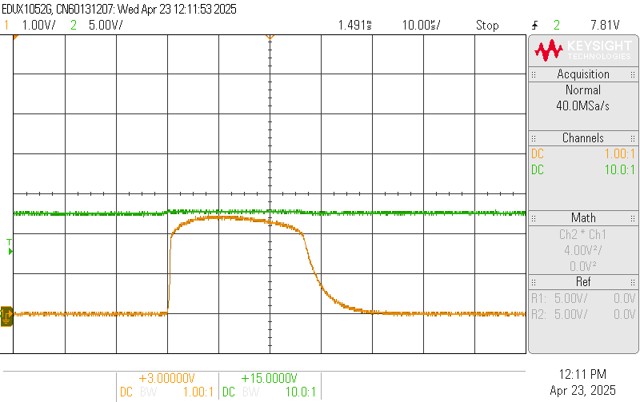 | 3, zoom of 2  5V supply  yellow = mosfet gate, 1V/div, 10µs/div  green = supply at clamp, 5V/div, 10µs/div  Gate voltage returning to zero indicates that the mosfet is being turned on & off during the clamping phase.  The voltage remaining high must then be due to the capacitance in the PSU & Remora.
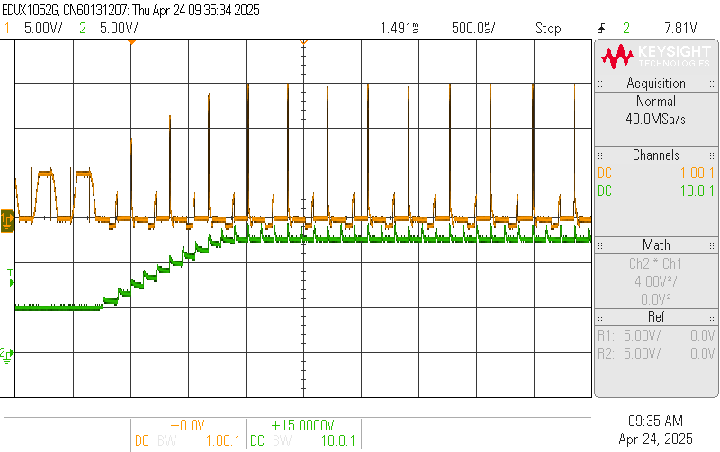 | 4  5V supply  yellow = ecom V phase output, 5V/div, 500µs/div  green = supply at Remora, 5V/div, 500µs/div  The high amplitude (>10V) spikes on V-phase occur at the commutation frequency.

currents
(Remora settings slightly different to those for voltage measurements above, running at slightly higher rpm)
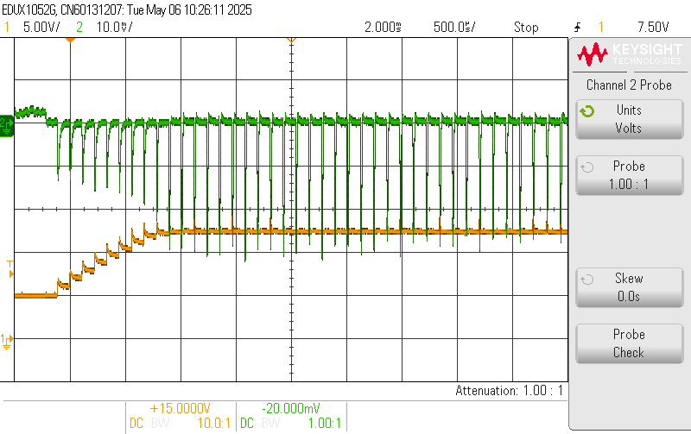 | 5  5V supply  yellow = supply at Remora, 5V/div, 500µs/div  green = current in Remora +ve line, 2A/div, 500µs/div  The spikes occur at 3× the commutation frequency, i.e. one for each phase.  Initially at ~ 110µs period
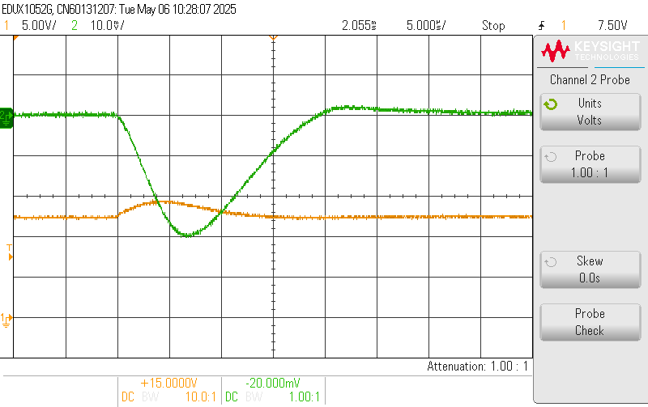 | 6 zoom of 5  5V supply  yellow = supply at Remora, 5V/div, 5µs/div  green = current in Remora +ve line, 2A/div, 5µs/div  6A peak current fed from Remora to PSU & clamp circuit.  Approximately a triangular shape width 20µs  So average current ≈ 6A ÷2 × 40µs ÷ 110µs = 1.1A  The current & voltage both start to rise at the same time, but peak current is lags the peak PSU voltage by about 6.8µs
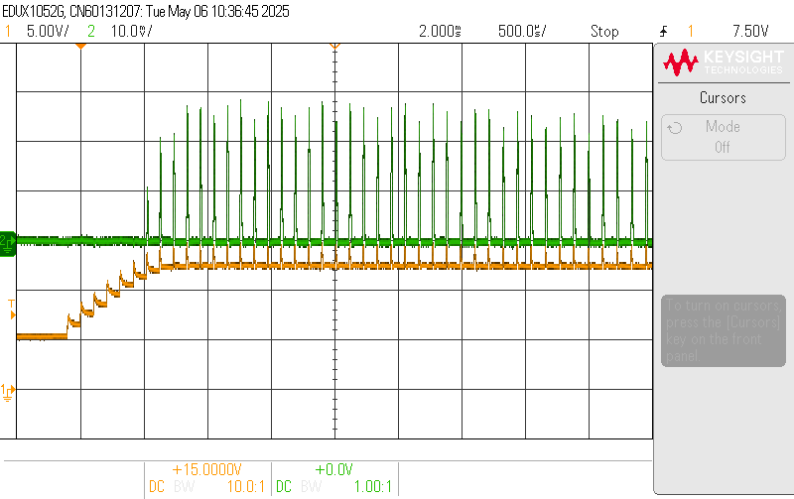 | 7  5V supply  yellow = supply at Remora, 5V/div, 500µs/div  green = current in clamp +ve line, 2A/div, 500µs/div
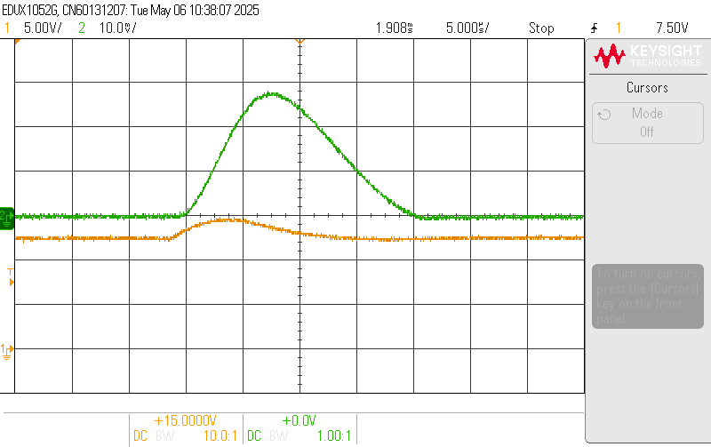 | 8 zoom of 7  5V supply  yellow = supply at Remora, 5V/div, 10µs/div  green = current in clamp +ve line, 2A/div, 10µs/div  peak current & width are very similar to the current from Remora, but some current must be flowing into the power supply output capacitor as indicated by the rise in the voltage.  The rise in current is delayed from the start of the voltage rise & the peak current lags the peak PSU voltage by about 9µs
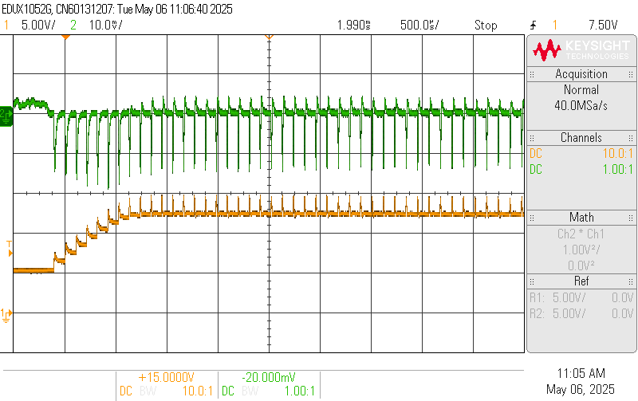 | 9  5V supply  yellow = supply at Remora, 5V/div, 500µs/div  green = current in PSU +ve line, 2A/div, 500µs/div
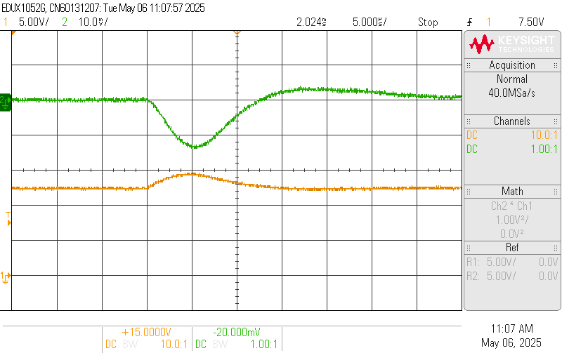 | 10 zoom of 9  5V supply  yellow = supply at Remora, 5V/div, 5µs/div  green = current in PSU +ve line, 2A/div, 5µs/div  The current & voltage both start to rise at the same time, and peak current is coincident with the peak PSU voltage
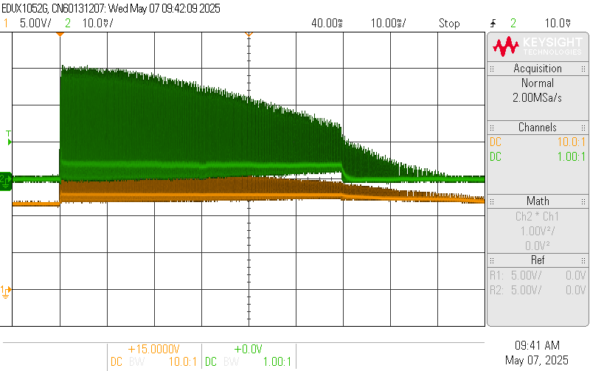 | 11  11.5V supply  yellow = supply at Remora, 5V/div, 10ms/div  green = current in clamp +ve line, 5A/div, 10ms/div
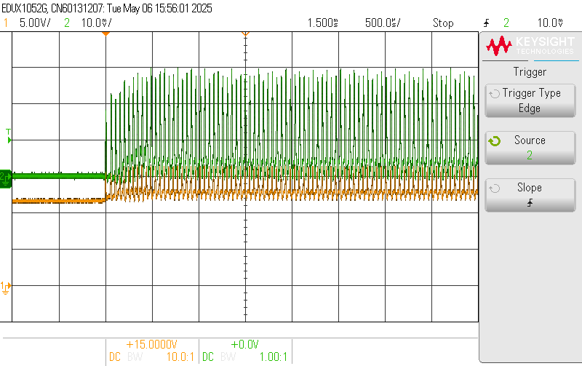 | 12, as 11 but faster time-base  11.5V supply  yellow = supply at Remora, 5V/div, 500µs/div  green = current in clamp +ve line, 5A/div, 500µs/div
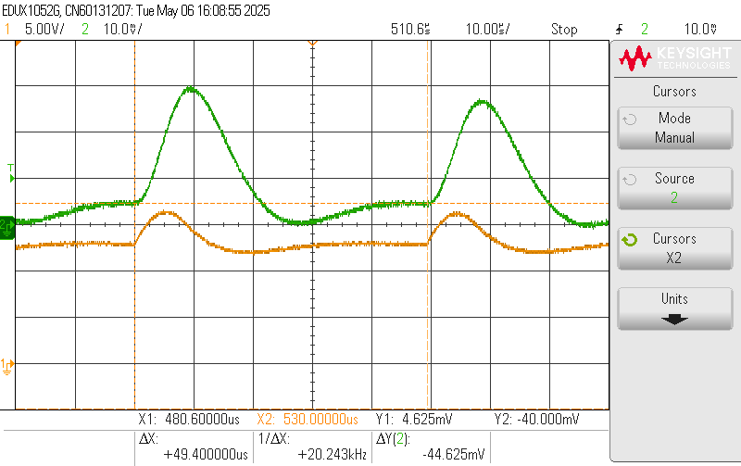 | 13 zoom of 12  11.5V supply  yellow = supply at Remora, 5V/div, 10µs/div  green = current in clamp +ve line, 5A/div, 10µs/div  ipk = 14.5A  iav from scope measurement =4.22A  irms from scope measurement = 6.1A  current prior to steep rise = 2.3A  period = 49.4µs  Approximately a triangular shape width = 23µs  2.3A step width = 9.4µs  0A to 2.3A ramp width = 10µs  check on iav:  Iav ≈ [(14.5÷2×23µs)+ (2.3÷2×10µs) + (2.3×9.4µs)]÷ 49.4µs = 4A, in reasonable agreement with scope measurement.  Vpk = 16.5V Vav = 13.25V  so power = 13.25V × 4.22A = 56W scope maths = 55W  From waveform 11 duration ≈ 60ms so energy = 3.36J

Mosfet Safe Operating Area (SOA) & Thermal considerations
Mosfet SOA  Using IRLB3034 as an example of an SOA chart, because used it in the thermal calculation example below  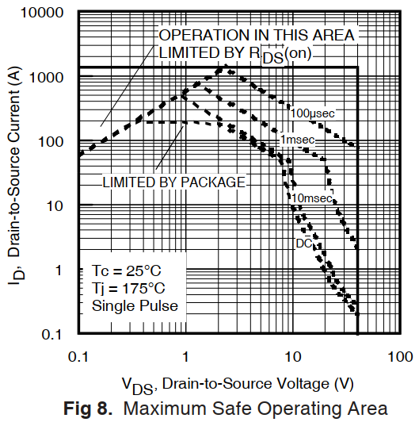 | At 11.5V supply the current pulses are about 15A with a triangular shape of width 23µs, but to allow a generous safety margin use 30A & 50µs. SOA data usually has plots of curves at 100µs so use this instead of 50µs giving an even greater safety margin. The voltage for the SOA will be 15V.  Taking the IRLB3034 SOA as an example its DC SOA at 15V is only about 3A, but its 100µs SOA is about 200A, however this is for a temperature rise of 150°C from 25°C to 175°C. For a good lifetime better to restrict the temperature rise to 75°C so therefore the 100µs SOA current would be reduced to 100A.  This is still in excess of our requirement of 30A so is OK.  The actual temperature rise for the 15A 23µs triangular pulse will be very considerably lower than 75°C.
Thermal calculations  just to get an estimate of whether a heatsink is required or not. | thermal energy formula: Q = m × c × Δt  Q = energy J  m = mass kg  c = specific heat capacity J / kg · K  Δt = temperature rise K (or °C)  If the energy was dumped in an aluminium heatsink  specific heat capacity = 900 J / kg · K  allow 20K temperature rise for the aluminium  ∴ mass = 0.19g  If the energy was dumped in a copper sheet  specific heat capacity = 385 J / kg · K  allow 20K temperature rise for the copper sheet  ∴ mass = 0.44g  For reference the total mass of a TO-220 is about 1.9g, so it may be able to absorb the energy without an additional heatsink.
Thermal simulation model  Using IRLB3034 in a TO-220 package as an example. Because it has a thermal model on the data-sheet. (Although it only has a moderate DC SOA its pulse SOA is acceptable).  Triangular power pulses applied with 55W average, see waveform 13.  R5 with a thermal resistance of 62K/W represents a TO-220 without a heatsink.  In the model:  current represents thermal power  voltage represents temperature   | IRLB3034 thermal model results    Red = junction temperature rise at 60ms, average = 50°C  & temperature ripple due to the individual triangular power pulse is small at about 2°C.  green = TO-220 case temperature rise, at 60ms = 35°C  So a TO-220 package without a heatsink has an acceptable temperature rise for a single 60ms burst of pulses, even with an 11.5V supply.

