Remora1 Production Test
Revision 0.0
December 2023

Pad identification

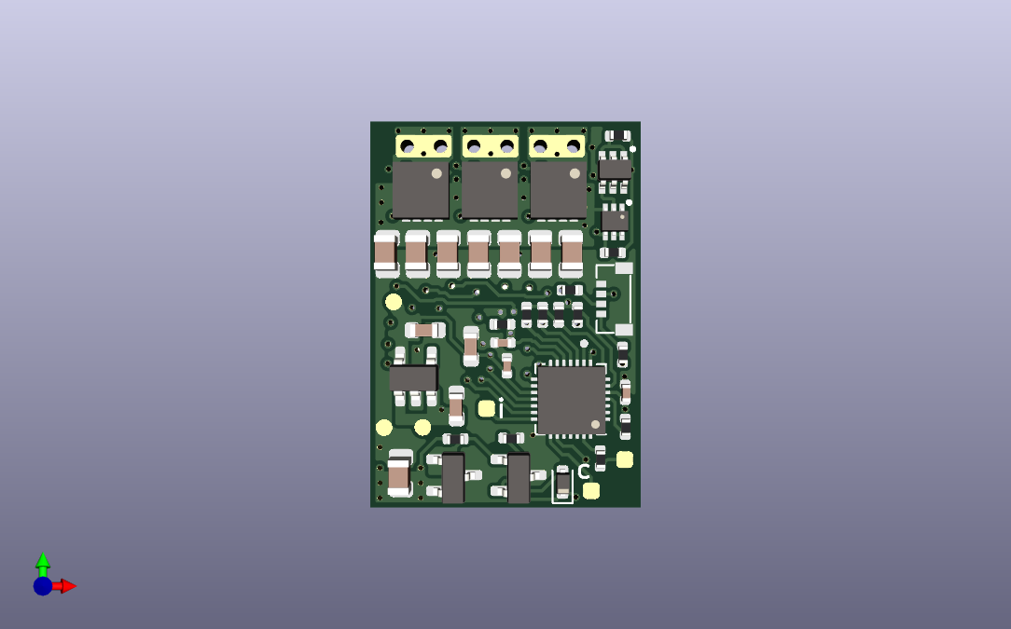
VCC, 12V4
VDD, 3V3
GND
SWD_IO
SWD_CLK
PB6
VBUS (VIN)
PA2
PA15
GND
VDC,10.3V

Procedure
setup / action | measure | expected result
visual inspection | check for no missing or misplaced parts, no bad joints or solder bridges | all OK
Low Voltage Start & Run
set power supply to 1.5V, but output off
connect power supply to + & - terminals
turn power supply output on | power supply current | 43mA to 52mA
 | VCC to GND | 11.954V to 12.914V
 | VDD to GND | 3.234V to 3.366V
reduce power supply voltage to 1.25V | power supply current | 75mA to 81mA
 | VCC to GND | 9V to 12.914V
High Voltage Test
increase power supply voltage to 13.5V | power supply current | 4.5mA to 7.5mA
 | VDC to GND | 8.7V to 12.7V
 | VCC to GND | 11.954V to 12.914V
Memory Programming
programme the flash memory
reduce power supply voltage to zero & turn off
Operation With Motor Connected
connect motor, make sure its mechanically secure
turn power supply on
slowly increase power supply voltage | check motor rotation | normal rotation
reduce power supply voltage to zero & turn off
Reverse Polarity Test
reverse connections to + & - terminals
turn power supply on, increase power supply voltage to 13.5V | power supply current | <1.7mA
reduce power supply voltage to zero & turn off
restore normal connections to + & - terminals
turn power supply on, increase power supply voltage to 13V | check for motor rotation | normal rotation
End of Tests
reduce power supply voltage to zero & turn off
end

Revision History
revision | date | changes
0.0 | 29 December 2023 | initial draft, based on 2 prototypes with adaptor board
0.1 | 17 April 2024 | changes based on Remora1 measurements.  current at 1.5V revised  1.2V test revised to 1.25V, current revised, VCC to GND revised  current at 13.5V revised

