Activity 2

Define Client Side Attacks

1) XSS - Allows remote attackers to alter a URL with a malicious script that will redirect a message or request.
2)Clickjacking: Tricks users into clicking misleading graphics that trigger an exploit. For example: A button that reads "Download" in large text.
3)Content spoofing: Tricks a user into believing that a website is legitimate. For example, a fake login page that steals your credentials after you submit them.
4) Drive-by download: Triggers downloads without the user's knowledge when a webpage is visited.
5) Phishing: A form of social engineering that manipulates a user into providing personal confidential information, such as user credentials and bank account information.

Activity 3
1) Linkedin, Facebook, Twitter, harvesting robots.txt files, querying whois records which could contain names, emails, phone numbers and addresses
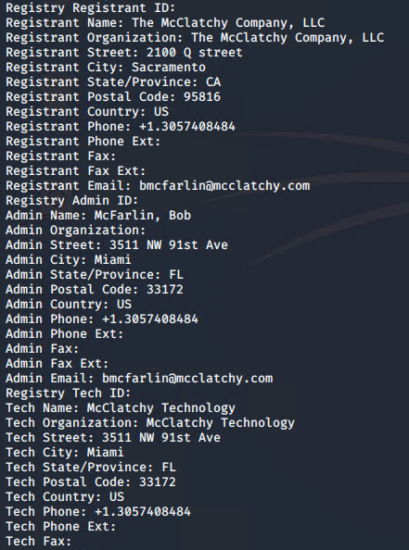
2)

