Week 8 - Networking Fundamentals Homework: Rocking your Network!

Phase 1: "I'd like to Teach the World to Ping"

Hollywood Offices relevant IP addresses fping results

fping -g 15.199.95.91/28 - All 14 IP addresses unreachable
fping -g 15.199.94.91/28 - All 14 IP addresses unreachable
fping -g 11.199.158.91/28 - All 14 IP addresses unreachable
fping -g 167.172.144.11/32 – IP Address 167.172.144.11 is reachable
fping -g 11.199.141.91/28 – All 14 IP addresses unreachable

ping operates on ICMP and is therefore layer 3, the network layer.

Mitigation – If there is any concern, it would be possible to restrict ICMP echo to prevent responses from ping requests.

Phase 2: "Some Syn for Nothin`"

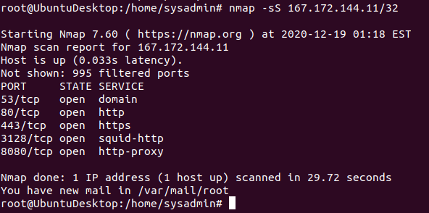

SYN Scans utilise layer 4, transport layer

Mitigation – Needs further investigation to determine if the above open ports need to stay open and if so, are they secure and that if any proxies are not open proxies.

Phase 3: "I Feel a DNS Change Comin' On"

Step 1

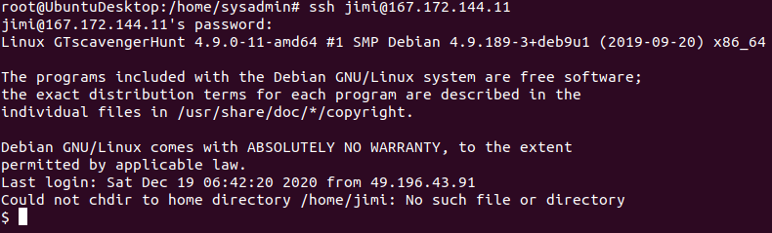
.

Step 2

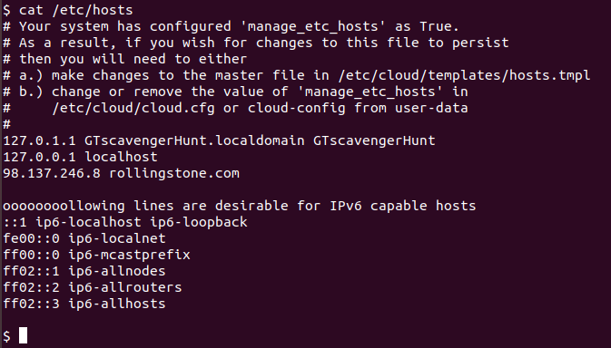
.

Step 3

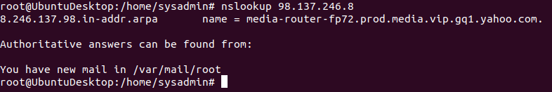

The rockstar server accepted the default login credentials with a remote connection on port 22 (SSH). SSH uses OSI layer 7 – the application layer

etc/hosts contained an entry to direct requests made to the host rollingstone.com to the IP address 98.137.246.8

A reverse dns query made with nslookup resolved the IP address of 98.137.246.8 to media-router-fp72.prod.media.vip.gq1.yahoo.com

DNS queries use OSI layer 7 – the application layer

Summary – Malicious entry in etc/hosts file which appears that it was intended to redirect traffic for rollingstone.com to a different IP address. Only users with access to accounts with elevated privileges should be able to write to the etc/hosts file. This could be a serious security issue, would recommend a thorough examination of the system and password changes.

Phase 4: "ShARP Dressed Man"

1)
cd /etc
nano packetcaptureinfo.txt

2)
Open google drive link
https://drive.google.com/file/d/1ic-CFFGrbruloYrWaw3PvT71elTkh3eF/view?usp=sharing

3)
Determine if there is any suspicious activity that could be attributed to a hacker -

There appears to be an ARP spoofing attack, with two sources having different MAC addresses both claiming the same IP address.

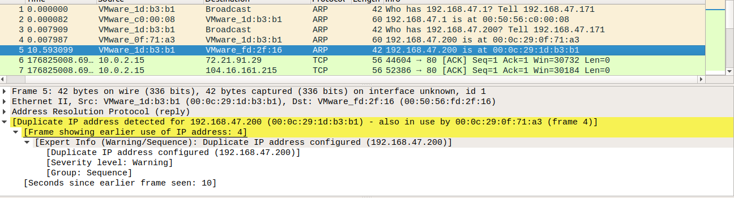

The hacker has also initiated a HTTP POST to gottheblues.com, this was on HTTP/port80 and not HTTPS/port443 so we are able to read some information as plaintext. The post appears to offer the sale of credentials that are able to be used to login via SSH for a million dollars. This could be a serious security issue, would recommend a thorough examination of the system and password changes.

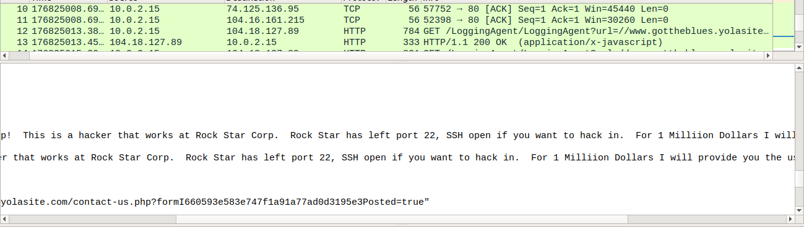

The OSI layer is the network layer and application layer

