Unit 10 **-** Cryptography Homework

Riddle 1

Caesar Cipher with a shift value of -8

Input - ozcjmz

Output - gruber

Key - 6skd8s

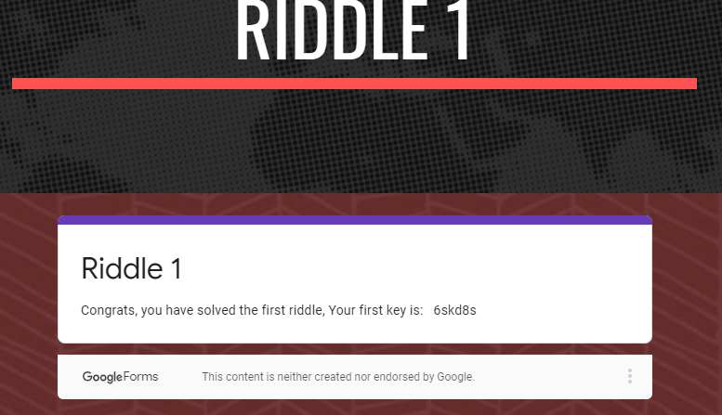

Riddle 2

Solution - binary -> utf-8

Input - 01000111 01100101 01101110 01101110 01100101 01110010 01101111

Output - Gennero

Key - cy8snd2

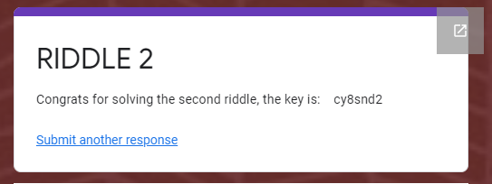

Riddle 3

Solution - echo "4qMOIvwEGXzvkMvRE2bNbg==" | openssl enc -pbkdf2 -nosalt -aes-256-cbc -out out.txt -d -base64 -K 5284A3B154D99487D9D8D8508461A478C7BEB67081A64AD9A15147906E8E8564 -iv 1907C5E255F7FC9A6B47B0E789847AED

Input - 4qMOIvwEGXzvkMvRE2bNbg==

Output - takagi

Key - ud6s98n

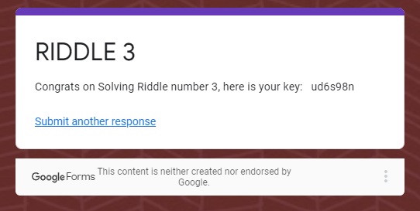

Riddle 4

Answers :

1) Jill's public key

2) Jill's private key

3) 12 Asymmetric and 15 Symmetric

4) Alices's public key

key - 7gsn3nd2

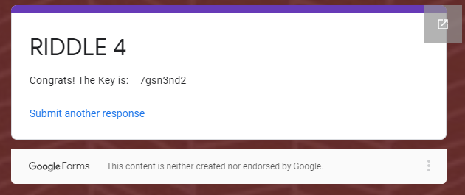

Riddle 5

Solution - hashcat -m 0 temp rockyou.txt

*Input - 3b75cdd826a16f5bba0076690f644dc7*

Output - argyle

Key - ajy39d2

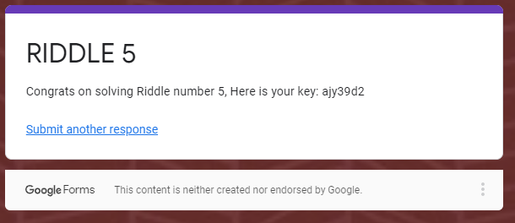

Riddle 6

Solution - steghide extract -sf mary-lamb.jpg ; #pass : ABC ;

Output - mcclane

Key - 7skahd6

