**Homework Week 7**

Task 1: Create a GPO: Disable Local Link Multicast Name Resolution (LLMNR)

Followed instructions and attached a screenshot

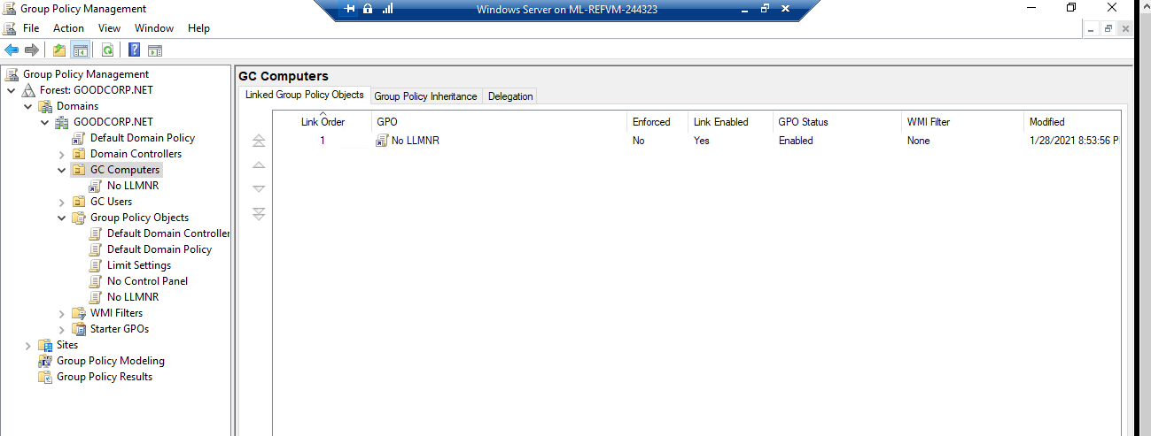

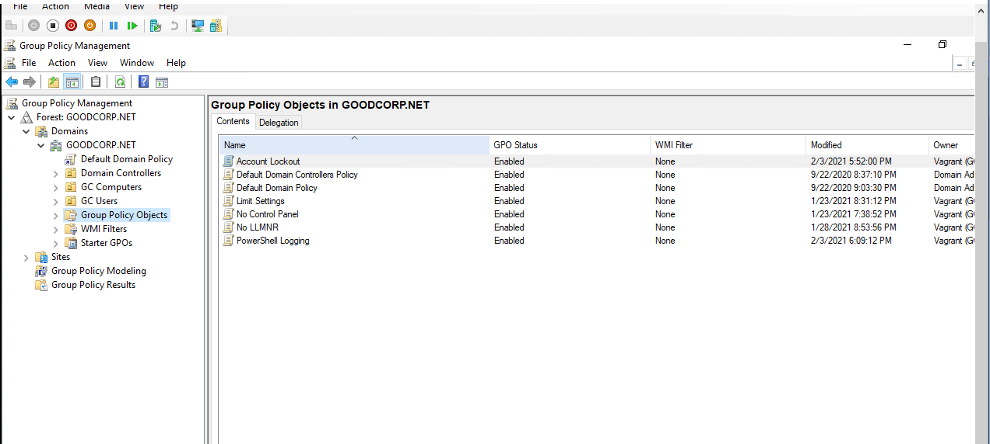

Task 2: Create a GPO: Account Lockout

Followed instructions and used Microsoft's 10/15/15 recommendation. Attached screenshots

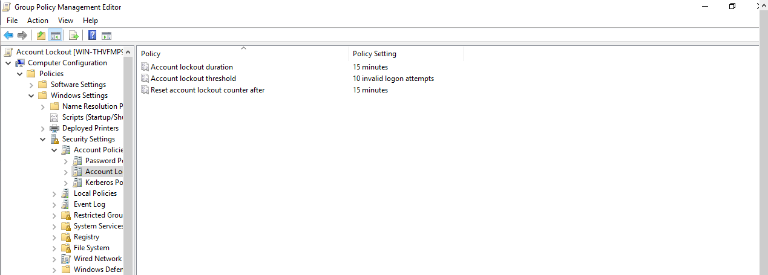

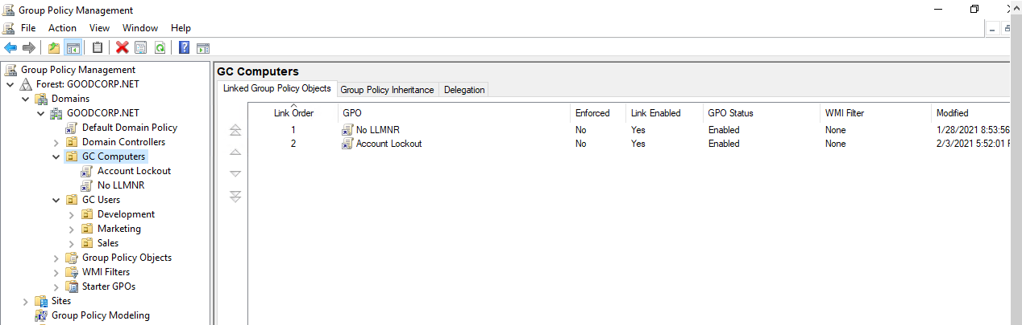

Task 3: Create a GPO: Enabling Verbose PowerShell Logging and Transcription

Followed all instructions and completed task successfully. Attached some screenshots.

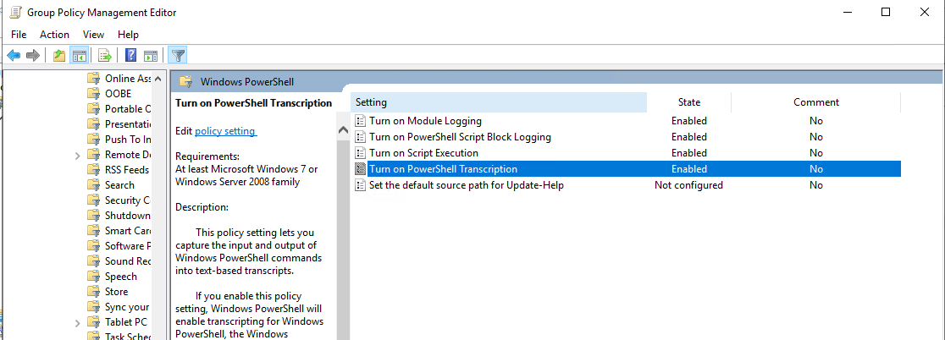

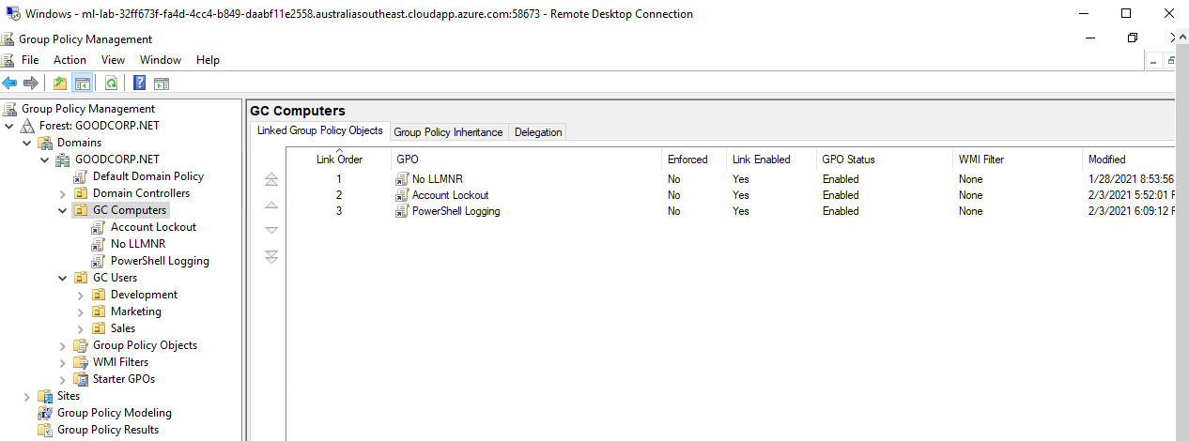

Task 4: Create a Script: Enumerate Access Control Lists

$directory = Get-ChildItem .

foreach ($item in $directory) {

Get-Acl $item | Format-List

}

Bonus Task 5: Verify Your PowerShell Logging GPO

Attached screenshot below

