Week 9 - Networks Fundamentals II Homework

Mission 1

Using nslookup to query MX records for starwars.com returned the following results.

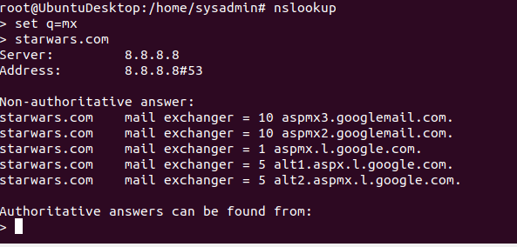

Upon examining the starwars.com MX record, it is different than the expected servers of asltx.l.google.com and asltx.2.google.com. This could be affected by the TTL (time to live) value of starwars.com, which is how often it updates itself and could also possibly be affected by a local DNS cache.

Mission 2

I did an MX record query and SPF record query for theforce.net. The new IP address of the mail server, 45.23.176.21 is not listed as authorized IP address to handle mail for theforce.net domain. Unfortunately, mail sent before the new IP address change becomes live will probably be treated as unsolicited mail.

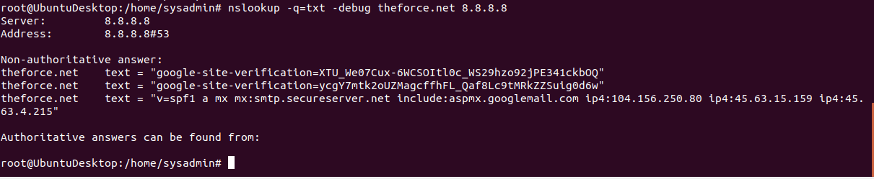

Mission 3

There appears to be no entry for resistance.theforce.net I was unable to resolve this entry. A new CNAME entry should be made.

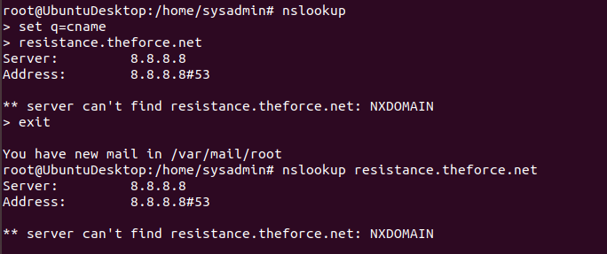

Mission 4

A query of princessleia.site NS records indicate two name servers. However, the backup name server of ns2.galaxybackup.com is not listed as a name server. I would suggest adding ns2.galaxybackup.com as a backup NS record.

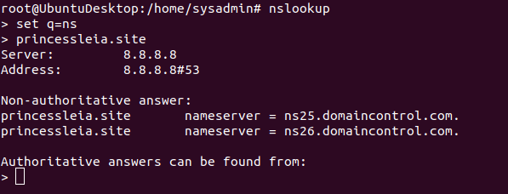

Mission 5

Batuu -> D -> C -> E -> F -> J -> K -> N -> O -> R -> S -> Jedha

Mission 6

Used aircrack-ng to decrypt key with a wordlist attack

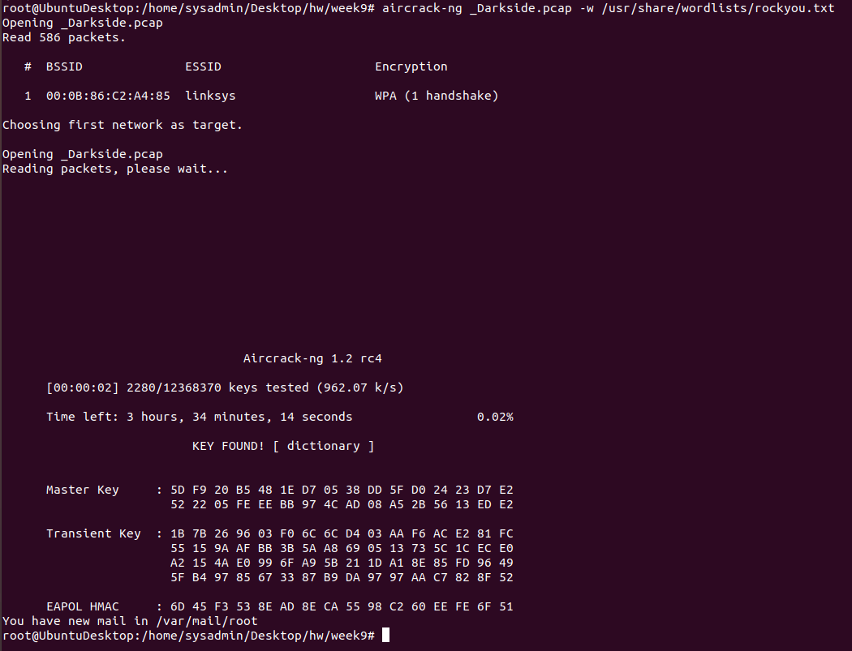

Mission 7

IP Addresses located in .pcap file when analyzed using wireshark with the wireless network key entered for decryption. There were several local IP addresses, but I have only included the IP addresses that I can see are from an outside source.

IPv4 - 68.9.16.25 MAC – 00:0b:86:c2:a4:85

IPv4 - 68.9.16.30 MAC – 00:0b:86:c2:a4:85

Mission 8

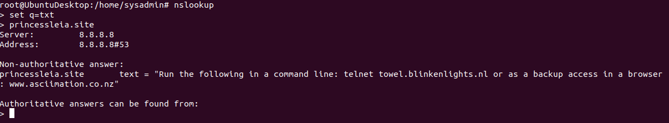

telnet towel.blinkenlights.nl

