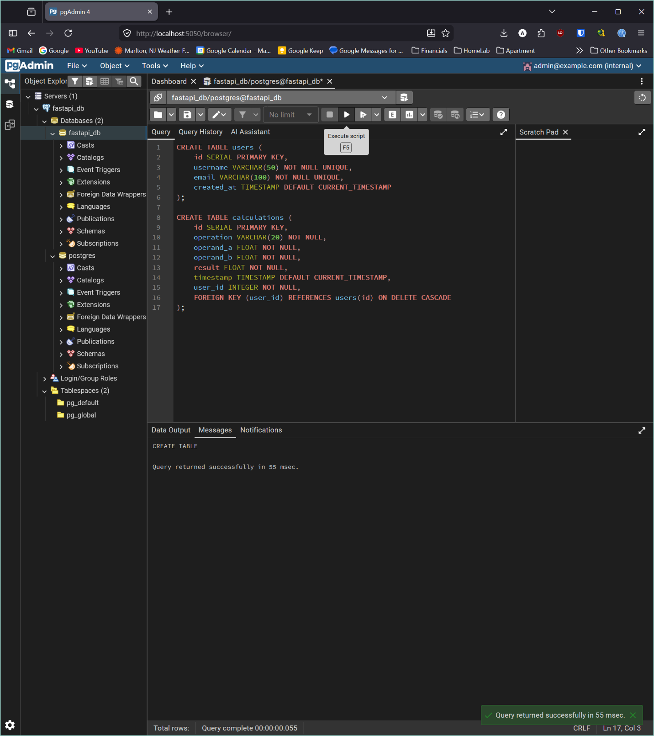Two tables are created: users to store user accounts with a unique username and email, and calculations to store math operations linked to a user via a foreign key (user_id). 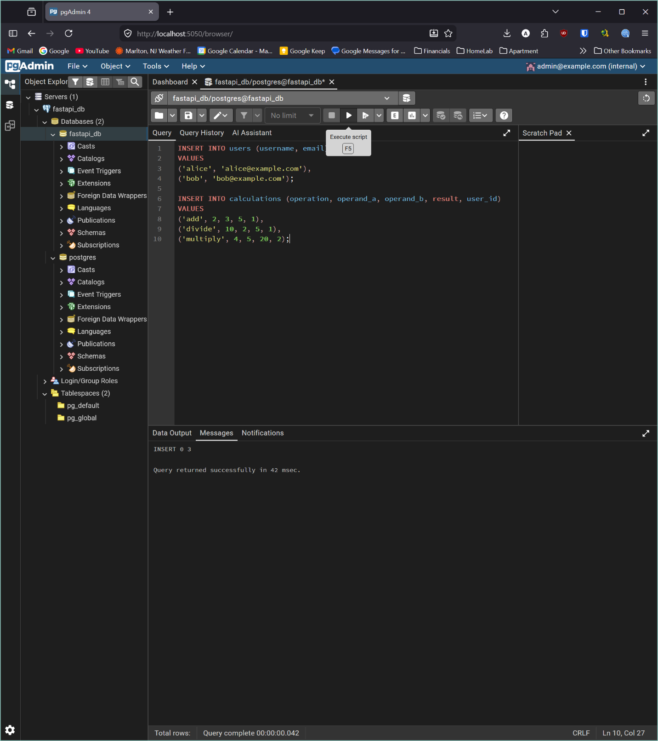Sample data is inserted — two users (alice and bob) and three calculations (add and divide for alice, multiply for bob) — to populate the tables for testing. 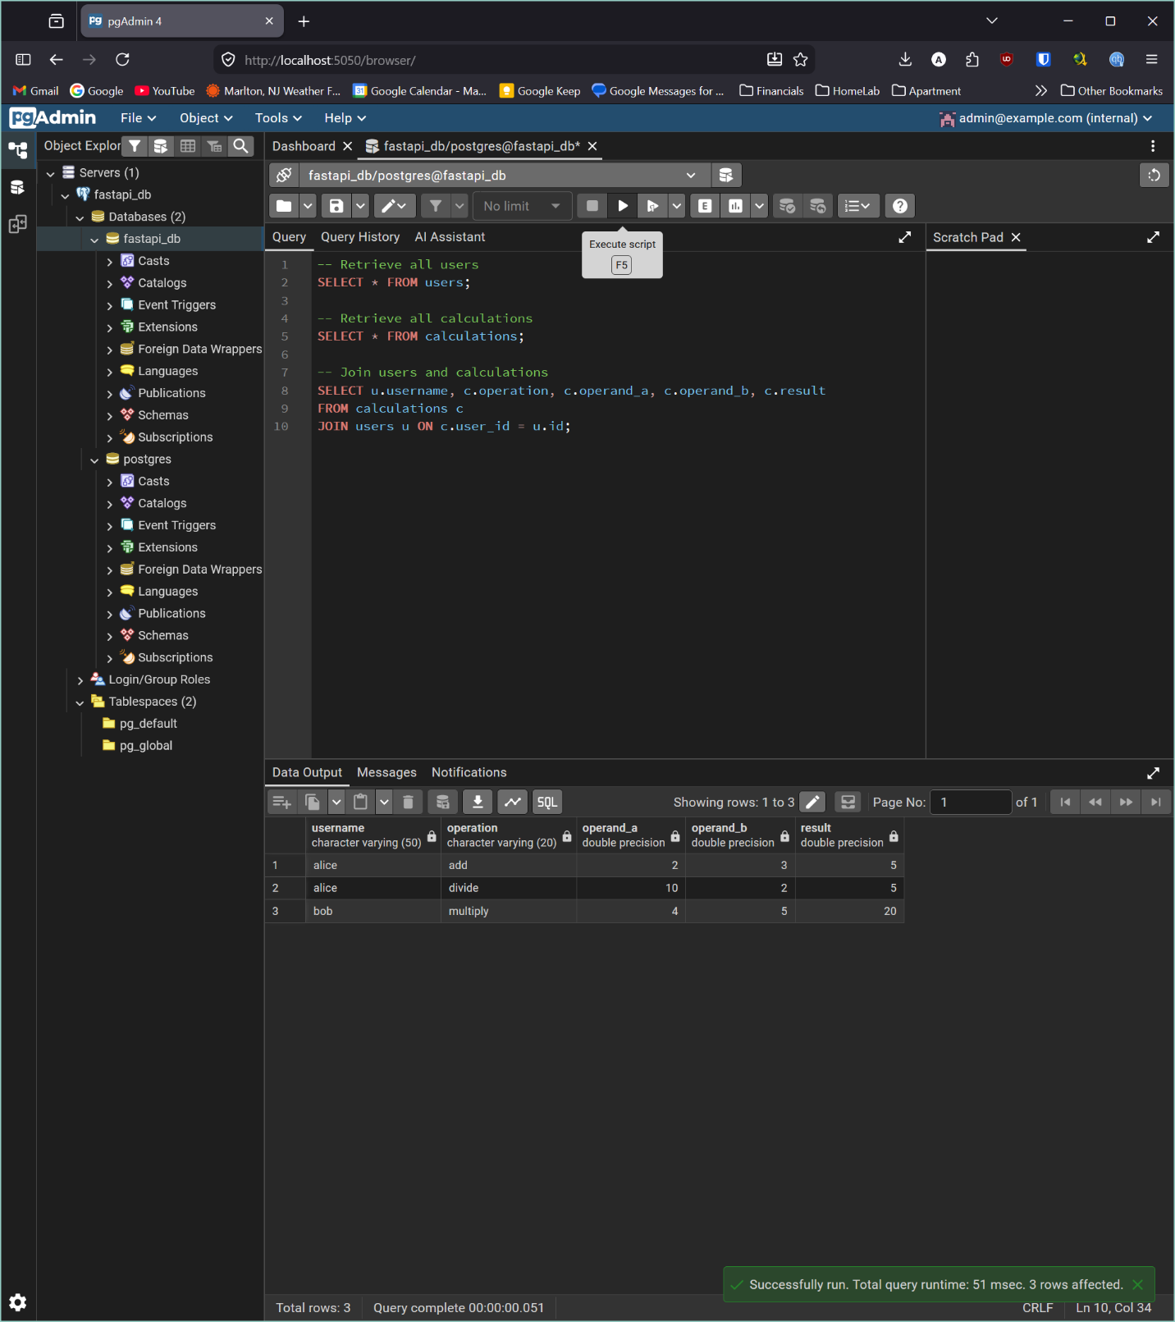Three SELECT queries retrieve the data: one for all users, one for all calculations, and a JOIN that combines both tables to show which user performed each calculation. 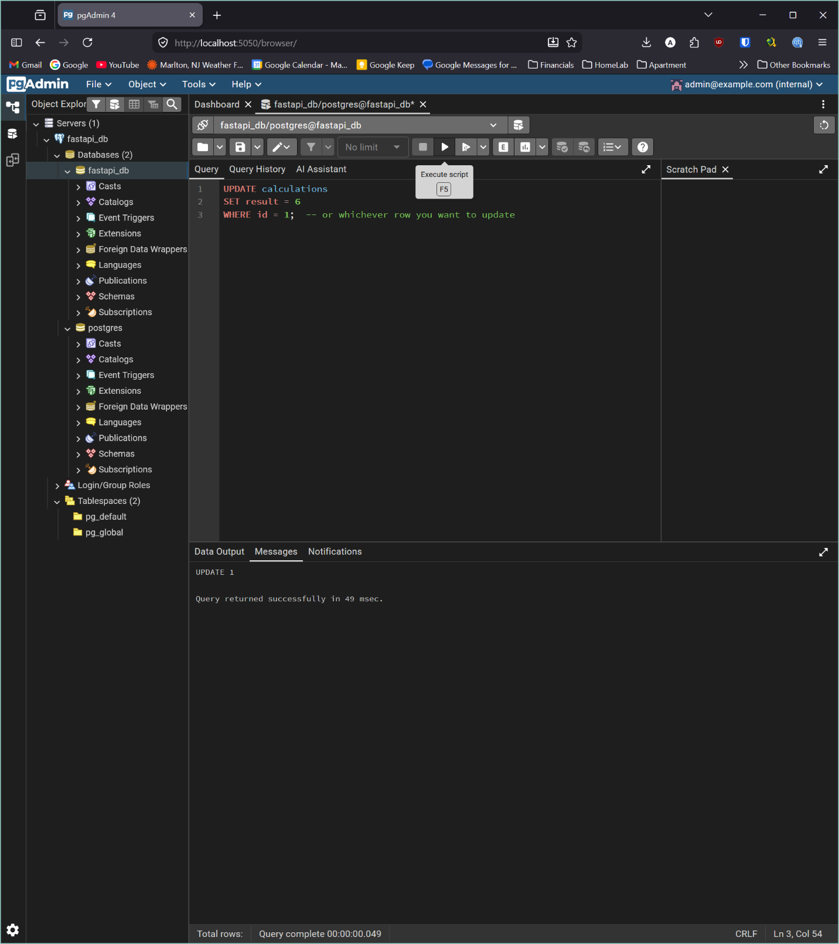The result column of calculation id=1 is corrected from 5 to 6 using an UPDATE statement, demonstrating how to modify existing records. 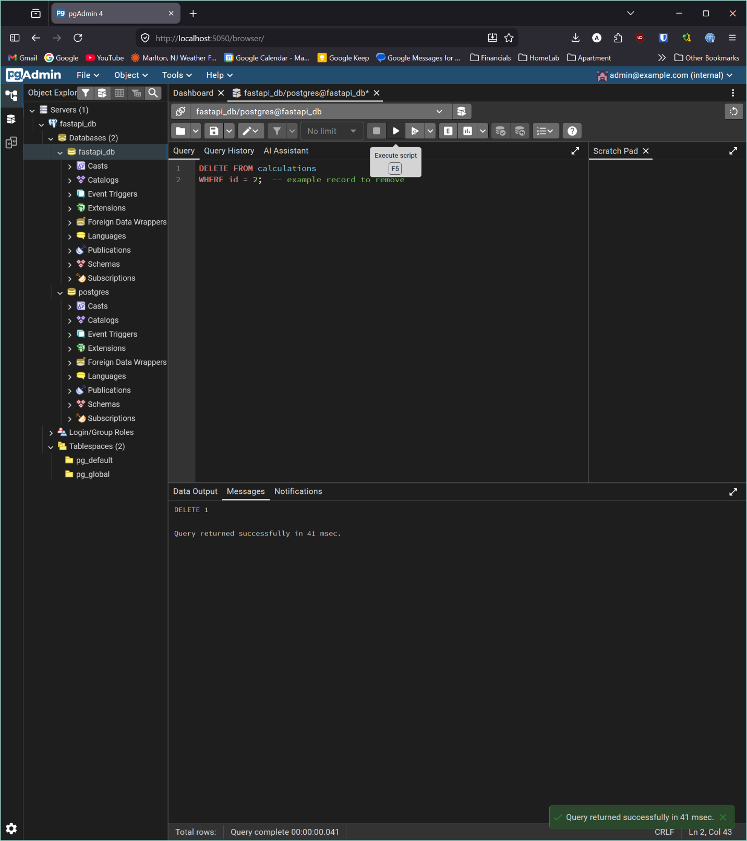Calculation id=2 is permanently removed from the table using a DELETE statement, demonstrating how to remove individual records without affecting the rest of the data.

