HCI Assessed Coursework

Tan De Hui Adrian (2427239T)

Ang Jun Wei Dickson (2427283A)

Tan Shi Qi Samantha (2427277T)

*Abstract*—This report explored the statistics of the world’s population of people having non-communicable diseases and the risk factors that could contribute to such diseases such as alcohol consumption, obesity and prevalence of insufficient activity. Firstly, it starts with an introductory paragraph, followed by the design concepts and design process that leads to the development of the website, followed by the implementation of the website. Next, the evaluation technique used is discussed. Lastly, we discussed the conclusion of this report and how it can be improved in the future.

Keywords—interaction, information, visualization, health, noncommunicable, diseases

# Introduction

Non-communicable diseases (NCDs) are diseases of long duration and generally slow progression. It is not a disease that is transmissible directly from one person to another. Many of the diseases are chronic diseases, however some chronic diseases are not non-communicable. [1] Non-communicable diseases (NCDs) are responsible for most deaths worldwide as it kills 41 million people each year, which is equivalent to 71% of all deaths globally. [2] Yet, the numbers are not slowing down. This results in more people requiring health treatments and the increased cost of healthcare. It is important for people to know how much impact NCDs have caused across the globe. Our team developed a web application, HealthView which is an interactive and visualization web application that allows people to understand the risk factors contributing to NCD and aim to work against bad health, by using data collected from the World Health Organization (WHO). The aim of Healthview is to aid in health management by educating people on the various risk factors that may lead to NCDs that people should pay more attention to. The four main types of NCDs that are the leading causes of death globally are diabetes mellitus, cardiovascular diseases, malignant neoplasms and chronic pulmonary diseases. [3] Access to relief and care for NCDs remains as a challenge to many countries due to the high percentage of people within their countries having such diseases. NCDs are often referred to ‘lifestyle’ diseases because NCDs are preventable illnesses but it mostly happens because of individuals’ daily habits and poor lifestyle choices such as the overuse of alcohol, lack of exercise, tobacco use and poor diets. However, with inadequate information on the impact of NCDs, many people are not prepared to either start or maintain healthy lifestyles. Therefore, it is important for individuals to have adequate knowledge on NCDs and how they can protect themselves against NCDs.

# Design Concept

The team wanted to showcase the risk factors of non-communicable diseases that is prevalent in terms of a global point of view. In order to accurately represent that, we decided that making use of a globe to represent it was appropriate. As the globe lies within the space, we also chose to include stars in the background to simulate the likes of a globe in space. Each country has their own sets of data for the various risk factors contributing to non-communicable diseases and that was portrayed in various charts like bar charts, pie charts and stacked charts to show the demographic of the different risk factors and among the population in a single country. Some of the risk factors the team has chosen is amount of alcohol consumption, obesity as well as prevalence of insufficient activity in each country. We also reflect the premature death rate from NCD under the age of 70 to link the various risk factors to the death rates. All the data sets were taken from World Health Organization (WHO). [4]

Each country in the globe is a clickable region where the individual can click on and it will display the chart on the right side of the globe. When the user mouse over the clickable country, a tool tip will be shown indicating some of the country’s general information such as region, gross domestic product, area size, population and population density. To facilitate ease of country selection, a dropdown list of all countries is provided, which performs the same operation as clicking on the globe. To indicate which country the user has selected via the dropdown or clicked on the globe, the selected country will be colored in green to indicate. The globe will also rotate to that selected country and place it in the center of the globe.

The charts that are populated upon clicking or selecting a country includes the data for alcohol consumption, obesity rates as well as prevalence of insufficient activities for each country respectively. The user is also able to click on the bar in the chart which will break the data down into finer details such as the types of alcohol for alcohol consumption, genders for obesity and insufficient activities. The user may also choose to compare the difference in data between two or three countries. To compare the difference between the countries, the user can simply just click on another country or select via the dropdown.

# Design Process

The team first create a paper prototype by sketching out on papers a globe as well as a tool tip that showed the charts with the data. Heuristic evaluation was then done with this prototype to a group of 20 people to gather their feedback. After the feedbacks were gathered, the team then worked on the improvements and created a wireframe.

The wireframe reflected a globe as well as changes made to the displaying of the chart on the side as opposed to being part of the tooltip. This was a common feedback given from the first paper prototype as the participants believed that the tooltip idea initially was not able to facilitate the participants in terms of properly viewing the data shown. Heuristic evaluation was then done on the second wireframe to gather any additional feedbacks.

After the feedback was gathered for the wireframe prototype, the team then moved on the implementing the idea into a website.

# Implementation

In order to achieve the desired idea, the team decided to implement it using HTML and JavaScript. To create the Earth, d3.js JavaScript library [5] was used to draw the globe, append the path and water on the globe using the world and path data, namely in world.json and names.csv files. To get the name of the countries as well as their various data on the risk factors, we made use of d3.js’s queue.defer() method to read all the required data set for the chart population later. All the data sets are in CSV format, making it easier to classify the data into arrays in JavaScript.

We wanted to show the different general information of each country when the user mouse over on the region such as population, area, population density and gross domestic product. D3.js allows us to achieve that by creating a tooltip and then appending the different data read in from names.csv into the tooltip.

With the different data sets, we used ApexCharts.js [6] to populate the different charts. We did it in a way when the user clicks on the country region, the chart will be populated on the right side of the globe as shown in the figure below.

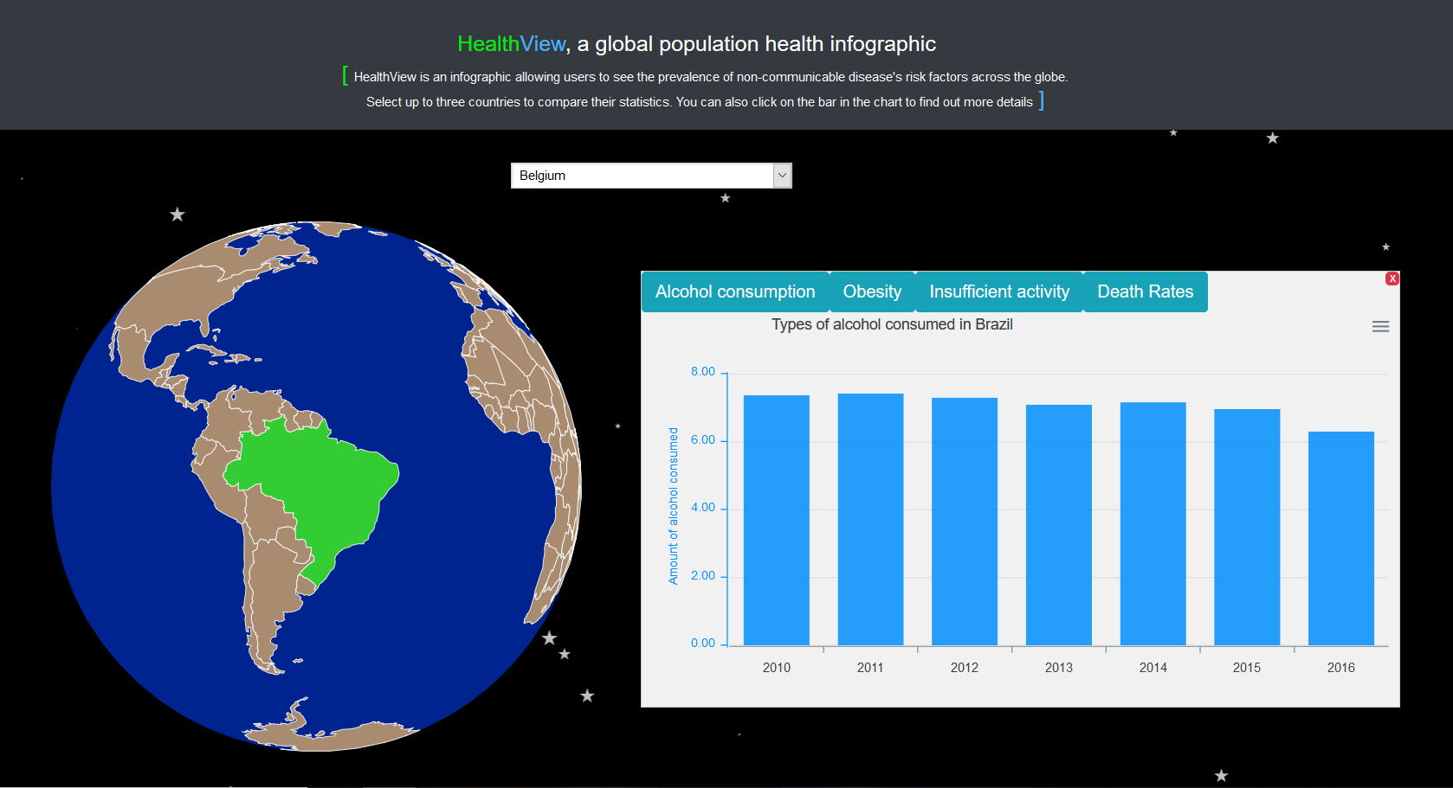

Figure 1. Population of a single country’s chart

We also wanted to allow users to be able to compare different countries’ statistics against each other. We allowed a maximum of up to three countries to be selected for comparison, any number of countries for comparison above three will be reset to just that single country the user has clicked on, as denoted in figure 1.

The figures below show the comparison between two and three countries.

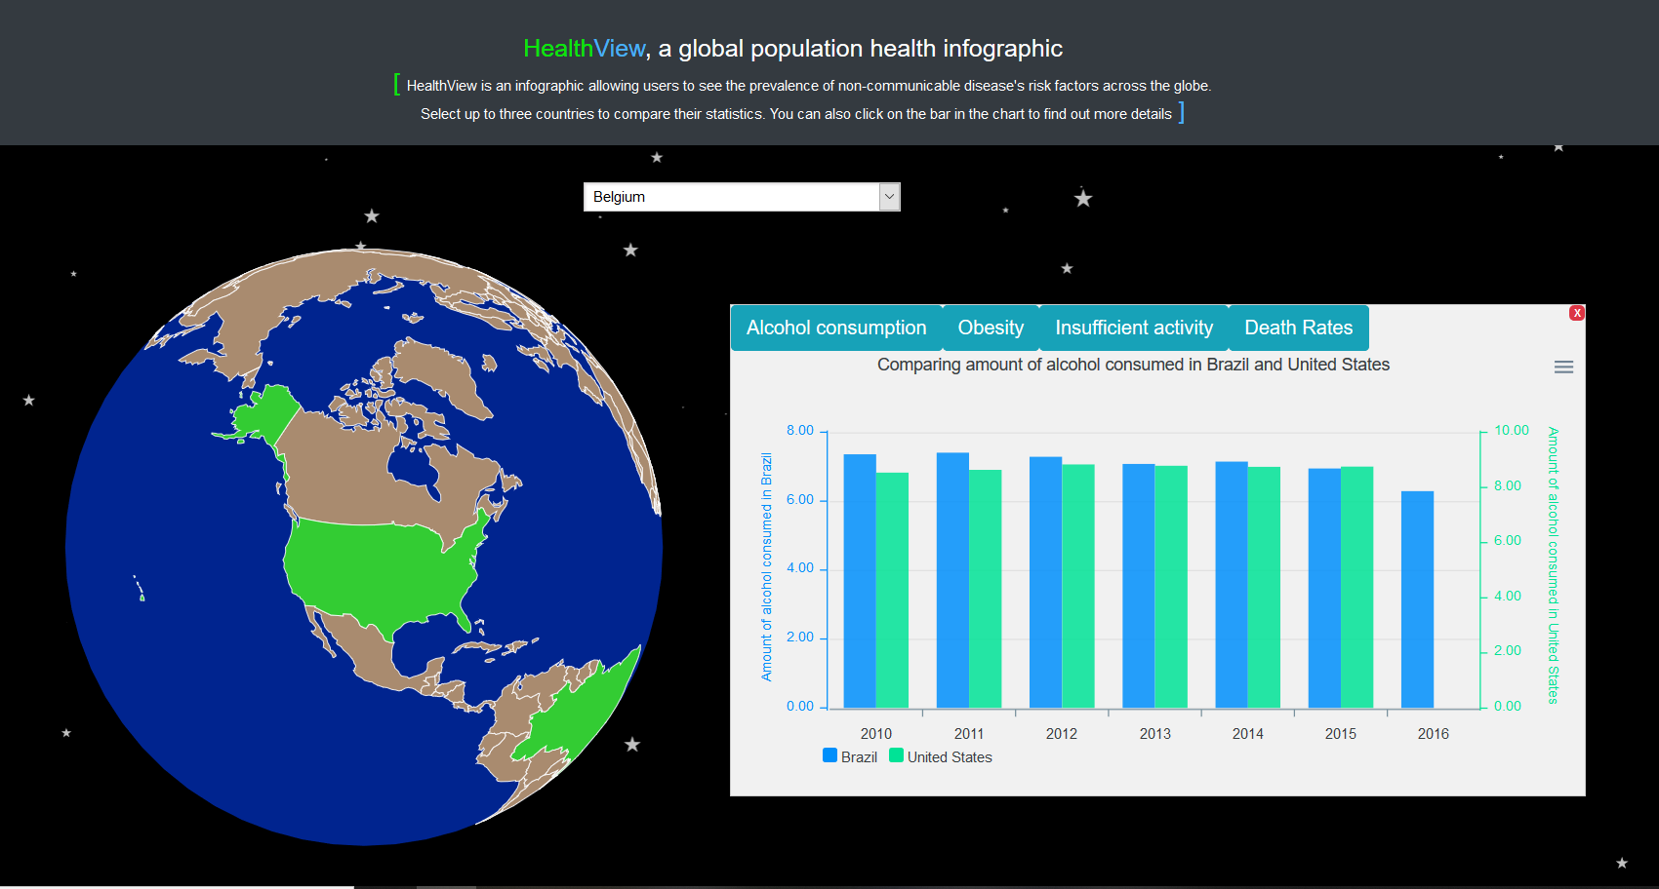

Figure 2. Comparison of two countries

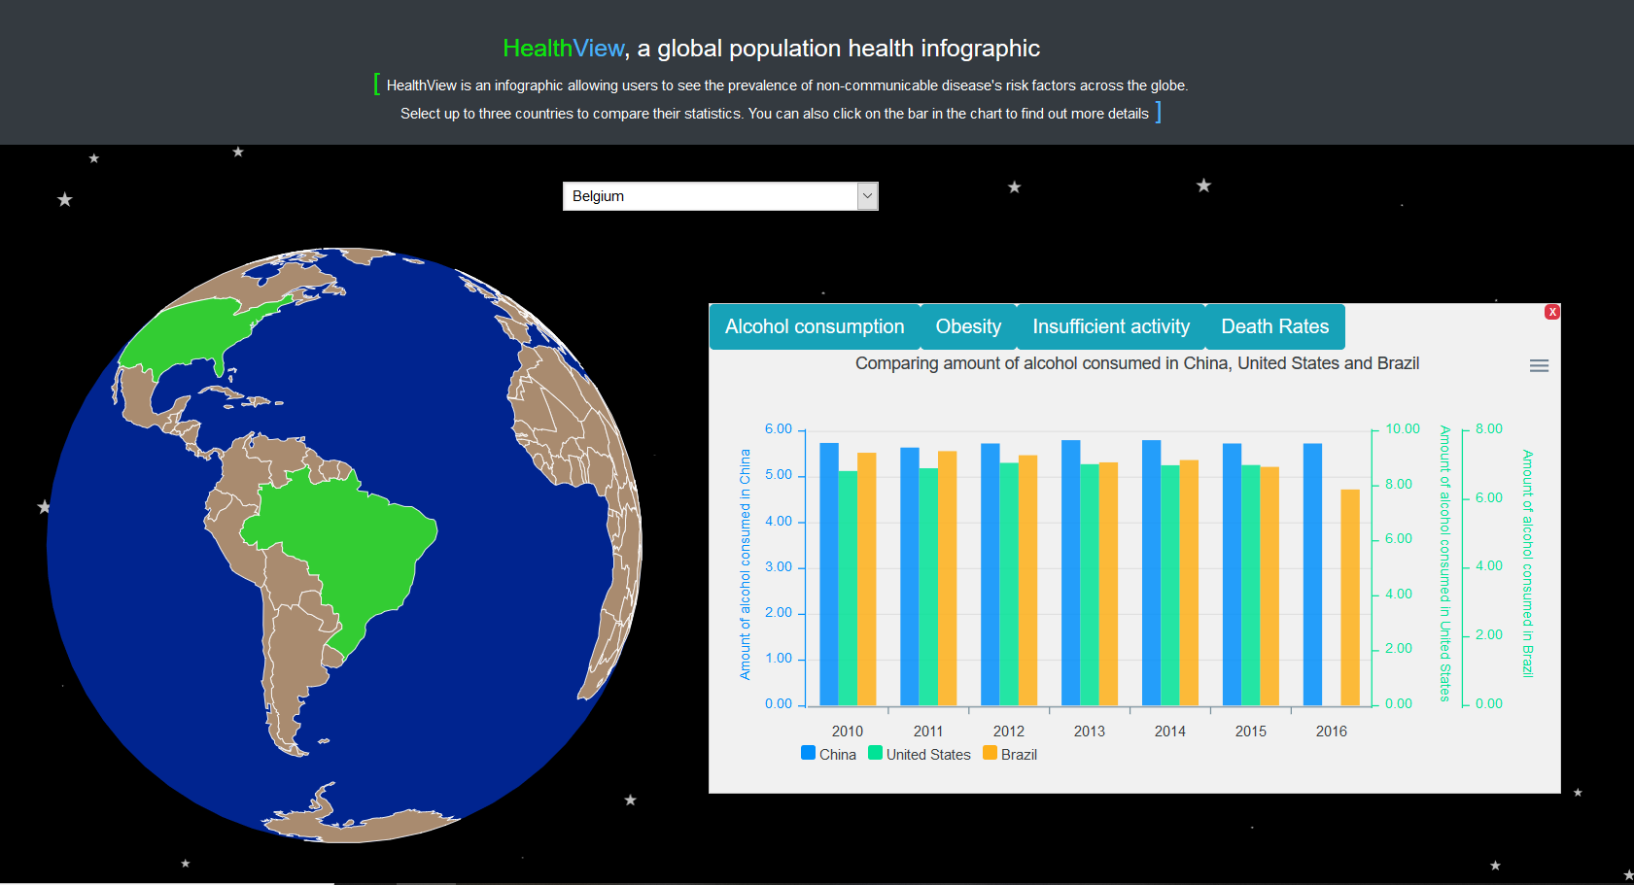

Figure 3. Comparison of three countries

The above figures from 1 to 3 displays the alcohol consumption in the country/countries selected, being visualized using ApexCharts.js’ column chart. [7] The user can also toggle between obesity and insufficient activity data set.

The chart also shows the different types of alcohol such as beer, wine and spirits, the amount of the types of alcohol consumption as well as the premature death rates in a particular year by clicking on the corresponding bar on the chart. This is denoted in the figures below.

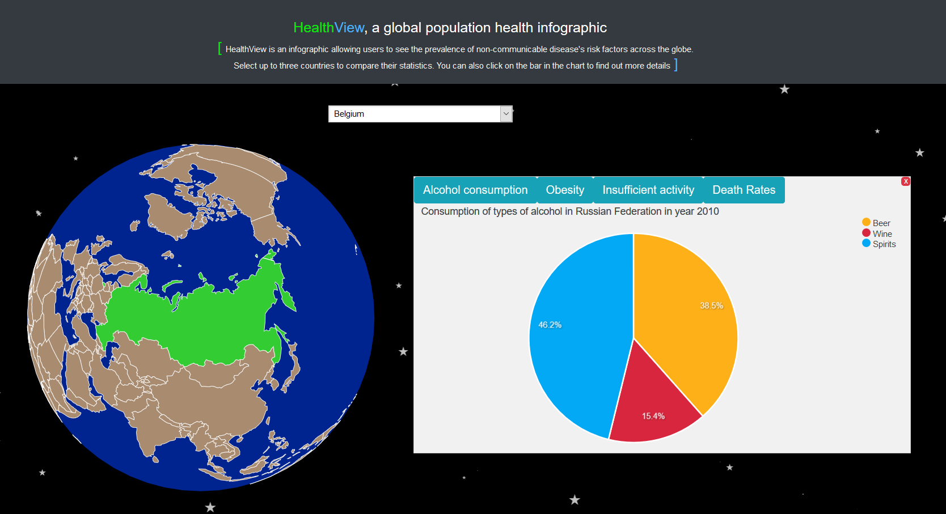

Figure 4. Types of alcohol consumption in a single country

Figure 4 shows the types of alcohol consumption in Russia in the year 2010 visualized using ApexCharts.js pie chart. [8] Beer is denoted in yellow and wine is denoted in red as these are the colors of the liquid respectively. Spirits is denoted in blue to show the difference in a clearer manner.

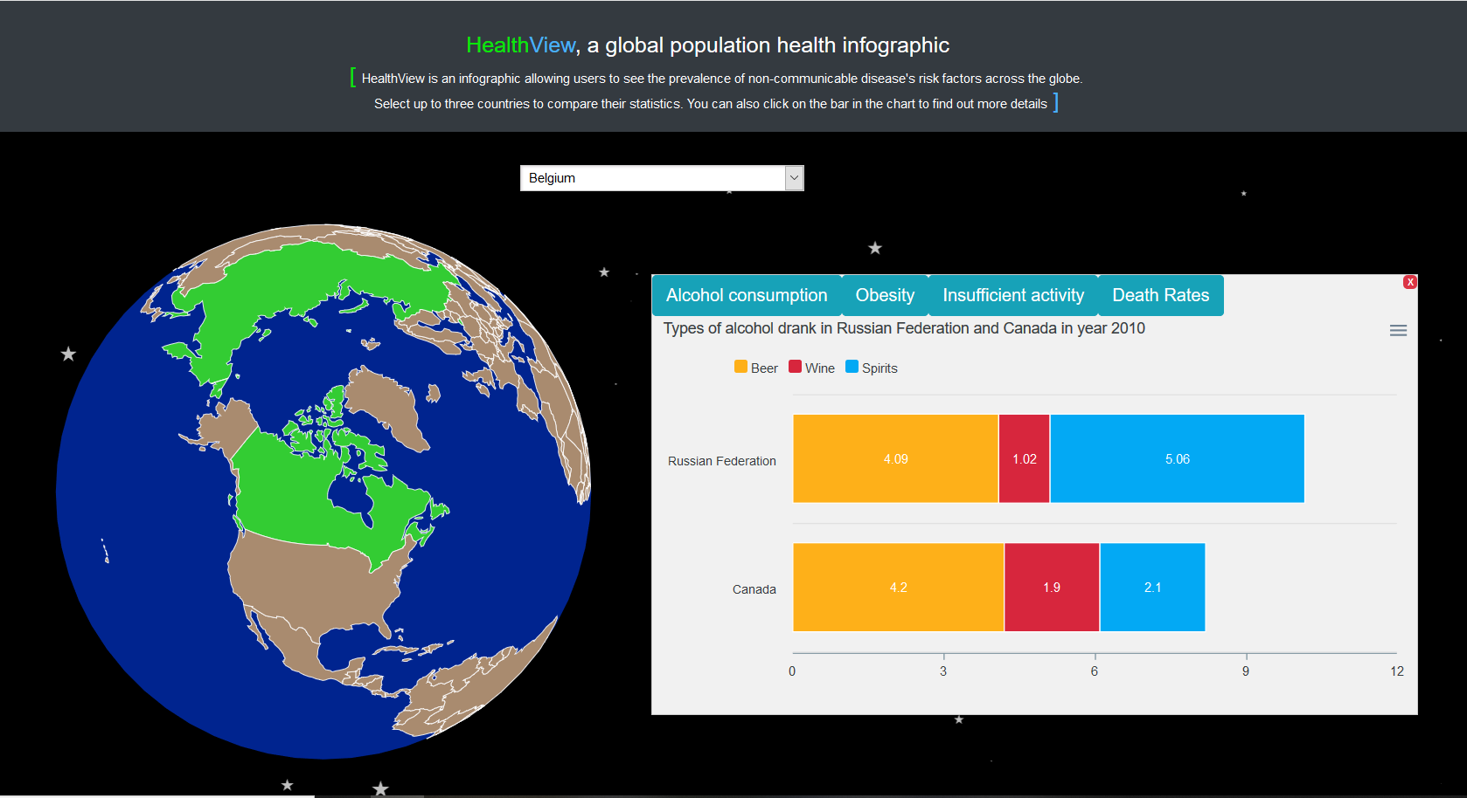

Figure 5. Types of alcohol consumption in two countries

Figure 5 shows the types of alcohol consumption in Russia and Canada in year 2010 visualized using ApexCharts.js stacked bar chart. [9] Stacked bar chart to differentiate clearly the differences in the types of alcohol consumed in the different countries. Similarly, the colors for beer, wine and spirit is yellow, red and blue.

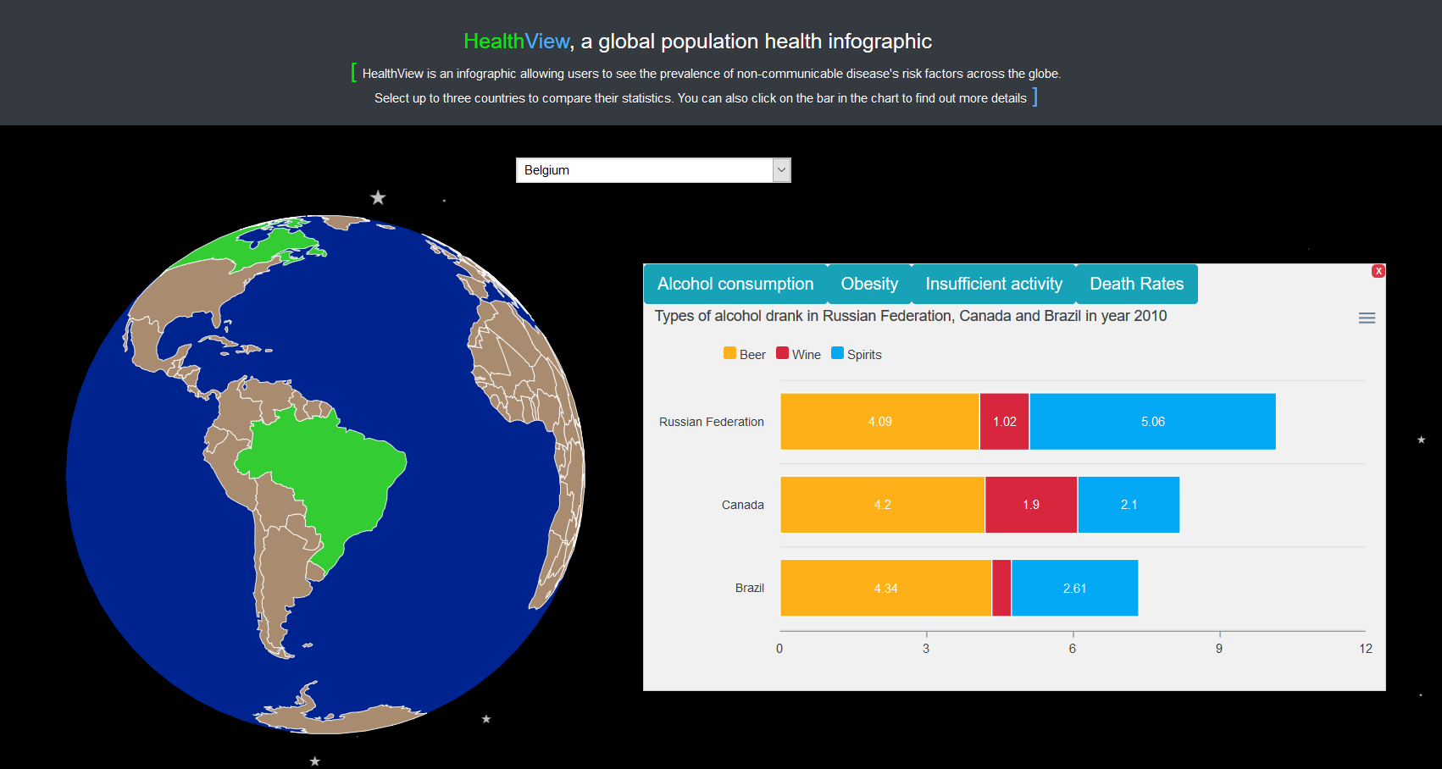

Figure 6. Types of alcohol consumption in three countries

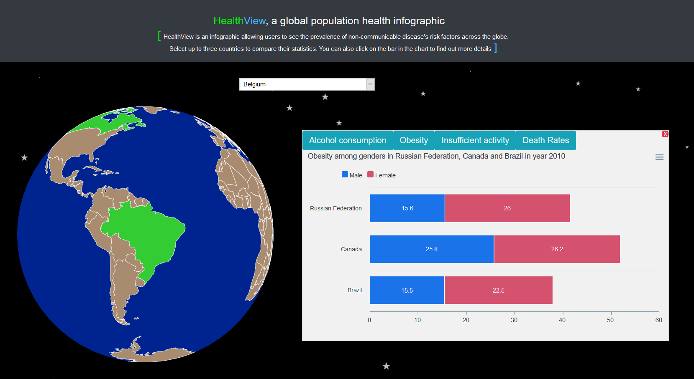

Figure 7. Obesity among gender charts

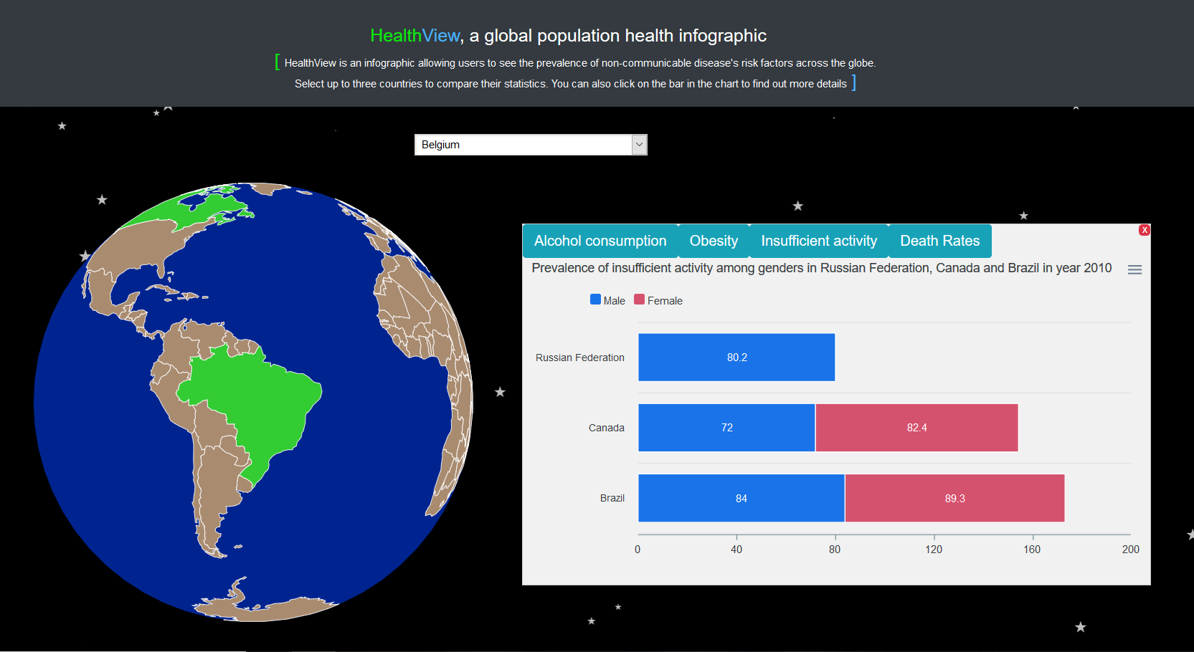

Figure 8. Prevalence of insufficient activity among gender charts

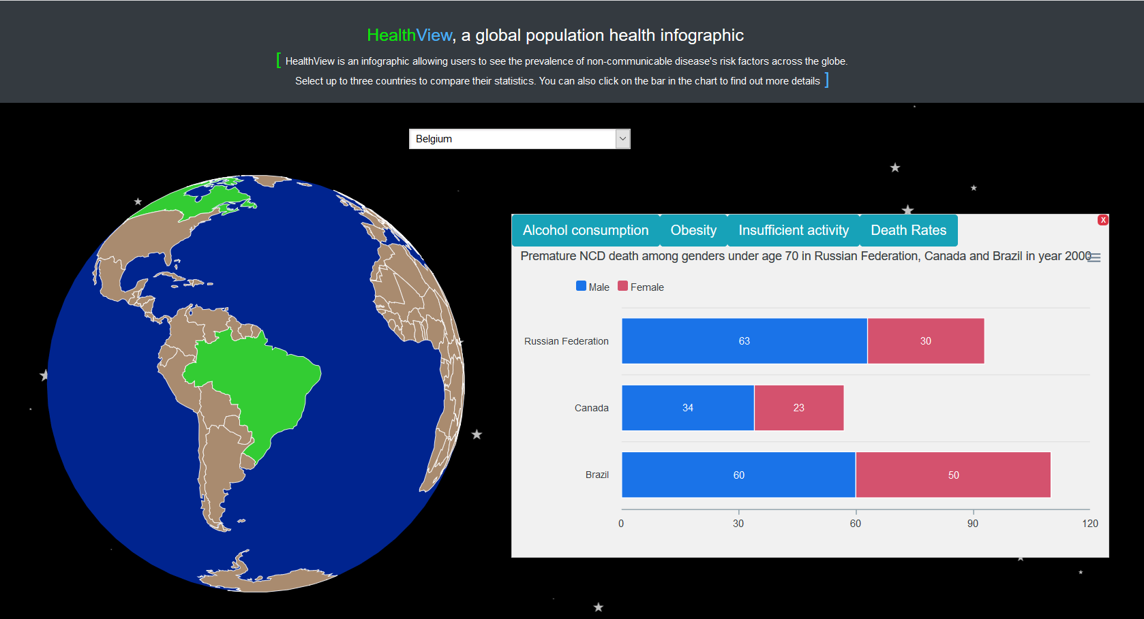

Figure 9. Premature NCD death rates among gender charts

Figure 6 shows the type of alcohol consumed in Russia, Canada and Brazil in the year 2010. It is also visualized using ApexCharts.js stacked bar chart. [9] The colors used are the same as the one in Figure 5. Figure 7 shows the obesity rate among the three countries and the colors blue and red denotes males and females respectively. This is also similar in the insufficient activity chart, where the data is visualized in a stacked bar chart with the same colors denoting males and females as shown in figure 8 as well as figure 9 where it shows the premature NCD death rates among the genders in the respective countries.

The way we keep track of how many countries are selected is via an array. The way the array is reset is when the array has 3 different countries’ id or when the user clicks on the close button in the chart area.

Bootstrap is also used to make the buttons look more appealing than just plain buttons with no styling. Particles.js [10] is used in this project to create the moving stars in the background to simulate the likes of the earth in space.

# Evaluation

For our evaluation, the team used Heuristic evaluation technique that is defined as a review of user interface, looking closely at user experience aspects. It helps to identify usability problems in the user interface design. We gathered a group of 10 evaluators who will evaluate from our paper prototype to final product in all the various evaluation phase. The evaluators also signed the ethics checklist form before beginning the evaluation. Firstly, we presented paper prototypes to the evaluators. The evaluation process is conducted against a set of design guidelines, also known as heuristics established by Nielson and Molich. [11] The reason why the team chose to perform heuristic evaluation is because heuristic evaluation can provide the team quick feedback and results on how to improve the user interface design. In addition, different evaluators can find different usability problems as it can be difficult for a single individual to find all usability problems. This can help to detect the highest number of possible usability problems before the final design is produced. For the evaluation phase, evaluators go through the paper prototypes and user interface design. They will inspect the application’s flow and interfaces against the 10 guidelines. Whenever they come across an issue or an area for improvement, the team will record the issue down in the heuristic worksheet that is attached in the Appendices section. After the evaluators have completed their evaluations, the team conducted a meeting to summarize what the findings were and ranked the issues that should be addressed according to its severity.

For the final product, the team allowed the evaluators to go onto the website and test for the usability and the functionality of the website. The responses from the evaluators after exploring the website was recorded using a questionnaire.

## First Evaluation Phase

In the first evaluation phase, the paper prototypes used for the first evaluation phase are attached below.

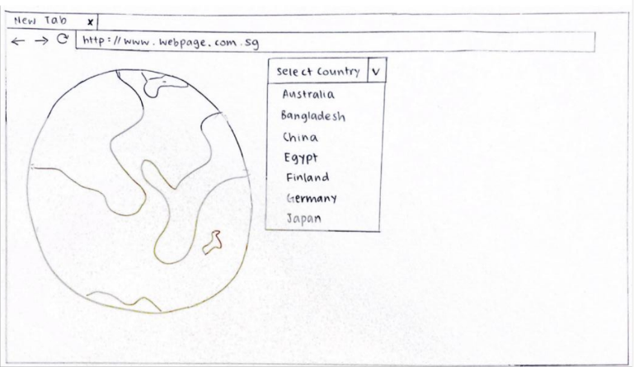

Figure 10. First paper prototype(I)

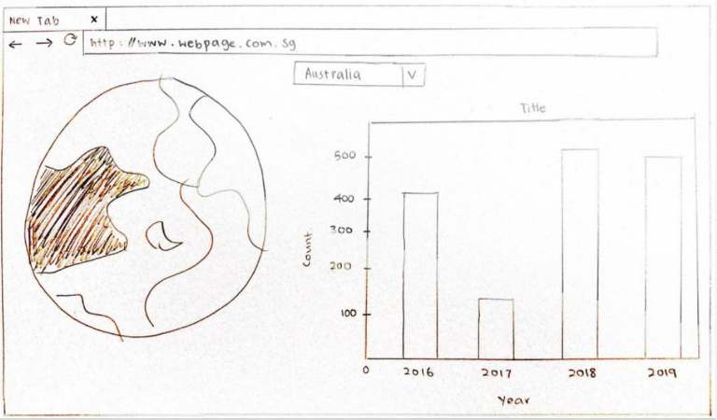

Figure 11. First paper prototype(II)

From this evaluation phase, there are some feedback raised in concern with the guidelines among the evaluators. The feedbacks received from the evaluators are then collated and discussed within the team. Each issue was assigned a level of severity. The issues included, the ‘Flexibility and efficiency of use’ guideline where some evaluators find the design of the website, based on the paper prototype too simple. While some voiced the simplicity of the website a good thing, some however mentioned that more filters can be implemented in the bar-chart section to find certain results that users may want to see or compare. The ‘Aesthetic and minimalist design’ guideline where evaluators provided feedback on rearranging the positions of the elements in order for the website to maintain hierarchy and more visually appealing, specifically, the drop-down button where users can use to select a certain country, can be placed at the top of the globe interface, while the globe interface can be placed in the middle of the website. The ‘Aesthetic and minimalist design’ guideline where there is a lack of informative text present in the website. Evaluators commented that there should be some text first, giving users an idea of the purpose of the website, then moving on to the interactions.

## Second Evaluation Phase

In the second evaluation phase, the evaluators were tasked to repeat the evaluation process with the second set of paper prototypes, with changes made to the user interface design based on the feedback from the first evaluation phase. The paper prototypes used for the second evaluation phase are attached below.

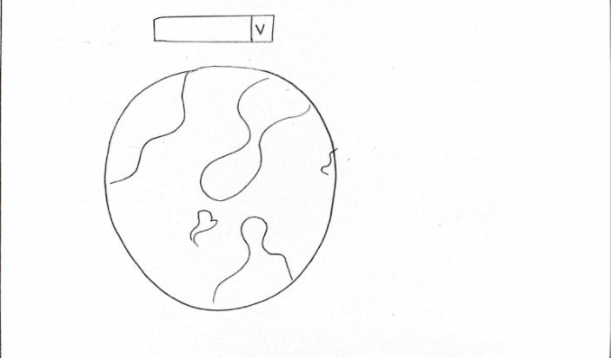

Figure 12. Second paper prototype(I)

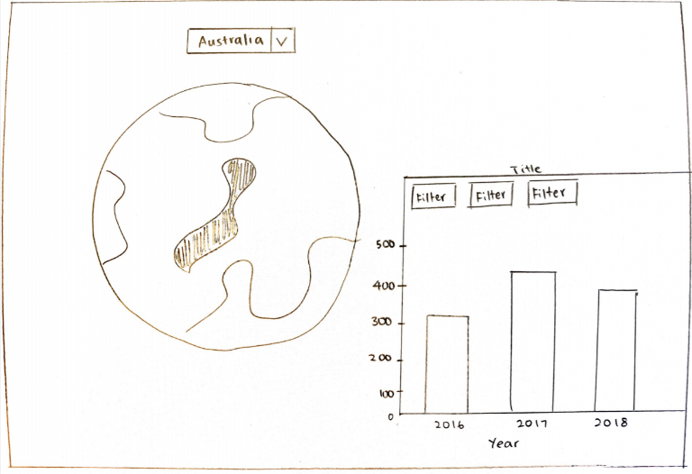

Figure 13. Second paper prototype(I)

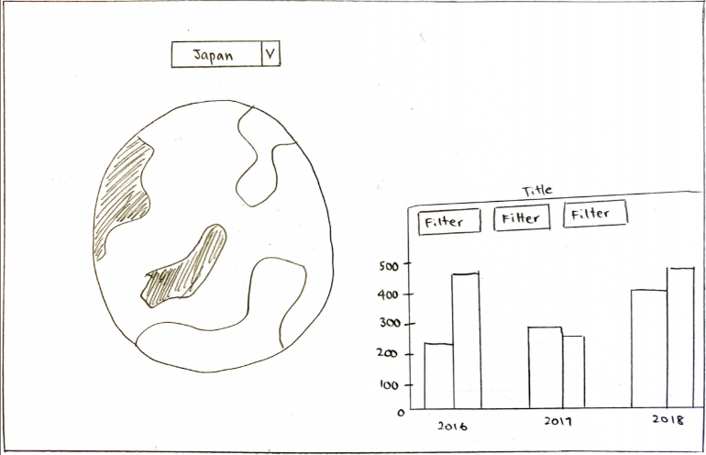

Figure 14. Second paper prototype(III)

## Third Evaluation Phase

In our third evaluation, we created wireframes and repeated the evaluation with the same evaluators with the additional changes made to the prototypes. The wireframes attached below are used for the evaluation.

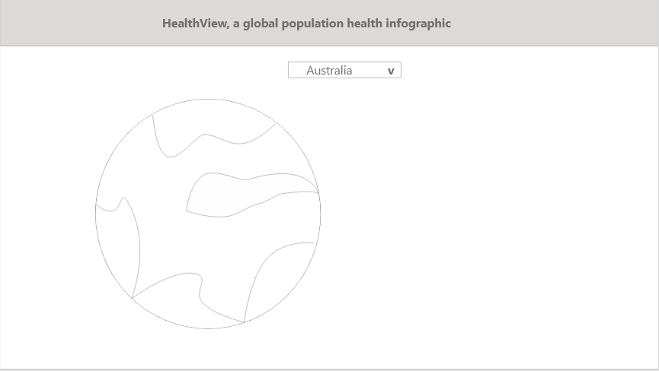

Figure 15. Wireframe(I)

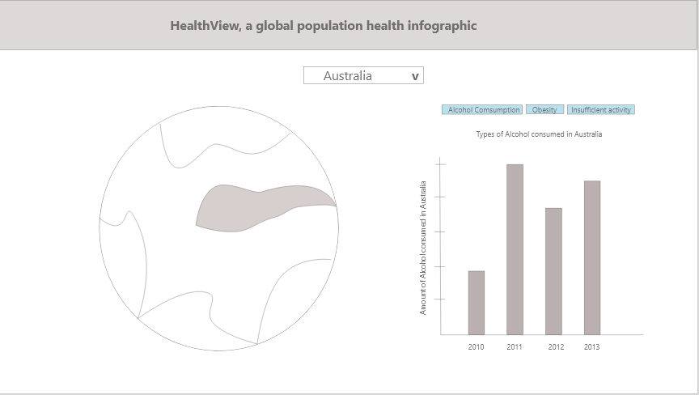

Figure 16. Wireframe(II)

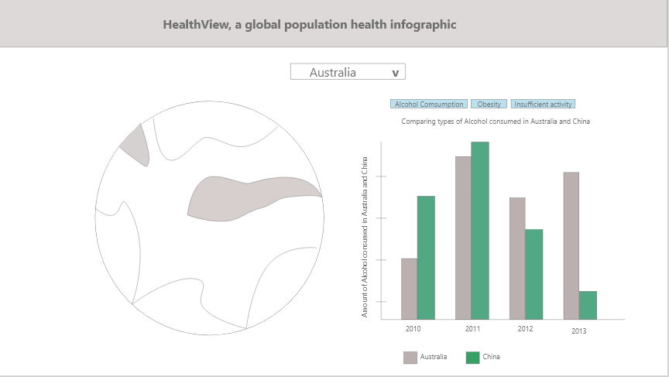

Figure 17. Wireframe(III)

## Final Evaluation Phase

In the final evaluation, we decide to employ the evaluation technique through user participants for the evaluators to test the usability and the functionality of the website. The evaluators will go onto the website and then evaluate it by filling up a questionnaire created in Google Docs.

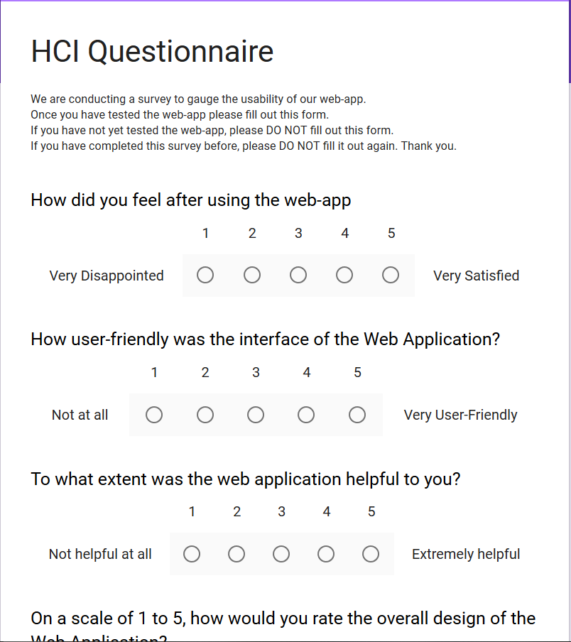

Figure 18. Questionnaire for evaluation

Figure 18 shows a screenshot of the questionnaire that the evaluators answered. All the feedbacks and responses from the evaluators were collected through a questionnaire.

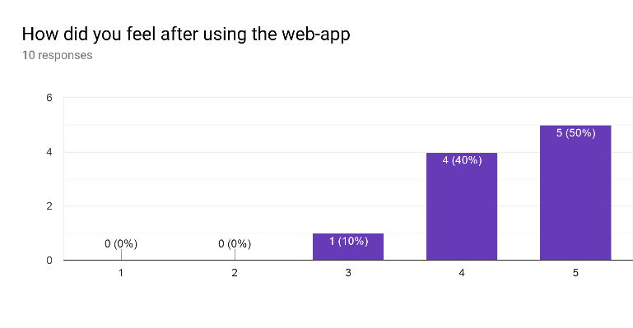

Figure 19. First question

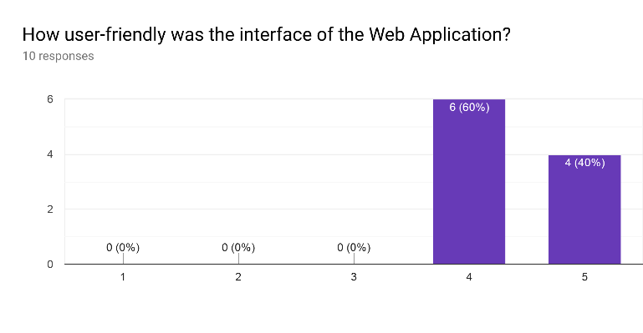

Figure 20. Second question

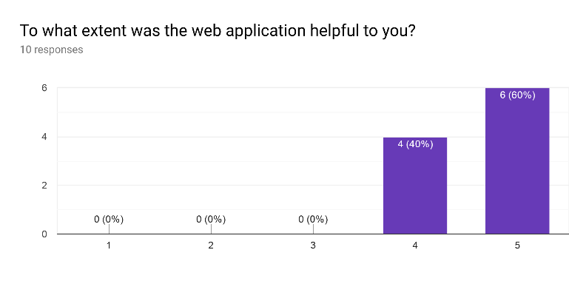

Figure 21. Third question

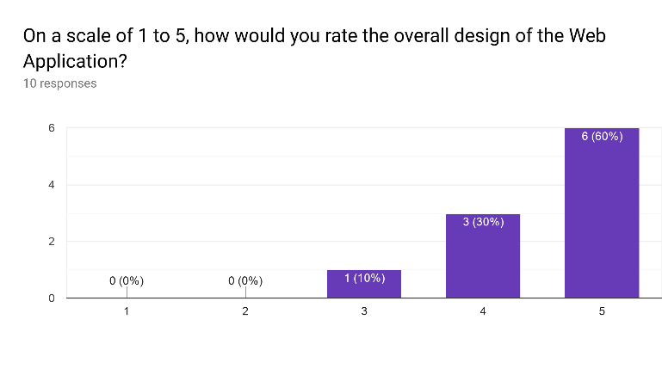

Figure 22. Fourth question

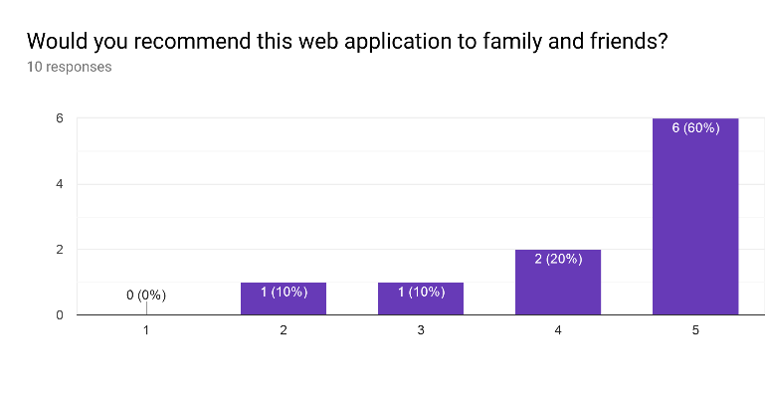

Figure 23. Fifth question

The above figures from figure 19 to figure 23 are the results from the responses of the evaluators. Overall, the design of the website was well received by the evaluators, it was noted to be user-friendly and helpful to them.

# conclusion and future works

In conclusion, based on the evaluators’ feedback, we can safely deduce that our website for population health is able to provide users with informative and useful statistics to the general public to work against risk factors contributing to non-communicable diseases while being easy and friendly to use.

Future works that can be implemented in the website can be as follows:

1. Implementation of 3D bar chart on the globe itself. This will serve as a general view of the different data set with different color coding while preserving the rest of the existing functionalities.

2. Including more kinds of data in the website as well as to explore with other methods of visualizing the data in the website.

# References

|  |  |
| --- | --- |
| [1] | "Wikipedia," [Online]. Available: https://en.wikipedia.org/wiki/Non-communicable_disease. |
| [2] | World Health Organization, 1 June 2018. [Online]. Available: https://www.who.int/news-room/fact-sheets/detail/noncommunicable-diseases. |
| [3] | "Healthline," [Online]. Available: https://www.healthline.com/health/non-communicable-diseases-list#most-common. |
| [4] | W. H. Organisation, "Global Health observatory data repository," [Online]. Available: http://apps.who.int/gho/data/node.main.A858?lang=en. [Accessed 25 Nov 2019]. |
| [5] | D3, "D3js - Data driven documents," [Online]. Available: https://d3js.org/. [Accessed 25 Nov 2019]. |
| [6] | ApexCharts.js, "ApexCharts.js - Modern & Interactive Open-source Charts," [Online]. Available: https://apexcharts.com/. [Accessed 25 Nov 2019]. |
| [7] | ApexCharts, "ApexCharts.js - Basic Column Chart," [Online]. Available: https://apexcharts.com/javascript-chart-demos/column-charts/basic/. [Accessed 25 Nov 2019]. |
| [8] | ApexCharts, "ApexCharts.js - Simple Pie Chart," [Online]. Available: https://apexcharts.com/javascript-chart-demos/pie-charts/simple-pie-chart/. [Accessed 25 Nov 2019]. |
| [9] | ApexCharts, "ApexCharts.js - Stacked Bar Chart," [Online]. Available: https://apexcharts.com/javascript-chart-demos/bar-charts/stacked/. [Accessed 25 Nov 2019]. |
| [10] | V. Garreau, "particles.js - A lightweight JavaScript library for creating particles," [Online]. Available: https://vincentgarreau.com/particles.js/. [Accessed 28 Nov 2019]. |
| [11] | "10 Usability Heuristics for User Interface Design," Nielsen Norman Group, 24 April 1994. [Online]. Available: https://www.nngroup.com/articles/ten-usability-heuristics/. |

# Appendice

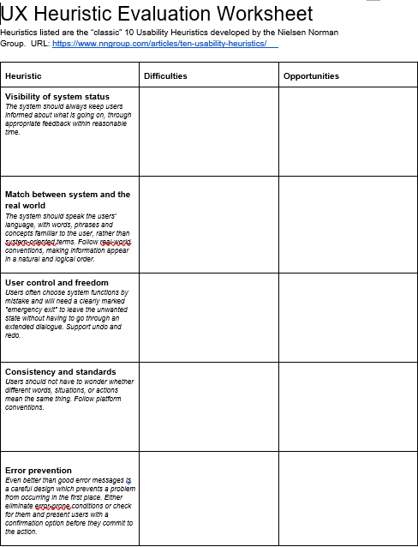

Figure 24. Heuristic worksheet(II)

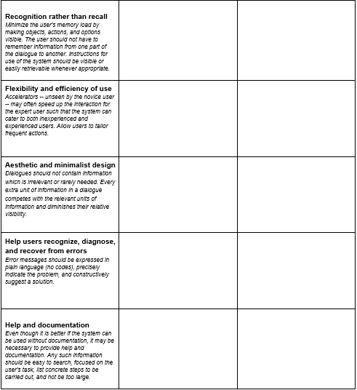

Figure 25. Heuristic worksheet(I)



Figure 26. Ethics Checklist