Slope

Smoothing using gaussian filter.

Elevation file

Saga Wetness Index

Specific Catchment Area

1. We use the elevation File: “1x1_top_campus.TIFF”
2. (Processing tool box) **Gaussian Filter:** use file 1x1_top_campus.TIFF

*One of the principle justifications for using the Gaussian filter for smoothing is due to its frequency response. Their effect is to remove high spatial frequency components from an image.*

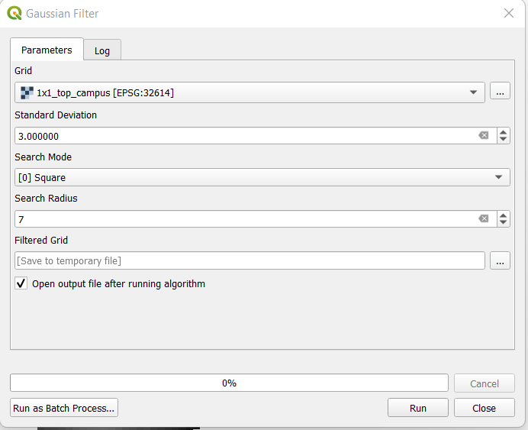

*Output new file: filtered grid*

1. (Processing tool box) **Saga wetness index:** use file filtered grid.

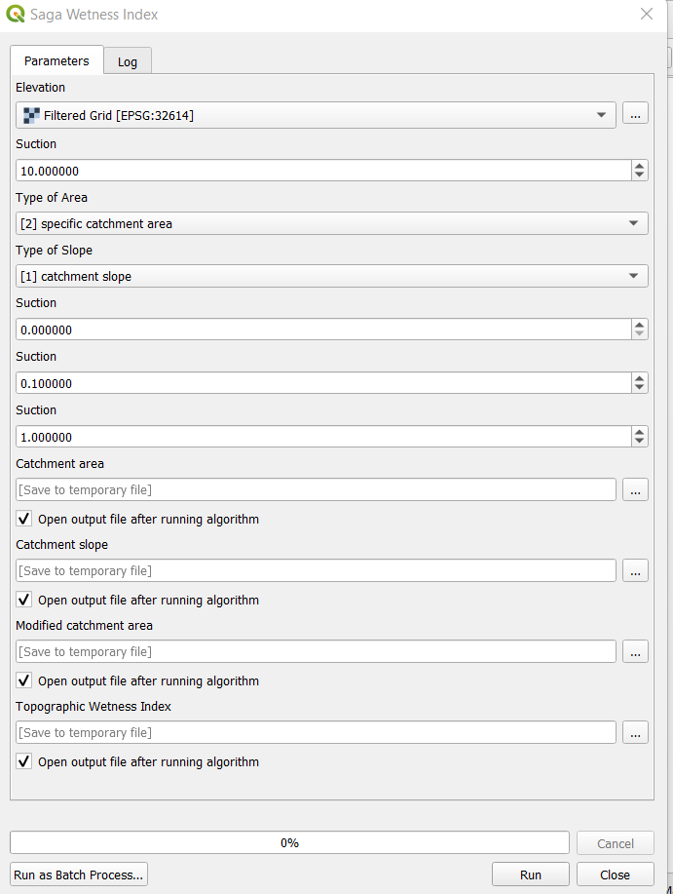

*Output new files: Topographic wetness index, catchment slope, others*.

