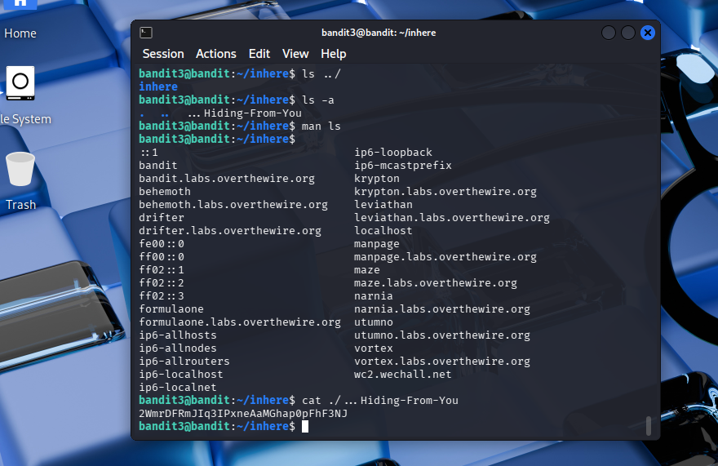
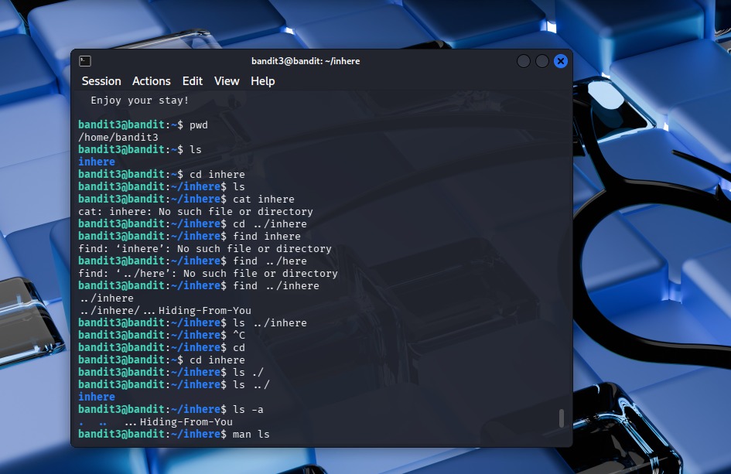
In challenge level 3, I learned about hidden files. In linux, any folder that starts with dot (.) is considered. So, when I tried using ls, it didn’t show anything, even when I’m already in ‘inhere’ file directory. Because I thought there was nothing inside it, as you can see, I tried printing the contents in inhere file using the cat command, and it didn’t show anything. So, I used ls -a command. This command shows all list of the file including the hidden one, then I found the hidden file inside of it. After finding it, I was able to find the password for the next level.

