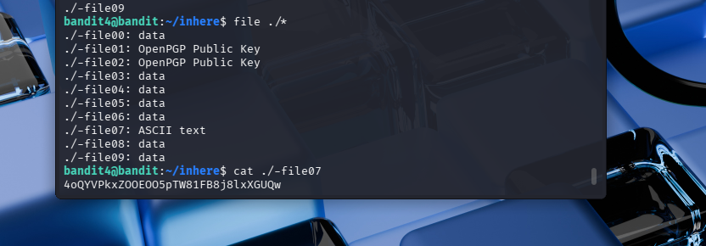
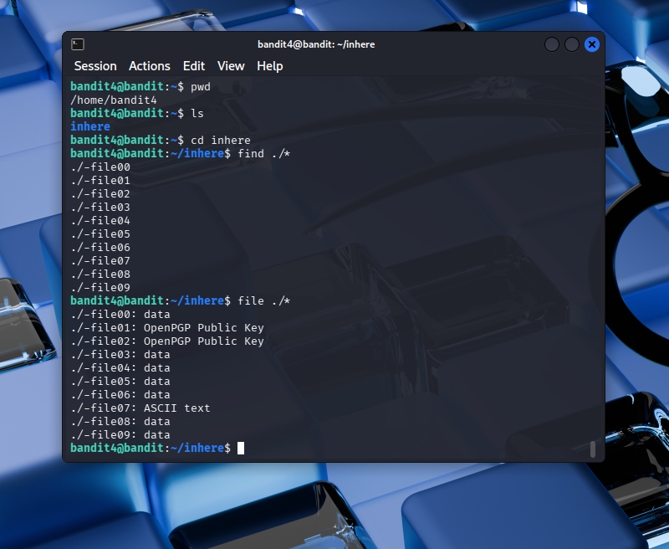
In challenge level 4, this level wasn’t hard, but it was tiring looking through all of the file one by one to see which one has the password, then I learned that there’s a way for me to not read all of the file one by one using the file ./*. The file command is used to identify the type of file, by examining its content, rather than relying on the file extension (e.g. .docx, .pdf, & txt). And the asterisk (*) is a wildcard in Linux that acts as a powerful filter. Instead of just selecting everything, it lets me handle groups of files at once by matching parts of their names—like finding every file that starts with the same word or ends with the same extension. This makes it much faster to perform actions on specific files without having to type out each name one by one.

