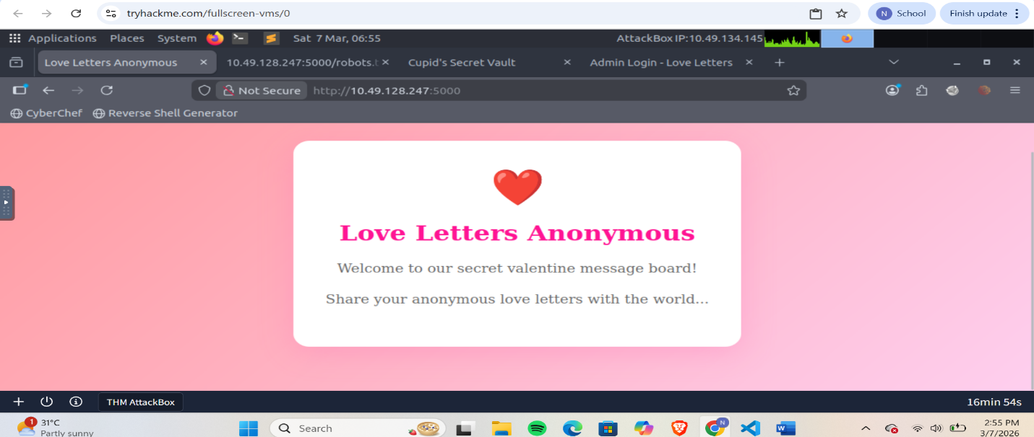
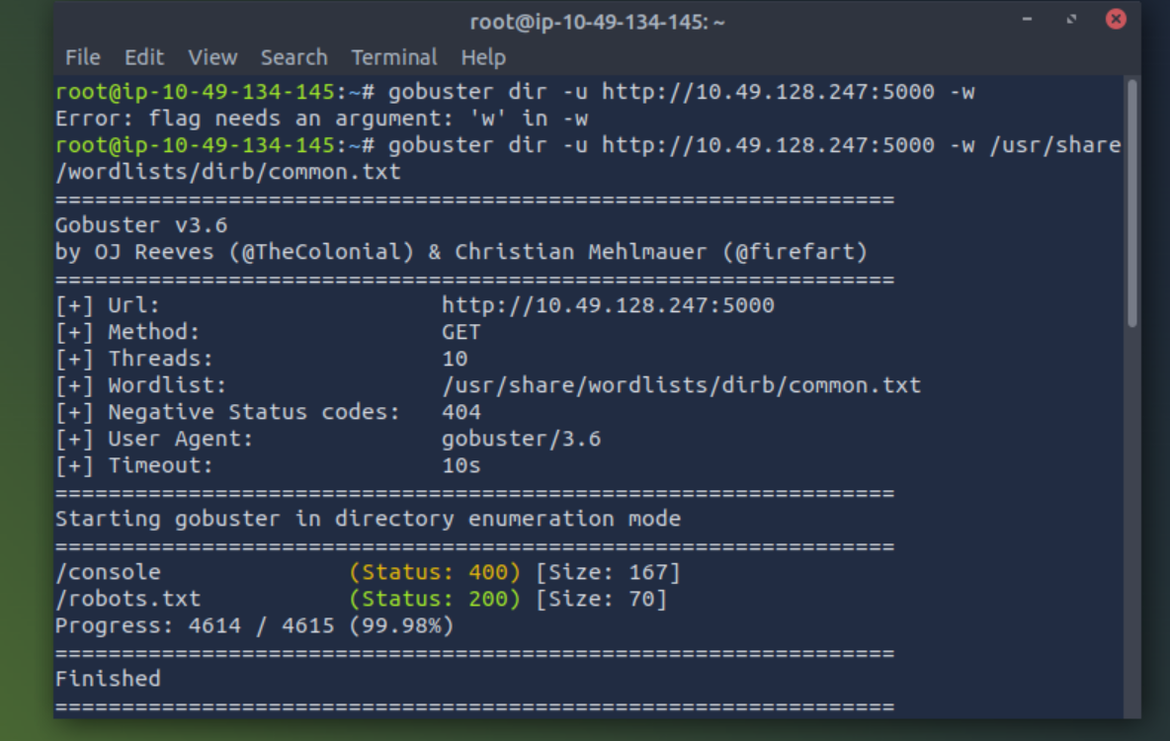
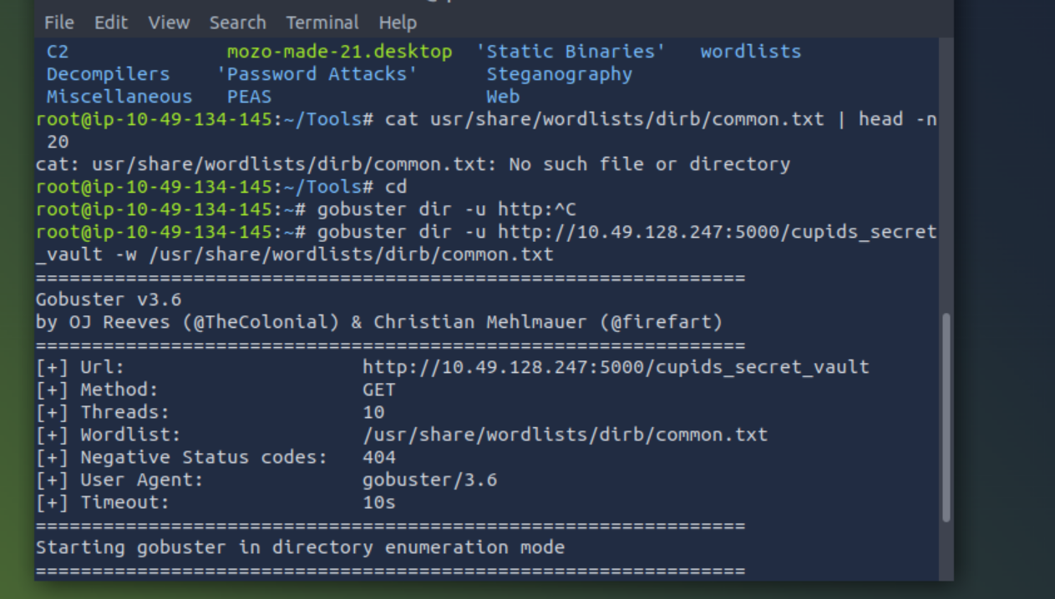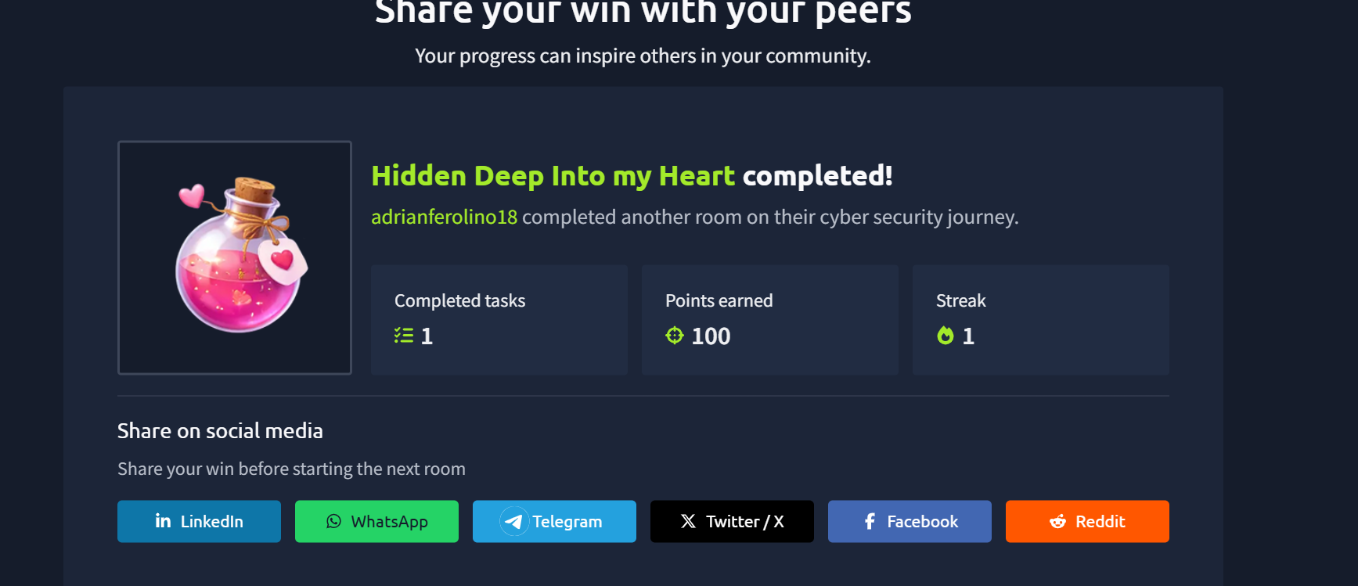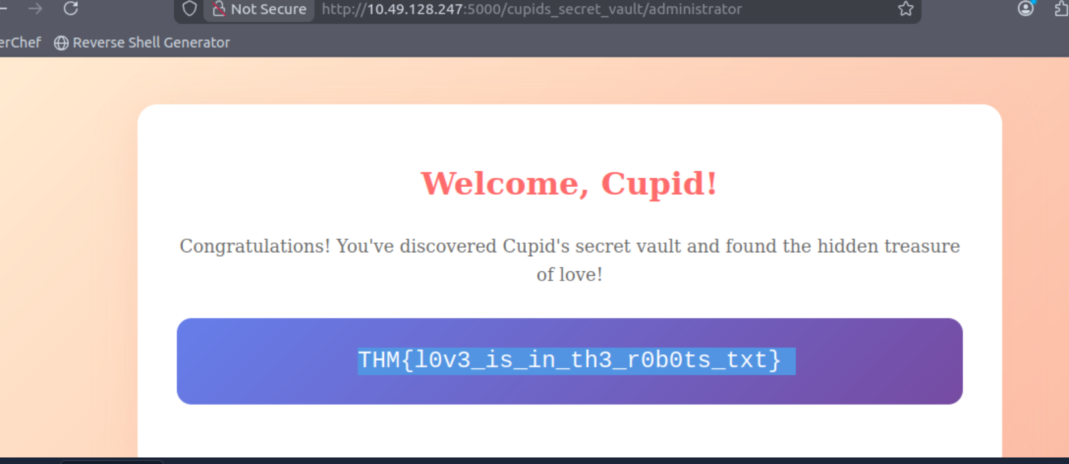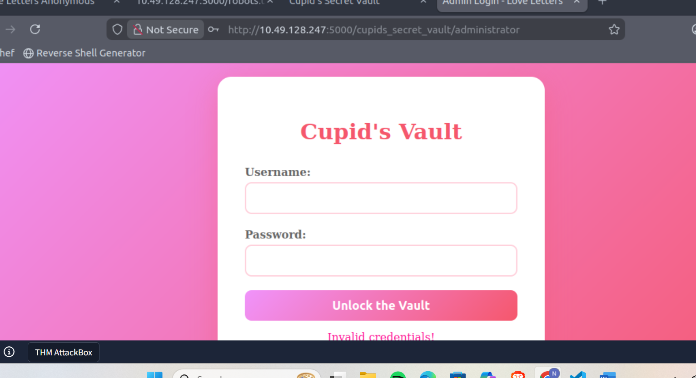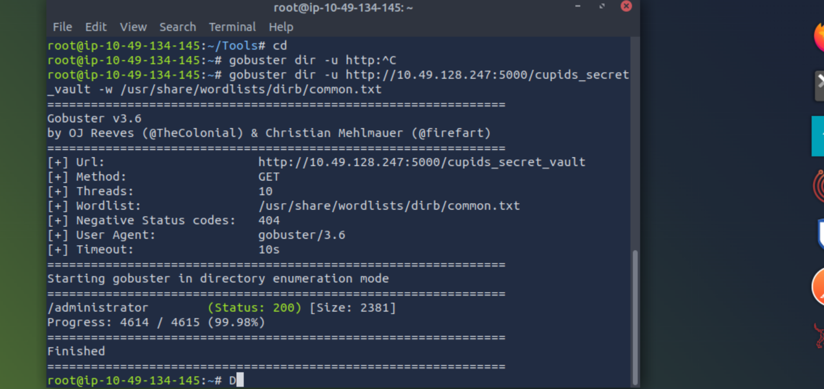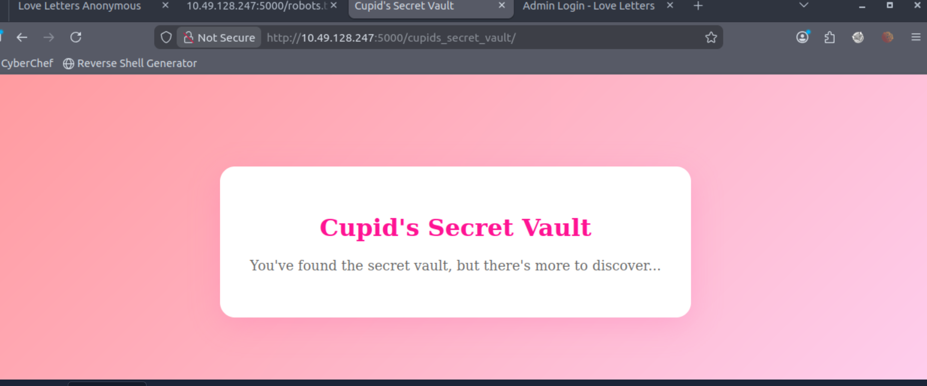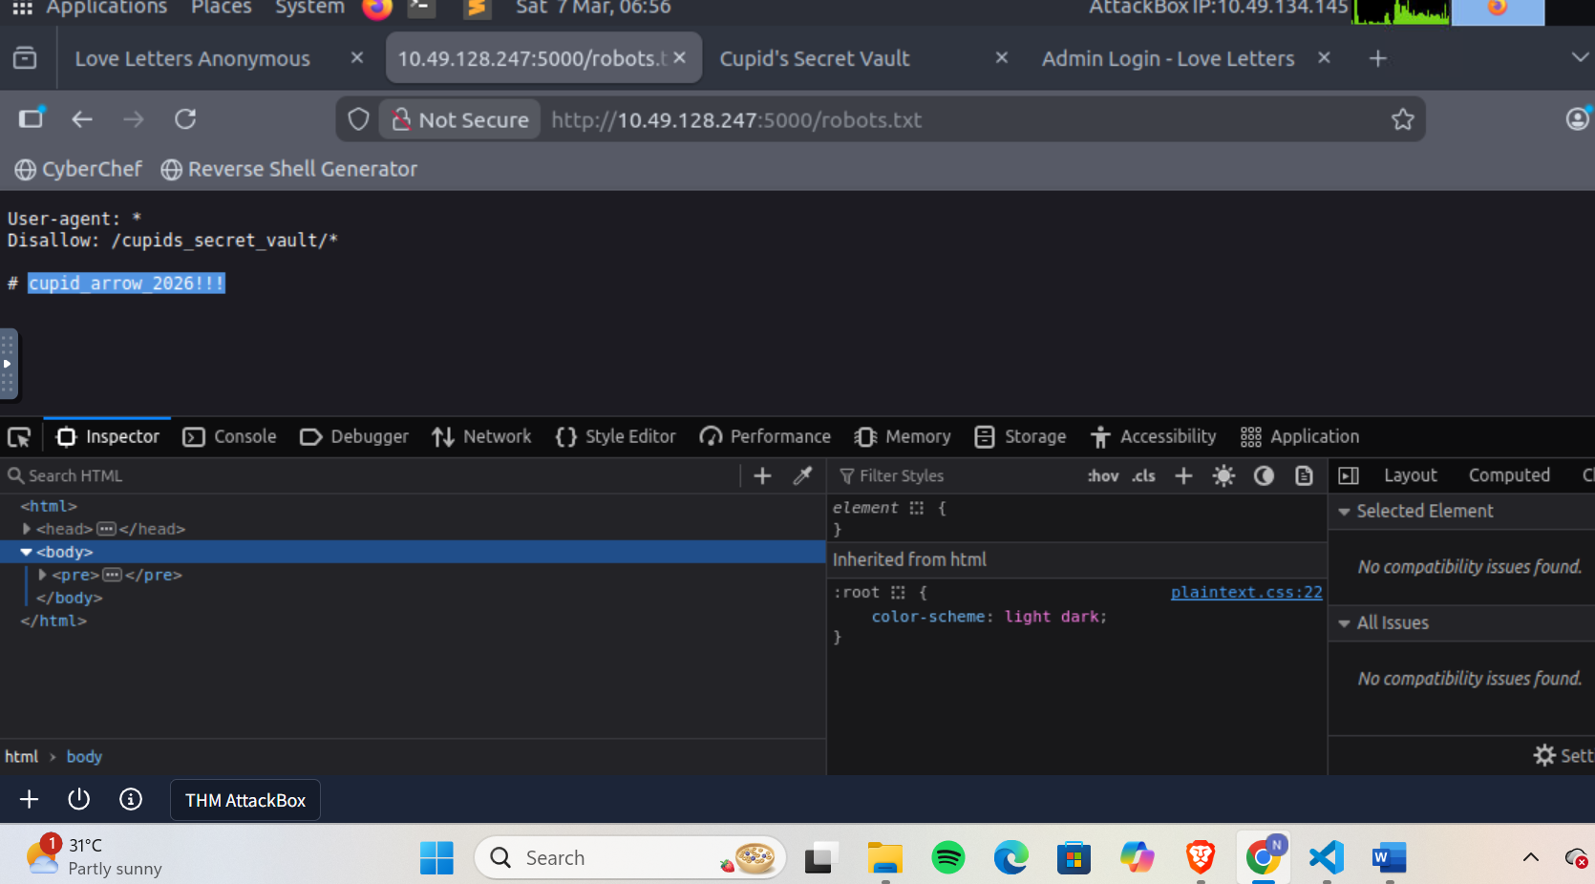

This was my first time exploring tryhackme, and my first time trying CTF challenge, and for my first time, I learned a lot. I only have knowledge in accessing directories/subdirectories files, so I had a hard time on how to solve this, because I didn’t know where to find the directories and subdirectories of a web, even the hidden files. And each day, I’m only given 1 hour to solve the challenge. It took me a lot of tries until I discovered about the gobuster command, which lists the hidden directories, files, DNS, and subdomains on web servers. When I learned about this command, I was able to solve the challenge quickly. The command I used was “gobuster dir -u [the url] -w /usr/share/dirb/wordlists/common.txt”. The “dir” stands for directories, since I’m looking for directories, , then “-u” for the url, then “-w” for wordlists. Wordlists is a list of words used for cracking a password or file/directory enumeration. Using this, I was able to find the hidden file, which is the “robots.txt”. Then I tried adding the robots.txt to the URL, and was able to find a clue: a password and a user something. Now, I wasn’t sure about the disallow, so I just tried to add it to the URL and was able to find another directory of the web, which says “there’s more to discover”, so I tried using the gobuster again, using the new URL. Then I found the “/admin” directory, and tried searching it in web, and I was to find the admin login. And that was how I was able to solve the Challenge. Although the challenge says easy, it was hard for me to figure things out, as I did not have anyone to ask for, so I just searched it online, and I’m starting to learn new things about web exploitation.

